

Capstone Project Report
NYAN
CPRO 2901 F.
Yaksh Sharma, Aaryan Garg, Harmanpreet Singh, Ramandeep Kaur and Muh Fadlullah Lawal

Table of Contents
1. Introduction 4
1.1 Problem Statement 4
1.2 Objectives 4
1.3 Scope 4
2. Literature Review / Background Research 4
2.1 NPC control 4
2.2 NLU for short, domain-bound text 5
2.3 Learning-to-rank for action selection 5
2.4 LLMs under constraint 5
3. System Requirements 5
3.1 Actors and use cases 5
3.2 Functional requirements 6
3.3 Non-functional requirements 7
3.4 Data Requirements 7
3.5 Assumptions and dependencies 7
4. Architecture and Interfaces 8
4.1 System architecture/design 8
4.1.1 Module Responsiblities 8
4.2 Database Design / Data Schema 9
4.2.1 ER diagram 9
4.3 Diagrams 10
4.3.1 Data flow diagrams 10
4.3.2 Sequence diagram 10
4.3 API(MVP) 11
4.4 Use case diagram 12
5. Project planning 13
5.1 Project management plan 13
5.2 Work breakdown structure (WBS) 13
5.3 Gnatt Chart 13
5.4 Roles and Responsibilities 14
6. Risk Management 15
7. Conclusion 16

Table of figures:
Figure 1: Use case diagram outlining the blacksmith and user interaction. 7
Figure 2: System architecture diagram that explains where each part of the system will be located. 8
Figure 3: ERD showing the entities and the coloums for the database of the project. 10
Figure 4: Dataflow diagram that shows how the data is flowing throughout the lifecycle of an instance of the game. 11
Figure 5: Sequence diagram for all the processes in the backend. 11
Figure 6: Use case diagram for the blacksmith and user mock interaction. 13
Figure 7: Gnatt chart for the expected timeline of different stages of building the game. 14

1. Introduction

1.1 Problem Statement
Conventional NPCs in 2D games are commonly implemented with fixed state machines, behavior trees, and pre-scripted dialogue. These techniques yield predictable and repetitive behavior, which reduces immersion and replay value. Future multiplayer or persistent worlds intensify the problem: NPCs must adapt to different players yet maintain a coherent identity. This project addresses the gap by building an adaptive NPC that learns from interactions and responds with contextual, personality-consistent actions while meeting strict performance and safety constraints.

1.2 Objectives
Deliver a Unity-based 2D MVP (Blacksmith Shop) that demonstrates adaptive NPC behavior.
Run local ML for NLU (intent + tone/sentiment + safety flags) and for candidate selection of the NPC’s action/line (What is ML.NET and how does it work?, n.d.).
Persist genetic (base) traits and growth (learned) traits per Player-NPC pair.
Keep the system offline-first, with an optional bounded LLM “polish” step (no new facts).
Define and track evaluation metrics for understanding, selection quality, constraints/safety, and player outcomes.

1.3 Scope
In scope: single-player MVP; NPC appears only inside the blacksmith shop; /interact is called only if player provides text or a meaningful ActionEvent; local NLU; template/tiny-local candidate generation; ML re-ranker; safety & lore checks; persistence of growth traits and interaction logs; dashboarded metrics.
Out of scope (MVP): multiplayer synchronization; long-form generation; large online LLM reliance; world-scale content.

2. Literature Review / Background Research

2.1 NPC control
FSM/Behavior Trees/Scripting: clear and maintainable, but static; content explosion for coverage.
Utility AI/Dynamic Scripting: tune weights/utilities during play; more variety but still designer driven.
Personality frameworks: Big Five/PAD influence tone and choice weighting; easy to expose as numeric traits (Senanayake, n.d.).

2.2 NLU for short, domain-bound text
- BoW/TF-IDF + Logistic Regression/Linear SVM: strong baseline; add char n-grams for typos/slang (Mikolov, n.d.).
- fastText (subword): robust to OOV/misspellings; efficient CPU inference; good multi-label classifier (Armand Joulin, n.d.).
- Small LSTM/GRU: preserves order when phrasing matters; exportable via ONNX

2.3 Learning-to-rank for action selection
- Pointwise (Logistic Regression) vs Pairwise (LightGBM/LambdaMART).
- Proven for ranking candidates using rich feature sets (intent scores, traits, lore overlap, novelty, cooldowns).

2.4 LLMs under constraint
- Great at drafting, risky for latency/hallucinations (martindevans, n.d.). We gate with:
- short rewrite only;
- no new facts;
- safety+constraints;
- optional/offline-first.

3. System Requirements

3.1 Actors and use cases
Actor: Player.
UC-1: Enter Blacksmith Shop → NPC instantiated.
UC-2: Interact with Blacksmith:
- Extend: Drop Item (optional), Provide Text (optional).
- Include: View NPC Response.
- Guardrail: /interact is only triggered when text or a meaningful ActionEvent exists (no ambient spam).
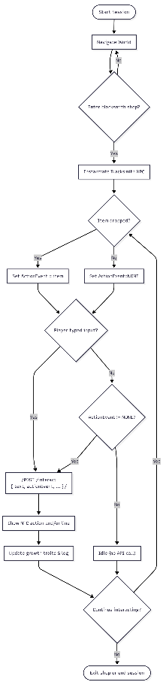
Figure 1: Use case diagram outlining the blacksmith and user interaction.

3.2 Functional requirements
- Instantiate NPC only inside the shop.
- /interact when (actionEvent != NONE) OR (text not empty).
- NLU returns multi-label intents; tone/sentiment/friendliness; safety/OOD flags; confidences.
- Context builder retrieves lore/policies; slots required for pricing/policies must come from retrieved facts.
- Candidate generation: templates and/or tiny local drafts; guaranteed ≥1 candidate via deterministic stub.
- Re-ranker selects the best candidate; ε-greedy/Thompson Sampling optionally explores near-ties.
- Safety & post: profanity + policy checks; block/regenerate if violated.
- Persistence: growth traits & interaction logs; bounded updates (EMA/clamp).
- Feature flags: independently enable/disable templates, drafts, polish.
- Metrics: structured logs per turn; offline evaluation scripts.

3.3 Non-functional requirements
- Latency 50 ≤ 300 ms; 95 ≤ 600 ms.
- Offline-first; network optional for polish.
- Reliability: 99% success for /interact under nominal load.
- Safety pass ≥ 98%; constraint pass ≥ 95%.
- Observability: traceId per turn; durations per stage; candidate list & scores.

3.4 Data Requirements
- Scenario bank (100–200 cases) with gold intents, acceptable actions, optional best line.
- Golden transcripts (5–10) for regression testing.
- Lore/policy docs chunked for retrieval; embeddings (file-based) or simple BM25 index.

3.5 Assumptions and dependencies
English only; profanity list available; gameplay limited to the shop scene; laptop-class CPU.

4. Architecture and Interfaces

4.1 System architecture/design
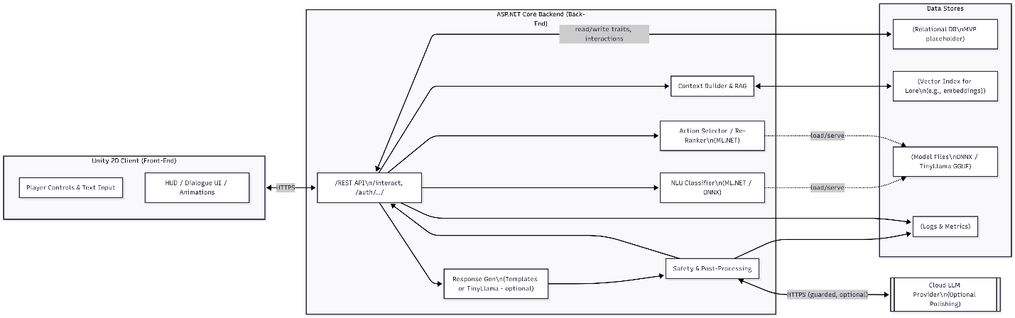
Figure 2: System architecture diagram that explains where each part of the system will be located.

4.1.1 Module Responsiblities
- Unity Client: movement, UI, text input; triggers /interact only on text or meaningful action.
- API Gateway: request validation, feature flags, traceId, logging.
- NLU: ONNX/ML.NET model → intents, tone/sentiment, safety.
- Context Builder (RAG): retrieve relevant lore/policy snippets; fill slot values.
- Candidate Sources: templates; tiny local generator; deterministic stub.
- Re-Ranker (L2R): select best (action, line); optional exploration.
- Safety & Post: profanity; policy/lore constraints; optional short LLM polish.
- Persistence: NPC genetics; player–NPC growth; interaction logs & metrics.

4.2 Database Design / Data Schema

4.2.1 ER diagram
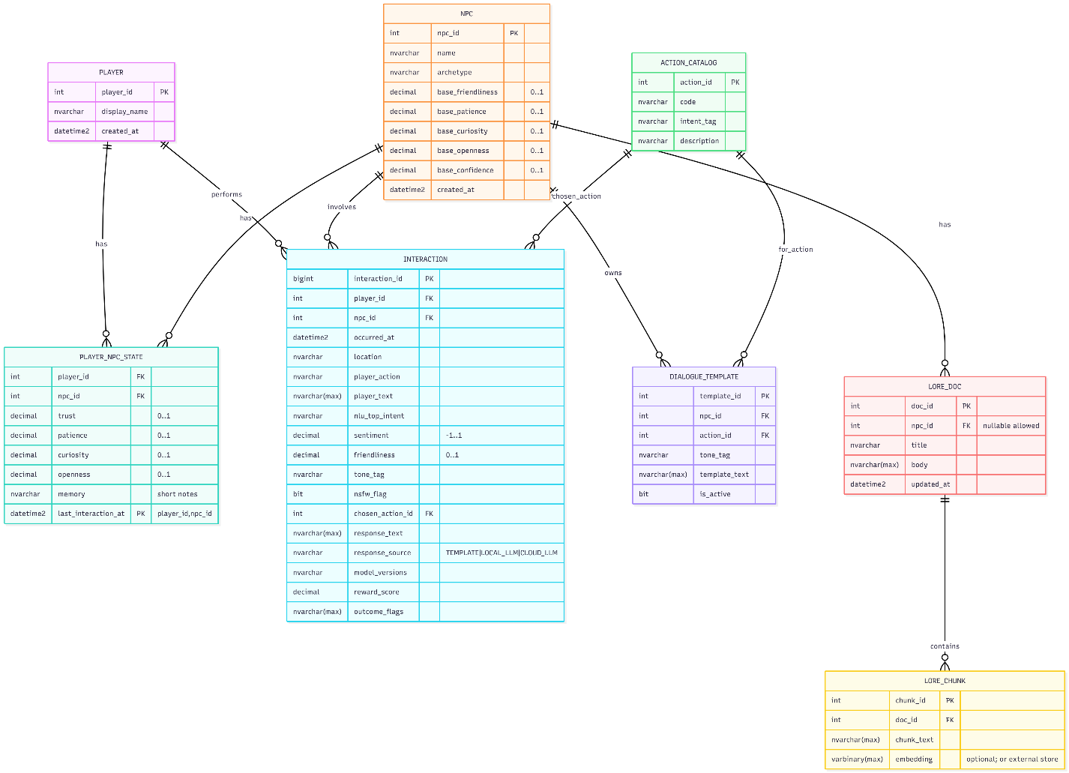
Figure 3: ERD showing the entities and the coloumns for the database of the project.
Entity Definition:
- NPC(npc_id PK, name, archetype, location, base_friendliness, base_patience, base_curiosity, base_openness, base_confidence, created_at).
- PLAYER(player_id PK, display_name, created_at).
- PLAYER_NPC_STATE(player_id FK, npc_id FK, trust, patience, curiosity, openness, last_interaction_at, memory_short_notes, PK: player_id+npc_id).
- INTERACTION(interaction_id PK, player_id FK, npc_id FK, occurred_at, location, player_action, player_text, nlu_top_intent, sentiment, friendliness, tone_tag, nsfw_flag, chosen_action_id FK, response_text, response_source, model_versions, reward_score, outcome_flags).
- ACTION_CATALOG(action_id PK, code, intent_tag, description).
- DIALOGUE_TEMPLATE(template_id PK, npc_id FK, action_id FK, tone_tag, template_text, is_active).
- LORE_DOC / LORE_CHUNK for grounding.

4.3 Diagrams

4.3.1 Data flow diagrams
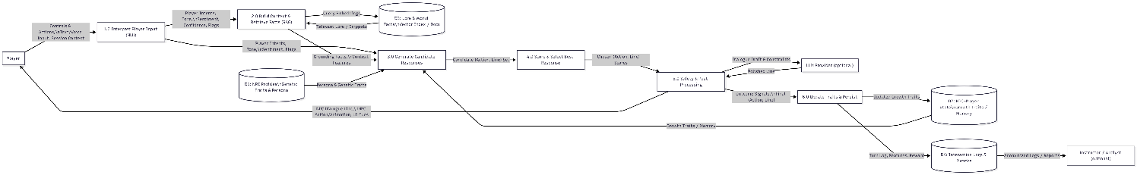
Figure 4: Dataflow diagram that shows how the data is flowing throughout the lifecycle of an instance of the game.

4.3.2 Sequence diagram
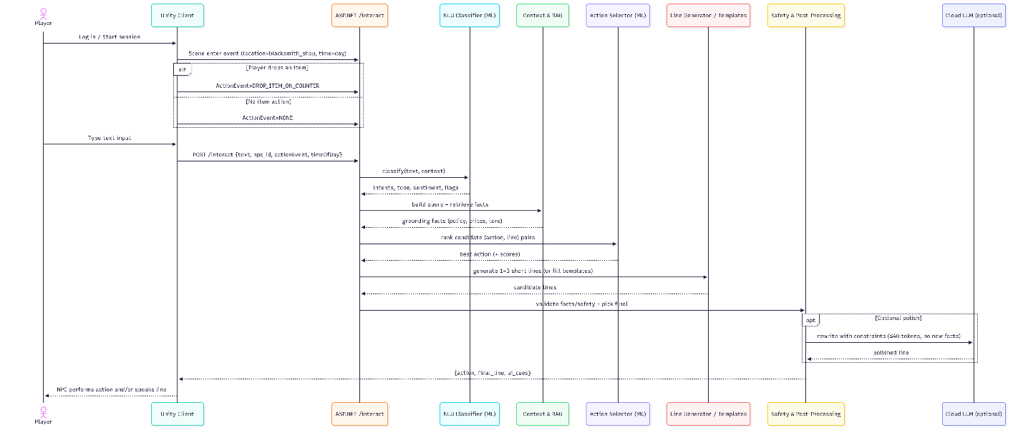
Figure 5: Sequence diagram for all the processes in the backend

4.3 API(MVP)
POST /interact — called only when text or action present.
{
"traceId": "uuid",
"playerId": 123,
"npcId": 10,
"location": "blacksmith_shop",
"timeOfDay": "day",
"actionEvent": "DROP_ITEM_ON_COUNTER",
"text": "Please repair this sword."
}

Response
{
"action": "OFFER_REPAIR",
"line": "I can fix that blade for 3 silver by dusk.",
"uiCues": { "emote": "nod" },
"safety": { "passed": true, "flags": [] },
"chosenCandidateScore": 0.83,
"traceId": "uuid"
}

Latency budgets (targets):
- NLU ≤ 150 ms; Context/RAG ≤ 80 ms; Candidate sources ≤ 120 ms; Re-ranker ≤ 40 ms; Safety/Post ≤ 20 ms; Transport ≤ 20 ms.

4.4 Use case diagram
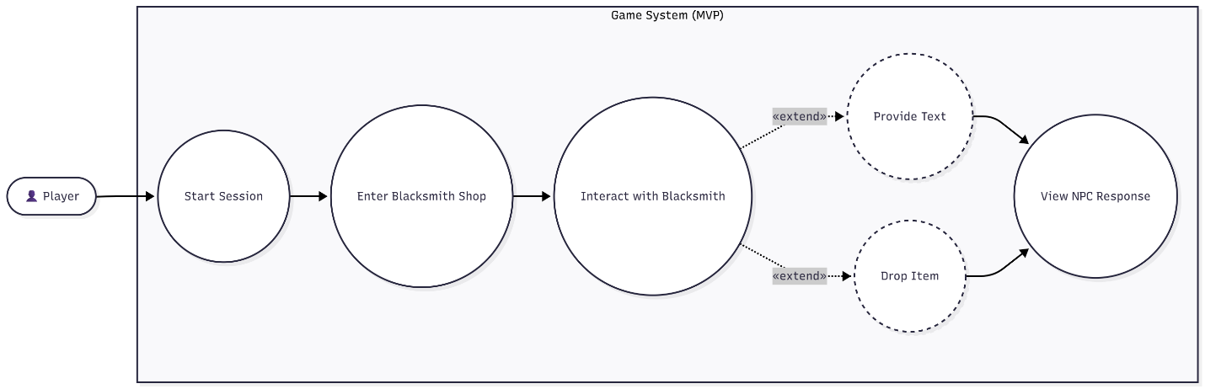
Figure 6: Use case diagram for the blacksmith and user mock interaction.

5. Project planning

5.1 Project management plan
This project will have a Hybrid Iterative plan with weekly demos: Client/UI → API & logging → NLU → Candidate sources + Re-ranker → Safety & Persistence → Evaluation & Slides. Change-freeze in the final week.

5.2 Work breakdown structure (WBS)
Table 1: Table with the work breakdown structure.
ID | Task | Deliverables
1.0 | Unity scene & UI | Controls, dialogue HUD
2.0 | API & logging | /interact, tracing, structured logs
3.0 | NLU train/inference | ONNX/ML.NET model, validation report
4.0 | Candidates + Re-ranker | Templates, tiny drafts (opt), trained ranker
5.0 | Safety & Persistence | Filters, lore store, DB schema & migrations
6.0 | Evaluation | Scenario bank, metrics scripts/dashboards
7.0 | Docs & Demo | Report, slides, demo script

5.3 Gnatt Chart
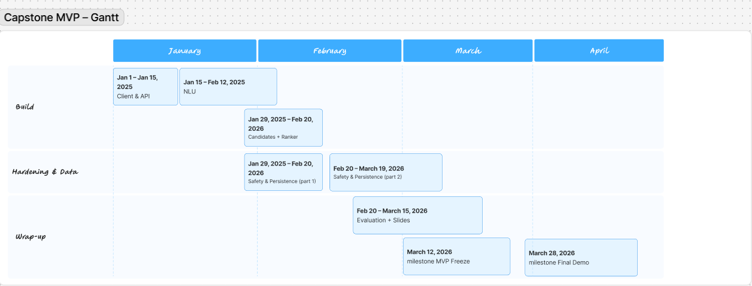
Figure 7: Gnatt chart for the expected timeline of different stages of building the game.

5.4 Roles and Responsibilities
- Yaksh: Backend + Database
- Aaryan: Unity UI/UX
- Fedil: ML + Evaluation
- Harman: Documentation + PM
- Raman: Animation and asset creation+ dataset validation

6. Risk Management
Table 2: Table showing the Risk management strategies and plans
Risk Description | Probability | Impact | Risk Score | Mitigation Plan | Owner / Status
Training data too small for NLU | Medium | Medium | Medium | Use fastText + char n-grams; augmentation; active learning from logs. | ML Open
Latency spikes on laptop | Medium | High | High | Preload models; cache lore; cap candidates; profile ML.NET. | Backend — Open
Unsafe/NSFW user input or output | High | High | High | Two-stage filters; deflect templates; monitoring; red-team tests. | All — Active
LLM polish adds facts | Medium | Medium | Medium | Disable by default; ≤40-token rewrite; “no new facts” constraint; unit tests. | Backend — Ctrl
Schema migration failure | Low | Medium | Low | Versioned migrations; DB backups; seed data. | DB — Open
Scope creep (extra scenes/LLM features) | Medium | Medium | Medium | MVP gate + change control; weekly scope review. | PM — Open
Team bandwidth / exams | Medium | Medium | Medium | Pairing; adjust scope; freeze dates. | PM — Open
Late integration bugs | Medium | High | High | CI smoke tests; golden transcripts; feature flags for rollback. | All — Active

7. Conclusion
The prototype demonstrates that adaptive NPCs are practical with compact, controllable ML. Separating NLU, context, candidate generation, ranking, and safety yields predictable latency, measurable quality, and maintainable code. Persisted growth traits provide continuity. The architecture is extendable to multiplayer and new scenes without redesign, and the evaluation plan ensures we can iterate with confidence.

