RestAssured API Automation Project

Pre-requisite:

As soon as you import a project in eclipse, update the project using the maven update option as below. This is to resolve issue if any maven dependency not downloaded properly:

1. Right click on project : Go to “Maven” : Select “Update Project”

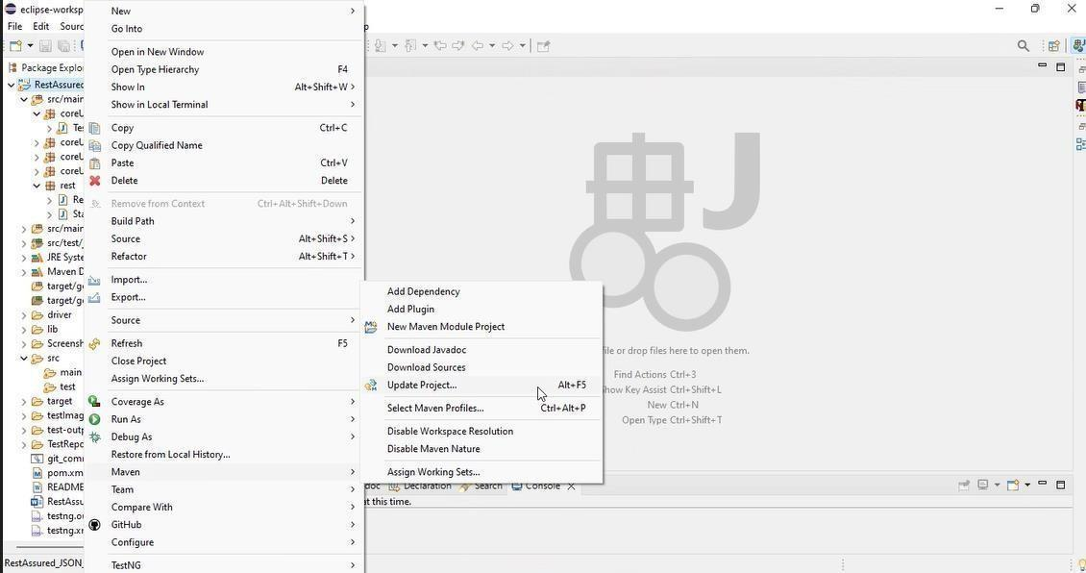

1. In Update Maven Project Box Select “Force Update of Snapshots/Releases” and click OK

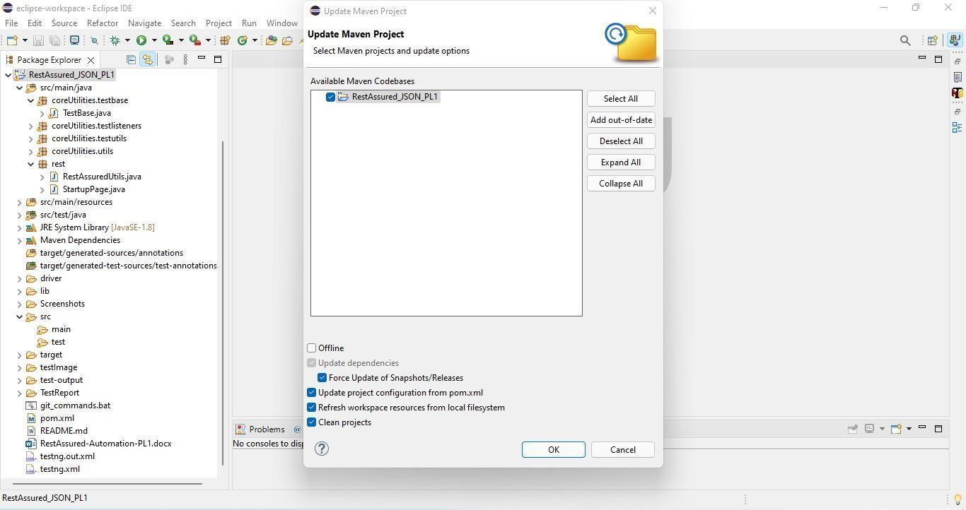

Template Code Structure:

1. Below are the packages and files you will be required to work upon.
2. Other Files and packages you can ignore.
3. In other Files and packages do not do any changes. It would affect your evaluation.
4. You are not required to work in “Test” Folder. Files there are non- editable. Editing those files and trying to save them will throw error and would affect your evaluation.

|  |  |  |
| --- | --- | --- |
| **Package** | **Class/File** | **Description** |
| src/main/java/coreUtilities/utils/ | FileOperations.java | 1. Contains methods to read from excel file. 2. Method is in templated form. 3. **You will be required to implement these methods as very first activity, because for creating post the data**   **should be read from excel.** |
| /src/main/java/rest | ApiUtil.java | 1. All core activities to be performed here. 2. The comments associated with each templated method here describe the expectation. 3. Declare any variable/object you need to share data/status between different methods. 4. Do not modify the signature of methods declared here. 5. You can create additional supportive common methods in   CommonEvents class. |
| /src/main/java/rest | AuthUtil.java | 1. Class already defined to read and return bearer   token from config.properties file. |
| /src/main/java/rest | CustomResponse | We have already created custom response object class. You need to use this and use it as return type from ApiUtil.java class methods. |
| /src/main/resources/ | Config.xlsx | Data present to be used in Implementing functions. |
| /src/main/java/coreUtilities/utils | CommonEvents.java | 1. Contains all common activities. 2. Certain templated common methods declared here. 3. You implement them as per your need. 4. You can add any additional   method for common activity here |
|  | Testng.xml | Execution needs to kick started from TestNG xml |

PROBLEM STATEMENT

Need to automate the following activities using RestAssured.

# Key Activities to implement:

Below activities need to be implemented in the ApiUtil.java file present in src/main/java/rest package.

|  |  |  |  |
| --- | --- | --- | --- |
| **Sl No.** | **Summary** | **Action** | **Expected Result** |
| **1** | Retrieve all departments in Method:  getAllDepartments(String endpoint, Object body) | 1. Create an URL by combining the BASE_URL (already declared) and path parameter (provided as an argument in method). The final URL becomes: **https://healthapp.yaksha.com/api/AssetReports/GetAllDepartments** 2. Include a bearer token for authentication in authorization header. 3. Trigger a GET call to the specified endpoint. 4. Create an object of type CustomResponse and initialize it with values extracted from the Response object:  * Response * statusCode (extracted from Response object) * DepartmentId list (extracted from Response object) * DepartmentName list (extracted from Response object) * Status (extracted from Response object)  1. Return the CustomResponse object from the method. | - Returns an object of type CustomResponse containing statusCode, status, DepartmentId list, DepartmentName list, and the complete Response object.  - StatusCode should be 200.  - Status should be OK.  - DepartmentId and DepartmentName lists should not be empty and should not be null. |
| **2** | Retrieve all the list of items in Method:  getAllItems(String endpoint, Object body) | 1. Create an URL by combining the BASE_URL (already declared) and path parameter (provided as an argument in method). The final URL becomes: **https://healthapp.yaksha.com/api/AssetReports/GetAllItems** 2. Include a bearer token for authentication in authorization header. 3. Trigger a GET call to the specified endpoint. 4. Create an object of type CustomResponse and initialize it with values extracted from the Response object:  * Response * statusCode (extracted from Response object) * ItemId list (extracted from Response object) * ItemName list (extracted from Response object) * Status (extracted from Response object)  1. Return the CustomResponse object from the method. | - Returns an object of type CustomResponse containing statusCode, status, ItemId list, ItemName list, and the complete Response object.  - StatusCode should be 200.  - Status should be OK.  - ItemId list and ItemName list should not be empty. |
| **3** | Retrieve incentive summary report in Method:  getIncentiveSummaryReport(String URL, Object body) | 1. The final URL is provided as a parameter (URL) and that is: **https://healthapp.yaksha.com/BillingReports/INCTV_DocterSummary?FromDate=" + fromDate + "&ToDate=" + toDate + "&IsRefferalOnly=" + isRefferal** 2. Include a bearer token for authentication in authorization header. 3. Trigger a GET call to the specified endpoint. 4. Create an object of type CustomResponse and initialize it with values extracted from the Response object:  * Response * statusCode (extracted from Response object) * PrescriberId list (extracted from Response object as a list) * PrescriberName list (extracted from Response object as a list) * DocTotalAmount list (extracted from Response object as a list) * TDSAmount list (extracted from Response object as a list) * NetPayableAmount list (extracted from Response object as a list) * Status (extracted from Response object)  1. Return the CustomResponse object from the method. | - Returns an object of type CustomResponse containing statusCode, status, PrescriberId list, PrescriberName list, DocTotalAmount list, TDSAmount list, NetPayableAmount list and the complete Response object.  - StatusCode should be 200.  - Status should be OK.   * PrescriberId list, PrescriberName list, DocTotalAmount list, TDSAmount list and NetPayableAmount list should not be empty and should not be null. |
| **4** | Retrieve incentive referral summary report in Method:  getIncReffSummReport(String URL, Object body) | 1. The final URL is provided as a parameter (URL) and that is: **https://healthapp.yaksha.com/BillingReports/INCTV_DocterSummary?FromDate=" + IncFromDate + "&ToDate=" + IncToDate + "&IsRefferalOnly=" + isRefferal** 2. Include a bearer token for authentication in authorization header. 3. Trigger a GET call to the specified endpoint. 4. Create an object of type CustomResponse and initialize it with values extracted from the Response object:  * Response * statusCode (extracted from Response object) * PrescriberName list (extracted from Response object as a list) * PrescriberId list (extracted from Response object as a list) * DocTotalAmount list (extracted from Response object as a list) * TDSAmount list (extracted from Response object as a list) * NetPayableAmount list (extracted from Response object as a list) * Status (extracted from Response object)  1. Return the CustomResponse object from the method. | - Returns an object of type CustomResponse containing statusCode, status, PrescriberId list, PrescriberName list, DocTotalAmount list, TDSAmount list, NetPayableAmount list and the complete Response object.  - StatusCode should be 200.  - Status should be OK.   * PrescriberId list, PrescriberName list, DocTotalAmount list, TDSAmount list and NetPayableAmount list should not be empty and should not be null. |
| **5** | Retrieve hospital income incentive report in Method:  getHospIncIncReport(String endpoint, Object body) | 1. The final URL is provided as a parameter (endpoint) and that is: **https://healthapp.yaksha.com/Reporting/HospitalIncomeIncentiveReport?FromDate="+ IncFromDate + "&ToDate=" + IncToDate + "&ServiceDepartments=" + ServiceDepartments** 2. Include a bearer token for authentication in authorization header. 3. Trigger a GET call to the specified endpoint. 4. Create an object of type CustomResponse and initialize it with values extracted from the Response object:  * Response * statusCode (extracted from Response object) * ServiceDepartmentId list (extracted from Response object as a list) * ServiceDepartmentName list (extracted from Response object as a list) * NetSales list (extracted from Response object as a list) * ReferralCommission list (extracted from Response object as a list) * GrossIncome list (extracted from Response object as a list) * OtherIncentive list (extracted from Response object as a list) * HospitalNetIncome list (extracted from Response object as a list) * Status (extracted from Response object)  1. Return the CustomResponse object from the method. | - Returns an object of type CustomResponse containing statusCode, status, ServiceDepartmentId list, ServiceDepartmentName list, HospitalNetIncome list, NetSales list, OtherIncentive list, ReferralCommission list and GrossIncome list and the complete Response object.  - StatusCode should be 200.  - Status should be OK.   * ServiceDepartmentId list, ServiceDepartmentName list, HospitalNetIncome list, NetSales list, OtherIncentive list, ReferralCommission list and GrossIncome list should not be empty and should not be null. |
| **6** | Retrieve employee bill items in Method:  getEmpBillItem(String endpoint, Object body) | 1. Create an URL by combining the BASE_URL (already declared) and path parameter (provided as an argument in method). The final URL becomes: **https://healthapp.yaksha.com/api/Incentive/EmployeeBillItems?employeeId=" + employeeId** 2. Include a bearer token for authentication in authorization header. 3. Trigger a GET call to the specified endpoint. 4. Create an object of type CustomResponse and initialize it with values extracted from the Response object:  * Response * statusCode (extracted from Response object) * EmployeeIncentiveInfoId object (extracted from Response object) * EmployeeId object (extracted from Response object) * FullName object (extracted from Response object) * TDSPercent object (extracted from Response object) * EmpTDSPercent object (extracted from Response object) * IsActive object (extracted from Response object) * EmployeeBillItemsMap list (extracted from Response object as a list) * Status (extracted from Response object)  1. Return the CustomResponse object from the method. | - Returns an object of type CustomResponse containing statusCode, status, EmployeeIncentiveInfoId object, EmployeeId object, IsActive object, FullName object, TDSPercent object, EmpTDSPercent object, EmployeeBillItemsMap list, and the complete Response object.  - StatusCode should be 200.  - Status should be OK.  - EmployeeIncentiveInfoId object, EmployeeId object, IsActive object , FullName object , TDSPercent object , EmpTDSPercent object , EmployeeBillItemsMap list should not be null and should not be empty. |
| **7** | Retrieve inventory fiscal years in Method:  getInvntryFiscalYrs(String endpoint, Object body) | 1. Create an URL by combining the BASE_URL (already declared) and path parameter (provided as an argument in method). The final URL becomes: **https://healthapp.yaksha.com/api/Inventory/InventoryFiscalYears** 2. Include a bearer token for authentication in authorization header. 3. Trigger a GET call to the specified endpoint. 4. Create an object of type CustomResponse and initialize it with values extracted from the Response object:  * Response * statusCode (extracted from Response object) * FiscalYearId list (extracted from Response object as a list) * FiscalYearName list (extracted from Response object as a list) * StartDate list (extracted from Response object as a list) * EndDate list (extracted from Response object as a list) * IsActive list (extracted from Response object as a list) * Status (extracted from Response object)  1. Return the CustomResponse object from the method. | - Returns an object of type CustomResponse containing statusCode, status, FiscalYearId  list, FiscalYearName  list, StartDate  list, EndDate  list, IsActive  list and the complete Response object.  - StatusCode should be 200.  - Status should be OK.   * FiscalYearId   list, FiscalYearName  list, StartDate  list, EndDate  list, IsActive list should not be null. |
| **8** | Activate inventory in Method:  getActInventory(String endpoint, Object body) | 1. Create an URL by combining the BASE_URL (already declared) and path parameter (provided as an argument in method). The final URL becomes: **https://healthapp.yaksha.com/api/ActivateInventory/** 2. Include a bearer token for authentication in authorization header. 3. Trigger a GET call to the specified endpoint. 4. Create an object of type CustomResponse and initialize it with values extracted from the Response object:  * Response * statusCode (extracted from Response object) * StoreId list (extracted from Response object as a list) * Name list (extracted from Response object as a list) * StoreDescription list (extracted from Response object as a list) * Status (extracted from Response object)  1. Return the CustomResponse object from the method. | - Returns an object of type CustomResponse containing statusCode, status, StoreId list, Name list, StoreDescription list and the complete Response object.  - StatusCode should be 200.  - Status should be OK.  - StoreId list, Name list and StoreDescription list should not be empty and should not be null. |

NOTE: "Please do not delete any file in the src folder. But you are free to add any other file".

Expectations:

* 1. **Learners should write automation scripts using Java and REST Assured to automate the API testing for all the provided methods (e.g., GET, POST, PUT, DELETE).** In other words, the automation script should perform all mentioned API interactions, including validation of responses.
  2. **Learners should not use any pre-built libraries or tools to validate API responses (e.g., JSON schema validation tools).** They should manually validate the response content (e.g., status codes, response body, etc.) by writing their own logic for assertion.

IMPLEMENTATION/FUNCTIONAL REQUIREMENT

* 1. **Code Quality/Optimizations**
     1. Associates should have written clean code that is readable.
     2. Associates need to follow SOLID programming principles.

# Execution Steps to Follow

1. **You are mandatorily required to run test cases for applications before final submission. Without which project evaluation will not happen.**
2. **You can launch test cases any time as follows: Right click on testng.xml and run TestNGSuite**

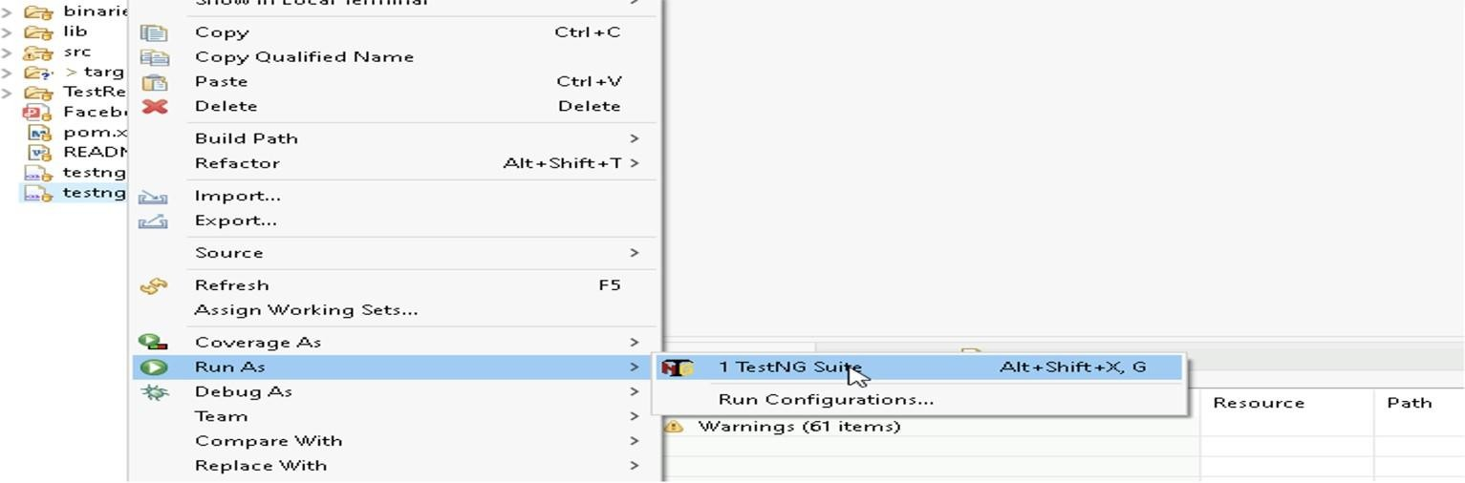

1. **Before final submission, you are also required to push your code to GIT. Following are the steps to follow:**

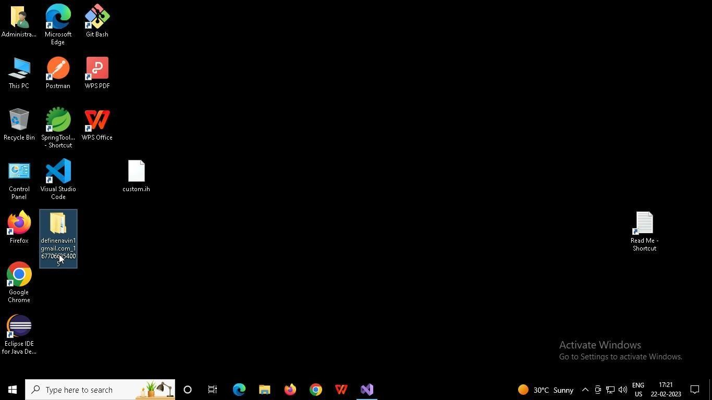

In your project folder, you will find a batch file named git_commands

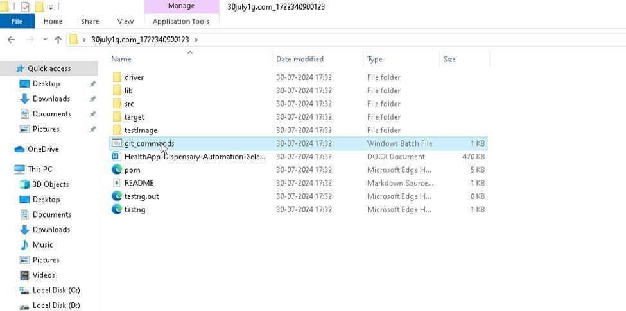

Double-click the batch file to run it. It will run the commands to push your code to GIT.

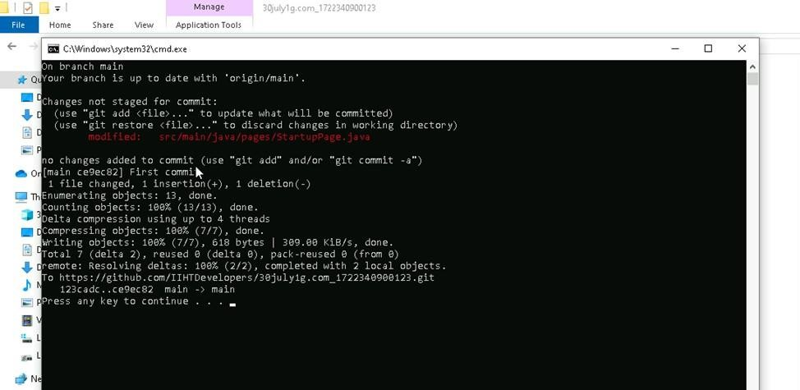

===============================================================================

All the Best