yaksha health app with typescript and

playwright

**Usecase summary**

**Project Name:** healthapp.yaksha app – Medical Record Management System

**Use Case Summary:** healthapp.yaksha is a healthcare application designed to manage Electronic Medical Records (EMR). it allows users to view, search, and manage patient records. It features functionality such as adding/editing patient records, filtering data by doctor and department, and exporting records. The primary use case is to automate the process of medical record management, ensuring efficient and reliable operations for healthcare providers.

**Technology Stack:**

* **Automation Tool:** Playwright (for testing)

**Key Features:**

* **Patient Record Management:** Add, edit, and delete patient records.
* **Filtering and Search:** Search medical records by date range, doctor, department, and more.
* **Export Functionality:** Export records for offline access.

**Expected Outcomes:**

* Automate key healthcare operations like patient record handling, filtering, and validation.
* Ensure the accurate retrieval and modification of medical records, enhancing operational efficiency.

**Overview of the application**

**Pages/Features that are to be focused for the application**

Please use the Application URL <https://healthapp.yaksha.com>

PROBLEM STATEMENT

Need to automate the following activities using playwright+typescript

**You will be given a excel file named to validate and search data**

|  |  |  |
| --- | --- | --- |
| **Path** | **File** | **Description** |
| src\data | result .xlsx | 1. Contains data to read from excel file. |
| src\tests\commonMethods | readExcel(filePath, sheetName) | Should be implemented such way that it reads the data from shared “sheetName” from excel of given “filePath” and return the data in Record<string, string> |
| src\ pages | * AppointmentPage * UtilitiesPage * DispensaryPage * ProcurementPage * LoginPage * PatientPage * ADTPage * RadiologyPage * LaboratoryPage | 1. All core activities to be performed here. 2. The comments associated with each templated method here describe the expectation. 3. Declare any variable/object you need to share data/status between different methods. 4. Do not modify the signature of methods declared here. |
| src\tests | keywords.ts | Implement methods SearchPatients() and VerifyResults() |

**Here’s a detailed table format for the test cases to be tested**

| **Test Case No.** | **Test Case Name** | **Test Steps to be performed** | **Path & Method Used** | **Expected Result** |
| --- | --- | --- | --- | --- |
| 1 | Verify Login with Valid Credentials | 1.the application will read the result .xlsx file to fetch the user name and password using “login” string from common methods  2.it should call the method  Use performLogin () 3.perform login method will perform authentication with the username and password  4. Verify admin name is visible on the home page. | **Reference path**  \src\pages\**LoginPage**  **methods**  performLogin() | Successfully logs in with provided credentials. The user is logged in the admin page  Returns true for success; otherwise, false. |
| 2 | Verify Page Navigation and Load Time for Billing Counter | 1. Use verifyBillingCounterLoadState() to check module load. 2. Open "Change Billing Counter" module using ChangeBillingCounter. 3. Set acceptable load time: 1000ms. 4. Verify counter presence; select the first counter if available. 5. Log a message if no counters are found. | **Reference path**  \src\ pages\ **UtilitiesPage**  **methods**  verifyBillingCounterLoadState() | Navigates to "Change Billing Counter". Proceeds if counters are available and loaded within 1 second; logs a message otherwise. |
| 3 | Patient Search with Valid Data | 1. Navigate to Appointment page using navigateToAppointmentPage(). 2. Use selectFirstPatient() to verify the first patient's name. 3. Search for a patient by name using the search bar and press Enter. 4. Validate that search results contain the searched name. 5. Verify results using verifyPatientNames(). | **Reference path**  \src\ pages\ **AppointmentPage**  **methods**  navigateToAppointmentPage(), searchPatient() | Displays patient name in search results. Ensures short name matches the searched data. |
| 4 | Activate Counter in Dispensary | 1. Use verifyActiveCounterMessageInDispensary() to: - Navigate to the Dispensary page. - Select a random counter if available. - Activate the counter and verify the activation message. 2. Log counter selection and activation status. | **Reference path**  \src\ pages\ **DispensaryPage**  **methods**  verifyActiveCounterMessageInDispensary() | Counter activation message matches the selected counter name. Returns true for success; false otherwise. |
| 5 | Purchase Request List Load | 1.Use verifyPurchaseRequestListElements() to check verify of elements:  purchaseRequest, purchaseOrder, goodsArrivalNotification, quotations,  settings,  reports,  favoriteButton,  okButton,  printButton,  firstButton,  previousButton,  nextButton,  lastButton. | **Reference path**  \src\ pages\ **ProcurementPage**  **methods**  verifyPurchaseRequestListElements() | All elements are present and visible on the procurement page Returns true for success; logs missing elements and returns false otherwise. |
| 6 | Verify Error Message While Adding New Lab Test | 1. Navigate to Laboratory > Settings. 2. Select "Add New Lab Test". 3. Click "Add" without providing inputs. 4. Capture and verify the error message: "Lab Test Code Required". | **Reference path**  \src\ pages\ **LaboratoryPage**  **methods**  verifyErrorMessage() | Error message: "Lab Test Code Required" is displayed. Logs success or failure and ensures the modal is closed. |
| 7 | Handle Alert on Radiology Module | 1. Navigate to Radiology module and select "List Request" sub-module. 2. Apply filter using dates .  3. the application will read the data from excel file using the common methods name (“DateRange”) (eg  fromDate: 01-01-2020 to toDate: 11-11-2024.) 3. Click "Add Report" button. 4. Use handleAlert() to verify and accept the alert if the message matches. 5. the application will check for the matched data . | **Reference path**  \src\ pages\ **RadiologyPage**  **methods**  handleAlert() | Alert dialog matches expected message and is accepted. Returns true for success; false for failure in handling the alert. |
| 8 | Data-Driven Testing for Patient Search | 1. Navigate to Patient Section.  2. application will use the common method to use read the excel to search for patient which is there in the dataset using the name (“patientnames”) 3. Use the search bar to find patients. 4. Compare retrieved names with expected names from Excel. 5. Log success or failure for each match. | **Reference path**  \src\ pages\ **PatientPage**  **methods**  searchAndVerifyPatients() | Matches all patient names from Excel. Returns true for success; logs mismatches and returns false if any fail. |
| 9 | Error Handling and Logging in Purchase Request List | 1. Navigate to Procurement module. 2. Apply invalid date filter. 3. Click "OK". 4. Capture and verify the error message: "Date is not between range. Please enter again." | **Reference path**  \src\ pages\ **ProcurementPage**  **methods**  verifyNoticeMessageAfterIncorrectFilters() | Triggers and verifies the error message for invalid date range. Logs success for match; failure for mismatch. |
| 10 | Keyword-Driven Framework for Appointment Search | 1. Use searchAndVerifyPatient() to: - Retrieve patient name. - Validate patient name is not empty. 2. Verify results contain the searched patient. 3. Timeout is set to 2 seconds. | **Reference path**  \src\ pages\ **AppointmentPage**  **methods**  searchAndVerifyPatient(), verifyResults() | Successfully retrieves and verifies patient in search results. |
| 11 | Modular Script for Patient Search | 1. Navigate to the Appointment section. 2. Use searchPatientInAppointment() to execute the search. 3. Validate the patient search result. | **Reference path**  \src\ pages\ **AppointmentPage**  **methods**  searchPatientInAppointment() | You should be able to search patient search data |
| 12 | Verify Assertion for Counter Activation | 1. Navigate to the Dispensary section. 2. Verify the visibility of the counter button. 3. Activate counter using activateCounter button. 4. Verify deactivateCounterButton visibility. | **Reference path**  \src\ pages\ **DispensaryPage**  **methods**  verifyCounterisActivated() | Returns true if counter activation is successful. Returns false if activation fails or required element is not found. |
| 13 | Verify Locator Strategy for Appointment Search | 1. Navigate to Appointment page. 2. Verify visibility of patient list. 3. Use the search bar to find a patient by name or hospital code. 4. Verify search results. | **Reference path**  \src\ pages\ **AppointmentPage**  **methods**  searchAndVerifyPatientList() | Verify that each patient's name in the result matches the search term |
| 14 | Verify Tooltip Text on Star Icon in Laboratory | 1. Navigate to Laboratory Dashboard. 2. Verify visibility of star icon. 3. Hover over the star icon and retrieve tooltip text. 4. Log the retrieved tooltip text. | **Reference path**  \src\ pages\ **LaboratoryPage**  **methods**  retrieveTooltipText(), hoverOverElement() | “ remember this tool tip ” message should be displayed  Returns empty string if no tooltip text is present. |
| 15 | Navigation Exception Handling on Dispensary Page | 1. Attempt navigation to Dispensary page with maxRetries. 2. Click activateCounter button. 3. Confirm page load by verifying key element presence. | **Reference path**  \src\ pages\ **DispensaryPage**  **methods**  navigateToDispensary() | activation of the should be enabled |
| 16 | Web Element Handling for Dropdowns in Purchase Request | 1. Navigate to Purchase Request List. 2. Apply date range filter. 3. Retrieve dates from "Requested Date" column and validate each date within range. 4. the data range will be called from the common methods “data range”  5.wait for success or failure | **Reference path**  \src\ pages\ **ProcurementPage**  **methods**  verifyRequestedDateColumnDateWithinRange() | It should be able to retrieve dates are within range. Returns false if any date falls outside the range. |
| 17 | Login with Invalid Credentials | 1. Reset state by logging out if already logged in. 2. Use performLoginWithInvalidCredentials to check the invalid user .  3 loginData common method is used to fetch the username and password from the excel  3. Capture and verify error message: "Invalid Usser". | **Reference path**  \src\ pages\ **LoginPage**  **methods**  performLoginWithInvalidCredentials() | Displays error message: "Invalid User". Logs success if message matches; logs failure otherwise. |

Learners will gain experience in building strongly-typed applications using React.js and managing data flow with **TypeScript**. They'll learn how to define interfaces, use types for error prevention, and improve code maintainability.

With **Playwright**, learners will learn to write and execute automated tests for the <https://healthapp.yaksha.com>

  app. Key skills include:

* **Browser Automation**: Interacting with web elements and testing multiple browsers.
* **Assertions & Validations**: Ensuring app behavior meets expected results.
* **End-to-End Testing**: Automating real user interactions and validating overall app functionality.

IMPLEMENTATION/FUNCTIONAL REQUIREMENT

* 1. **CODE QUALITY/OPTIMIZATIONS**
     1. Associates should have written clean code that is readable.
     2. Associates need to follow SOLID programming principles.

**Execution Steps:**

**Steps for Execution:**

1. **Please open the folder created on desktop with the email name you used to login.**

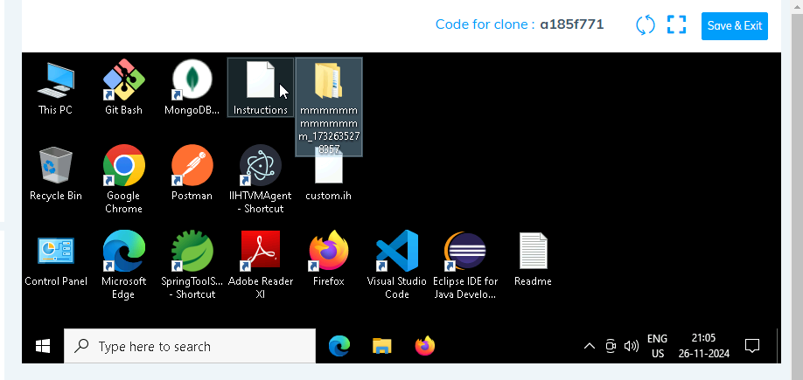

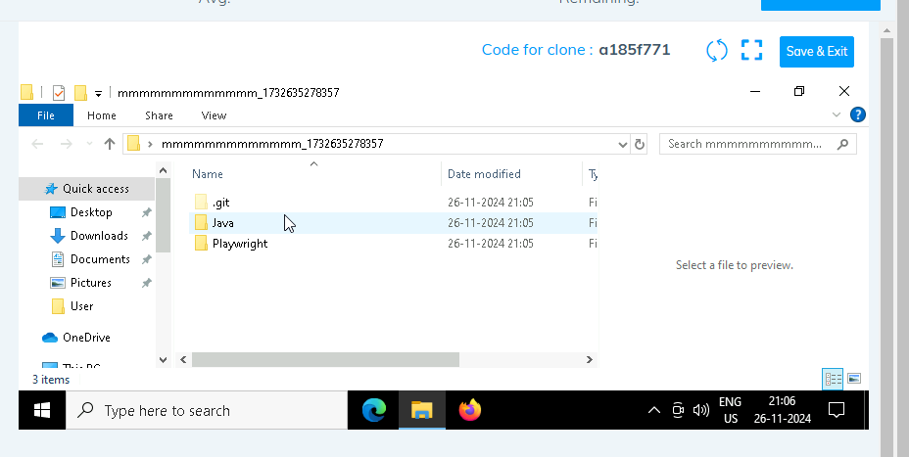

1. **Go into the Playwright folder**

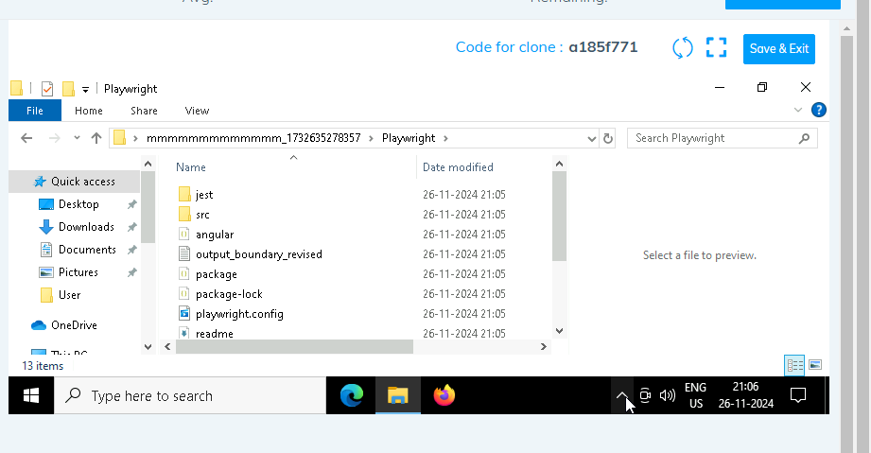

1. **Open command prompt with it’s location and use below command:**

**code .**

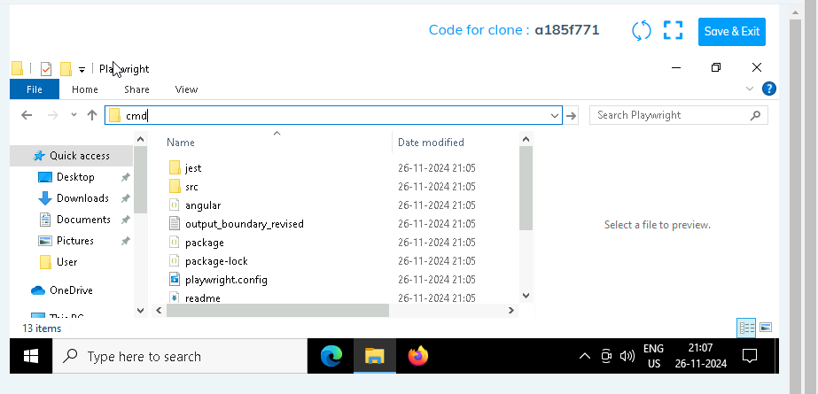

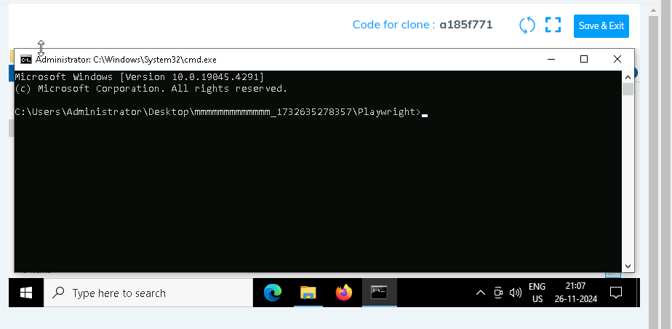

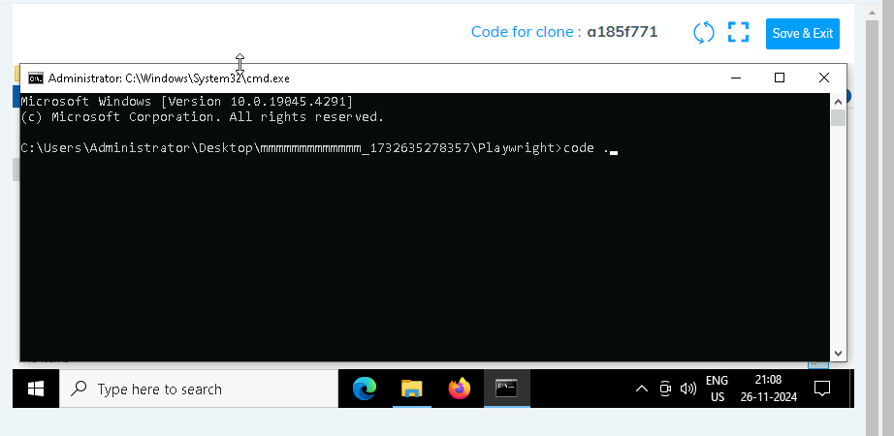

1. **Once VsCode is open. Please open it’s terminal by:**

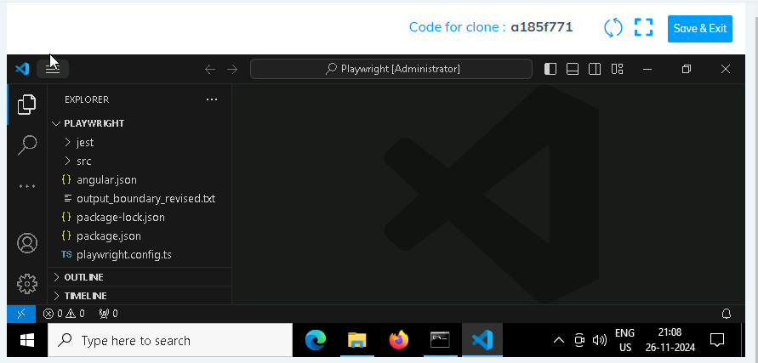

1. **Install all dependencies using**

**npm install**

1. **Install playwright**

**npx playwright install**

1. **Run the Tests**:

**npx playwright test ./src/tests/PL1_testcases/yaksha.spec.ts**

1. **Once you have executed the test cases. Now it is must to push your code to git. For this, please go inside the folder created on desktop with the email id you have used to login and then:**
   1. **Open gitbash**

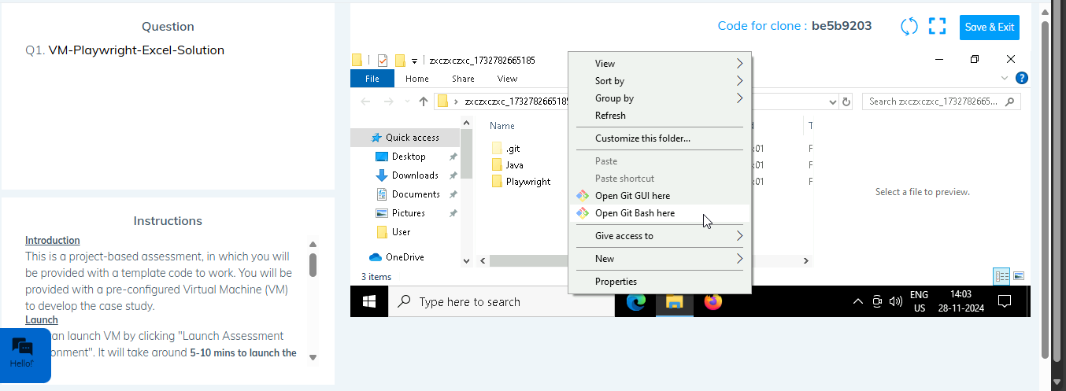

* 1. **Add all files**

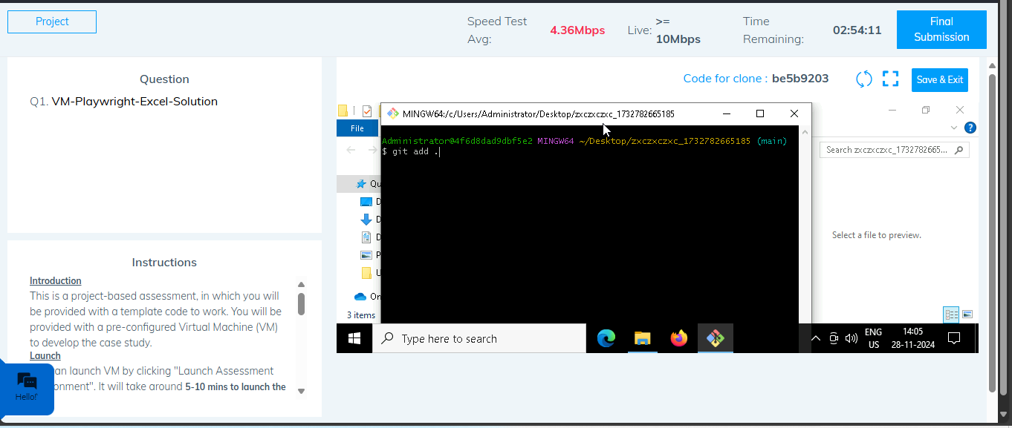

* 1. **Commit the changes**

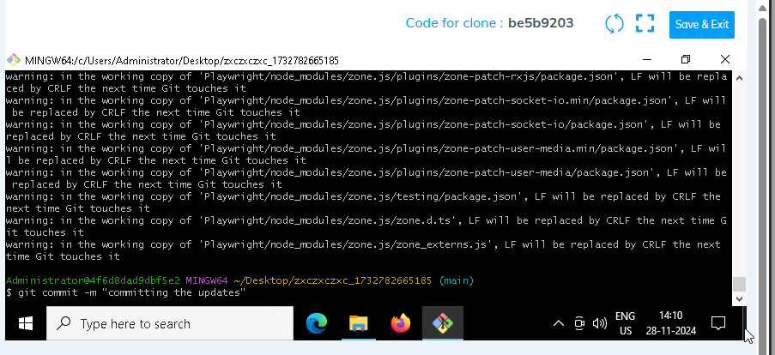

* 1. **Push the changes**

