Yakshita Rakholiya

Dhruv Ranpariya

Suraj Salunkhe

Course: CS-608-21141

Assignment-3

Team-2

Q-1

Determine if a given root of a tree is a valid binary search tree (BST) A valid BST is defined as follows:

* Given root, the **left** **subtree** of a node contains only nodes with keys **less** **than** **the** **node's** **key**.
* Given root, the **right** **subtree** of a node contains only nodes with keys **greater** **than** **the** **node's** **key**.
* Ensure that both the left and right subtrees are also binary search trees.

**Example:**

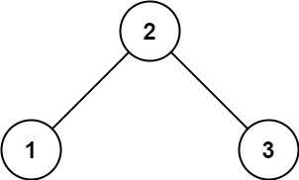

**Input:** root = [2,1,3]

**Output:** true

Q-2

**Balanced** **Binary** **Tree**

Determine if a binary tree is height-balanced.

A height-balanced binary tree is defined as a binary tree in which the left and right subtrees of every node differ in height by no more than 1.

**Example:**

**Input:** root = [3,9,20,null,null,15,7]

**Output:** true

**3. Convert** **Sorted** **Array** **to** **Binary** **Search** **Tree**

Given an integer array, where the elements are sorted in **ascending** **order**, convert it to a **height-balanced** binary search tree.

A **height-balanced** binary tree is a binary tree in which the depth of the two subtrees of every node never differs by more than one.

**Input:** nums = [-10,-3,0,5,9]

**Output:** [0,-3,9,-10,null,5]

