**Yakshita B Rakholiya**

**yr92282n@pace.edu**

**Student ID: U01875270**

**Course: CS-612-23279**

**Project-1**

* Follow “course-vm-setup.pdf” in the Week1 forum to download Dropbox folder “course-vm-2022" with course tutorial "Internet Computing Hands-on Tutorials-v11"; follow tutorial Section 1 to set up VirtualBox on your computer; import virtual machine “ubuntu22-basic” from file “ubuntu22-basic.ova”; and import virtual machine “ubuntu22-full” from file “ubuntu22-full.ova”.

🡪 I import the ubuntu22-basic.ova

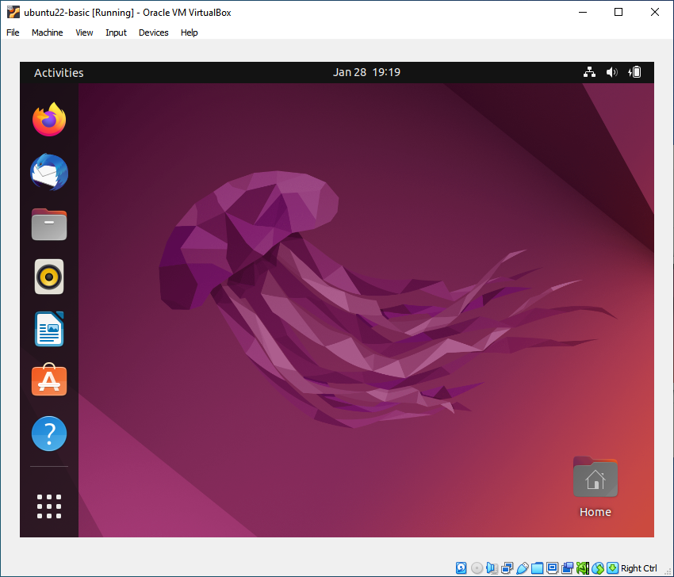

🡪 I import the ubuntu22-full.ova

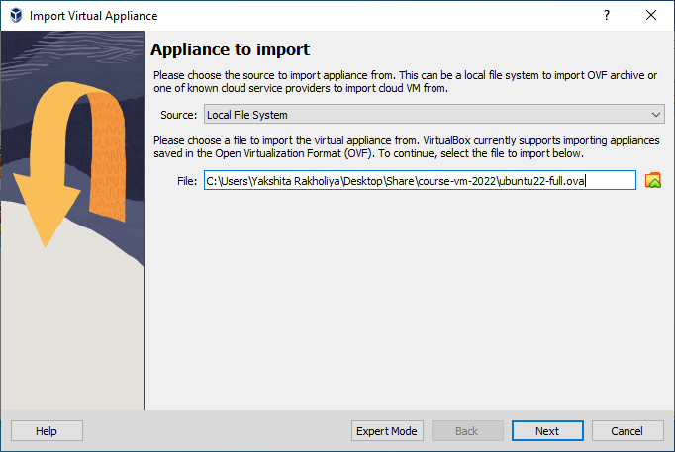

🡪 Here is the VM with ubuntu22-basic, ubuntu22-full, and ubuntu-Yakshita-Rakholiya.

* Follow course tutorial Section 2 to develop your own copy of the course VM in a folder named “ubuntu-” followed by your first name, a hyphen “-”, then your last name. For example, if your name is Mike Steven, then your VM folder would be “ubuntu-Mike-Steven”. You will follow tutorial sections 3-4 to complete your own VM development in the coming 3 weeks.

🡪Here is the VM with My name: Yakshita Rakholiya

