Ingnam Yalamber

Yalamberlimbu900@gmail.com

Abstract

Authors mindset while designing, implementing and testing the system can be seen here on this report briefly

Web programming

Project Documentation

Contents

Table of Figures 1

Introduction 2

Login Credentials 3

Video Link 3

Checklist of the implemented features 4

Testing 6

System Design 8

Test Outcomes 15

Conclusion 20

References 21

# Table of Figures

Figure 1:Home page 8

Figure 2:Teams page 8

Figure 3: Matches Page 9

Figure 4 : Detail information of match-page within the match page 9

Figure 5 : User login and register page with form validation 10

Figure 6 :Admin login page with form validation 10

Figure 7:Admin dashboard 11

Figure 8: Admin dashboard- Admin Add team page 11

Figure 9: Admin dashboard- Admin Edit team page 12

Figure 10: Admin dashboard- Admin Delete team page 12

Figure 11 : Admin dashboard- Admin Add match page 13

Figure 12:Admin dashboard- Admin Delete match page 13

Figure 13:Admin dashboard- Admin Edit matches 14

Figure 14: Admin dashboard- Admin Approve/Delete comment made by the users 14

Figure 15: Alert message after posting comments 15

Figure 16: Message after successful registration of user 15

Figure 17: Duplicate email validation 16

Figure 18:Match page according to the team 16

Figure 19:User edit comment 17

Figure 20: Comments posted by the user 17

Figure 21: User login wrong credentials 18

Figure 22: Edit and delete option for own comments 18

Figure 23: Storing of the user password in encrypt from 19

# Introduction

This report shows all the procedures, testing and debugging done while making the proper backend functionality for the given website. The main objective of this assignment was to make a proper website for publishing the football matches result. This site will be accessed by either the user or admin of the page. User can view the matches details, team information and post comment on the matches. Also, the user can edit and delete the comments they have posted making the site more user friendly. And for the admin all the basic functionality has been implemented in the site. This site can be used to properly maintained by the any non-technical users as per the need of the company.

# Login Credentials

|  |  |  |
| --- | --- | --- |
| S.N | **ADMIN EMAIL** | **ADMIN PASSWORD** |
| 1 | [**yalamberingnam900@gmail.com**](mailto:yalamberingnam900@gmail.com) | yalamber |
|  | **User1** | **User1 Password** |
| 2 | [**bibhu@gmail.com**](mailto:bibhu@gmail.com) | bibhu |
|  | **User2** | **User2 Password** |
| 3 | [**ram@gmail.com**](mailto:ram@gmail.com) | ram |

# Video Link

<https://www.youtube.com/watch?v=d-ZUH_lmsUQ>

# Checklist of the implemented features

All the function that have been implemented by the author are briefly described below all the basic features and some advance features have been implemented of the user and the admin such as add, edit and delete, teams and match in the web page for the admin and view match result and post reviews, delete and edit review and many more for the users.

|  |  |  |  |  |
| --- | --- | --- | --- | --- |
| S.N | Functionality | Completed?(  Yes/no/partially) | Files that contain the code for the feature | Any comments for the feature(Username/Password) |
| Main Administrator Features | | | | |
| 1 | Administrator Login | Yes | admin_login.php | Email: yalamberingnam900@gmail.com  Password:yalamber |
| 2 | Add team | Yes | admin_add_team.php | Main admin can add team in the page |
| 3 | Edit team | Yes | admin_edit_team.php/edit_team.php | Main admin can edit the information of the team |
| 4 | Delete team | Yes | admin_delete_team.php | Main admin can delete the team |
| 5 | Add match | Yes | admin_add_match.php | Main admin can add the match results |
| 6 | Edit match | Yes | admin_edit_match.php | Main admin can edit the match information |
| 7 | Delete match | Yes | admin_delete_match.php | Main admin can delete the match |
| 8 | Approve/delete comments | Yes | admin_comment.php | Main admin should approve the comment made by user to be displayed on the site. Admin can also not approve and delete the comment |
| User Features | | | | |
| 9 | Post comment | Yes | user_match.php | User can post the comment once they are logged in into their account |
| 10 | Edit comment | Yes | user_edit_comment.php | User can edit the comment once they are logged in into their account |
| 11 | Delete comment | Yes | user_match.php | User can delete their comment once they are logged in into account |
| 12 | Latest matches on home page | Yes | Index.php | User can view the top 10 latest matches result with or without logging on the home page |
| 13 | View matches detail with comments | Yes | user_match.php | User can view the match detail with comments posted by the user by clicking on the more button with or without logging |
| 14 | View comments made by only a particular user by clicking on the username | Yes | Comments.php | User can view the comments made by the user by clicking on their name |
| 15 | View the matches played by the specific team | Yes | team_matches.php | Users can view the matches played by only the specific team by clicking on the team name |
| 16 | Securely store password | Yes | User_login_register.php | When registering the user, their password is hashed and stored in database |
| 17 | Calculate and display the winner of the match | Yes | matches.php | Match result are calculated automatically and displayed in the match result |
| 18 | Register user | Yes | user_login_register.php | User can register a user account |
| 19 | User login | Yes | user_login_register.php | User can log into their user account by filling the correct credentials.  User email: [bibhu@gmail.com](mailto:bibhu@gmail.com)  Password: bibhu  User email: [ram@gmail.com](mailto:ram@gmail.com)  Password:ram |
| 20 | Image upload | No |  | Optional single upload or multiple image upload |
| 21 | Social media button | No |  | Social media button to share the match on the social media |
| 22 | Allow admin to manage admin | No |  | Main admin should be able to add, edit and delete other admin |
| 23 | League table | No |  | Convert the team list into the league and view all the wins and loss of the team |
| 24 | Team stats page | No |  | Show the number of matches played, win rate, number of win, number of loss, number of draws |
| 25 | Add season | No |  | Different year tournament can be tracked |
| 26 | Nested Comments | No |  | Allow users to comment on another comments |

# Testing

Testing is one of the important parts of designing the better system. While implementing the functionality on the web system or any system on every step it is essential to test the functionality properly. Many tests were performed on the same functionality before acing the features. Table below only shows the testing of the functionality to show that they work perfectly or partially.

|  |  |  |  |
| --- | --- | --- | --- |
| S. N | Data | Expected Output | Actual Output |
| 1 | Admin Login with correct credentials | Direct the page to the admin dashboard | Page directed to the admin dashboard |
| 2 | Admin login with wrong credentials | Show the message “Wrong credentials” | “Wrong credentials” message displayed |
| 3 | Add teams after the admin login from admin dashboard | Add team successfully only when the admin is logged in from the admin dashboard | Teams added successfully only when the admin is logged in from the admin dashboard |
| 4 | Edit teams after the admin login, from admin dashboard | Edit team successfully only when the admin is logged in from the admin dashboard | Team edited successfully only when the admin is logged in from the admin dashboard |
| 5 | Delete teams after the admin login, from admin dashboard | Delete team successfully only when the admin is logged in from the admin dashboard | Team deleted successfully only when the admin is logged in from the admin dashboard |
| 6 | Add matches after the admin login from admin dashboard | Add matches successfully only when the admin is logged in from the admin dashboard | Teams matches successfully only when the admin is logged in from the admin dashboard |
| 7 | Edit matches after the admin login, from admin dashboard | Edit matches successfully only when the admin is logged in from the admin dashboard | Matches edited successfully only when the admin is logged in from the admin dashboard |
| 8 | Delete matches after the admin login, from admin dashboard | Delete matches successfully only when the admin is logged in from the admin dashboard | Match deleted successfully only when the admin is logged in from the admin dashboard |
| 9 | Approve comment | Display the comments made by the user before displaying it in the match page and display the comment on that match page | Comment displayed that are posted by the user and the comment is display in the match page |
| 10 | Do not approve comment | Delete the comment posted by the users | Comment posted by the user deleted |
| 11 | User login with correct credentials | * Log in into the page as the username and direct to the homepage * Be able to comment on the matches | * User logged in into their account and directed to the homepage * User was able to post the comment on the matches |
| 12 | User login with wrong credentials | Display the message “Wrong credentials” | “Wrong Credentials message displayed” |
| 13 | Post comment after the user login | Display alert showing “Your comment will be posted once approved” and no display the comment until it is approved | Alert message displayed showing “Your comment will be posted once approved”. And comment is not displayed immediately |
| 14 | User logged in and navigated to the match detail page | After the user logs in, if there is comment they have posted than show edit and delete option below the comment | Edit and delete button displayed when the user is and logged and the comment is made by them in the match page |
| 15 | Edit comment | User can edit their comment.  Update the comment and display the edited comment on the match | Comment was updated and displayed the edited comment on the match page |
| 16 | Delete comment | User can delete the comment. Comment should be deleted from the database and not display anymore | Comment deleted and was not displayed anymore on the match page |
| 17 | Click username | Display all the comments made by the user | All the comments made by the user displayed |
| 18 | Click team name | Display all the matches played by the team | All the matches played by the team displayed |
| 19 | Home page | Display latest 10 matches and all the team name with their points | Latest 10 matches and all team name with their name displayed |
| 20 | Teams page | Display all the teams with their points | All the teams displayed with their points |
| 21 | Match page | Display all the matches with their information | All the matches displayed with their information |
| 22 | Login/register page | Display the form to register and login as user | Form displayed to register and login as user |
| 23 | Admin login | Display the admin login form | Admin login form displayed |
| 24 | Register and user account with already user email | Display message “User exist” | “User exist” message displayed |
| 25 | Register user form validation | Display the error message if any one or more field are left empty | Error message displayed when any one or more than one filed are left empty |
| 26 | Accessing the admin dashboard without logged in as admin from URL | Redirect to the index page | Page directed to the index page |

# System Design

Figure :Home page

Figure :Teams page

Figure : Matches Page

Figure : Detail information of match-page within the match page

Figure : User login and register page with form validation

Figure :Admin login page with form validation

Figure :Admin dashboard

Figure : Admin dashboard- Admin Add team page

Figure : Admin dashboard- Admin Edit team page

Figure : Admin dashboard- Admin Delete team page

Figure : Admin dashboard- Admin Add match page

Figure :Admin dashboard- Admin Delete match page

Figure :Admin dashboard- Admin Edit matches

Figure : Admin dashboard- Admin Approve/Delete comment made by the users

# Test Outcomes

Figure 15: Alert message after posting comments

Figure 16: Message after successful registration of user

Figure 17: Duplicate email validation

Figure 18:Match page according to the team

Figure 19:User edit comment

Figure 20: Comments posted by the user

Figure 21: User login wrong credentials

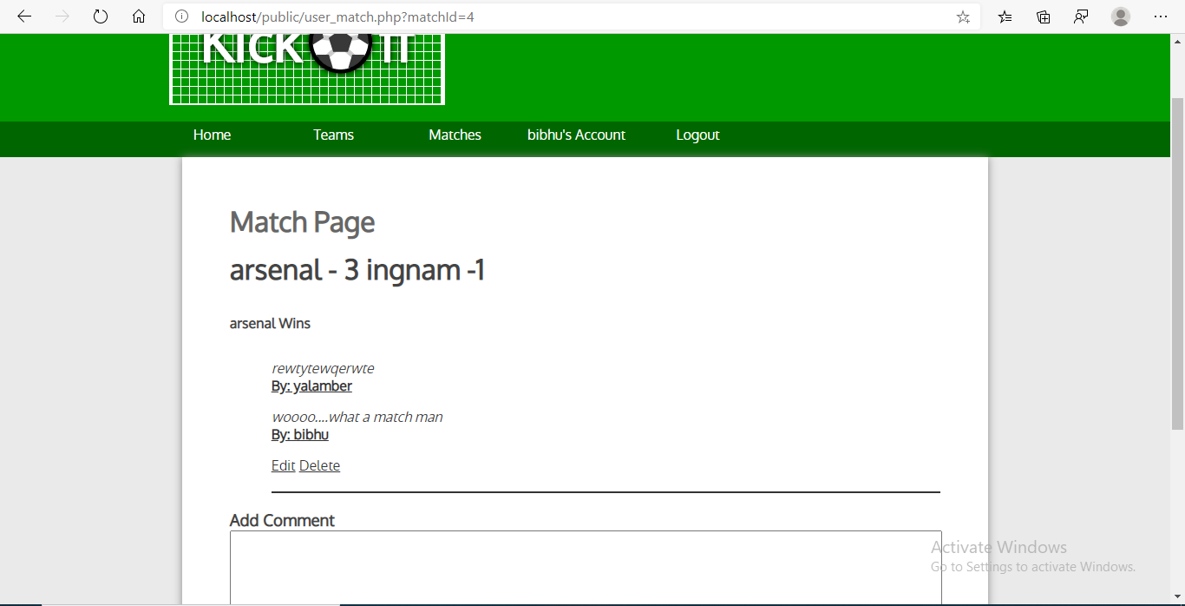

Figure 22: Edit and delete option for own comments

Figure : Storing of the user password in encrypt from

# Conclusion

This whole project was done on the back-end site of the website. The first thing was to design a proper database for storing the information that are needed in the webpage. Site was connected to the database using the PDO of PHP. PHP was used to implement the features like add, edit and delete for users and admin. Every basic feature of users and admin works properly and tested properly along with some of the advance features like comment approval by the admin and storing of users account password using the inbuilt functions of the PHP, password hash. Still it lacks many features that could have been implemented if there was just little more time. Functionality that are implemented here woks flawlessly without any bug. There are no any features left incomplete.

For the future works the author is going to implement the advance features such as season tracking of the game, on which year the game was played and the automatic update of the team points after each game win. This feature can be implemented with the help of the conditional syntax such as IF and ELSE in the PHP. Hence to conclude the overall experience was great and learned many extra things about PHP and backend.

The way the author wrote the code is good, but it can still be done better. There were multiple times the author must repeat the same code again and again. This could be minimized by using the MVC pattern in the future work and writing the class for the greater usability.

# References

* Guru99.com. 2020. *PHP Date & Time Function With Example*. [online] Available at: <https://www.guru99.com/php-date-functions.html> [Accessed 22 April 2020].
* Php.net. 2020. *PHP: Password_Hash - Manual*. [online] Available at: <https://www.php.net/manual/en/function.password-hash.php> [Accessed 22 April 2020].
* Codingcage.com. 2020. *Fetch Data From Multiple Tables With PHP And Mysql*. [online] Available at: <https://www.codingcage.com/2014/12/fetch-data-from-multiple-tables-in-php.html> [Accessed 22 April 2020].
* W3schools.com. 2020. *PHP Mysqli Fetch_Row() Function*. [online] Available at: <https://www.w3schools.com/php/func_mysqli_fetch_row.asp> [Accessed 22 April 2020].