**INTRODUCTION TO DATA MANAGEMENT**

#### PROJECT REPORT

(Project Semester January-April 2025)

***Dashboard on Sustainable Energy Trends***

Submitted by

Y Monish

Registration No: 12308948

Section : K23EG

Course Code : INT217

Under the Guidance of

Mr. Jaffar Amin Chacket

**(UID :** 30453**)**

**Discipline of CSE/IT**

**Lovely Professional University, Phagwara**



#### CERTIFICATE

This is to certify that **Monish** bearing Registration no. 12308948 has completed

INT217 project titled, **“Sustainable Energy Trends”** under my guidance and supervision.

To the best of my knowledge, the present work is the result of his/her original development, effort and study.

Mr. Jaffar Amin Chacket

Assistant Professor

**School of Computer Science and Engineering**

Lovely Professional University Phagwara, Punjab.

Date:11 April,25

#### DECLARATION

I, **Monish**, student of B.Tech. (Computer Science and Engineering) under CSE/IT Discipline at, Lovely Professional University, Punjab, hereby declare that all the information furnished in this project report is based on my own intensive work and is genuine.

Date: 11 April,25 Signature of the student

Y Monish

Registration No. 12308948

# Acknowledgments:

I would like to extend my heartfelt gratitude to the following individuals and resources that have contributed to the development of this project:

* **Kaggle.com**: I am grateful to Kaggle.com for providing the dataset used in this project. The availability of high-quality data on their platform has been instrumental in conducting thorough analysis and creating meaningful visualizations.
* **Ms. Tanima Thakur**: I owe a debt of gratitude to Ms. Tanima Thakur, my teacher, whose guidance and support have been invaluable in helping me develop my skills in Excel. Her patience, expertise, and encouragement have empowered me to explore and utilize data analysis tools effectively.
* **Project Contributors**: I would like to thank everyone who has contributed to this project, whether through direct assistance, feedback, or inspiration. Your support and collaboration have played a crucial role in shaping the outcome of this endeavor.

This project is a testament to the knowledge, mentorship, and collaborative spirit of those who have supported and inspired me along the way.

# Introduction

In an era marked by escalating concerns about climate change and environmental sustainability, the pursuit of renewable and sustainable energy sources has become imperative. As nations grapple with the dual challenge of meeting growing energy demands while mitigating carbon emissions, the need for comprehensive analysis and informed decision-making in the energy sector has never been more pressing.

The project at hand endeavors to address this critical need by presenting an interactive dashboard focused on sustainable energy trends. By leveraging data sourced from Kaggle.com and employing data analysis techniques learned through guidance from Ms. Tanima Thakur, this project aims to provide stakeholders with a comprehensive tool for exploring and understanding key indicators related to sustainable energy.

Through the amalgamation of diverse datasets encompassing variables such as GDP growth rate, CO2 emissions, GDP per capita, primary energy consumption, access to electricity, and sources of electricity, the dashboard offers users a multifaceted view of global energy trends. By enabling interactive exploration and visualization of these trends over time and across different regions, the dashboard facilitates insights into the complex interplay between economic development, energy consumption, and environmental impact.

The following report serves as a companion to the interactive dashboard, offering an in-depth analysis of the methodologies, findings, and implications derived from the data. By elucidating the significance of sustainable energy trends and elucidating key insights gleaned from the analysis, this report seeks to inform stakeholders, policymakers, and researchers alike, fostering a deeper understanding of the challenges and opportunities inherent in the pursuit of a sustainable energy future.

**Source of dataset:** Dataset is taken from Kaggle.com

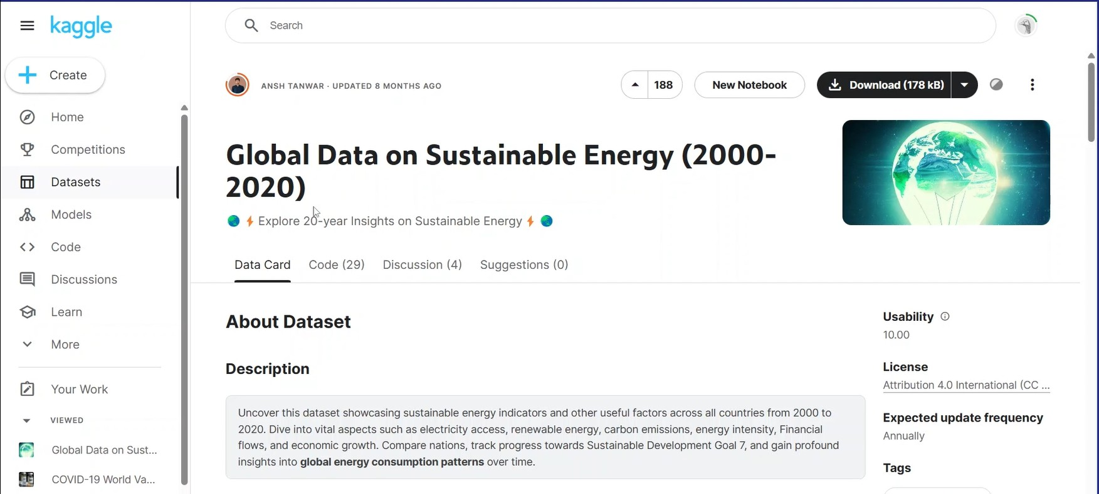

There are **3650 rows** and **21 columns** in the dataset

# Point Of Analysis:

### Compare the sources of electricity comes from different sources like fossils fuels, nuclear energy, renewable energy:

The analysis compares the sources of electricity across regions, highlighting the proportions derived from fossil fuels, nuclear energy, and renewable sources. It unveils variations in energy mix, emphasizing shifts towards sustainable alternatives, underscoring the global transition towards cleaner energy systems.

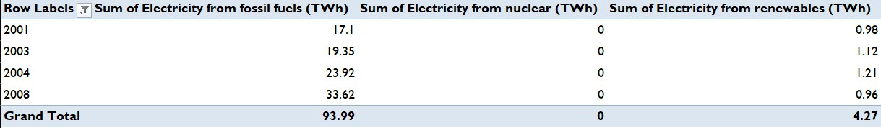

Visualization

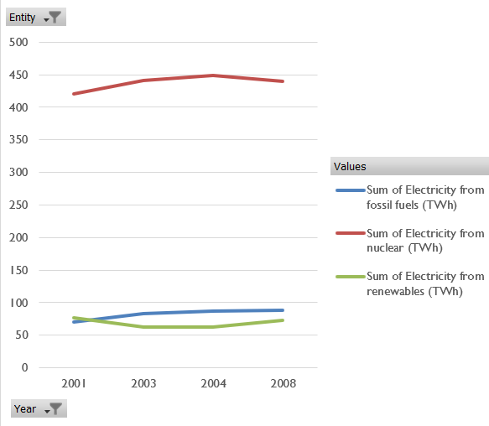

## Compare what percentage of population are accessible to electricity in different years:

This analysis contrasts the percentage of population with access to electricity across various years, revealing trends in electrification rates. It underscores progress in global electrification efforts, identifying disparities between regions and highlighting the ongoing challenge of ensuring universal access to reliable energy infrastructure.

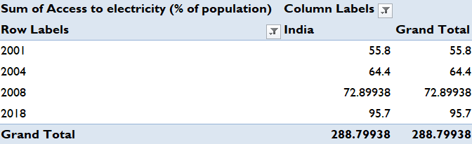

Visualization

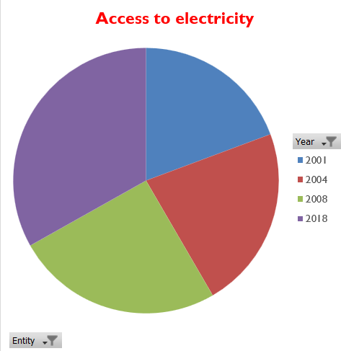

## Compare energy consumption year wise of different country:

This analysis juxtaposes the energy consumption patterns of various countries over different years, elucidating trends and disparities in resource utilization. It offers insights into the factors driving energy demand, highlighting variations in consumption behavior and informing strategic energy policy decisions.

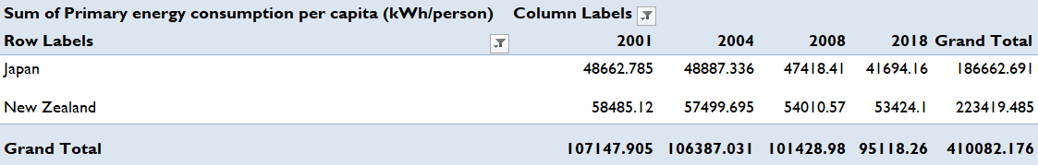

Visualization

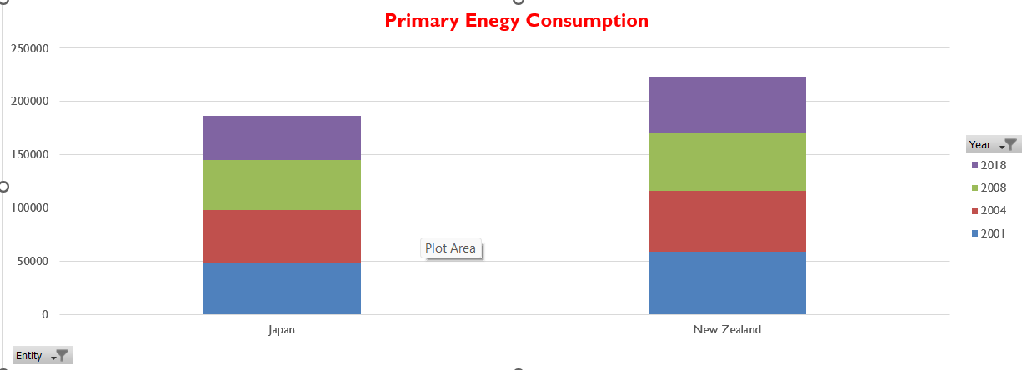

## Compare Gdp per capita of different county year wise:

This analysis contrasts the GDP per capita of diverse countries over various years, unveiling economic trends and disparities in wealth distribution. It provides insights into the relative economic prosperity of nations, highlighting factors influencing growth trajectories and informing strategies for sustainable development.

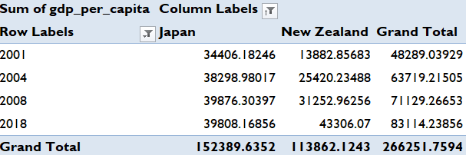

Visualization

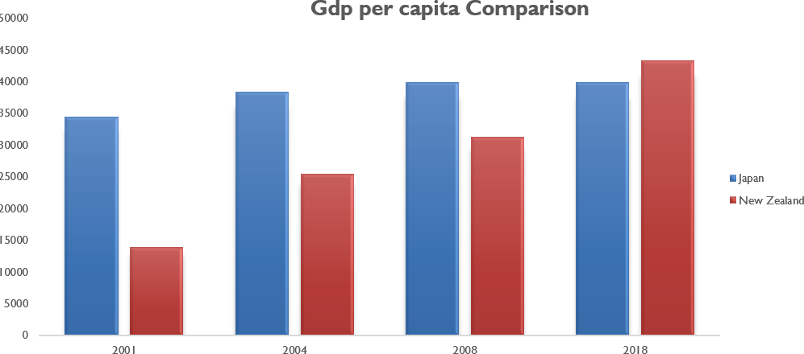

## How different countries control their carbon emission in different years:

This analysis examines the strategies employed by various countries to manage and reduce carbon emissions across different years. It highlights diverse approaches, including policy interventions, technological innovations, and renewable energy adoption, shedding light on effective mitigation measures and areas for improvement in global climate action.

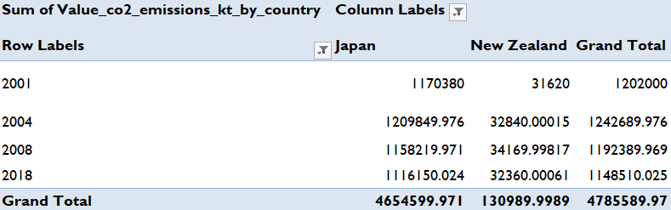

Visualization

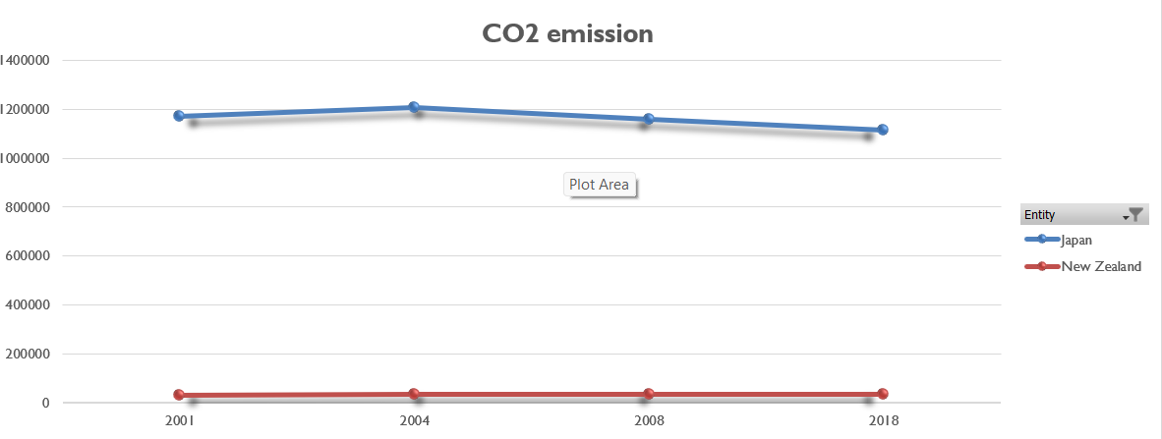

## Compare GDP growth rate of different countries year wise:

This analysis juxtaposes the GDP growth rates of various countries over different years, revealing economic trends and disparities in growth trajectories. It offers insights into the factors driving economic expansion, including policy decisions, global economic conditions, and sectoral contributions, informing assessments of national economic performance.

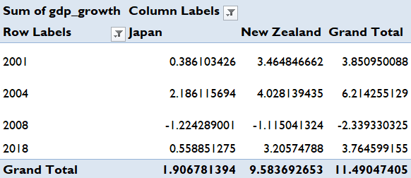

Visualization

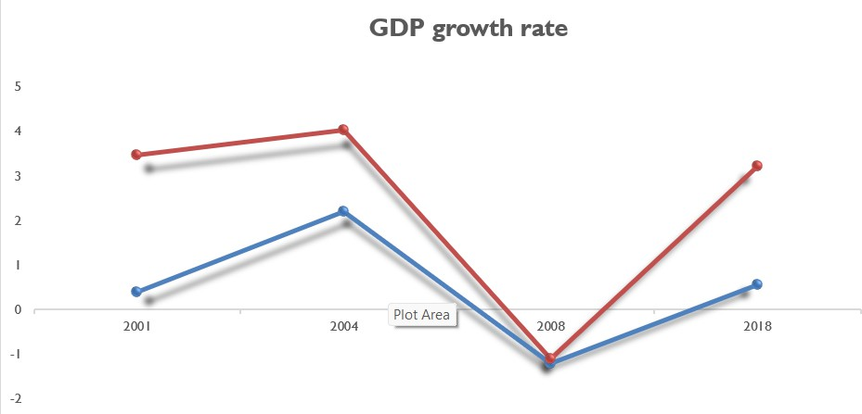

# Dashboard

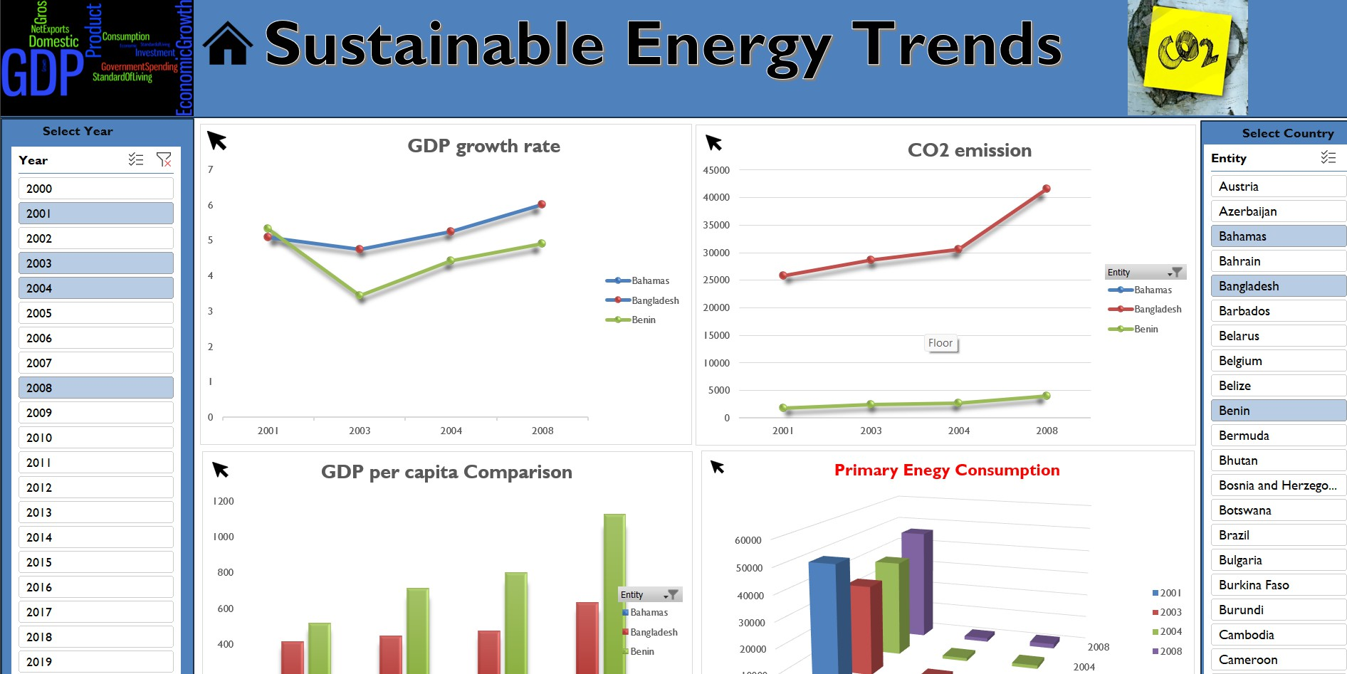

**Slicers are also added:**

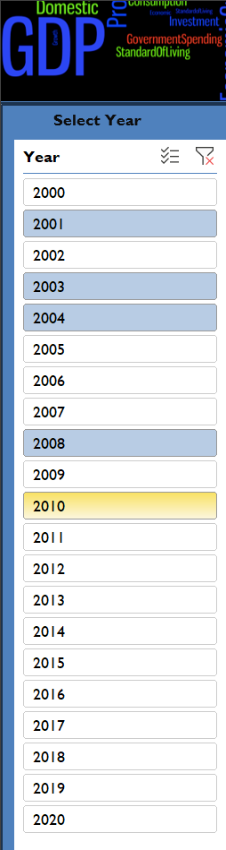

### Conclusion

In conclusion, the interactive dashboard and accompanying analysis offer valuable insights into sustainable energy trends and economic indicators across the globe. Through comprehensive exploration of variables such as energy consumption, GDP per capita, carbon emissions, and electrification rates, the project has provided a nuanced understanding of the complex interplay between economic development and environmental sustainability.

Key findings reveal significant variations in energy consumption patterns, GDP growth rates, and access to electricity among different countries and regions. The analysis underscores the critical importance of transitioning towards renewable energy sources and implementing effective policies to mitigate carbon emissions and address climate change.

Moreover, the comparison of GDP growth rates and energy consumption highlights the intricate relationship between economic prosperity and energy demand, emphasizing the need for balanced and sustainable development strategies.

Looking ahead, the insights gleaned from this project can inform policy decisions, investment strategies, and international cooperation efforts aimed at promoting sustainable energy development and fostering inclusive economic growth. By leveraging data-driven analysis and interactive visualization tools, stakeholders can work towards building a more resilient, equitable, and environmentally sustainable future for all.

In closing, this project serves as a testament to the power of data analytics and collaborative research in addressing pressing global challenges. As we continue to navigate the complexities of the energy transition and strive for a more sustainable world, the lessons learned from this endeavor will undoubtedly guide us towards a brighter and more sustainable future.