**Develop Alexa Skill for COVID-19 Recommendations**

Table of contents:

* Introduction
* Overview

1.Purpose

* Result

1.Screenshots of Output

* Application
* Conclusion
* Future Scope

***Introduction:***

Social distancing is major recommendation for Covid. Isn’t it Irony that how can we get the information of covid if we don’t meet people. We all know Google is always solution for that.But people are becoming lazy even for searching.So What to do??...then **ALEXA SKILL** came into picture.We can just get information and recommondations by just voice commands.

Alexa is one of the most popular and powerful personal assistants. Amazon is a little weird with it, though. You can only get the full experience on select Android phones, Amazon Fire devices, and Amazon Echo devices. That makes it a tad restrictive. However, you’re likely here because you own one of those devices and want Alexa to do more. We can definitely help with that. Here are the best skills and apps for Alexa! Most of the skills worth using are for things like smart home tech, checking the weather, and playing music. There are some other tools it can utilize as well.

***Overview:***

Here, We are gonna do a Skill for alexa that gives total cases in nation,some safety measures etc.

Purpose:

To get covid info just by voice commands because avoid meeting people due to social distancing.

***Result:***

We will get different recommendations, Covid cases in Indaia and in different states of India.

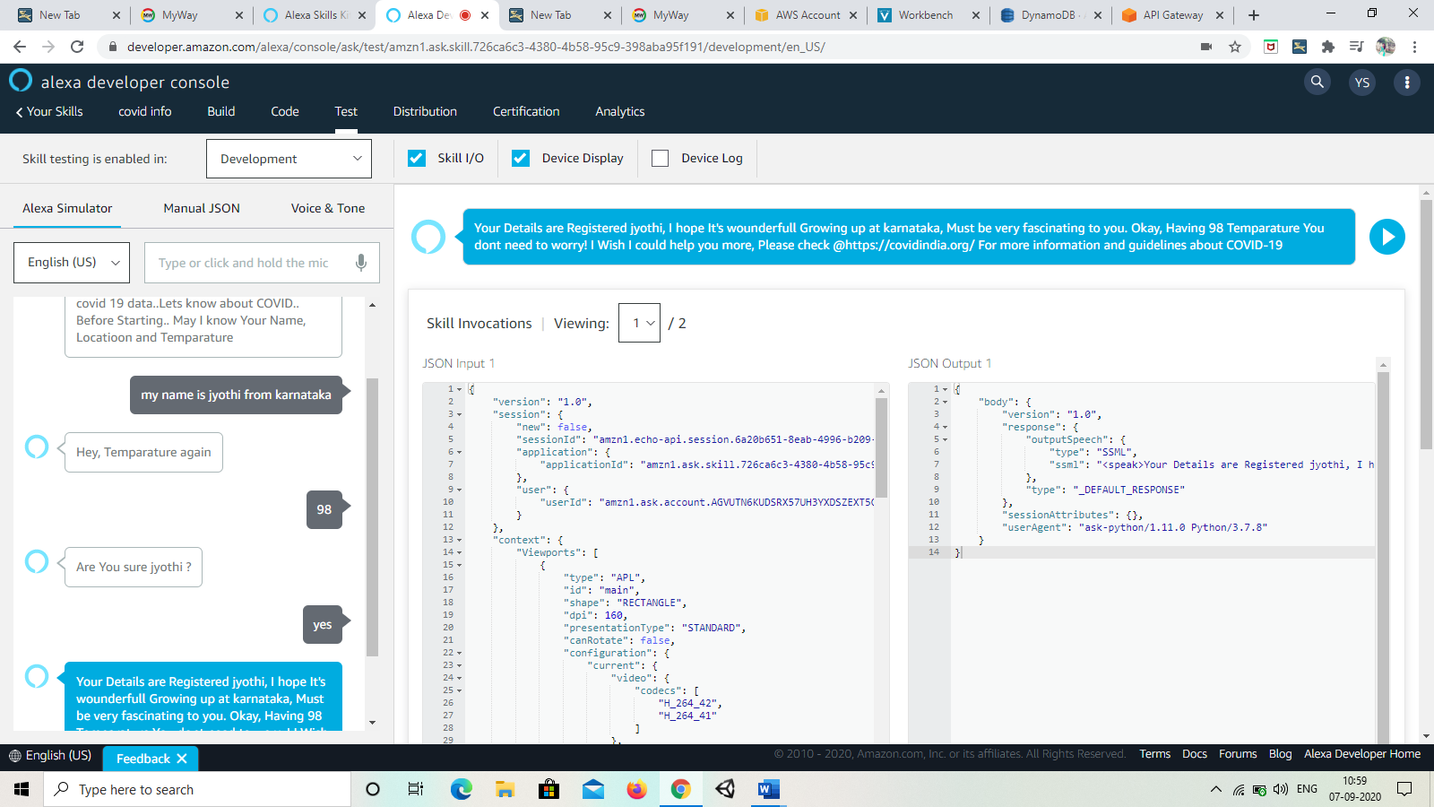Screenshots of output:

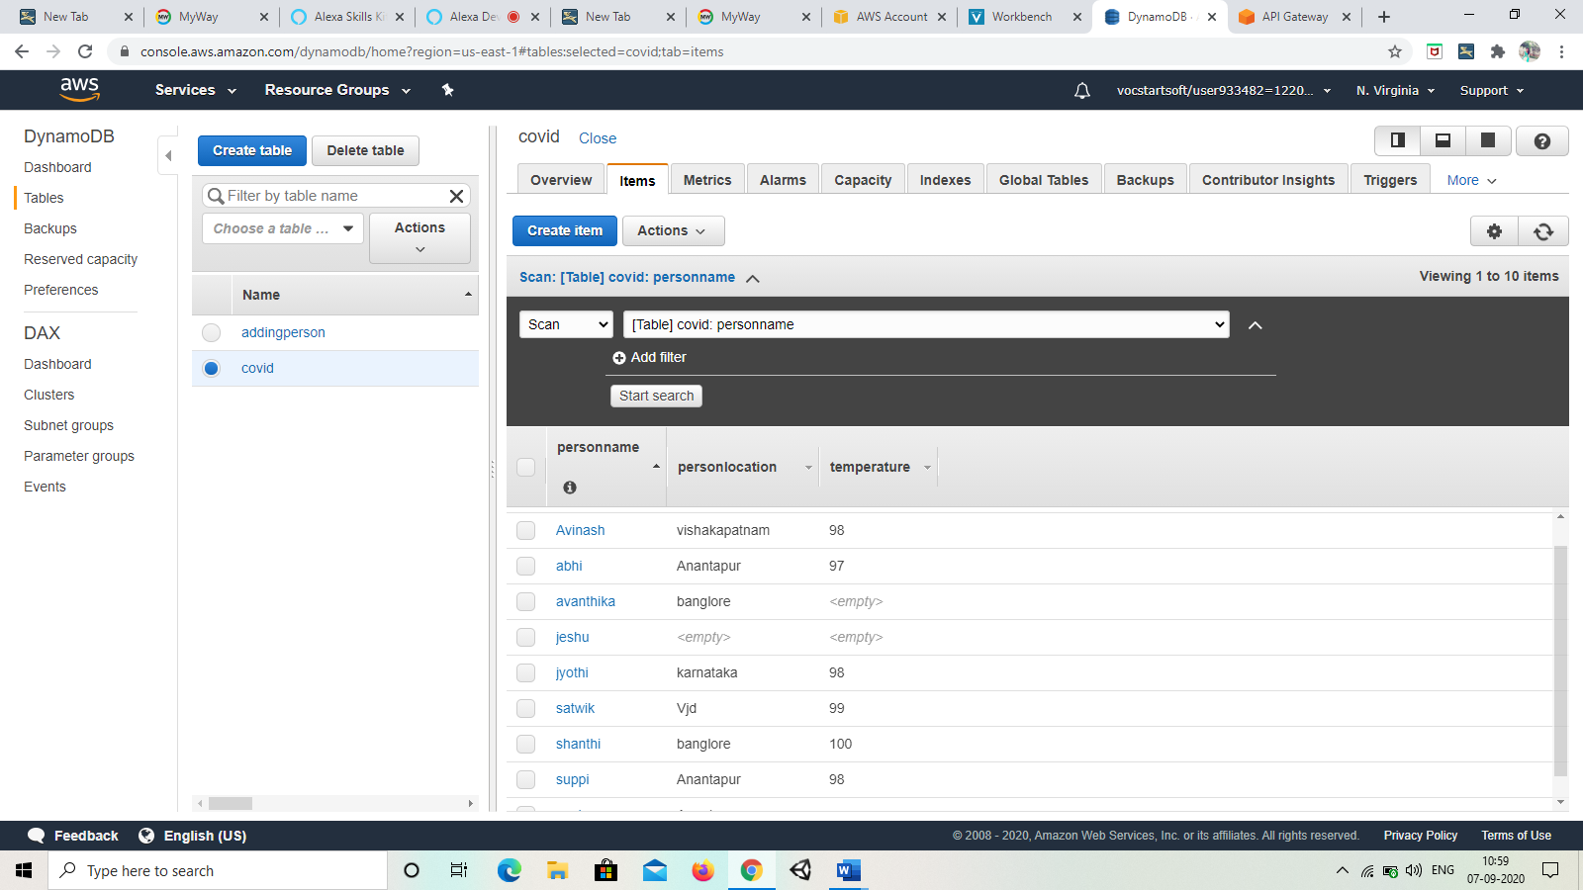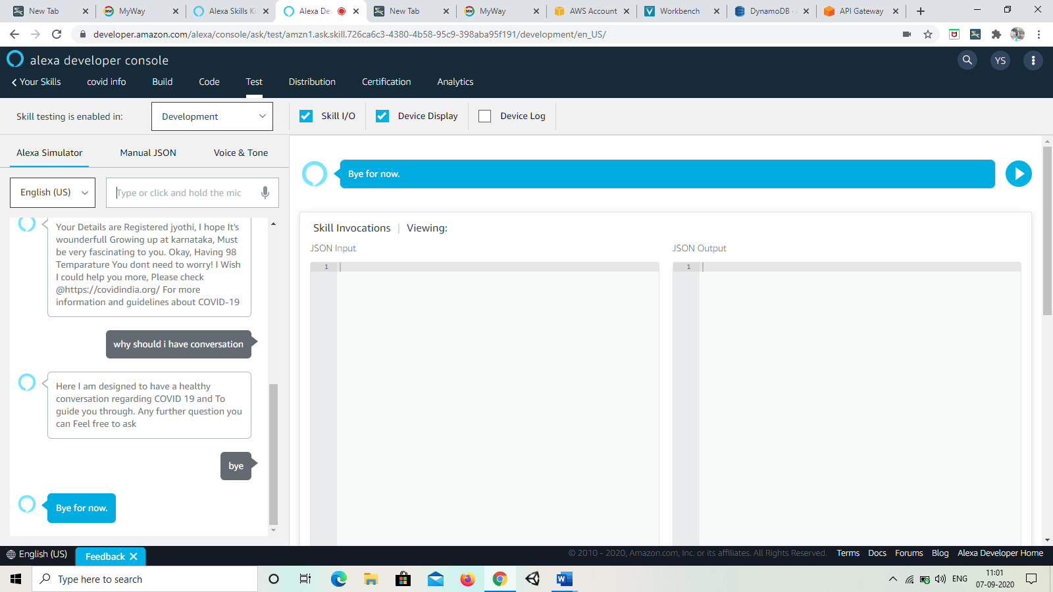

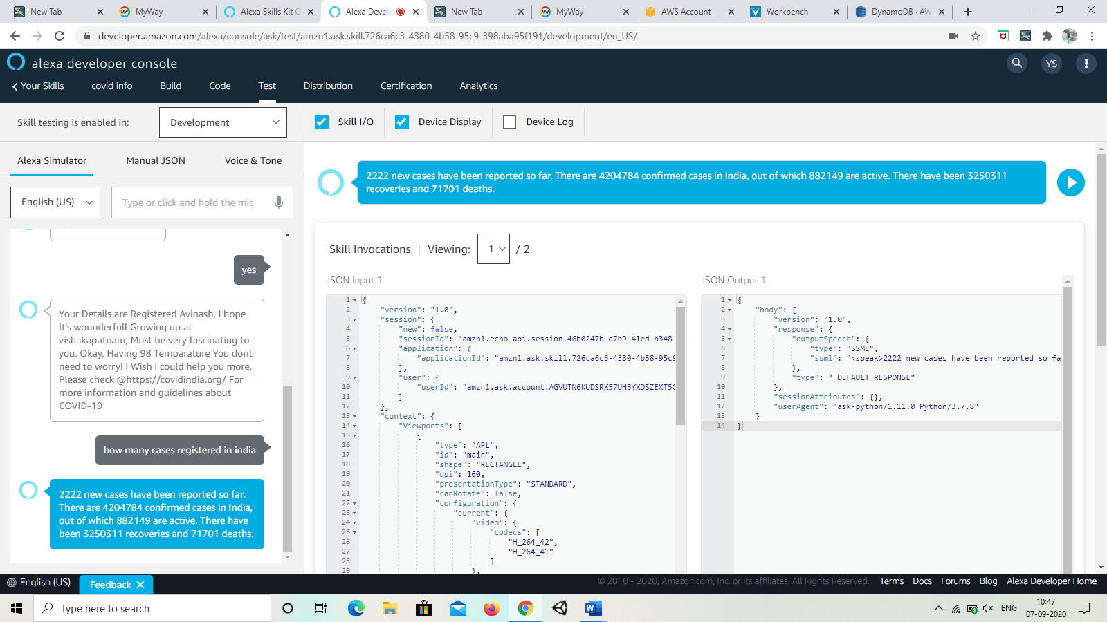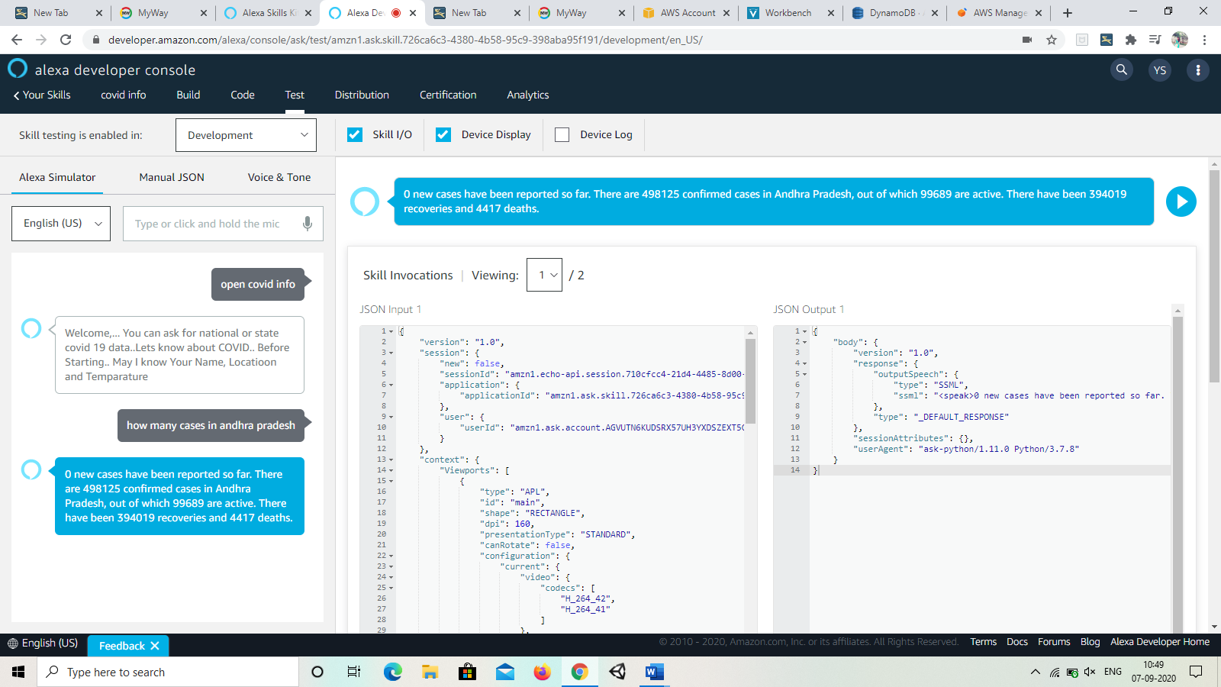

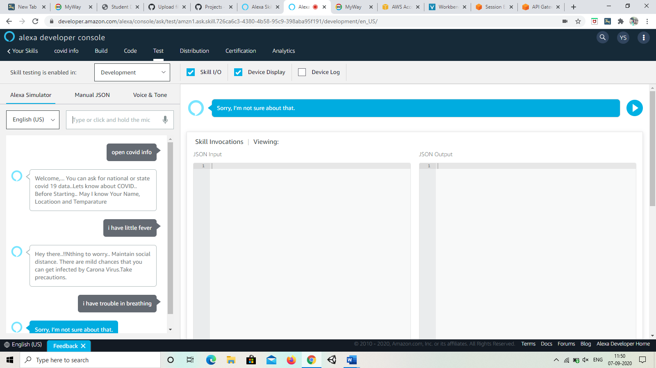

***Application:***

Some applications of alexa are:

* Ordering products
* Translation
* Music
* Talk in a ride

And many more…

***Conclusion:***

So,here we created an alexa skill for covid recomandations by giving our name,location,temperature. Every entry will be redirected in dynamicdatabase.

***Future Scope:***

Amazon Echo Becomes Our Favourite Assistant: With skills that allow it to remember appointments, book flights, create song lists and order food, you will never be able to find a better assistant. Both in our work and personal lives, we will be depending on Alexa to keep things in track. Amazon Echo Will Have Even More Features: There is no stopping innovation, especially for technology that is successful. So it makes sense to think that amazon will make even better versions of Echo, which are packed with yet-to-be-seen features. Perhaps they will even make accessories and peripherals to go with the Echo. Nothing is for certain, but the possibility is definitely there.