# Integral

## Terminology：

* Riemann integral (黎曼积分 / 定积分)
* Improper integral （反常积分 / 不定积分）
* Singularity (奇点)
* Divergence (发散)
* Convergence (收敛)
* Polar coordinate system (极坐标)
* Symmetry (对称性)
* Even Function / odd function (偶函数 / 奇函数)
* [Differentiable](https://en.wikipedia.org/wiki/Derivative) (可微的)
* Remainder (余项)

## Taylor's formula

If $f(x)$ is k times differentiable at point $x∈\left(a,b\right),$ then to any $x_{0}∈\left(a,b\right),$ we could use the following equation to approximates $f\left(x\right)$:

$$f\left(x\right)= \frac{f(x_{0})}{0!}+\frac{\acute{f\left(x_{0}\right)}}{1!}\left(x-x_{0}\right)+…+\frac{f^{\left(n\right)}\left(x_{0}\right)}{n!}{\left(x-x_{0}\right)}^{n}+R_{n}(x)$$

$R_{n}\left(x\right)$ is reminder here, for partial expansion ($x∽x_{0}$), we use [Peano](https://en.wikipedia.org/wiki/Peano) form of the remainder

$$R_{n}\left(x\right)= ∘({(x-x_{0})}^{n})$$

For global expansion, we use [Lagrange](https://en.wikipedia.org/wiki/Joseph_Louis_Lagrange) form of the remainder (k+1 times differentiable)

$$R_{n}\left(x\right)= \frac{f^{\left(n+1\right)}(ϱ)}{\left(n+1\right)! }{\left(x-x_{0}\right)}^{n+1} (\text{ϱ between x and}{ x}_{0} )$$

### e.g. Prove:

$$\sin{x=x-\frac{1}{3!} x^{3}+…}$$

### e.g. $f\left(x\right)$ is 2 times differentiable when $x∈\left[0,1\right],$ $f\left(0\right)=0$, $f\left(1\right)=1.$ $\int_{0}^{1}{f\left(x\right)dx=1}.$ Prove:

1. $∃ ϱ ∈\left(0,1\right)$ let $\acute{f\left(ϱ\right)}=0$

$∃ η ∈\left(0,1\right), let f^{''}\left(η\right)<-2$

## Lagrange Mean Value Theorem

if $f$ is a continuous function on the closed interval $[a,b]$, and differentiable on the open interval $(a,b)$, then there exists a point $ξ$ in $(a,b)$ such that:

$$k=\frac{f\left(b\right)-f(a)}{b-a}=\acute{f\left(ξ\right)} (a<ξ<b)$$

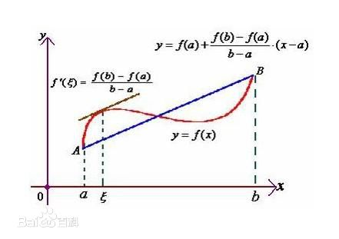

e.g. Assume $\{x_{n}\}$: $x_{1}>0 , x_{n}e^{x_{n+1}}=e^{x_{n}}-1$, n=1,2,3…, Prove $\left\{x_{n}\right\}$ is bounded, and calculate $\lim_{n→∞}{x_{n}}$

## Riemann integral (definite integral)

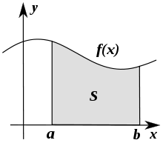

$$S= \sum_{1}^{∞}{f\left(x\right)dx= \int_{a}^{b}{f(x)dx}}$$

Has two limits: [a, b] is bounded, f(x) in [a, b.] is bounded

## Improper integral

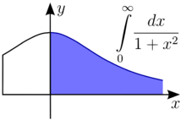

Break those two limits: [a, b] is bounded, f(x) in [a, b.] is bounded

Principle: we only allow one Singularity exist in one integral, So:

$$\int_{-∞}^{+∞}{f\left(x\right)dx= }\int_{-∞}^{c}{f(x)dx+\int_{c}^{+∞}{f(x)dx}}$$

## Tips:

$\frac{dx}{x}= d\ln{x}$

## Examples

### e.g. Assume a, b >0, improper integral $\int_{0}^{+∞}{\frac{1}{x^{a}∙{(2020+x)}^{b}}dx}$ is bounded, we could get:

(A) a < 1 and b > 1 (B) a > 1 and b > 1

(C) a < 1 and a + b > 1 (D) a > 1 and a + b < 1

### e.g. Assume a > b >0, improper integral $\int_{0}^{+∞}{\frac{1}{x^{a}{+x}^{b}}dx}$ is bounded, we could get:

(A) a > 1 and b > 1 (B) a > 1 and b < 1

(C) a < 1 and a + b > 1 (D) a < 1 and a + b < 1

### e.g. Assume a >0, improper integral $\int_{1}^{+∞}{\frac{\ln{(1+\sin{\frac{1}{x^{a}}})}}{x^{b}\ln{\cos{\frac{1}{x}}}}dx}$ is bounded, we could get a + b > 3

Hint: When $μ∼1$, $\ln{μ} ∼ μ-1$, $1-\cos{x} ∼ \frac{1}{2} x^{2}$

### e.g. Prove:

$$I= \int_{2}^{+∞}{\frac{1}{x{(ln{x)}}^{p}}dx }$$

When p >1, I is Convergence, when p $≤1$, I is Divergence

### e.g. Calculate the result of (Symmetry)

$$\int_{0}^{10}{x\left(x-1\right)\left(x-2\right)…(x-5)…(x-9)(x-10)dx}$$

### e.g. Calculate the result of

$$\int_{0}^{4}{x\sqrt{4x-x^{2}}dx}$$