**Using remote sensing image data and social media to analyze the interaction between human activity and Lake Mille Lacs**

**Table of Contents**

Introduction 1

Importance of Lakes 2

Purpose & Hypothesis 5

Study Area 5

Methodology 6

Data Sets 6

Data Processing 7

Result 9

Factor Analysis 9

Thematic Map 11

## Introduction

The earth is called "the water planet" because it has about 14,108 cubic kilometers of water. However, 97.5% of this water is present in the sea, and almost all of the remaining fresh water is locked on the ice sheet of the Antarctic or Arctic or as groundwater. Therefore, we can freely access only the water in lakes (0.007%) and in rivers (0.002%). Among them, the lake is the best “source of available fresh water” on the surface of the earth. Lakes are considered water sources for fishing, water transport, recreation, and tourism. Here, I listed five of the most important roles of lakes:

### ****Importance of Lakes****

#### ****Lakes as a Water Sources****

Global water use is distributed in household water (18.4%), industrial water (17.4%) and agricultural water (64.1%). Lakes are an important source of water for all these uses. Taking Japan as an example, Xiapu Lake can provide 61.45 tons of water per second. This water is used for agricultural water (82.7%), industrial water (13.3%) and public water supply (3.8%); household water is supplied to Ibaraki Prefecture, Chiba Prefecture and Tokyo. The water in Lugu Lake meets the drinking water demand of 14 million people in Shiga, Kyoto, Osaka and Hyogo Prefecture. As an agricultural reservoir, the history of the Manook Reservoir (Kagawa) dates back to the Great Tiger era (701 BC to 704 AD). Lake water as a source of hydropower is also priceless. In Japan, hydroelectric power accounts for about 10% of power generation.

#### ****Lakes for Fishing****

Saltwater lakes connecting the oceans are rich in fish harvesting: Take Japan as an example, Shinji Lake with 9.971 tons (mainly corbicula shellfish and freshwater smelt), Badain Reservoir has 8419 tons, and Ogawara Lake has 6,241 tons. Kasumigaura Lake grows 5,471 tons of trout. Wuhu has 3326 tons of fish, which is the highest catch in freshwater lakes. The high-yielding fishery has brought great economic income to Japan.

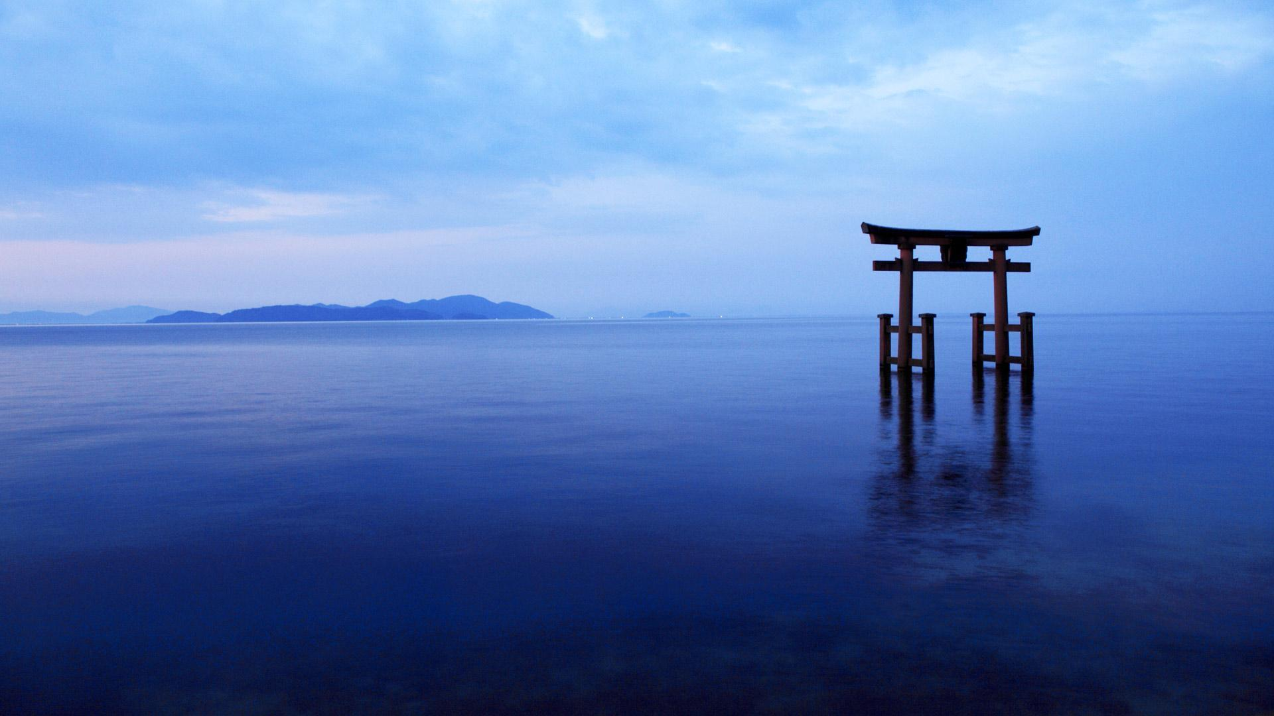***. Fig. 1.1 Biwa Lake - A Source of Drinking Water for 14 Million People***

#### ****Lakes as Tourist and Recreation Locations****

People feel relaxed around water as symbolized by the expression "water and greenery." People use lakeshores for talking walks and other recreation and sports activities such as boating and fishing. Take Japan as an example, such as boating and fishing. There are 37.5 million tourists in Lugu Lake, 21.3 million in Luzhi Lake, 7.87 million in Lake Toya, 6.44 million in Kawaguchi Lake (16 million in Lake Fuji), 4.66 million in Lake Chuzenji, and 3.90 million in Lake Yamanaka. There are 2.72 people in Omanu Lake and 2.56 million in Shiji Lake. Many people also visited the dams near major cities and tourist attractions: 1.49 million Jones Reservoir (Iwate) and 1.44 million in the Kamafusa Reservoir (Miyagi Prefecture).

#### ****Lakes as Biodiversity Conservation Areas****

Taking Japan as an example, Lugu Lake has a history of 4 million years and there are about 52 species of freshwater fish (12 indigenous species) and 46 species of shellfish (20 indigenous species). The lake is not just a home for fish, but it is also home to waterfowl and many other life forms. It is noteworthy that in the case of migratory birds, if a habitat deteriorates, the ecosystem of the destination country will also be affected.

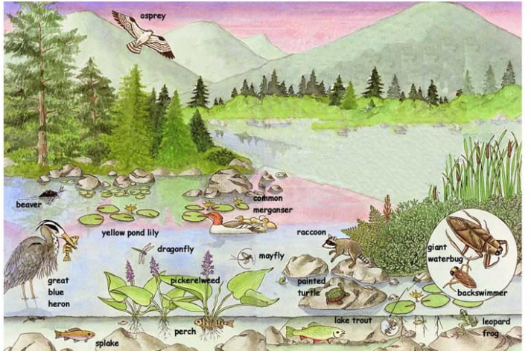

***Fig. 1.2 Lake habitat rich in biodiversity***

#### ****Lakes as Natural Balance Preserving Reservoirs****

Taking Japan as an example, according to calculations, Wuhu has protected floodwaters of about 7.8 million people and 50 trillion yen (about 50 billion US dollars) of assets by acting as flood prevention tools. At present, Watarager Reservoir (Gunma County) is used as a flood control tank, although it was originally a mine pollution sedimentation tank built for the Asio copper mine. The wetlands scattered near the Yanaka reservoir have become paradise for wild animals outside the flood season.

### ****Purpose & Hypothesis****

As mentioned above, the lake is a human being cannot ignore the wealth. It has brought incalculable resources to mankind. Based on this concept, this article proposes the hypothesis that people living in areas near lakes have a higher quality of life than people living in other areas. We will quantify the quality of life by combining data from three aspects of society, economy, and physical geography to prove this hypothesis.

## Study Area

Mille Lacs Lake is a large but shallow lake in the state of Minnesota. Two islands in the center make up Mille Lacs National Wildlife Refuge. The lake has many species of fish including walleye, northern pike, muskie, jumbo perch, smallmouth bass, largemouth bass, black crappie, burbot, and tullibee. It is one of Minnesota's most popular fishing lakes. Every year, many people come to the Mille Lacs lake area for fishing, which brings considerable economic income to the local resident. Therefore, the author thinks that mile lacs lake brings more resources to the surrounding residents than other areas, which allows the surrounding residents to have a better quality of life.

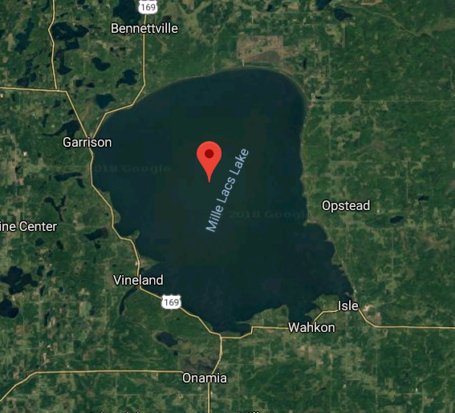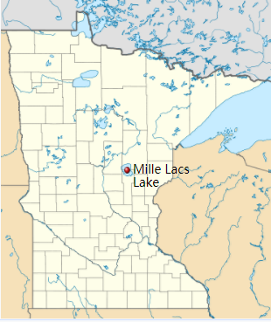

***Fig. 2.1 Mille Lacs Lake***

## Methodology

### Data Sets

This paper mainly uses two sets of data, one set of satellite remote sensing images from LANDSAT8, and the other set of social and economic data downloaded from census bureau.

The study area is Mille Lacs County, Aitkin County, and Crow Wing County, which are the three counties closest to the mile lacs lake. Three county shapefiles (census block group level) were downloaded through the TIGER (Topologically Integrated Geographic Encoding and Referencing) file provided by US census bureau.

Three census data were used in the study. They are ACS 2015 5-Year estimated Data, Business census data, and 2010 decennial census data. The study extracted and calculated seven types of Environmental and socioeconomic variables from ACS 2015 5-Year estimated Data, including Employment status, Poverty rate, Educational achievement (Bachelor's degree), Housing density, Housing Vacancy rate, Median house value, Median number of Rooms.

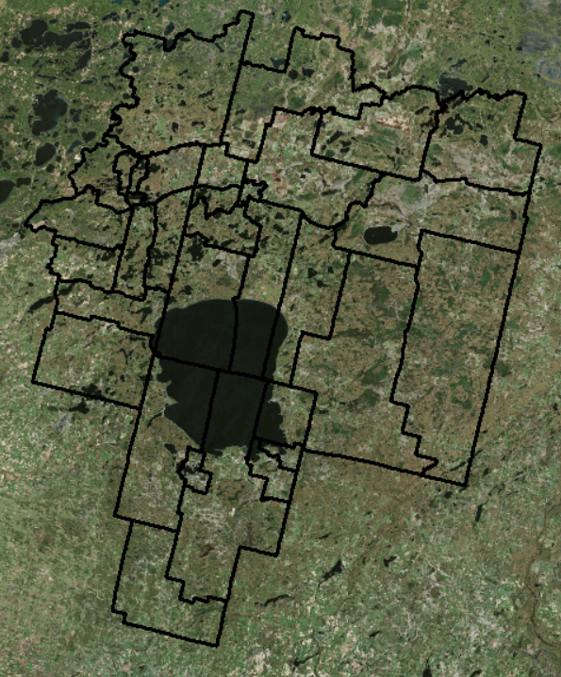

***Fig. 3.1 Mille Lacs County, Aitkin County, and Crow Wing County Shapefile（Block Group）***

Three groups of crime indexes were selected from Business census data: Personal Crime Index, Murder Index, and Robbery Index. Only in 2017, this group crime index is available online. However, even if the time does not match other data, this study only needs to prove that there is a geographical difference in the residents' quality of life, that is, the residents around mile lacs lake have higher quality of life. Two types of socio-economic data were extracted from 2010 decennial census data, namely Population density and Median household income.

### Data Processing

The data processing flow chart for this study is shown below. The NDVI (normalized vegetation index) was extracted (In Li and Weng's Measuring the quality of life in city of Indianapolis by integration of remote sensing and census data, it is mentioned that higher vegetation coverage means a higher level of quality of life.) from the three counties through the LANDSAT8 satellite remote sensing images. Joint analysis with economic and geographic data. The quality of life index is finally calculated.

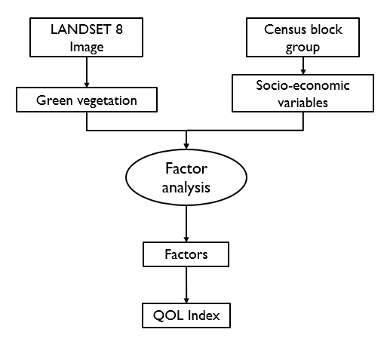

***Fig. 3.1 Work Flow Chart***

The data filtering process is shown in the figure below. The standardization of the 12 kinds of economic and social data downloaded and NDVI is to measure each data on the same scale. Finally, Factor analysis removes the more relevant factors and integrates the remaining factors into several factors. Each factor represents one aspect of the quality of life.

***Fig. 3.2 Data Filtering***

## Result

### Factor Analysis

According to data filtering, a total of 8 groups of independent data are left, namely, population density, employee rate, education attainment, medium family income, housing density, housing vacancy rate, housing quantity, and house value. Eight kinds of data can be integrated into four factors, and four factors can explain more than 88% of the data.

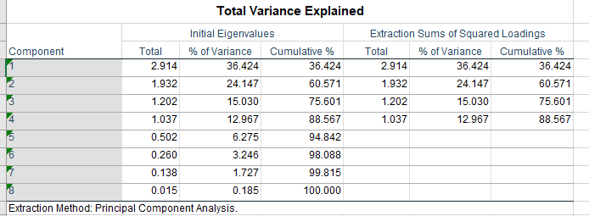

***Fig. 4.1 Factor Analysis***

According to the composition of each factor and the paper 'Measuring the quality of life in city of Indianapolis by integration of remote sensing and census data' of G Li, Q Weng (Mentioned that Loadings of 0.71 and higher are considered excellent, 0.63 very good, 0.55 good, 0.45 fair and 0.32 poor) to explain the meaning of each factor.

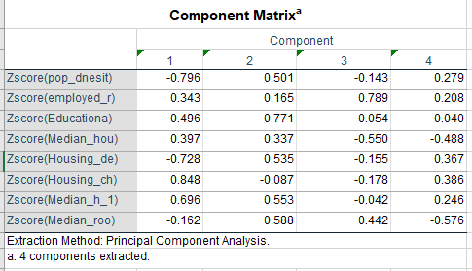

***Fig. 4.2 Component Matrix***

According to the above table, Factor 1 is highly negatively correlated with population density and house density and is positively correlated with the vacancy rate of housing, which can be interpreted as the spatial occupancy of the population. Factor 2 is highly related to the proportion of college students and can be interpreted as the ratio of higher education. Factor 3 is highly related to the employment rate and can be interpreted as the level of local economic income. Factor 4 is negatively correlated with housing size and income and can be interpreted as the level of economic conditions of the residents. Unlike the preceding factors, factor 4 should be as small as possible. According to the composition of each factor, the formula for calculating the quality of life index is as follows:

### Thematic Map

#### A close up of a map Description generated with high confidenceA close up of a map Description generated with high confidenceThematic Map Of Factors

A close up of a map

Description generated with high confidenceA close up of a map

Description generated with high confidence

***Fig. 4.3 Thematic Map By Factors***

The map above is a thematic map derived from four factors. Red represents higher values, blue represents lower values. The red shape of the central area is the outline of mile lace lake. We can see that the per capita space near the lake is usually bigger and has a higher education attainment rate. At the same time, they have a higher income level, and the surrounding housing prices are also higher.

#### Thematic Map of QOL

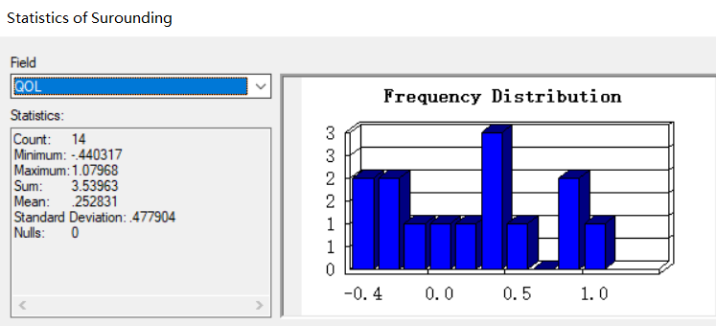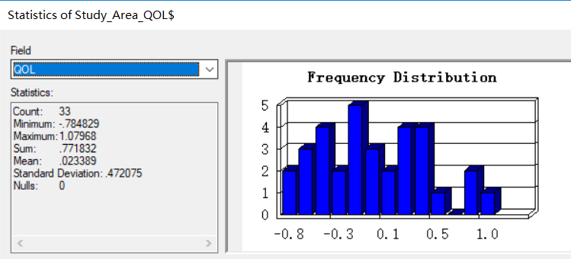A close up of a map

Description generated with high confidence

***Fig. 4.3 Thematic Map of QOL***

This is the map of quality of life. The red area is selected to represent the area close to the mile lacs lake, and its average quality of life index is calculated to be 0.25, which is more than ten times the average of all regions. Therefore, through this study, the author has reason to believe that Mille lacs lake brings more resources to the surrounding residents, so that it has a better quality of life.