**Using remote sensing image data to assess Fire risk of Acadia National Park**

**Content**

Introduction 2

Study Area 5

Methodology 6

Data Sets 6

Evaluation factors and weights 7

Result 8

Assessment Factor Thematic Map 8

Conclusion 9

**Land Use Analysis (GEOG-536-90)**

**Advisor: ChengBin Deng**

**Author: YalinYang**

## Introduction

The forest area accounts for one-third of the world's land, providing vital organic infrastructure for some of the planet's densest, most diverse collections of life. It supports the livelihoods of countless species and more than 7 billion people. However, a large number of trees are cut every year. The forest land cleared every year exceeds one million acres. Recently, the United Nations announced March 21, 2012, as International Forest Day, which is also part of the global effort to publicize the value and dilemma of woodland around the world. At the beginning of this festival, the United Nations cited 21 reasons for the importance of forests.

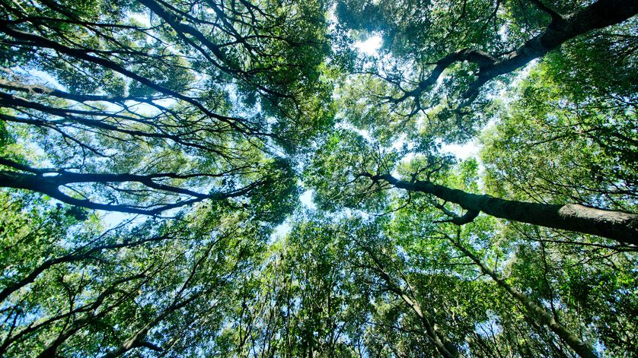

Those 21 reasons include, **1. They help us breathe.** Forests pump out oxygen we need to live and absorb the carbon dioxide we exhale (or emit). **2. They're more than just trees.** Nearly half of the known species live in forests, including 80% of the biodiversity on land. **3. People live there, too.** About 300 million people in the world live in forests, of which an estimated 60 million indigenous people rely almost entirely on native forests. **4. They keep us cool.** By growing the crown in the sun, the trees can also create shade on the ground. Urban trees can help keep buildings cool and reduce the need for electric fans or air conditioners.

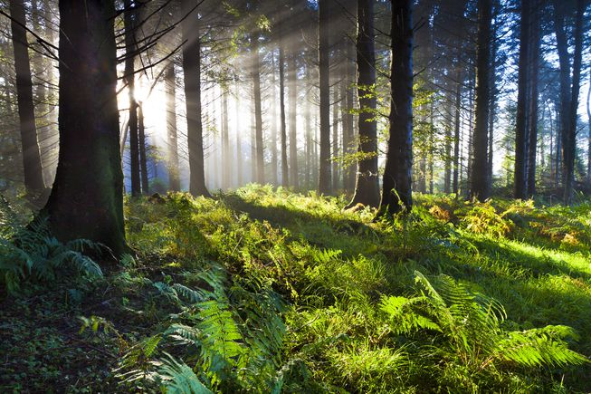

**5. They keep Earth cool.** There is another way for trees to break the heat: to absorb carbon dioxide that contributes to global warming. **6. They make it rain.** Big forests can affect regional weather patterns and even create their own microclimate. **7. They fight flooding.** Tree roots are important allies in the storm, especially in low-lying areas like the plains. **8. They pay it forward.** In addition to flood prevention, the absorption of surface runoff can also protect downstream ecosystems**.9. They refill aquifers.** The forest is like a giant sponge that captures runoff instead of rolling it over the surface. **10. They block wind.** A group of trees can be used as windbreaks to provide cushion for wind-sensitive crops. **11. They keep dirt in its place.** The forest's root network stabilizes a large amount of soil, supporting the entire ecosystem and preventing wind or water erosion. **12. They clean up dirty soil.** In addition to keeping the soil in place, the forest can also use phytoremediation to remove certain contaminants. **13. They clean up dirty air.** Forests can eliminate large-scale air pollution. **14. They muffle noise pollution.** The disappearance of sound in the forest makes trees a popular natural noise barrier.

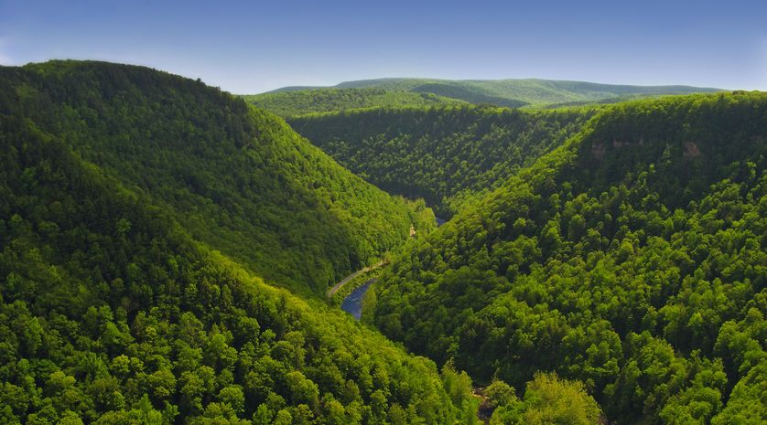

**15. They feed us.** Trees can provide fruit, nuts, seeds and juice. **16. They give us medicine.** Forests provide a wealth of natural medicines and are increasingly able to stimulate synthetic by-products.**17. They help us make things.** We have long used these renewable resources to produce everything from paper and furniture to home and clothing**. 18. They create jobs.** According to statistics from the United Nations, more than 1.6 billion people rely on forests to make a living, and 10 million people directly engage in forest management or protection. **19. They create majesty. 20. They help us explore and relax.** Our intrinsic attraction to forests is part of the phenomenon known as "natural biology" and is still at a relatively early stage of scientific interpretation**. 21. They're pillars of their communities.**

To sum up, the forest is a precious resource for human beings. However, forest fires have brought incalculable losses to humans, both economically and ecologically. How to prevent forest fire has become the focus of the majority of scholars. In this study, the authors evaluated the fire risk of forests in the Acadia national park from four aspects: slope, aspect, elevation, and type of land use, based on evaluation factors in the evaluation case for ecological suitability of forest land used by Esri China, construct the Acadia national park fire risk thematic map, Provide supplementary opinions for the location of local firefighting facilities.

## Study Area

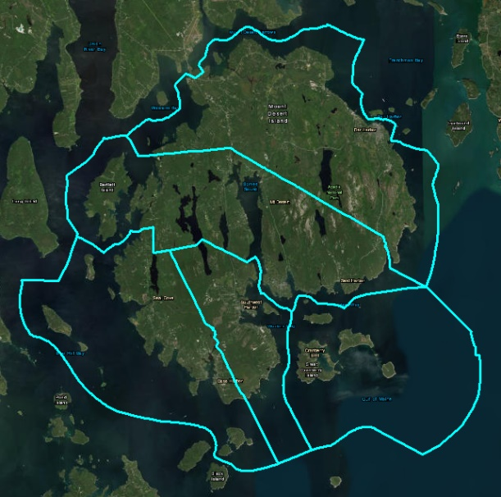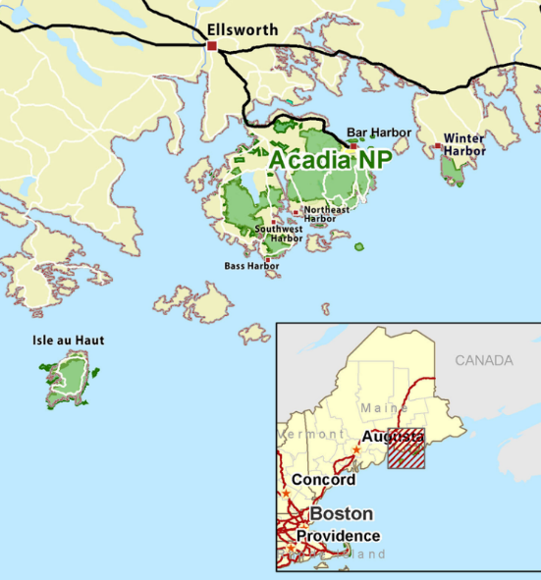Acadia National Park is a United States [national park](https://en.wikipedia.org/wiki/National_park) located in the state of [Maine](https://en.wikipedia.org/wiki/Maine), southwest of [Bar Harbor](https://en.wikipedia.org/wiki/Bar_Harbor,_Maine). The park reserves much of [Mount Desert Island](https://en.wikipedia.org/wiki/Mount_Desert_Island) and associated smaller islands along the [Atlantic coast](https://en.wikipedia.org/wiki/Atlantic_Ocean). From October 17, 1947, 10,000 acres (4,000 hectares) of Acadia National Park burned in a fire that began along a winding road several miles west of Hulls

***Fig. 2.1 Acadia National Park***

Cove. That destroyed a total area of 17,188 acres (6,956 ha) of wooded land on Mount Desert Island and 200,000 acres (81,000 ha) statewide Collectively, the fires killed a total of 16 people. The fire brought incalculable losses to the local people. The reconstruction of the forest took ten years to complete.

In order to prevent such a tragedy from happening again, the study assessed the fire risk of the national park through the evaluation method of forest land adaptability provided by ESRI China and provided an auxiliary opinion for the site selection of fire protection facilities.

## Methodology

### Data Sets

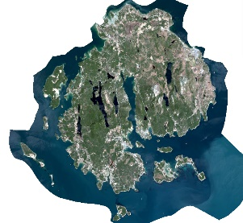This paper mainly uses two kinds of remote sensing data, one is the LANDSAT 8 remote sensing image. The second category is DEM (Digital Elevation Model). Through the processing of two sets of data, we can obtain information on land use type, slope, aspect, and elevation. The specific processing flow is shown below.

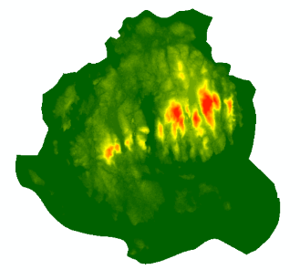



***Fig. 3.1 Image Processing Flow***

The shapefile of the study area was downloaded from the national park service website (<https://www.nps.gov/gis/data_info/metadata.html>).

### Evaluation factors and weights

|  |  |  |  |  |  |
| --- | --- | --- | --- | --- | --- |
| Slope | 0 – 10 (5) | Land cover type | Water (restricted | Aspect | -1 (9) |
| **0 – 44 (8)** |
| **Forest (5)** | **45-89 (7)** |
| **10 – 25 (4)** | **90 – 134 (6)** |
| **Bare Soil (2)** | **135 - 179 (5)** |
| **180 – 224 (4)** |
| **>25 (3)** | **Developed (1)** | **225 – 269 (3)** |
| **270 - 314 (2)** |
| **315 – 360 (1)** |

The evaluation factors adopted in this paper are directly selected from the assessment models adopted by the ESRI China company in 2014 for the evaluation of the ecological suitability of forest lands.

***Fig. 3.2 Fire Risk Assessment Model***

But instead of this, the elevation is divided into 5 levels in this model. Due to the overall lower elevation of the study area, it is always at the first level. Therefore, according to this, the weights of the three factors under the terrain factor in the evaluation model are modified. Three factors with equal weights are divided into Slope (0.2), Aspect (0.2), and Elevation (0.1). After the final adjustment, the evaluation model is as above.

Finally, we can get the fire risk assessment formula from the above figure, because the elevation of the study area is less than 600 meters, so the elevation factor is replaced by a constant 5.

Fire risk assessment formula is as above.

## Result

### Assessment Factor Thematic Map

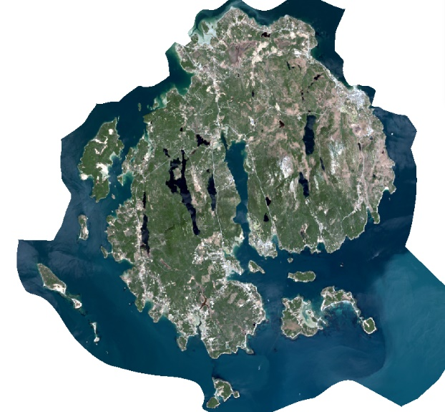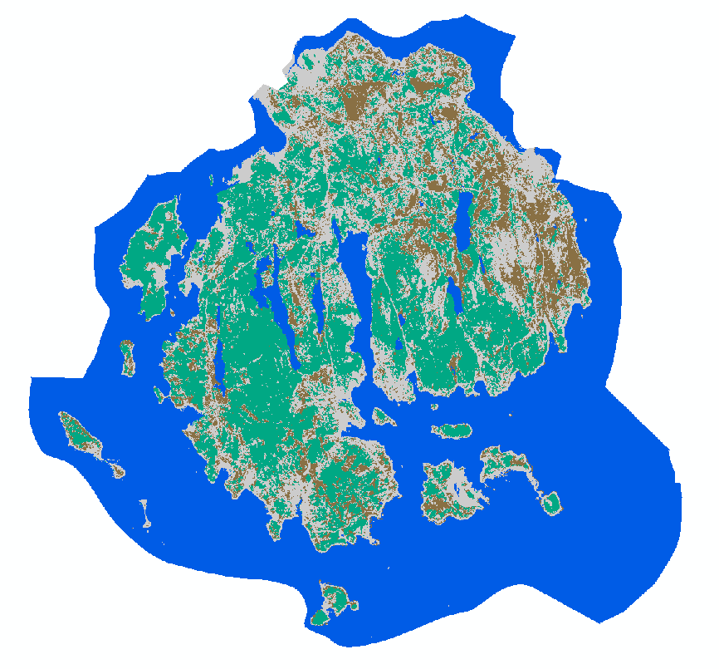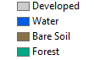The type of land use of the Acadia national park was obtained by monitoring the maximum likelihood method in the classification. Compare it with LANDSAT 8 remote sensing image (RGB 321) and compare the results as follows:

***Fig. 4.1 Comparison of Land Use Type Thematic Maps and Remote Sensing Images***

According to the regional statistical calculation in ArcGIS, the total forest coverage rate in the study area is 23%, and the water coverage is removed. The forest coverage rate is 45%.

The slope and thematic maps of the study area were generated from the DEM image by the Slope tool and the Aspect tool in ArcGIS respectively. The result is as follows.

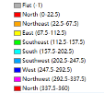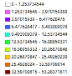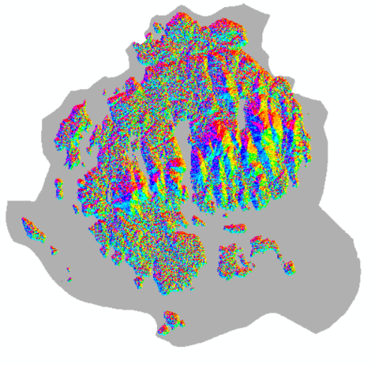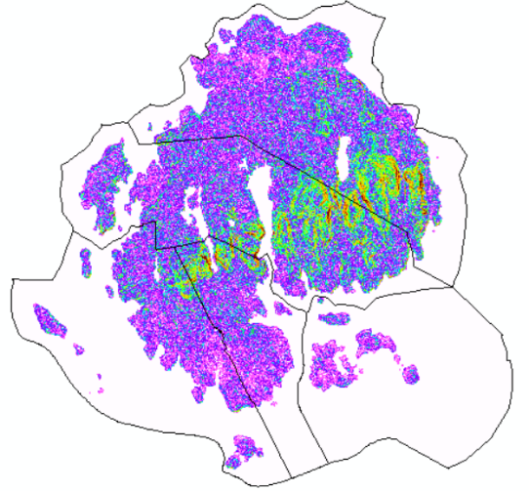

***Fig. 4.2 Comparison of Land Use Type Thematic Maps and Remote Sensing Images***

The values in the thematic map obtained are reclassified using the reclassify tool in ArcGIS according to the grades in the evaluation factor model. Into the fire assessment model to calculate, you can get the fire risk thematic map.

### Conclusion

Finally, the fire risk map of Acadia national park was obtained through the evaluation model. The calculated fire risk index is divided into three levels at equal intervals: Low Risk, Medium, and High Risk. The fire risk thematic map obtained is compared with the thematic map of the highest weighted land use type. The results are as follows:

***Fig. 4.3 Comparison of Thematic Maps of Fire Risk and Thematic Maps of Land Use Types*** 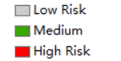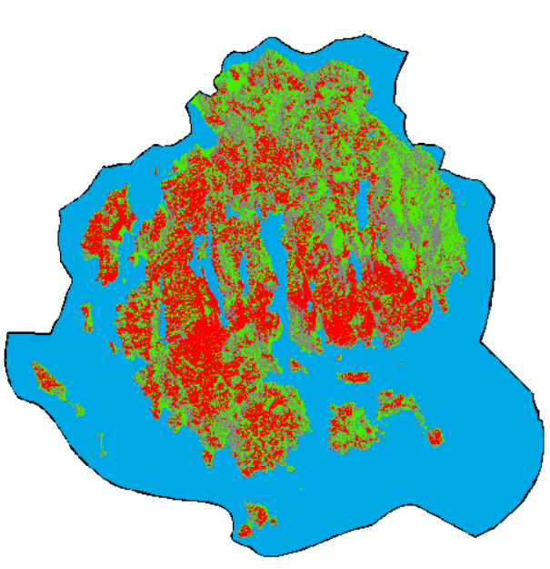

Through comparison, it is found that the fire risk map obtained is reliable. In general forest areas have a high fire risk. In contrast, developed areas generally have a lower risk of fire. The risk of fire in bare soil is moderate. And each type of land use has a different slope depending on where the location is, and it has different fire risks.

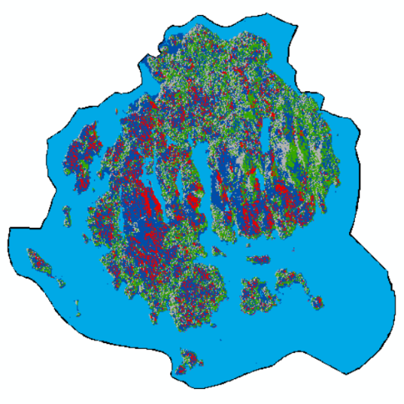In the end, the author divides the high-risk area into two parts: the high-risk area and the area that requires more pay attention. Pay more The attention area is the area where the highest intercept risk index is generated by 10%, which means that these areas are extremely prone to fire.

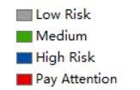

***Fig. 4.4 Fire Risk Thematic Map***

The conclusion of this paper is that due to the range of ups and downs is not large enough. Therefore, the fire risk and land use types in Acadia National Park are closely related. The red area on the map above is a region of research that is prone to fire. The authors suggest that these red areas be equipped with the necessary firefighting facilities so that they can control the fire for the first time and minimize the harm caused by the fire.