Depression Detection using EEG

In this project we are using deep learning CNN algorithm to predict depression from EEG signals dataset. Now-a-days humans are more prone to depression due to competitive environment in all fields and timely detection of depression can help humans in recovering faster. All existing techniques were dependent on manual counselling or traditional machine learning algorithms such as SVM are not accurate. To predict depression accurately we are applying CNN algorithm which will filtered trained data at multiple layers to get optimized features which result into increase prediction accuracy.

To train CNN algorithm we have downloaded Depression EEG signals dataset from KAGGLE and below screen showing some dataset details

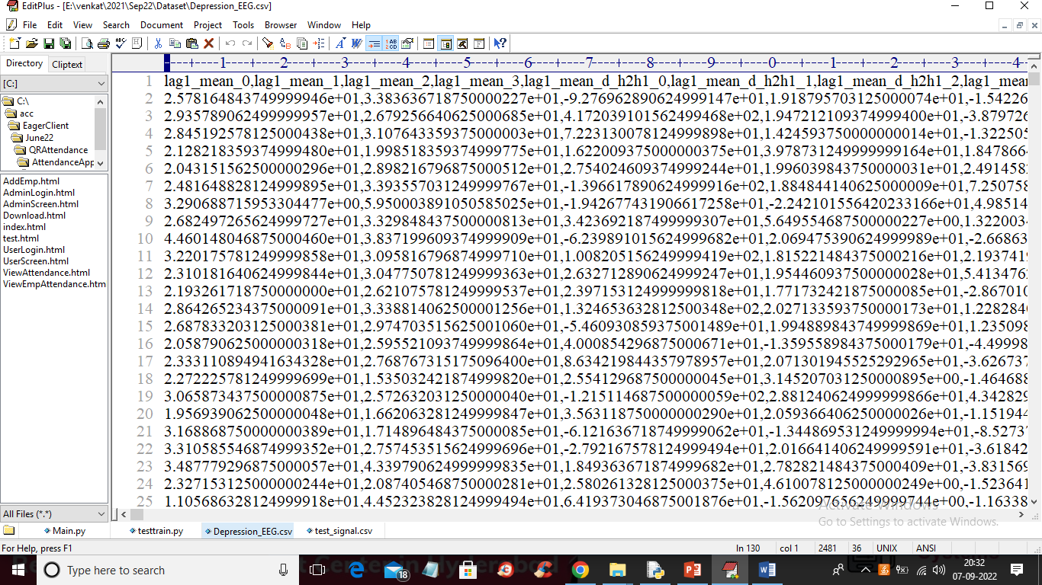

In above dataset screen first row represents dataset column names and remaining rows represents dataset values and this values are extracted from EEG signals and each rows contains 989 columns.

To implement this project we have designed following modules

1. Upload EEG-Signal Dataset: using this module we will upload dataset to application and then extract normal and depressed records from dataset
2. Features Extraction: using this module we will replace all missing values and then extract features from dataset and then split dataset into train and test where application used 80% dataset for training and 20% for testing
3. Run Existing SVM Algorithm: using this module we will train SVM algorithm on 80% training dataset and then evaluate its performance on 20% dataset in terms of accuracy and precision
4. Run Propose CNN Algorithm: using this module we will train propose CNN algorithm on 80% training dataset and then evaluate its performance on 20% dataset in terms of accuracy and precision
5. Predict Depression from Test Signals: using this module we will upload test dataset and then CNN will predict weather test data is normal or DEPRESSED
6. Comparison Graph: using this module we will plot comparison graph between SVM and CNN

SCREENSHOTS

To run project double click on ‘run.bat’ file to get below screen

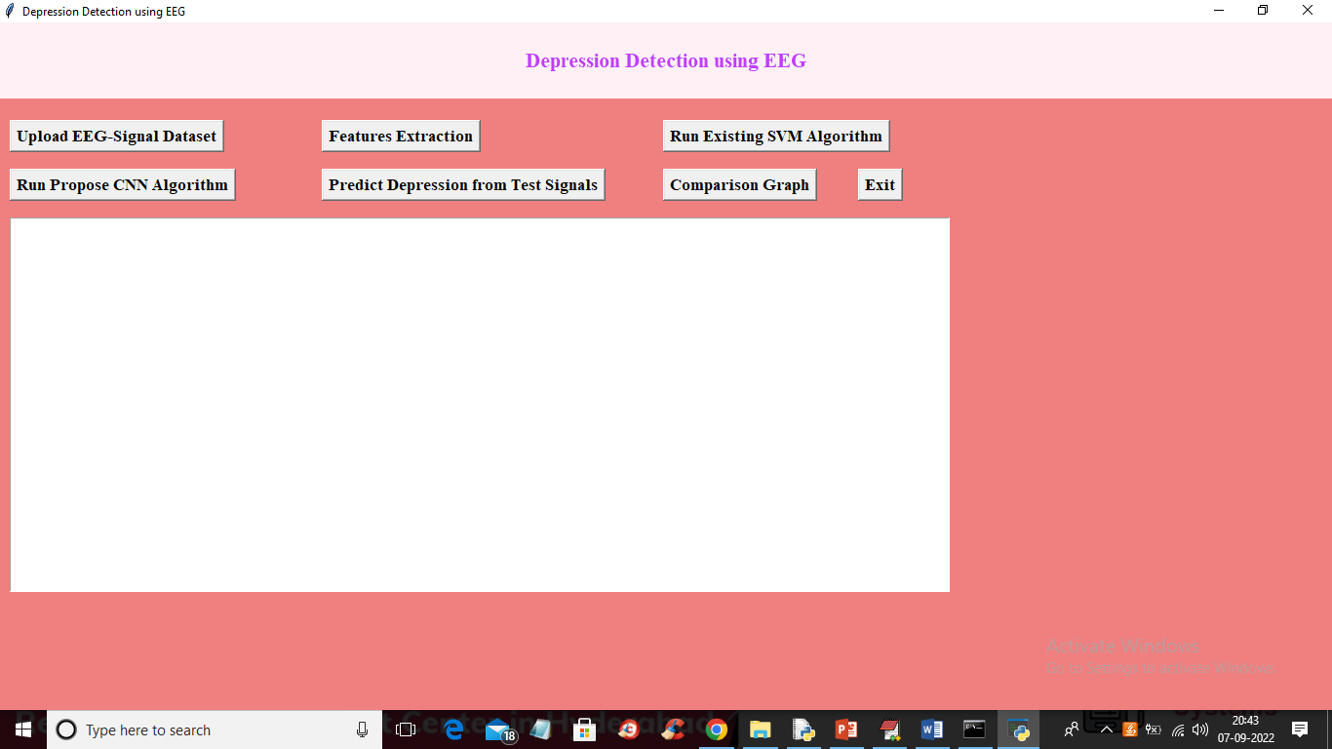

In above screen click on ‘Upload EEG-Signal Dataset’ button to upload dataset and get below output

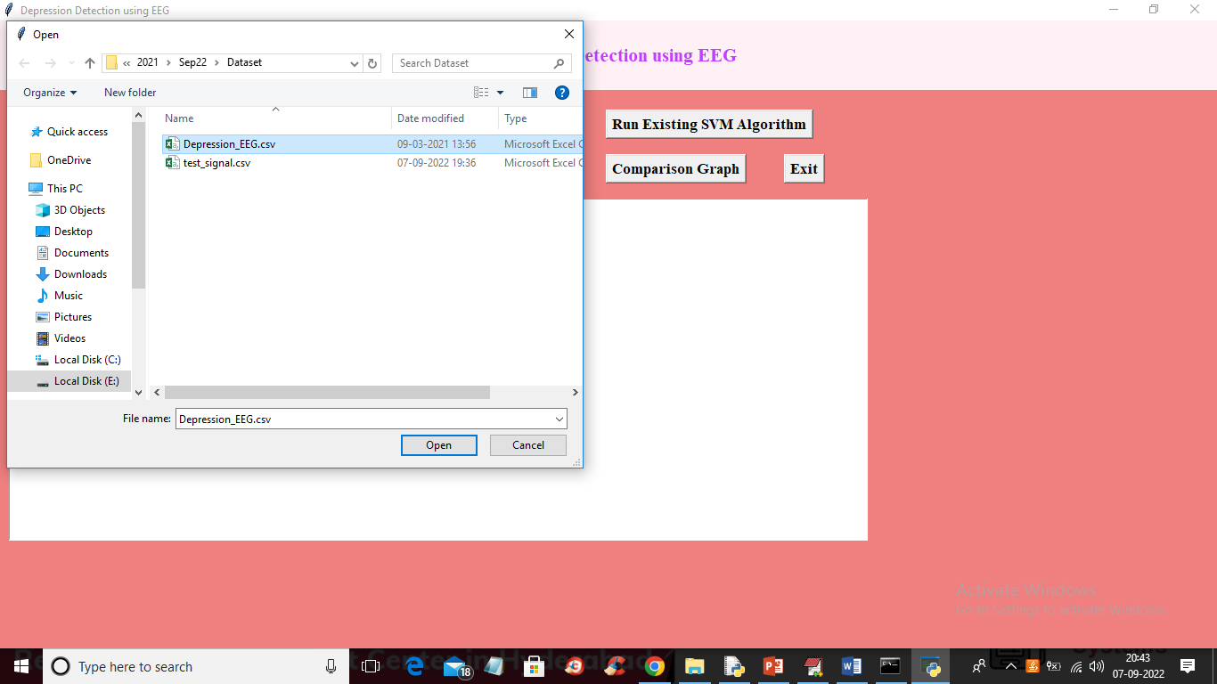

In above screen selecting and uploading EEG-Signal dataset and then click on ‘Open’ button to load dataset and get below output

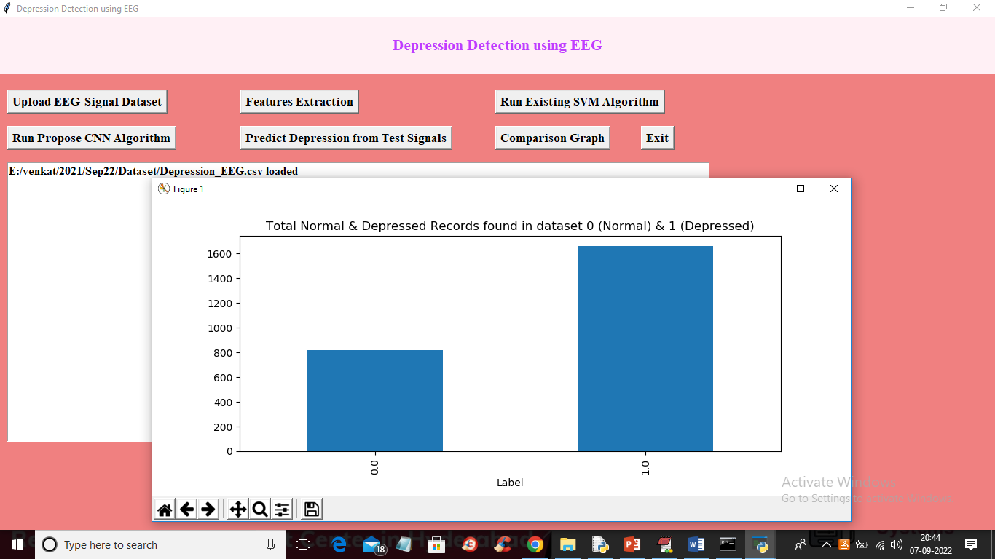

In above screen dataset loaded and in graph x-axis represents labels as 0 or 1 where 0 means Normal and 1 means Depressed and y-axis represents counts of records and now close above graph and then click on ‘Features Extraction’ button to extract features from the dataset and get below output

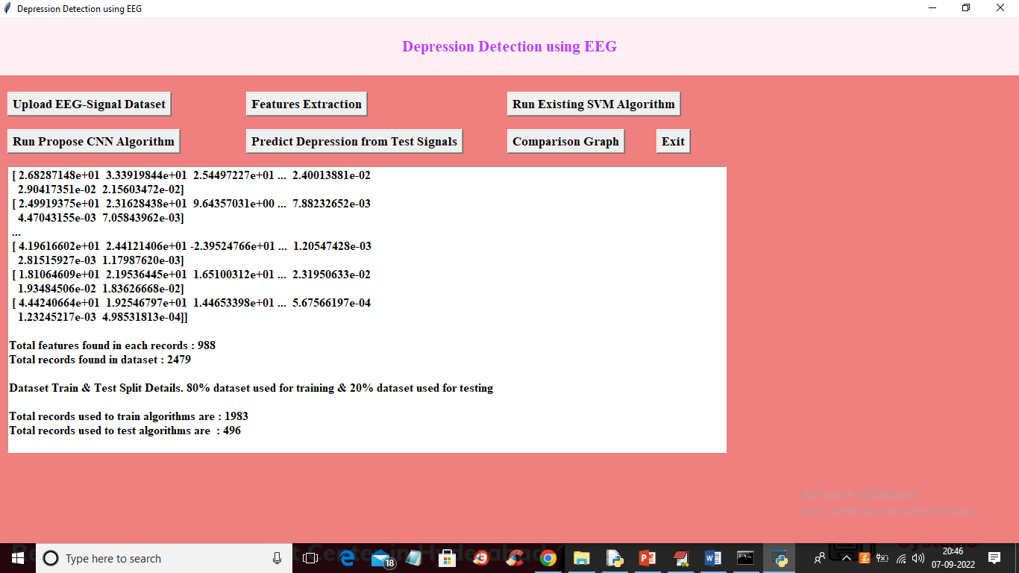

In above screen we can see extracted features and then each records contains 988 columns or features and dataset contains total records as 2479 and we can see train and test data details and now train and test data is ready for training. Now click on ‘Run Existing SVM Algorithm’ button to train SVM and get below output

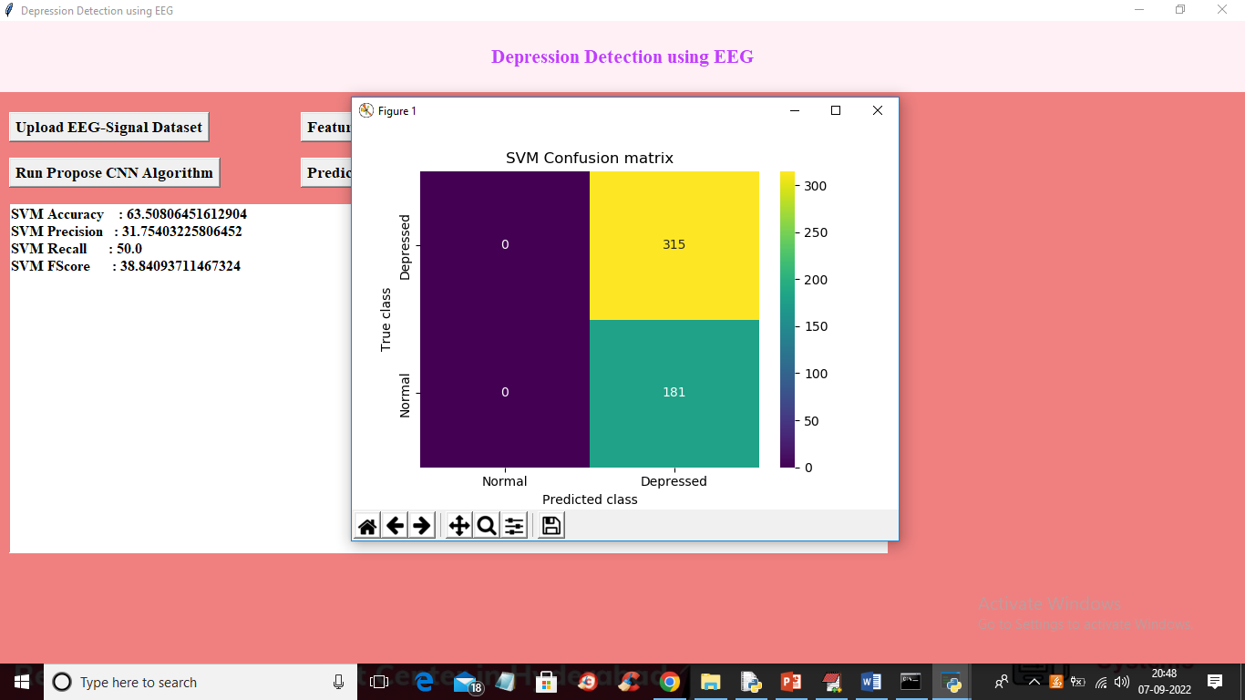

In above screen with SVM we got 63% accuracy and in confusion matrix graph x-axis represents Predicted classes and y-axis contains TRUE classes and we can see SVM predicted all records as Depressed and its performance is not good and now close above graph and then click on ‘Run Propose CNN Algorithm’ button to train CNN and get below output

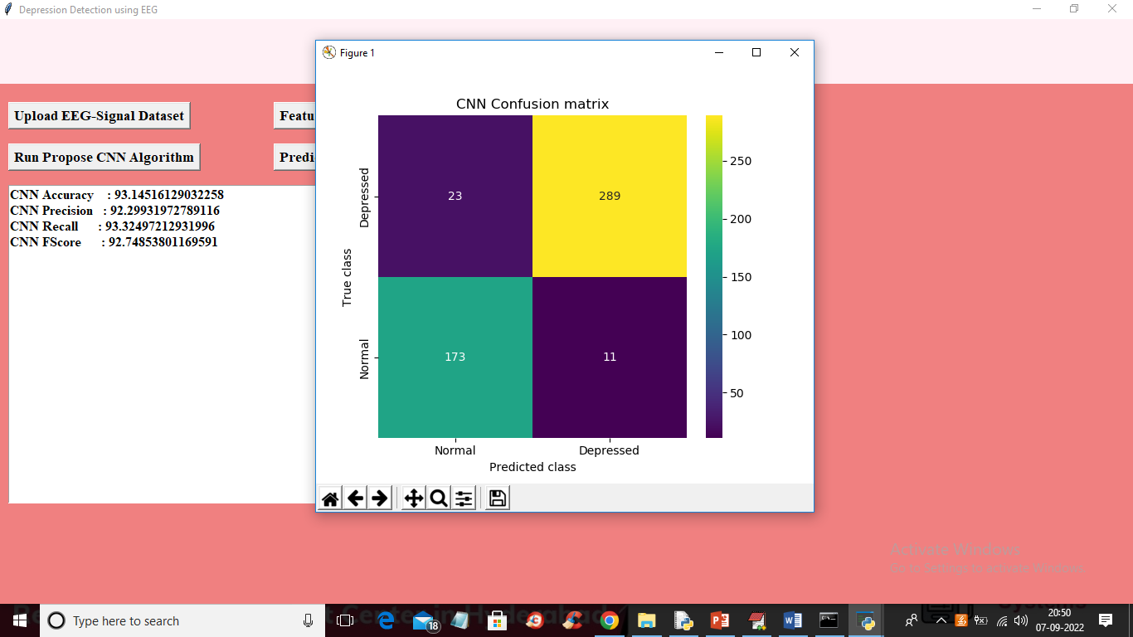

In above screen with CNN we got 93% accuracy and in confusion matrix graph different colour boxes represents CORRECT prediction count and same colour boxes represents INCORRECT prediction count and CNN predicted only 23 and 11 as wrong prediction and 173 and 289 as correct prediction. Now close above graph and then click on ‘Predict Depression from Test Signals’ button to upload test data and get prediction output

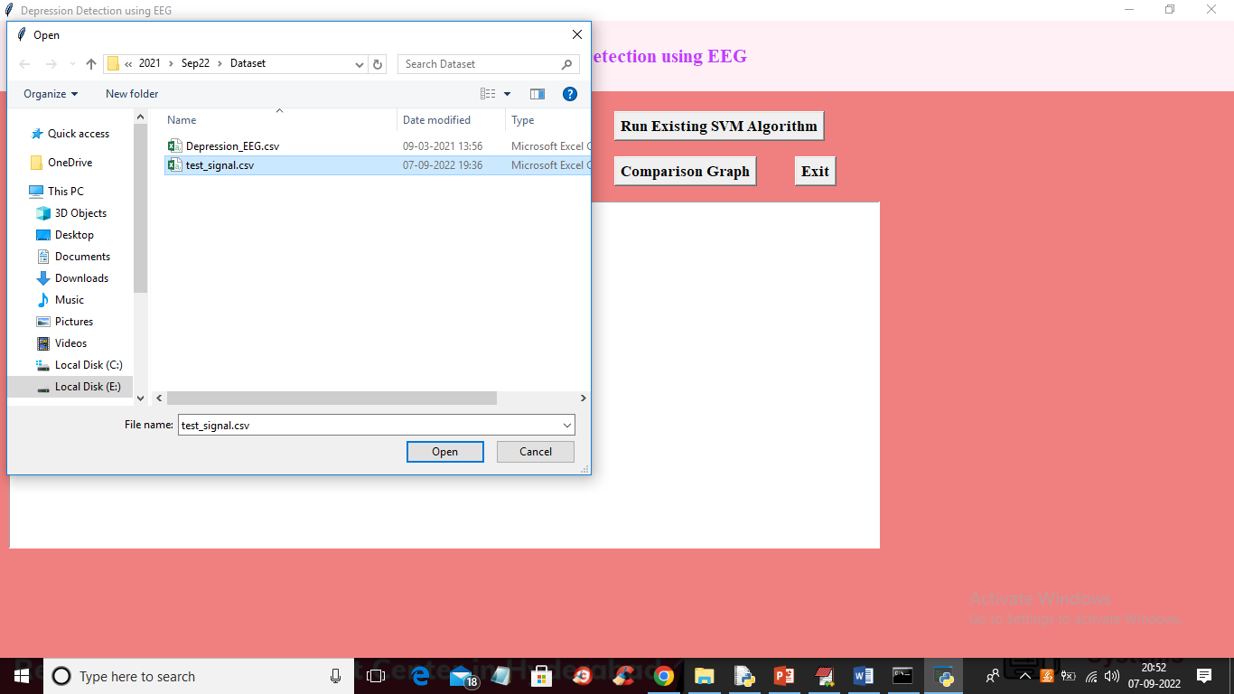

In above screen selecting and uploading ‘test_signal.csv’ file and then press Open button to load test data and get below prediction output

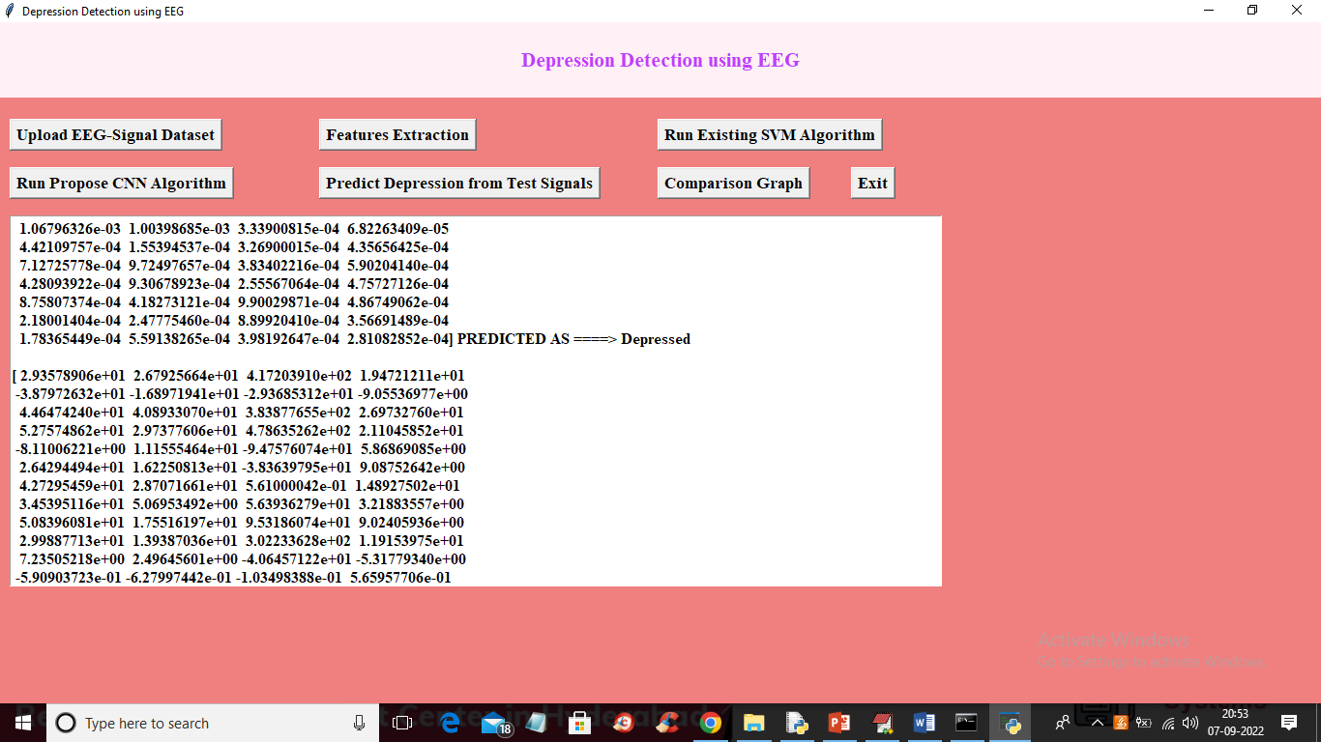

In above screen in square bracket we can see TEST data values and after =🡺 symbol we can see prediction as Depressed or Normal and you can scroll above output screen to view all prediction output like below screen

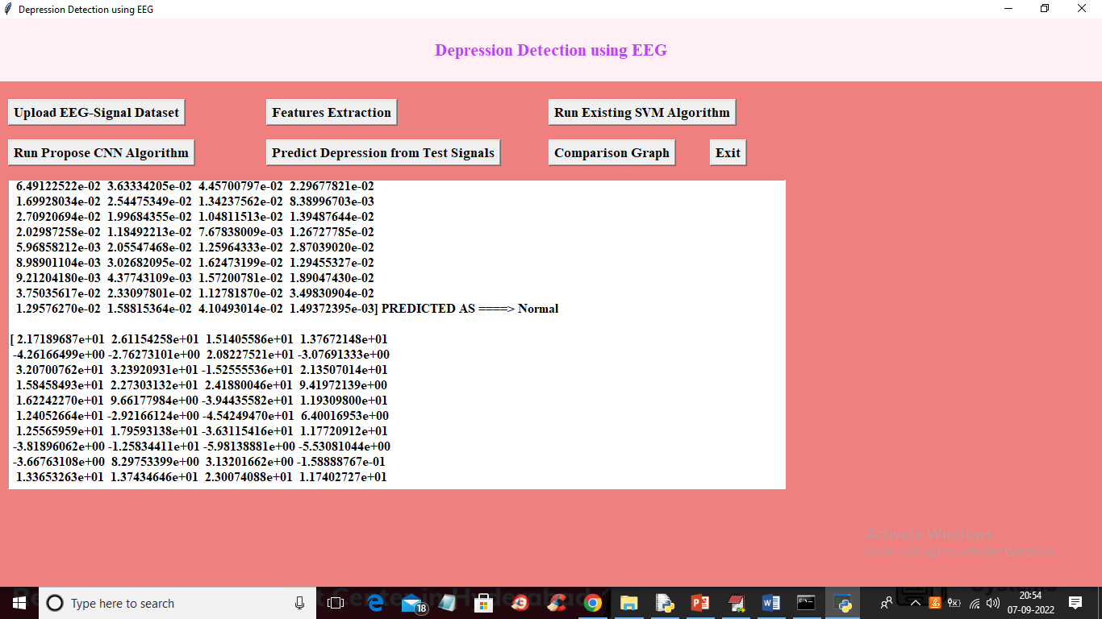

Now click on ‘Comparison Graph’ button to get below graph

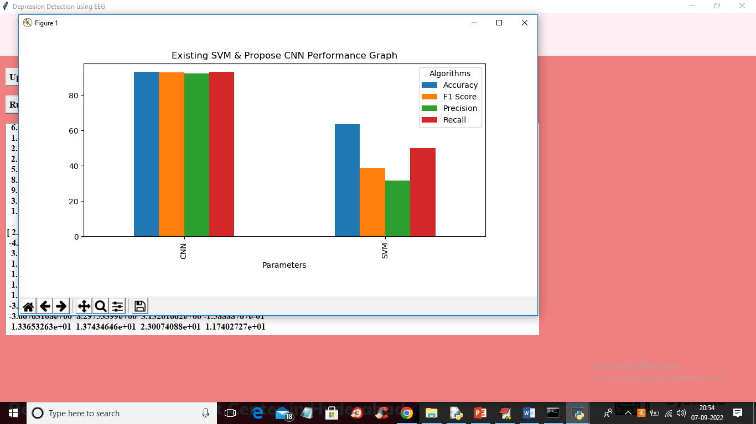

In above graph x-axis represents algorithm names and y-axis represents accuracy, precision, recall and FSCORE in different colour bars and in above graph we can see CNN got high values compare to SVM