Assignment-1

Data structures and algorithm

Name: Yallaling m Kurubagatti

Roll_No: 230

USN: 01FE20BEC078

Programms:

1)

Read an array of numbers with size n and count frequency of positive/negative numbers

#include <stdio.h>

#include <stdlib.h>

void read_array(int [] , int );

void disp_array(int [] , int );

void p_freq(int [] , int );

void n_freq(int [] , int );

int main()

{

int arr[100];

int n;

printf("Enter the array size: \n ");

scanf("%d",&n);

read_array(arr,n);

disp_array(arr,n);

p_freq(arr,n);

n_freq(arr,n);

return 0;

}

void read_array(int a[] , int b )

{

int i;

printf("\n Enter %d Array elements : \n",b);

for(i=0;i<b;i++)

{

scanf("%d",&a[i]);

}

}

void disp_array(int a[] , int b)

{

int i;

printf("\n Displaying %d Array elements : \n",b);

for(i=0;i<b;i++)

{

printf("%d \t",a[i]);

}

}

void n_freq(int a[] , int b)

{

int i,neg;

neg=0;

for(i=0;i<b;i++){

if(a[i]<0)

{

neg++;

}

}

printf("\n Negative number count : %d ",neg);

}

void p_freq(int a[] , int b)

{

int i,pos;

pos=0;

for(i=0;i<b;i++){

if(a[i]>0)

{

pos++;

}

}

printf("\n Positive number count : %d ",pos);

}

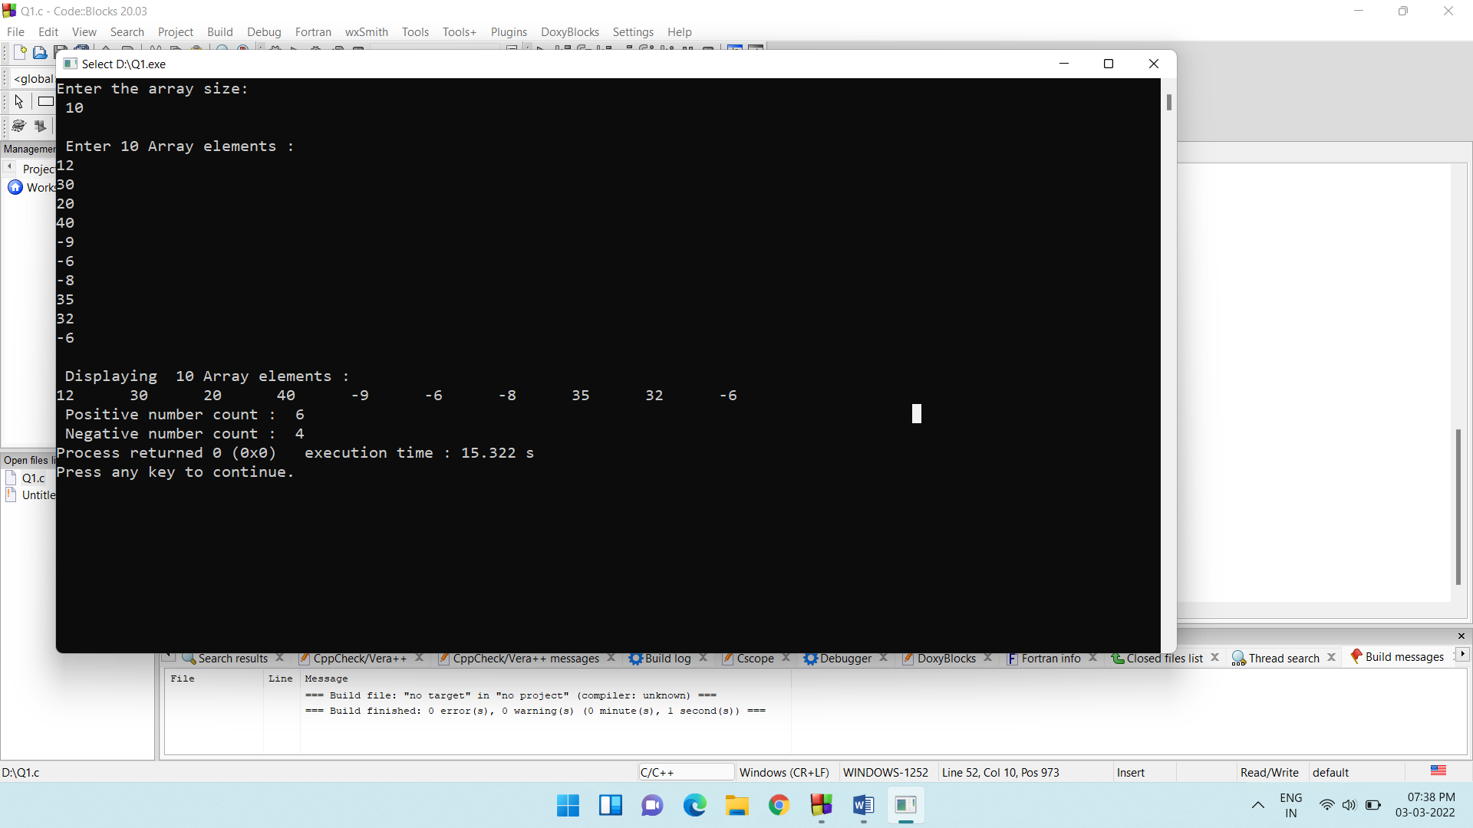

2)

Read an array of n numbers. Input the number from keyboard (consider it as a key number) and check whether the key number is present in the array or not, also display the index at which the key number is present.

#include <stdio.h>

#include <stdlib.h>

void read_array(int [], int);

void print_array(int [], int);

void find_key(int [] , int);

int main()

{

int arr[100];

int n;

printf("Enter the size of the array : ");

scanf("%d",&n);

read_array(arr,n);

find_key(arr,n);

return 0;

}

void read_array(int a[], int b)

{

int i;

printf("Enter %d Array elements : \n",b);

for(i=0;i<b;i++)

{

scanf("%d",&a[i]);

}

}

void print_array(int a[], int b)

{

int i;

for(i=0;i<b;i++)

{

printf("%d\t",a[i]);

}

}

void find_key(int a[] , int b)

{

int i,j,key;

j=0;

printf("\nEnter the key number : ");

scanf("%d",&key);

for(i=0;i<b;i++)

{

if(a[i]==key)

{

j=i+1;

printf("\n The key number is present in the given array and is present in the %d position \n",j);

}

}

print_array(a,b);

}

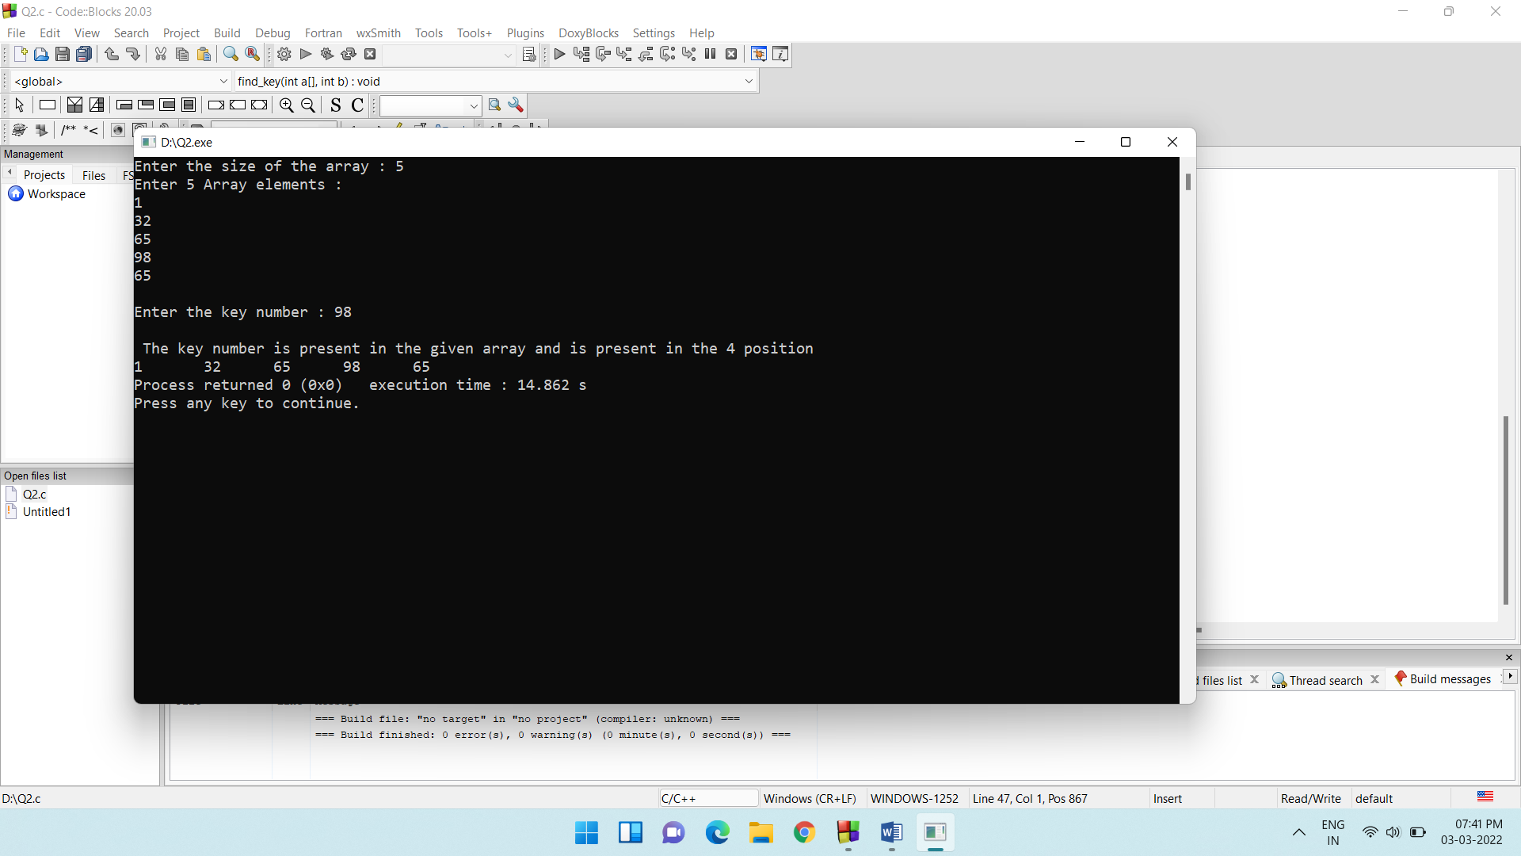

3)

There is a company NI Infotech which has N number of employees working in it. NI Infotech gives bonus to its employees according to the following terms and conditions.

|  |  |  |  |
| --- | --- | --- | --- |
| **S.No** | **Experience (years)** | **Basic Salary** | **Bonus applicable** |
| 1 | 5-7 | 10600 | 10% of basic |
| 2 | 8-10 | 21300 | 20% of basic |
| 3 | 10> | 32100 | 30% of basic |

calculate the bonus for N employees and display the salary of N employees after getting bonus.

#include <stdio.h>

#include <stdlib.h>

struct employee

{

int basic;

int experience;

float salary;

}employee[50];

void read_employee(struct employee[] ,int);

void calculate_salary(struct employee[] , int);

int main()

{

int n;

printf("Enter the total number of employees : \n");

scanf("%d",&n);

read_employee(employee,n);

return 0;

}

void read_employee(struct employee employee[50],int b)

{

int i=1;

int j = b;

printf("\n Enter %d employee details : \n ",j);

while(j!=0)

{

printf("\n Enter experience of employee %d : ",i);

scanf("%d",&employee->experience);

j--;

i++;

}

calculate_salary(employee,b);

}

void calculate_salary(struct employee employee[50], int b)

{

if(employee -> experience >= 5 || employee -> experience <= 7)

{

employee->basic = 10600;

employee->salary = employee->basic + (employee->basic * 0.10f);

printf("\n\n Basic : %d\n Salary after adding Bonus: %.2f \n",employee->basic,employee->salary);

}

if(employee -> experience>=8 || employee->experience<=10)

{

employee->basic = 21300;

employee->salary = employee->basic + (employee->basic * 0.20f);

printf("\n\n Basic : %d\n Salary after adding Bonus: %.2f \n",employee->basic,employee->salary);

}

if(employee->experience>10)

{

employee->basic = 32100;

employee->salary = employee->basic + (employee->basic * 0.30f);

printf("\n\n Basic : %d\n Salary after adding Bonus: %.2f \n",employee->basic,employee->salary);

}

}

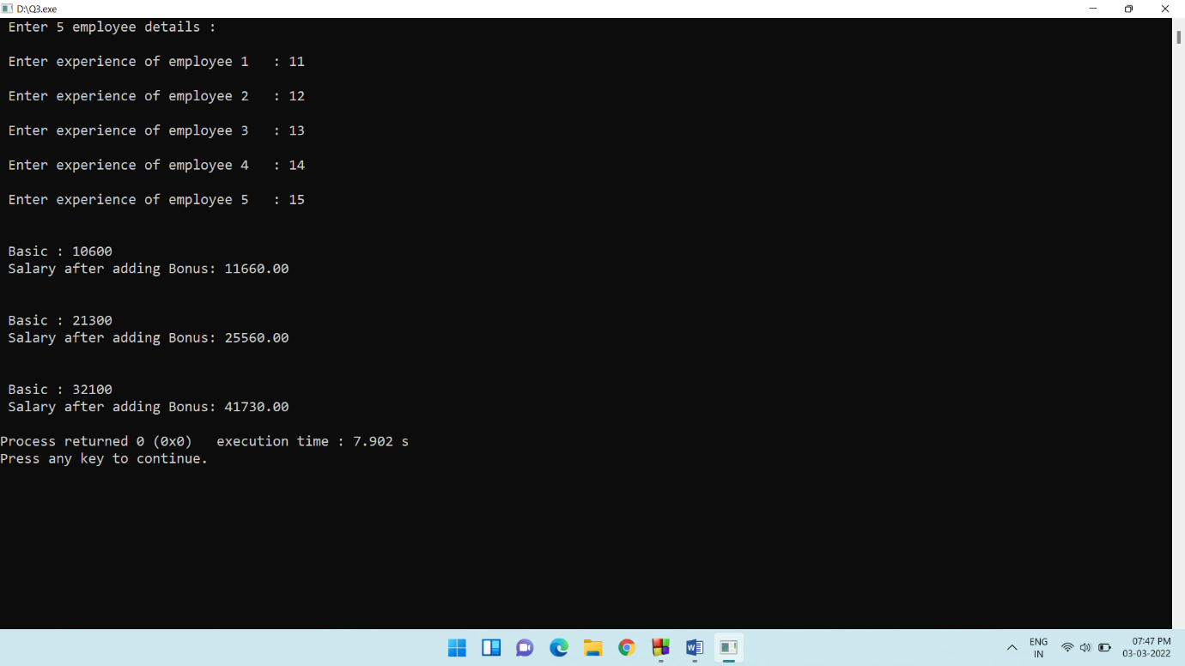

4)

In a class there are 10 students. Course teacher of “DS with Applications ” wants to calculate the class average and also count total number of students who scored above and below class average. Most of the students IQ is very high. Help course teacher to solve the above problem.

#include <stdio.h>

#include <stdlib.h>

struct student

{

int sno;

int marks;

}st[10];

void read_student(struct student[] ,int);

void find_average(struct student[] ,int );

void find_below_av(struct student[] ,int , float );

void find_above_av(struct student[] ,int, float );

int main()

{

int n =10;

read_student(st, n);

find_average(st,n);

return 0;

}

void read_student(struct student st[],int b){

int i;

int max_marks = 0;

printf("\n Enter the maximium marks to be obtained : ");

scanf("%d",&max_marks);

for(i=0;i<b;i++)

{

st[i].sno = i + 1;

printf("Enter the marks of student %d : ",i+1);

scanf("%d",&st[i].marks);

}

}

void find_average(struct student st[], int b)

{

int sum = 0;

float average = 0 ;

int i;

for(i=0;i<b;i++)

{

sum = sum + st[i].marks;

}

average = (float)(sum / b);

printf("\nThe class average is %f",average);

find_above_av(st,b,average);

find_below_av(st,b,average);

}

void find_below_av(struct student st[] ,int b, float av)

{

int i ;

printf("Students scored below average : ");

for(i = 0; i<b ; i++)

{

if(st[i].marks < av)

{

printf("\n Student number : %d \n Marks obtained : %d \n",st[i].sno,st[i].marks);

}

}

}

void find_above_av(struct student st[] ,int b, float av)

{

int i ;

printf("\n \n Students scored above average : ");

for(i = 0;i<b;i++)

{

if(st[i].marks > av)

{

printf("\n Student number : %d \n Marks obtained : %d \n",st[i].sno,st[i].marks);

}

}

}

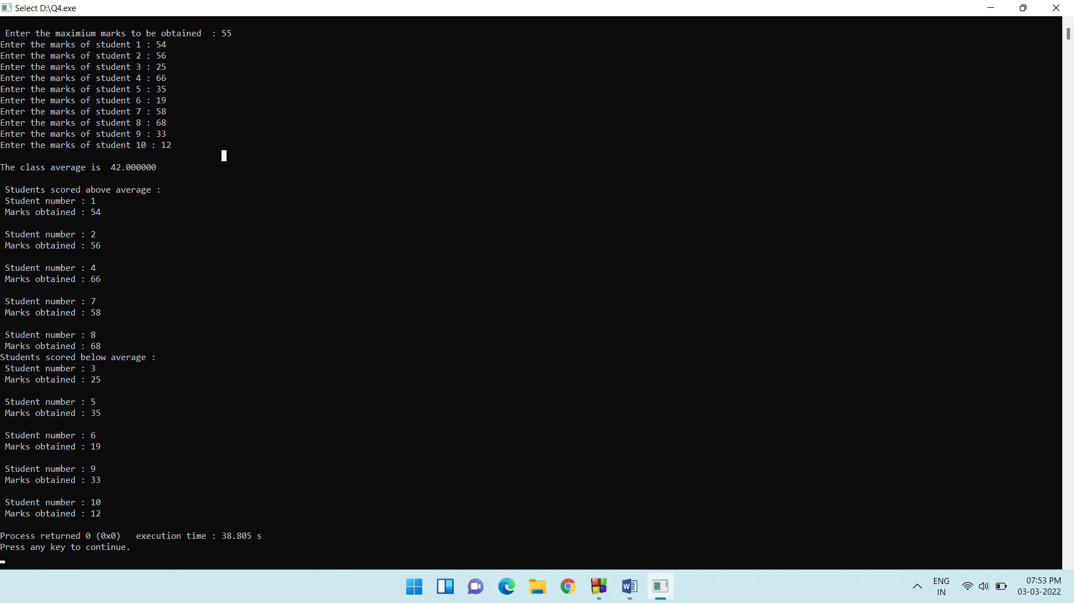

5)

KLE Technological University is a well know university for its academic excellence and Innovations. It provides a well structured LIBRARY facility for its students. Students can avail book facility of the LIBRARY. A student can take a book for a period of maximum of 15 days. If returned after the deadline, a student has to pay penalty of Rs 2.0/day.

In the month of January 2021, there are N students who returned the book late. For each student, read the number of days after the deadline, he/she is returning the book. calculate the followings.

1. Calculate the average penalty collected.
2. Calculate the Maximum penalty paid by a student.
3. Calculate the minimum penalty paid by a student.
4. Calculate the total penalty collected.

#include <stdio.h>

#include <stdlib.h>

struct book_return

{

int sno;

int due_days;

int penalty;

}st[100];

void read_student_return(struct book_return st[],int b)

{

int i,j;

j = 1;

for(i=0;i<b;i++,j++)

{

printf("\n Enter number of due days of student %d\t",j);

scanf("%d",&st[i].due_days);

st[i].sno = j;

}

}

void calc_penalty(struct book_return st[], int b)

{

int i ;

for(i=0;i<b;i++)

{

st[i].penalty = st[i].due_days * 2 ;

printf("\n The penalty for student %d is : %d ",st[i].sno,st[i].penalty);

}

}

void find_average_penalty_and_sum(struct book_return st[], int b)

{

int sum = 0;

float average=0;

int i;

for(i=0;i<b;i++)

{

sum = sum + st[i].penalty ;

}

average = (float)sum/b;

printf("\n The total penalty collected was : %d ",sum);

printf("\n The average penalty collected is %0.2f",average);

}

void find_largest_penalty(struct book_return st[], int b)

{

int largest;

int i,snumb;

largest = st[0].penalty;

for(i=0;i<b;i++)

{

if(st[i].penalty > largest)

{

largest = st[i].penalty;

snumb = st[i].sno;

}

}

printf("\nThe maximum penalty collected was %d rupees from student number %d ",largest ,snumb);

}

void find_lowest_penalty(struct book_return st[], int b)

{

int lowest;

int i,snum;

lowest = st[0].penalty;

for(i=0;i<b;i++)

{

if(st[i].penalty < lowest)

{

lowest = st[i].penalty;

snum = st[i].sno;

}

}

printf("\nThe minimum penalty collected was %d rupees from student number %d ",lowest ,snum);

}

int main()

{

int n;

printf("\nEnter the total numbers of students whose due date is to be entered : ");

scanf("%d",&n);

read_student_return(st,n);

calc_penalty(st,n);

find_average_penalty_and_sum(st,n);

find_largest_penalty(st,n);

find_lowest_penalty(st,n);

return 0;

}

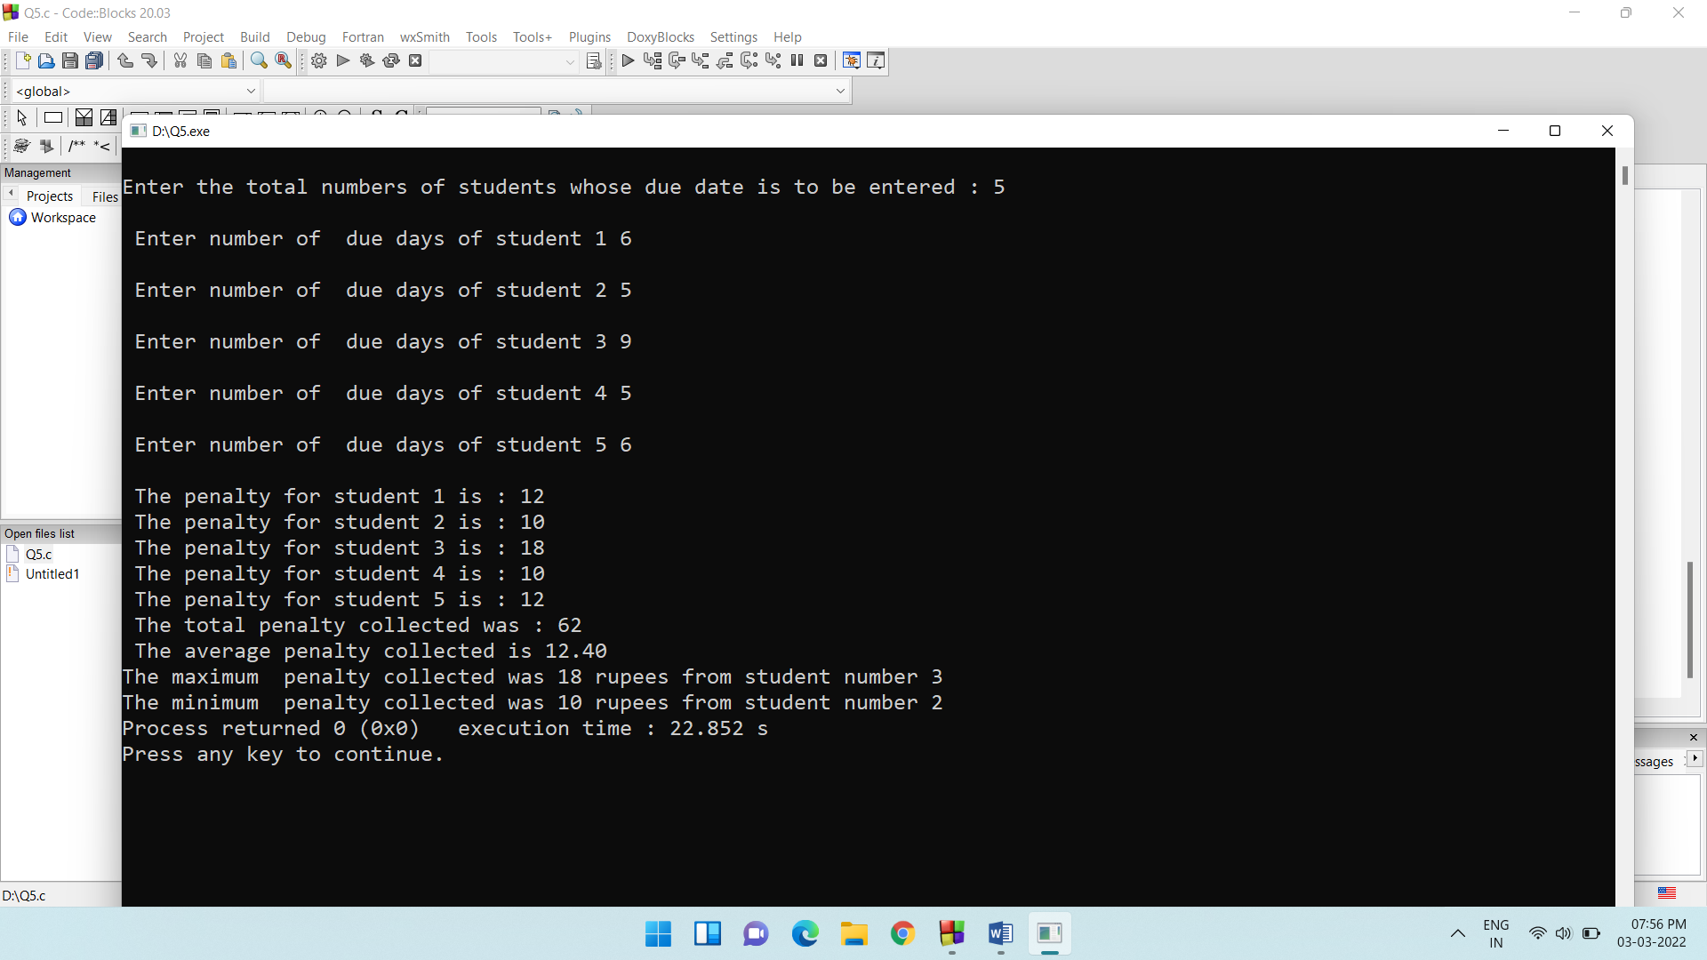

6)

KLE Technological University is a well know university for its academic excellence and Innovations. Top ranked students, always prefer the University for their Graduation in BE. Assume that for the year 2020-21 there are N students admitted to the university for the 1st year. Help University to do the followings.

1. Read the rankings of N students.
2. Arrange the rankings in ascending order.
3. Display the highest and lowest ranks of students.

#include <stdio.h>

#include <stdlib.h>

struct kle_tech

{

int ranks;

int sno;

}st[100];

void read_rankings(struct kle_tech [] , int);

void ascending_ranks(struct kle_tech [] ,int );

void display_highest_lowest(struct kle_tech[], int );

int main()

{

int n;

printf("\n Enter the total number of students whose rank is to be entered : \t ");

scanf("%d",&n);

read_rankings(st,n);

ascending_ranks(st,n);

display_highest_lowest(st,n);

return 0;

}

void read_rankings(struct kle_tech st[],int b)

{

int i,j;

for(i=0,j=1;i<b;i++,j++)

{

printf("\n Enter rank of student %d \t",j);

scanf("%d",&st[i].ranks);

st[i].sno = j;

}

}

void ascending_ranks(struct kle_tech st[] , int b)

{

int i,j;

int temp_ranks,temp_no;

for(i=0;i<b;i++)

{

for(j=i+1;j<b;j++)

{

if(st[i].ranks > st[j].ranks)

{

temp_ranks = st[i].ranks;

temp_no = st[i].sno;

st[i].ranks = st[j].ranks;

st[i].sno = st[j].sno;

st[j].ranks = temp_ranks;

st[j].sno = temp_no;

}

}

}

printf("\nThe ascending order of the ranks are : \n ");

for(i=0;i<b;i++)

{

printf("\n Rank number : %d \n Student number : %d \n",st[i].ranks,st[i].sno);

}

}

void display_highest_lowest(struct kle_tech st[],int b)

{

int i;

int lowest, highest;

int lno,hno;

highest = lowest = st[0].ranks;

hno = lno = st[0].sno;

for(i=0;i<b;i++)

{

if(st[i].ranks > lowest)

{

lowest = st[i].ranks;

lno = st[i].sno;

}

if(st[i].ranks < highest )

{

highest = st[i].ranks;

hno = st[i].sno;

}

}

printf("\n Highest rank = %d \t \t Student number : %d \n",highest,hno);

printf("\n Lowest rank = %d \t \t Student number : %d \n",lowest,lno);

}

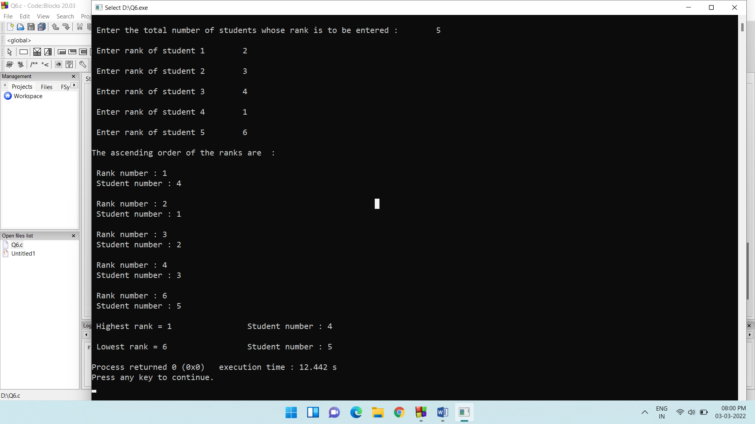

7)

Income tax department will collect the tax from the tax payers all around the Nation. For the financial year 2019-20, assume that the Income tax department has collected the tax from N number of tax payers. Help the Income tax department to do the followings.



1. Calculate the total number of tax payers who paid tax more than 2.5lakhs.
2. Calculate the total number of tax payers who paid tax between 50000 rupees to 150000rupees.
3. Calculated the average tax collected.

#include <stdio.h>

#include <stdlib.h>

struct tax_pay

{

int tno;

int tax;

}tp[100];

void read_tax_payer(struct tax_pay[],int );

void calc_above_twopointfive(struct tax_pay[],int);

void calc_betw_fifty_onefifty(struct tax_pay[],int);

void calc_average_tax(struct tax_pay [] ,int );

int main()

{

int n;

printf("\n Enter the total number of taxpayers : ");

scanf("%d",&n);

read_tax_payer(tp,n);

calc_above_twopointfive(tp,n);

calc_betw_fifty_onefifty(tp,n);

calc_average_tax(tp,n);

return 0;

}

void read_tax_payer(struct tax_pay tp[],int b)

{

int i,j;

for(i=0,j=1;i<b;i++,j++)

{

printf("\nEnter the tax amt of taxpayer %d : \n",j);

scanf("%d",&tp[i].tax);

tp[i].tno = j;

}

}

void calc_above_twopointfive(struct tax_pay tp[],int b)

{

int i,tp_25,count;

count = 0;

printf("\n Tax payers paying above 250000 are : \n \n");

for(i=0;i<b;i++)

{

if(tp[i].tax > 250000)

{

tp_25 = tp[i].tno;

printf("\n Taxpayer number : %d \n",tp_25);

count++;

}

}

printf("\n Total people paying tax above 250000 are : %d \n ",count);

}

void calc_betw_fifty_onefifty(struct tax_pay tp[],int b)

{

int i,tp_25,counts;

counts = 0;

printf("\n Tax payers paying between 50000 and 150000 are : \n \n");

for(i=0;i<b;i++)

{

if(tp[i].tax > 50000 && tp[i].tax < 150000)

{

tp_25 = tp[i].tno;

printf("\n Taxpayer number : %d \n",tp_25);

counts++;

}

}

printf("\n Total people paying tax between 50000 and 150000 are : %d \n ",counts);

}

void calc_average_tax(struct tax_pay tp[],int b)

{

int i;

int sum = 0;

float average= 0.0;

for(i=0;i<b;i++)

{

sum = sum + tp[i].tax;

}

average = (float)sum/b;

printf("\n The total tax collected was : %d ",sum);

printf("\n The average tax collected was : %0.2f ",average);

}

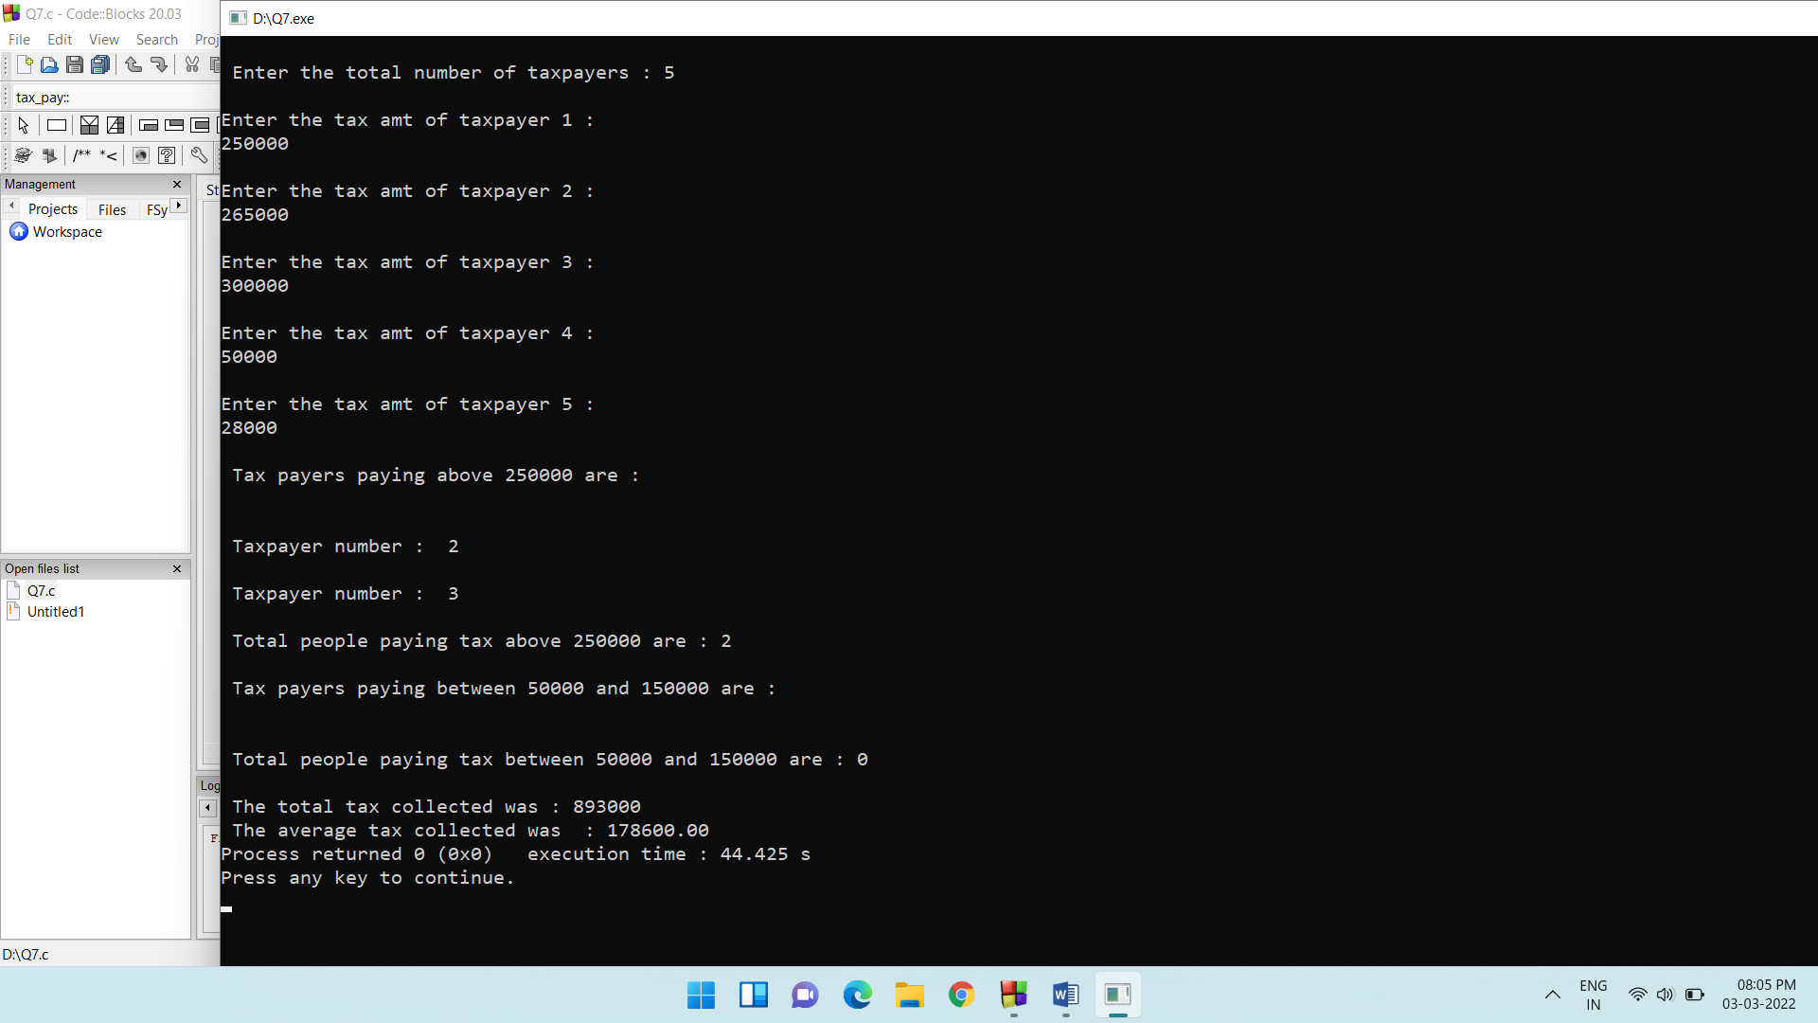

8)

A middle class family would always like to spend the money wisely, because of their financial status. They can’t afford to purchase the luxurious items unlike the Rich Class family. Even if they do, they do it very occasionally. In order to keep track of the expenditure of the entire year, the middle class family maintains a record of how much they spent every month of that year.

Assume that for the year 2020, the family maintains a record of expenditure for each month. At the end of the year, the family would like to know followings about their expenditure.

1. Which month of the year they spent more (display month number)
2. Which month of the year they spent less(display month number)
3. Which are the months they spent more than 35000 rupees?(display month number)
4. Calculate the average expenditure of the family for the year.

#include <stdio.h>

#include <stdlib.h>

struct expend

{

int months;

int expenditure;

}exp[12];

void read_expenditure(struct expend []);

void spent_more(struct expend []);

void spent_less(struct expend []);

void spent_ab_35(struct expend []);

void average_expenditure(struct expend []);

int main()

{

int n;

read_expenditure(exp);

spent_more(exp);

spent_less(exp);

spent_ab_35(exp);

average_expenditure(exp);

return 0;

}

void read_expenditure(struct expend exp[])

{

int i,j;

for(i=0,j=1;i<12;i++,j++)

{

printf("\nEnter the expenditure of month %d \t",j);

scanf("%d",&exp[i].expenditure);

exp[i].months = j;

}

}

void spent_more(struct expend exp[])

{

int i,mno;

int highest;

highest = exp[0].expenditure;

mno = 0;

for(i=0;i<12;i++)

{

if(exp[i].expenditure > highest)

{

highest = exp[i].expenditure;

mno = exp[i].months;

}

}

printf("\n The highest spent month was: %d \n The expenditure was : %d",mno,highest);

}

void spent_less(struct expend exp[])

{

int i,mno;

int lowest;

lowest = exp[0].expenditure;

mno = 0;

for(i=0;i<12;i++)

{

if(exp[i].expenditure < lowest)

{

lowest = exp[i].expenditure;

mno = exp[i].months;

}

}

printf("\n The lowest spent month was: %d \n The expenditure was : %d",mno,lowest);

}

void spent_ab_35(struct expend exp[])

{

int i,mno;

mno = 0;

printf("\n The months where the expenditure was above 35000 were : \n ");

for(i=0;i<12;i++)

{

if(exp[i].expenditure > 35000)

{

mno = exp[i].months;

printf("%d\t ",mno);

}

}

}

void average_expenditure(struct expend exp[])

{

int i,sum;

sum = 0;

float average = 0;

for(i=0;i<12;i++)

{

sum = sum + exp[i].expenditure;

}

average = (float)sum/12;

printf("\n The total expenditure was : %d ",sum);

printf("\n The average expenditure was : %0.2f ",average);

}

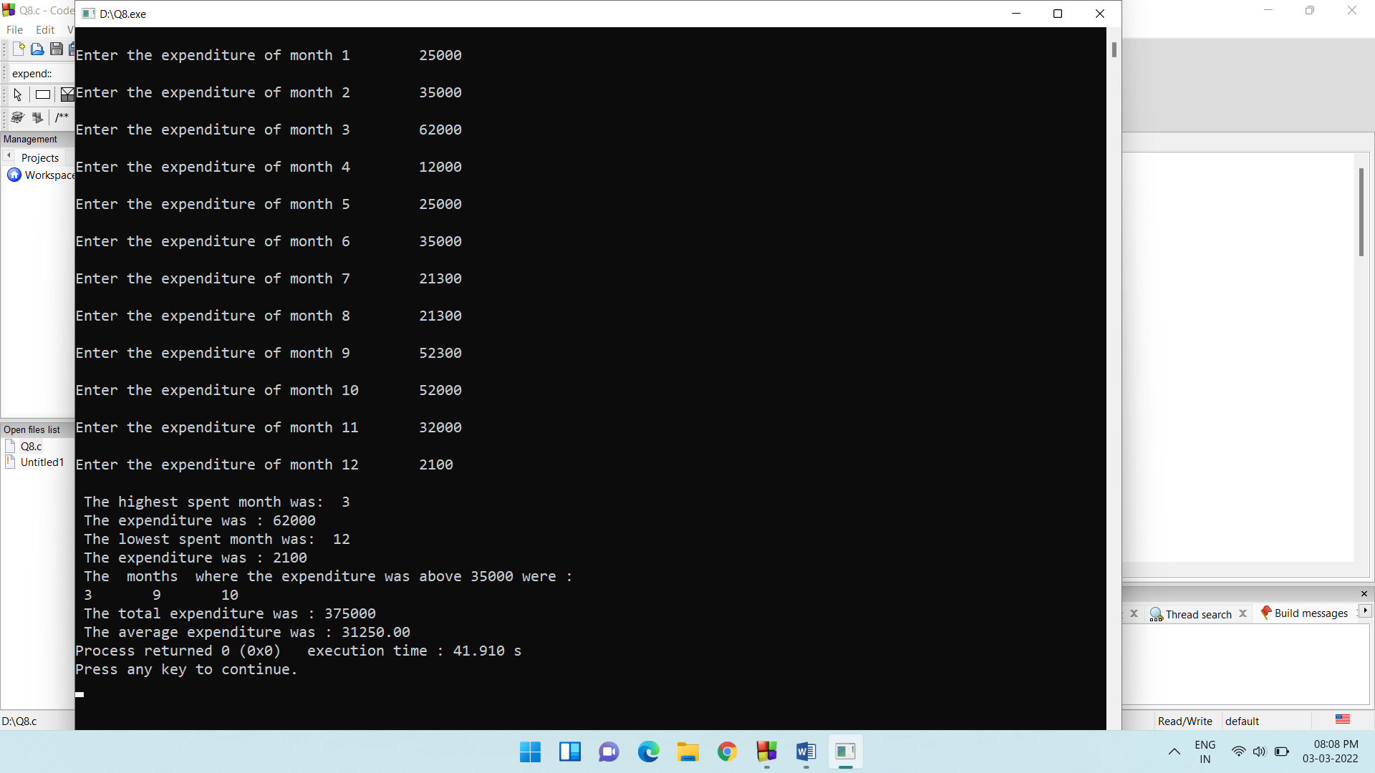

9)

C programming for problem solving is a course offered to first semester students of KLE Technological University. The course conducts POST TESTs to students for a maximum of 10 marks. Once all the POST TESTS are conducted, the marks scored by each student will be announced. Help the course teacher to do the followings.

1. How many students scored EVEN marks?
2. How many students scored ODD marks?
3. Find, if any student scored 100% marks? Display appropriate message.
4. How many students scored 100% marks?

#include <stdio.h>

#include <stdlib.h>

struct post_test

{

int sno;

int marks;

}pt[100];

void read_marks(struct post_test[],int );

void find_even(struct post_test[],int );

void find_odd(struct post_test[],int );

void find_cent(struct post_test[] , int);

int main()

{

int n;

printf("\n Enter the number of students : \t ");

scanf("%d",&n);

read_marks(pt,n);

find_even(pt,n);

find_odd(pt,n);

find_cent(pt,n);

return 0;

}

void read_marks(struct post_test pt[],int b)

{

int i,j;

for(i=0,j=1;i<b;i++,j++)

{

printf("\nEnter the marks of student %d : ",j);

scanf("%d",&pt[i].marks);

pt[i].sno = j;

}

}

void find_even(struct post_test pt[] ,int b)

{

int i;

int even;

printf("\nThe students scoring even marks are : \n ");

for(i=0;i<b;i++)

{

if(pt[i].marks % 2 == 0)

{

even = pt[i].sno;

printf("\n Student number : %d \t marks : %d ",even, pt[i].marks);

}

}

}

void find_odd(struct post_test pt[] ,int b)

{

int i;

int odd;

printf("\nThe students scoring odd marks are : \n");

for(i=0;i<b;i++)

{

if(pt[i].marks % 2 != 0)

{

odd = pt[i].sno;

printf("\n Student number : %d \t marks : %d ",odd, pt[i].marks);

}

}

}

void find_cent(struct post_test pt[],int b)

{

int i;

int count = 0;

printf("\nStudents scoring 100 percent are : \n");

for(i=0;i<b;i++)

{

if(pt[i].marks == 10)

{

printf("\n Student number : %d ",pt[i].sno);

count++;

}

}

printf("\n Congrats ! <3 \n");

printf("\n The total number of students who scored 100 percent is : %d ",count);

}

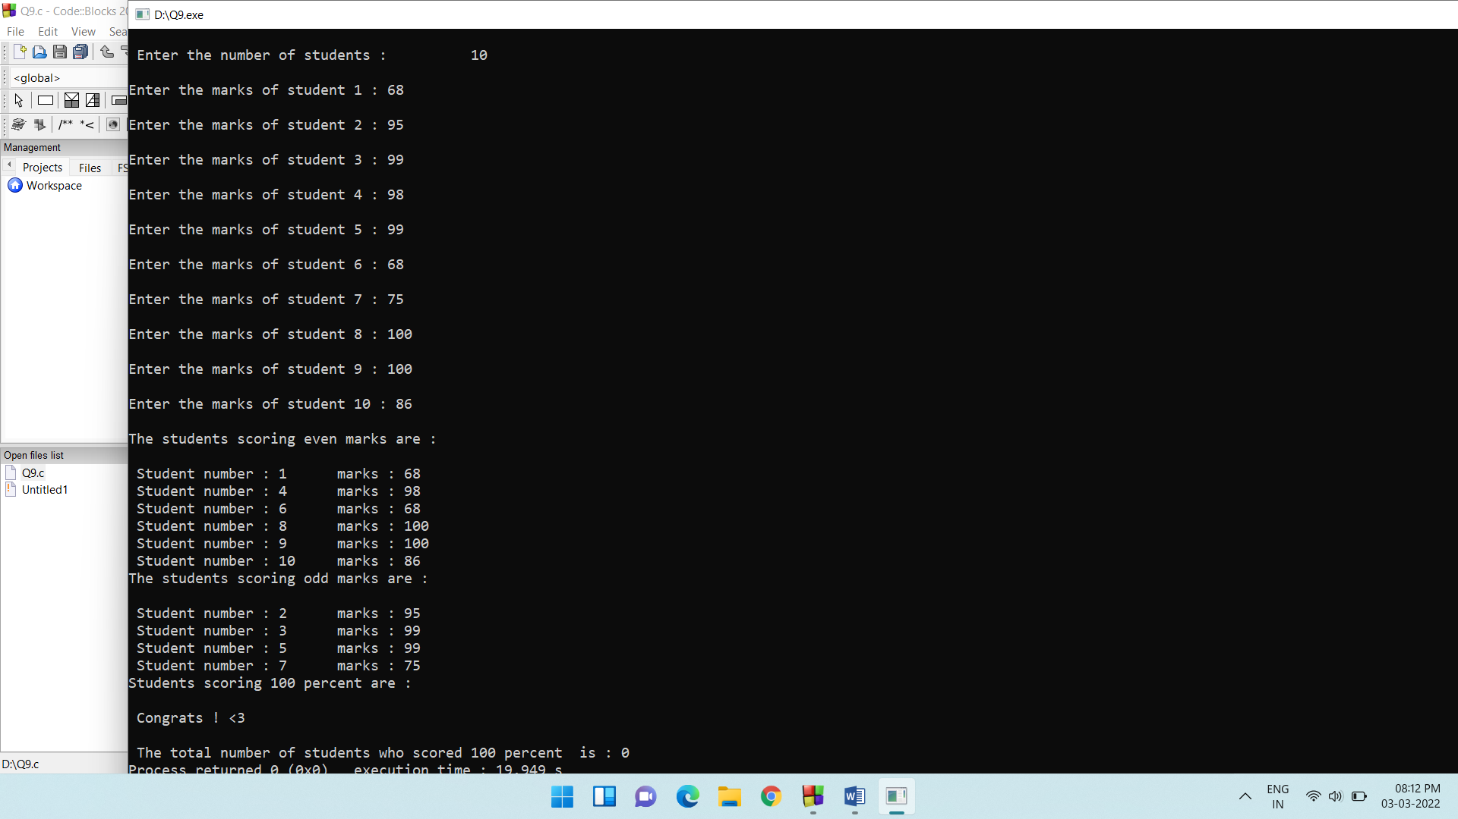

10)

Ashish is studying in 3RD standard in KENDRIYA VIDYALA, Hubballi. He is writing the Mathematics Test in the school.



One of the questions was to find the PRIME NUMBERS among a set of N numbers. Help Ashish to find the PRIME numbers.

#include <stdio.h>

#include <stdlib.h>

void find_prime(int [],int );

void read_num(int[] , int);

int main()

{

int ar[100];

int n;

printf("\n Enter number of elements : \n");

scanf("%d",&n);

read_num(ar,n);

find_prime(ar,n);

return 0;

}

void read_num(int a[],int b)

{

int i;

printf("\nEnter %d elements into the array : \n",b);

for(i=0;i<b;i++)

{

scanf("%d",&a[i]);

}

printf("\n Entered successfully ..\n");

}

void find_prime(int a[] ,int b)

{

int i,j,flag;

printf("\nThe prime numbers in the array are : \n ");

for(i=0;i<b;i++)

{

j = 2;

flag = 1;

while (j < a[i]) {

if (a[i] % j == 0) {

flag = 0;

break;

}

j++;

}

if (flag == 1) {

printf("%d \t", a[i]);

}

}

}

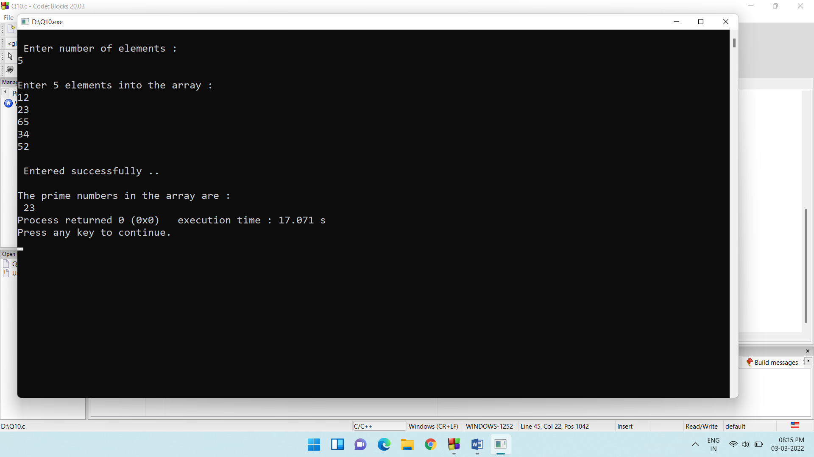

11)

Godrej constructed a new Apartment with N flats, in Hubballi. At the end of each month the Secretary of the apartment, collects the total units of electricity consumed by each flat. As per the table given below, help Secretary to calculate the total bill to be paid by each flat.

|  |  |
| --- | --- |
| Units Consumed | Charges apply |
| 0-100 | 1.5 Rs/Unit |
| 101-250 | 2.3 Rs/Unit, for above 100 units |
| 251-600 | 4.0 Rs/Unit, for above 250 units |
| Above 600 | 5.5 Rs/Unit, for above 600 units |
|  |  |

#include <stdio.h>

#include <stdlib.h>

struct apartment

{

int flatno;

int unit;

}ap[100];

void read_unit(struct apartment[],int );

void calc_bill(struct apartment[],int );

int main()

{

int n ;

printf("\nEnter the total number of flats in the apartment : \n");

scanf("%d",&n);

read_unit(ap,n);

calc_bill(ap,n);

return 0;

}

void read_unit(struct apartment ap[],int b)

{

int i,j;

for(i=0,j=1;i<b;i++,j++)

{

printf("\nEnter the units of flat %d ",j);

scanf("%d",&ap[i].unit);

ap[i].flatno = j;

}

}

void calc_bill(struct apartment ap[],int b)

{

int i;

float total_flat;

total_flat = 0;

for(i=0;i<b;i++)

{

if(ap[i].unit >=0 && ap[i].unit <= 100)

{

total_flat = ap[i].unit * 1.5;

printf("\n Flat number : %d\t Bill : %.2f",ap[i].flatno,total_flat);

}

if(ap[i].unit >=101 && ap[i].unit <= 250)

{

total_flat = ap[i].unit * 2.3;

printf("\n Flat number : %d\t Bill : %.2f",ap[i].flatno,total_flat);

}

if(ap[i].unit >=251 && ap[i].unit <= 600)

{

total_flat = ap[i].unit * 4.0;

printf("\n Flat number : %d\t Bill : %.2f",ap[i].flatno,total_flat);

}

if(ap[i].unit >600)

{

total_flat = ap[i].unit * 5.5;

printf("\n Flat number : %d\t Bill : %.2f",ap[i].flatno,total_flat);

}

}

}

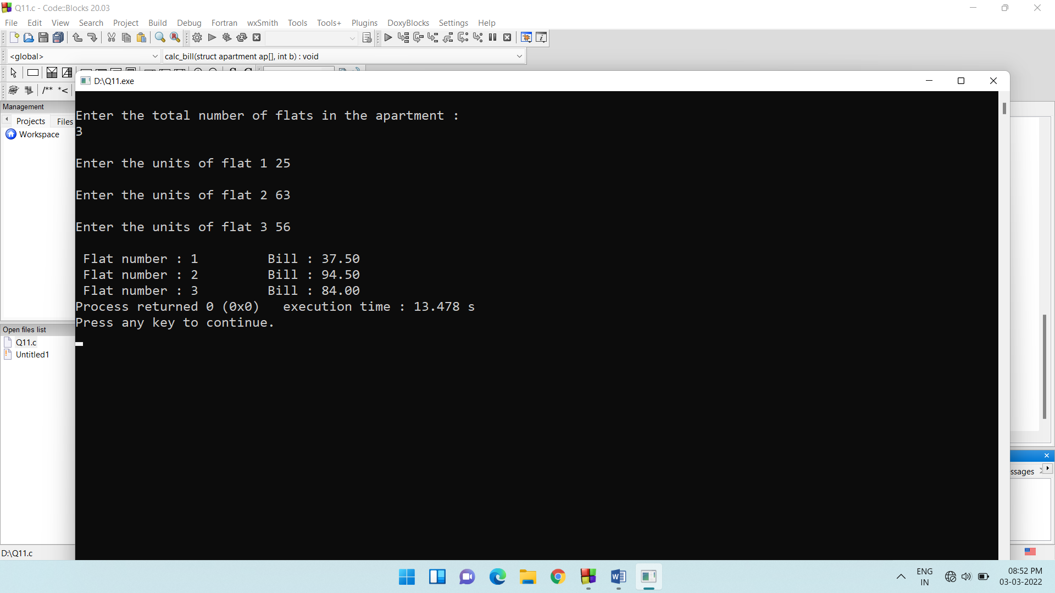

12)

Write a modular c program to perform the following:

 a) Read 1D array

b) Display 1D array

c) To find the maximum digit in every element of an array and find sum of all maximum digits.

Write a suitable main function to call the above user defined functions

**Example:**

Input: arr[3] = {132,458,732}

Output: Maximum digit in a[0]=3

Maximum digit in a[1]=8

Maximum digit in a[2]=7

Sum=3+8+7=18

#include <stdio.h>

#include <stdlib.h>

void read_array(int [],int );

void find_max_dig(int[],int);

void print_array(int [] ,int);

int main()

{

int a[100];

int n;

printf("\n Enter the size of array : ");

scanf("%d",&n);

read_array(a,n);

print_array(a,n);

find_max_dig(a,n);

return 0;

}

void read_array(int a[],int b)

{

int i;

printf("\nEnter %d array elements: \n ",b);

for(i=0;i<b;i++)

{

scanf("%d",&a[i]);

}

}

void print_array(int a[],int b)

{

int i;

printf("{");

for(i=0;i<b;i++)

{

printf(" %d \t ",a[i]);

}

printf("}");

}

void find_max_dig(int a[],int b)

{

int i,s;

int first,middle,last,sum,largest;

sum = 0;

for(i=0;i<b;i++)

{

first = a[i]/100;

s = a[i]%100;

last = s % 10;

middle = s/10;

if(first > middle && first > last)

largest = first;

if(middle > first && middle > last)

largest = middle;

if(last > first && last > middle)

largest = last;

printf("\n Maximum digit in a[%d] is %d ",i,largest);

sum = sum + largest;

}

printf("\nSum of largest is : %d ",sum);

}

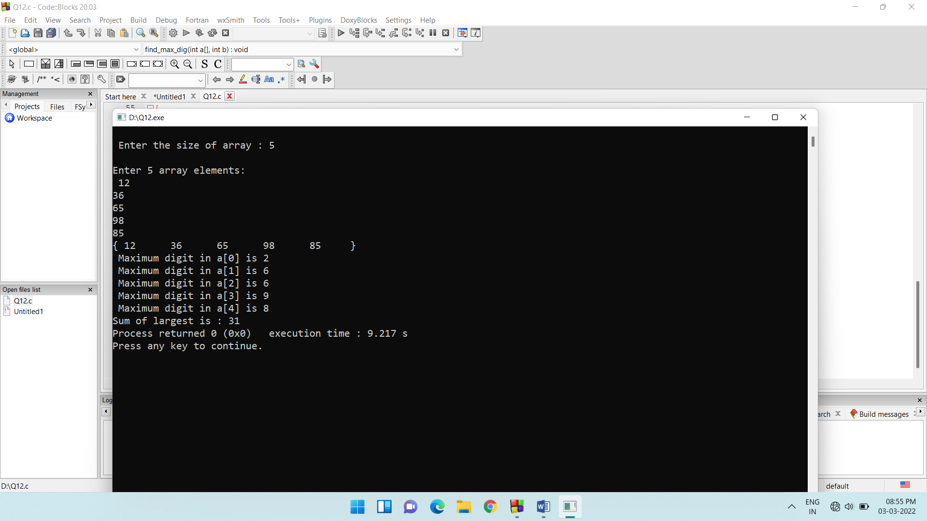

13)

Write a modular C program to read a list of n random numbers and check whether each element of an array is perfect number or not.

#include <stdio.h>

#include <stdlib.h>

void find_perfect(int [],int );

void read_array(int [],int );

int main()

{

int a[100];

int n;

printf("Enter the size of array : ");

scanf("%d",&n);

read_array(a,n);

find_perfect(a,n);

return 0;

}

void read_array(int a[],int b)

{

int i;

printf("\nEnter %d elements : \n",b);

for(i=0;i<b;i++)

{

scanf("%d",&a[i]);

}

}

void find_perfect(int a[],int b)

{

int i,j,temp;

for(i=0;i<b;i++)

{

int sum=0;

temp=a[i];

for(j=1;j<=(temp-1);j++)

{

if(temp%j==0)

{

sum=sum+j;

}

}

if(sum==temp)

{

printf("\n %d is perfect\n",temp);

}

else{

printf("\n %d is not perfect \n",temp);

}

}

}

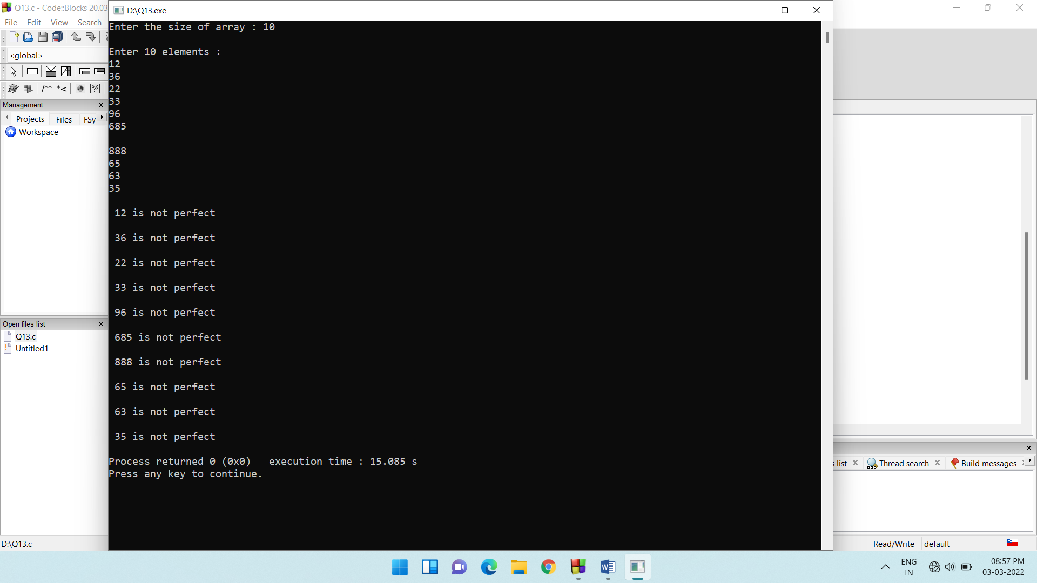

14)

Find equilibrium index in an array. An index is equilibrium, where sum of right side elements is equal to sum of left side elements.

Ex: A={-7,1,5,2,-4,3,0} Here '3' is equilibrium index since A[0]+A[1]+A[2] = A[4]+A[5]+A[6].

#include <stdio.h>

#include <stdlib.h>

int find_index(int [], int );

int main()

{

int a[100];

int n,eqi;

printf("\nEnter array size : ");

scanf("%d",&n);

printf("\nInput the array elements : ");

for(int i = 0; i < n; i++)

{

scanf("%d",&a[i]);

}

eqi = find_index(a,n);

printf("\nEquilibrium Index : %d\n", eqi);

return 0;

}

int find_index(int a[], int b)

{

int i, j;

int l_sum, r_sum;

for (i = 0; i < b; ++i)

{

l_sum = 0;

for (j = 0; j < i; j++)

l_sum += a[j];

r_sum = 0;

for (j = i + 1; j < b; j++)

r_sum += a[j];

if (l_sum == r_sum)

return i;

}

return -1;

}

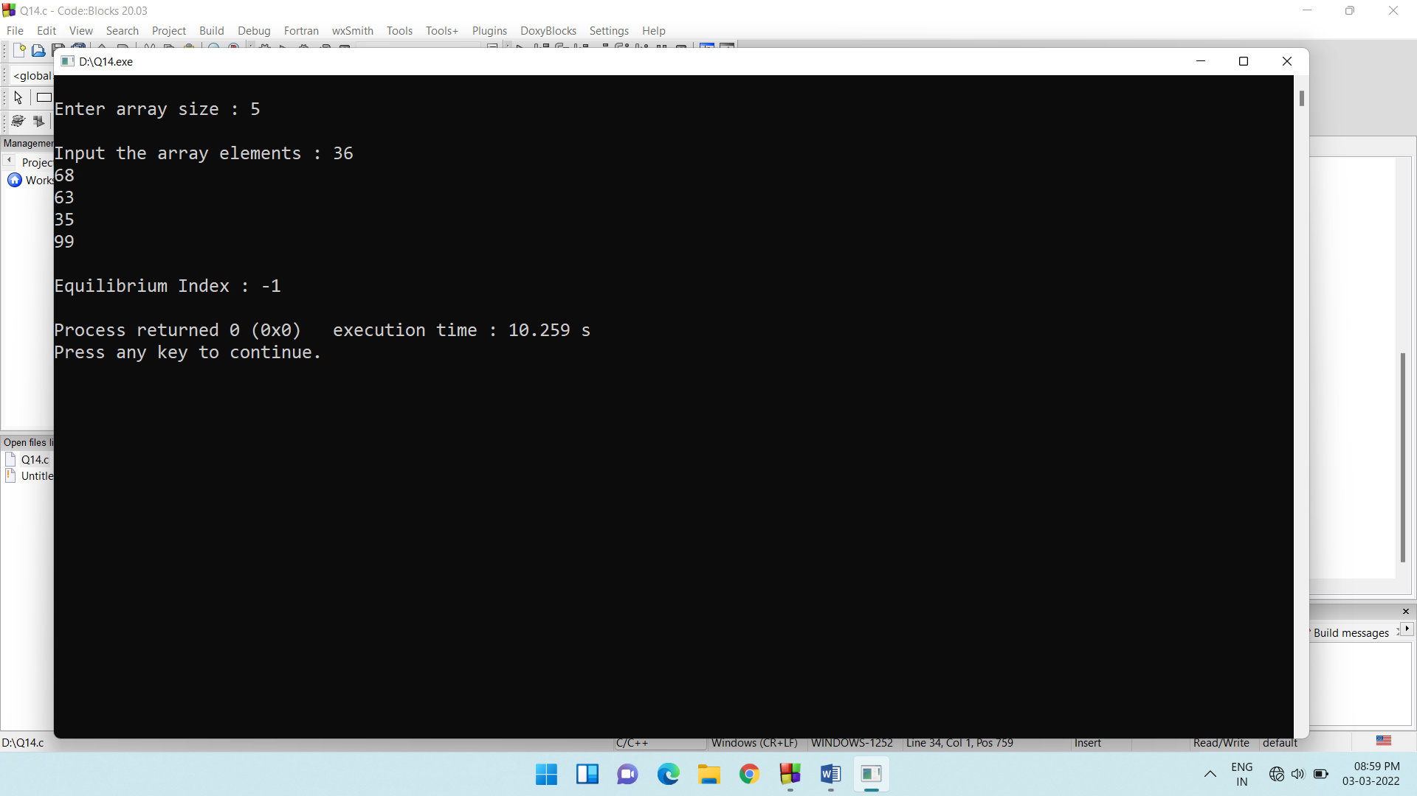

15)

Calculate the minimum number of platforms required for a railway station so that no train waits. Given arrival and departure of all trains (in 24Hr format) in separate arrays.

Ex: arr[] = {9.00, 9.40, 9.50, 11.00, 15.00, 18.00}

dep[] = {9:10, 12.00, 11.20, 11.30, 19.00, 20.00}

#include <stdio.h>

#include <stdlib.h>

void read_arr(int arr[],int n)

{

int i;

printf("\nEnter arrival times of train : \n");

for(i=0;i<n;i++)

{

scanf("%d",&arr[i]);

}

}

void read_dep(int dep[],int n)

{

int i;

printf("\nEnter departure times of train : \n");

for(i=0;i<n;i++)

{

scanf("%d",&dep[i]);

}

}

int findPlatform(int arr[], int dep[], int n)

{

int plat_needed = 1, result = 1;

int i = 1, j = 0;

for (int i = 0; i < n; i++) {

plat_needed = 1;

for (int j = i + 1; j < n; j++) {

if ((arr[i] >= arr[j] && arr[i] <= dep[j]) || (arr[j] >= arr[i] && arr[j] <= dep[i]))

plat_needed++;

}

if(plat_needed > result)

{

result = plat_needed;

}

}

return result;

}

int main()

{

int n;

printf("\nEnter total number of arrivals and departures of train : ");

scanf("%d",&n);

int p_req;

int arr[100], dep[100];

read_arr(arr,n);

read_dep(dep,n);

p_req = findPlatform(arr,dep,n);

printf("\nThe total number of platforms required are : %d",p_req);

return 0;

}

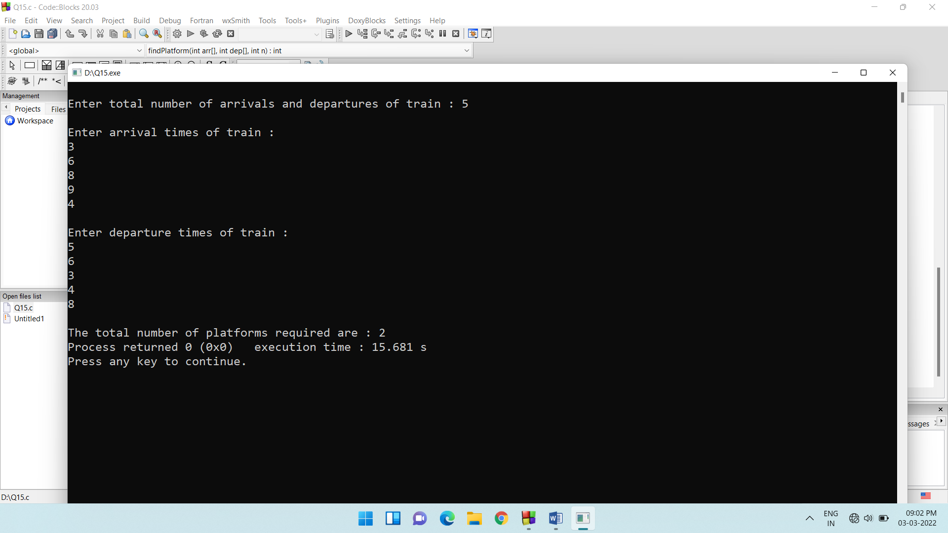

16)

Write a modular C program to reverse an array.

#include <stdio.h>

#include <stdlib.h>

void read_array(int [],int );

void reverse_array(int [],int);

void print_array(int [],int );

int main()

{

int n;

int a[100];

printf("\nEnter array size : \t");

scanf("%d",&n);

read_array(a,n);

print_array(a,n);

reverse_array(a,n);

print_array(a,n);

return 0;

}

void read_array(int a[],int n)

{

int i;

printf("\nEnter %d elements : ",n);

for(i = 0;i < n;i++)

{

scanf("%d",&a[i]);

}

}

void print_array(int a[],int n)

{

int i;

printf("\nThe array elements are : \n");

for(i=0;i<n;i++)

{

printf("\t%d\t",a[i]);

}

}

void reverse_array(int a[],int n )

{

int i;

int temp;

for(i = 0 ; i < n/2 ; i++)

{

temp = a[i];

a[i] = a[n-i-1];

a[n-i-1] = temp;

}

}

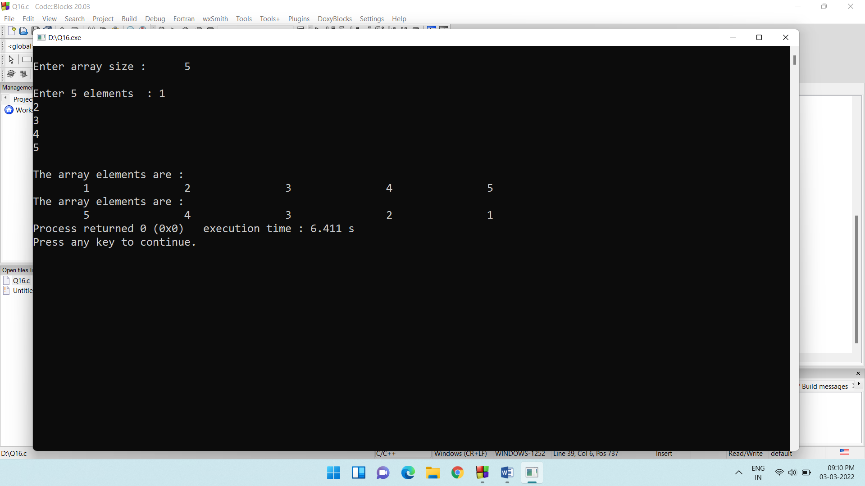

17)

Read the 2 sets(2 arrays) of numbers with same size n. Then exchange the content of two sets.

#include<stdio.h>

int main()

{

int n,i;

printf("enter size of arrays.(Note: The sizes of both arrays should be same)\n");

scanf("%d",&n);

int a[n],b[n];

for(i=0;i<n;i++)

{

printf("enter elements of first array\n");

scanf("%d",&a[i]);

}

for(i=0;i<n;i++)

{

printf("enter elements of second array\n");

scanf("%d",&b[i]);

}

swaparray(a,b,n);

}

swaparray(int a[],int b[],int n)

{

int temp,i;

for(i=0;i<n;i++)

{

temp=a[i];

a[i]=b[i];

b[i]=temp;

}

printf("Array 1\n");

for(i=0;i<n;i++)

{

printf("%d\t",a[i]);

}

printf("\n");

printf("Array 2\n");

for(i=0;i<n;i++)

{

printf("%d\t",b[i]);

}

}

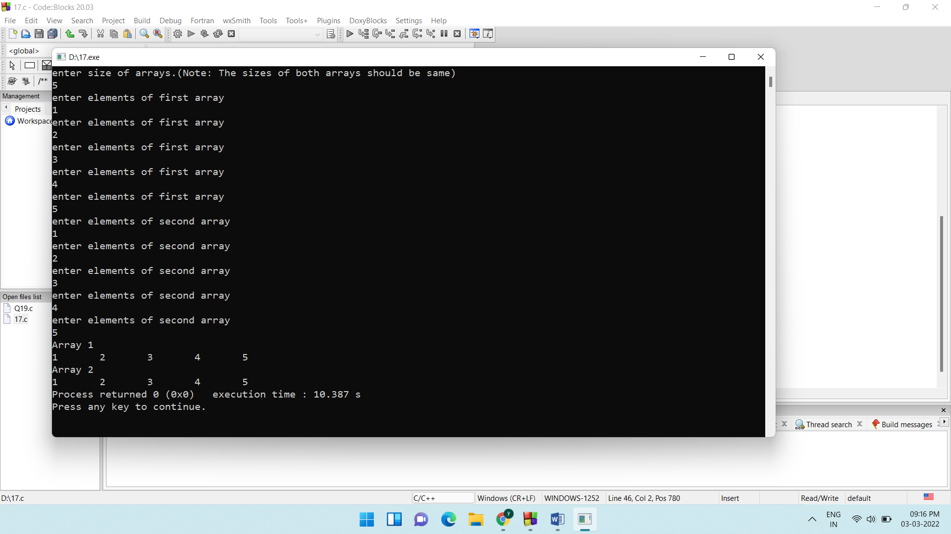

18)

Read an array of numbers with size n and another number m. then for every element print the sum of m next numbers in sequence from array.

#include<stdio.h>

void read(int*,int);

void summ(int*,int);

void main()

{

int n;

printf("enter the number of elments\n");

scanf("%d",&n);

int num[n];

read(&num,n);

summ(&num,n);

}

void read(int *num,int n)

{

printf("enter the array elements\n");

for(int i=0;i<n;i++)

{

scanf("%d",&num[i]);

}

}

void summ(int *num,int n)

{

int m,sum=0;

printf("enter the key word\n");

scanf("%d",&m);

for(int i=0;i<n-m;i++)

{

for(int j=i+1;j<i+1+m;j++)

{

sum=sum+num[j];

}

printf("for the element %d the sum of m next numbers in sequence from array is %d\n",i,sum);

sum=0;

}

}

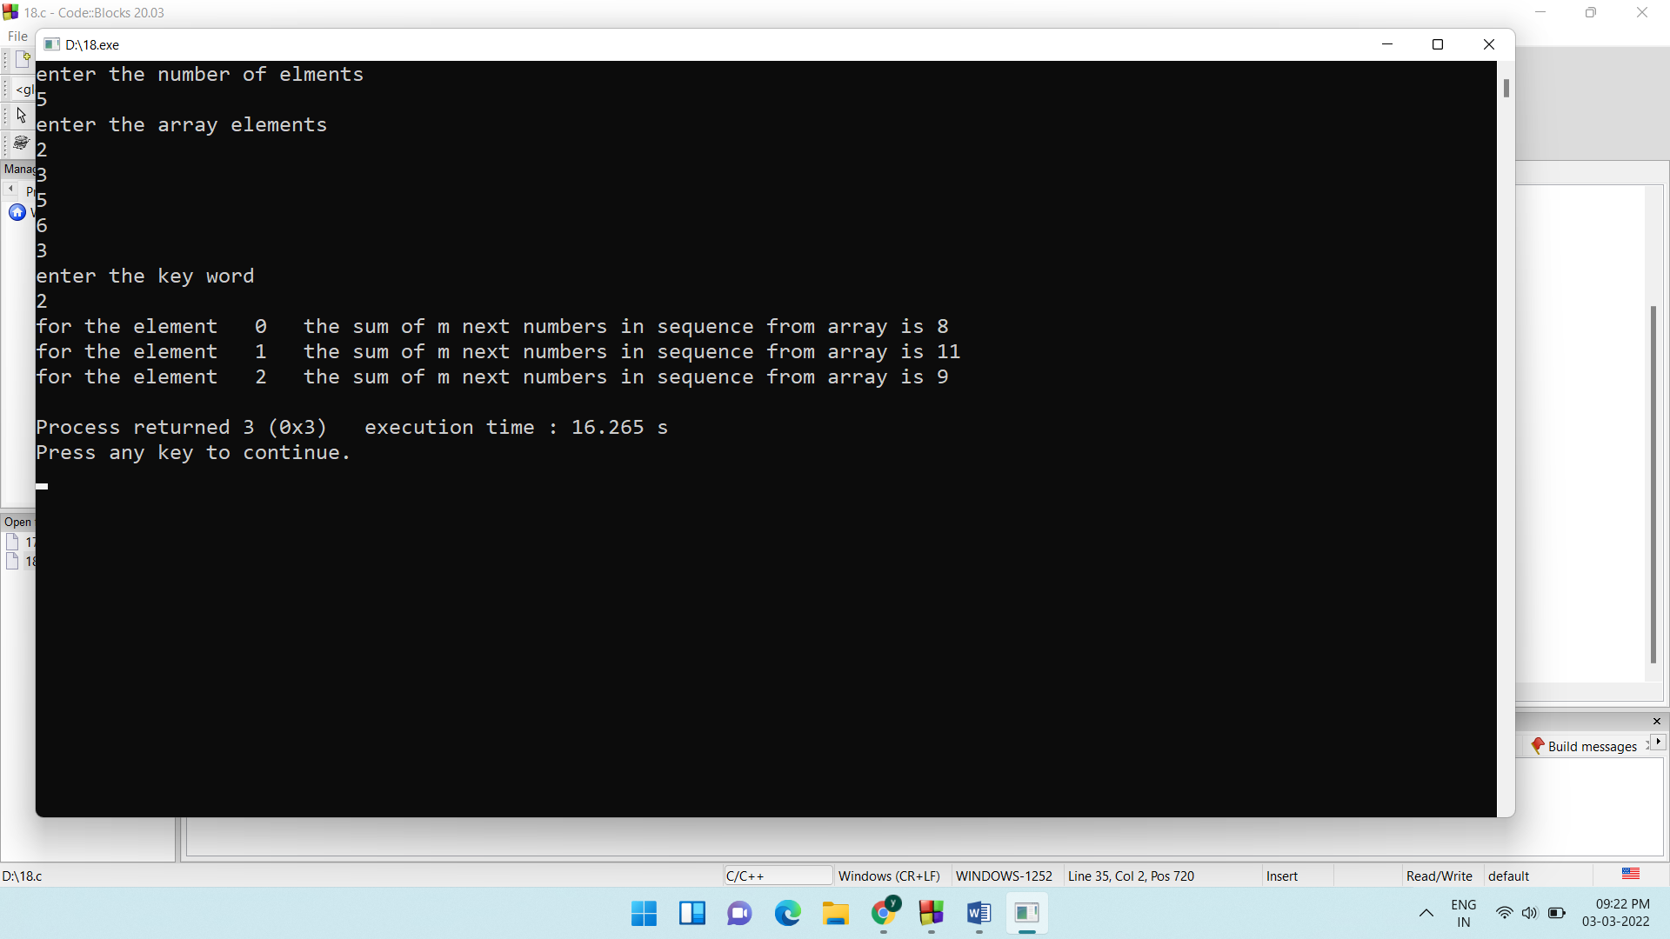

19)

Read n number and sort them using bubble sort

#include<stdio.h>

int main()

{

int n,i;

printf("enter size of array\n");

scanf("%d",&n);

int a[n];

printf("enter elements of array\n");

for(i=0;i<n;i++)

{

scanf("%d",&a[i]);

}

ascending(a,n);

descending(a,n);

}

ascending(int a[], int n)

{

int i,j,temp;

for(i=0;i<n-1;i++)

{

for(j=0;j<n-i-1;j++)

{

if(a[j]>a[j+1])

{

temp=a[j];

a[j]=a[j+1];

a[j+1]=temp;

}

}

}

printf("Ascending order\n");

for(i=0;i<n;i++)

{

printf("%d\n",a[i]);

}

}

descending(int a[], int n)

{

int i,j,temp;

for(i=0;i<n-1;i++)

{

for(j=0;j<n-i-1;j++)

{

if(a[j]<a[j+1])

{

temp=a[j];

a[j]=a[j+1];

a[j+1]=temp;

}

}

}

printf("Descending order\n");

for(i=0;i<n;i++)

{

printf("%d\n",a[i]);

}

}

