Практикум
Тема: «Разработка приложения конвертера валют».

Цель: разработать приложение конвертер валют, которое позволяет пользователям быстро и удобно преобразовывать суммы из одной валюты в другую на основе актуальных курсов обмена, обеспечивая точность и удобство использования.

Ход работы
- Создадим дизайн для нашего приложения
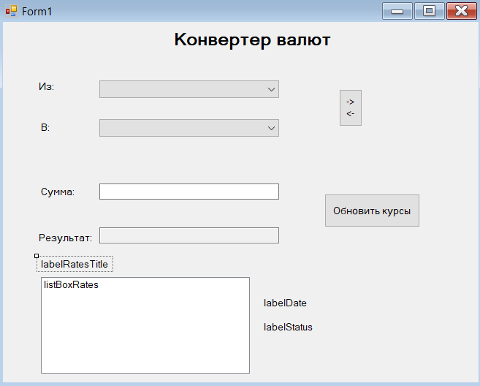
- Создадим код для нашего приложения
using System;
using System.Collections.Generic;
using System.Windows.Forms;
using System.Net.Http;
using System.Xml;
using System.Threading.Tasks;
using System.Globalization;

namespace CurrencyConverter
{
public partial class Form1 : Form
{
private Dictionary<string, decimal> exchangeRates = new Dictionary<string, decimal>();
private DateTime exchangeRateDate;
private bool ratesLoaded = false;

private readonly Dictionary<string, string> currencyNames = new Dictionary<string, string>
{
{ "RUB", "Российский рубль" },
{ "USD", "Доллар США" },
{ "EUR", "Евро" },
{ "CNY", "Китайский юань" },
{ "KRW", "Южнокорейская вона" }
};

public Form1()
{
InitializeComponent();
InitializeForm();
_ = LoadExchangeRatesAsync();
}

private void InitializeForm()
{
this.Text = "Конвертер валют";
this.Size = new System.Drawing.Size(480, 450);
this.StartPosition = FormStartPosition.CenterScreen;

labelRatesTitle.Text = "Курсы валют к RUB";

foreach (var currency in currencyNames)
{
string displayText = currencyNames[currency.Key];
comboBoxFrom.Items.Add(displayText);
comboBoxTo.Items.Add(displayText);
}

comboBoxFrom.SelectedIndex = 0;
comboBoxTo.SelectedIndex = 1;

buttonSwapCurrencies.Click += ButtonSwapCurrencies_Click;
buttonUpdateRates.Click += ButtonUpdateRates_Click;
textBoxAmount.TextChanged += TextBoxAmount_TextChanged;
comboBoxFrom.SelectedIndexChanged += ComboBox_SelectedIndexChanged;
comboBoxTo.SelectedIndexChanged += ComboBox_SelectedIndexChanged;

textBoxAmount.KeyPress += TextBoxAmount_KeyPress;
}

private async Task LoadExchangeRatesAsync()
{
try
{
labelStatus.Text = "Загрузка курсов...";
buttonUpdateRates.Enabled = false;

using (HttpClient client = new HttpClient())
{
string xmlData = await client.GetStringAsync("https://www.cbr.ru/scripts/XML_daily.asp");

XmlDocument xmlDoc = new XmlDocument();
xmlDoc.LoadXml(xmlData);
XmlNode dateNode = xmlDoc.SelectSingleNode("//ValCurs/@Date");
if (dateNode != null)
{
exchangeRateDate = DateTime.ParseExact(dateNode.Value, "dd.MM.yyyy", CultureInfo.InvariantCulture);
labelDate.Text = $"Дата курса: {exchangeRateDate.ToString("dd.MM.yyyy")}";
}

XmlNodeList valuteNodes = xmlDoc.SelectNodes("//Valute");

exchangeRates.Clear();
listBoxRates.Items.Clear();

exchangeRates["RUB"] = 1m;

List<string> rateDisplay = new List<string>();

foreach (XmlNode node in valuteNodes)
{
string charCode = node.SelectSingleNode("CharCode").InnerText;
string valueStr = node.SelectSingleNode("Value").InnerText;
string nominalStr = node.SelectSingleNode("Nominal").InnerText;

valueStr = valueStr.Replace(",", ".");

if (decimal.TryParse(valueStr, NumberStyles.Any, CultureInfo.InvariantCulture, out decimal value) &&
int.TryParse(nominalStr, out int nominal))
{

decimal rate = value / nominal;

if (currencyNames.ContainsKey(charCode))
{
exchangeRates[charCode] = rate;

rateDisplay.Add($"1 {charCode} = {rate:F4} RUB");
}
}
}

rateDisplay.Sort();
foreach (string rate in rateDisplay)
{
listBoxRates.Items.Add(rate);
}

if (!exchangeRates.ContainsKey("KRW"))
{
exchangeRates["KRW"] = 0.067m;
listBoxRates.Items.Add($"1 KRW = 0.0670 RUB (примерно)");
}

ratesLoaded = true;
labelStatus.Text = "Курсы загружены";

buttonUpdateRates.Enabled = true;

await ConvertCurrencyAsync();
}
}
catch (Exception ex)
{
labelStatus.Text = $"Ошибка загрузки: {ex.Message}";

SetTestRates();
ratesLoaded = true;
buttonUpdateRates.Enabled = true;
}
}

private void ButtonSwapCurrencies_Click(object sender, EventArgs e)
{
if (comboBoxFrom.SelectedIndex >= 0 && comboBoxTo.SelectedIndex >= 0)
{
int fromIndex = comboBoxFrom.SelectedIndex;
int toIndex = comboBoxTo.SelectedIndex;

comboBoxFrom.SelectedIndex = toIndex;
comboBoxTo.SelectedIndex = fromIndex;

_ = ConvertCurrencyAsync();
}
}

private async void ButtonUpdateRates_Click(object sender, EventArgs e)
{
await LoadExchangeRatesAsync();
}

private async void TextBoxAmount_TextChanged(object sender, EventArgs e)
{
if (textBoxAmount.Text.Length > 0 && decimal.TryParse(textBoxAmount.Text.Replace(",", "."),
NumberStyles.Any, CultureInfo.InvariantCulture, out _))
{
await ConvertCurrencyAsync();
}
}

private async void ComboBox_SelectedIndexChanged(object sender, EventArgs e)
{
if (comboBoxFrom.SelectedIndex >= 0 && comboBoxTo.SelectedIndex >= 0 && ratesLoaded)
{
await ConvertCurrencyAsync();
}
}

private async Task ConvertCurrencyAsync()
{
if (!ratesLoaded) return;

try
{
string fromCurrency = GetCurrencyCodeByDisplayName(comboBoxFrom.SelectedItem?.ToString());
string toCurrency = GetCurrencyCodeByDisplayName(comboBoxTo.SelectedItem?.ToString());

if (string.IsNullOrEmpty(fromCurrency) || string.IsNullOrEmpty(toCurrency))
{
textBoxResult.Text = "Ошибка выбора валют";
return;
}

if (!decimal.TryParse(textBoxAmount.Text.Replace(",", "."),
NumberStyles.Any, CultureInfo.InvariantCulture, out decimal amount))
{
textBoxResult.Text = "Введите число";
return;
}

if (!exchangeRates.ContainsKey(fromCurrency) || !exchangeRates.ContainsKey(toCurrency))
{
textBoxResult.Text = "Курс не найден";
return;
}

decimal fromRateToRub = exchangeRates[fromCurrency];
decimal toRateToRub = exchangeRates[toCurrency];

decimal amountInRubles = amount * fromRateToRub;
decimal result = amountInRubles / toRateToRub;

textBoxResult.Text = result.ToString("N2");
}
catch (Exception ex)
{
textBoxResult.Text = "Ошибка расчета";
labelStatus.Text = $"Ошибка: {ex.Message}";
}
}

private string GetCurrencyCodeByDisplayName(string displayName)
{
if (string.IsNullOrEmpty(displayName)) return "";

foreach (var currency in currencyNames)
{
if (currency.Value == displayName)
{
return currency.Key;
}
}

return "";
}

private void SetTestRates()
{
exchangeRates.Clear();
listBoxRates.Items.Clear();

exchangeRates["RUB"] = 1m;
exchangeRates["USD"] = 77.70m;
exchangeRates["EUR"] = 90.34m;
exchangeRates["CNY"] = 10.96m;
exchangeRates["KRW"] = 0.067m;

listBoxRates.Items.Add("1 USD = 77.70 RUB");
listBoxRates.Items.Add("1 EUR = 90.34 RUB");
listBoxRates.Items.Add("1 CNY = 10.96 RUB");
listBoxRates.Items.Add("1 KRW = 0.0670 RUB");

exchangeRateDate = DateTime.Now;
labelDate.Text = $"Дата курса: {exchangeRateDate.ToString("dd.MM.yyyy")} (тестовые)";
labelStatus.Text = "Используются тестовые курсы";
}

private void TextBoxAmount_KeyPress(object sender, KeyPressEventArgs e)
{
if (!char.IsControl(e.KeyChar) && !char.IsDigit(e.KeyChar) &&
e.KeyChar != '.' && e.KeyChar != ',')
{
e.Handled = true;
}

if (e.KeyChar == ',')
{
e.KeyChar = '.';
}

if ((e.KeyChar == '.' || e.KeyChar == ',') &&
((sender as TextBox)?.Text.Contains(".") == true ||
(sender as TextBox)?.Text.Contains(",") == true))
{
e.Handled = true;
}
}
}
}

- Тестируем это
