Dalton Bailey
8-29-2022
Sam Siewert
CSCI 490
Project Proposal
Summary Description
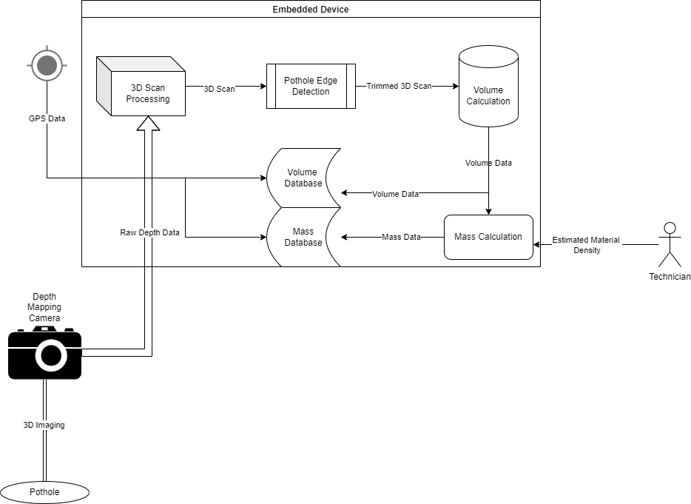

Major goals and objectives

My major goals for this project are to improve upon existing but proprietary software by developing my own open source solution which can fill in some gaps where the original software was lacking. My main goal for the software is for it to be able to produce accurate repeatable measurements of potholes with very little input from the user. The software should be able to accurately identify the edges of the pothole by using either some method of gradient analysis to calculate where the measured slope of the scan starts to take a consistent and measurably similar slope in one direction, or some method of simple machine learning to properly identify edges. This software should be able to run on a relatively low spec device; ideally something in the Raspberry Pi’s league; said device would obviously require a 3D depth mapping camera to provide the software with proper data for analysis. Upon receiving depth data from the camera the software would first process this data into a 3D image or model. This 3D image would then have one of the methods of edge detection mentioned previously performed on it in order to “trim” the image. This trimmed image can then have it’s volume calculated.
The only input that should be required from the user would be initiating the scan of the pothole and then consequently inputting the density of the desired patching material once the calculation has been performed. This density value will be used to calculate a required mass of material to fill in the pothole, however this user input is not strictly needed as the software will also store the volume calculated during it’s scan in a local database; which could then later be synced up to a larger database of potholes when the device regains access to a network connection. However if the user does input the estimated material density; then the mass will be calculated and stored in it’s own database. Ideally the device performing these measurements would also have access to GPS data so that it could tag the volume and mass data with a GPS location; however this is more of a stretch goal.

My Vision
My vision is to deliver software which can use a 3D depth mapping camera
Value Proposition

