Dalton Bailey

8-29-2022

Sam Siewert

CSCI 490

**Project Proposal (Draft)**

**Summary Description**

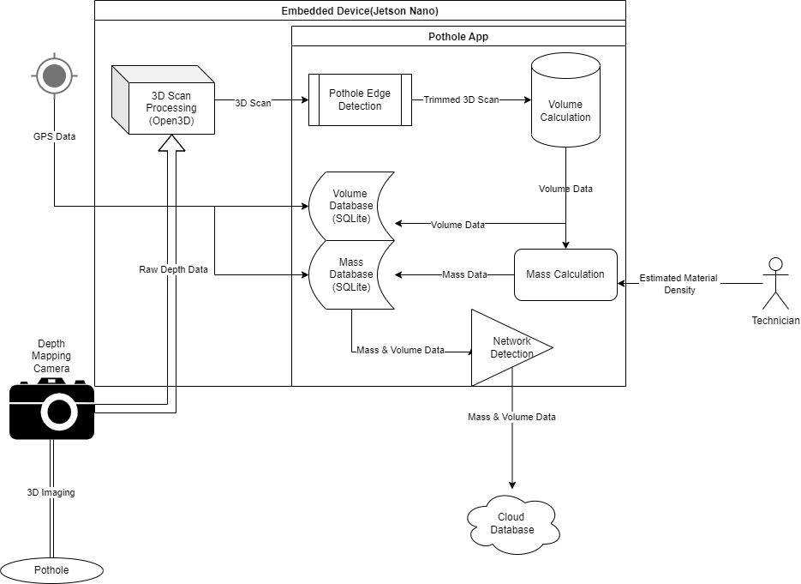

My project will provide a solution for civil engineers which will allow them to gain an accurate and repeatable measurement of pothole volume; which can then be used to calculate the mass of material required to patch the pothole. The application will also be able to report on the required mass to fill the pothole so long as the technician using it can provide a density for the desired patching material. These calculations can then be synced to a larger cloud database, once the device regains network connection, for long term storage and further data processing/analysis.

**Major goals and objectives**

My major goals for this project are to improve upon existing but proprietary software by developing my own open source solution which can fill in some gaps where the original software was lacking. My main goal for the software is for it to be able to produce accurate repeatable measurements of potholes with very little input from the user. The software should be able to accurately identify the edges of the pothole by using either some method of gradient analysis to calculate where the measured slope of the scan starts to take a consistent and measurably similar slope in one direction, or some method of simple machine learning to properly identify edges. This software should be able to run on a relatively low spec device; ideally something in the Raspberry Pi’s league; said device would obviously require a 3D depth mapping camera to provide the software with proper data for analysis. Upon receiving depth data from the camera the software would first process this data into a 3D image or model. This 3D image would then have one of the methods of edge detection mentioned previously performed on it in order to “trim” the image. This trimmed image can then have it’s volume calculated.

The only input that should be required from the user would be initiating the scan of the pothole and then consequently inputting the density of the desired patching material once the calculation has been performed. This density value will be used to calculate a required mass of material to fill in the pothole, however this user input is not strictly needed as the software will also store the volume calculated during it’s scan in a local database; which could then later be synced up to a larger database of potholes when the device regains access to a network connection. However if the user does input the estimated material density; then the mass will be calculated and stored in it’s own database. Ideally the device performing these measurements would also have access to GPS data so that it could tag the volume and mass data with a GPS location; however this is more of a stretch goal.

**My Vision**

My vision is to deliver software which can use a 3D depth mapping camera to produce accurate and repeatable volume and mass calculations of potholes. These measurements will aid engineers in the process of patching the potholes by removing almost all guesswork and manual calculation. Ideally the engineer will just point the device at the pothole, initiate the scan, and then input the density of the patching material (if known) the program will take care of the rest. Whatever device this system is running on will store all of the data locally on a SQLite database, until it regains a network connection where it can sync it’s local database with a cloud database for long term storage.

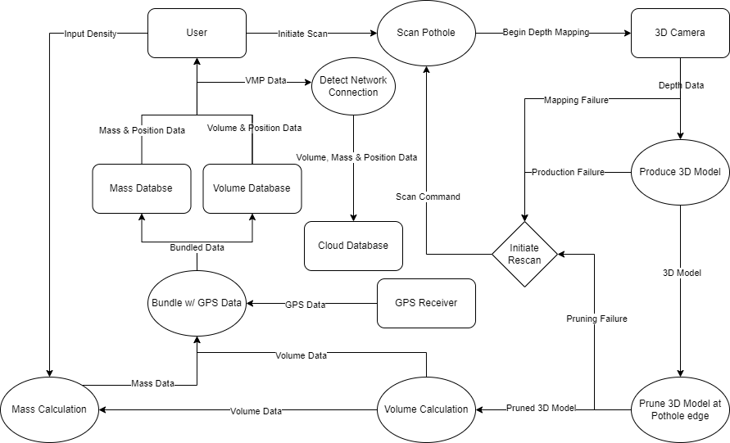

**Value Proposition**

Someone would want to use my system as ideally my system will require very little input or calculation on the users end, but would provide them with accurate measurements for potholes. The tool I design would remove almost all of the guesswork that currently goes into patching potholes. If I can get GPS tagging working properly then pothole scans could be stored in a central database. City officials may find my software particularly valuable for that reason, as using my solution they could send out a small team of technicians to scan areas which have received high reports of potholes; the technicians could then return these scans to the office and the appropriate officials could then allocate the exact amount of required patching material to fill all of the potholes. If I am able to accomplish my stretch goals; the final device will ideally be able to be attached to a vehicle which can be driven around the city scanning all potholes as it goes. The software does have some very lofty stretch goals; however the most difficult aspect of this software will likely be pruning the 3D scan and then calculating volume based on that scan; once that has been implemented the stretch goals will likely be less difficult to implement.