Dalton Bailey

8, Sept, 22

Sam Siewert

CSCI 490

**Pothole projection and pruning program (QuadP)**

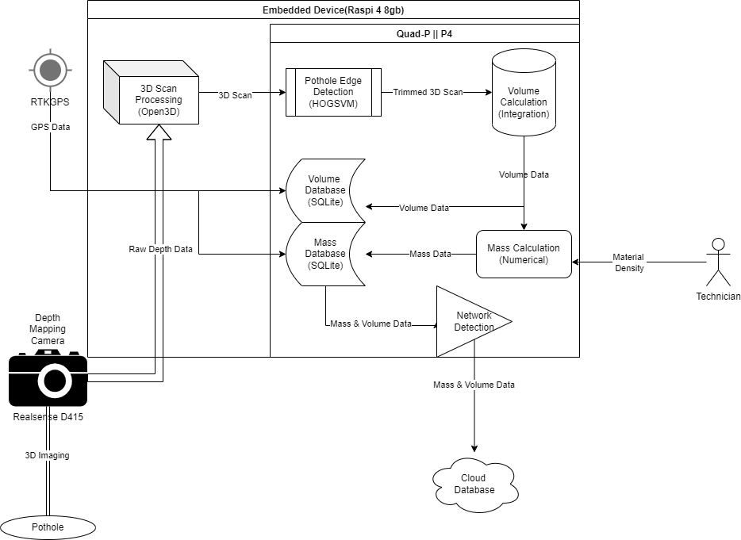**Summary Description**

*Fig. 1: Block Diagram*

Project Description

* Solution for civil engineers to provide them with accurate and repeatable measurements of pothole volume
* Automated pothole edge detection
* Local database storage and synchronization with a larger cloud database
* Research assisting tool for engineers/technicians testing the viability of new pothole patching material
* Minimal user input required for calculation

**Major goals and objectives**

My major goals for this project are to improve upon existing but proprietary software by developing my own open source solution which can fill in some gaps where the commercial software was lacking. My main goal for the software is for it to produce accurate repeatable measurements of potholes with very little input from the user. The software has features that can automatically and accurately identify the edges of the pothole by using some method of gradient analysis to calculate where the measured slope of the scan starts to take a consistent and measurably similar change in one direction. This software should be able to run on a relatively low spec device; e.g. something in the Raspberry Pi’s league; the device would obviously require a 3D depth mapping camera to provide the software with proper data for analysis. Upon receiving depth data from the 3D camera the software would first process this data into a 3D image or model, and then this 3D image would then have edge detection performed on it in order to “trim” the image. This trimmed image will be used to calculate volume via integration.

The inputs that should be required from the user would be initiating the scan of the pothole and inputting the density of the desired patching material. This density value will be used to calculate a required mass of material to fill in the pothole, when needed. However density is not strictly needed as the software will also store the volume calculated during it’s scan in a local database; which could then later be synced up to a larger database of potholes when the device regains access to a network connection. However if the user does input the estimated material density, then the mass will be calculated and stored in it’s own database. Ideally the device performing these measurements would also have access to GPS data so that it could tag the GPS location; however this is an advanced feature of this application. The software should overall provide civil engineers with a robust and simple measurement tool which can assist them in their never ending battle against the decay of infrastructure.

**My Vision**

My vision is to deliver software which can use a 3D depth mapping camera to produce accurate and repeatable volume and mass calculations of potholes. These measurements will aid engineers in patching the potholes with accurate amount of materials to fill in the potholes. The engineer will just need point the device at the pothole, initiate the scan, and then input the density of the patching material (if known) the program will take care of the rest of the calculation. Whatever device this system is running on will store all of the data locally on a SQLite database, until it re-accesses a network connection where it will sync it’s local database with a cloud database for long term storage.

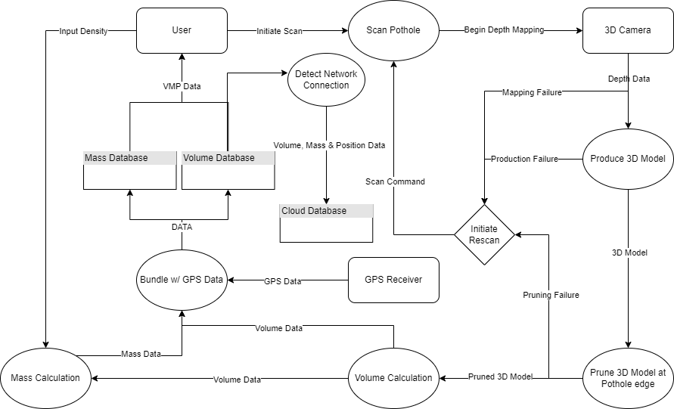

*Fig. 2: Data flow Diagram*

**Value Proposition**

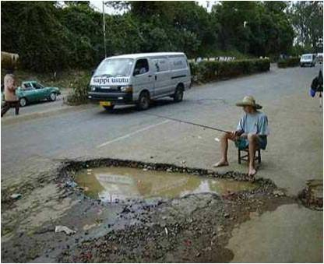Potholes are a consistent and very expensive problem, and require constant maintenance to stop them from growing exponentially. The infrastructure in the USA is continually decaying, the ASCE currently gives our roads across the nation a grade of D; furthermore in 2019 the Illinois Department of transportation paid $25 million dollars on pothole repairs. The money required for these repairs comes from the taxpayer, and civil engineers are also liable for any damages caused by potholes to vehicles using the road, so a good tool to help civil engineers patch potholes is very much needed. Engineers/Technicians would want to use my system as ideally my system will require very little input or calculation on the users end, but would provide them with accurate measurements for potholes. The tool I design would remove almost all of the guesswork that currently goes into patching potholes. If I can get GPS tagging working properly then pothole scans could be stored in a central database. City officials may find my software particularly valuable for that reason, as using my solution they could send out a small team of technicians to scan areas which have received high reports of potholes; the technicians could then return these scans to the office and the appropriate officials could then allocate the exact amount of required patching material to fill all of the potholes. If the GPS tagging works properly then technicians would even be able to return to sites of repaired potholes and see how well each individual pothole has been holding up after the repair. If I am able to accomplish my stretch goals; the final device will ideally be able to be attached to a vehicle which can be driven around the city scanning all potholes as it goes. The software does have some very lofty stretch goals; however the most difficult aspect of this software will likely be pruning the 3D scan and then calculating volume based on that scan; once that has been implemented the stretch goals will likely be less difficult to implement.