Bazar.com
A Multi-tier Online Book Store: Design Document
Distributed and Operating Systems, Lab 1 (Fall 2026)
Yamama Sawalma | Lama Damere

1. Overview
Bazar.com is a small online book store built as a two-tier system of microservices. It sells four books in two topics: distributed systems and undergraduate school.
The system has three independent services. Each is a small Python/Flask web application running in its own Docker container:
Service | Port | Responsibility
front-end | 5000 | The only service clients use. It validates requests and forwards them to the back end.
catalog | 5001 | Owns the catalog: stock, price and topic of every book. Supports query and update.
order | 5002 | Handles purchases and keeps a persistent log of all orders.

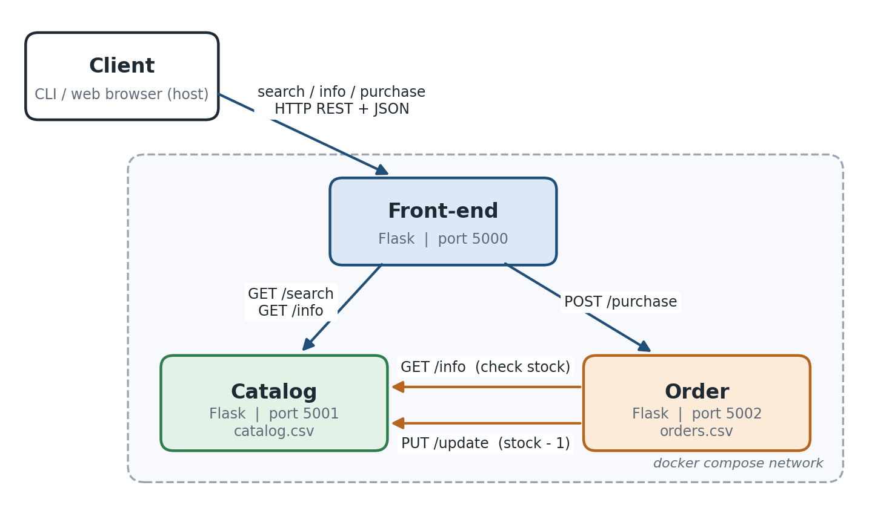
Figure 1: Bazar.com architecture. Each service runs in its own Docker container.
All communication is HTTP REST with JSON bodies. No component imports another component's code. They only know each other's URLs, which are passed in as environment variables (CATALOG_URL, ORDER_URL). Because of this, the three services can run on three different machines just by changing those URLs.

2. REST Interface

Front-end (what clients call)
Method | URL | Result
GET | /search/<topic> | [{"id": 1, "title": "..."}, ...]
GET | /info/<item_id> | {id, title, topic, quantity, price}
POST | /purchase/<item_id> | {"message": "bought book <title>", "order": {...}}

Catalog
Method | URL | Result
GET | /search/<topic> | query-by-subject
GET | /info/<item_id> | query-by-item
PUT | /update/<item_id> | body {"price": x}, {"quantity": n} or {"quantity_delta": d}
GET | /catalog | the whole catalog (debugging)

Order
Method | URL | Result
POST | /purchase/<item_id> | buys one copy
GET | /orders | all orders received

Errors use standard HTTP status codes with a JSON body {"error": "..."}: 404 unknown item, 409 out of stock, 503 a back-end service is unreachable.

3. How It Works
search / info. The front-end forwards the request to the catalog, which reads catalog.csv and returns the matching books. The front-end passes the JSON reply and the status code back to the client unchanged.
purchase. The front-end forwards the request to the order server, which:
- queries the catalog (GET /info/<id>). If the book does not exist it returns 404, and if the stock is 0 it returns 409 out of stock;
- asks the catalog to decrement the stock (PUT /update/<id> with {"quantity_delta": -1});
- appends the order to orders.csv and logs bought book <title>.
restock / price change. New stock arrives through the catalog's update operation ({"quantity_delta": +n}). The client exposes this as the restock and price commands.

Concurrency
Flask runs every request in its own thread (threaded=True), so concurrent requests are served in parallel without any low-level threading code.
The catalog is the only service that changes stock, so it keeps one threading.Lock around every read-modify-write of catalog.csv. Checking stock and decrementing it therefore happen as one atomic step. A quantity_delta that would push stock below zero is refused with 409.
This matters because the order server's step 1 (check) and step 2 (decrement) are two separate requests. Two clients can both see "1 in stock" in step 1. The catalog serialises their step 2 and only the first succeeds, so the second purchase fails cleanly instead of selling a book that does not exist. The concurrent client command shows this: with 2 copies left, 5 parallel purchases give exactly 2 successes and 3 failures (see docs/client_output.txt).

Persistence
- catalog/data/catalog.csv is created from seed_catalog.csv on first start and rewritten on every update. It is written to a temporary file first and then renamed, so a crash never leaves a half-written file.
- order/data/orders.csv is an append-only log.
In Docker both data/ folders are named volumes, so the data survives container restarts (docker compose down -v resets it).

4. Design Decisions and Trade-offs
- Python + Flask. This is a micro-framework with REST and multithreading built in. It keeps every service under ~150 lines, which is the point of microservices.
- CSV instead of SQLite. With four books a CSV file is enough, easy to read by hand, and has no extra dependencies. The cost is that every update rewrites the whole file and we must do our own locking. SQLite would give us transactions for free.
- Arguments in the URL (/info/2) instead of a JSON body. This matches the lab appendix, works from a browser, and makes the logs easy to read.
- POST for purchase. A purchase creates a new order and is not idempotent (calling it twice buys two books), so POST fits better than PUT. Catalog updates use PUT because they change an existing resource.
- Order server checks, catalog enforces. The stock check in the order server gives a clear error early, but the real guarantee is the catalog's atomic update. This keeps all stock logic in one place, the owner of the data.
- Front-end is stateless. It only forwards requests, so it could be replicated behind a load balancer without any change.
- Flask development server. It is simple and enough for a lab. A real deployment would use a production WSGI server such as gunicorn.

5. Known Limitations
- Single catalog instance. The lock lives in the catalog's memory, so it only protects one catalog process. Running two catalog replicas against one file would break the stock guarantee.
- No distributed transaction. If the order server crashes after the catalog decremented stock but before the order is written, one copy is "lost" (stock goes down but there is no order). Likewise, if the catalog's reply is lost on the network, the order server reports a failure even though stock was taken.
- Order ids are computed from the number of lines in orders.csv. This is correct only while a single order server writes the file.
- No authentication. Anyone who can reach port 5001 can change prices or stock.
- No caching. Every search and info goes to the catalog and reads the file from disk.

6. Possible Improvements
- SQLite with transactions instead of CSV plus a lock. This gives atomic updates that also work across several processes.
- Caching in the front-end for search/info, invalidated by the catalog on every update. This reduces load on the catalog.
- Replication. Run several catalog and order replicas behind the front-end and keep them consistent (for example, a primary-backup protocol for writes).
- Reliable purchases. Give each purchase a unique request id so retries are idempotent, and record a "pending" order before decrementing stock so that a crash can be recovered from.
- Automatic restocking. Add a background job in the catalog that adds stock periodically.
- Health checks in docker-compose.yml, so the front-end only starts once the back end is ready.

7. How to Run
Requirements: Docker with Docker Compose, and Python 3.10+ with pip install -r requirements.txt for the client.
docker compose up -d --build # start the three containers
python client/client.py demo # run the full scenario
docker compose logs -f # watch the services' log messages
docker compose down -v # stop and reset the data
python run_local.py # or: run everything without Docker

