 | الجمهورية العربية السورية  وزارة التعليم العالي والبحث العلمي  الجامعة السورية الخاصة | 

Smart Opinion Survey Platform
Junior Project Report

Prepared by:
Yaman Bassam Almatar
Yousef Ahmad Alzoubi
Hasan Abdalruhman Yahya
Supervised by:
Eng. Shadi Blidi
Eng. Maya Alahmad

Project Repository:
https://github.com/Yaman8almatar/smart-survey-platform

Academic Year
2025 – 2026

SUPERVISOR CERTIFICATION

I certify that the preparation of this project entitled Smart Opinion Survey Platform, prepared by
Yaman Almatar and Yousef Alzoubi and Hasan Yahya, was made under my supervision at Department of Software & Information System College of Artificial Intelligence Engineering in partial fulfillment of the Requirements for the Degree of Bachelor of Software and Information System Engineering

Name:

Signature:

Date:

Abstract

The Smart Opinion Survey Platform is a web-based intelligent survey system designed to improve the reliability of feedback collection by connecting service providers with demographically qualified respondents. Traditional online survey distribution often depends on public links or uncontrolled sharing, which may lead to random participation, weak respondent qualification, duplicate submissions, and open-text answers that are difficult to analyze consistently. The proposed system addresses these issues through a two-sided platform where service providers create targeted surveys and respondents view only surveys that match their demographic profiles.
The implemented system is built using Django 4.2.11, PostgreSQL 15, Django Templates, Bootstrap, Chart.js, pytest, pytest-django, and Hugging Face Inference API integration. The architecture follows a layered pattern in which views delegate workflows to service classes, services enforce business rules, repositories isolate Django ORM access, domain models define database entities, and the infrastructure layer isolates external AI communication. The system supports service provider registration, respondent registration, authentication, survey creation, question management, targeting criteria, survey publication and closing, response submission, duplicate-response prevention, dashboards, administrative account management, and system reporting.
Open-text answers are processed through a sentiment analysis component that normalizes Hugging Face output into positive, neutral, or negative labels and stores the result state safely. The project demonstrates a complete software engineering lifecycle, including requirements modeling, Agile iterative planning with Sprint 0, UML diagrams, database design, implementation documentation, test planning, traceability, and final evaluation. The final service-layer automated test suite passed successfully with 163 tests and 0 failures, and the GitHub Actions CI workflow completed successfully. The main contribution of the project is the integration of demographic targeting, controlled participation, duplicate-response prevention, and AI-assisted qualitative feedback analysis within one maintainable academic software platform.

Table of Contents

Abstract III
Table of Contents IV
List of Figures VIII
List of Tables X
Glossary of Terms and Definitions XII
Section One: Project Introduction 1
Chapter 1: General Introduction 1
1.1 Project Overview and Background 1
1.2 Problem Statement and Academic Importance 1
1.3 Project Objectives (Main objective , Sub-Objectives) 1
1.4 Project Scope, Constraints, and Assumptions 2
1.5 Contribution to Knowledge and Field 3
1.6 Research Methodology and Scientific Methods 3
1.7 Document Organization 4
1.8 Basic Definitions and Concepts 4
Chapter 2: Project Development and Management Methodology 5
2.1 Selected Development Methodology and Justification 5
2.2 Project Schedule and Sprint Plan 5
2.3 Risk Management 7
2.4 Team Roles and Responsibilities 8
2.5 Quality Management 8
2.6 Project Management Tools 8
2.7 Monitoring and Continuous Evaluation 9
2.8 Software Configuration Management 9
2.8.1 Git Repository Structure 9
2.8.2 Branching and Merging Strategy 10
2.8.3 Development Workflow 11
2.8.4 Tags and Release Management 12
2.8.5 Configuration Items Controlled 12
Section Two: Theoretical Study and Analysis 13
Chapter 3: Literature Review and Related Work 13
3.1 Previous Studies in Smart and Similar Systems 13
3.2 Modern Techniques and Frameworks in the Field 14
3.3 Comparative Analysis of Existing Systems 15
3.4 Research Gap and Proposed Innovation 15
3.5 Theoretical Framework 15
3.6 Modern and Future Trends 16
Chapter 4: Requirements Modeling and Analysis 17
4.1 Feasibility Study 17
4.2 Requirements Collection 17
4.3 Stakeholders and Needs Analysis 18
4.4 Functional Requirements 18
4.5 Non-Functional Requirements 20
4.6 Requirement Prioritization and Management 21
4.7 UML Requirement Diagrams 21
4.7.1 Main Use Case Diagram 21
4.7.2 Use Case Descriptions 22
4.7.3 Activity Diagrams 27
4.7.4 Sequence Diagrams 30
4.7.5 Test Case Descriptions 33
4.8 Modeling According to the Agile Methodology 34
4.8.1 Product Backlog and User Stories 34
4.8.2 SRS Support for Academic Traceability 35
4.9 Requirements Analysis and Documentation 36
Section Three: Design and Architecture 39
Chapter 5: System Architectural Design 39
5.1 High-Level Design 39
5.1.1 Architectural Block Diagram 39
5.1.2 Architectural Pattern Used 40
5.1.3 System Architecture Design 41
5.2 Database Design 42
5.2.1 Chen Entity Relationship Diagram 42
5.2.2 Relational Schema 43
5.2.3 Constraints and Keys 44
5.3 External Interface Design 46
5.4 Security and Authorization Design 47
Section Four: Implementation and Testing 48
Chapter 6: Implementation Environment and Tools 48
6.1 Software Tools and Libraries 48
6.2 Development Environment and Project Structure 49
6.3 Programming Languages and Frameworks 50
6.4 Database Server and Operating System 50
6.5 Dependencies 51
6.6 Version Control and Source Control Tools 51
6.7 CI/CD Tools 52
6.8 Testing Environment 52
Chapter 7: Software Implementation 54
7.1 Project File Structure 54
7.2 Module Implementation 55
7.3 API Implementation 56
7.3.1 Django Web Route and Form Submission Example 56
7.3.2 External API Integration Example 57
7.4 Data Access Layer Implementation 58
7.5 Business Logic Layer Implementation 60
7.6 User Interface Implementation 61
7.7 Intelligent Algorithm Implementation 65
Chapter 8: Testing and Evaluation 67
8.1 Test Plan 67
8.2 Testing Types 68
8.3 Test Diagrams 69
8.3.1 Test Case Diagrams 69
8.3.2 Test Result Diagrams 69
8.4 Test Results and Analysis 70
8.5 Quality Metrics 72
Section Five: Results and Recommendations 73
Chapter 9: Results and Analysis 73
9.1 System Implementation Results 73
9.2 Comparative Analysis with Existing Systems 79
9.3 Achievement of Objectives 80
9.4 Strengths and Weaknesses Analysis 80
9.5 Key Performance Indicators (KPIs) 81
Chapter 10: Conclusion and Recommendations 83
10.1 Project Summary and Main Achievements 83
10.2 Difficulties and Challenges Faced by the Project 84
10.3 Future Development Suggestions 85
10.4 Recommendations 86

List of Figures
Figure | Title
Figure 2.1 | Agile Gantt Chart with Sprint 0
Figure 2.2 | GitHub Repository Overview
Figure 2.3 | SCM Branching Strategy Screenshot
Figure 2.4 | SCM Development Workflow
Figure 2.5 | GitHub Release Version V1.0
Figure 4.1 | Main Use Case Diagram
Figure 4.2 | Activity Diagram - Service Provider Survey Workflow
Figure 4.3 | Activity Diagram - Respondent Participation Workflow
Figure 4.4 | Activity Diagram - Administrator Management and Reporting Workflow
Figure 4.5 | Sequence Diagram - Publish Survey
Figure 4.6 | Sequence Diagram - Submit Survey Response
Figure 4.7 | Sequence Diagram - Generate System Reports
Figure 5.1 | System Block Diagram
Figure 5.2 | Layered System Architecture Design
Figure 5.3 | Chen Entity Relationship Diagram
Figure 5.4 | Relational Schema
Figure 7.1 | Public Home Page
Figure 7.2 | Provider Dashboard
Figure 7.3 | Survey Edit Page
Figure 7.4 | Eligible Surveys Page
Figure 7.5 | Submission Confirmation Page
Figure 7.6 | Analytics Dashboard
Figure 7.7 | Admin System Reports Page
Figure 8.1 | Test Case Coverage Diagram
Figure 8.2 | Pytest Execution Result Screenshot
Figure 8.3 | GitHub Actions CI Result Screenshot
Figure 9.1 | Public Home Page
Figure 9.2 | Provider Dashboard
Figure 9.3 | Survey Edit Page
Figure 9.4 | Eligible Surveys Page
Figure 9.5 | Submission Confirmation Page
Figure 9.6 | Analytics Dashboard
Figure 9.7 | Admin System Reports Page
Figure 9.8 | Local Pytest Execution Result
Figure 9.9 | GitHub Actions CI Result

List of Tables
Table | Title
Table 1.1 | Project Objectives
Table 1.2 | Project Scope, Constraints, and Assumptions
Table 1.3 | Basic Definitions and Concepts
Table 2.1 | Sprint-Based Project Execution Plan
Table 2.2 | Risk Register
Table 2.3 | Team Roles and Responsibilities
Table 2.4 | Git Repository Structure
Table 2.5 | Branching Strategy
Table 2.6 | Release Management
Table 3.1 | Literature Review Summary
Table 3.2 | Comparative Analysis of Existing Systems
Table 4.1 | Feasibility Study
Table 4.2 | Stakeholder Analysis
Table 4.3 | Functional Requirements
Table 4.4 | Non-Functional Requirements
Table 4.5 | MoSCoW Requirement Prioritization
Table 4.6 | Main Use Case Specifications
Table 4.7 | Product Backlog Summary
Table 4.8 | User Stories
Table 4.9 | Iterative Feature List
Table 4.10 | Requirements Traceability Matrix
Table 4.11 | Initial Test Cases
Table 5.1 | Architectural Layers
Table 5.2 | Database Entities
Table 5.3 | Database Constraints and Keys
Table 5.4 | External API Design
Table 5.5 | Security and Authorization Design
Table 5.6 | User Roles and Access Levels
Table 6.1 | Technology Stack
Table 6.2 | Development Environment and Project Structure
Table 6.3 | Programming Languages and Frameworks
Table 6.4 | Database Server and Runtime Environment
Table 6.5 | Main Python Dependencies
Table 6.6 | Version Control and Source Control Tools
Table 6.7 | Continuous Integration and Deployment Status
Table 6.8 | Testing Environment
Table 7.1 | Project File Structure
Table 7.2 | Implementation Modules
Table 7.3 | Django Web Route Example
Table 7.4 | External API Integration
Table 7.5 | Repository Classes
Table 7.6 | Service Classes
Table 7.7 | User Interface Components
Table 7.8 | Smart Sentiment Analysis Flow
Table 8.1 | Table 8.1: Test Plan
Table 8.2 | Table 8.2: Testing Types
Table 8.3 | Test Results Summary
Table 8.4 | Main Test Case Results
Table 8.5 | Quality Metrics
Table 9.1 | Actual System Outputs
Table 9.2 | Comparative Analysis with Existing Systems
Table 9.3 | Project Objectives Achievement
Table 9.4 | Strengths and Weaknesses
Table 9.5 | System KPIs
Table 10.1 | Main Project Achievements
Table 10.2 | Project Challenges
Table 10.3 | Future Development Suggestions
Table 10.4 | Recommendations

Glossary of Terms and Definitions
Term | Definition
Agile | A software development approach based on incremental delivery, feedback, and adaptation.
Sprint 0 | A preliminary Agile phase used for discovery, requirements analysis, architecture planning, environment setup, and technical preparation before implementation.
Use Case | A description of an interaction between an actor and the system to achieve a specific goal.
Functional Requirement | A requirement that defines a function or behavior the system must provide.
Non-Functional Requirement | A requirement that defines a quality attribute such as security, usability, reliability, maintainability, or performance.
Targeting Criteria | Demographic filters used to determine whether a respondent is eligible for a survey.
MVT | Model-View-Template, the architectural structure commonly used by Django applications.
Layered Architecture | An architectural style that separates the system into layers such as presentation, services, repositories, domain models, and infrastructure.
Service Layer | A layer that contains business rules, validation, authorization checks, and workflow orchestration.
Repository Pattern | A design pattern that isolates data access logic from business logic.
ORM | Object-Relational Mapping, a technique that maps application objects to relational database tables.
Django ORM | Django’s built-in ORM used to query and persist model objects in the database.
PostgreSQL | The relational database management system used by the project.
Chen ERD | A conceptual entity-relationship notation representing entities, attributes, relationships, and cardinalities.
Relational Schema | A logical database representation using tables, primary keys, foreign keys, and constraints.
Sequence Diagram | A UML diagram that shows object interactions over time.
Activity Diagram | A UML diagram that shows workflow logic, decisions, and process flow.
Class Diagram | a UML diagram that shows system classes, attributes, methods, and relationships.
Sentiment Analysis | An NLP task that classifies text into positive, negative, or neutral sentiment.
Hugging Face Inference API | An external API used by the system to perform sentiment analysis on open-text answers.
RTM | Requirements Traceability Matrix linking requirements to design, implementation, and testing evidence.
SCM | Software Configuration Management, covering version control, branches, releases, and controlled changes.
CI | Continuous Integration, an automated process for running checks and tests after code changes.
CD | Continuous Delivery or Continuous Deployment. It is not implemented in the current project scope.
GitHub Actions | The CI tool used to run Django checks and service-layer tests automatically.
CSRF | Cross-Site Request Forgery protection used by Django to secure form submissions.
KPI | Key Performance Indicator, a measurable value used to evaluate system performance or project outcomes.

Section One: Project Introduction

Chapter 1: General Introduction

1.1 Project Overview and Background
In digital service environments, decisions about product improvement, customer satisfaction, and operational quality should be based on reliable feedback rather than assumptions. Survey systems are useful only when the collected data represents the intended audience. Public survey links can invite irrelevant participation, uncontrolled samples, and low-confidence results. The Smart Opinion Survey Platform addresses this weakness by combining survey creation with respondent qualification and intelligent analysis.
The platform connects service providers who need reliable feedback with respondents who maintain demographic profiles. A targeting mechanism matches survey criteria against respondent profile data before a survey is displayed. Open-text answers are processed through a sentiment analysis component, transforming qualitative responses into measurable indicators for dashboards and reports.

1.2 Problem Statement and Academic Importance
The core problem is the weak reliability of traditional survey distribution. When a survey is shared publicly, the survey owner cannot ensure that respondents belong to the intended demographic segment. This creates sample bias, reduces decision validity, and may produce misleading recommendations. The second problem is the manual analysis of open-text answers. Manual analysis is slow, inconsistent, and difficult to scale.
From an engineering perspective, the problem is suitable for a senior software project because it requires requirements engineering, role-based workflows, database design, layered architecture, AI service integration, service-level validation, automated testing, and traceability.

1.3 Project Objectives (Main objective , Sub-Objectives)
The main objective of this project is to design and implement a smart two-sided web-based survey platform that connects service providers with demographically matched respondents. The platform aims to improve the reliability of survey participation by reducing random access to surveys and by supporting decision-making through automated analysis of open-text responses. The project objectives are defined in a measurable form to ensure that each objective can be validated during implementation, testing, and final evaluation.

Table 1.1: Project Objectives
Objective ID | Objective | Measurable Outcome
OBJ-M | Build a two-sided survey platform connecting service providers and respondents. | The system provides separate workflows for service providers, respondents, and administrators, including registration, authentication, role-based navigation, and role-specific dashboards.
S-OBJ-01 | Reduce random survey participation through demographic targeting and eligibility filtering. | Respondents can view only published surveys that match their demographic profiles and have not been previously answered by them.
S-OBJ-02 | Automate the interpretation of open-text answers using sentiment analysis. | Open-text answers are processed through the sentiment analysis component and stored with one of the following analysis states: positive, neutral, negative, or failed.
S-OBJ-03 | Provide dashboards and reports to support decision-making. | Service providers can view survey-level analysis results, while administrators can view aggregate platform metrics related to users, surveys, and responses.
S-OBJ-04 | Apply disciplined software engineering practices throughout the project lifecycle. | The project documentation includes requirements analysis, UML diagram placeholders, architectural design, database design, implementation structure, testing evidence, and requirements traceability.

1.4 Project Scope, Constraints, and Assumptions
This section defines the boundaries of the Smart Opinion Survey Platform. The project scope identifies the functions that are included in the current implementation, while the out-of-scope items clarify what is intentionally excluded from this version. The constraints describe the limitations that affected the project, and the assumptions define the conditions expected to be true for the system to operate correctly.

Table 1.2: Project Scope, Constraints, and Assumptions
Category | Description
In Scope | The system includes user registration, login and logout, demographic profile management, survey creation, survey updating, survey deletion, question management, targeting criteria definition, survey publication and closing, eligible survey listing, response submission, duplicate response prevention, sentiment analysis for open-text answers, provider dashboards, administrator account management, and system reports.
Technical Scope | The system is implemented as a Django 4.2.11 web application using PostgreSQL 15, Django ORM, Django Templates, Bootstrap, Bootstrap Icons, Chart.js, pytest, pytest-django, requests, and Hugging Face Inference API integration.
Out of Scope | The current version does not include training a machine learning model from scratch, a native mobile application, a public REST API, payment or reward mechanisms, advanced respondent quality scoring, asynchronous AI processing, or full production-scale deployment.
Constraints | The project is constrained by the limited semester duration, limited infrastructure resources, dependency on the availability and response time of the external Hugging Face Inference API, and the need to insert final diagrams, screenshots, and test execution evidence before final submission.
Assumptions | The system assumes that respondents provide accurate demographic data, service providers define valid targeting criteria, environment variables are configured correctly, PostgreSQL is available during execution, and final screenshots and diagrams will be inserted into the report before submission.

1.5 Contribution to Knowledge and Field
The project contributes an academic implementation that integrates demographic targeting and AI-assisted feedback analysis inside one maintainable web platform. The innovation is not the invention of a new machine learning model. The contribution is the engineering integration of controlled eligibility, duplicate prevention, qualitative feedback processing, dashboards, and traceability into a coherent software system.

1.6 Research Methodology and Scientific Methods
This report follows an engineering research methodology. The project is handled as a software engineering problem that requires problem analysis, requirements identification, system design, implementation, testing, and evaluation. This methodology is suitable because the project aims to build a working smart software system, not to propose a purely theoretical algorithm. The problem is analyzed from two main perspectives. The first is data reliability, where the project addresses the weakness of random survey participation by using demographic targeting and eligibility filtering. The second is decision support, where the system applies sentiment analysis to open-text answers and converts them into structured indicators that can support dashboards and reports.
The scientific methods used in this project include stakeholder analysis, use case modeling, requirements analysis, architectural design, database modeling, implementation-based validation, and test case mapping. The requirements are derived from the needs of service providers, respondents, administrators, academic supervisors, and future maintainers. These requirements are then translated into architecture components, database entities, implementation modules, and testing evidence.
This methodology ensures that each major requirement is connected to the corresponding analysis, design, implementation, and testing elements. Therefore, the project can be evaluated as a complete engineered system rather than as a set of isolated implementation files.

1.7 Document Organization
The document is organized according to the university senior project guide. Section One introduces the project and development methodology. Section Two presents the theoretical study and requirements analysis. Section Three documents design and architecture. Section Four documents implementation and testing. Section Five presents results, analysis, conclusions, and recommendations. Section Six contains appendices and references.

1.8 Basic Definitions and Concepts
The following terms represent the basic concepts used throughout the analysis, design, implementation, and testing chapters of this report.
Table 1.3: Basic Definitions and Concepts
Term | Definition
Two-Sided Survey Platform | A platform that connects service providers who create surveys with respondents who answer them.
Demographic Targeting | A filtering method that matches surveys with respondents based on age, gender, and region.
Eligibility Filtering | A process that shows respondents only the surveys they are allowed to answer.
Sentiment Analysis | An NLP technique that classifies open-text answers as positive, neutral, or negative.
Layered Architecture | An architecture style that separates the system into presentation, service, repository, data, and infrastructure layers.
Service Layer | The layer responsible for business rules, validation, authorization, and workflow control.
Repository Pattern | A design pattern that separates database access from business logic.
Relational Schema | A database design that represents entities as tables with keys and constraints.
SCM | Software Configuration Management controls source code versions, branches, and releases.
Requirements Traceability | A method for linking requirements to use cases, design, implementation, and tests.

Chapter 2: Project Development and Management Methodology

2.1 Selected Development Methodology and Justification
The project was managed using an Agile Iterative and Incremental Development methodology. This methodology is suitable because the system consists of several independent but connected modules, including authentication, survey management, demographic targeting, response submission, sentiment analysis, dashboards, and administration. These modules can be planned, implemented, reviewed, and improved across multiple sprints.
A preliminary Sprint 0 was added before implementation. Its purpose was to define the project scope, analyze requirements, prepare the MVP, organize the product backlog, prioritize use cases, prepare the initial SRS, create the core UML placeholders, and establish the architecture baseline. This step was necessary because starting implementation before requirements analysis and design would violate disciplined software engineering practice.
This methodology supports the project by allowing the team to deliver the platform gradually while maintaining traceability between requirements, design, implementation, and testing. It also reduces development risk because each sprint produces a clear output that can be reviewed before moving to the next stage.

2.2 Project Schedule and Sprint Plan
The project schedule was organized as an Agile iterative execution plan from 1 March 2026 to 11 May 2026. Sprint 0 was included before implementation to cover requirements analysis, MVP scope definition, UML preparation, architecture baseline, ERD, and implementation readiness. Figure 2.1 presents the approved sprint-based Gantt chart.

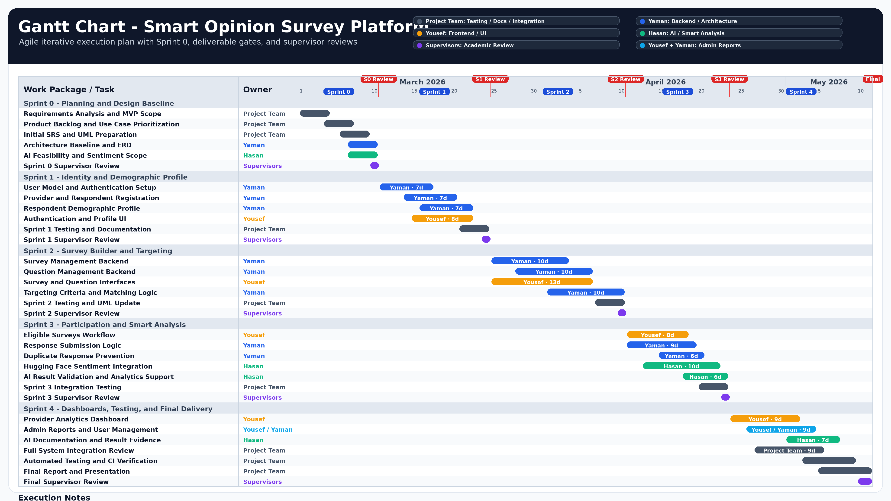
Figure 2.1: Agile Gantt Chart
Table 2.1: Sprint-Based Project Execution Plan
Sprint | Period | Main Objective | Key Deliverables
Sprint 0 | Mar 1 – Mar 10, 2026 | Requirements, planning, and system design preparation. | MVP scope, backlog, use cases, initial SRS, UML placeholders, architecture baseline, and ERD baseline.
Sprint 1 | Mar 11 – Mar 24, 2026 | Identity management and demographic profile implementation. | Registration, login, role-based access, respondent profile, and initial database schema.
Sprint 2 | Mar 25 – Apr 10, 2026 | Survey builder and targeting engine implementation. | Survey management, question management, targeting criteria, and matching logic.
Sprint 3 | Apr 11 – Apr 23, 2026 | Participation workflow and smart analysis integration. | Eligible surveys, response submission, duplicate prevention, and sentiment analysis.
Sprint 4 | Apr 24 – May 11, 2026 | Results, integration, testing, and academic delivery. | Dashboards, full integration, final testing evidence, report, and presentation.

2.3 Risk Management
Table 2.2: Risk Register
Risk ID | Risk | Probability | Impact | Mitigation
R-01 | External AI API becomes unavailable. | Medium | High | Store the response first, mark sentiment analysis as FAILED, and allow future retry.
R-02 | Incorrect targeting criteria are defined. | Medium | High | Validate gender, age range, and region through Targeting Service before saving criteria.
R-03 | Duplicate respondent submissions occur. | Low | High | Apply service-level duplicate checks and enforce a database unique constraint.
R-04 | Separation of concerns is violated. | Medium | High | Preserve the dependency direction: views → services → repositories → ORM.
R-05 | Test execution evidence is insufficient. | Medium | Medium | Run pytest in a valid Python environment and attach the execution screenshot.
R-06 | Final diagrams are inserted late. | Medium | Medium | Reserve diagram placeholders and insert final UML, ERD, architecture, and testing diagrams before submission.
R-07 | Git branch divergence affects final delivery. | Medium | Medium | Synchronize develop with origin/develop and document the final branch status before submission.

2.4 Team Roles and Responsibilities
Table 2.3: Team Roles and Responsibilities
Team Member / Role | Responsibility Area | Main Tasks
YAMAN | Backend Development and Architecture | Django project structure, domain models, service layer, repository layer, database design, and architecture consistency.
YOUSEF | Frontend and User Interface | Django templates, forms, Bootstrap pages, provider and respondent workflows, dashboard presentation, and UI screenshots.
HASAN | AI Integration and Smart Analysis | Hugging Face integration, sentiment analysis validation, analytics support, and intelligent component documentation.
Project Team | Quality Assurance and Documentation | Testing support, UML updates, report preparation, integration review, and presentation materials.
Supervisors | Academic Supervision | Reviewing methodology, requirements quality, engineering design, documentation structure, and final deliverables.

2.5 Quality Management
Quality management was applied throughout the sprints rather than postponed until the final stage. The project quality controls include layered architecture, service-level validation, repository isolation, database constraints, automated test cases, documentation, and requirements traceability.
The repository includes 163 service-layer tests covering authentication, profile management, survey lifecycle, question management, targeting, response submission, sentiment analysis, and administration. The test suite was executed successfully using pytest, and the final execution evidence is attached in Appendix C. This confirms that the main business rules were validated before final delivery.

2.6 Project Management Tools
The project used Git and GitHub for source control and collaboration. The repository also includes a docs folder for architecture and UML documentation, pytest and pytest-django for automated testing, Docker Compose for PostgreSQL setup, and environment variables for configuration and secret management.
These tools supported version control, documentation organization, automated testing, database setup, and environment-specific configuration during development.

2.7 Monitoring and Continuous Evaluation
Project monitoring was performed through weekly progress reviews, sprint deliverable checks, implementation review, test execution, and continuous documentation updates. The team also conducted periodic reviews with the academic supervisors to validate the project direction, requirements quality, architectural decisions, and documentation structure.
Continuous evaluation was based on comparing the implemented modules with the planned requirements, use cases, and test cases. Supervisor feedback was used to refine the report structure, improve the engineering documentation, and ensure that the final deliverables remained aligned with the academic project requirements.

2.8 Software Configuration Management
Software Configuration Management (SCM) was applied to control source code changes, branch organization, version history, dependencies, database migrations, and environment configuration. The project source code was managed using Git and hosted on GitHub under the repository Yaman8almatar/smart-survey-platform.
The repository contains the complete Django web application, including application modules, configuration files, domain models, services, repositories, infrastructure integration, templates, static files, tests, documentation, dependency files, and Docker configuration. This structure supports controlled development and improves traceability between requirements, implementation, testing, and final delivery.

2.8.1 Git Repository Structure
The project was maintained in a single GitHub repository because the system is implemented as one Django web application rather than separated frontend and backend repositories. The repository includes the main application code, documentation, test files, configuration files, and dependency management files.
Table 2.4: Git Repository Structure
Repository Element | Purpose
apps/ | Contains Django applications for users, surveys, responses, analysis, admin panel, and core models.
services/ | Contains business logic, validation rules, authorization checks, and workflow orchestration.
repositories/ | Contains database access logic using Django ORM.
infrastructure/ | Contains external integration code, including the Hugging Face sentiment analysis client.
templates/ | Contains shared Django templates and layout files.
static/ | Contains CSS, JavaScript, and static frontend assets.
tests/ | Contains automated tests for service-layer behavior and business rules.
docs/ | Contains architecture, requirements, UML, and implementation documentation.
requirements.txt | Defines Python package dependencies.
docker-compose.yml | Provides PostgreSQL setup for the development environment.
.env.example | Documents required environment variables without exposing secrets.

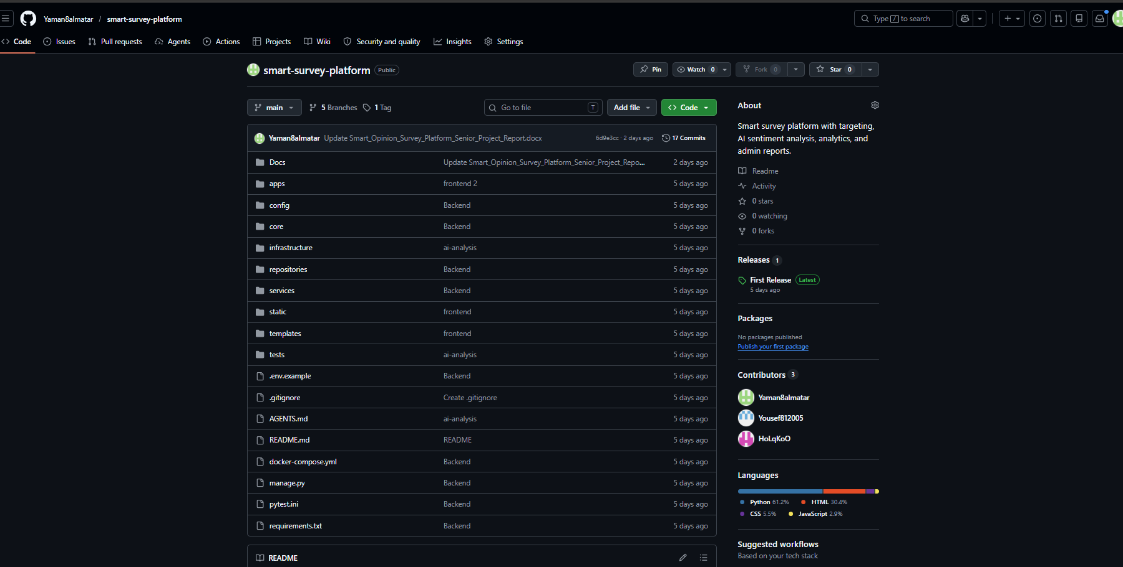
Figure 2.2: GitHub Repository Overview

2.8.2 Branching and Merging Strategy
A simplified branching strategy was adopted to support Agile incremental development and controlled integration. The repository uses a stable main branch, an integration develop branch, and feature branches for isolated development work.
The main branch represents the stable integrated version of the system. The develop branch is used to combine completed features before final merging. Feature branches are created for specific development areas such as backend core implementation, frontend implementation, and AI analysis.
Table 2.5: Branching Strategy
Branch | Purpose
main | Stable branch used for final integrated delivery.
develop | Integration branch used to combine completed feature work before release.
feature/backend-core | Feature branch used for backend core implementation.
feature/frontend | Feature branch used for frontend and user interface implementation.
feature/ai-analysis | Feature branch used for AI and sentiment analysis implementation.
This branching structure improved development isolation, reduced uncontrolled changes, and allowed each major feature area to be reviewed before integration.
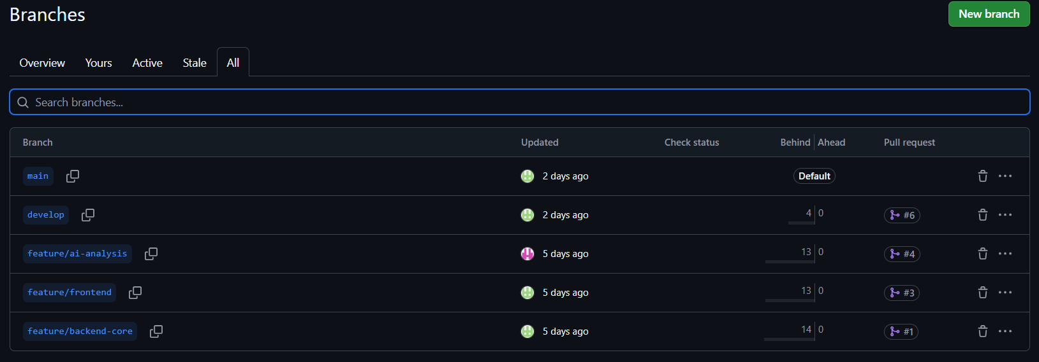
Figure 2.3: SCM Branching Strategy Screenshot

2.8.3 Development Workflow
The development workflow followed an incremental and task-based process. Each major task was implemented in a separate branch or controlled development area, then reviewed and integrated into the main codebase.
The workflow was applied as follows:
- A development task or feature was identified.
- A feature branch was prepared for the related implementation area.
- The feature was implemented and tested locally.
- The completed work was reviewed before integration.
- Integrated work was merged into the development branch.
- The final stable version was merged into the main branch for delivery.
This workflow supported code stability, clear change tracking, and controlled integration throughout the project lifecycle.
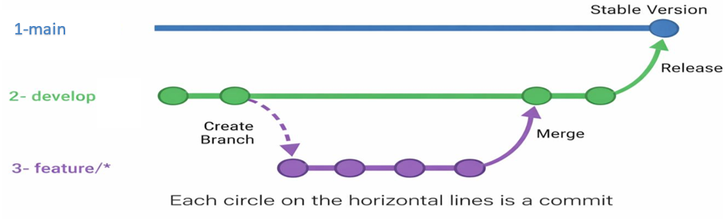
Figure 2.4: SCM Development Workflow

2.8.4 Tags and Release Management
Git tags and GitHub releases were used to mark stable delivery points. The final repository includes release evidence for V1.0, which represents a stable project release after integration from the develop branch.
Release management was used to document a validated system state and provide a clear reference point for final submission. Only stable and integrated code should be tagged as an official release.
Table 2.6: Release Management
Release | Description
V1.0 | First stable integrated release of the Smart Opinion Survey Platform.
Release Source | Created after merging the develop branch into the main branch.
Purpose | Marks the final delivery version used for academic submission and evaluation.

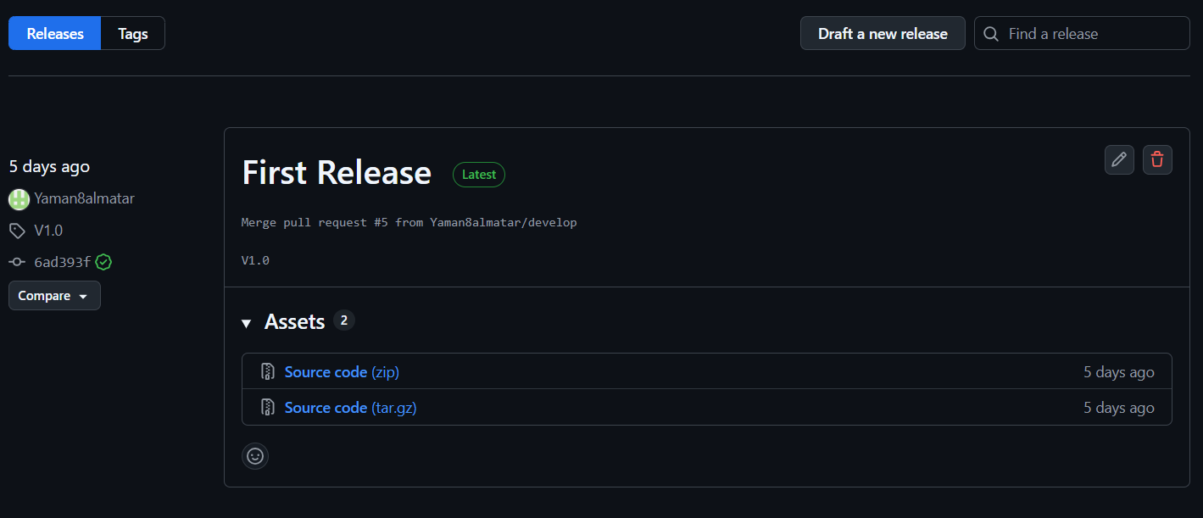
Figure 2.5: GitHub Release Version V1.0

2.8.5 Configuration Items Controlled
The project controlled several configuration items to ensure repeatability and maintainability. These items include source code files, dependency files, database migrations, environment configuration examples, documentation files, and test files.
Sensitive values such as secret keys, database credentials, and Hugging Face API tokens are not stored directly in the repository. Instead, they are configured through environment variables and documented using [.env.example].

This SCM approach supports maintainability, collaboration, traceability, and final delivery control. It also ensures that the submitted system can be reviewed as a stable software product rather than an uncontrolled collection of source files.

Section Two: Theoretical Study and Analysis

Chapter 3: Literature Review and Related Work

3.1 Previous Studies in Smart and Similar Systems
Recent literature shows that online surveys are efficient for collecting responses, but they may suffer from weak sample quality, uncontrolled participation, and limited representativeness. The AAPOR Task Force emphasized that online sample quality should not be evaluated only through response or completion rates, but also through representativeness, inferential reliability, recruitment method, and methodological transparency. Wu et al. also showed that online survey response quality is affected by how clearly the target population is defined, not only by the number of invitations sent.
Other studies focus on questionnaire data quality and sentiment analysis. Jaeger highlighted that online questionnaire quality is affected by questionnaire design, respondent characteristics, distraction, carelessness, and data-quality metrics. Sentiment analysis research shows that open-text feedback can be converted into structured indicators using machine learning, deep learning, and transformer-based models such as BERT.
Based on these studies, the proposed project combines two directions: controlled respondent eligibility and automated open-text analysis. Unlike studies that focus only on online survey quality or only on sentiment classification, this project implements a complete web-based survey platform with demographic targeting, duplicate-response prevention, sentiment analysis, dashboards, and software engineering traceability.
.
Table 3.1: Literature Review Summary
Reference | Focus | Main Contribution | Gap Relevant to This Project
AAPOR Task Force, 2023 [3] | Online sample quality | Defines quality considerations for online samples, including representativeness, recruitment, and reporting transparency. | Does not provide an implemented academic software platform.
Wu et al., 2022 [4] | Online survey response rates | Provides a meta-analysis of response rates in published online survey research. | Focuses on response rates rather than integrated eligibility filtering and AI analysis.
Jaeger, 2022 [5] | Online questionnaire data quality | Identifies factors and metrics affecting the reliability and validity of online questionnaire data. | Does not implement respondent-side demographic eligibility filtering.
Tan et al., 2023 [6] | Sentiment analysis methods | Reviews sentiment analysis approaches, datasets, preprocessing, classifiers, and future research directions. | Focuses on AI methods rather than full survey workflow integration.
Language Representation Model Study, 2023 [7] | Sentiment analysis of customer feedback | Applies machine learning and BERT-based language representation models to airline review sentiment classification. | Domain-specific analysis; not a complete targeted survey platform.
Samir et al., 2023 [8] | Deep learning sentiment analysis | Applies deep learning models to airline customer feedback sentiment classification. | Does not address survey targeting, duplicate prevention, dashboards, or requirements traceability.

This review shows that existing studies address parts of the problem separately. Survey research focuses on data quality and sample reliability, while sentiment analysis research focuses on classifying textual feedback. The Smart Opinion Survey Platform addresses the gap by combining demographic targeting, controlled participation, duplicate prevention, and AI-supported feedback analysis within one engineered software system.

3.2 Modern Techniques and Frameworks in the Field
Modern smart survey systems commonly combine web frameworks, relational databases, responsive user interfaces, dashboard visualization, automated testing, and external AI services. In this project, Django was selected as the main web framework because it supports rapid development, clean design, authentication, templates, forms, and database-driven applications. PostgreSQL was used as the relational database engine because the system depends on structured entities, relationships, foreign keys, and integrity constraints.
The user interface was implemented using Django Templates, Bootstrap, and Bootstrap Icons to provide server-rendered responsive pages. Chart.js was used to visualize survey results and platform metrics because it provides flexible chart types suitable for dashboards. Automated verification was supported through pytest and pytest-django, which are appropriate for testing service-layer business rules and repository-backed workflows.
For the intelligent component, the system uses the Hugging Face Inference API to perform sentiment analysis on open-text answers. This approach is suitable for the project because it allows the system to use an existing text-classification model instead of training a machine learning model from scratch. Hugging Face documentation defines text classification as assigning labels to text, including use cases such as sentiment analysis.

3.3 Comparative Analysis of Existing Systems
Table 3.2: Comparative Analysis of Existing Systems
Criterion | Google Forms | SurveyMonkey Audience | Qualtrics Panels | Proposed Platform
Main Purpose | General form and survey creation. | Paid targeted survey respondents. | Commercial research panels. | Academic smart survey platform.
Audience Targeting | Mainly through sharing and access settings. | Uses paid targeting options and panelists. | Provides targeted panel services. | Uses respondent demographic profiles.
AI Text Analysis | Not a core standard workflow. | Available depending on advanced features. | Available in advanced ecosystems. | Integrated sentiment analysis.
Duplicate Control | Configurable in limited cases. | Controlled by platform workflow. | Controlled by panel workflow. | Service validation and database constraint.
Transparency | Closed commercial system. | Closed commercial system. | Closed commercial system. | Documented architecture, tests, and traceability.
The comparison shows that existing systems provide strong survey or panel services, but the proposed platform combines demographic targeting, duplicate prevention, sentiment analysis, and academic software engineering traceability in one implemented system.

3.4 Research Gap and Proposed Innovation
The identified gap is the absence of a lightweight academic system that combines respondent-side demographic profiles, integrated survey eligibility matching, duplicate-response control, AI-assisted sentiment analysis, dashboards, and software engineering traceability in one implemented platform.
The proposed innovation is not a new machine learning algorithm. Instead, the innovation is the architectural and functional integration of demographic targeting, controlled participation, sentiment analysis, and decision-support dashboards within a complete software engineering project. This makes the system suitable for academic evaluation because the project can be assessed through requirements, design, implementation, testing, and traceability evidence.

3.5 Theoretical Framework
The project is based on the following theoretical and engineering concepts:
- Two-sided platform: value is produced through interaction between service providers who create surveys and respondents who answer them.
- Demographic targeting: respondent eligibility is derived from profile attributes such as age, gender, and region.
- Sentiment analysis: open-text answers are classified into positive, neutral, or negative sentiment labels.
- Layered architecture: presentation, services, repositories, domain models, and infrastructure are separated to improve maintainability.
- Requirements traceability: requirements are mapped to use cases, implementation areas, and test cases to support verification.
.

3.6 Modern and Future Trends
Future survey platforms are moving toward stronger respondent segmentation, automated insight extraction, quality metrics, dashboard-based reporting, and AI-supported analysis. In this direction, the Smart Opinion Survey Platform can be extended with asynchronous AI processing, stronger respondent quality controls, topic modeling, richer analytics, audit logs, privacy controls, and CI/CD automation.
These improvements are treated as future work, not as current implemented features. This distinction is important because the final report must not claim features that are not implemented in the current system version.

Chapter 4: Requirements Modeling and Analysis

4.1 Feasibility Study
The feasibility study evaluates whether the Smart Opinion Survey Platform can be built and operated within the available technical, operational, economic, and schedule constraints. The project is feasible because it uses available open-source frameworks, a clear role-based workflow, and an external AI service instead of training a model from scratch. Django is suitable for rapid and clean web application development, PostgreSQL provides a stable relational database environment, pytest-django supports Django testing with pytest, and Hugging Face supports text classification tasks such as sentiment analysis.

Table 4.1: Feasibility Study
Feasibility Type | Assessment
Technical Feasibility | Feasible because Django 4.2.11, PostgreSQL 15, Bootstrap, Chart.js, pytest, requests, and Hugging Face Inference API are available and appropriate for the project scope.
Operational Feasibility | Feasible because the system actors are clear: service provider, respondent, and administrator.
Economic Feasibility | Feasible because the project uses open-source frameworks and an external AI API instead of training a model from scratch.
Schedule Feasibility | Feasible because the work was organized into Sprint 0 and four implementation sprints.

4.2 Requirements Collection
Requirements were collected from the project idea, seminar discussions, approved use cases, the official university report guide, and inspection of the implemented Django repository. The collection process focused on identifying the needs of the main actors: service providers, respondents, administrators, academic supervisors, and future maintainers.
The collected requirements were then refined into functional requirements, non-functional requirements, use cases, user stories, and test cases. This ensured that the report did not describe the system only at a conceptual level, but linked each requirement to analysis, design, implementation, and testing evidence.

4.3 Stakeholders and Needs Analysis
Stakeholder analysis identifies the main parties affected by the system and clarifies their needs. The Smart Opinion Survey Platform has three primary operational stakeholders: service providers, respondents, and administrators. It also has academic and maintenance stakeholders, because the project must be evaluated, documented, and maintained as a software engineering system.

Table 4.2: Stakeholder Analysis
Stakeholder | Need | System Response
Service Provider | Create targeted surveys and obtain reliable feedback analytics. | Survey creation, question management, targeting criteria, publication, closing, and analysis dashboard.
Respondent | Participate only in surveys relevant to their demographic profile. | Registration, demographic profile management, eligible survey listing, response submission, and answered survey history.
System Administrator | Manage user accounts and monitor platform activity. | User management, account status actions, and system reports.
Academic Supervisors | Review and evaluate the project quality and academic completeness. | Review of methodology, requirements, architecture, documentation, testing evidence, and final deliverables.

4.4 Functional Requirements
Table 4.3: Functional Requirements
ID | Functional Requirement | Actor
FR-01 | The system shall allow a service provider to create an account using name, email, and password. | Service Provider
FR-02 | The system shall allow a respondent to create an account with demographic data. | Respondent
FR-03 | The system shall allow users to log in using email and password. | Service Provider, Respondent, System Administrator
FR-04 | The system shall allow authenticated users to log out. | Service Provider, Respondent, Administrator
FR-05 | The system shall allow service providers to create surveys with title and description. | Service Provider
FR-06 | The system shall allow service providers to update their own draft survey details. | Service Provider
FR-07 | The system shall allow service providers to delete their own draft or closed surveys. | Service Provider
FR-08 | The system shall support multiple-choice, rating-scale, and open-text question types. | Service Provider, Respondent
FR-09 | The system shall allow service providers to add questions to their own draft surveys. | Service Provider
FR-10 | The system shall support deleting questions on owned draft surveys. | Service Provider
FR-11 | The system shall allow service providers to define demographic targeting criteria for their own draft surveys. | Service Provider
FR-12 | The system shall allow service providers to publish surveys only when required publication conditions are satisfied. | Service Provider
FR-13 | The system shall allow service providers to close published surveys. | Service Provider
FR-14 | The system shall allow service providers to view analytics for their own surveys. | Service Provider
FR-15 | The system shall allow respondents to manage their demographic profile. | Respondent
FR-16 | The system shall list only eligible published surveys for a respondent. | Respondent
FR-17 | The system shall allow respondents to submit responses to eligible published surveys. | Respondent
FR-18 | The system shall prevent a respondent from submitting more than one response to the same survey. | Respondent
FR-19 | The system shall allow respondents to view surveys they have already answered. | Respondent
FR-20 | The system shall allow administrators to activate, suspend, and soft-delete user accounts. | System Administrator
FR-21 | The system shall allow administrators to generate system reports for platform activity. | System Administrator
FR-22 | The system shall run sentiment analysis for open-text answers and store the result state. | System

4.5 Non-Functional Requirements
Table 4.4: Non-Functional Requirements
NFR ID | Category | Requirement | Measurable Criterion / Verification
NFR-01 | Security | The system shall protect account passwords using Django password hashing. | Passwords are stored hashed, not plaintext.
NFR-02 | Security | The system shall restrict protected functions according to user roles. | Service Provider, Respondent, and Administrator workflows are separated by role checks.
NFR-03 | Security | The system shall load real runtime secrets and API tokens from environment variables. | Database settings and AI API token are loaded from environment variables; .env is not committed.
NFR-04 | Usability | The system shall provide role-specific navigation and dashboard pages. | Each role has relevant navigation links and dashboard pages.
NFR-05 | Usability | The system shall provide clear forms and feedback messages for main workflows. | Forms validate user input and display success or error messages.
NFR-06 | Performance | The system should return normal local page requests within 2 seconds during academic testing. | Target to be verified manually or with browser timing before final submission.
NFR-07 | Reliability | The system shall keep a submitted response saved if sentiment analysis fails. | Failed external analysis is recorded as FAILED without deleting the submitted response.
NFR-08 | Maintainability | The system shall separate UI, services, repositories, models, and external integrations. | The implementation follows Views → Services → Repositories → Models/ORM → Database.
NFR-09 | Data Integrity | The system shall prevent duplicate responses for the same survey and respondent. | One response per survey/respondent is enforced by validation and a database constraint.
NFR-10 | Privacy | The system shall store respondent demographic data on the server side for profile and survey eligibility workflows. | Demographic data is used for profile management and eligibility matching only.

4.6 Requirement Prioritization and Management
Table 4.5: MoSCoW Requirement Prioritization
Priority | Requirements
Must | Authentication, role-based access, survey CRUD, question management, targeting criteria, survey publication/closing, eligible survey filtering, response submission, duplicate prevention, sentiment analysis, and provider analysis dashboard.
Should | Admin account management, system reports, service-layer tests, and clear dashboard-based result presentation.
Could | CI/CD workflow, accessibility audit, performance testing, audit logs, richer analytics, and asynchronous AI processing.
Won’t | Native mobile application, payment/reward system, training a machine learning model from scratch, public REST API, and large-scale production deployment.

4.7 UML Requirement Diagrams

4.7.1 Main Use Case Diagram
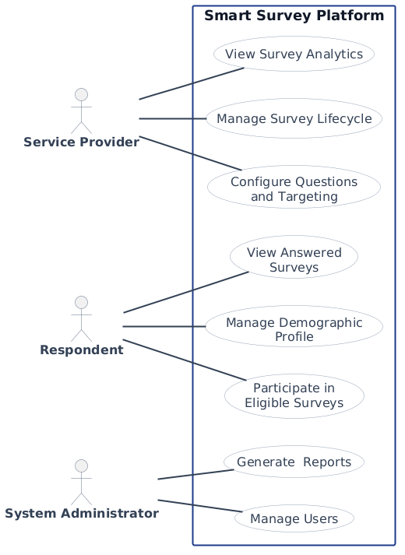
Figure 4.1: Main Use Case Diagram

4.7.2 Use Case Descriptions
Table 4.6: Main Use Case Specifications
Field | Description
Use Case ID and Name | UC-M01: Manage Survey Lifecycle
Primary Actor | Service Provider
Brief Description | This use case allows a service provider to create, update, delete, publish, and close surveys according to their lifecycle status.
Main Flow | 1. The service provider opens the survey management page.  2. The system displays the provider’s surveys and available actions.  3. The provider creates a new survey with title and description.  4. The system saves the survey as a draft.  5. The provider updates or deletes the survey while it is still in draft status when needed.  6. The provider publishes the survey after completing the required questions and targeting criteria.  7. The provider closes the published survey when response collection is complete.
Postconditions | 1. The survey status is correctly maintained as draft, published, or closed.  2. Published surveys become available to eligible respondents.  3. Closed surveys no longer accept responses.
Alternative Flow | The provider may keep the survey in draft status and complete questions or targeting criteria later.
Exceptions | 1. The system rejects update or delete actions if the survey is not in draft status.  2. The system rejects publication if the survey has no questions or no targeting criteria.  3. The system rejects closing if the survey is not published.

Field | Description
Use Case ID and Name | UC-M02: Configure Questions and Targeting
Primary Actor | Service Provider
Brief Description | This use case allows a service provider to add survey questions and define demographic targeting criteria for an owned draft survey.
Main Flow | 1. The service provider opens the question or targeting management page for a draft survey.  2. The system validates provider ownership and draft status.  3. The provider adds questions using supported question types: multiple-choice, rating-scale, or open-text.  4. The system validates question text, question type, required flag, order, and options when needed.  5. The system saves the question and related options.  6. The provider defines targeting criteria using gender, age range, and region.  7. The system validates and stores the targeting criteria.
Postconditions | 1. The survey contains valid questions.  2. The survey has targeting criteria used for respondent eligibility filtering.  3. The survey becomes closer to publication readiness.
Alternative Flow | The provider may leave optional targeting fields empty when no restriction is required for that field.
Exceptions | 1. The system rejects question changes if the survey is not in draft status.  2. The system rejects invalid multiple-choice options.  3. The system rejects invalid targeting criteria such as an invalid age range.

Field | Description
Use Case ID and Name | UC-M03: View Survey Analytics
Primary Actor | Service Provider
Brief Description | This use case allows a service provider to view response counts, sentiment results, and question summaries for an owned survey.
Main Flow | 1. The service provider opens the analytics page for a selected survey.  2. The system validates that the survey belongs to the provider.  3. The system loads submitted responses and answers.  4. The system loads sentiment analysis results for open-text answers.  5. The system calculates response counts, sentiment counts, rates, and question summaries.  6. The system displays the analytics dashboard.
Postconditions | 1. The provider views survey analytics.  2. The survey data remains unchanged.
Alternative Flow | If no responses exist, the system displays empty or zero-value analytics.
Exceptions | The system rejects access if the survey does not exist or does not belong to the provider.

Field | Description
Use Case ID and Name | UC-M04: Manage Demographic Profile
Primary Actor | Respondent
Brief Description | This use case allows a respondent to view or update demographic profile data used for survey eligibility.
Main Flow | 1. The respondent opens the demographic profile page.  2. The system displays the current profile data if available.  3. The respondent enters or updates age, gender, region, and interests.  4. The respondent submits the form.  5. The system validates the profile data.  6. The system saves the updated demographic profile.
Postconditions | 1. The respondent profile is stored or updated.  2. Future eligibility checks use the latest demographic data.
Alternative Flow | The respondent may view the profile without submitting changes.
Exceptions | The system rejects invalid profile data and displays validation messages.

Field | Description
Use Case ID and Name | UC-M05: Participate in Eligible Surveys
Primary Actor | Respondent
Brief Description | This use case allows a respondent to view eligible surveys and submit a response to an eligible published survey.
Main Flow | 1. The respondent opens the eligible surveys page.  2. The system loads the respondent demographic profile.  3. The system retrieves published surveys.  4. The system applies targeting criteria and removes surveys already answered by the respondent.  5. The respondent selects an eligible survey.  6. The system displays ordered questions and options.  7. The respondent submits answers.  8. The system validates eligibility, duplicate response status, required answers, and answer formats.  9. The system saves the response and answers.  10. The system runs sentiment analysis for open-text answers when applicable.
Postconditions | 1. A response and answer set are stored.  2. The respondent cannot submit another response to the same survey.  3. Open-text sentiment analysis results are completed or marked failed.
Alternative Flow | If no eligible surveys exist, the system displays an empty list message.
Exceptions | 1. The system rejects submission if the respondent is not eligible.  2. The system rejects duplicate responses.  3. The system rejects missing required answers or invalid answer formats.  4. If sentiment analysis fails, the response remains saved, and the analysis result is marked failed.

Field | Description
Use Case ID and Name | UC-M06: View Answered Surveys
Primary Actor | Respondent
Brief Description | This use case allows a respondent to view surveys previously answered by the respondent.
Main Flow | 1. The respondent opens the answered surveys page.  2. The system validates that the user is a respondent.  3. The system loads responses submitted by the respondent.  4. The system builds a history list with survey title, description, and submission date.  5. The system displays the answered survey history.
Postconditions | 1. The respondent sees previously answered surveys.  2. No response data is changed.
Alternative Flow | If no answered surveys exist, the system displays an empty history state.
Exceptions | The system rejects access if the user is not a respondent.

Field | Description
Use Case ID and Name | UC-M07: Manage Users and Reports
Primary Actor | System Administrator
Brief Description | This use case allows a system administrator to manage user account status and view platform activity reports.
Main Flow | 1. The administrator opens the administration area.  2. The system validates administrator access.  3. The system displays user accounts with available actions.  4. The administrator activates, suspends, or soft-deletes a selected user account.  5. The system validates the action and prevents self-destructive actions.  6. The system updates the selected account status.  7. The administrator opens the system reports page.  8. The system validates the report date range.  9. The system aggregates user, survey, response, growth, and most-active-survey metrics.  10. The system displays report cards and charts.
Postconditions | 1. Valid account status actions are applied.  2. The administrator views system report metrics.  3. Platform data remains consistent.
Alternative Flow | If no date range is entered, the system uses the default reporting range.
Exceptions | 1. The system rejects access for non-administrators.  2. The system rejects suspending or deleting the administrator’s own account.  3. The system rejects invalid report date ranges.

4.7.3 Activity Diagrams
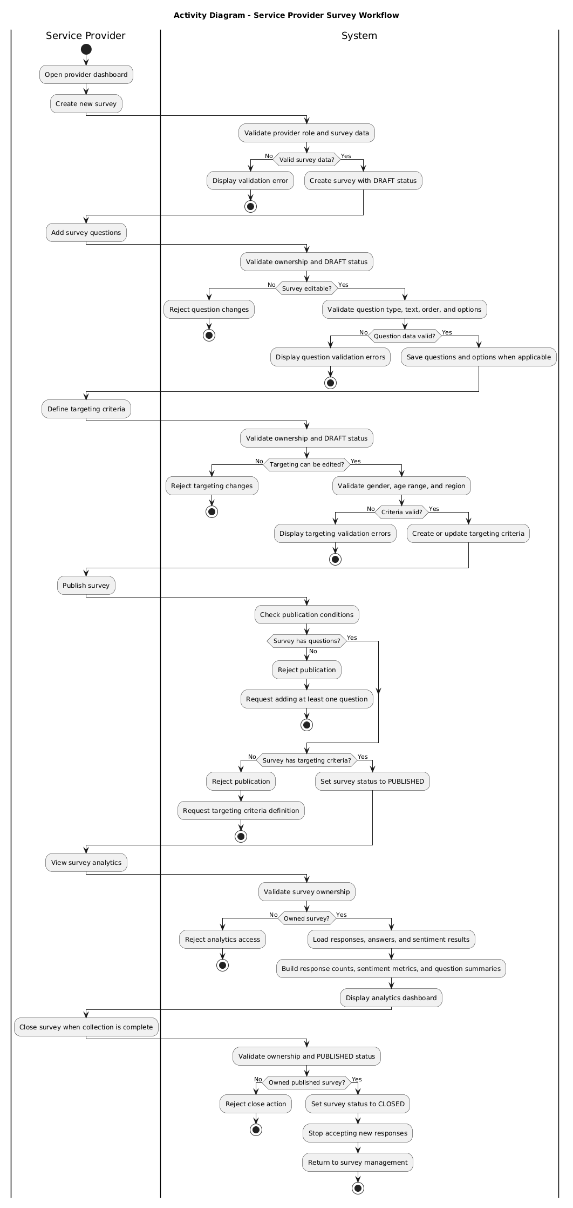
Figure 4.2: Activity Diagram - Service Provider Survey Workflow
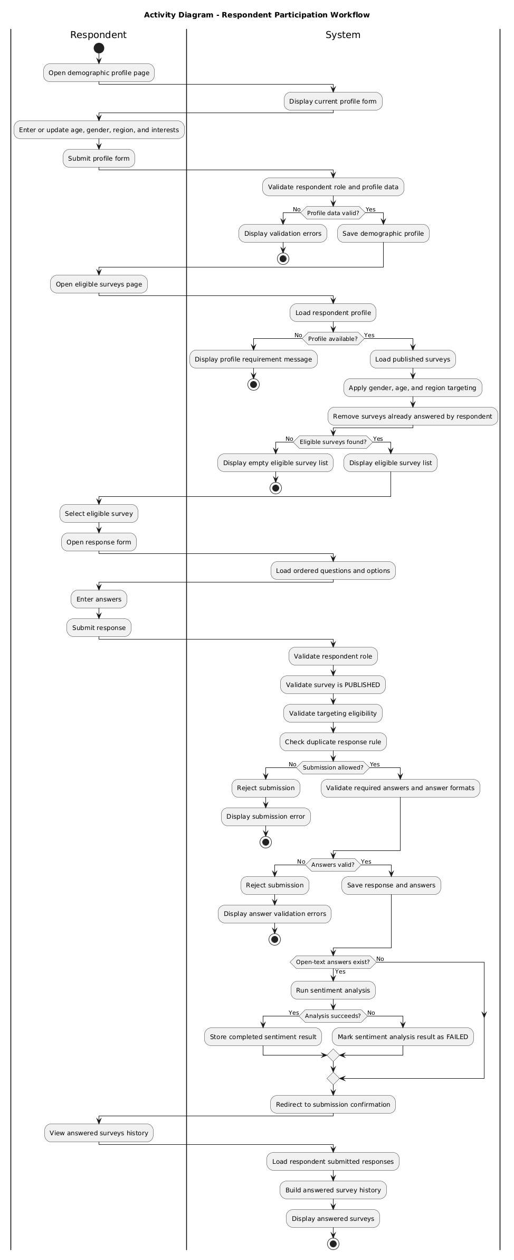
Figure 4.3: Activity Diagram - Respondent Participation Workflow
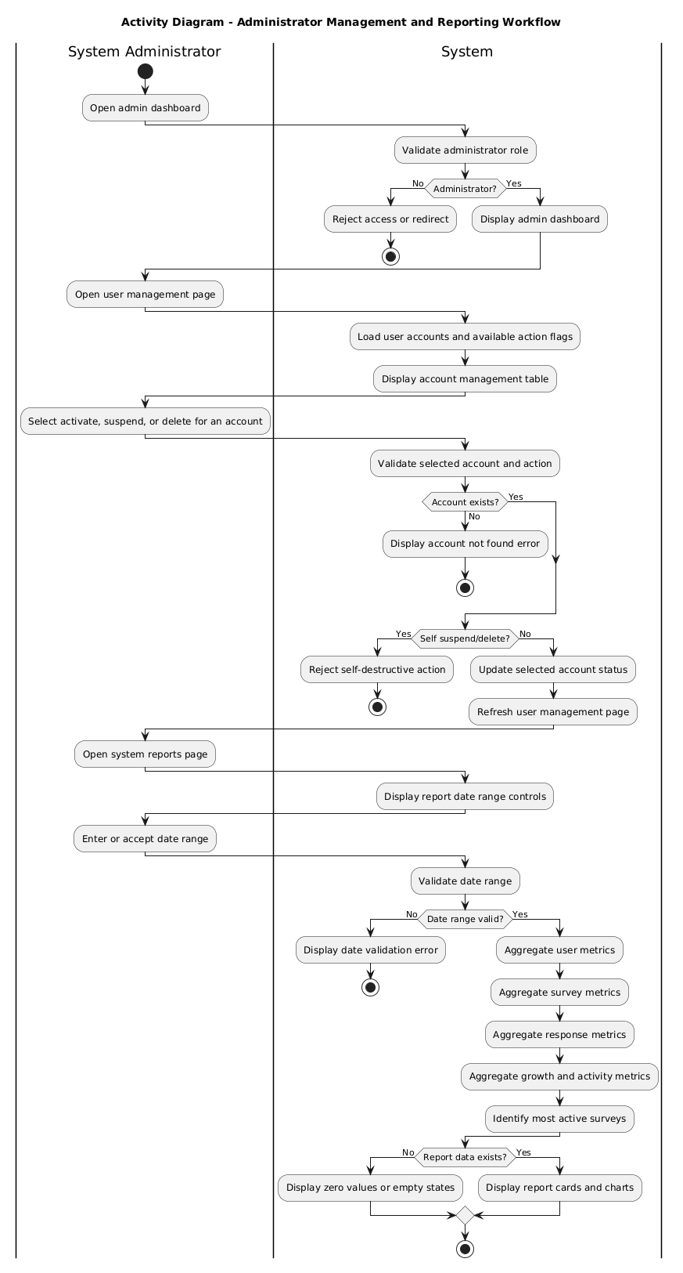
Figure 4.4: Activity Diagram - Administrator Management and Reporting Workflow

4.7.4 Sequence Diagrams
The sequence diagrams focus on the most critical system workflows rather than listing every use case. The selected diagrams represent survey publication, respondent participation with sentiment analysis, provider analytics, and administrator reporting.
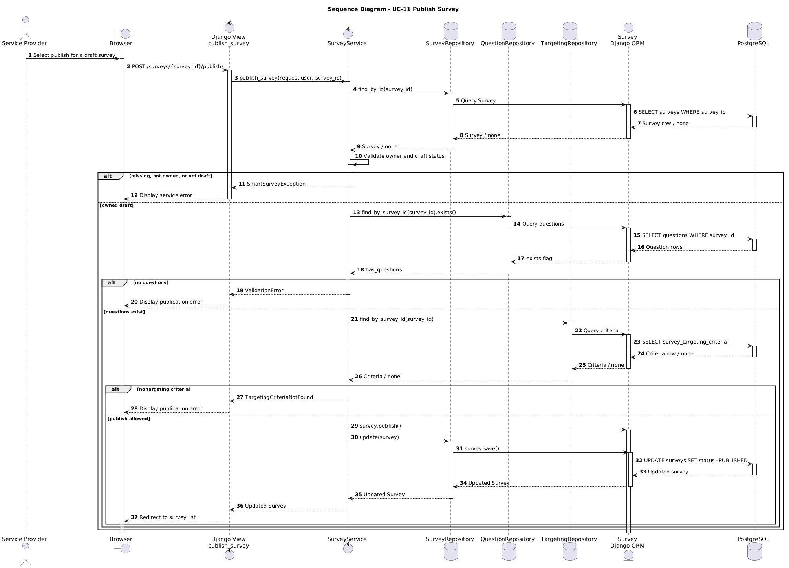
Figure 4.5: Sequence Diagram - Publish Survey
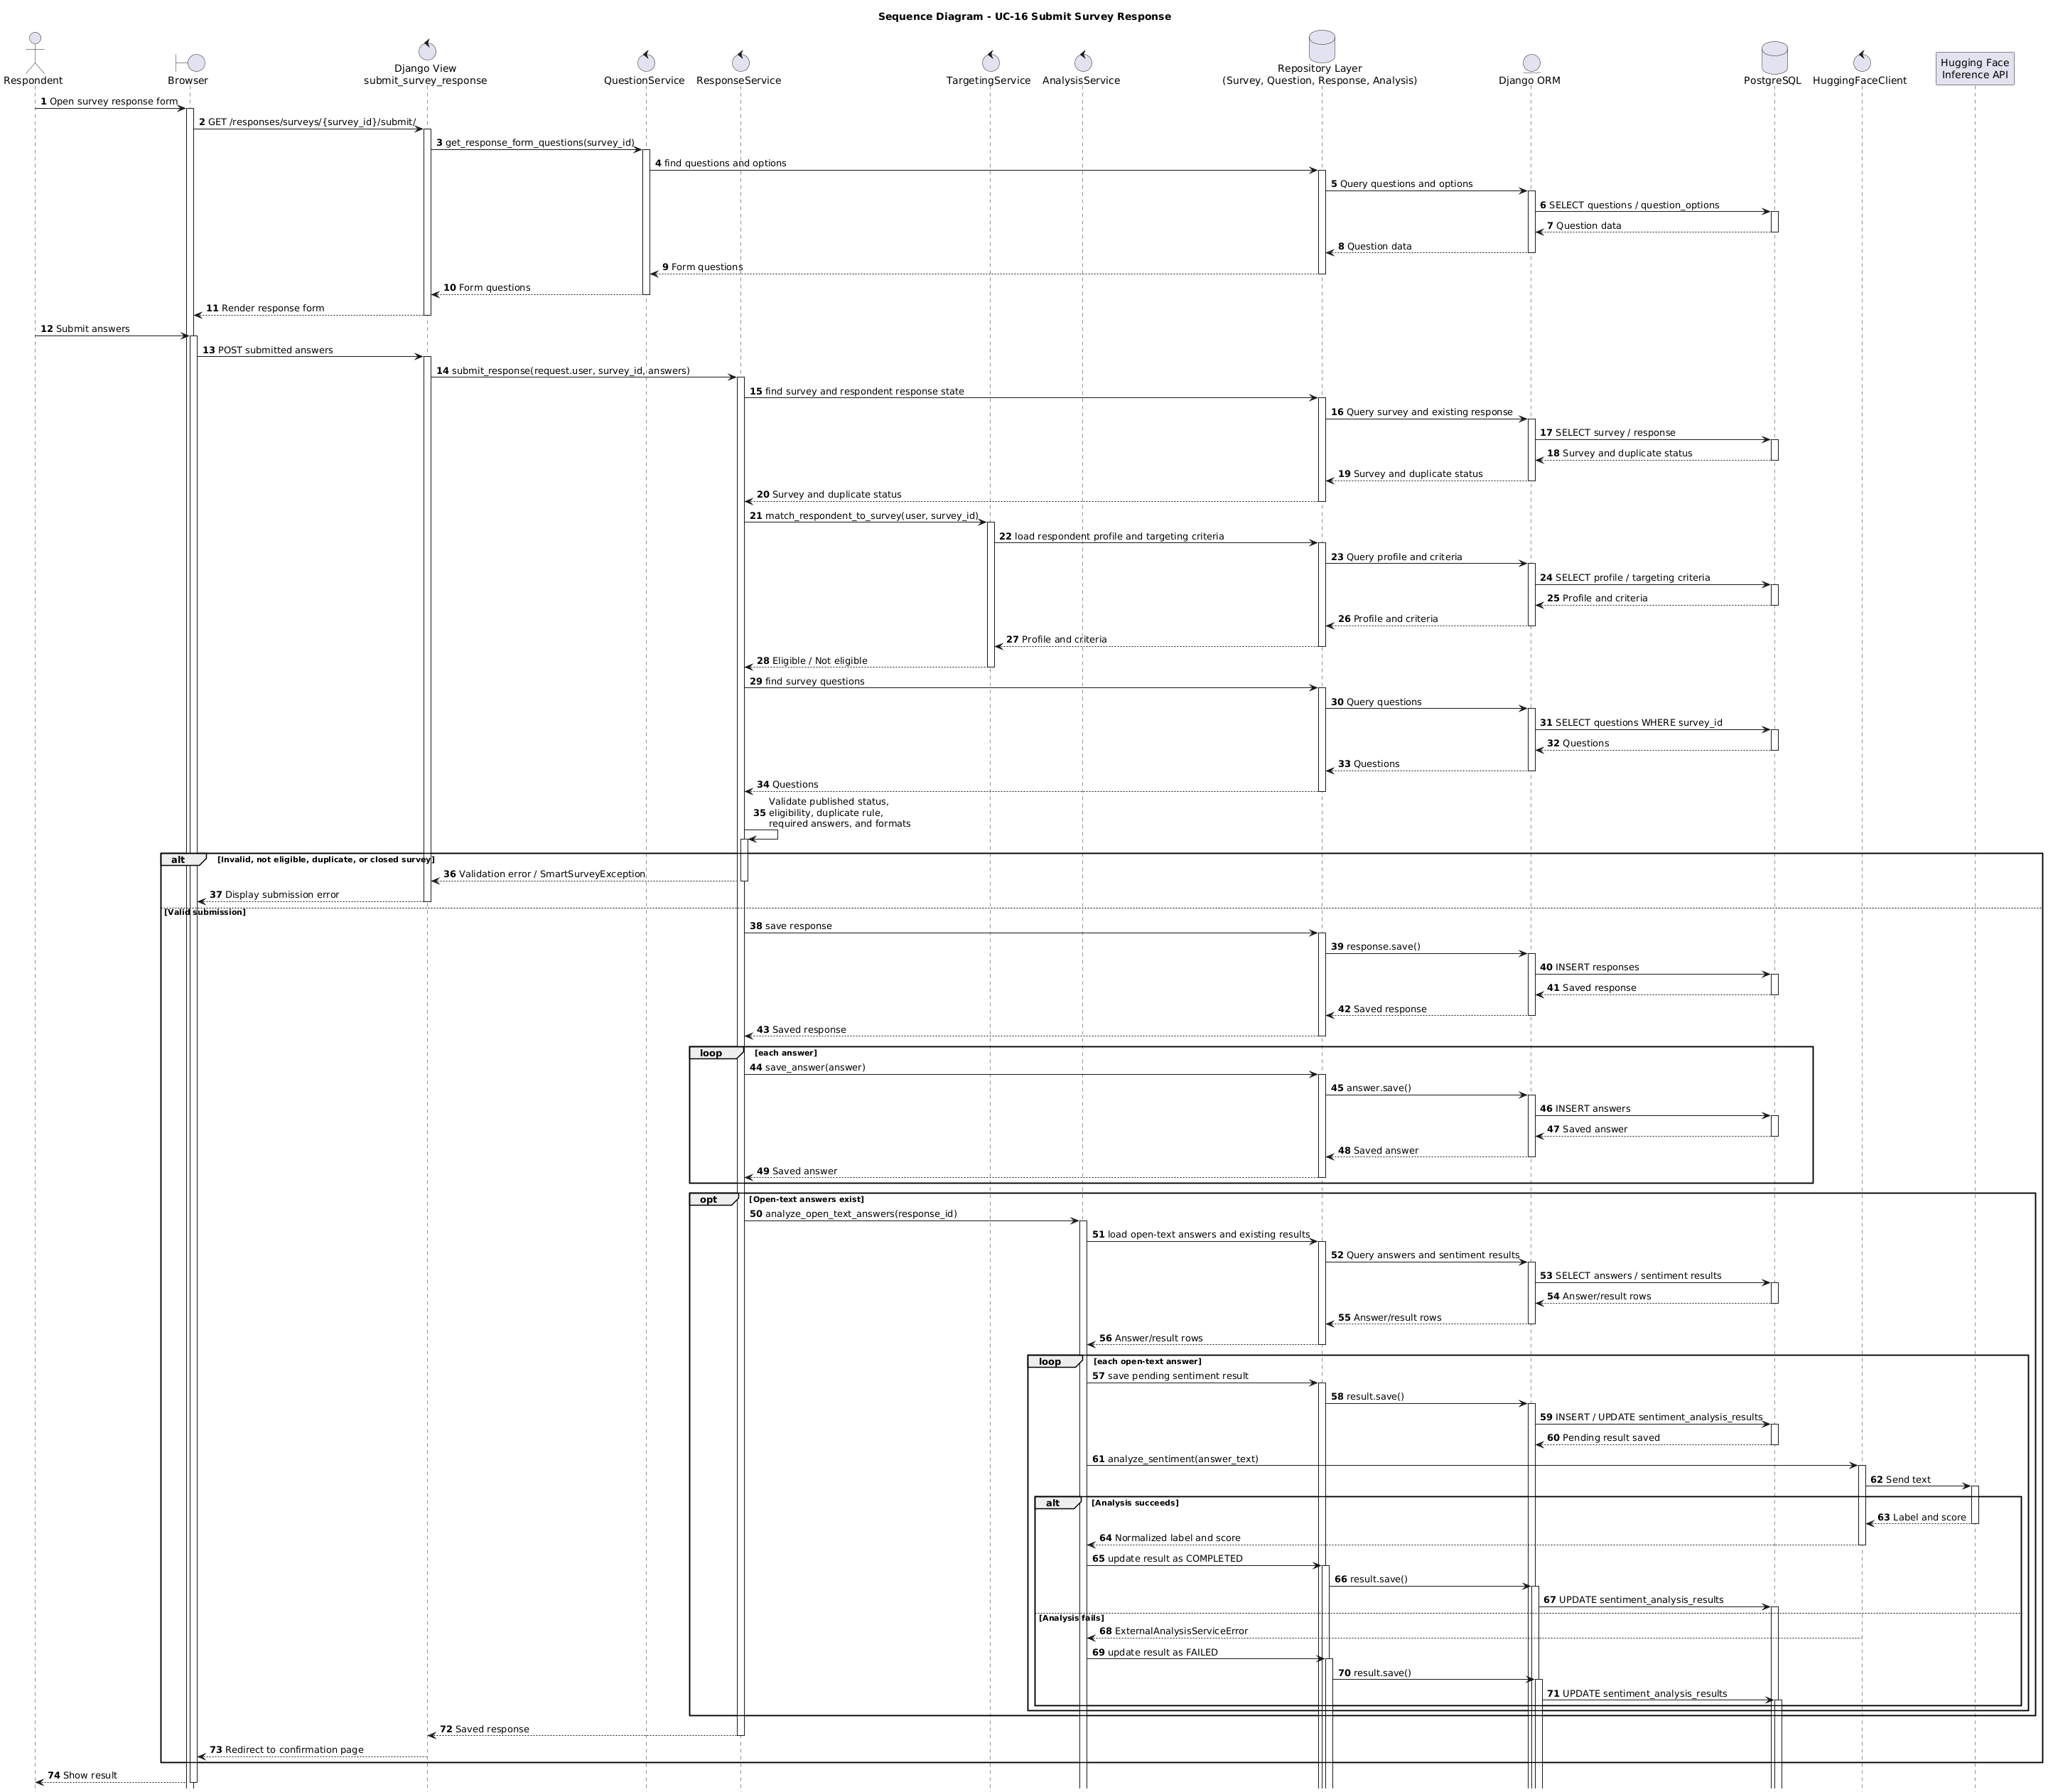
Figure 4.6: Sequence Diagram - Submit Survey Response
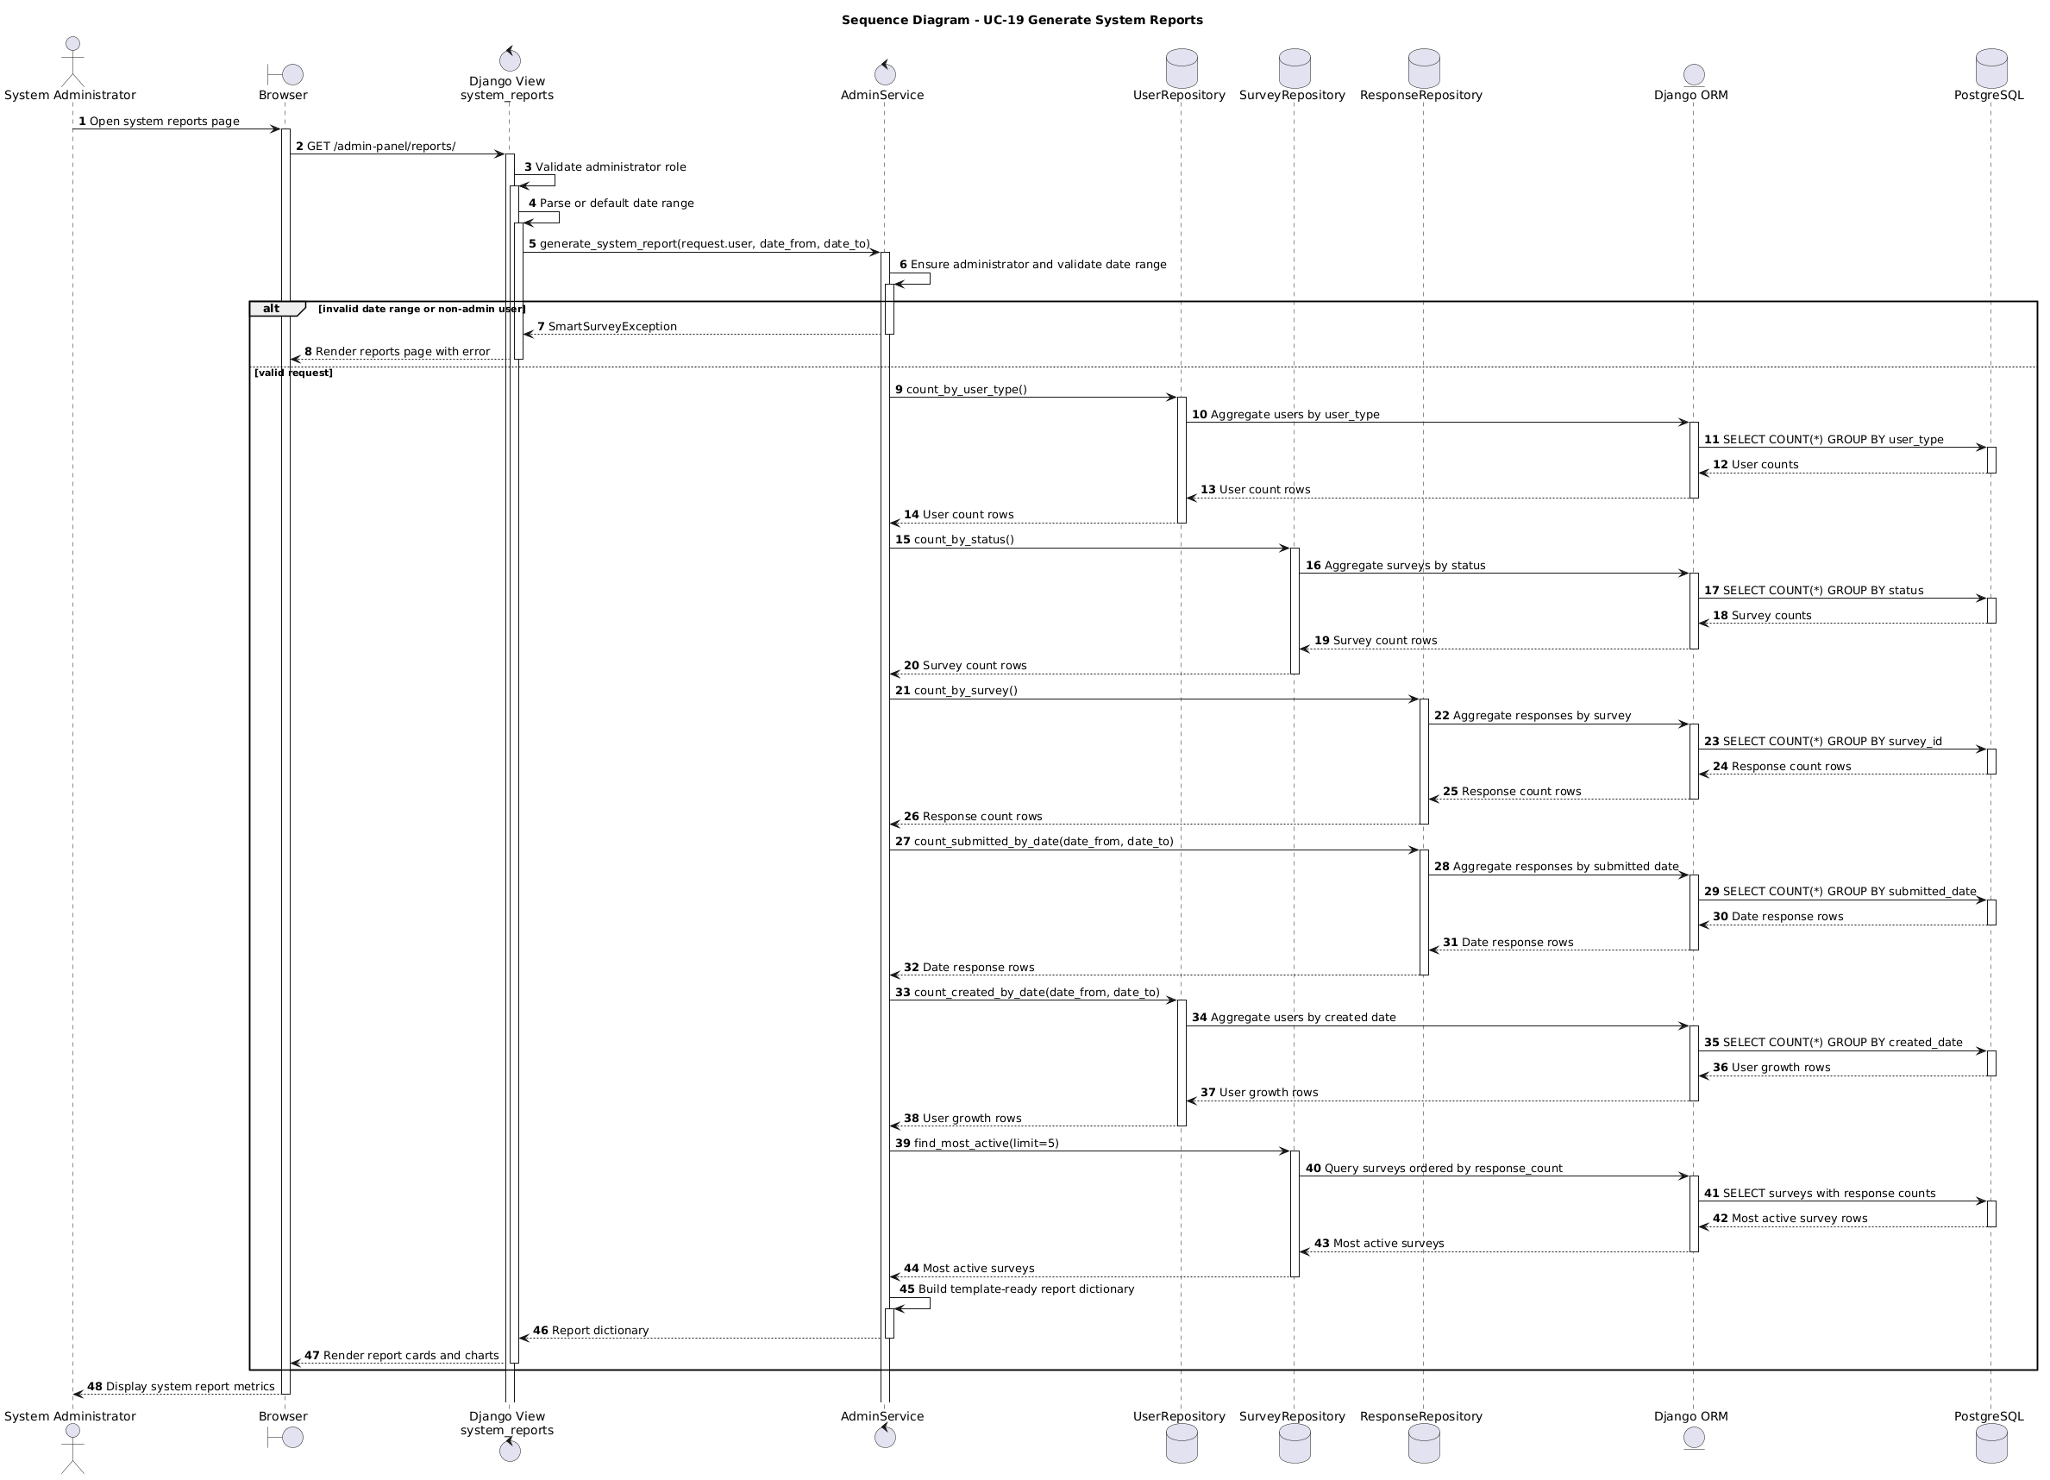
Figure 4.7: Sequence Diagram - Generate System Reports

4.7.5 Test Case Descriptions
Test Case | Scenario | Input / Condition | Expected Result | Related Use Case
TC-01 | Register service provider | Valid provider name, email, and password | Service provider account is created successfully | UC-01
TC-02 | Register respondent | Valid respondent account and demographic data | Respondent account and demographic profile are created | UC-02
TC-03 | Reject duplicate email | Registration request uses an existing email | Validation error is returned, and account is not created | UC-01, UC-02
TC-04 | Reject inactive account login | Suspended or deleted user attempts login | Login is rejected and access is blocked | UC-03
TC-05 | Add supported question type | Provider adds multiple-choice, rating-scale, or open-text question to draft survey | Question is saved according to its type and validation rules | UC-08
TC-06 | Publish incomplete survey | Draft survey has no questions or no targeting criteria | Publication is rejected with validation error | UC-11
TC-07 | Filter eligible surveys | Respondent profile and survey targeting criteria exist | Only matching, unanswered, published surveys are displayed | UC-15
TC-08 | Reject duplicate response | Respondent already answered the selected survey | Duplicate response error is returned | UC-16
TC-09 | Analyze open-text answer | Respondent submits an open-text answer | Sentiment result is stored as completed or failed safely | UC-13, UC-16
TC-10 | Admin suspends account | Administrator suspends an active user account | Account status becomes SUSPENDED | UC-18

4.8 Modeling According to the Agile Methodology
The project followed an Agile Iterative and Incremental Development methodology. Therefore, modeling focused on product backlog items, user stories, sprint-based feature delivery, and continuous refinement of requirements across iterations. A complete traditional SRS was not used as the primary management model; however, the functional and non-functional requirements were documented in a structured form to support academic traceability.

4.8.1 Product Backlog and User Stories
Table 4.7: Product Backlog Summary
Backlog ID | Backlog Item | Related Use Case | Priority | Sprint
PB-01 | Register service providers and respondents. | UC-01, UC-02 | Must | Sprint 1
PB-02 | Authenticate users and redirect them by role. | UC-03, UC-04 | Must | Sprint 1
PB-03 | Create and manage surveys. | UC-05, UC-06, UC-07 | Must | Sprint 2
PB-04 | Add survey questions with supported question types. | UC-08 | Must | Sprint 2
PB-05 | Define demographic targeting criteria. | UC-10 | Must | Sprint 2
PB-06 | Publish and close surveys. | UC-11, UC-12 | Must | Sprint 2
PB-07 | Display eligible surveys to respondents. | UC-15 | Must | Sprint 3
PB-08 | Submit survey responses and prevent duplicates. | UC-16 | Must | Sprint 3
PB-09 | Analyze open-text answers using sentiment analysis. | UC-16, UC-13 | Must | Sprint 3
PB-10 | Display provider analytics dashboard. | UC-13 | Must | Sprint 4
PB-11 | Manage user accounts by administrator. | UC-18 | Should | Sprint 4
PB-12 | Generate system reports. | UC-19 | Should | Sprint 4

Table 4.8: User Stories
Story ID | User Story | Acceptance Criteria
US-01 | As a service provider, I want to create surveys so that I can collect feedback from respondents. | The provider can create a draft survey with title and description.
US-02 | As a service provider, I want to add questions and targeting criteria so that the survey reaches the correct audience. | Questions and targeting criteria are saved only for owned draft surveys.
US-03 | As a service provider, I want to publish a complete survey so that eligible respondents can answer it. | Publication is allowed only when questions and targeting criteria exist.
US-04 | As a respondent, I want to view only eligible surveys so that I participate in relevant surveys. | The displayed surveys match the respondent profile and exclude answered surveys.
US-05 | As a respondent, I want to submit a survey response so that my feedback is recorded. | The response is saved once, and duplicate submissions are rejected.
US-06 | As a service provider, I want to view analytics so that I can understand survey results. | The dashboard shows response metrics and sentiment analysis results.
US-07 | As an administrator, I want to manage user accounts so that platform access is controlled. | The administrator can activate, suspend, or soft-delete user accounts.
US-08 | As an administrator, I want to generate system reports so that platform activity can be monitored. | Reports show user, survey, and response metrics.

4.8.2 SRS Support for Academic Traceability
Although the project was not managed using a traditional waterfall methodology, SRS-style documentation was used to structure the functional requirements, non-functional requirements, actors, use cases, and traceability matrix. This helped maintain academic clarity and ensured that implementation and testing could be mapped back to documented requirements.

Table 4.9: Iterative Feature List
Iteration / Sprint | Implemented Feature Group | Main Output
Sprint 0 | Discovery, requirement analysis, backlog setup, and architecture baseline. | MVP scope, initial requirements, use cases, and architecture plan.
Sprint 1 | Authentication, roles, and respondent profile foundation. | Registration, login/logout, role handling, and demographic profile structure.
Sprint 2 | Survey management, question management, targeting, and publication workflow. | Survey CRUD, question creation, targeting criteria, publish/close logic.
Sprint 3 | Respondent participation and intelligent analysis. | Eligible survey filtering, response submission, duplicate prevention, and sentiment analysis.
Sprint 4 | Dashboards, administration, reporting, testing, and documentation. | Analytics dashboard, admin user management, system reports, tests, and final report evidence.

4.9 Requirements Analysis and Documentation
Requirements traceability was used to ensure that each functional requirement is connected to the corresponding design component and testing scenario. This supports verification and prevents implementation features from becoming disconnected from the documented requirements.

Table 4.10: Requirements Traceability Matrix
Req. ID | Requirement Summary | Related Use Case | Design / Implementation Component | Related Test Case
FR-01 | Register service provider account. | UC-01 | AuthenticationService, UserRepository, User model, registration view/form | TC-01
FR-02 | Register respondent with demographic data. | UC-02 | AuthenticationService, ProfileRepository, User model, RespondentProfile model | TC-02
FR-03 | Login using email and password. | UC-03 | AuthenticationService, UserRepository, Django authentication/session | TC-03
FR-04 | Logout authenticated users. | UC-04 | Django logout view and session framework | TC-04
FR-05 | Create surveys with title and description. | UC-05 | SurveyService, SurveyRepository, Survey model, survey form/view | TC-05
FR-06 | Update own draft survey details. | UC-06 | SurveyService, SurveyRepository, Survey model | TC-05
FR-07 | Delete own draft or closed surveys. | UC-07 | urvey.can_delete, SurveyService.delete_survey, survey templates | TC-05
FR-08 | Support multiple-choice, rating-scale, and open-text question types. | UC-08, UC-16 | Question model, Answer model, QuestionService, ResponseService | TC-06
FR-09 | Add questions to owned draft surveys. | UC-08 | QuestionService, QuestionRepository, QuestionOption model, question form/view | TC-06
FR-10 | Update and delete questions on owned draft surveys. | UC-09 | QuestionService, QuestionRepository | TC-07
FR-11 | Define demographic targeting criteria. | UC-10 | TargetingService, TargetingRepository, TargetingCriteria model | TC-08
FR-12 | Publish surveys only when publication conditions are satisfied. | UC-11 | SurveyService, QuestionRepository, TargetingRepository, Survey model | TC-09
FR-13 | Close published surveys. | UC-12 | SurveyService, SurveyRepository, Survey model | TC-09
FR-14 | View analytics for owned surveys. | UC-13 | AnalysisService, ResponseRepository, AnalysisRepository, analytics dashboard | TC-10
FR-15 | Manage respondent demographic profile. | UC-14 | ProfileService, ProfileRepository, RespondentProfile model, profile form/view | TC-11
FR-16 | List only eligible published surveys for respondent. | UC-15 | SurveyService, TargetingRepository, ResponseRepository, ProfileRepository | TC-12
FR-17 | Submit responses to eligible published surveys. | UC-16 | ResponseService, QuestionService, Response model, Answer model | TC-13
FR-18 | Prevent duplicate response for same survey/respondent. | UC-16 | ResponseService, ResponseRepository, Response unique constraint | TC-13
FR-19 | View already answered surveys. | UC-17 | ResponseService, ResponseRepository, answered surveys view/template | TC-14
FR-20 | Activate, suspend, and soft-delete user accounts. | UC-18 | AdminService, UserRepository, User model, admin user management view | TC-15
FR-21 | Generate system reports for platform activity. | UC-19 | AdminService, UserRepository, SurveyRepository, ResponseRepository, reports dashboard | TC-16
FR-22 | Run sentiment analysis for open-text answers and store result state. | UC-16, UC-13 | AnalysisService, HuggingFaceClient, AnalysisRepository, SentimentAnalysisResult model | TC-17

Table 4.11: Initial Test Cases
Test Case | Scenario | Input / Condition | Expected Result | Related Req. ID
TC-01 | Register service provider | Valid provider name, email, and password | Service provider account is created | FR-01
TC-02 | Register respondent | Valid account and demographic data | Respondent account and profile are created | FR-02
TC-03 | Login validation | Valid credentials, invalid credentials, suspended/deleted account | Valid active user logs in; invalid or inactive users are rejected | FR-03
TC-04 | Logout user | Authenticated user requests logout | Session is ended and user is redirected | FR-04
TC-05 | Survey draft CRUD | Provider creates, updates, or deletes own draft survey | Draft survey is created, updated, or deleted according to status rules | FR-05, FR-06, FR-07
TC-06 | Add supported question types | Provider adds multiple-choice, rating-scale, or open-text question | Question is saved according to type and validation rules | FR-08, FR-09
TC-07 | Update/delete question service rule | Provider updates or deletes a question on an owned draft survey | Service accepts valid draft operations and rejects invalid ones | FR-10
TC-08 | Define targeting criteria | Provider submits gender, age range, or region criteria | Targeting criteria are created or updated | FR-11
TC-09 | Publish and close survey | Draft survey with questions and targeting; published survey to close | Complete draft is published; published survey is closed | FR-12, FR-13
TC-10 | View survey analytics | Provider opens analytics for owned survey | Response counts, sentiment metrics, and summaries are displayed | FR-14
TC-11 | Manage demographic profile | Respondent submits valid profile data | Profile is saved and used for eligibility | FR-15
TC-12 | Filter eligible surveys | Respondent profile and targeting criteria exist | Only matching unanswered published surveys are displayed | FR-16
TC-13 | Submit response and prevent duplicate | Respondent submits answers, then tries again | First response is saved; duplicate submission is rejected | FR-17, FR-18
TC-14 | View answered surveys | Respondent has submitted responses | Answered survey history is displayed | FR-19
TC-15 | Manage user accounts | Administrator activates, suspends, or soft-deletes account | Account status is updated, and self-destructive actions are rejected | FR-20
TC-16 | Generate system reports | Administrator selects or accepts date range | Platform report metrics are generated and displayed | FR-21
TC-17 | Analyze open-text answer | Response contains open-text answer | Sentiment result is stored as completed or failed safely | FR-22

Section Three: Design and Architecture

Chapter 5: System Architectural Design

5.1 High-Level Design
The Smart Survey Platform is implemented as a Django web application using Django MVT combined with an explicit layered architecture. Django MVT is used to structure web presentation through views, templates, and models, while the layered architecture separates presentation, business logic, data access, domain models, and external AI integration.
The presentation layer contains Django views, forms, templates, Bootstrap, and Chart.js. The service layer contains business rules, validation, authorization checks, and workflow orchestration. The repository layer isolates database operations through Django ORM. The domain/data layer contains the persistent models, relationships, constraints, and helper methods. The infrastructure layer isolates communication with the Hugging Face Inference API.

5.1.1 Architectural Block Diagram
The system block diagram illustrates the main components of the Smart Survey Platform and how they interact. Users access the system through a web browser. The browser communicates with Django views, which render templates, process forms, and call service classes. Service classes apply business rules and call repositories. Repositories access Django ORM models, which are mapped to the PostgreSQL database. The AI component is isolated through HuggingFaceClient, which communicates with the Hugging Face Inference API.
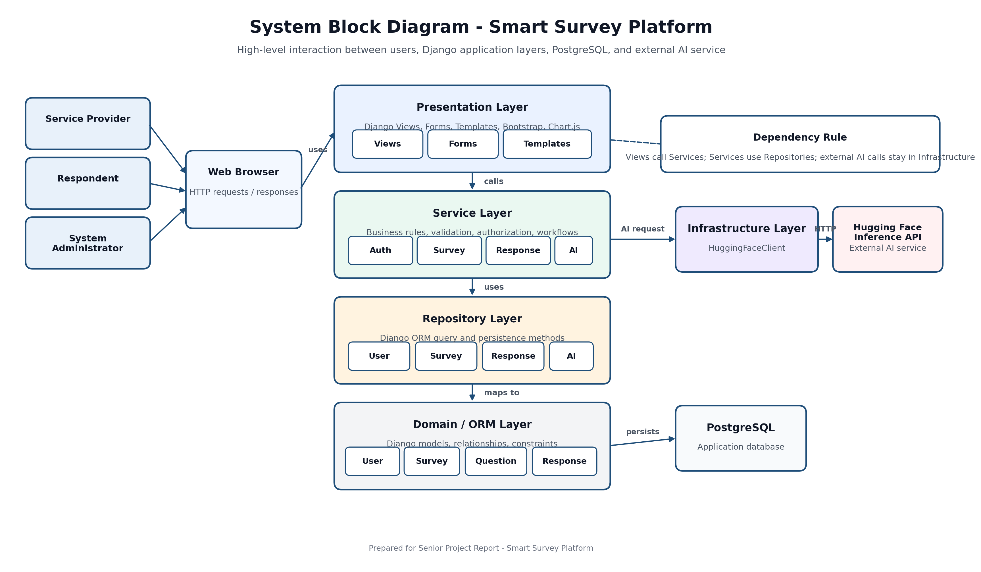Figure 5.1: System Block Diagram

5.1.2 Architectural Pattern Used
The architectural pattern used in this project is Layered Architecture implemented inside a Django MVT web application. Django MVT provides the web framework structure, while the layered architecture enforces separation of concerns between presentation, business logic, data access, domain models, and infrastructure.
The main dependency direction is:
Views → Services → Repositories → Django ORM Models → PostgreSQL
The intelligent analysis dependency direction is:
ResponseService → AnalysisService → HuggingFaceClient → Hugging Face Inference API
The system does not use a microservices architecture. It is implemented as a modular monolithic Django application with strict internal layers.
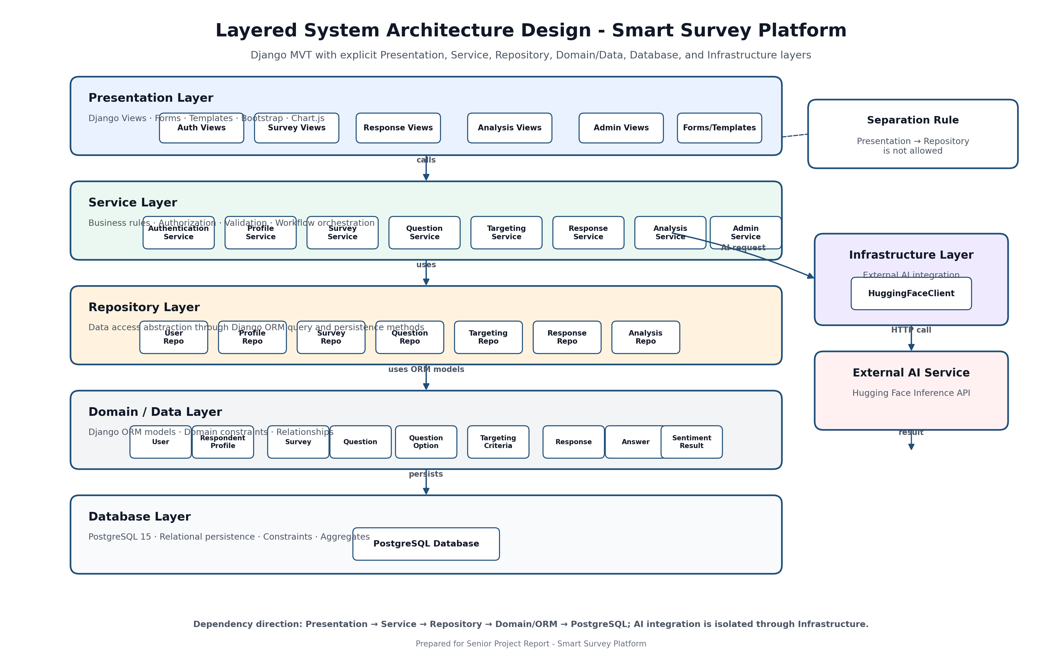
Figure 5.2: Layered System Architecture Design

5.1.3 System Architecture Design
The system architecture is organized into five main layers. The presentation layer handles HTTP requests, form validation, template rendering, and user interface responses. It does not contain business rules. The service layer contains the core business logic, including role validation, survey lifecycle rules, targeting checks, duplicate response prevention, and sentiment analysis orchestration. The repository layer isolates database queries and persistence operations. The domain/data layer defines the Django ORM models, relationships, constraints, and helper methods. The infrastructure layer isolates external communication with the Hugging Face Inference API.

Table 5.1: Architectural Layers
Layer | Implementation Location | Responsibility
Presentation Layer | apps/*/views.py, apps/*/forms.py, templates/, static/ | Handles requests, forms, templates, UI rendering, and user feedback.
Service Layer | services/ | Contains business rules, authorization checks, validation, and workflow orchestration.
Repository Layer | repositories/ | Encapsulates database queries and persistence operations through Django ORM.
Domain / Data Layer | apps/core/models/ | Defines persistent entities, relationships, constraints, and domain helper methods.
Infrastructure Layer | infrastructure/huggingface_client.py | Handles external AI communication with the Hugging Face Inference API.
Database Layer | PostgreSQL | Stores users, profiles, surveys, questions, responses, answers, and sentiment analysis results.

5.2 Database Design

5.2.1 Chen Entity Relationship Diagram
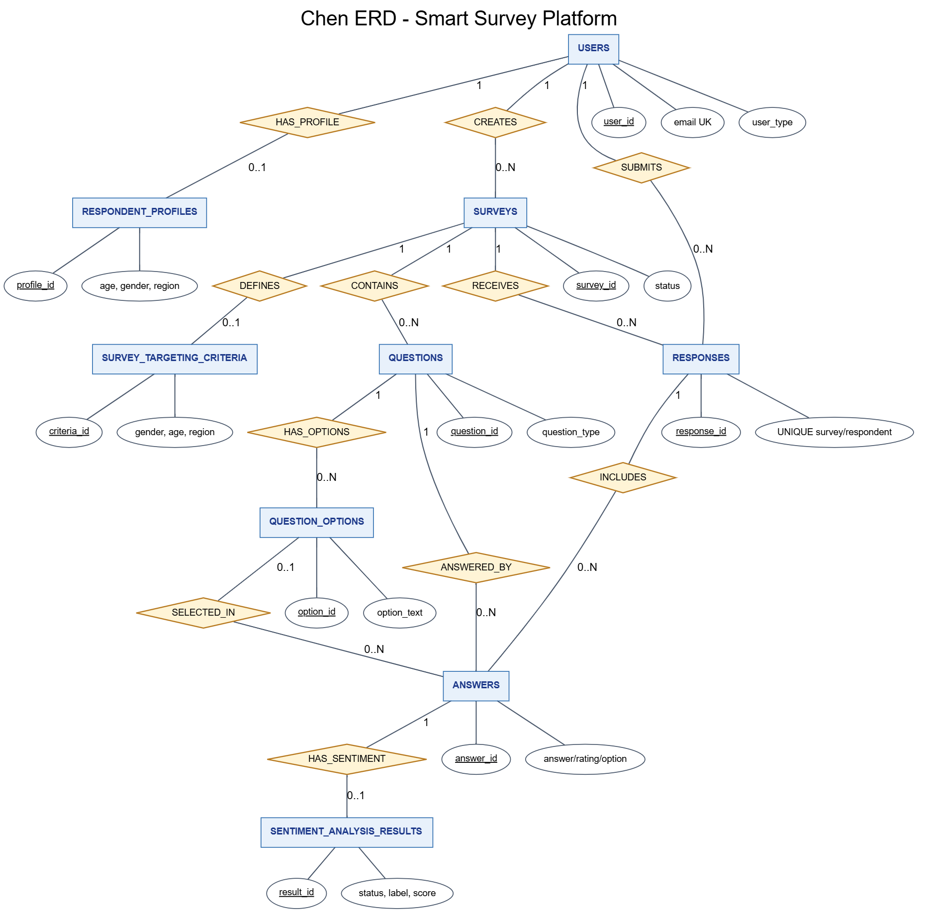
Figure 5.3: Chen Entity Relationship Diagram

5.2.2 Relational Schema

Figure 5.4: Relational Schema

Table 5.2: Database Entities
Model | Database Table | Purpose
User | users | Custom user model using email authentication, role, account status, and creation timestamp.
RespondentProfile | respondent_profiles | One-to-one demographic profile for respondent users, including age, gender, region, interests, and update timestamp.
Survey | surveys | Survey owned by a service provider, with title, description, status, creation, publication, and closing timestamps.
Question | questions | Survey question with question text, question type, required flag, and ordering index.
QuestionOption | question_options | Multiple-choice option linked to a question.
TargetingCriteria | survey_targeting_criteria | One-to-one survey targeting configuration using gender, age range, and region.
Response | responses | Survey submission by a respondent, with a uniqueness rule preventing duplicate participation.
Answer | answers | Question-level answer supporting open-text values, rating-scale values, and selected multiple-choice options.
Sentiment  Analysis  Result | sentiment_analysis_results | One-to-one sentiment analysis result for open-text answers, including label, score, status, and analysis timestamp.

5.2.3 Constraints and Keys
Table 5.3: Database Constraints and Keys
Key / Constraint | Type | Purpose
users.user_id | Primary Key | Uniquely identifies each user account.
users.email | Unique | Prevents duplicate accounts and supports email-based authentication.
respondent_profiles.profile_id | Primary Key | Uniquely identifies each respondent profile.
respondent_profiles.user_id | One-to-One Foreign Key | Ensures that each respondent has at most one demographic profile.
surveys.survey_id | Primary Key | Uniquely identifies each survey.
surveys.provider_id | Foreign Key | Links each survey to its service provider.
questions.question_id | Primary Key | Uniquely identifies each survey question.
questions.survey_id | Foreign Key | Links each question to its survey.
question_options.option_id | Primary Key | Uniquely identifies each multiple-choice option.
question_options.question_id | Foreign Key | Links each option to its question.
survey_targeting_criteria.criteria_id | Primary Key | Uniquely identifies each targeting criteria record.
survey_targeting_criteria.survey_id | One-to-One Foreign Key | Ensures that each survey has at most one targeting criteria record.
responses.response_id | Primary Key | Uniquely identifies each submitted response.
responses.survey_id | Foreign Key | Links each response to the survey being answered.
responses.respondent_id | Foreign Key | Links each response to the respondent who submitted it.
responses(survey_id, respondent_id) | Unique Constraint | Prevents duplicate survey participation by the same respondent.
answers.answer_id | Primary Key | Uniquely identifies each answer.
answers.response_id | Foreign Key | Links each answer to its submitted response.
answers.question_id | Foreign Key | Links each answer to the question being answered.
answers.selected_option_id | Nullable Foreign Key | Supports multiple-choice answers without forcing selected options for open-text or rating-scale questions.
sentiment_analysis_results.result_id | Primary Key | Uniquely identifies each sentiment analysis result.
sentiment_analysis_results.answer_id | One-to-One Foreign Key | Ensures that each analyzed answer has at most one sentiment analysis result.

5.3 External Interface Design
The Smart Survey Platform is implemented as a server-rendered Django web application. The current system does not expose a public REST API. User interactions are handled through Django URL routes, views, forms, and templates. The only external API integration in the current implementation is the Hugging Face Inference API, which is used for sentiment analysis of open-text answers.
Table 5.4: External API Design
Field | Description
API Name | Hugging Face Inference API
API Type | External AI API
Purpose | Perform sentiment analysis on open-text survey answers.
Path / Endpoint | HF_SENTIMENT_MODEL_URL
Method | POST
Authentication | Bearer token configured through HF_API_TOKEN environment variable.
Parameters | text: the open-text answer submitted by the respondent.
Request Body | { "inputs": text }
Return Value | Sentiment prediction result containing label and confidence score.
Normalized Return Value | POSITIVE, NEUTRAL, or NEGATIVE with a numeric score.
Success Handling | The sentiment analysis result is stored with status COMPLETED.
Error Codes / Error Cases | 401/403: invalid or missing token.404: invalid model endpoint.429: rate limit.5xx: external service failure.Timeout, request failure, invalid JSON, invalid payload, unknown label, or invalid score are handled as external analysis errors.
Failure Handling | The submitted response remains saved, and the sentiment analysis result is stored with status FAILED.
Implementation Location | infrastructure/huggingface_client.py
Security Note | The API token is not exposed to templates or client-side JavaScript.

5.4 Security and Authorization Design
Security and authorization are implemented using Django authentication, session management, role-based access control, service-layer validation, ownership checks, database constraints, and environment-based configuration. The system uses Django session-based authentication rather than JWT or OAuth.
Table 5.5: Security and Authorization Design
Security Control | Design Decision
Authentication Mechanism | The system uses Django session-based authentication with email and password.
Password Storage | Passwords are stored using Django password hashing, not plaintext storage.
Session Management | Login and logout are handled through Django authentication and session infrastructure.
CSRF Protection | Django CSRF protection is used for form submissions.
Secret Management | Runtime secrets such as database credentials and Hugging Face API token are loaded from environment variables.
Role-Based Access Control | The system separates access according to Service Provider, Respondent, System Administrator, and Guest roles.
Ownership Validation | Service providers can update, delete, publish, close, and view analytics only for their own surveys.
Respondent Eligibility | Respondents can view and answer only published surveys matching their demographic profile and not already answered.
Duplicate Response Prevention | Service-level validation and a database unique constraint prevent repeated participation in the same survey.
External API Protection | Hugging Face API access is isolated in HuggingFaceClient; API tokens are not exposed to templates or JavaScript.
Admin Self-Protection | Administrators cannot suspend or soft-delete their own account.
Soft Deletion | User deletion is handled through account status rather than immediate physical deletion.

Table 5.6: User Roles and Access Levels
Role | Access Level
Guest | Can access public pages, registration pages, and login page only.
Service Provider | Can manage own surveys, questions, targeting criteria, publication/closing, and survey analytics.
Respondent | Can manage demographic profile, view eligible surveys, submit responses, and view answered surveys.
System Administrator | Can manage user account status and generate system reports.

Section Four: Implementation and Testing

Chapter 6: Implementation Environment and Tools

6.1 Software Tools and Libraries
Table 6.1: Technology Stack
Tool | Purpose | Evidence / Status
Python | Main backend programming language. | Confirmed by requirements.txt, manage.py, and .github/workflows/django-ci.yml. CI uses Python 3.11.
Django | Web application framework. | Confirmed by requirements.txt and config/settings.py.
PostgreSQL | Relational database server. | Confirmed by config/settings.py and docker-compose.yml.
Docker Compose | Runs the local PostgreSQL service. | Confirmed by docker-compose.yml. It does not define a Django application service.
Git | Version control tool. | Confirmed by Git repository status and branch information.
GitHub | Remote source control hosting. | Confirmed by git remote -v: https://github.com/Yaman8almatar/smart-survey-platform.git.
GitHub Actions | Continuous Integration tool. | Confirmed by .github/workflows/django-ci.yml; CI only, not deployment.
pytest | Test runner for service-layer tests. | Confirmed by requirements.txt, pytest.ini, and tests/services/.
pytest-django | Django integration for pytest. | Confirmed by requirements.txt and pytest.ini.
Hugging Face Inference API | External sentiment analysis service. | Confirmed by infrastructure/huggingface_client.py and .env.example.
Developer editor | Code editing environment. | Team-reported / not repository-evidenced. No PyCharm, VS Code, or other editor is claimed.

6.2 Development Environment and Project Structure
The project is a server-rendered Django web application organized using a layered architecture. The repository separates Django views and templates from services, repositories, domain models, and external infrastructure clients.

Table 6.2: Development Environment and Project Structure
Item | Description
Development environment | Local inspection was performed on Windows (Microsoft Windows NT 10.0.26200.0). CI is configured separately on Ubuntu.
Operating system | Local OS confirmed as Windows. CI runner confirmed as ubuntu-latest. Production OS is not confirmed.
Application type | Web-based Django survey management platform, confirmed by README.md, config/settings.py, and templates/base.html.
Main configuration folder | config/ contains Django settings and URL configuration.
Django apps | apps/admin_panel/, apps/analysis/, apps/core/, apps/responses/, apps/surveys/, and apps/users/.
Domain models | apps/core/models/ contains User, RespondentProfile, Survey, Question, QuestionOption, TargetingCriteria, Response, Answer, and SentimentAnalysisResult.
Services | services/ contains business workflow classes such as authentication, survey, question, targeting, response, analysis, profile, and admin services.
Repositories | repositories/ contains data access classes using Django ORM.
Infrastructure | infrastructure/huggingface_client.py isolates Hugging Face API communication.
Templates | Shared templates are under templates/; app templates are under apps/*/templates/.
Static files | static/css/site.css and static/js/site.js provide project CSS and JavaScript.
Tests | tests/services/ contains 8 service test files and 160 detected test functions.
Documentation/report assets | Docs_1/ contains seminar/report assets. docs/ is local ignored working context according to .gitignore.

6.3 Programming Languages and Frameworks
Table 6.3: Programming Languages and Frameworks
Category | Technology | Purpose
Programming language | Python | Backend application code and Django project execution.
Web framework | Django 4.2.11 | Web routing, views, models, forms, authentication, and templates.
Template engine | Django Templates | Server-rendered HTML templates.
UI framework | Bootstrap 5.3.3 | User interface styling, confirmed in templates/base.html.
Icon library | Bootstrap Icons 1.11.3 | Navigation and UI icons, confirmed in templates/base.html.
Charting library | Chart.js 4.4.1 | Dashboard and report charts, confirmed in templates/base.html.
ORM | Django ORM | Model mapping and database access.
HTTP client | requests 2.31.0 | External Hugging Face API calls in infrastructure/huggingface_client.py.
External AI API | Hugging Face Inference API | Sentiment analysis for open-text answers.
Test framework | pytest 8.1.1 | Service-layer test execution.
Django test integration | pytest-django 4.8.0 | Django settings and database support for pytest.

6.4 Database Server and Operating System
Table 6.4: Database Server and Runtime Environment
Item | Technology / Configuration | Purpose
Database server | PostgreSQL 15 from docker-compose.yml (postgres:15). | Local relational database service.
Database driver | psycopg[binary]==3.1.18 from requirements.txt. | Connect Django to PostgreSQL.
ORM | Django ORM from Django 4.2.11. | Map Django models to PostgreSQL tables.
Database configuration | config/settings.py reads DB_NAME, DB_USER, DB_PASSWORD, DB_HOST, and DB_PORT. | Environment-based database configuration.
Local operating system | Windows confirmed by local inspection command. | Local development/inspection environment.
CI operating system | ubuntu-latest in .github/workflows/django-ci.yml. | GitHub Actions test runner.
Django development server | python manage.py runserver documented in README.md. | Local development server.

6.5 Dependencies
Table 6.5: Main Python Dependencies
Dependency | Version | Purpose
Django | 4.2.11 | Web framework, ORM, templates, forms, authentication, and settings.
psycopg[binary] | 3.1.18 | PostgreSQL database driver.
python-dotenv | 1.0.1 | Load environment variables from .env.
pytest | 8.1.1 | Python test runner.
pytest-django | 4.8.0 | Django integration for pytest.
requests | 2.31.0 | HTTP client for external Hugging Face API calls.

6.6 Version Control and Source Control Tools
Table 6.6: Version Control and Source Control Tools
Tool / Item | Purpose / Status
Git | Repository uses Git for source control. Current branch status: main...origin/main.
GitHub remote | Confirmed remote: https://github.com/Yaman8almatar/smart-survey-platform.git.
Current branch | main is the active local branch.
Branch structure | Confirmed local branches include main, develop, feature/backend-core, and feature/frontend. Confirmed remote branches include origin/main, origin/develop, origin/feature/ai-analysis, origin/feature/backend-core, and origin/feature/frontend.
Tracked files | git ls-files reported 177 tracked files during inspection.
.gitignore | Ignores .env, virtual environments, cache files, local Codex files, and temporary Office files.
CI workflow tracking status | .github/workflows/django-ci.yml exists locally; current Git status showed .github/ as untracked before commit.

6.7 CI/CD Tools
Table 6.7: Continuous Integration and Deployment Status
Item | Status
CI tool | GitHub Actions.
Workflow file | .github/workflows/django-ci.yml.
Workflow name | Django CI.
Trigger | push and pull_request for main and develop.
Runner | ubuntu-latest.
Python version | Python 3.11 through actions/setup-python@v5.
Database service | PostgreSQL 15 through postgres:15.
Dependency installation | python -m pip install --upgrade pip and python -m pip install -r requirements.txt.
CI commands | python manage.py check and python -m pytest tests/services -q.
External API secrets | Uses dummy Hugging Face values in CI. No real token is stored in the repository.
Continuous Deployment | Not implemented. No deployment workflow exists.
Production Deployment | Not claimed. No production deployment evidence exists.
Execution evidence | CI workflow is configured; successful execution evidence should be captured from GitHub Actions after pushing.

6.8 Testing Environment
Table 6.8: Testing Environment
Item | Description
Test framework | pytest==8.1.1 from requirements.txt.
Django test support | pytest-django==4.8.0 from requirements.txt; pytest.ini sets DJANGO_SETTINGS_MODULE = config.settings.
Test location | tests/services/.
Service test files | 8 files were detected under tests/services/.
Test functions | 160 def test_ functions were detected under tests/services/.
Django check command | python manage.py check.
pytest command | python -m pytest tests/services -q.
Test scope | Service-layer workflows, validation rules, repositories through Django ORM, and AI analysis behavior using test doubles.
External API testing rule | CI uses dummy Hugging Face values; service tests should not depend on a real external API call.
Local execution evidence | Not confirmed in this chapter generation step. Local python command was unavailable; py --version returned Python 3.7.8, while CI is configured for Python 3.11.
GitHub Actions evidence | CI workflow is configured; successful run evidence should be captured after pushing the workflow to GitHub.

Chapter 7: Software Implementation
This chapter presents representative implementation examples from the Smart Survey Platform. The full source code is kept in the repository and can be placed in an appendix if required. The selected snippets demonstrate the implemented project structure, modules, web route handling, external API integration, data access, business rules, user interface, and AI-assisted sentiment analysis.

7.1 Project File Structure
The project uses a layered Django structure. The main folders are shown below.
Code snippet 7.1: Compact Project Structure
File path | Repository root
Purpose | Shows the main project folders without listing every implementation file.

smart-survey-platform/
|-- config/
|-- apps/
| |-- core/
| | `-- models/
| |-- users/
| |-- surveys/
| |-- responses/
| |-- analysis/
| `-- admin_panel/
|-- services/
|-- repositories/
|-- infrastructure/
|-- templates/
|-- static/
|-- tests/
| `-- services/
|-- requirements.txt
|-- docker-compose.yml
`-- .github/
`-- workflows/

Explanation: The structure separates configuration, Django apps, services, repositories, infrastructure clients, templates, static assets, tests, dependencies, database setup, and CI workflow files.
Table 7.1: Project File Structure
Folder / File | Responsibility
config/ | Django settings, root URL routing, WSGI/ASGI configuration.
apps/core/models/ | Persistent domain models such as users, surveys, questions, responses, answers, and sentiment results.
apps/users/ | Registration, login, logout, home redirection, user forms, and user templates.
apps/surveys/ | Provider survey creation, editing, deletion, question management, targeting, publishing, and closing.
apps/responses/ | Respondent profile management, eligible surveys, response submission, and answered survey history.
apps/analysis/ | Provider analytics dashboard views and templates.
apps/admin_panel/ | Administrator dashboard, user management, and system reports.
services/ | Business logic and workflow orchestration.
repositories/ | Data access layer using Django ORM queries.
infrastructure/ | External integration clients, including the Hugging Face client.
templates/ | Shared base layout and common template structure.
static/ | Project CSS and JavaScript files.
tests/services/ | Service-layer test suite.
requirements.txt | Python dependencies.
docker-compose.yml | Local PostgreSQL service configuration.
.github/workflows/ | GitHub Actions CI workflow.

7.2 Module Implementation
The application is organized by feature modules. Each module combines Django routes, views, forms, templates, service classes, repository classes, and domain models where required.
Table 7.2: Implementation Modules
Module | Main Files | Responsibility
Authentication and Users | apps/users/views.py; apps/users/forms.py; services/authentication_service.py; repositories/user_repository.py; apps/core/models/user.py | Register users, authenticate by email/password, reject inactive accounts, and route users by role.
Survey Management | apps/surveys/views.py; apps/surveys/forms.py; services/survey_service.py; repositories/survey_repository.py; apps/core/models/survey.py | Create, update, delete, publish, close, and list provider surveys.
Question Management | apps/surveys/views.py; apps/surveys/forms.py; services/question_service.py; repositories/question_repository.py; apps/core/models/question.py; apps/core/models/question_option.py | Add supported question types and options to draft surveys.
Targeting Criteria | apps/surveys/views.py; apps/surveys/forms.py; services/targeting_service.py; repositories/targeting_repository.py; apps/core/models/targeting_criteria.py | Define demographic restrictions and match respondents to surveys.
Response Submission | apps/responses/views.py; services/response_service.py; repositories/response_repository.py; apps/core/models/response.py; apps/core/models/answer.py | Validate eligibility, prevent duplicate responses, store responses, and store answers.
Analysis and Sentiment | apps/analysis/views.py; services/analysis_service.py; repositories/analysis_repository.py; infrastructure/huggingface_client.py; apps/core/models/sentiment_analysis_result.py | Build analytics and analyze open-text answers using Hugging Face.
Administration | apps/admin_panel/views.py; services/admin_service.py; repositories/user_repository.py; repositories/survey_repository.py; repositories/response_repository.py | Manage user accounts and generate system reports.
Core Domain Models | apps/core/models/*.py; core/enums.py; core/exceptions.py | Define persistent entities, status choices, validation helpers, and domain exceptions.
Targeting Criteria | apps/surveys/views.py; apps/surveys/forms.py; services/targeting_service.py; repositories/targeting_repository.py; apps/core/models/targeting_criteria.py | Define demographic restrictions and match respondents to surveys.
Response Submission | apps/responses/views.py; services/response_service.py; repositories/response_repository.py; apps/core/models/response.py; apps/core/models/answer.py | Validate eligibility, prevent duplicate responses, store responses, and store answers.
Analysis and Sentiment | apps/analysis/views.py; services/analysis_service.py; repositories/analysis_repository.py; infrastructure/huggingface_client.py; apps/core/models/sentiment_analysis_result.py | Build analytics and analyze open-text answers using Hugging Face.
Administration | apps/admin_panel/views.py; services/admin_service.py; repositories/user_repository.py; repositories/survey_repository.py; repositories/response_repository.py | Manage user accounts and generate system reports.

7.3 API Implementation
The project does not expose a public REST API. It is a server-rendered Django application that uses URL routes, HTML forms, and POST requests for web workflows. The only external API integration is the Hugging Face Inference API used for sentiment analysis.

7.3.1 Django Web Route and Form Submission Example
The respondent survey submission flow is implemented as a Django route and view. The route renders the response.
Table 7.3: Django Web Route Example
Item | Implementation
Route path | /responses/surveys/<survey_id>/submit/
HTTP methods | GET for the form and POST for submission
View function | submit_survey_response
Service called | ResponseService().submit_response(...)
Return behavior | On success, redirects to submission confirmation. On service errors, shows a message and keeps the user in the workflow.

Code snippet 7.2: Survey Response Route
File path | apps/responses/urls.py
Purpose | Defines the route used for respondent survey submission.

path(
"surveys/<int:survey_id>/submit/",
views.submit_survey_response,
name="submit_survey_response",
),

Explanation: This URL pattern maps a survey response submission URL to the Django view that renders and processes the form.
Code snippet 7.3: Survey Response Submission Handler
File path | apps/responses/views.py
Purpose | Processes submitted response form data and delegates business logic to the service layer.

if request.method == "POST":
try:
ResponseService().submit_response(
request.user,
survey_id,
_collect_answers(request.POST, questions),
)
except SmartSurveyException as error:
_show_service_error(request, error)
else:
messages.success(request, "Survey response submitted successfully.")
return redirect("responses:submission_confirmation")

Explanation: The view does not store answers directly. It collects form input, calls ResponseService, and returns either a success redirect or an error message.

7.3.2 External API Integration Example
The platform integrates with the Hugging Face Inference API through HuggingFaceClient. The API endpoint is read from HF_SENTIMENT_MODEL_URL, and the token is read from HF_API_TOKEN. The method sends a POST request with {"inputs": text} and returns a normalized sentiment label and score.
Table 7.4: External API Integration
Item | Implementation
Endpoint source | HF_SENTIMENT_MODEL_URL environment variable
Method | POST
Authentication | Bearer token from HF_API_TOKEN
Request body | {"inputs": text}
Return value | Normalized sentiment label and score
Error handling | Raises ExternalAnalysisServiceError for missing config, invalid input, failed request, or invalid response

Code snippet 7.4: Hugging Face HTTP Request
File path | infrastructure/huggingface_client.py
Purpose | Sends open-text answers to the external Hugging Face endpoint without exposing the token value.

headers = {"Authorization": f"Bearer {self.api_token}"}
payload = {"inputs": text}
try:
response = requests.post(
self.model_url,
headers=headers,
json=payload,
timeout=self.timeout,
)
response.raise_for_status()
except requests.RequestException as exc:
raise ExternalAnalysisServiceError(
"Hugging Face request failed."
) from exc

Explanation: The infrastructure client hides external HTTP communication from the service layer. The code uses environment-configured values but does not hardcode a real token.

7.4 Data Access Layer Implementation
Table 7.5: Repository Classes
Repository | Models/Tables Accessed | Responsibility
UserRepository | User / users | CRUD, email lookup, user listing, and account count queries.
ProfileRepository | RespondentProfile / respondent_profiles | Profile save, lookup, and update.
SurveyRepository | Survey / surveys | Survey CRUD, provider listing, published survey lookup, status counts.
QuestionRepository | Question, QuestionOption | Question CRUD and option lookup/save operations.
TargetingRepository | TargetingCriteria | Criteria save, lookup, update, and create-or-update operations.
ResponseRepository | Response, Answer | Response save, duplicate checks, answer persistence, and response aggregates.
AnalysisRepository | SentimentAnalysisResult | Sentiment result save, lookup, update, and survey-linked retrieval.

Code snippet 7.5: Duplicate Response Check
File path | repositories/response_repository.py
Purpose | Checks whether a respondent already answered a survey.

def has_response_for_survey(self, survey_id, respondent_id):
"""Return whether a respondent already answered a survey."""
return Response.objects.filter(
survey_id=survey_id,
respondent_id=respondent_id,
).exists()

Explanation: This repository method supports duplicate response prevention by asking the database whether a matching response already exists.
Code snippet 7.6: Create or Update Targeting Criteria
File path | repositories/targeting_repository.py
Purpose | Creates or updates survey targeting criteria using Django ORM.

criteria, _created = TargetingCriteria.objects.update_or_create(
survey=survey,
defaults={
"gender": gender,
"age_min": age_min,
"age_max": age_max,
"region": region,
},
)
return criteria

Explanation: The repository provides one method for both creating and updating demographic targeting data for a survey.
Code snippet 7.7: Most Active Surveys Query
File path | repositories/survey_repository.py
Purpose | Produces an aggregate query for the most active surveys.

return (
Survey.objects.annotate(response_count=Count("responses"))
.filter(response_count__gt=0)
.order_by("-response_count", "survey_id")[:limit]
)

Explanation: This ORM query is used by administrator reporting to rank surveys by submitted response count.

7.5 Business Logic Layer Implementation
Business rules are implemented in service classes rather than directly inside views. This makes workflows easier to test and keeps the view layer focused on HTTP behavior.

Table 7.6: Service Classes
Service | Responsibility
AuthenticationService | Registration, duplicate email validation, password hashing, and login credential validation.
ProfileService | Respondent demographic profile retrieval and update.
SurveyService | Survey lifecycle, ownership checks, publication rules, close rules, and eligible survey listing.
QuestionService | Question creation, option handling, question validation, and response form question data.
TargetingService | Targeting criteria save/update and respondent-to-survey matching.
ResponseService | Eligibility validation, duplicate prevention, answer validation, response persistence, and sentiment trigger.
AnalysisService | Open-text sentiment analysis and survey analytics summaries.
AdminService | Account activation/suspension/soft deletion and system report generation.

Code snippet 7.8: Survey Publication Rules
File path | services/survey_service.py
Purpose | Enforces survey publication rules before changing survey status.

def publish_survey(self, provider_user, survey_id):
survey = self._get_owned_survey(provider_user, survey_id)
if not survey.can_edit():
raise NotEditable("Only draft surveys can be published.")
if not self.question_repository.find_by_survey_id(
survey.survey_id
).exists():
raise ValidationError("A survey must have at least one question.")
if self.targeting_repository.find_by_survey_id(survey.survey_id) is None:
raise TargetingCriteriaNotFound(
"Survey targeting criteria is required."
)
survey.publish()
return self.survey_repository.update(survey)

Explanation: The service verifies ownership, draft status, question existence, and targeting criteria before publishing. This supports the publish survey use case.
Code snippet 7.9: Duplicate Prevention and Analysis Trigger
File path | services/response_service.py
Purpose | Prevents duplicate responses and triggers sentiment analysis after open-text answers are stored.

if self.validate_duplicate_response(respondent_user, survey_id):
raise DuplicateResponse(
"Respondent already submitted this survey."
)
response = self.response_repository.save(
Response(survey=survey, respondent=respondent_user)
)
if response.has_open_text_answers():
self.analysis_service.analyze_open_text_answers(
response.response_id
)

Explanation: The response workflow first blocks repeat submissions, then saves the response, and only then triggers sentiment analysis for open-text answers.
Code snippet 7.10: Sentiment Failure Handling
File path | services/analysis_service.py
Purpose | Handles external sentiment failures without deleting the saved response.

try:
analysis = self.huggingface_client.analyze_sentiment(
answer.answer_value
)
label = self._map_external_label(analysis.get("label"))
if label is None:
raise ExternalAnalysisServiceError(
"Unknown sentiment label."
)
result.mark_completed(label, analysis.get("score"), timezone.now())
except ExternalAnalysisServiceError:
result.mark_failed()

Explanation: The service records completed sentiment results when the API succeeds and marks the result as failed when the external analysis fails.

7.6 User Interface Implementation
The user interface is implemented using server-rendered Django templates. Bootstrap provides styling and responsive components. Chart.js is used for analytics and administrator report charts. The base layout provides role-specific navigation for service providers, respondents, and administrators.
Table 7.7: User Interface Components
UI Component | Template / Static File | Purpose
Base layout | templates/base.html | Shared page shell, navigation, Bootstrap, Bootstrap Icons, Chart.js, messages, and static assets.
Provider dashboard | apps/surveys/templates/surveys/provider_dashboard.html | Shows provider survey metrics and recent surveys.
Respondent dashboard | apps/responses/templates/responses/respondent_dashboard.html | Shows respondent profile and eligible survey summary.
Eligible surveys page | apps/responses/templates/responses/eligible_surveys.html | Lists surveys the respondent is eligible to answer.
Submit response page | apps/responses/templates/responses/submit_survey_response.html | Renders open-text, rating-scale, and multiple-choice inputs.
Analytics dashboard | apps/analysis/templates/analysis/analytics_dashboard.html | Shows provider analytics, sentiment summary, and question results.
Admin dashboard | apps/admin_panel/templates/admin_panel/admin_dashboard.html | Provides administrator entry point.
User management | apps/admin_panel/templates/admin_panel/user_management.html | Supports activate, suspend, and soft-delete actions.
System reports | apps/admin_panel/templates/admin_panel/system_reports.html; static/js/site.js | Shows platform report charts using Chart.js.
Styling | static/css/site.css | Project visual styles.
JavaScript | static/js/site.js | Question option builder and system report charts.

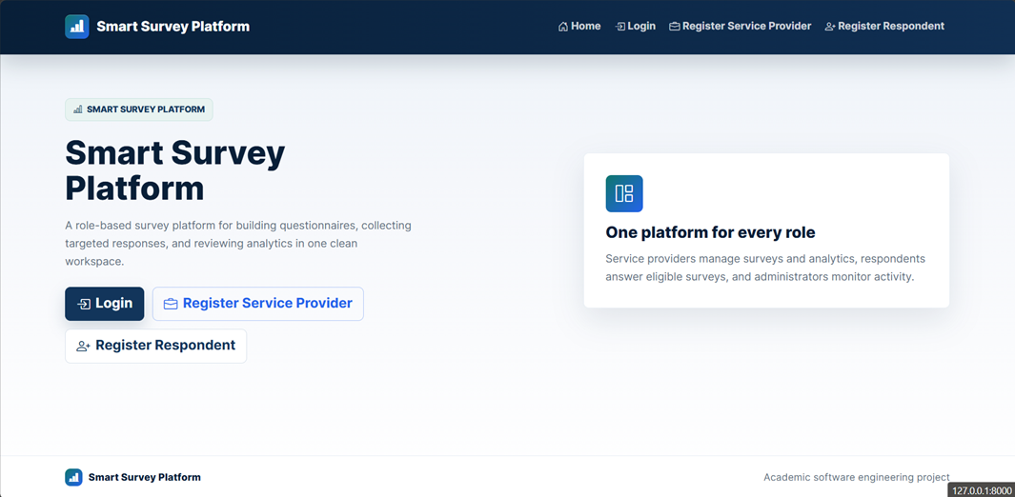
Figure 7.1: Public Home Page
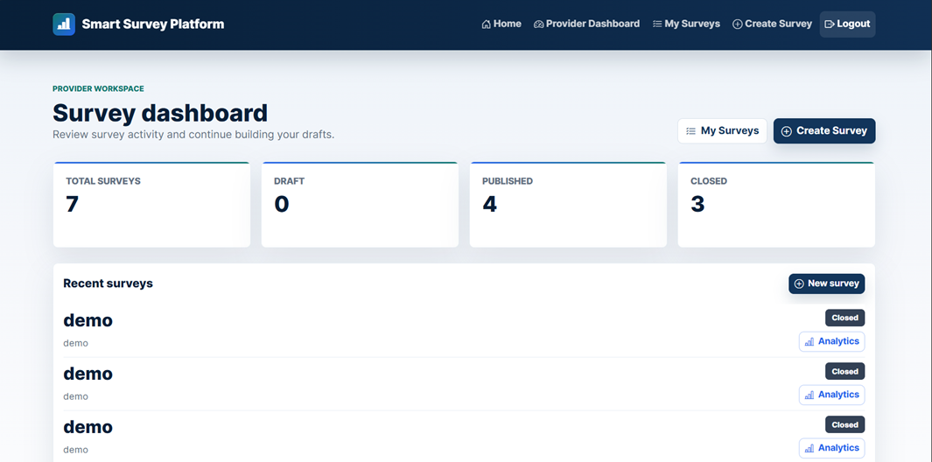
Figure 7.2: Provider Dashboard
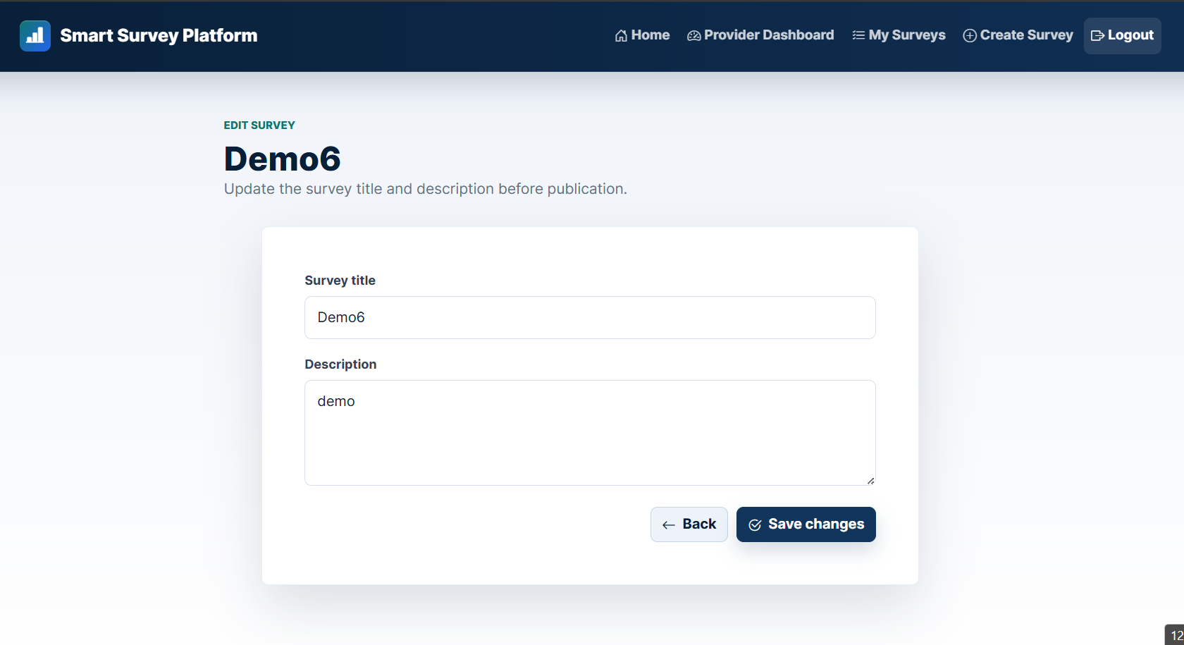
Figure 7.3: Survey Edit Page

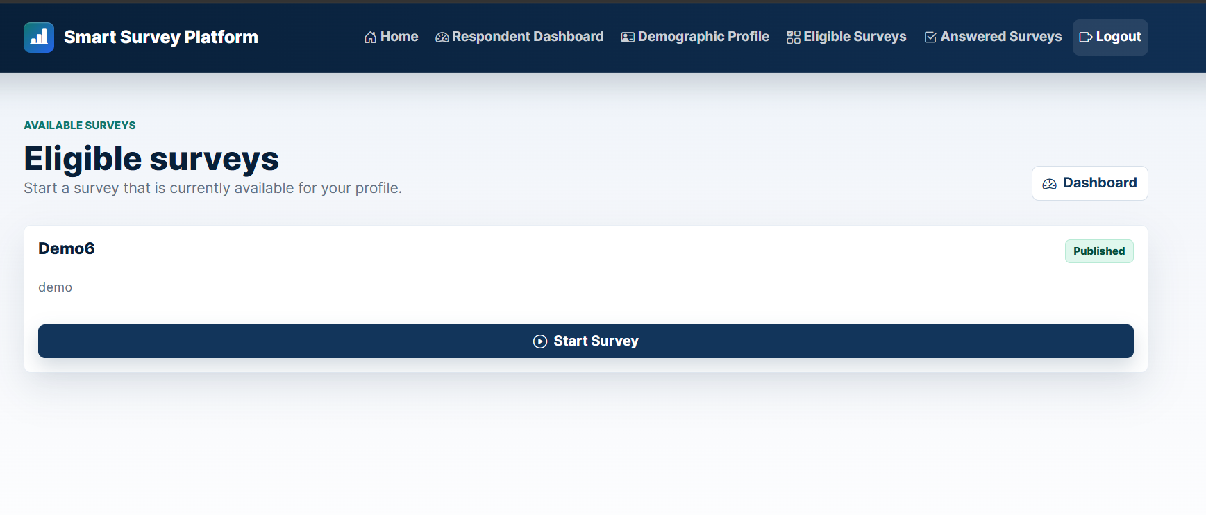
Figure 7.4: Eligible Surveys Page
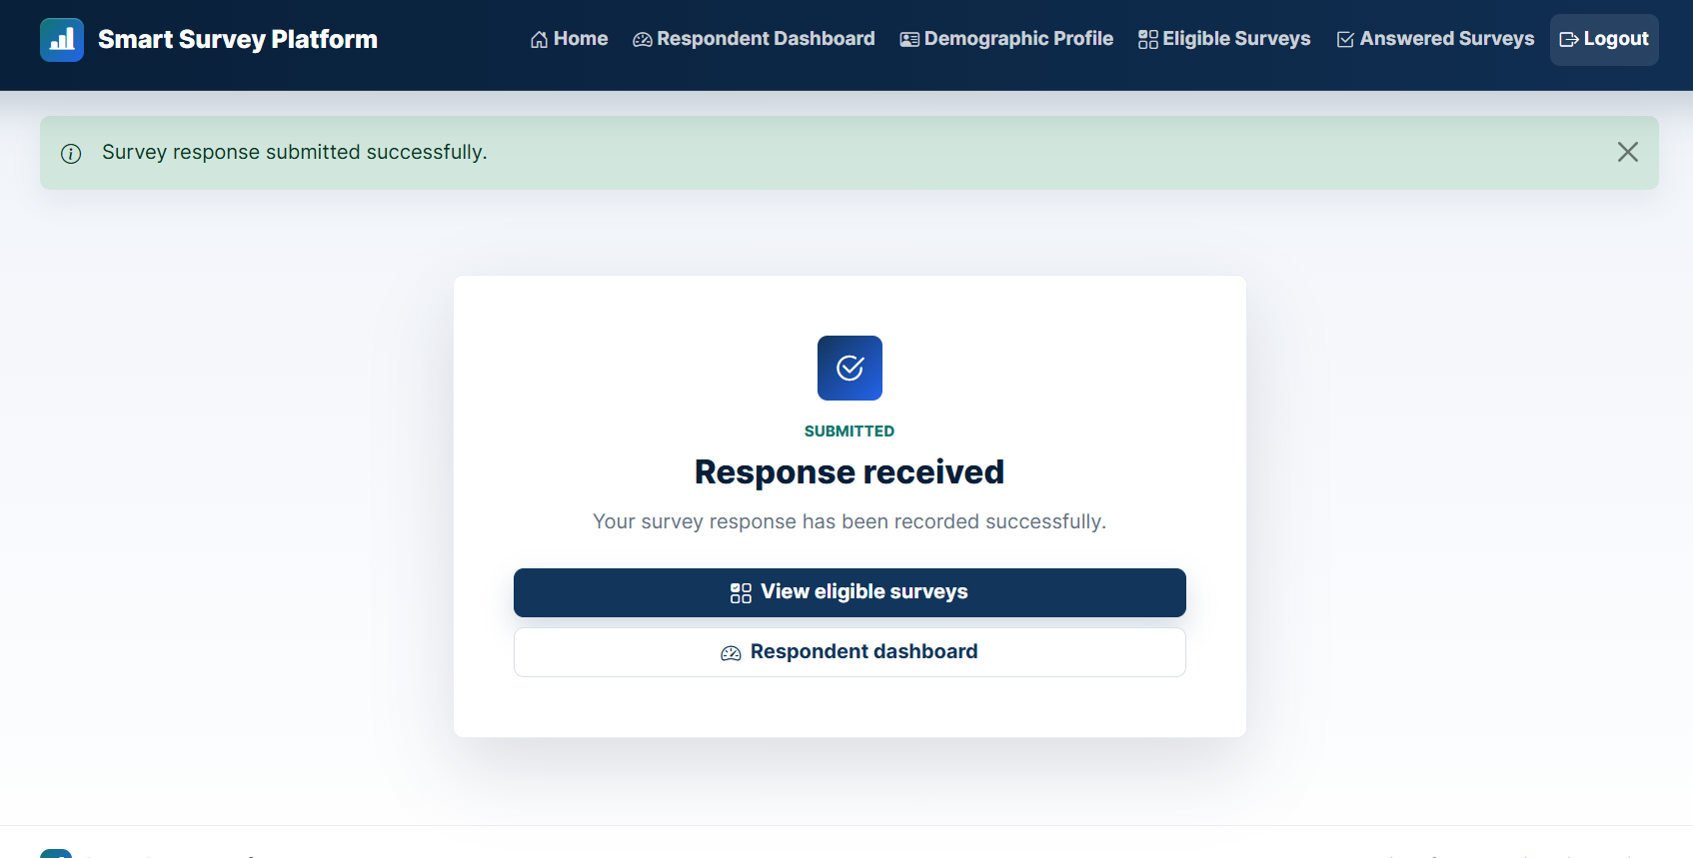
Figure 7.5: Submission Confirmation Page
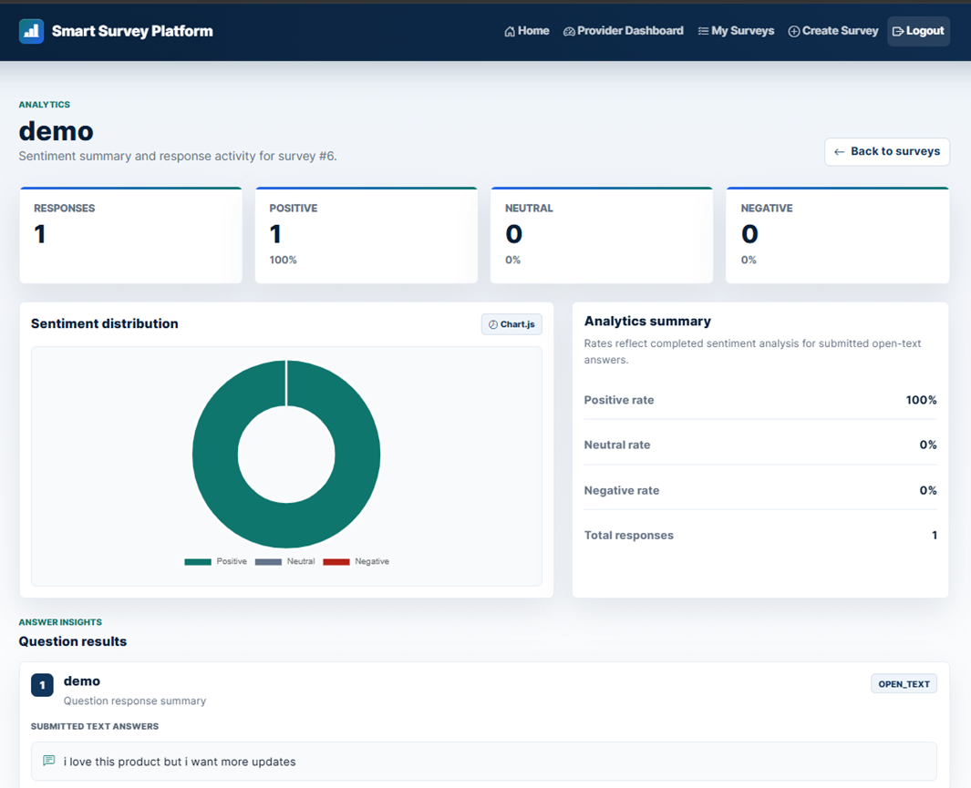
Figure 7.6: Analytics Dashboard
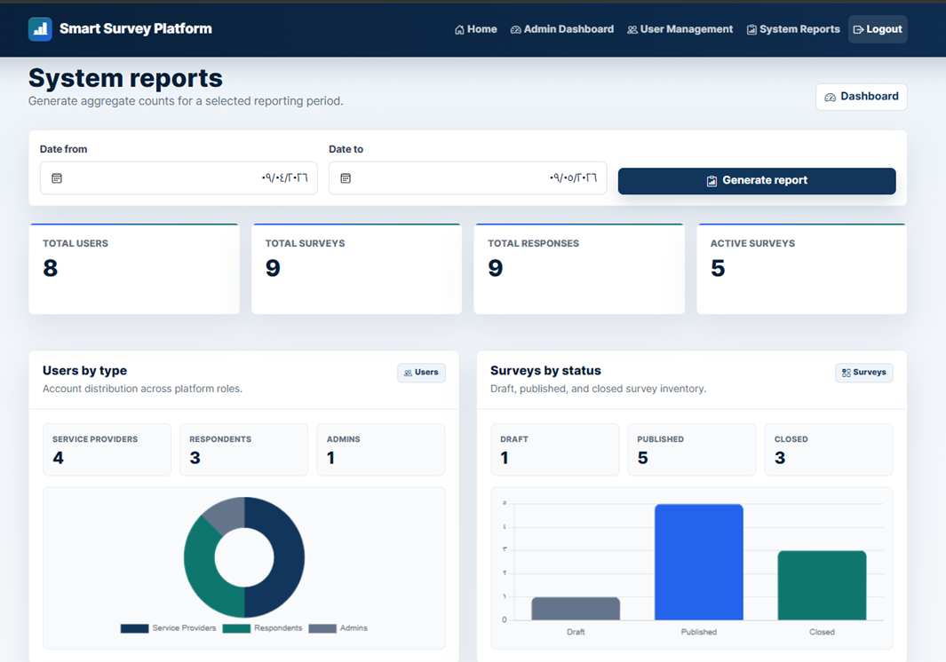
Figure 7.7: Admin System Reports Page

Code snippet 7.11: Dynamic Response Inputs
File path | apps/responses/templates/responses/submit_survey_response.html
Purpose | Renders different input controls based on each question type.

{% if question.is_open_text %}
<textarea
class="form-control"
name="{{ question.answer_name }}"
rows="4"
></textarea>
{% endif %}
{% if question.is_rating_scale %}
<select
class="form-select response-rating"
name="{{ question.rating_name }}"
>

Explanation: The template receives question metadata from the service layer and displays the correct input control for open-text and rating-scale questions. Multiple-choice inputs are rendered in the same template using radio buttons.

7.7 Intelligent Algorithm Implementation
The smart component is AI-assisted sentiment analysis for open-text answers. The implementation does not train a model from scratch. It stores the respondent response first, then analyzes open-text answers through the Hugging Face Inference API. Completed analysis stores a label, score, and analysis timestamp. Failed analysis marks the sentiment result as FAILED without deleting the submitted response.
Table 7.8: Smart Sentiment Analysis Flow
Step | Description | Output
1. Detect open-text answers | Response.has_open_text_answers() identifies whether the saved response contains open-text answers. | Decision to trigger analysis.
2. Create or reset pending analysis result | AnalysisService creates a pending SentimentAnalysisResult or resets an existing one. | Pending sentiment result.
3. Send text to HuggingFaceClient | AnalysisService calls HuggingFaceClient.analyze_sentiment(...). | External API request.
4. Normalize returned label and score | HuggingFaceClient maps provider labels to internal sentiment labels and converts score to a float. | Normalized label and score.
5. Store COMPLETED result | On success, mark_completed(...) stores label, score, and timestamp. | Completed sentiment result.
6. Store FAILED result if external API fails | On ExternalAnalysisServiceError, mark_failed() clears label/score and records failure status. | Failed sentiment result without losing the response.
Code snippet 7.12: Open-Text Answer Detection
File path | services/analysis_service.py
Purpose | Runs sentiment analysis only for answers that require it.

for answer in answers:
if not answer.requires_sentiment_analysis():
continue
result = self._get_or_create_pending_result(answer)

Explanation: The service skips non-text answers and prepares a sentiment result record only for open-text answers.
Code snippet 7.13: Sentiment Label Normalization
File path | infrastructure/huggingface_client.py
Purpose | Normalizes external sentiment labels into internal sentiment categories.

def _normalize_label(self, label):
"""Normalize external sentiment labels into internal sentiment categories."""
normalized_label = str(label).strip().upper()
mapped_label = self.LABEL_MAP.get(normalized_label)
if mapped_label is None:
raise ExternalAnalysisServiceError(
"Unknown sentiment label."
)
return mapped_label

Explanation: The external API can return different label formats. This method converts supported external labels into the platform internal sentiment categories.
The implementation uses an external pretrained sentiment model through an API; it does not train a new machine learning model.

Chapter 8: Testing and Evaluation

8.1 Test Plan
The test plan covers authentication, survey management, question handling, targeting criteria, respondent eligibility, response submission, duplicate prevention, sentiment analysis, and administrator functions. Automated testing is implemented mainly at the service layer using pytest and pytest-django. Manual validation is still required for browser-based UI behavior, while GitHub Actions is used to verify the automated test suite in CI.
Table 8.1: Test Plan
Test Area | What Was Tested | Tool / Method | Timing | Evidence
Authentication and user accounts | Provider registration, respondent registration, duplicate email rejection, and inactive account login rejection. | pytest service tests | During authentication feature work and final verification. | tests/services/test_authentication_service.py; local pytest passed.
Survey lifecycle | Create, update, delete, publish, close, ownership checks, and status rules. | pytest service tests | During survey module work and final verification. | tests/services/test_survey_service.py; local pytest passed.
Questions and targeting | Question types, options, question ordering, targeting criteria validation, and demographic matching. | pytest service tests | During survey preparation feature work and final verification. | tests/services/test_question_service.py; tests/services/test_targeting_service.py; local pytest passed.
Respondent eligibility | Eligible published unanswered surveys for respondent profiles. | pytest service tests | During respondent workflow work and final verification. | tests/services/test_survey_service.py; tests/services/test_targeting_service.py; local pytest passed.
Response submission | Valid response storage, answer validation, and restrictions for draft or closed surveys. | pytest service tests | During response workflow work and final verification. | tests/services/test_response_service.py; local pytest passed.
Duplicate prevention | Rejecting a second response to the same survey by the same respondent. | pytest service tests and database constraint inspection | During response workflow work and final verification. | tests/services/test_response_service.py; apps/core/models/response.py; local pytest passed.
Sentiment analysis | Open-text analysis, non-text answer exclusion, failed external analysis handling, and analytics summaries. | pytest service tests with test doubles | During analysis module work and final verification. | tests/services/test_analysis_service.py; services/analysis_service.py; local pytest passed.
Admin functions | Activate, suspend, soft-delete accounts, self-action restrictions, and system reports. | pytest service tests | During admin module work and final verification. | tests/services/test_admin_service.py; local pytest passed.
UI workflow validation | Forms, navigation, dashboards, messages, and role-specific pages. | Manual browser validation | Before final delivery. | UI screenshots should be inserted as final evidence.
CI validation | Django system check and service test command in GitHub Actions. | GitHub Actions workflow | After pushing workflow to GitHub. | GitHub Actions CI completed successfully.

8.2 Testing Types
Table 8.2: Testing Types
Testing Type | Applied? | Description | Evidence / Status
Unit testing | Limited | Individual service methods and validation rules are tested through service test files. | Covered through service-level pytest tests; the suite passed locally.
Service-layer testing | Yes | Business workflows are tested at the service layer. | 163 tests passed using python -m pytest tests/services -q.
Integration testing | Limited | Tests use Django settings and database-backed models through pytest-django. | pytest.ini, requirements.txt, and service tests.
System testing | Limited | Full browser end-to-end testing is not evidenced as an automated suite. | Manual workflow screenshots are recommended.
Acceptance testing | Not formally verified | No signed acceptance checklist or user acceptance evidence was found. | Can be added through supervisor or stakeholder review.
Performance testing | Not formally verified | No benchmark or measured response-time output exists. | Response time remains a target, not a verified metric.
Security testing | Limited | Configuration and code inspection support authentication, CSRF protection, role checks, ownership checks, and secret isolation. | No penetration testing evidence exists.
Usability testing | Limited | Internal/manual review can be described, but no real user survey/interview evidence exists. | UI screenshots and user feedback can strengthen this section.
Accessibility testing | Not formally verified | No accessibility testing tool output or checklist evidence exists. | Do not claim accessibility compliance.
Compatibility testing | Not formally verified | No cross-browser or device test matrix evidence exists. | Screenshots and browser checks would be required.

8.3 Test Diagrams
Test diagrams and screenshots are used to summarize selected testing coverage and test result evidence. Figure 8.1 summarizes the service-layer test coverage groups. Figures 8.2 and 8.3 provide execution evidence for local pytest execution and GitHub Actions CI.

8.3.1 Test Case Diagrams
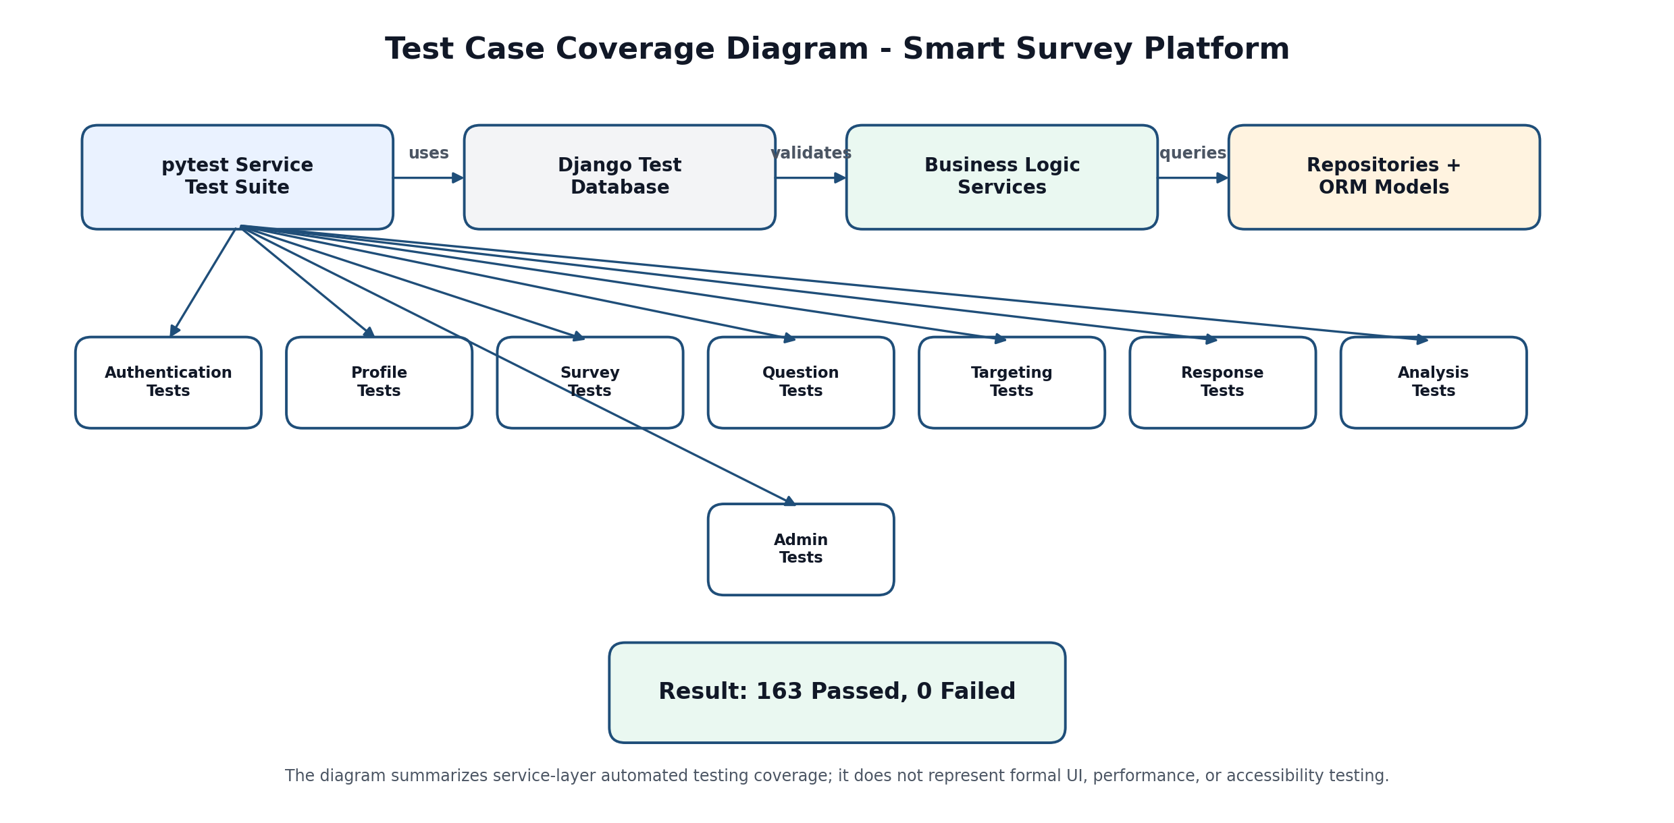
Figure 8.1: Test Case Coverage Diagram

8.3.2 Test Result Diagrams
Figure 8.2: Pytest Execution Result Screenshot
The local service-layer test suite was executed successfully using pytest. The result shows 163 passed tests, 0 failed tests, and total execution time of 84.74 seconds.
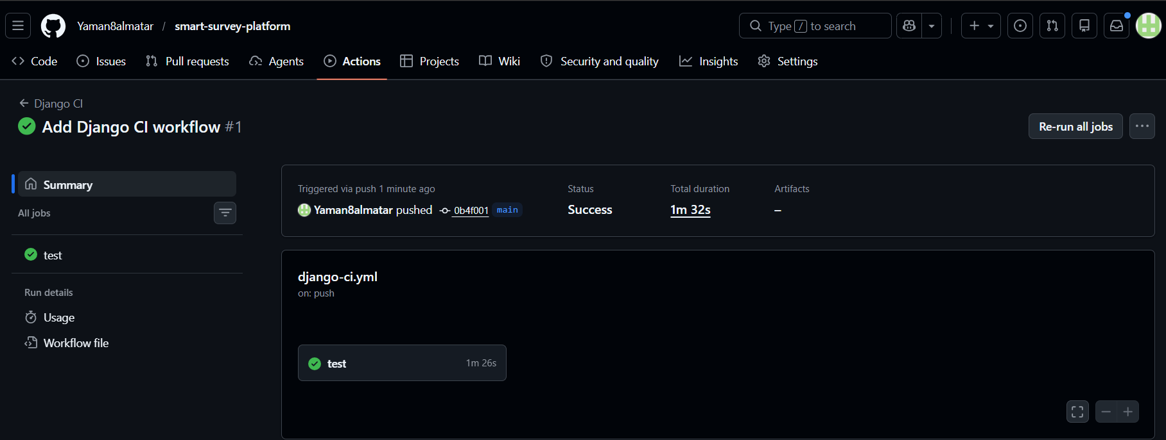
Figure 8.3: GitHub Actions CI Result Screenshot
The GitHub Actions CI workflow executed successfully after pushing the repository changes. The workflow completed with status Success and total duration of 1 minute and 32 seconds.

8.4 Test Results and Analysis
The automated service-layer test suite was executed successfully. The local pytest result reported 163 passed tests and 0 failed tests. The GitHub Actions CI workflow also completed successfully. These results verify the main automated service-layer workflows, while UI, performance, accessibility, and formal user testing remain limited or not formally verified.
Table 8.3: Test Results Summary
Test Category | Test Cases / Evidence | Passed | Failed | Status | Notes
Authentication service | Authentication-related service tests. | Passed | 0 | Passed | Covers registration, duplicate email, login, and inactive account rejection.
Profile service | Profile service tests. | Passed | 0 | Passed | Covers respondent profile retrieval, update, and validation rules.
Survey service | Survey lifecycle tests. | Passed | 0 | Passed | Covers create, update, delete, publish, close, ownership, and eligibility behavior.
Question service | Question management tests. | Passed | 0 | Passed | Covers question types, options, ordering, update, and delete service behavior.
Targeting service | Targeting criteria and demographic matching tests. | Passed | 0 | Passed | Covers targeting save/update and respondent-to-survey matching.
Response service | Response submission tests. | Passed | 0 | Passed | Covers response storage, duplicate prevention, answered surveys, and answer validation.
Analysis service | Sentiment analysis and analytics tests. | Passed | 0 | Passed | Covers API failure behavior, label mapping, and analytics summaries.
Admin service | Administration tests. | Passed | 0 | Passed | Covers account actions and system report generation.
Django system check | GitHub Actions runs python manage.py check. | Passed | 0 | Passed | CI workflow completed successfully.
CI service tests | GitHub Actions runs python -m pytest tests/services -q. | Passed | 0 | Passed | CI workflow completed successfully.

Table 8.4: Main Test Case Results
Test Case | Scenario | Expected Result | Actual Result | Status | Related Use Case
TC-01 | Register service provider. | A service provider account is created with valid data. | Passed in service-layer pytest execution. | Passed | UC-01
TC-02 | Register respondent. | A respondent account and demographic profile are created. | Passed in service-layer pytest execution. | Passed | UC-02
TC-03 | Reject duplicate email. | Registration with an existing email is rejected. | Passed in service-layer pytest execution. | Passed | UC-01, UC-02
TC-04 | Reject inactive account login. | Suspended or deleted accounts cannot authenticate. | Passed in service-layer pytest execution. | Passed | UC-03
TC-05 | Add supported question type. | Supported question data is saved for an owned draft survey. | Passed in service-layer pytest execution. | Passed | UC-08
TC-06 | Publish incomplete survey rejection. | A survey without required publication conditions is rejected. | Passed in service-layer pytest execution. | Passed | UC-11
TC-07 | Filter eligible surveys. | Respondent sees only published, matching, unanswered surveys. | Passed in service-layer pytest execution. | Passed | UC-15
TC-08 | Reject duplicate response. | A second response to the same survey by the same respondent is rejected. | Passed in service-layer pytest execution. | Passed | UC-16
TC-09 | Analyze open-text answer safely. | Open-text answers are analyzed, and failed analysis creates a failed result without deleting the response. | Passed in service-layer pytest execution. | Passed | UC-16, UC-13
TC-10 | Admin suspends account. | An administrator can suspend another user account but cannot suspend self. | Passed in service-layer pytest execution. | Passed | UC-18

8.5 Quality Metrics
Table 8.5: Quality Metrics
Metric | Value / Status | Interpretation
Number of service test files | 8 | Detected under tests/services/.
Number of passed service tests | 163 passed | Verified by local pytest execution.
Failed tests | 0 | No failed tests were reported in the pytest output.
Local test execution time | 84.74 seconds | The service-layer test suite completed in approximately 1 minute and 24 seconds.
CI status | Passed | GitHub Actions completed successfully with total duration of 1 minute and 32 seconds.
Coverage percentage | Not measured | No coverage report was generated.
Defect density | Not calculated | No formal defect log exists.
Response time | Target only | No page response-time benchmark was performed.
Known remaining defects | Not formally logged | No defect log exists. UC-09 question update/delete remains partially implemented at the web UI level if not completed later.

Section Five: Results and Recommendations

Chapter 9: Results and Analysis
The purpose of this chapter is to present the actual outputs produced by the Smart Survey Platform and evaluate the system against the project objectives. The evaluation focuses on system outputs, comparison with existing systems, objective achievement, strengths and weaknesses, and measurable performance indicators.

9.1 System Implementation Results
The implemented system produced working outputs for the three main user roles: service provider, respondent, and system administrator. The outputs include role-based dashboards, survey management pages, respondent eligibility filtering, response submission pages, analytics dashboards, administration pages, and testing/CI evidence.

Table 9.1: Actual System Outputs
Area | System Output
Public Interface | Public home page, login page, and registration pages for service providers and respondents.
Service Provider | Provider dashboard, survey list, create/edit/delete survey pages, question management, targeting criteria, publish/close actions, and analytics dashboard.
Respondent | Respondent dashboard, demographic profile page, eligible surveys page, submit response page, confirmation page, and answered surveys page.
Administrator | Admin dashboard, user management table, account status actions, and system reports page.
AI Analysis | Sentiment analysis records for open-text answers with status, label, score, and analysis timestamp.
Database Output | Stored users, profiles, surveys, questions, options, targeting criteria, responses, answers, and sentiment analysis results.
Testing Output | Local pytest execution result showing 163 passed tests and 0 failed tests.
CI Output | GitHub Actions CI workflow completed successfully with status Success.


Figure 9.1: Public Home Page

Figure 9.2: Provider Dashboard

Figure 9.3: Survey Edit Page


Figure 9.4: Eligible Surveys Page

Figure 9.5: Submission Confirmation Page

Figure 9.6: Analytics Dashboard


Figure 9.7: Admin System Reports Page
Figure 9.8: Local Pytest Execution Result
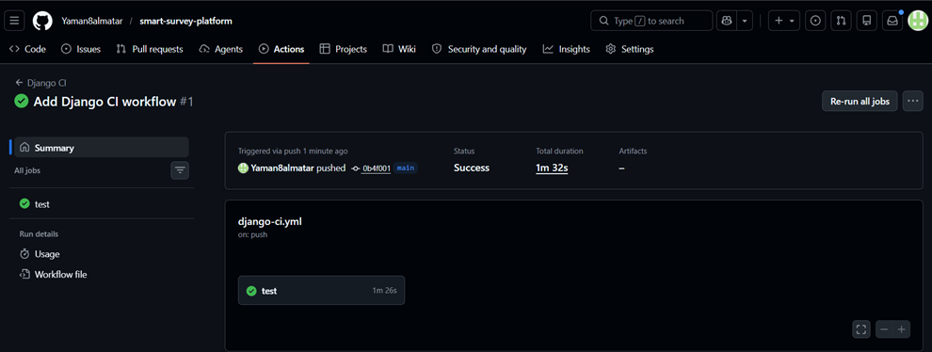
Figure 9.9: GitHub Actions CI Result

9.2 Comparative Analysis with Existing Systems
The Smart Survey Platform was compared with Google Forms, SurveyMonkey Audience, and Qualtrics. Google Forms is suitable for online forms and surveys with real-time analysis. SurveyMonkey Audience supports buying responses and targeting respondent groups by attributes such as country, gender, age range, income, and other options. Qualtrics supports advanced research workflows, customer research panels, and quality controls. The comparison below focuses on speed, data quality, cost, targeting, AI analysis, duplicate prevention, and implementation transparency.
Table 9.2: Comparative Analysis with Existing Systems
Criterion | Google Forms | SurveyMonkey Audience | Qualtrics | Smart Survey Platform
Speed | Fast for creating and sharing basic surveys. | Fast respondent acquisition through paid audience services. | Fast for enterprise research workflows. | Fast for academic/local workflows; formal page response-time benchmarking was not performed.
Accuracy / Data Quality | Basic response collection; targeting is mostly controlled through sharing and account settings. | Provides targeted respondents and platform-managed audience workflows. | Provides research-oriented audience and data-quality controls. | Uses profile-based eligibility filtering and duplicate response prevention.
Cost | Low cost for basic usage; advanced usage depends on Google Workspace plan. | Paid audience acquisition model. | Enterprise-oriented commercial platform. | Low academic implementation cost using open-source frameworks and an external AI API.
Targeting | Limited in the basic form workflow. | Supports targeting by demographic and other attributes. | Supports panels and advanced research audience management. | Built-in targeting by gender, age range, and region.
AI Analysis | Not the main standard workflow of basic forms. | Depends on product plan and ecosystem. | Advanced analytics ecosystem for enterprise research. | Integrated sentiment analysis for open-text answers.
Duplicate Prevention | Limited/configurable depending on settings. | Controlled through platform workflows. | Controlled through research platform workflows. | Enforced by service logic and database unique constraint.
Transparency | Commercial platform; internal implementation is not visible. | Commercial platform; internal implementation is not visible. | Commercial platform; internal implementation is not visible. | Fully documented academic implementation with requirements, UML, services, repositories, tests, and CI.

Source note: the comparison uses official product descriptions for Google Forms, SurveyMonkey Audience, and Qualtrics. The Smart Survey Platform column is based on the implemented project outputs and testing evidence.

9.3 Achievement of Objectives
This section evaluates the implemented system against the objectives defined in Chapter 1. The evaluation is based on the actual system behavior, service-layer tests, CI result, and documented implementation evidence.
Table 9.3: Project Objectives Achievement
Objective | Evaluation | Status
Build a web-based smart survey platform. | The system was implemented as a Django web application with role-based pages and dashboards. | Achieved
Allow service providers to manage surveys. | Providers can create, update, delete draft surveys, publish complete surveys, close published surveys, and view analytics. | Achieved
Support multiple question types. | The system supports multiple-choice, rating-scale, and open-text questions. | Achieved
Support demographic targeting. | Targeting criteria are implemented using gender, age range, and region. | Achieved
Show only eligible surveys to respondents. | Eligibility filtering is implemented using respondent profile data and targeting criteria. | Achieved
Prevent duplicate participation. | Duplicate responses are prevented through service validation and a database unique constraint. | Achieved
Analyze open-text answers intelligently. | Open-text answers are analyzed using the Hugging Face Inference API and stored as sentiment results. | Achieved
Provide analytics and reports. | Provider analytics and administrator reports are implemented. | Achieved
Apply software engineering traceability. | Requirements, use cases, architecture, UML, tests, and CI evidence are documented. | Achieved
Perform production deployment. | Production deployment was not part of the current academic scope. | Not within scope
Perform formal performance, accessibility, and user satisfaction studies. | These studies were not formally conducted with measurement tools or real user surveys. | Not formally verified

9.4 Strengths and Weaknesses Analysis
The system meets the main functional and academic objectives, but the evaluation must remain realistic. The strongest areas are architecture, traceability, testing, role separation, targeting, duplicate prevention, and AI-assisted sentiment analysis. The weaker areas are formal performance evaluation, accessibility testing, model accuracy measurement, and real-user usability testing.
Table 9.4: Strengths and Weaknesses
Area | Strengths | Weaknesses / Limitations
Architecture | Clear layered architecture: presentation, services, repositories, domain models, and infrastructure. | Further refinements could move more UI preparation logic into dedicated helpers or service methods.
Functional Scope | Core workflows for providers, respondents, and administrators are implemented. | Question update/delete should be confirmed as a complete web UI workflow before claiming full UI completion.
Testing | Automated service-layer tests passed: 163 passed and 0 failed. | Test coverage percentage was not measured.
CI | GitHub Actions CI completed successfully. | Continuous deployment is not implemented.
Data Integrity | Duplicate response prevention is enforced by service logic and database constraint. | No formal stress testing was conducted on large datasets.
AI Analysis | Open-text answers are analyzed automatically through an external sentiment model. | Model accuracy was not measured using a labeled project-specific dataset.
Reliability | If the external AI call fails, the submitted response remains saved and analysis status becomes FAILED. | No asynchronous retry queue is implemented.
UI | Role-specific dashboards and pages are implemented using Django templates and Bootstrap. | Formal usability testing with real users was not conducted.
Security | Password hashing, CSRF, role checks, ownership checks, and environment variables are used. | No penetration testing or formal security audit was conducted.
Accessibility | Bootstrap provides a responsive base. | No formal accessibility audit was conducted.

9.5 Key Performance Indicators (KPIs)
The following KPIs summarize the measurable results of the implemented system. Only verified values are reported. Unmeasured indicators are marked clearly to avoid unsupported claims.
Table 9.5: System KPIs
KPI | Result / Status | Interpretation
Automated service tests | 163 passed | Verified by local pytest execution.
Failed automated tests | 0 failed | No failed service tests were reported.
Pytest execution time | 84.74 seconds | The service-layer test suite completed in approximately 1 minute and 24 seconds.
CI status | Success | GitHub Actions CI completed successfully.
CI duration | 1 minute 32 seconds | The CI workflow executed Django check and service tests successfully.
Test coverage percentage | Not measured | No coverage report was generated.
Model accuracy | Not measured | No labeled dataset was used to calculate accuracy, precision, recall, or F1-score.
User satisfaction | Not measured | No formal user survey or interview was conducted.
Page response time | Not formally measured | No browser timing or load testing evidence was collected.
Defect density | Not calculated | No formal defect log was maintained.
Cost indicator | Low academic implementation cost | The system uses open-source frameworks and an external API rather than commercial respondent acquisition or enterprise platform licensing.

Overall, the Smart Survey Platform achieved its main academic and functional objectives. The strongest evidence is the successful implementation of the main workflows, the passing service-layer test suite, and the successful GitHub Actions CI workflow. However, model accuracy, usability satisfaction, accessibility compliance, and formal response-time performance remain future evaluation areas because they were not measured using dedicated tools or real-user studies.

Chapter 10: Conclusion and Recommendations
The purpose of this chapter is to close the project report by summarizing the main achievements of the Smart Survey Platform, identifying the challenges faced during development, proposing future improvements, and presenting recommendations for future students or organizations that may extend or adopt the system.

10.1 Project Summary and Main Achievements
The Smart Survey Platform was developed as a web-based system for creating, managing, targeting, answering, and analyzing surveys. The system was implemented using Django and follows a layered architecture that separates presentation, business logic, data access, domain models, and external AI integration.
The project achieved its main objective by delivering a functional survey platform with three main user roles: service provider, respondent, and system administrator. Service providers can manage surveys, questions, targeting criteria, publication status, and analytics. Respondents can manage demographic profiles, view eligible surveys, submit responses, and view answered surveys. Administrators can manage user accounts and generate system reports.
A major achievement of the project is the integration of AI-assisted sentiment analysis for open-text answers using the Hugging Face Inference API. This adds an intelligent component to the platform and allows qualitative feedback to be summarized using sentiment labels and scores.
The project also achieved strong engineering traceability. Requirements were documented, use cases were defined, UML and ERD assets were prepared, the system architecture was designed, and the implementation was validated through service-layer tests and a GitHub Actions CI workflow. The automated service-layer test suite passed successfully with 163 passed tests and 0 failed tests, and the CI workflow completed successfully.
Table 10.1: Main Project Achievements
Achievement | Description
Web-based survey platform | Implemented as a Django server-rendered web application.
Role-based system | Supports service provider, respondent, and system administrator roles.
Survey management | Supports survey creation, update, deletion, publishing, closing, and analytics.
Question management | Supports multiple-choice, rating-scale, and open-text question types.
Targeting criteria | Supports demographic targeting by gender, age range, and region.
Response submission | Allows respondents to answer eligible surveys.
Duplicate prevention | Prevents repeated participation using service validation and database constraints.
Smart analysis | Performs sentiment analysis for open-text answers using Hugging Face API.
Administration | Supports account status management and system report generation.
Testing | Service-layer test suite passed with 163 passed tests and 0 failed tests.
CI workflow | GitHub Actions CI workflow completed successfully.

10.2 Difficulties and Challenges Faced by the Project
Several challenges were faced during the development and documentation of the project. These challenges were technical, organizational, and time-related.
From the technical side, one challenge was maintaining a clean layered architecture. Django projects can easily mix views, business logic, and database operations if no strict structure is applied. To avoid this, the project separated the code into views, services, repositories, models, and infrastructure clients.
Another challenge was integrating the external Hugging Face API safely. External API calls can fail due to missing tokens, invalid responses, network issues, or service unavailability. The system handled this by saving the respondent response first, then marking sentiment analysis as failed if the external API call fails.
Testing was also a challenge. The project required a valid Python environment and PostgreSQL configuration. The local environment initially had incompatible Python execution issues, but this was addressed by running tests inside the correct virtual environment and by configuring GitHub Actions CI.
Documentation and diagram consistency were also difficult because the project evolved from earlier naming and design assets. Some old materials used previous names or incomplete diagrams. These assets required auditing and correction to match the final implementation.

Table 10.2: Project Challenges
Challenge Type | Challenge | Handling / Mitigation
Technical | Maintaining separation between views, services, repositories, and models. | Applied layered architecture and repository pattern.
Technical | External AI API failure risk. | Saved responses before analysis and marked failed analysis safely.
Technical | Preventing duplicate responses. | Used service-level validation and database unique constraint.
Technical | Keeping diagrams aligned with actual code. | Audited and corrected UML, ERD, and sequence diagrams.
Environment | Python environment incompatibility during testing. | Used correct virtual environment and configured GitHub Actions CI.
Documentation | Old project naming and legacy assets existed. | Standardized current name as Smart Survey Platform.
Time | Preparing implementation, testing, diagrams, screenshots, and report together. | Organized outputs by chapters and evidence-based documentation.

10.3 Future Development Suggestions
Although the current system satisfies the main academic and functional objectives, several improvements can be added in future work if the project continues.
First, the system can be extended with a full public REST API to support mobile applications or third-party integrations. This should be done only after defining API authentication, versioning, validation, and documentation.
Second, the AI analysis can be improved by evaluating sentiment model accuracy using a labeled dataset. The current system uses an external pretrained model through an API, but it does not measure model accuracy, precision, recall, or F1-score on project-specific data.
Third, performance testing can be added using benchmark tools and larger datasets. This would provide actual response-time metrics instead of only a target value.
Fourth, usability testing with real users can be conducted through questionnaires or structured interviews. This would provide measurable user satisfaction and interface feedback.
Fifth, accessibility testing should be added using tools such as Lighthouse or WCAG checklists. This would improve the system for users with different accessibility needs.
Sixth, the system can be improved by adding asynchronous background processing for sentiment analysis. This would prevent external API latency from affecting the response submission workflow.
Table 10.3: Future Development Suggestions
Suggested Improvement | Expected Benefit
Public REST API | Enables mobile applications and third-party integration.
Mobile application | Allows respondents to participate from mobile devices more conveniently.
Advanced AI evaluation | Measures model accuracy, precision, recall, and F1-score using labeled data.
Asynchronous AI jobs | Improves reliability and avoids waiting for external API calls during submission.
Retry queue for failed analysis | Allows failed sentiment analysis tasks to be retried later.
Formal performance testing | Provides measured response-time and load-handling evidence.
Accessibility audit | Improves usability for users with accessibility requirements.
Real-user usability testing | Measures satisfaction and identifies user interface weaknesses.
Exportable reports | Allows administrators and service providers to export analytics as PDF or Excel.
Notification system | Notifies users about survey status, new eligible surveys, or analysis completion.
Production deployment | Allows the system to be accessed outside the local development environment.

10.4 Recommendations
Several recommendations can be made for future students, developers, or organizations that may continue or adopt the Smart Survey Platform.
Future students should begin with requirements analysis and system design before implementation. Starting with code before defining requirements, use cases, architecture, and database design increases the risk of inconsistent implementation.
Developers extending the project should preserve the layered architecture. Views should remain responsible for HTTP behavior and rendering only, while business rules should remain inside services, database operations inside repositories, and external API calls inside infrastructure clients.
Organizations adopting the system should conduct additional evaluation before production use. This includes performance testing, accessibility testing, security review, user acceptance testing, and deployment planning.
The system should also avoid storing real API tokens or secrets in source code. Environment variables and ignored .env files should continue to be used for sensitive configuration.
Finally, future work should focus on measurable improvement. Claims about performance, user satisfaction, AI accuracy, or accessibility should only be made when supported by actual testing evidence.
Table 10.4: Recommendations
Target Group | Recommendation
Future students | Start with requirements, use cases, architecture, and database design before coding.
Future developers | Preserve separation of concerns between views, services, repositories, models, and infrastructure.
Future developers | Add new features through service and repository classes rather than placing business logic in views.
AI developers | Evaluate sentiment analysis accuracy using a labeled dataset before claiming model performance.
Testing team | Maintain automated tests and expand them with coverage reporting and UI/system tests.
UI team | Conduct usability testing with real users and improve the interface based on feedback.
Security reviewers | Perform a formal security review before any production deployment.
Organizations | Perform performance, accessibility, and acceptance testing before adopting the system operationally.
Deployment team | Add production deployment only after defining hosting, security, database backup, and monitoring plans.

In conclusion, the Smart Survey Platform achieved its main project goals as an academic software engineering system. It demonstrates a working implementation of survey creation, respondent targeting, response submission, AI-assisted sentiment analysis, dashboards, administration, automated testing, and CI validation. The project is technically acceptable for its current scope, while future work should focus on formal performance evaluation, usability testing, accessibility compliance, production deployment, and deeper AI model evaluation.

