Navigation bar (on top)

1. Company name
2. Search bar
3. login/create account
4. More(dropdown button)
5. Become seller
6. Cart

Grocery

1. Top offer
2. [Grocery](https://www.flipkart.com/grocery-supermart-store?marketplace=GROCERY&fm=neo%2Fmerchandising&iid=M_08600608-ebf0-416b-bee7-bd65bfef3033_1_372UD5BXDFYS_MC.CBUR1Q46W5F1&otracker=hp_rich_navigation_2_1.navigationCard.RICH_NAVIGATION_Grocery_CBUR1Q46W5F1&otracker1=hp_rich_navigation_PINNED_neo%2Fmerchandising_NA_NAV_EXPANDABLE_navigationCard_cc_2_L0_view-all&cid=CBUR1Q46W5F1)
3. Mobiles
4. Fashion
5. Electronic
6. Home
7. Appliances
8. Travel
9. Beauty, toys &more

Item’s list

* Each item in separate division.
* Image of item and name
* Option to buy and add to cart
* Increase the quantity of item
* User rating
* Discount offers if available

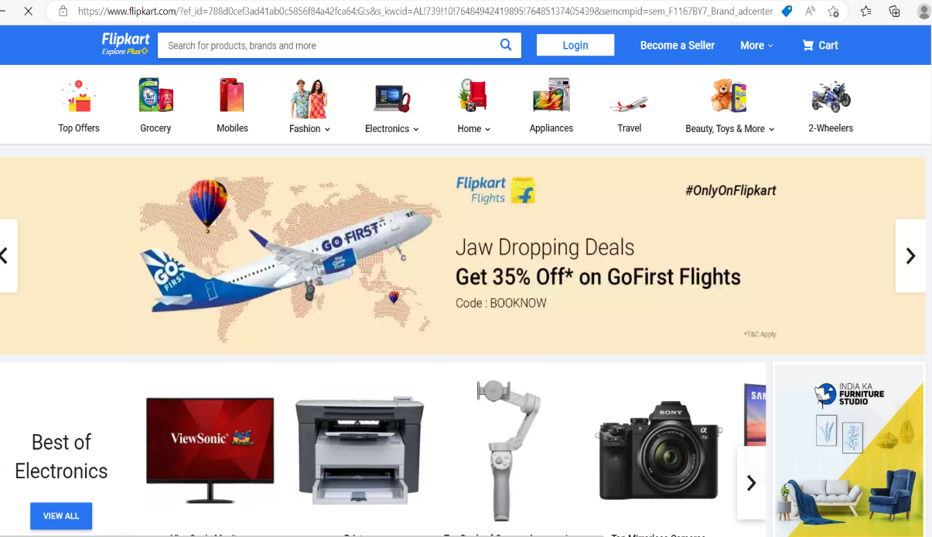

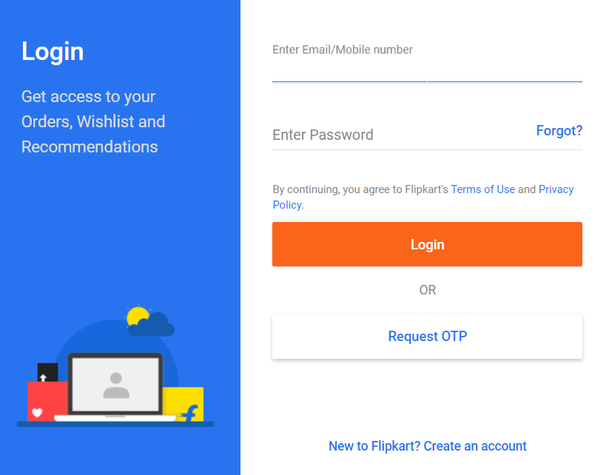

**Footer**

* About
* Help
* Policy
* Social
* Mail us