# Computer Network Programming

Introduction to the Socket Program in Linux

# Introduction

* A Simple Daytime Client
* A Simple Daytime Server
* Error handling: wrapper functions
* Types of Networking APIs
* BSD networking history
* Discover details of your local network

# Client-Server Model

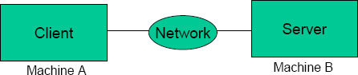

* Web browser and server
* FTP client and server
* Telnet client and server

# The Client/Server Model

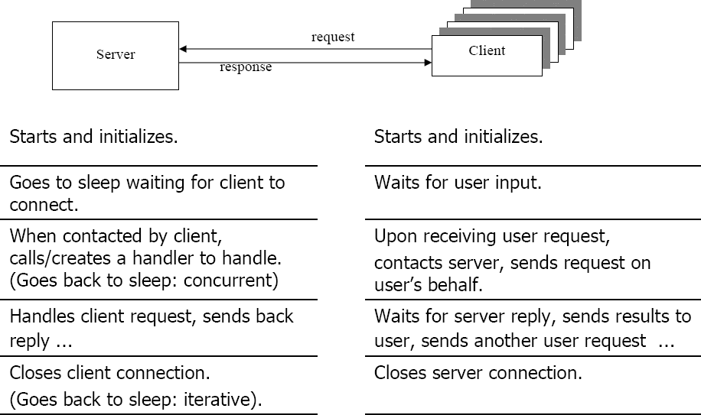

Client/Server on an LAN

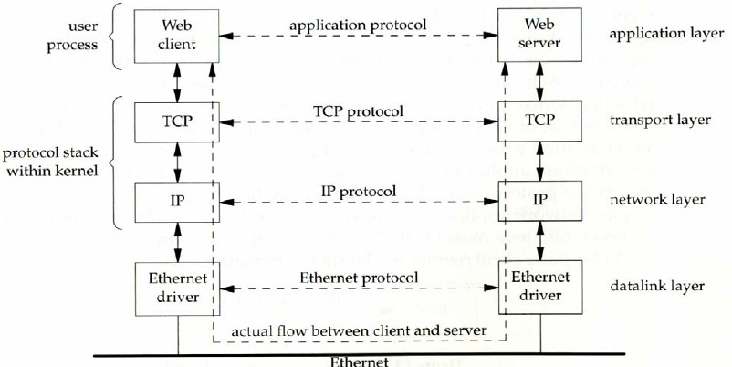

Client/Server via a WAN

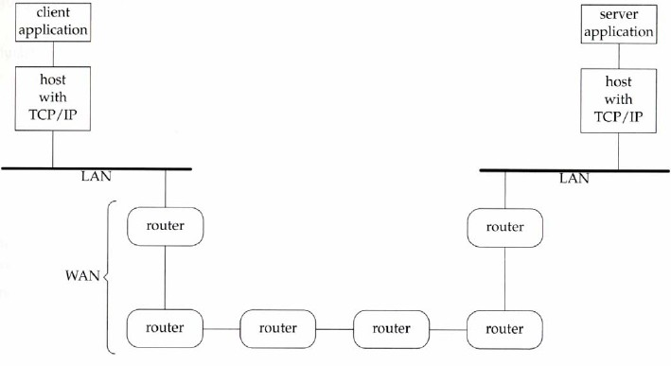

OSI vs. Internet Protocol Layers

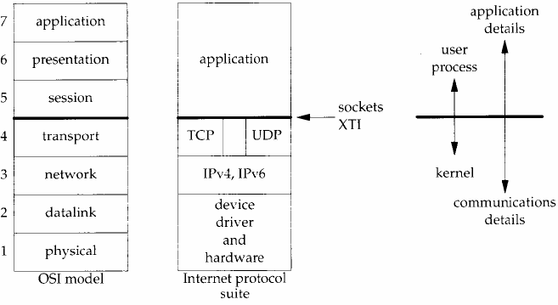

# Protocol Data and Headers

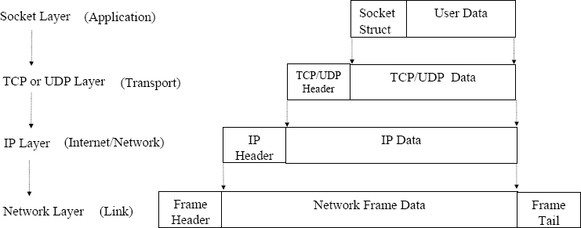

Socket API Location in OS

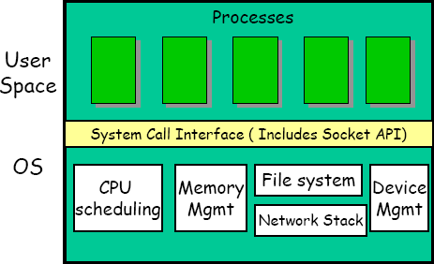

OSI and TCP/IP Model

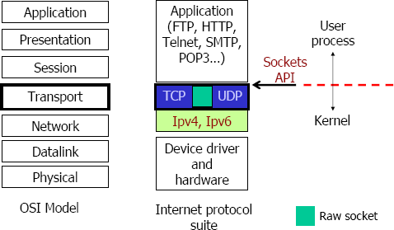

Sockets

## process sends/receives messages to/from its socket

* socket analogous to door

### sending process shoves message out door

* + transport infrastructure brings message to the door at receiving process

A Daytime client/server using socket API

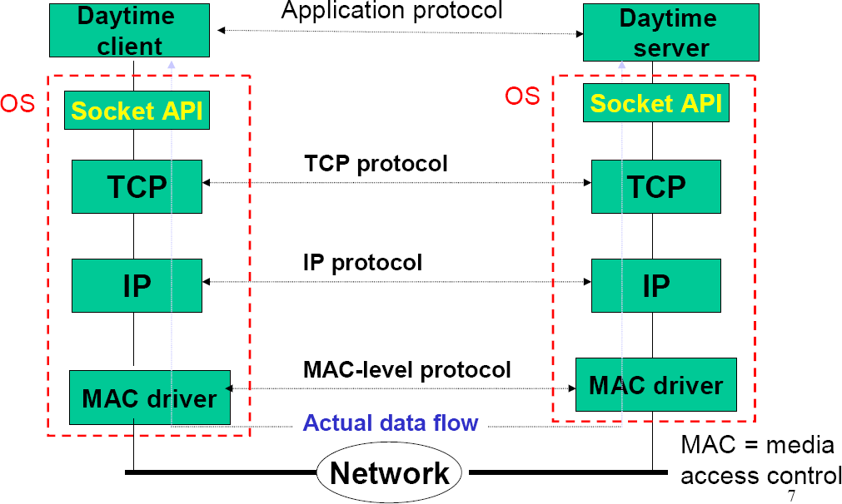

Connectionless: Functions Used

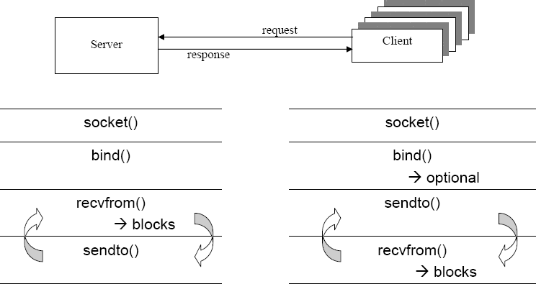

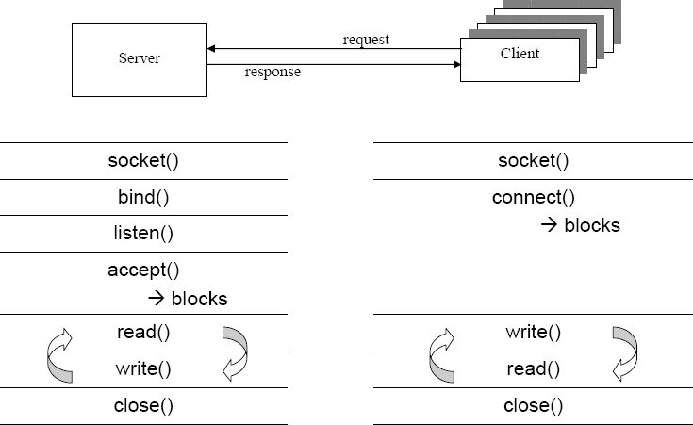

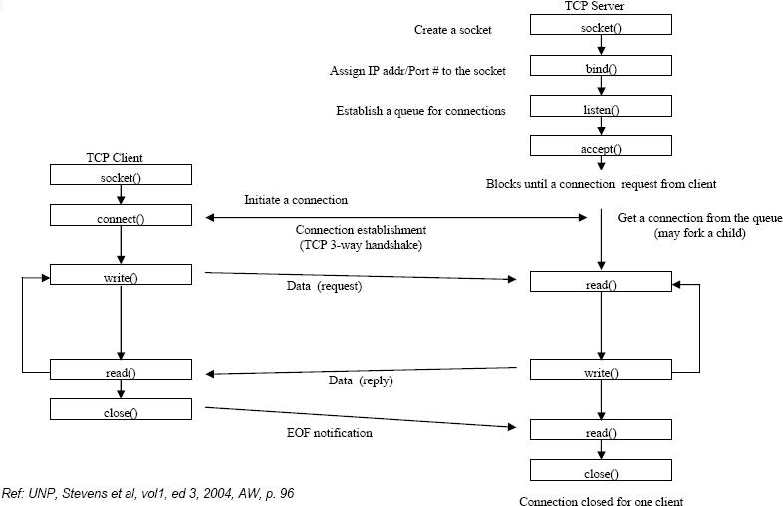

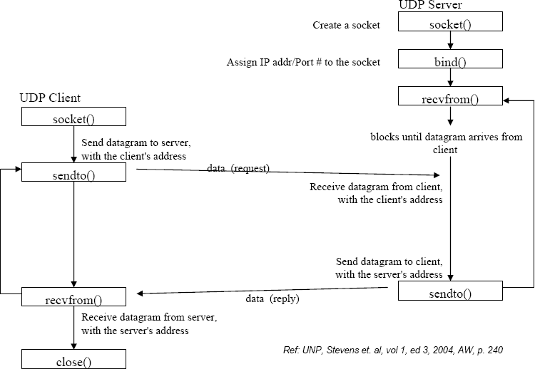

Five Steps to Create a Simple Daytime Client

1. Create TCP socket: get a file descriptor
2. Prepare server address structure: filling IP address and port number
3. Connect to the server: bind the file descriptor with the remote server
4. Read/write from/to server
5. Close socket

# TCP client/server connection sequence

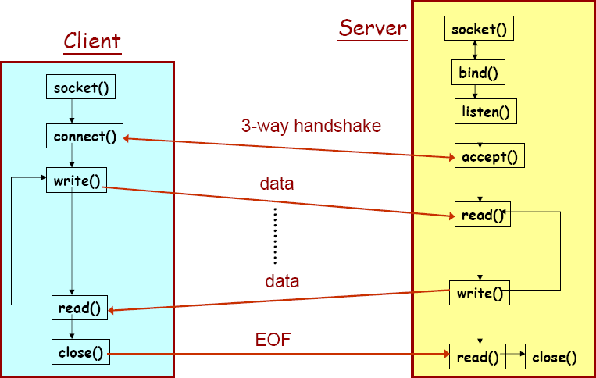

Three-Way Handshake of TCP

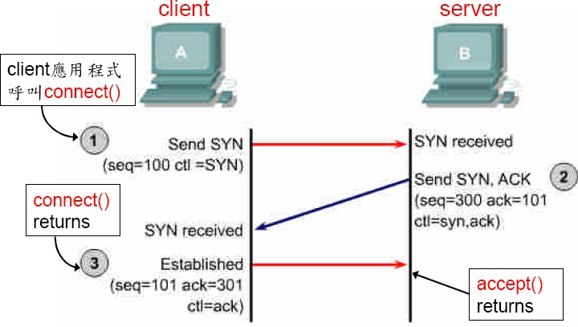

intro/daytimetcpcli.c (1/2)

**#include "unp.h"**

**int main(int argc, char **argv)**

**{**

**int sockfd, n;**

**char recvline[MAXLINE + 1]; struct sockaddr_in servaddr;**

**if (argc != 2)**

**err_quit("usage: a.out <IPaddress>");**

**if ( (sockfd = socket(AF_INET, SOCK_STREAM, 0)) < 0) err_sys("socket error");**

Command-Line Arguments

int main(int argc, char *argv[])

## int argc

### Number of arguments passed

* char *argv[]
  + Array of strings
  + Has names of arguments in order
    - argv[ 0 ] is first argument

## Example: $ mycopy input output

### argc: 3

* + argv[ 0 ]: “mycopy"
  + argv[ 1 ]: "input"
  + argv[ 2 ]: "output"

Step 1: Create A Socket

**int sockfd;**

…

**sockfd = socket(AF_INET, SOCK_STREAM, 0);**

* Call to the function **socket()** creates a transport control block (hidden in kernel), and returns a reference to it (integer used as index)

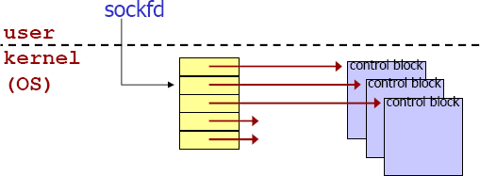

Parameters of the **socket** Call

**int socket(int *domain*, int *type*, int *protocol*);**

### returns a socket descriptor (or negative value on errors)

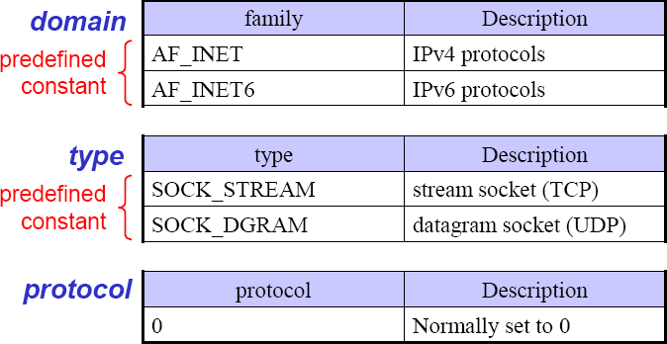

Socket functions

* + listenfd = Socket(AF_INET, SOCK_STREAM, 0); //建立TCP套接口描述字

bzero(&servaddr, sizeof(servaddr)); //地址結構清零servaddr.sin_family = AF_INET; //IPv4協議servaddr.sin_addr.s_addr = htonl(INADDR_ANY); //內核指定地址servaddr.sin_port = htons(SERV_PORT); //總所諸知端口#9877

// 允許啟動一個監聽服務器並捆綁其眾所周知端口，即使以前建立的將此端口用作它們的本地端口的連接仍存在。

Setsockopt(listenfd, SOL_SOCKET, SO_REUSEADDR, &on,

sizeof(on));

Bind(listenfd, (SA *) &servaddr, sizeof(servaddr)); //綁定本機地址和端口

Listen(listenfd, LISTENQ); //監聽

|  |  |  |
| --- | --- | --- |
|  | intro/daytimetcpcli.c (2/2) | |
|  |  |  |
| servaddr.sin_family = AF_INET; servaddr.sin_port = htons(13); /* daytime server */  if (inet_pton(AF_INET, argv[1], &servaddr.sin_addr) <= 0) err_quit("inet_pton error for %s", argv[1]);  if (connect(sockfd, (SA *) &servaddr, sizeof(servaddr)) < 0) err_sys("connect error");  while ( (n = read(sockfd, recvline, MAXLINE)) > 0) { recvline[n] = 0; /* null terminate */  if (fputs(recvline, stdout) == EOF) err_sys("fputs error");  } if (n <0 )  err_sys("read error");  exit(0);  } | |  |

bzero(&servaddr, sizeof(servaddr));

# How to identify clients to accept, and servers to contact?

* + Machine??

– by its IP address (e.g., 140.127.234.180)

* + Application/service/program??
    - by (IP address and) port number
    - standard applications have own, “well-known”port numbers

### SSH: 22

* + - * Mail: 25
      * Web: 80
      * Look in /etc/services for more (for Unix OS)

Using Ports to Identify Services

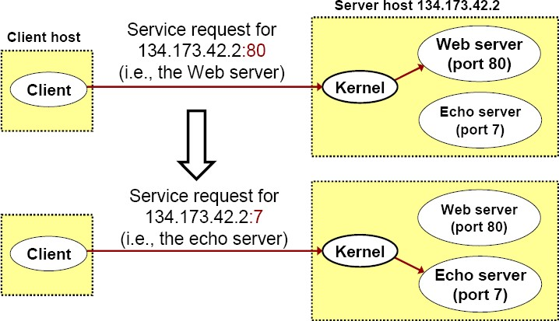

Port Numbers

* + A (protocol) port is an abstraction used by TCP/UDP to distinguish applications on a given host
    - A port is identified by a 16-bit integer known as the *port number*
  + Three ranges of port numbers :
    - Well-known ports
    - Registered ports
    - Dynamic ports

# Well-known Ports

* + Port numbers ranging from 0 to 1,023
    - A set of pre-assigned port numbers for specific uses
  + Port numbers are managed by ICANN.
    - Short for the ***I***nternet ***C***orporation for ***A***ssigned ***N***ames and

***N***umbers (ICANN)

* + - Used to be controlled solely by IANA (**I**nternet **A**ssigned **N**umbers **A**uthority)

# Some Well-known Ports

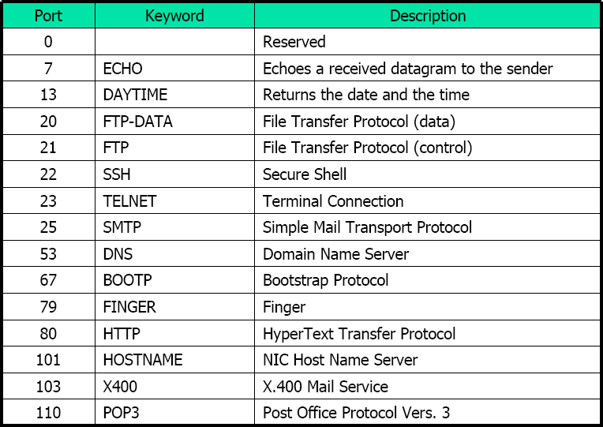

Registered Ports

* + Port numbers ranging from 1,024 to 49,151
  + Not assigned or controlled by ICANN; however their uses need to be registered via an ICANN-accredited registrar to prevent duplications

# Dynamic Ports

* + Port numbers ranging from 49,152 to 65,535
  + Neither assigned or registered. They can be used by anyone
    - These are ephemeral ports
    - Also known as private ports



# Specifying Server’s IP Address and Port Number

## Filling in structure sockaddr_in

struct sockaddr_in {

unsigned short sin_family; /* address family (always AF_INET) */ unsigned short sin_port; /* port num in network byte order */ struct in_addr sin_addr; /* IP addr in network byte order */ unsigned char sin_zero[8]; /* pad to sizeof(struct sockaddr) */

};

Client程式須在此結構的欄位中填入server的IP address和port number

struct sockaddr_in servaddr;

…

bzero(&servaddr, sizeof(servaddr));

# bzero 從位址&servaddr 處開始將

sizeof(servaddr) 位元組的空間清為0

* 亦可使用標準庫存函式memset或其它方法

memset(&servaddr,0x0,sizeof(servaddr));

servaddr.sin_family = AF_INET;

servaddr.sin_port = **htons**(13);/* port no=daytime server */ if (**inet_pton**(AF_INET, argv[1], &servaddr.sin_addr) <= 0)

err_quit("inet_pton error for %s", argv[1]);

* htons將整數轉為network byte order
* inet_pton將位址字串轉換為內部儲存格式

(傳回負值表轉換失敗)

* + Two ways to store 16-bit/32-bit integers
    - Little-endian byte order (e.g. Intel)
    - 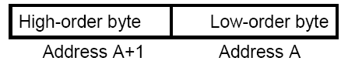Big-endia

n byte order (E.g. Sparc)

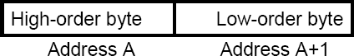

## IPv4 host address: represents a 32-bit address

### written on paper (”dotted decimal notation”):

**129.240.71.213**

– binary in bits: **10000001 11110000 01000111**

**10001011**

* + - hexadecimal in bytes: **0x81 0xf0 0x47 0x8b**

## Network byte order uses big-endian ordering

* + Little-endian:

### one 4 byte int on x86, StrongARM, XScale, …:

* + Big-endian:

…:



– one 4 byte int on PowerPC, POWER, Sparc,

Computer Network Programming 37

* + How do two machines with different byte-orders communicate?
    - Using network byte-order
    - Network byte-order = big-endian order
  + Conversion macros **(<netinet/in.h>)**
    - **uint16_t htons (uint16_t n)**
    - **uint32_t htonl (uint32_t n)**
    - **uint16_t ntohs (uint16_t n)**
    - **uint32_t ntohl (uint32_t n)**

**host to network conversion (s: short; l: long)**

**network to host conversion (s: short; l: long**

## inet_pton() is new for IPv6 and may not exist yet

(現在的Linux上沒問題).

* + Oldest:

serveraddr.sin_addr.s_addr =

inet_addr(“129.240.65.193”);

* + Newer: inet_aton(“129.240.65.193”,

&serveraddr.sin_addr);

比inet_pton少一個參數(第一個AF_INET)

int connect(int *sockfd*,

struct sockaddr_in \**serv_addr*, int *addrlen*);

* **used by TCP client only**

## *sockfd* - socket descriptor (returned from socket())

* *serv_addr:* socket address, struct sockaddr_in is used
* *addrlen* := sizeof(struct sockaddr_in)

## 傳回負值表連線建立失敗(如server不回應)

Step 4: Read/Write from/to Server

while ( (n = read(sockfd, recvline, MAXLINE)) > 0) { recvline[n] = 0; /* null terminate */

if (fputs(recvline, stdout) == EOF) err_sys("fputs error");

} if (n < 0)

err_sys("read error");

read Function

int read(int *sockfd*, char \**buf*, int *maxlen*);

### ***sockfd*** - socket descriptor (returned from socket())

* + ***buf*:** buffer (in your program) to store received data
  + ***maxlen***: maximum number of bytes to receive
  + Returns: # of bytes received (<=***maxlen***) if OK, 0 if connection has been gracefully closed, negative number on error

關於使用read讀取資料

recvline

## 從server送過來的data是先放在

application

## 位於kernel的socket receive

buffer

**user process**

Read data

application buffer

## client應用程式呼叫read()將此

buffer的資料取回放於自己程式的buffer recvline

* 如socket receive buffer中沒有資

**Kernel** TCP

IP

Socket receive buffer

## 料，則read呼叫會被block (暫時無法return)

Input queue datalink

# fputs 與err_sys

## **fputs**是C的標準庫存函數，功能是將字串str寫到

file pointer *stream中

int fputs( const char *str, FILE *stream );

* + 成功傳回非負整數值；否則傳回EOF
  + **stdout**: File pointer for standard output stream. Automatically opened when program execution begins.
  + **err_sys**是作者自行定義的函數(需先include “unp.h”

方可使用)

Test the Program

* 從課程網頁下載原始程式檔
* 依課程網頁的說明解壓縮、設定、及編譯程式
* 若可出現類似下列執行結果即表示成功

程式的**output**

本機

ws1 [unpv12e/intro]% ./daytimetcpcli 127.0.0.1

Mon Mar 5 15:36:27 2007

ws1 [unpv12e/intro]%

# 關於程式執行

* “./”表示執行目前這個目錄中的…
* 測試時本機必須有執行Daytime server。有些系統如Ubuntu預設沒有Daytime server，則必須先啟動Daytime server
* Daytime server的程式碼稍後介紹

# Error Handling: Wrappers

### /* include Socket */

int 大寫

### Socket(int family, int type, int protocol)

{

int n;

lib/wrapsock.c

將函數傳回值的檢查包裝在以大寫字母開頭的同名函數中

### if ( (n = socket(family, type, protocol)) < 0) err_sys("socket error");

return(n);

}/

* end Socket */

intro/daytimetcpsrv.c (1/2)

#include"unp.h"

#include<time.h> int

main(int argc, char **argv)

{

int listenfd, connfd;

struct sockaddr_in servaddr; char buff[MAXLINE];

time_t ticks;

listenfd = Socket(AF_INET, SOCK_STREAM, 0);

intro/daytimetcpsrv.c



### bzero(&servaddr, sizeof(servaddr)); servaddr.sin_family= AF_INET;

servaddr.sin_addr.s_addr = htonl(INADDR_ANY); servaddr.sin_port= htons(13); /* daytime server */

大寫

### Bind(listenfd, (SA *) &servaddr, sizeof(servaddr));

大寫

### Listen(listenfd, LISTENQ);

for ( ; ; ) { 大寫

connfd = Accept(listenfd, (SA *) NULL, NULL); ticks = time(NULL);

snprintf(buff, sizeof(buff), "%.24s\r\n", ctime(&ticks)); Write(connfd, buff, strlen(buff));

Close(connfd);

} 大寫

### }

int bind(int ***sockfd***, const struct sockaddr_in \****name***,

int ***namelen*** );

* ***sockfd***: Descriptor identifying an unbound socket. (returned by the ***socket*** function.)
* ***name*:** A pointer to a protocol-specific address
* ***namelen***: Length of the value in the ***name***
* parameter, in bytes.
* returns: 0 if OK, negative number on error

int listen(int ***sockfd***, int ***backlog***);

* ***sockfd***: Descriptor identifying a bound socket. (returned by the ***socket*** function.)
* ***backlog***: how many connections we want to queue
* Protocol dependency on IPv4
* Iterative server: no overlap of service times of different clients ( 一次只能服務一個client)
* Need for concurrent server: fork, prefork, or thread
* Need for daemon: background, unattached to a terminal
* TCP socket
* UDP socket
* raw socket over IP (bypass TCP/UDP)
* datalink (bypass IP)
  + BPF (BSD Packet Filter)
  + DLPI (SVR4 Data Link Provider Interface)

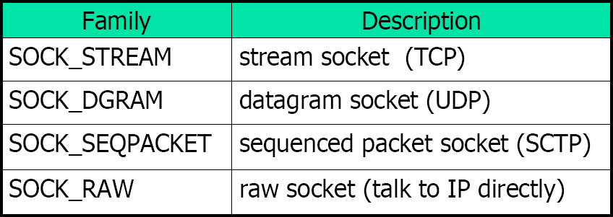



# Some Relevant Socket System

Calls and Header Files

int socket(int *family, int type, int protocol);*

int bind(int *sockfd, const struct sockaddr *addr, socklen_t addrlen);*

int listen(int *sockfd, int backlog);*

int accept(int *sockfd, struct sockaddr *cliaddr, socklen_t *cliaddrlen);*

int connect(int *sockfd, struct sockaddr *servaddr, socklen_t *servaddrlen);*

ssize_t recvfrom(int *sockfd, void *buff, size_t len, int flags, struct sockaddr *from,* socklen_t \**fromlen);*

ssize_t sendto(int *sockfd, void *msg, size_t len, int flags, struct sockaddr *to,* socklen_t *tolen);*

struct hostent gethostbyname(const char \**name);* int shutdown(int *sockfd, int howto);*

<sys/socket.h>

<netinet/in.h>

<netdb.h>

54