Let’s say you played an A note somewhere on the fretboard, for example, on the 5th fret of the 6th string. If you moved up a fret (to the 6th fret), you would now be playing a Bb (or A#). If you moved up one more fret (to the 7th fret), you would now be playing a B natural. The power of the above list should be apparent to you by now. If you know it, then given a starting note, you can get to any other note that you are looking for. Observe the following diagram:

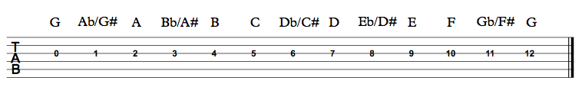

In the above image, the open ‘G’ is the starting point, played as a ‘0’ on the 3rd string. Moving up one fret at a time (1 semitone), we simply go through each note of the musical alphabet.

SHARPS and FLATS

‘Sharps’ (#) are produced by moving a natural note up one semitone (one fret). For example, The note ‘A’, becomes ‘A#’ when moved up one semitone.

‘Flats’ (b) are produced by moving a natural note down one semitone (one fret). For example, the note ‘A’, becomes ‘Ab’ when moved down one semitone.

There is a distance of two frets (interval = tone) between most of the natural notes.

‘B’ is a tone away from ‘A’. ‘E’ is a tone away from ‘D’. As you have probably figured out (or observed in the list of notes), all of the notes in between can be referred to as either a sharp or a flat, depending on which note is your reference point.

For example, there is a note in between A and B. This note is called A Sharp (A#) or B Flat (Bb).

There is a note in between D and E. This is called D# or Eb.

Put simply, for each ‘sharp’, there is an equivalent ‘flat’, and vice versa. This is known as **enharmonic equivalence**.

***The tricky thing (again, you’ve probably already observed this) is that there is an interval of only one semitone between some natural notes. This occurs from ‘B’ to ‘C’, and from ‘E’ to ‘F’*.**

