CSI_5_BDD
Student ID: 4214293

Contents
Introduction 2
Task 1 2
Task 2 4
Task 3 6
Task 4 20
Part A 20
Explanation of Query A 23
Part B 24
Explanation of Query B 26
Part C 27
Explanation of Query C 29
Part D 30
Explanation of Query D 36
Part E 37
Explanation of Query E 50
Task 5 52
Conclusion 62
Link to the video 63
References 64

Introduction
This report outlines the design and implementation of the database system LSBU Manufacturing Ltd, while focusing on entity-relationship diagrams, normalisation, SQL querying, and data visualisation with the help of Power BI.

Task 1
For case study B, The ER diagram shows the entities, attributes, and relationships between the different attributes. It ensures that data integrity is needed for completing tasks 3 and 4.
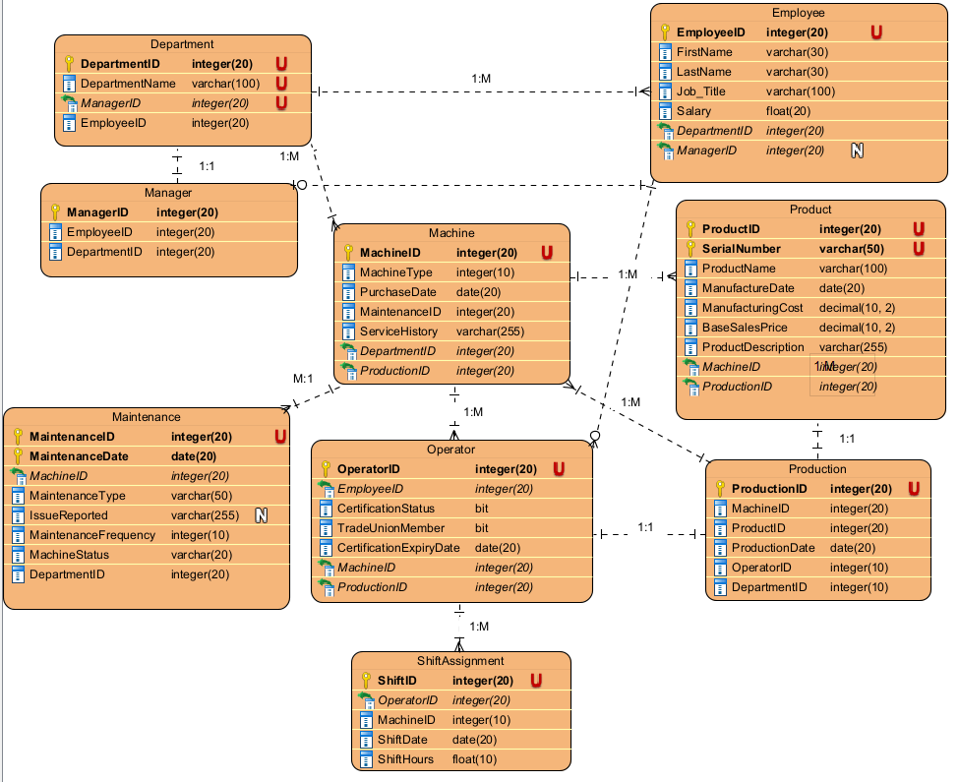
Figure 1 – ER Diagram showing the entities and the relationships
The notation used to create the ER diagram was the Chen notation (Cio-wiki.org, 2023).
Primary Key – A column, that uniquely identifies a row or record in a table.
Foreign Key – A column, that references the primary key of another table, to enforce relationships between two tables.
Relationship – When an attribute has a connection with another attribute in another table (One-to-One), (One-to-Many), (Many-to-One), and (Many-to-Many) (GeeksforGeeks, 2024b).
Referential Integrity – Rules which are enforced to ensure that the foreign key always reference the valid primary key.
Entity | Primary Key | Foreign Keys | Relationships
Department | DepartmentID | ManagerID, EmployeeID | (One-to-Many) with Employee  (One-to-Many) with Machine  (One-to-One) with Manager
Employee | EmployeeID | DepartmentID,  ManagerID | (One-to-Zero or One) with Manager  (One-to-Zero or Many) with Operator
Manager | ManagerID | EmployeeID, DepartmentID | (One-to-Zero or Many) with Employee
Maintenance | MaintenanceID | MachineID, DepartmentID | (Many-to-One) with Machine
Machine | MachineID | DepartmentID, ProductionID | (Many-to-One) with Department  (One-to-Many) with Product  (One-to-Many) with Production  (One-to-Many) with Maintenance  (One-to-Many) with Operator
Operator | OperatorID | EmployeeID, MachineID, ProductionID | (One-to-Many) with ShiftAssignment  (Zero or many-to-One) with Employee  (One-to-One) with Production
ShiftAssignment | ShiftID | OperatorID, MachineID | (One-to-one) with Operator
Product | ProductID, SerialNumber (Composite Key) | MachineID, ProductionID | (One-to-One) with Production
Production | ProductionID | MachineID, ProductID, OperatorID, DepartmentID | (Many-to-One) with Machine  (One-to-One) with Product  (One-to-Many) with Operator
Table 1 – Entity-Relationship Definitions

Task 2
Functional dependencies occur when one attribute determines another attribute (GeeksforGeeks, 2024c).
- Department:
  - DepartmentID ManagerID – Each department has one manager managing that department.
  - DepartmentID EmployeeID – Each department can contain multiple employees.
- Employee:
  - EmployeeID DepartmentID – Each employee belongs to one department.
  - EmployeeID ManagerID - Each employee is managed by one manager.
- Manager:
  - ManagerID EmployeeID – Each manager is an employee in the company.
  - ManagerID DepartmentID – Each manager manages one department.
- Machine:
  - MachineID DepartmentID – Each machine belongs to one department.
- Maintenance:
  - MaintenanceID MachineID – Each maintenance record is for one machine.
  - MaintenanceID DepartmentID – Each maintenance record is requested by a department.
- Operator:
  - OperatorID EmployeeID – Each Operator is an employee.
- ShiftAssignment:
  - ShiftID OperatorID – Each shift is assigned to one operator.
  - ShiftID MachineID – Each shift involves one machine for production.
- Product:
  - (ProductID, SerialNumber) ProductName – The combination of both ProductID and SerialNumber is used to determine the ProductName.
  - (ProductID, SerialNumber) ManufactureDate– The combination is used to determine the ManufactureDate.
  - (ProductID, SerialNumber) ManufacturingCost – The combination determines the ManufacturingCost.
  - (ProductID, SerialNumber) BaseSalesPrice - The combination determines the BaseSalesPrice.
- Production:
  - ProductionID MachineID – Each production process usually involves one machine to carry out that process.
  - ProductionID ProductID – Each production process produces at least one product.
  - ProductionID OperatorID – Each production process involves one operator.
  - ProductionID DepartmentID – Each production process is managed by one department.

The database design satisfies 3NF/BCNF:
- Ensuring all attributes are atomic (1NF).
- All the non-key values are functionally dependent on the primary key (2NF) – e.g. (ProductID, SerialNumber) ProductName.
- Eliminating transitive dependencies (3NF).
Each functional dependency (XY), since X, would be a super key and doesn’t contain multiple overlapping candidate keys (Studytonight, 2019). For e.g. DepartmentID and OperatorID are superkeys in the case of the database design.
Ensuring that the database is well structured, efficient and doesn’t contain any redundancy.

Task 3
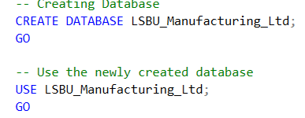
Figure 2.1 – Creating the database and using the database

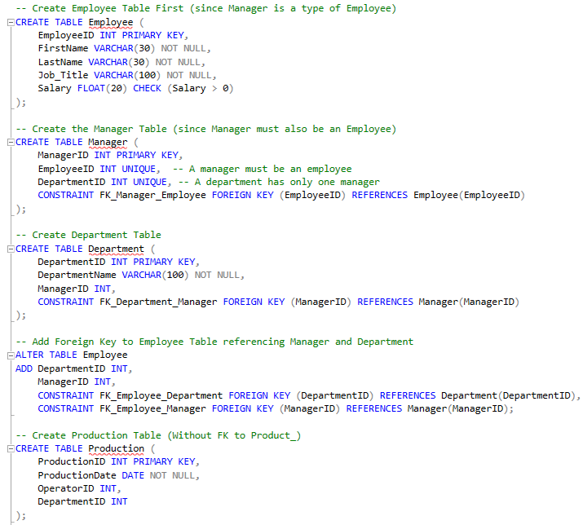
Figure 2.2.1 – Creating and altering the tables within the database

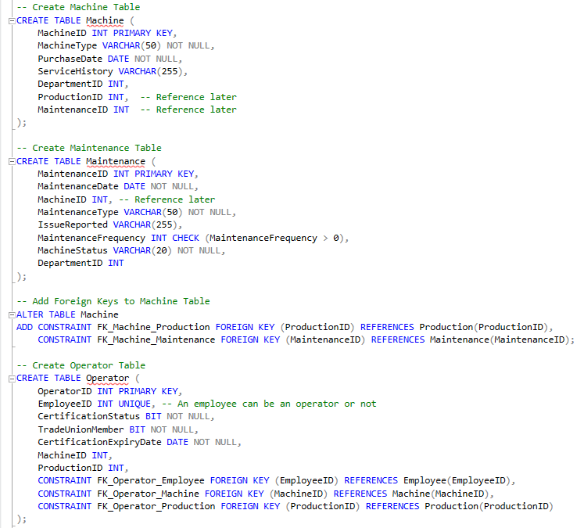
Figure 2.2.2 – Creating and altering the tables within the database
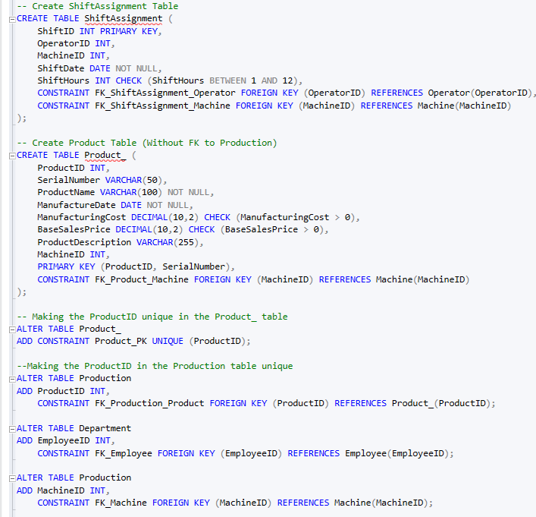
Figure 2.2.3 – Creating and altering the tables within the database

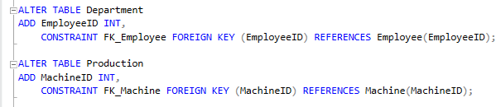
Figure 2.2.4 – Altering the tables within the database

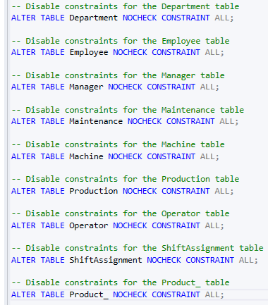
Figure 2.3 – Disabling the constraints on all the tables
To help create the insert statements, DeepSeek was used to assist with the creation of the different statements to save time, so that this time can be used for completing other tasks in this assignment.
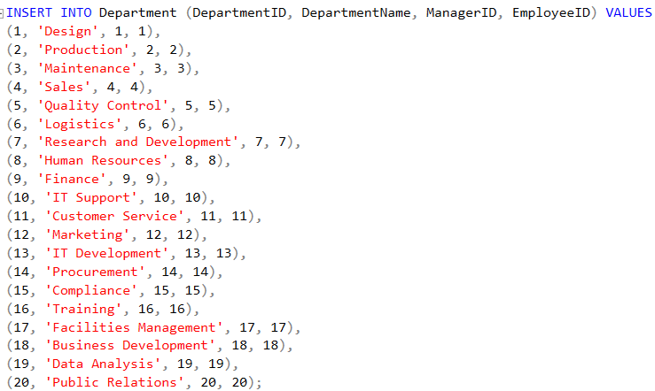
Figure 2.4.1 – Inserting records into the Department table
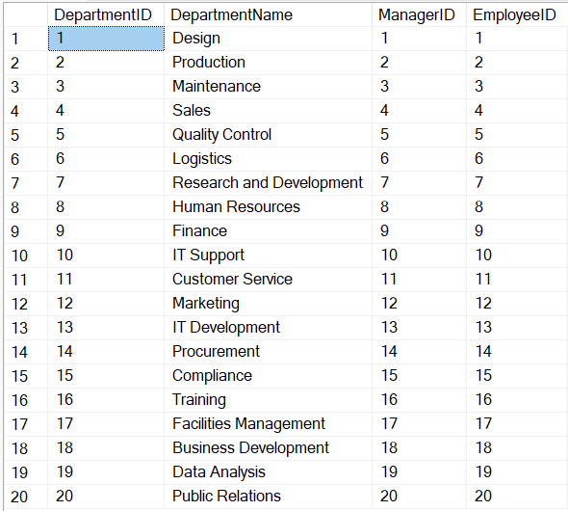
Figure 2.4.2 – Record output for the Department Table
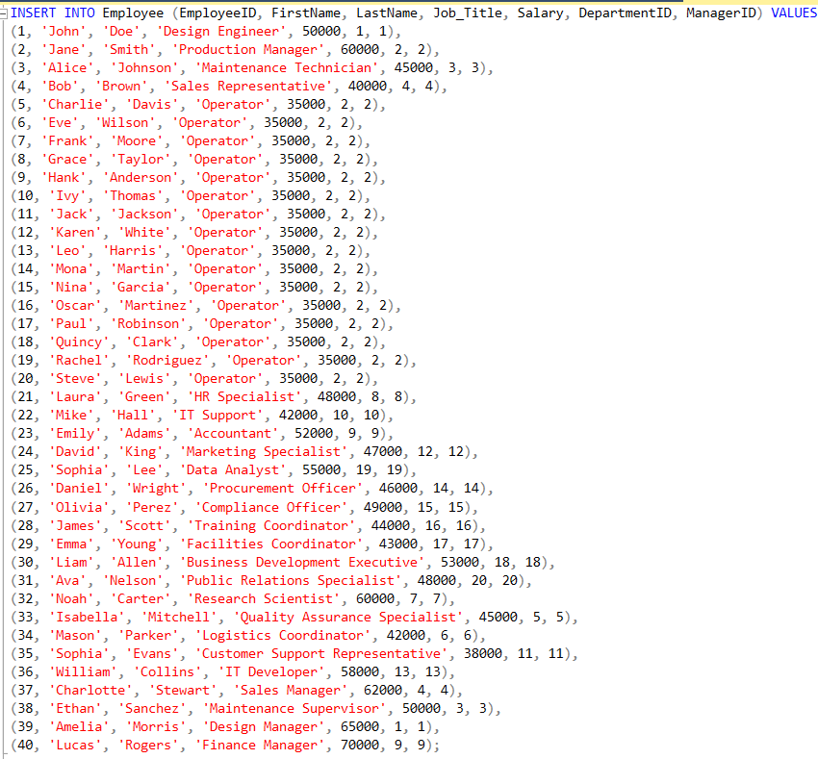
Figure 2.5.1 – Inserting records into the Employee table

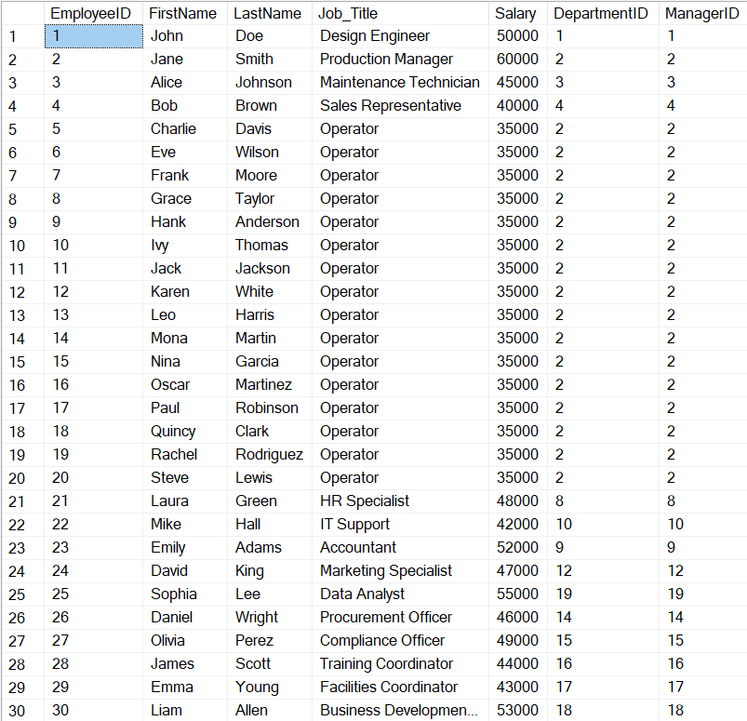
Figure 2.5.2 – Record output for the Employee Table
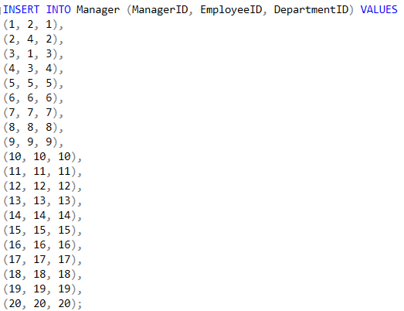
Figure 2.6.1 – Inserting records into the Manager table

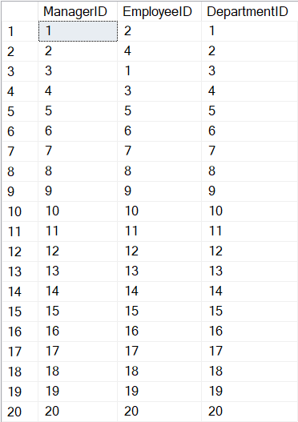
Figure 2.6.2 – Record output for the Manager Table
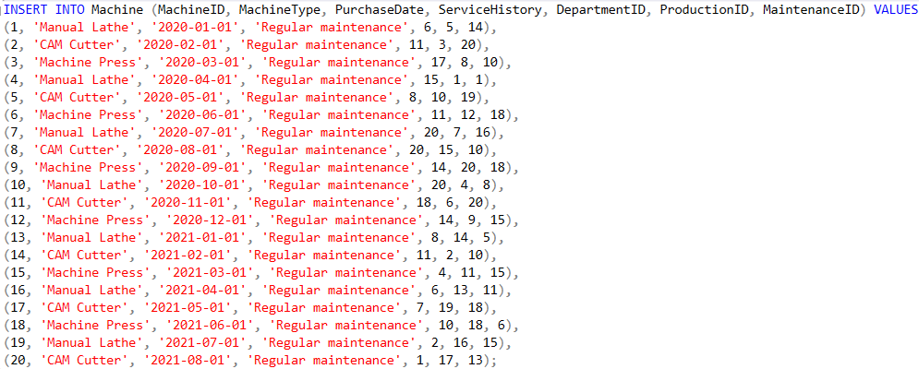
Figure 2.7.1 – Inserting records into the Machine table
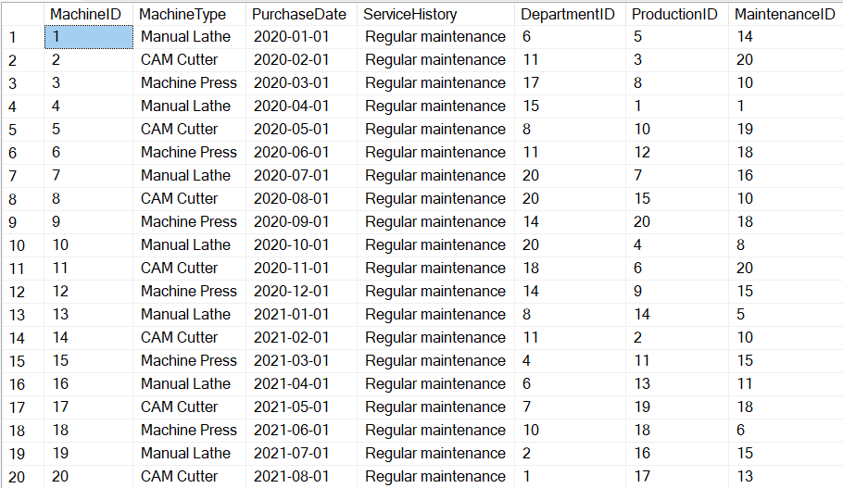
Figure 2.7.2 – Record output for the Machine Table
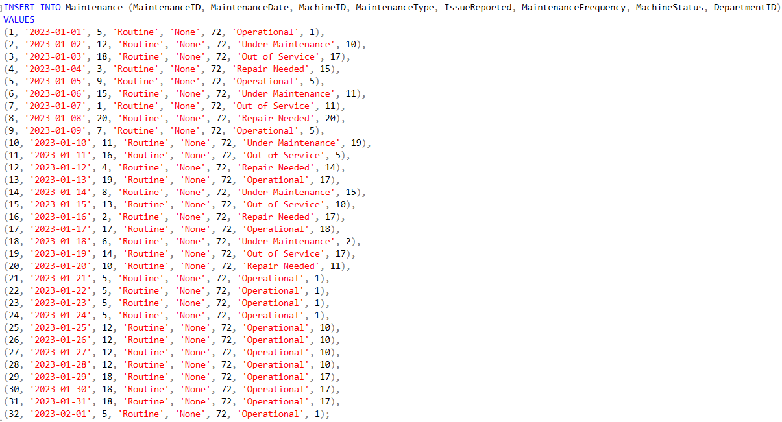
Figure 2.8.1 – Inserting records into the Maintenance table

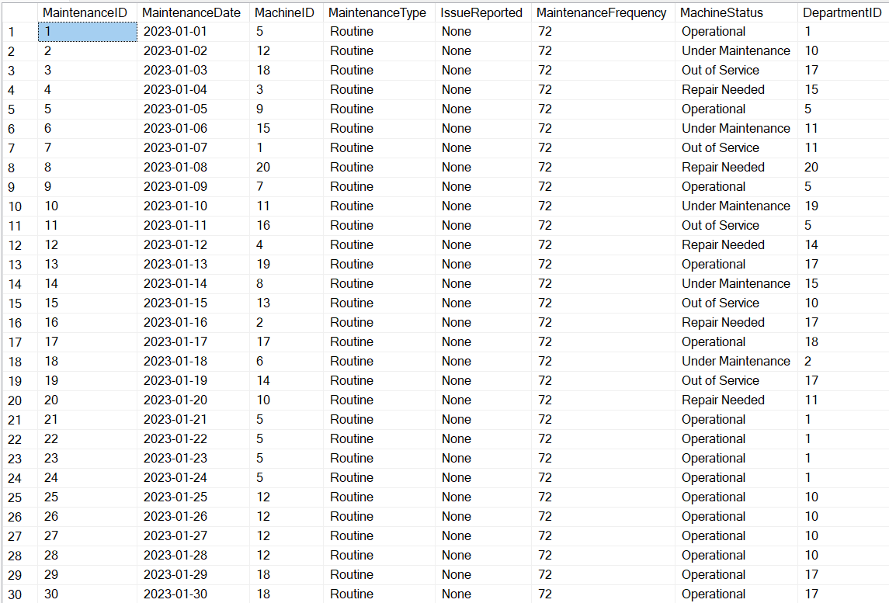
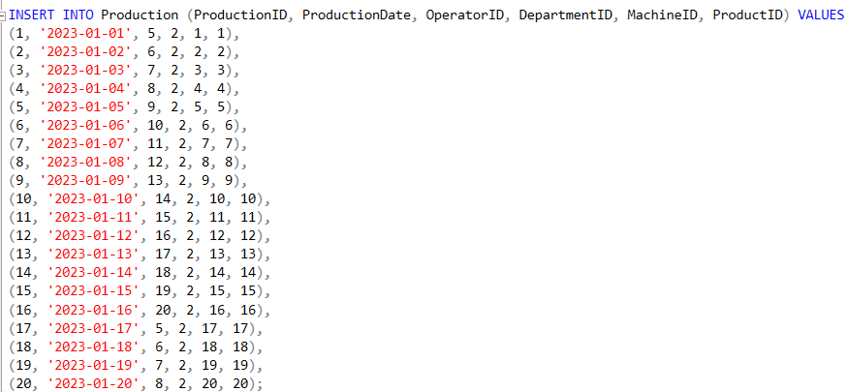
Figure 2.8.2 – Record output for the Machine Table

Figure 2.9.1 – Inserting records into the Production table

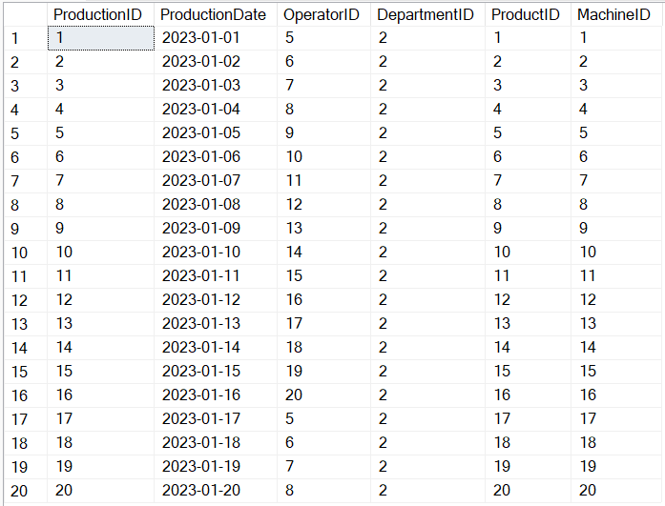
Figure 2.9.2 – Record output for the Production Table
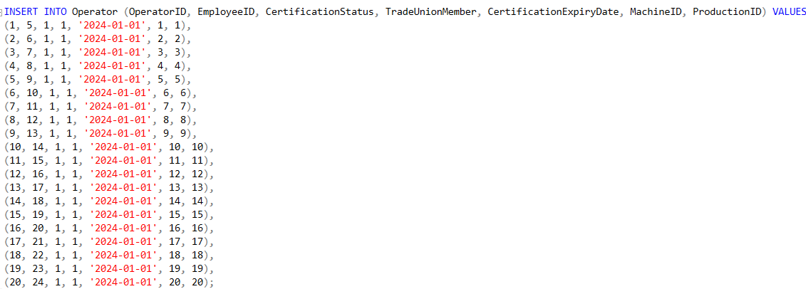
Figure 2.10.1 – Inserting records into the Operator table
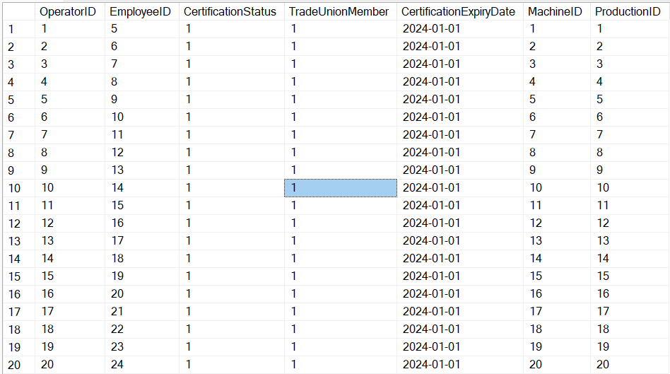
Figure 2.10.2 – Record output for the Operator Table

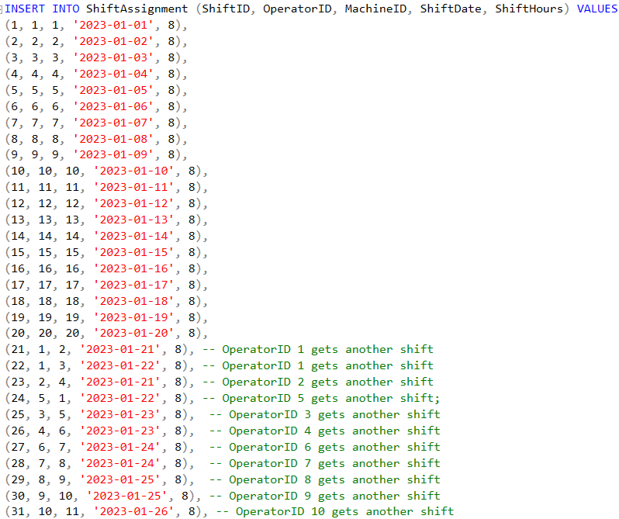
Figure 2.11.1 – Inserting records into the ShiftAssignment table
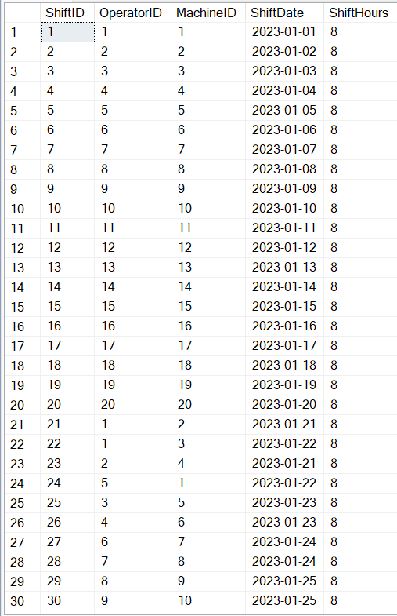
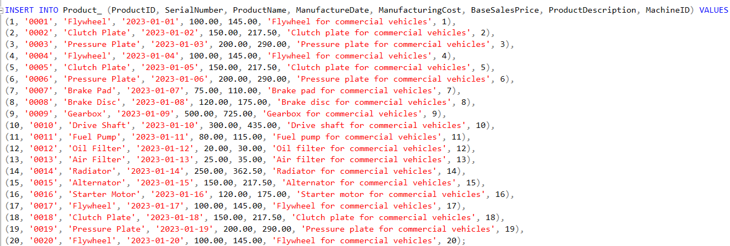
Figure 2.11.2 – Record output for the ShiftAssignment Table

Figure 2.12.1 – Inserting records into the Product_ table
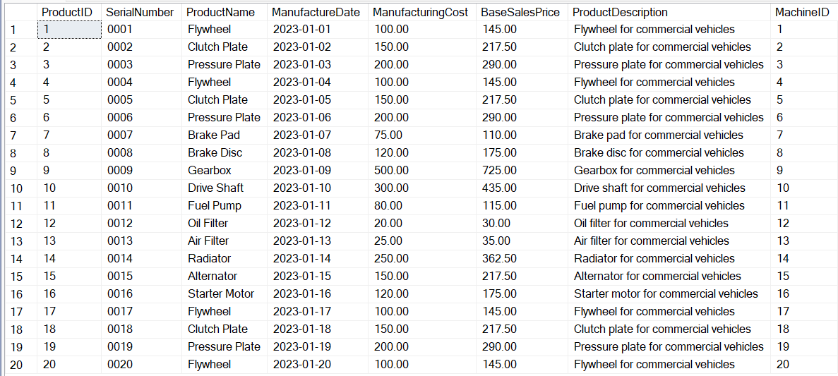
Figure 2.12.2 – Record output for the Product_ Table
The database was built with referential integrity, parent tables were created first, foreign keys were added through ALTER. Constraints were disabled to allow for inserting records into the tables.

Task 4

Part A
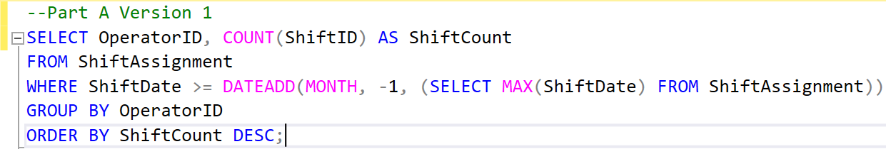
Figure 3.1.1 – Part A SQL Query Snippet
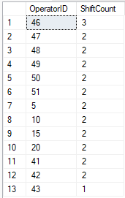
Figure 3.1.2 – Output of the Part A SQL Query Snippet

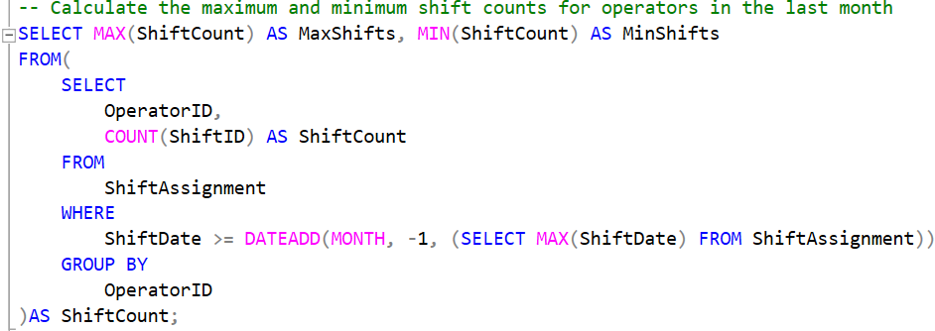
Figure 3.2.1 – Part A SQL Query Snippet
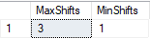
Figure 3.2.2 – Output of the Part A SQL Query Snippet

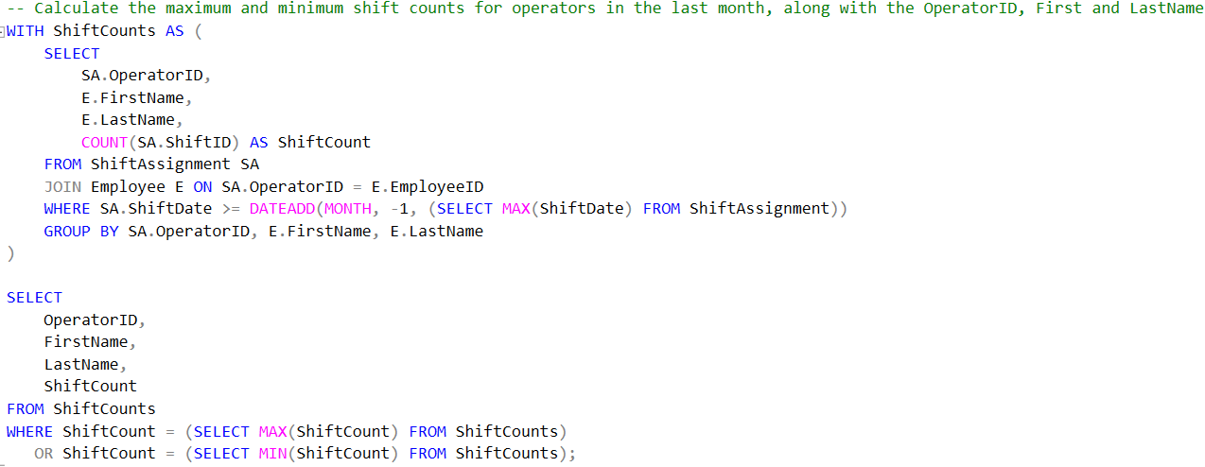
Figure 3.3.1 – Part A SQL Query Snippet

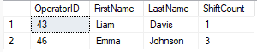
Figure 3.3.2 – Output of the Part A SQL Query Snippet

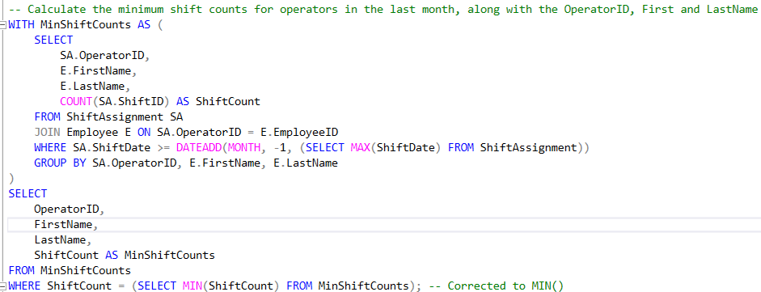
Figure 3.3.3 – Improved Part A SQL Query Snippet

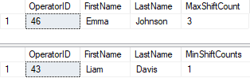
Figure 3.3.4 – Output of the improved Part A SQL Query Snippet

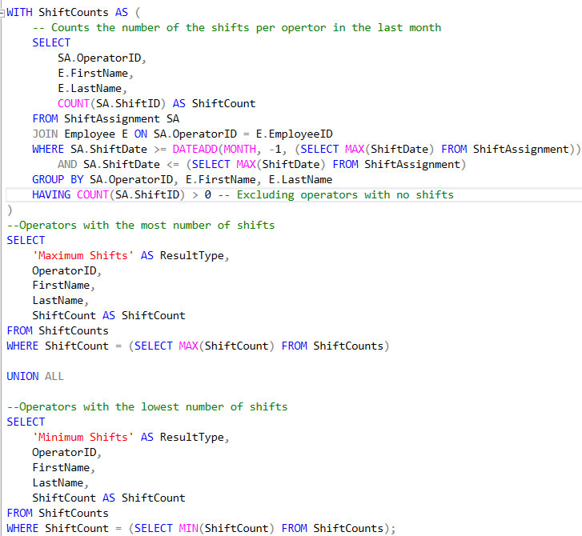
Figure 3.3.5 – Improved Part A SQL Query Snippet
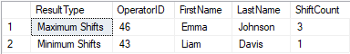
Figure 3.3.6 – Output of the improved Part A SQL Query Snippet

Explanation of Query A
The initial query (Figure 3.1.1) identifies Operators who worked in the past month and ranks them from the highest number of shifts to the lowest number of shifts. The maximum and minimum number of shifts (worked by Operators) in the last month is required.
Figures 3.2.1-3.3.6 added a subquery for counting the number of shifts. The INNER JOIN links the two tables Employee and ShiftAssignment, matching records together to include names (FirstName, LastName) of the Operator.
The CTE (Common Table Expression), improves readability, maintainability, and reduces errors by improving the structure of the query (Stratascratch.com, 2023).
Figure 3.3.5 defines the date ranges, column ‘ResultType’ is added to distinguish the max/min values and combines the two SELECT statements into one result via UNION ALL.

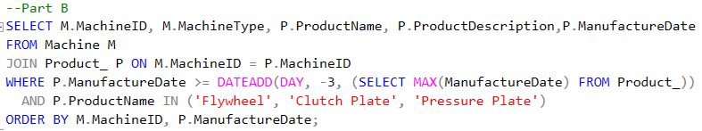
Part B

Figure 4.1 – Part B SQL Query Snippet
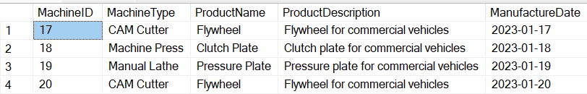
Figure 4.2 – Output of the Part B SQL Query Snippet
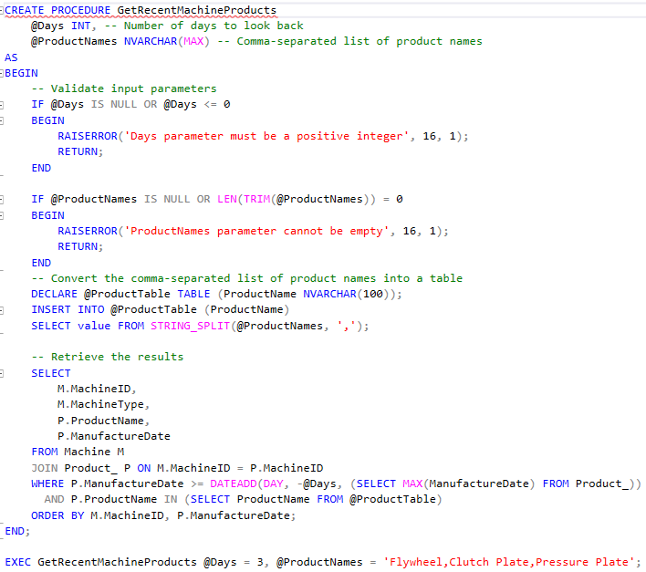
Figure 4.3 – Part B SQL Query Snippet
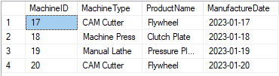
Figure 4.4 – Output of the Part B SQL Query Snippet
Figure 4.5 – Executing procedure for Test case 1 Part B SQL Query Procedure
Figure 4.6 – Output for Test case 1 Part B SQL Query Procedure

Figure 4.7 – Executing procedure for Test case 2 Part B SQL Query Procedure

Figure 4.8 – Output for Test Case 2 Part B SQL Query Procedure

Explanation of Query B
Figure 4.1 retrieves the list of machines that have produced products (Flywheel, Clutch Plate, Pressure Plate) within the past three days. It selects the MachineID, MachineType, ProductName, ProductDescription, and ManufactureDate.
Further enhancements were made (Figures 4.3-4.8) which improved the flexibility, reusability, and security via input validation (checking for any NULL/empty values and invalid day parameters) and using error handling with the help of RAISERROR.
The stored procedures are compiled only once and can be executed at any time (in their executable form) (geeksforgeeks, 2020). It is now well-defined and can fail safely if the user enters invalid inputs.

Part C
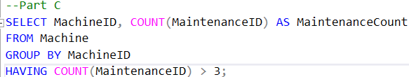
Figure 5.1 – Part C SQL Query Snippet
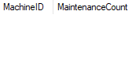
Figure 5.2 – Output of the Part C SQL Query Snippet
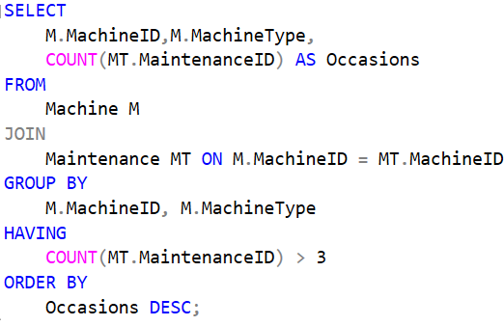
Figure 5.3 – Part C SQL Query Snippet

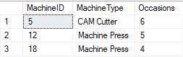
Figure 5.4 – Output of the Part C SQL Query Snippet

Figure 5.5 – Indexing MachineID Part C SQL Query Snippet
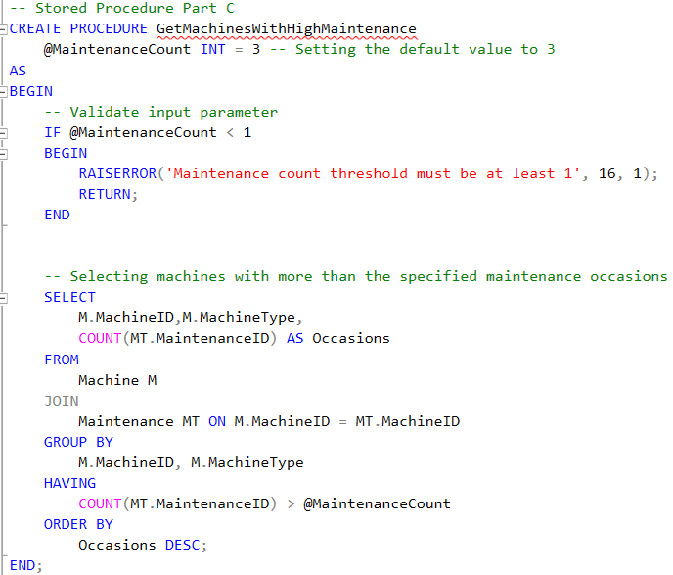
Figure 5.6 – Part C SQL Query Snippet


Figure 5.7 – Output of the Part C SQL Query Snippet

Explanation of Query C
Figure 5.1 failed to return the correct results due to a lack of JOINs between the Machine and Maintenance tables. Figure 5.3 properly joins these tables, displaying the MachineType plus the maintenance record counts exceeding greater than 3 and is sorted by Occasions.
Furthermore, the MachineID attribute in the Maintenance table was indexed to improve the query performance, as indexes allow one to find a record or a list of records faster (Bharti, 2022).
By implementing a stored procedure using the parameter (MaintenanceCount), replacing the hardcoded value in the query. It validates the input by (MaintenanceCount < 1), enabling efficient query use instead of query modification. It is flexible when receiving different inputs.

Part D
To help construct the query requiring a stored procedure, (WilliamDAssafMSFT, 2025), (WiseOwlTutorials, 2012a), and (WiseOwlTutorials, 2012b) were used as guidance to create these stored procedures.
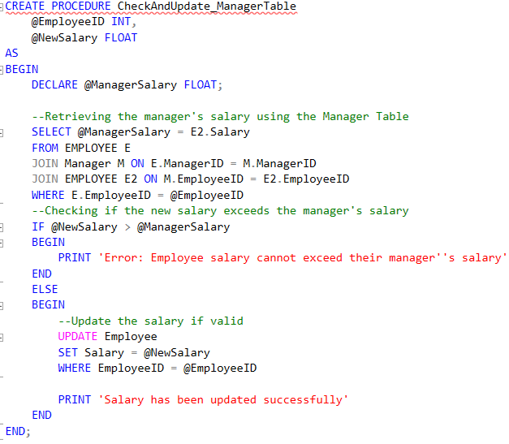
Figure 6.1.1 – Part D SQL Query Snippet
Figure 6.1.2 – Testing Procedure (Test Case 1)
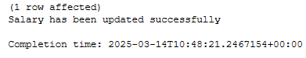
Figure 6.1.3 – Expected Output (Test Case 1)

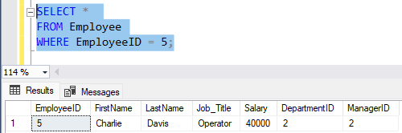
Figure 6.1.4 – Checking the changes made to Employee ID 5 (Test Case 1)

Figure 6.1.5 – Testing Procedure (Test Case 2)
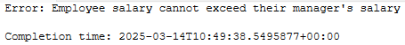
Figure 6.1.6 – Expected Output (Test Case 3)

Figure 6.1.7 – Testing Procedure (Test Case 3)

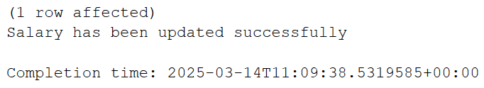
Figure 6.1.8 – Expected Output (Test Case 3)

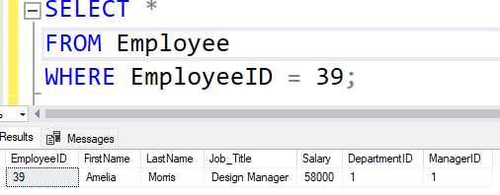
Figure 6.1.9 – Checking the changes made to Employee ID 5 (Test Case 3)
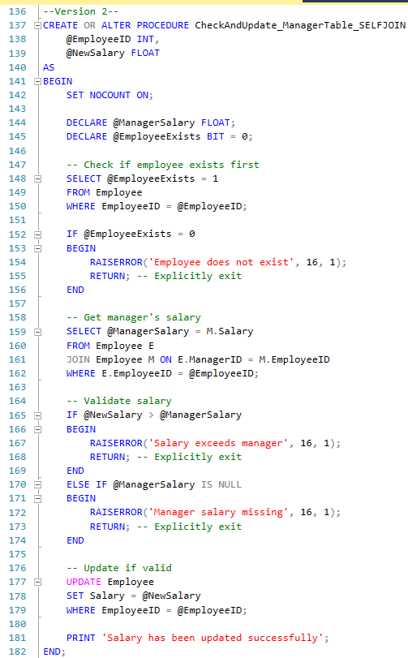
Figure 6.2.1 – Part D SQL Query Snippet

Figure 6.2.2 – Testing Procedure (Test Case 1)
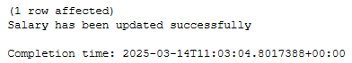
Figure 6.2.3 – Expected Output (Test Case 1)

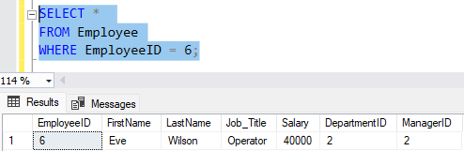
Figure 6.2.4 – Checking the changes made to Employee ID 6 (Test Case 1)

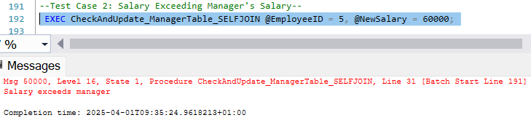
Figure 6.2.5 – Testing Procedure (Test Case 2)

Figure 6.2.6 – Testing Procedure (Test Case 3)

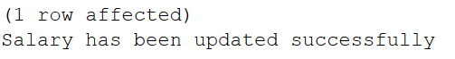
Figure 6.2.7 – Expected Output (Test Case 3)

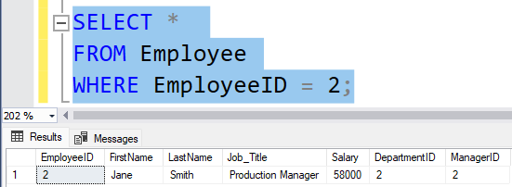
Figure 6.2.9 – Checking the changes made to Employee ID 6 (Test Case 3)
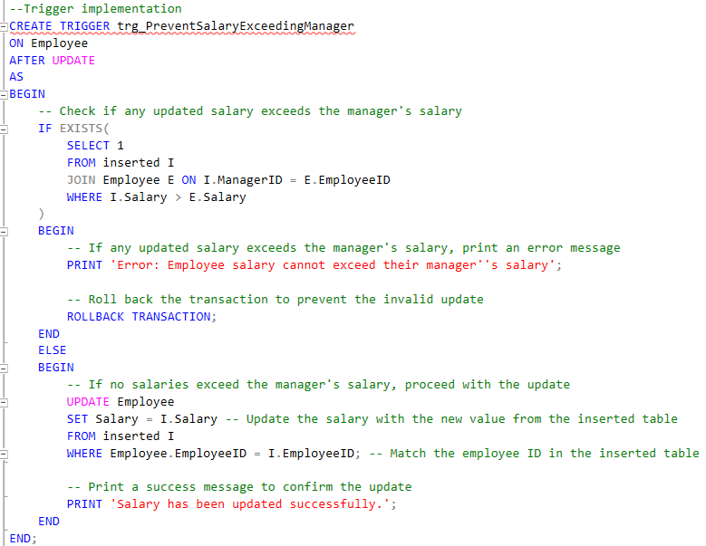
Figure 6.3.1 – Part D SQL Query Snippet
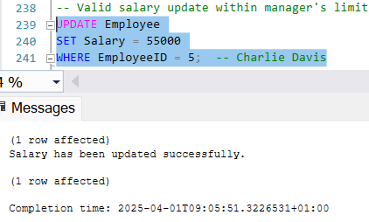
Figure 6.3.2.1 – Testing Trigger (Test Case 1)
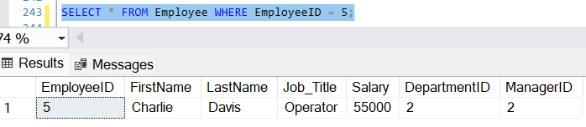
Figure 6.3.2.2 – Output of Trigger (Test Case 1)

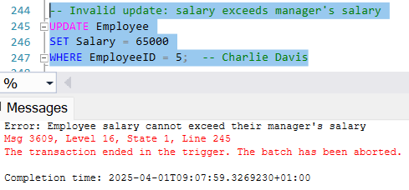
Figure 6.3.3 – Testing Trigger (Test Case 2)
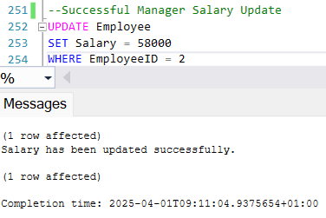
Figure 6.3.3.1 – Testing Trigger (Test Case 3)
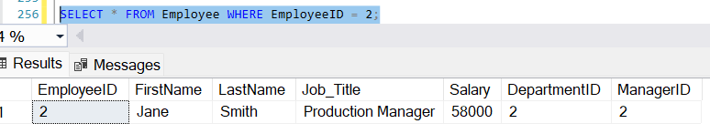
Figure 6.3.3.2 – Testing Trigger (Test Case 3)

Explanation of Query D
Figure 6.1.1 uses a stored procedure with parameters (EmployeeID, NewSalary) to check if an employee’s salary exceeds the manager’s salary by joining the Employee and the Manager’s table.
A self-join (Figure 6.2.1) on the Employee table, eliminates extra joins with the Manager table and simplifies the query, thus improving performance (w3resource, 2025).
Figure 6.3.1 implements a trigger since is known for automatically executing specific events, maintaining consistency and enforcing business rules (GeeksforGeeks, 2020b). They, automatically execute depending on specific events, whereas stored procedures must be executed manually – suitable for DBMS beginners.
ROLLBACK TRANSACTION reverses any changes that are made during the current transaction that have not taken place. This ensures that the database returns to its previous state by undoing any uncommitted changes (GeeksforGeeks, 2020a).

Part E

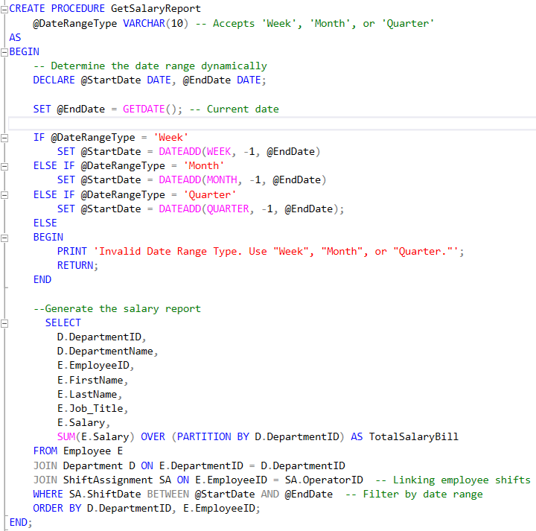
Figure 7.1.1 – Part E Query Snippet

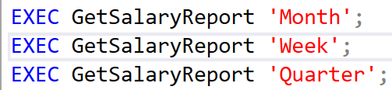
Figure 7.1.2 – Testing the Part E Query

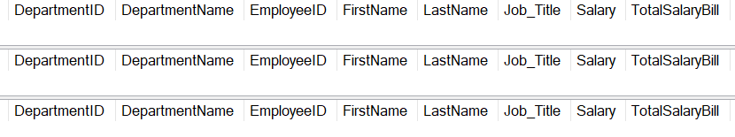
Figure 7.1.3 – Output the Part E Query

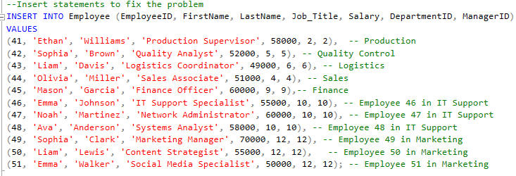
Figure 7.1.4 – Inserting more records into the Employee Table

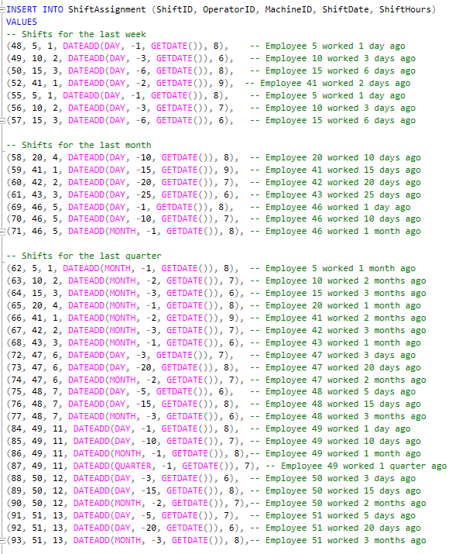
Figure 7.1.5 – Inserting more records into the ShiftAssignment Table

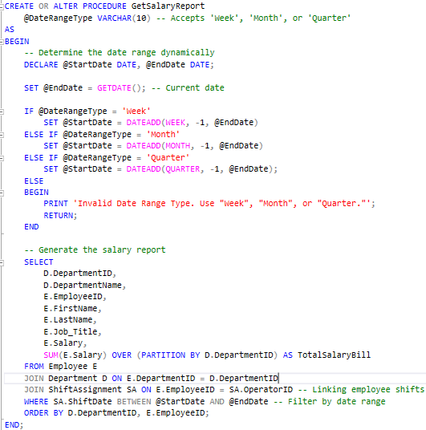
Figure 7.2.1 – Part E Query Snippet
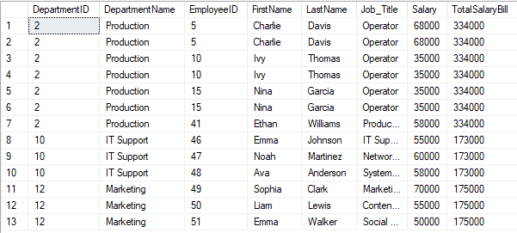
Figure 7.2.2 – Output of the Weekly Salary Report Part E Query

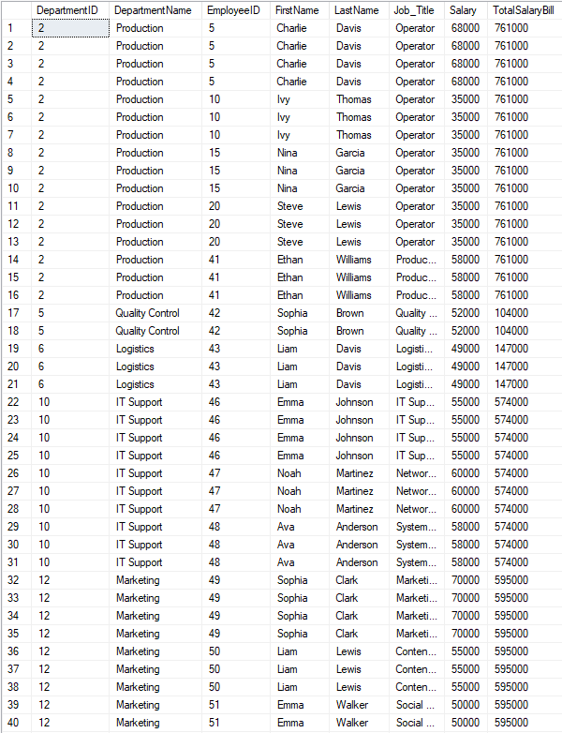
Figure 7.2.3 – Output of the Monthly Salary Report Part E Query
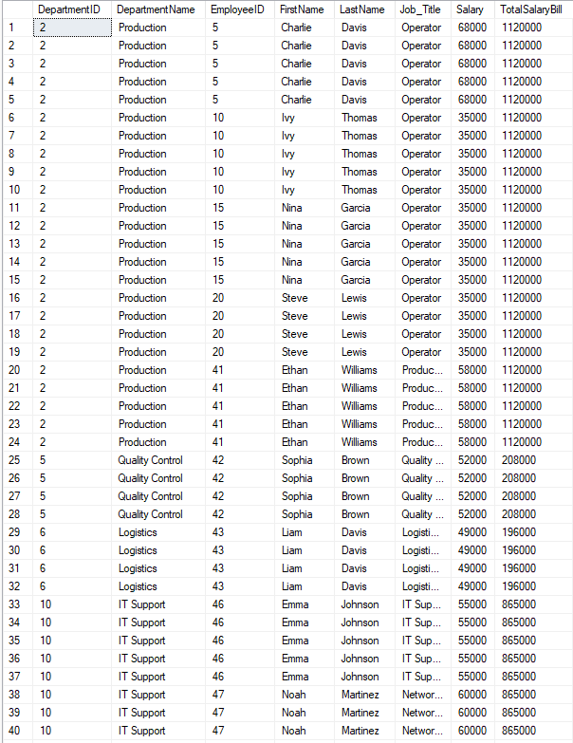
Figure 7.2.4 – Output of the Quarterly Salary Report Part E Query
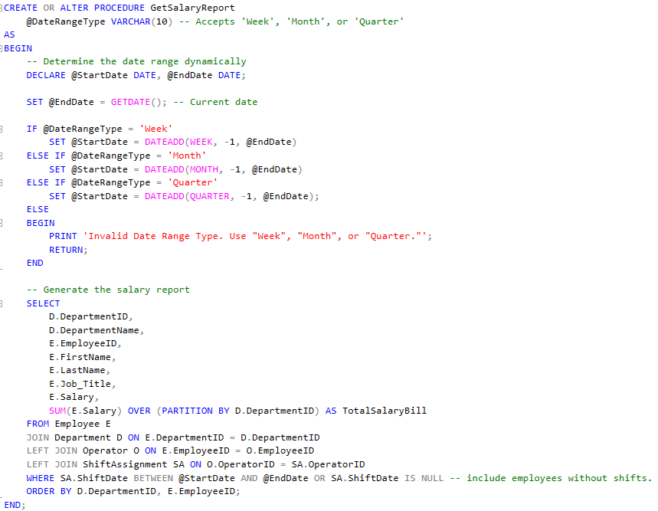
Figure 7.3.1 – Part E Query Snippet

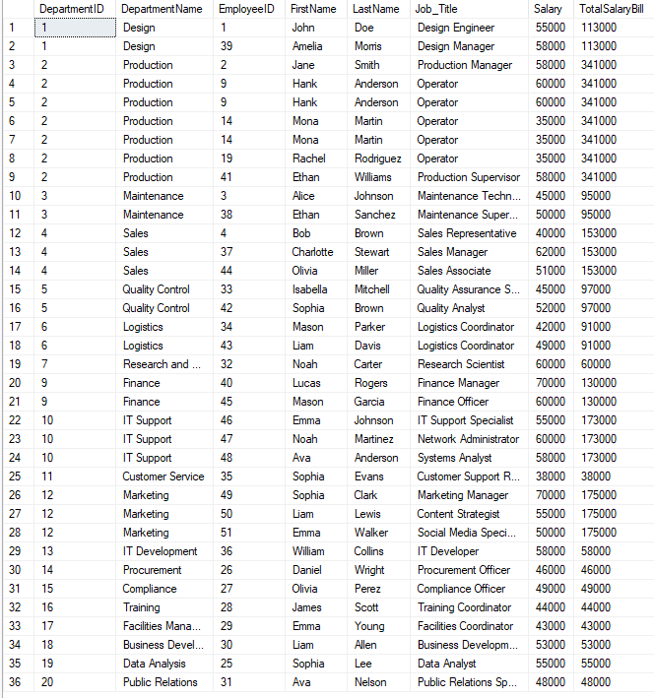
Figure 7.3.2 – Output of the Weekly Salary Report Part E Query

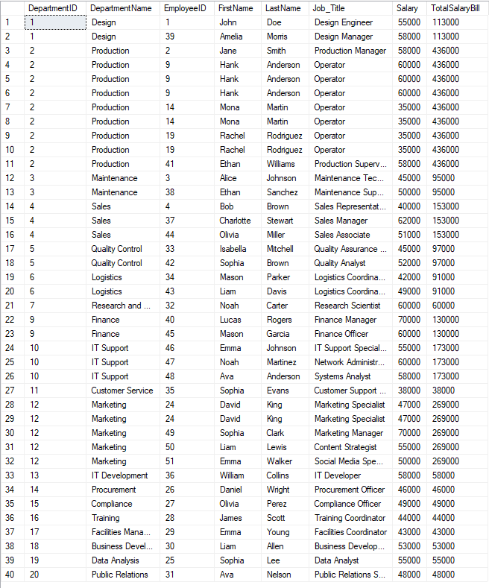
Figure 7.3.3 – Output of the Monthly Salary Report Part E Query

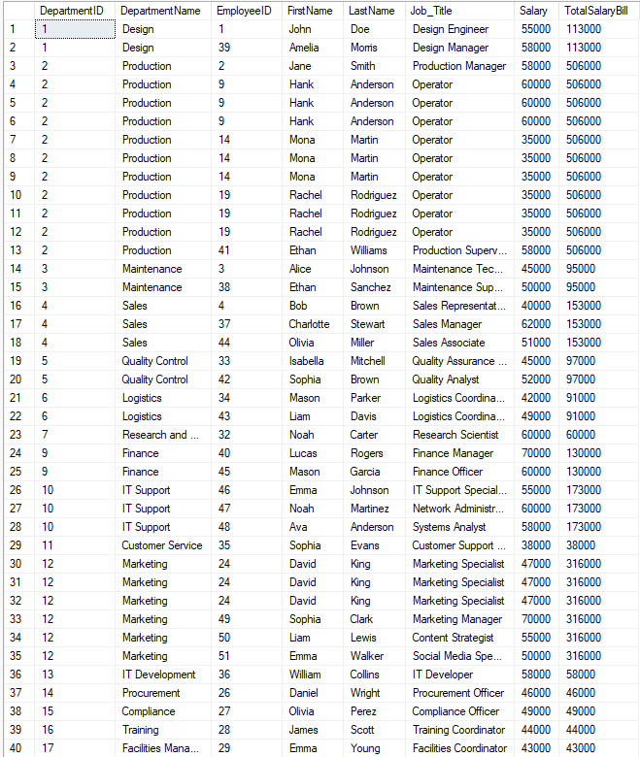
Figure 7.3.4 – Output of the Quarterly Salary Report Part E Query

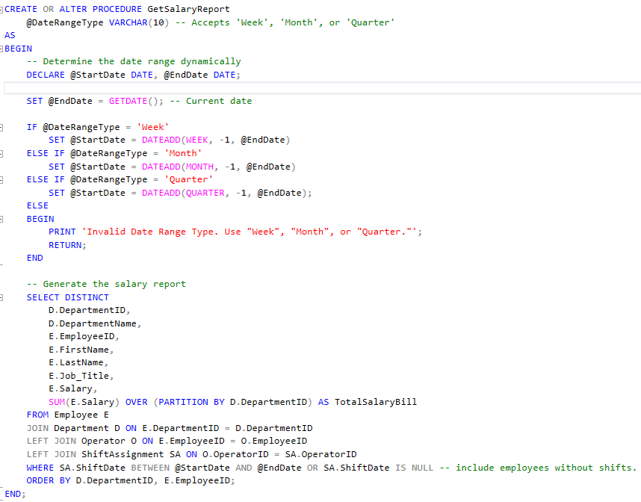
Figure 7.4.1 – Part E Query Snippet

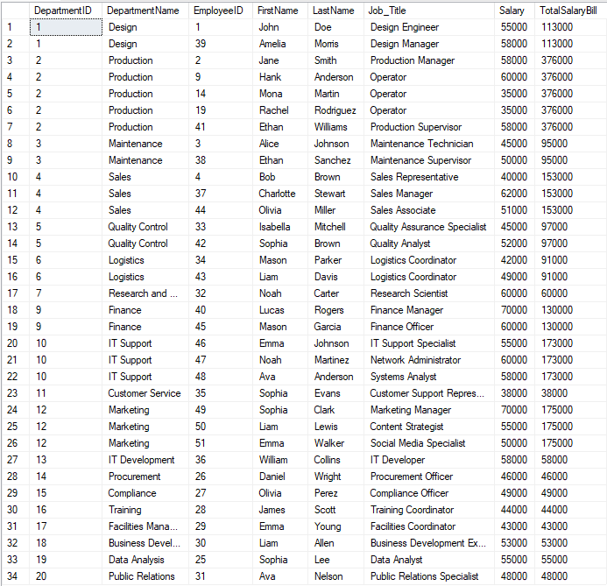
Figure 7.4.2 – Output of the Weekly Salary Report Part E Query

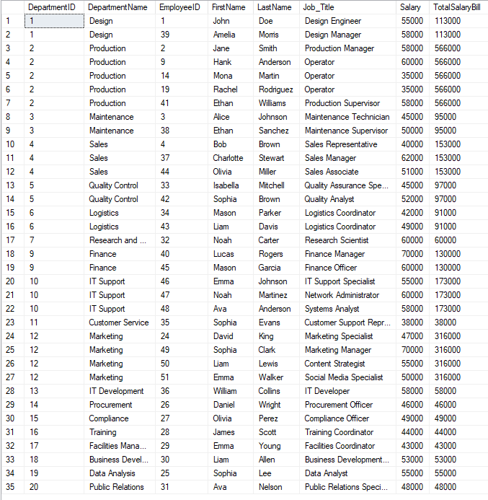
Figure 7.4.3 – Output of the Monthly Salary Report Part E Query

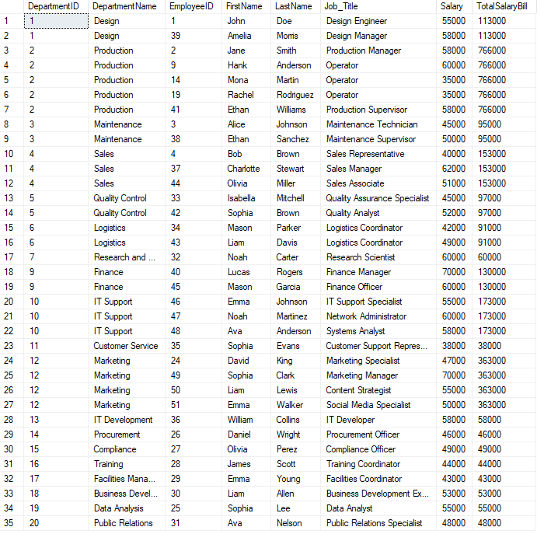
Figure 7.4.4 – Output of the Quarterly Salary Report Part E Query

Explanation of Query E
Figure 7.1.1 generates the department's weekly/monthly/quarterly salary reports via JOINs between the Employee-Department and Employee-ShiftAssignment tables, with the Partition By function (divides the results into partitions to which the functions are applied) (GeeksforGeeks, 2024a).
In the early execution, no data was returned (Figure 7.1.3) due to missing records within that date range.
Figures 7.1.4 – 7.1.5, added in records for the ShiftAssignment and Employee table to ensure the procedure is functioning.

Figure 7.3.1 uses a LEFT JOIN to include all the departments in the report but adds duplicate records that were not required.
Figure 7.4.1, eliminating duplicates by using DISTINCT while including all the departments in the report. Providing a salary report across all the departments and time periods, which solved the completeness of data

Task 5
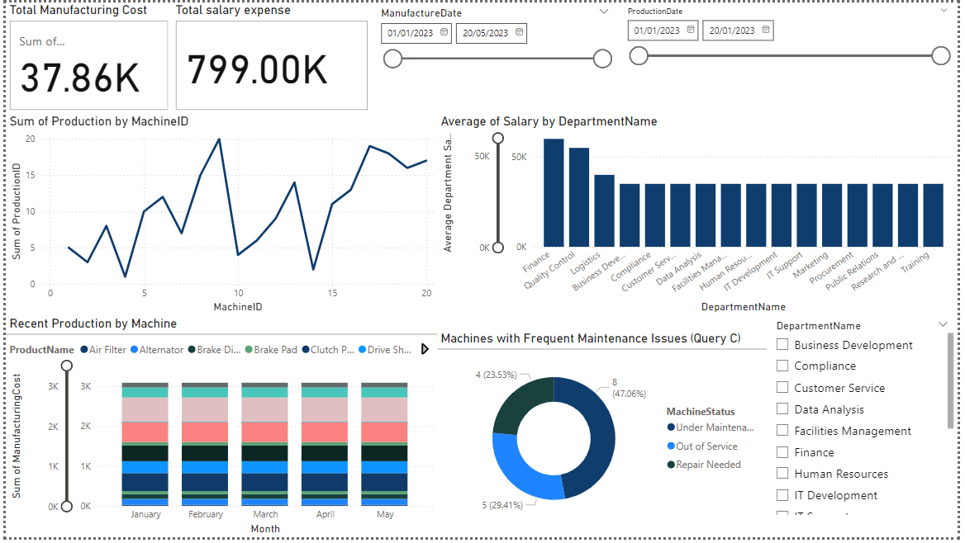
Power BI was used to create an interactive dashboard, including slicers and filters wherever applicable. (GeeksforGeeks, 2023), was used to help to create and design the dashboard.

Figure 8.1 – Overview of the dashboard Page 1
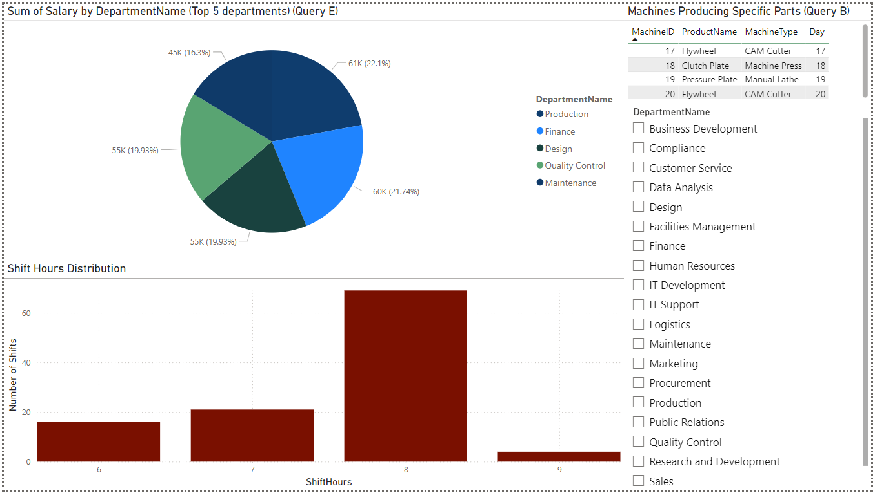
Figure 8.2 – Overview of the dashboard Page 2

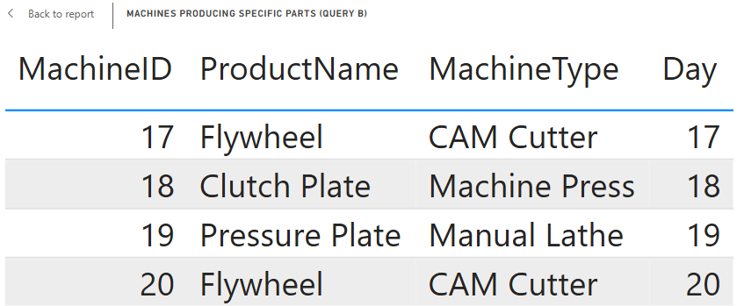
Figure 8.3 – Table showing the different Machines Producing different specific part (Query B)
Figure 8.3 displays a table, which tracks the production across different machines (Machine ID 17-20) for products (Flywheel, Clutch Plate, and Pressure Plate) in the last 3 days.
The key metrics, MachineID, MachineType, ProductName, and ManufactureDate.
This table helps to monitor real-time production activities whilst ensuring that machines are utilized effectively. Which helps in identifying high-demand products (increasing production accordingly) and improving operational efficiency.

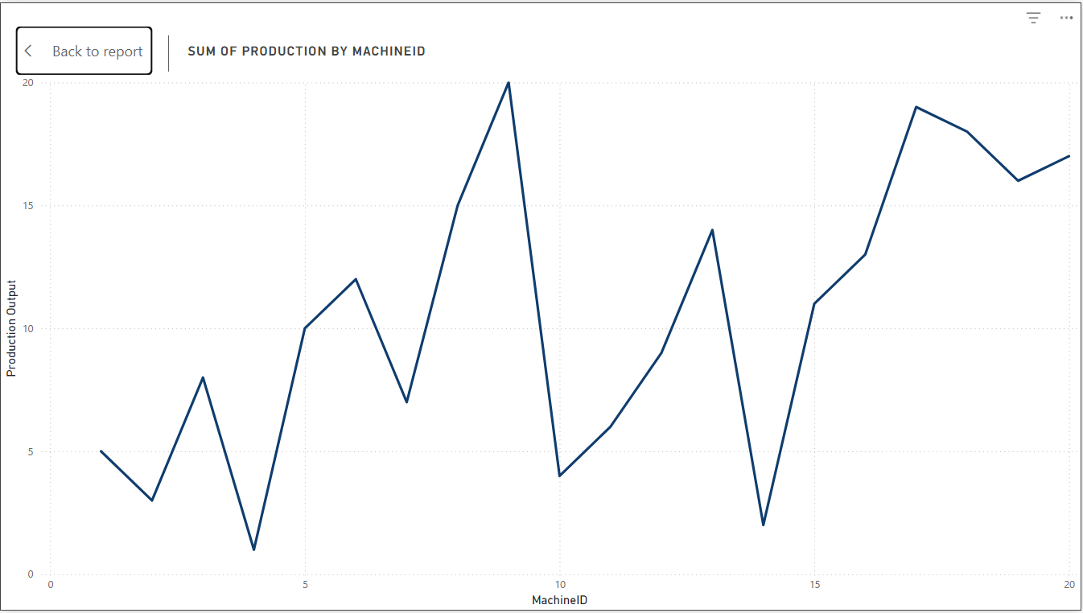
Figure 8.4 – Line graph representing the Sum of Production by MachineID
Figure 8.4 represents a line graph for comparing the production across machines to identify high and low-performing equipment when it comes to production.
The key metrics, MachineID and total production output.
It highlights machines that may require maintenance or workload balancing. For instance, machines with the highest production output may need to prioritise servicing over other machines.
A line graph is ideal for operational troubleshooting and future planning when it comes to resource allocation and investment into maintaining old machines and purchasing new machines.

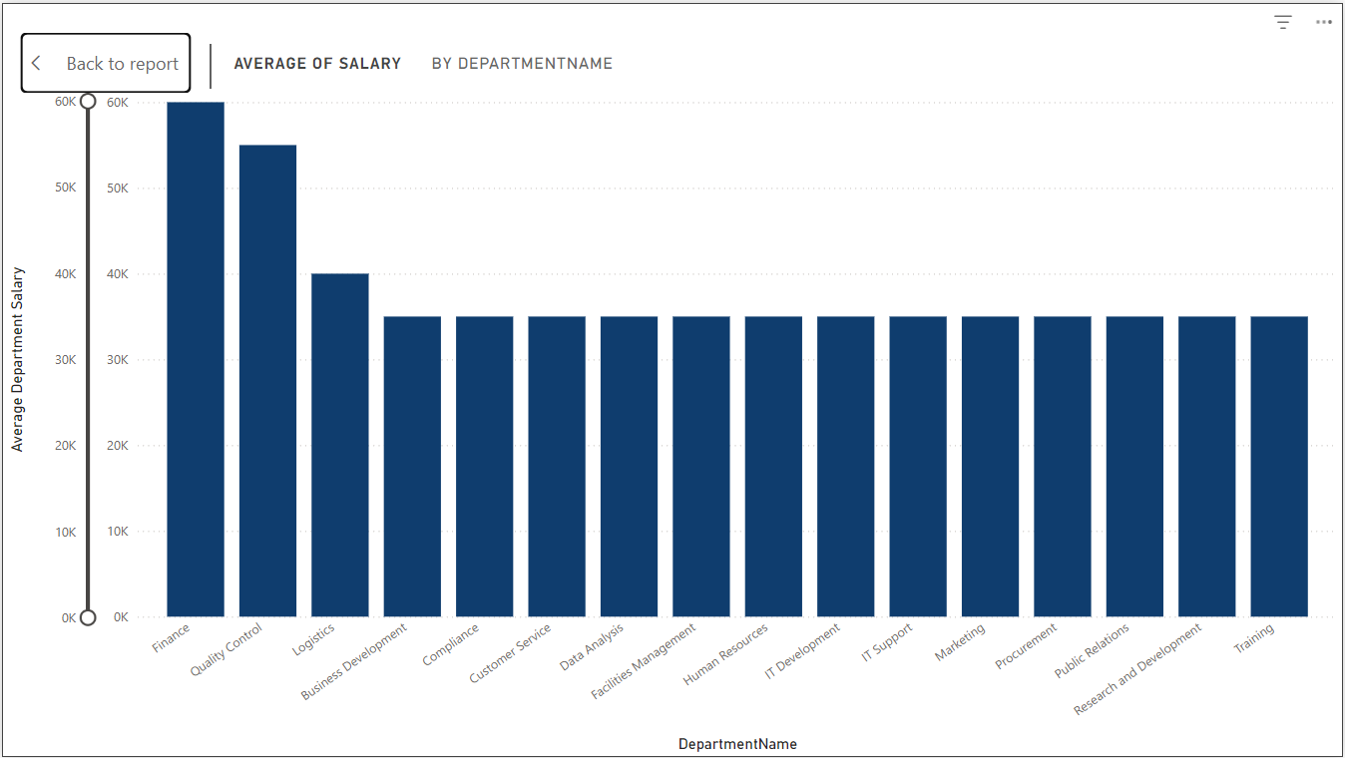
Figure 8.5 – Bar Graph Showing Average Salary Across Different Departments
Figure 8.5 analyse the Average Salary by Department, providing an overview of the salary distribution across the company.
The key metrics, DepartmentName and Average Salary.
A bar chart was selected due to its straightforward ability to represent and compare the different departments based on a single quantitative value. The individual employee’s salary was aggregated to calculate the average department salary.
This visualisation is ideal for identifying any salary inequalities, which allow the company to make more informed decisions in terms of strategic budgeting, planning and overall contributing to a more equitable and more efficient organizational structure.

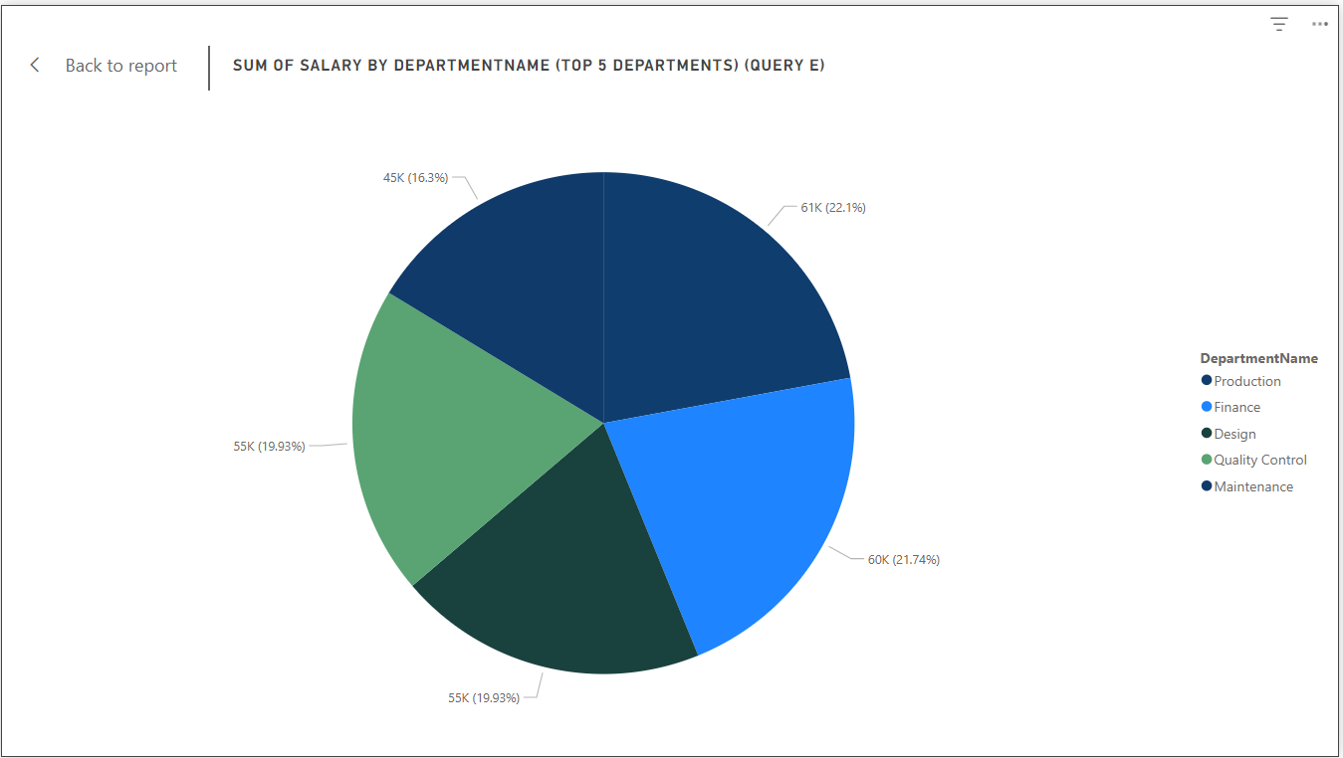
Figure 8.6 – Pie Chart Showing Sum Salary Across Different Departments (Query E)
Figure 8.6 presents the total salary (summed for each department) for the top 5 departments, which shows their share of the company’s salary budget.
The key metric, DepartmentName.
A pie chart was selected to represent the part-to-whole relationship between each department’s salary and the total salary expenditure.
The aggregated data allows for identifying the departments with the largest and smallest salaries, which supports decisions that relate to factors such as resource allocation, budget planning, and cost management.
Production has one of the highest salaries, suggesting that investing in better machines to increase output will control labour costs, achieve economies of scale and maintain competitive pricing.
With this visualization, it identifies inequalities, which enables informed budgeting, planning and overall contributing to an efficient organizational structure.

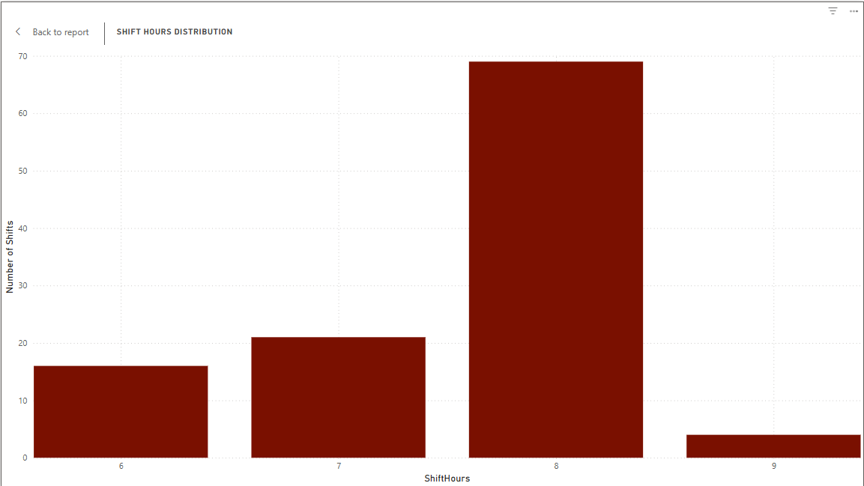
Figure 8.7 – Bar Chart Showing the Shift Hours Distribution
Figure 8.7 presents a histogram for analysing the distribution of shift hours (6-9) taken by operators. Using the aggregated shift data, it shows that 8-hour shifts are the most common, which makes it ideal for most operators working mostly 8 hours per day operating the machines.
The key metric is the number of shifts per duration (6-9 hours).
A histogram was chosen to understand the distribution of shift hours, revealing any patterns or trends when it comes to shift scheduling.
The chart clearly shows that 8-hour shifts are the most common, which makes it ideal for most operators working mostly 8 hours per day operating the machines.
This visualisation allows the operations Manager to balance/manage staff whilst considering the productivity requirements in identifying the standard and outlier shift patterns. It can be used in making decisions related to staffing, resource allocation, and the management of labour (Operators).

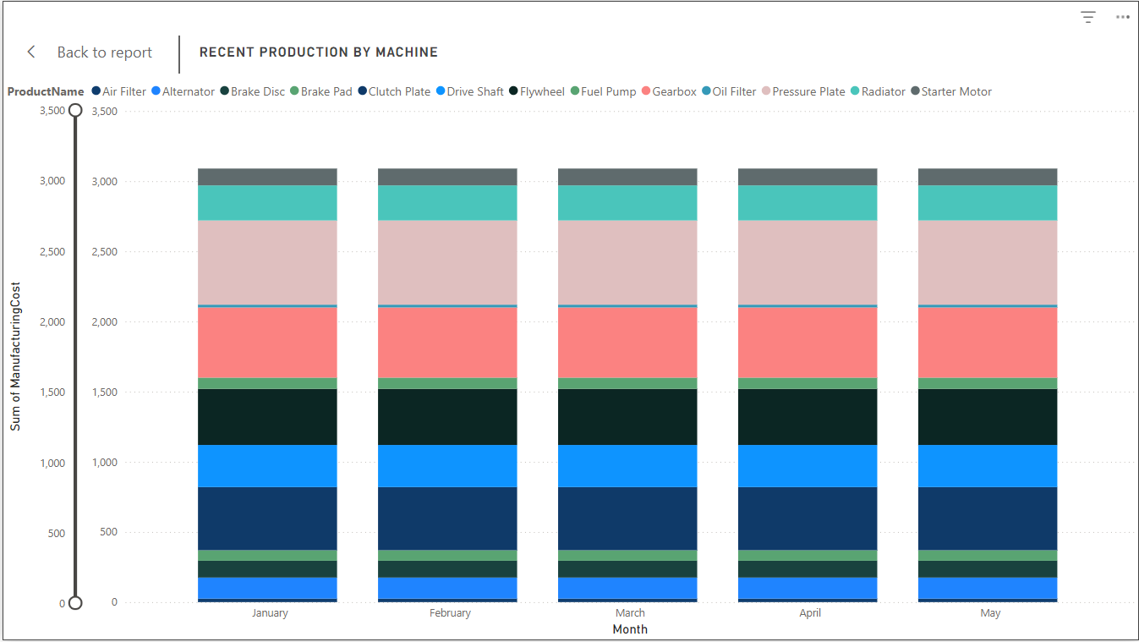
Figure 8.8 – Stacked Bar Chart Showing the Shift Hours Distribution
Figure 8.8 presents a stacked bar chart for tracking the manufacturing costs for products over time.
The Key metrics, Month, ProductName, and total manufacturing cost.
It helps to identify cost trends, such as which products are contributing the most to expenses, enabling better production planning. Allowing the company to make informed decisions for production planning and resource allocation.
The stacked bar chart also shows the total cost per month while breaking down contributions by product.

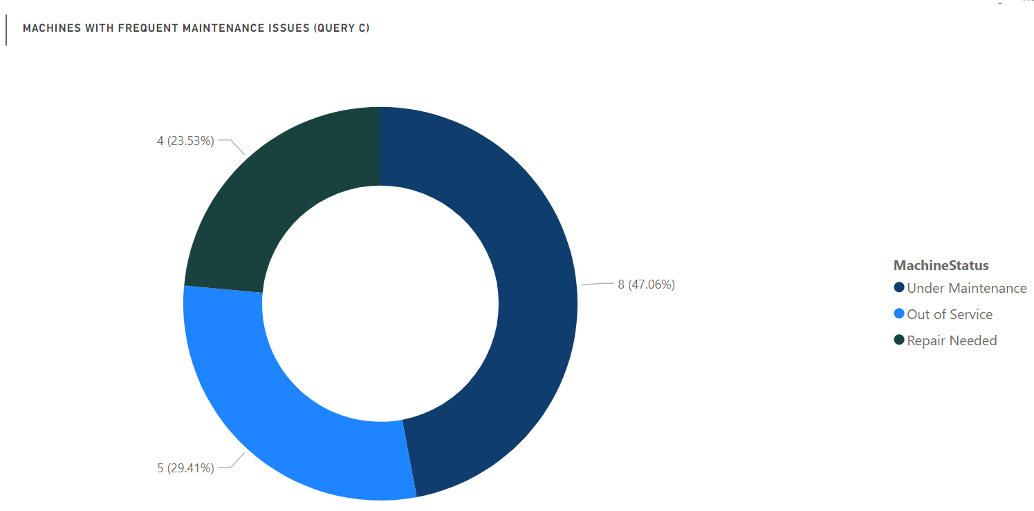
Figure 8.9 – Stacked Bar Chart Showing the Shift Hours Distribution
Figure 8.9 presents a doughnut chart showing the machines with frequent maintenance needs (MaintenanceCount > 3) - using a filter which has a maintenance count higher than 3.
The key metrics are MachineID and MachineStatus.
Machine Status was chosen to provide insight into the operational impact of these frequent maintenance issues.
It indicates that machines that require being replaced or regularly maintained, or those that are currently under repair.
The doughnut chart displays a graphical representation of the results of SQL query part c, showing the proportional distribution of these statuses within the context of the machine as having high maintenance needs. Providing insights into maintenance patterns.

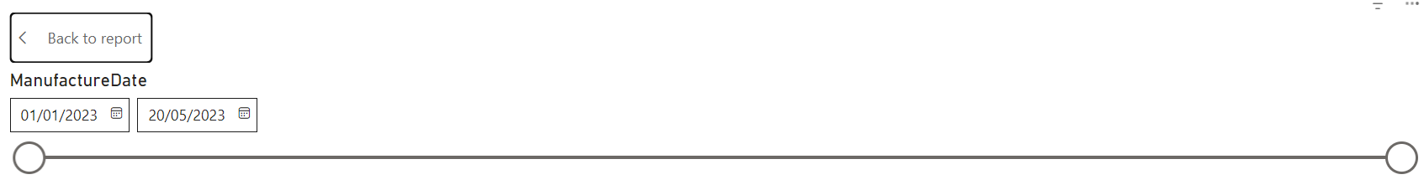
Figure 8.10 – Slicer for the ManufactureDate

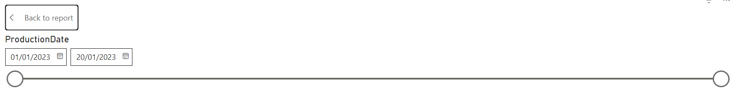
Figure 8.11 – Slicer for the ProductionDate

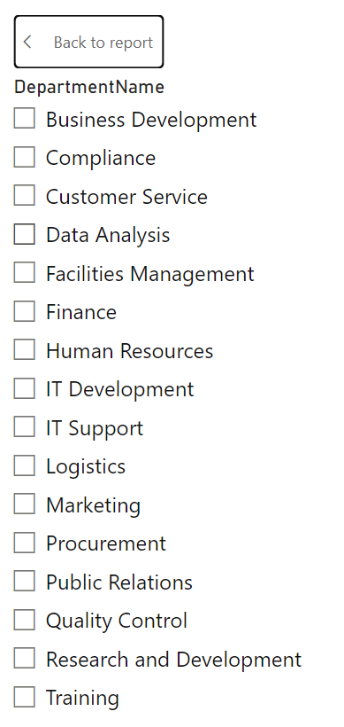
Figure 8.12 – Slicer for the DepartmentName

Figure 8.10-8.12, present slicers which are used for filtering the data based on date range and department.
The Manufacture and ProductionDate slicers, allow for analysis of the trends over specific timeframes.
DepartmentName slicer focuses on the analysis of selected departments. Allowing the user to focus on the performance and data related to individual departments.
Adding slicers to the dashboard allows for an easy-to-use interface making it ideal to filter data, unlike filters which require more clicks (Linkedin.com, 2025). They are more visible on the dashboard for making quick selections. Allowing non-technical users to interact, analyse and understand the data seamlessly.
They are more visible on the dashboard when it comes to making quick selections. For non-technical (non-data) users to be able to interact, analyse and understand the data seamlessly.

Conclusion
Overall, this coursework provided me with hands-on experience in database design and implementation (ER diagrams, normalization) to manipulate data and extract data via SQL Queries (stored procedures, triggers) and data visualization (Power BI dashboard). It has strengthened my database management skills, from the design to the implementation element, allowing me to apply these skills in academic and professional work with data systems.

Link to the video
https://www.youtube.com/watch?v=KnYsem2H1Wk – Databases video

References
- Bharti, N. (2022). Advantages and Disadvantages of Indexing in SQL. [online] Scaler Topics. Available at: https://www.scaler.com/topics/sql/advantages-and-disadvantages-of-indexing-in-sql/ [Accessed 25 Mar. 2025].
- Cio-wiki.org. (2023). Chen’s Notation - CIO Wiki. [online] Available at: https://cio-wiki.org/wiki/Chen%27s_Notation [Accessed 26 Feb. 2025].
- GeeksforGeeks (2024a). PARTITION BY vs GROUP BY in SQL. [online] GeeksforGeeks. Available at: https://www.geeksforgeeks.org/partition-by-vs-group-by-in-sql/ [Accessed 20 Mar. 2025].
- geeksforgeeks (2020). Advantages and Disadvantages of Using Stored Procedures - SQL. [online] GeeksforGeeks. Available at: https://www.geeksforgeeks.org/advantages-and-disadvantages-of-using-stored-procedures-sql/ [Accessed 20 Mar. 2025].
- GeeksforGeeks. (2020a). Difference between COMMIT and ROLLBACK in SQL. [online] Available at: https://www.geeksforgeeks.org/difference-between-commit-and-rollback-in-sql/ [Accessed 22 Mar. 2025].
- GeeksforGeeks. (2020b). Difference between Trigger and Procedure in DBMS. [online] Available at: https://www.geeksforgeeks.org/difference-between-trigger-and-procedure-in-dbms/ [Accessed 22 Mar. 2025].
- GeeksforGeeks. (2023). Power BI Tutorial. [online] Available at: https://www.geeksforgeeks.org/power-bi-tutorial/ [Accessed 24 Mar. 2025].
- GeeksforGeeks. (2024b). Types of Relationship in Database. [online] Available at: https://www.geeksforgeeks.org/types-of-relationship-in-database/ [Accessed 28 Mar. 2025].
- GeeksforGeeks. (2024c). What is Functional Dependency in DBMS? [online] Available at: https://www.geeksforgeeks.org/what-is-functional-dependency-in-dbms/ [Accessed 1 Mar. 2025].
- Linkedin.com. (2025). LinkedIn. [online] Available at: https://www.linkedin.com/pulse/5-key-benefits-using-slicers-power-bi-anurodh-kumar-gdaqf/ [Accessed 26 Mar. 2025].
- Stratascratch.com. (2023). SQL CTEs: Usage, Advantages, and Drawbacks - StrataScratch. [online] Available at: https://www.stratascratch.com/blog/sql-ctes-usage-advantages-and-drawbacks/ [Accessed 9 Mar. 2025].
- Studytonight (2019). 1NF, 2NF, 3NF and BCNF in Database Normalization | Studytonight. [online] Studytonight.com. Available at: https://www.studytonight.com/dbms/database-normalization.php [Accessed 13 Mar. 2025].
- w3resource. (2025). Sql self join. [online] Available at: https://www.w3resource.com/sql/joins/perform-a-self-join.php [Accessed 14 Mar. 2025].
- WilliamDAssafMSFT (2025). Create a Stored Procedure - SQL Server. [online] learn.microsoft.com. Available at: https://learn.microsoft.com/en-us/sql/relational-databases/stored-procedures/create-a-stored-procedure?view=sql-server-ver16 [Accessed 14 Mar. 2025].
- WiseOwlTutorials (2012a). SQL Server Programming Part 1 - Stored Procedure Basics. [online] YouTube. Available at: https://www.youtube.com/watch?v=fjNsRV4zLdc [Accessed 14 Mar. 2025].
- WiseOwlTutorials (2012b). SQL Server Programming Part 2 - Stored Procedure Parameters. [online] www.youtube.com. Available at: https://www.youtube.com/watch?v=Vs-atxMs4mw [Accessed 4 March 2023].

