

Cairo University
Faculty of Computing and Artificial Intelligence
Department of Computer Science

Qurany

Supervised by
Dr. Fatima Omara

Implemented by

20226142 | Abdulrahman Hossam eldien
20226143 | Ahmed Nessal
20226054 | Abdulrahman Zakaria Fadl
20226009 | Ahmed Ezzidin
20226116 | Yamen Yasser

Graduation Project Academic Year 2025-2026
Midyear Short Documentation

Version 2.
Table of Contents
1. Abstract
2. Background
2.1 Introduction to the Domain
2.2 Motivation
2.3 Beneficiaries
2.4 Main Techniques
2.5 Main Application
3. Problem Definition
4. Related Work
4.1 Existing Implementations
4.2 Main Differences
5. Project Specifications
5.1 System Architecture
5.2 Stakeholders
5.3 Functional Requirements
5.4 Non-Functional Requirements
5.5 Diagram Descriptions
5.6 AI Components
6. Work Plan
7. References

1. Abstract
Millions of Muslims worldwide are committed to the memorization and accurate recitation of the Holy Quran, a practice that traditionally necessitates consistent listening and evaluation sessions with qualified Sheikhs. However, the limited availability of qualified instructors, geographical constraints, and scheduling difficulties create significant barriers that hinder many learners from receiving regular, accurate feedback on their recitation. While several digital solutions have emerged to address this gap, the most prominent among them, such as Tarteel AI, restrict their advanced capabilities including detailed mistake analysis and live correction.
Qurany is a graduation project motivated by the personal and communal need for inclusive alternative. The application leverages modern artificial intelligence techniques, including streaming speech-to-text engines, real-time text alignment algorithms, and live validation modules, to listen to a user's recitation, recognize the corresponding Quranic verses, and highlight mistakes in real time. By providing these capabilities at no cost, Qurany aims to democratize access to high-quality Quran recitation feedback for students, parents, and Islamic education institutions globally.
2. Background
2.1 Introduction to the Domain
The intersection of Software Engineering, Artificial Intelligence, and Islamic education represents a rapidly evolving domain with transformative potential. The Holy Quran, consisting of 114 Surahs and over 6,000 verses, is the central religious text of Islam, and its accurate recitation — governed by the intricate rules of Tajweed — is a fundamental obligation for every Muslim. Traditionally, the process of learning, memorizing, and reviewing Quranic recitation has been mediated by qualified human instructors (Sheikhs or Muqri'een) who listen to students, identify errors, and provide corrective guidance. This pedagogical model, while effective, is inherently constrained by instructor availability, geographical proximity, and temporal scheduling.
Recent advances in speech recognition, natural language processing, and real-time audio streaming have opened new avenues for augmenting this traditional model with intelligent, automated systems capable of providing instantaneous feedback. The application of AI to Arabic speech — and specifically to the highly specialized phonetic and prosodic characteristics of Quranic recitation — presents both a significant technical challenge and a profound social opportunity.
2.2 Motivation
The primary motivation for Qurany stems from a deeply personal and widely shared experience: the difficulty of maintaining a regular schedule of Quran review sessions with a qualified teacher. Many students, after completing their memorization, find it challenging to secure consistent access to a Sheikh for periodic review (Muraja'a), leading to gradual deterioration in recitation quality and memorization retention. This problem is compounded for individuals living in regions with limited access to qualified instructors or for those whose professional and academic obligations preclude regular in-person attendance.
We also want to be ready for all Muslims who want to memorize and learn the Quran, not just students and teachers who already have experience and knowledge about the Quran, which is something most apps, including Tarteel, do not provide. Tarteel itself has a large community of sheikhs and trained officials to follow up with users. We do not want to completely replace teachers and sheikhs, but we want a comprehensive program that can temporarily fill the gap or teach someone who cannot meet a sheikh.
2.3 Beneficiaries
- Ministry of Awqaf (Religious Endowments): Qurany can serve as a supplementary tool within government-administered Quran memorization programs, extending the reach of existing educational initiatives.
- Al-Azhar Al-Sharif: As the foremost institution of Islamic scholarship, Al-Azhar stands to benefit from a tool that supports its educational mission and can be integrated into its curricula and outreach programs.
- Islamic Education Institutions: Quran memorization centers (Kuttab), Islamic schools, and online academies can adopt Qurany as a practice and assessment aid for their students.
- Students and Learners: Individual learners at all levels — from beginners learning basic recitation to advanced students reviewing memorized portions — constitute the primary end-user base.
- General Muslims population: The primary and target users ,the application will contain more than recitation mode and read mode so it can help all kind of Muslims.
2.4 Main Techniques
- Real-Time Audio Streaming: The application captures audio input from the user's microphone in continuous, manageable chunks, enabling a seamless and uninterrupted recitation experience without the need to process entire recordings post-hoc.
- Streaming Speech-to-Text (STT): Leveraging advanced automatic speech recognition models fine-tuned for Arabic and Quranic phonetics, the system transcribes incoming audio streams into text with minimal latency.
- Text Alignment and Validation: The transcribed text is algorithmically aligned against the canonical Quranic text (Uthmani script) to identify the recited verse and detect deviations, omissions, substitutions, and other categories of recitation errors.

2.5 Main Application
The primary application of Qurany is live recitation correction: a real-time system that listens to a user reciting the Quran, identifies the verses being recited, and provides immediate visual feedback by highlighting errors and guiding the user toward accurate recitation. This application effectively simulates the core function of a human listener, providing continuous, patient, and objective feedback at any time and from any location.
3. Problem Definition
The accurate recitation and memorization of the Holy Quran is a practice that demands sustained engagement with qualified evaluators. A learner who has memorized portions of the Quran must regularly recite before a knowledgeable Sheikh who can identify errors in pronunciation (Makharij al-Huroof), application of Tajweed rules, verse sequencing, and word accuracy. Without this consistent feedback loop, memorization weakens, errors become ingrained, and the quality of recitation progressively degrades.
The core challenge is threefold:
- Scarcity of Qualified Instructors: The number of certified Quran reciters and teachers is finite and unevenly distributed across geographies. Many communities — particularly in non-Arabic-speaking countries and rural areas — lack sufficient access to qualified instructors.
- Scheduling and Accessibility Constraints: Even where qualified instructors are available, coordinating regular sessions is often impractical due to conflicting schedules, transportation difficulties, health considerations, and, as demonstrated during the COVID-19 pandemic, public health restrictions that limit in-person gatherings.
This problem statement highlights the need for a solution that is technologically advanced enough to provide accurate and immediate feedback on recitation; and available for free without financial conditions for many features, though certainly some require payment. It serves users at various levels of proficiency, languages, and access to technology. The Qurany app was envisioned as a direct response to this multidimensional challenge.
4. Related Work
4.1 Existing Implementations
The landscape of Quran-related applications is extensive, encompassing tools for reading, memorization, translation, and Tafsir (exegesis). However, the subset of applications that employ artificial intelligence for recitation evaluation is considerably narrower. The most prominent among these is Tarteel AI.
Tarteel AI is an artificial intelligence-powered application that enables users to recite the Quran and receive automated feedback. Its core features include:
- Voice-based verse recognition: Users recite aloud, and the application identifies the corresponding verse in the Quran.
- Mistake detection: The application highlights words that were recited incorrectly, enabling users to identify and correct errors.
- Memorization mode: A dedicated mode that assists users in testing and reinforcing their memorization by hiding portions of the text and evaluating the recitation against the expected content.
- Progress tracking: Users can monitor their recitation history and track improvements over time .
Other notable applications in the domain include: Quran Companion (focuses on memorization scheduling and progress tracking but lacks real-time recitation evaluation), Muslim Pro (a comprehensive Islamic lifestyle application that includes a Quran reader with audio playback but does not offer AI-driven recitation feedback), and Ayah (provides verse-by-verse audio with repeat functionality for memorization but operates as a passive listening tool rather than an interactive evaluator).
4.2 Main Differences
Qurany differentiates itself from existing solutions — and from Tarteel AI in particular — along several critical dimensions:
Dimension | Tarteel AI | Qurany
Mistake Highlighting | Available in premium tier | Available to all users without restriction
Real-Time Streaming | Batch-oriented processing in free tier | Continuous real-time streaming for all users
Full Quran Reader | Integrated with limitations | Fully integrated reader with search, bookmarks, and navigation
Target Audience | Specifically designed for students, institutions, and educational programs | General consumers
Inclusivity | Limited by financial accessibility | Designed for maximum inclusivity regardless of financial means
Error Correction Flow | Basic correction prompts | Detailed error handling with timers, progress freezing, and guided resumption
Depending on instructor | Most of time using the app only is not easy and useful and still needs sheikh, so Tarteel has big community on it containing a lot of groups and admins so you can ask them and be guided by them. | Qurany does not need community, because the application can guide you and give you a lot of Information’s about tajweed and qra'at .

The philosophical foundation of Qurany is that advanced AI-driven recitation feedback is a right, not a premium feature. By removing financial barriers and providing a comprehensive, feature-rich experience to all users, Qurany aims to serve as a public-good tool that supports the global Muslim community's engagement with the Quran.

5. Project Specifications
5.1 System Architecture
The system architecture of Qurany is organized around two principal processing flows, each designed to operate in real time and provide seamless, low-latency feedback to the user.
5.1.1 Live Recitation Streaming Flow
The primary flow processes the user's recitation from audio capture to visual feedback through the following sequential stages:
- Audio Chunking: The user's voice is captured via the device microphone and segmented into small, overlapping audio chunks (typically 250–500 milliseconds in duration). This chunking strategy ensures continuous processing without waiting for the user to complete a full verse or pause.
- Preprocessing: Each audio chunk undergoes preprocessing, including noise reduction, normalization, and silence detection. Silent segments are filtered to avoid unnecessary processing, while active speech segments are prepared for transcription.
- Streaming Speech-to-Text (STT): The preprocessed audio chunks are transmitted to the speech-to-text engine, which operates in streaming mode. Rather than waiting for a complete utterance, the STT engine produces incremental (partial) transcription results as audio data arrives, enabling near-instantaneous text output.
- Text Alignment: The incrementally transcribed text is aligned against the canonical Quranic text using a text alignment module. This module employs sequence matching algorithms to determine the most probable verse and position within the Quran that corresponds to the transcribed text. The alignment accounts for partial matches, diacritical variations, and common recitation patterns.
- Live Validation: The aligned text is compared word-by-word against the reference Quranic text. The validation engine identifies discrepancies and classifies errors (e.g., word substitution, omission, addition, or mispronunciation). The results are rendered to the user interface in real time, with correct words highlighted in one color and errors in another.
5.1.2 Error Handling and Correction Flow
When the validation engine detects an error, the system activates the error handling and correction flow:
- Text Update vs. Progress Freeze: Upon detecting a discrepancy, the system determines whether the error is transient (caused by the STT engine's incremental output, which may self-correct in subsequent chunks) or persistent. Transient errors trigger a text update — the displayed transcription is revised as more accurate data arrives. Persistent errors trigger a progress freeze, halting the advancement of the recitation position indicator.
- Timer Activation: When progress is frozen due to a persistent error, a configurable timer is initiated. This timer provides the user with a defined window to self-correct by re-reciting the problematic segment. Visual and/or auditory cues inform the user of the error and the remaining correction time.
- Resumption: If the user successfully re-recites the segment within the allotted time, the system validates the correction, updates the display, and resumes normal forward progress. If the timer expires without successful correction, the system logs the error, optionally provides the correct recitation as a reference, and allows the user to proceed.
This dual-flow architecture ensures that the system is both responsive and forgiving, accommodating the natural variability of human recitation while maintaining rigorous accuracy standards.
5.2 Stakeholders
Stakeholder | Role | Interest
Dr. Fatma Omara | Project Advisor | Academic supervision, technical guidance, and quality assurance of the project deliverables.
Student Development Team | Developers & Researchers | Design, implementation, testing, and documentation of the Qurany application.
MCIT | Institutional Sponsor | Supporting national digital transformation initiatives and development of AI-powered educational tools.
Ministry of Awqaf | Domain Authority | Potential adoption within government-administered Quran memorization programs and centers.
Al-Azhar Al-Sharif | Religious & Educational Authority | Validation of accuracy and suitability for Islamic educational contexts; potential curricular integration.
Islamic Education Institutions | Institutional Users | Adoption of Qurany as a supplementary teaching and practice tool in Quran schools.
End-Users: All general Muslims | Primary Users | Utilizing the application for daily recitation practice, memorization review, and self-assessment , Monitoring children's progress ,supporting home-based Quran learning ,and Using the tool as a supplementary aid or recommending it for independent student practice , It is not only for students or shiekhs.

5.3 Functional Requirements
ID | Requirement | Description | Priority
FR-01 | Live Recitation Transcription | The system shall capture audio and transcribe Quranic recitation into text in real time using a streaming STT engine. | High
FR-02 | Verse Recognition | The system shall automatically identify the Surah, verse number, and position corresponding to the user's recitation. | High
FR-03 | Mistake Highlighting | The system shall compare transcribed text against canonical Quranic text and visually highlight errors in real time. | High
FR-04 | Error Classification | The system shall classify detected errors into categories (substitution, omission, addition, sequence error). | Medium
FR-05 | Correction Feedback | The system shall provide the correct word or phrase when an error is detected. | High
FR-06 | Full Quran Reader | The system shall provide a complete, navigable Quran reader supporting the Uthmani script. | High
FR-07 | Search Functionality | The system shall allow users to search for specific words, phrases, verses, or Surah names. | Medium
FR-08 | Bookmarks | The system shall enable users to bookmark specific verses or pages for quick future access. | Medium
FR-09 | Recitation History | The system shall maintain a log of past recitation sessions including date, Surah, verse range, and error statistics. | Low
FR-10 | Progress Tracking | The system shall display overall progress including verses recited, error rates, and improvement trends. | Low
FR-11 | User Authentication | The system shall support user registration and login for personalized features. | Medium
FR-12 | Recitation Mode Selection | The system shall offer multiple modes including free recitation and memorization review. | Medium

5.4 Non-Functional Requirements

ID | Requirement | Description | Target Metric
NFR-01 | Real-Time Latency | End-to-end latency from audio capture to visual feedback shall not exceed a defined threshold. | ≤ 2 seconds
NFR-02 | Transcription Accuracy | The STT engine shall achieve a minimum word-level accuracy for Quranic Arabic recitation. | ≥ 85% accuracy
NFR-03 | Availability | The application shall be available for use at all times with minimal downtime. | 99% uptime
NFR-04 | Usability | The UI shall be intuitive, accessible, and navigable with minimal training. | SUS score ≥ 70
NFR-05 | Performance | The application shall handle concurrent audio streaming and text processing without perceptible lag. | Mid-range devices
NFR-06 | Scalability | Backend infrastructure shall support a growing user base without fundamental changes. | 1,000+ concurrent users
NFR-07 | Security | User data shall be protected using industry-standard encryption and access control. | AES-256, HTTPS, OAuth 2.0
NFR-08 | Portability | The application shall be deployable across Android, iOS, and Web platforms. | Cross-platform
NFR-09 | Maintainability | Codebase shall follow clean architecture principles and be well-documented. | Coverage ≥ 70%
NFR-10 | Alignment Accuracy | Text alignment module shall correctly identify the recited verse with high precision. | ≥ 90% accuracy

5.5 Diagram Descriptions
The following subsections provide detailed textual descriptions for the required UML and data diagrams, which are to be generated separately.
5.5.1 Use-Case Diagram
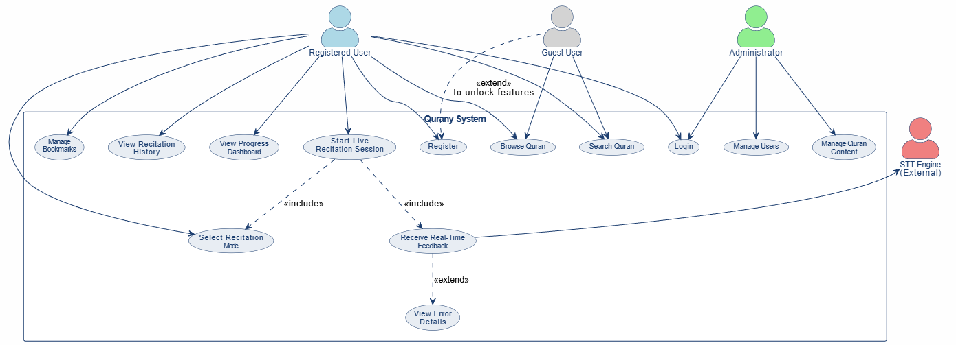

5.5.2 Class Diagram
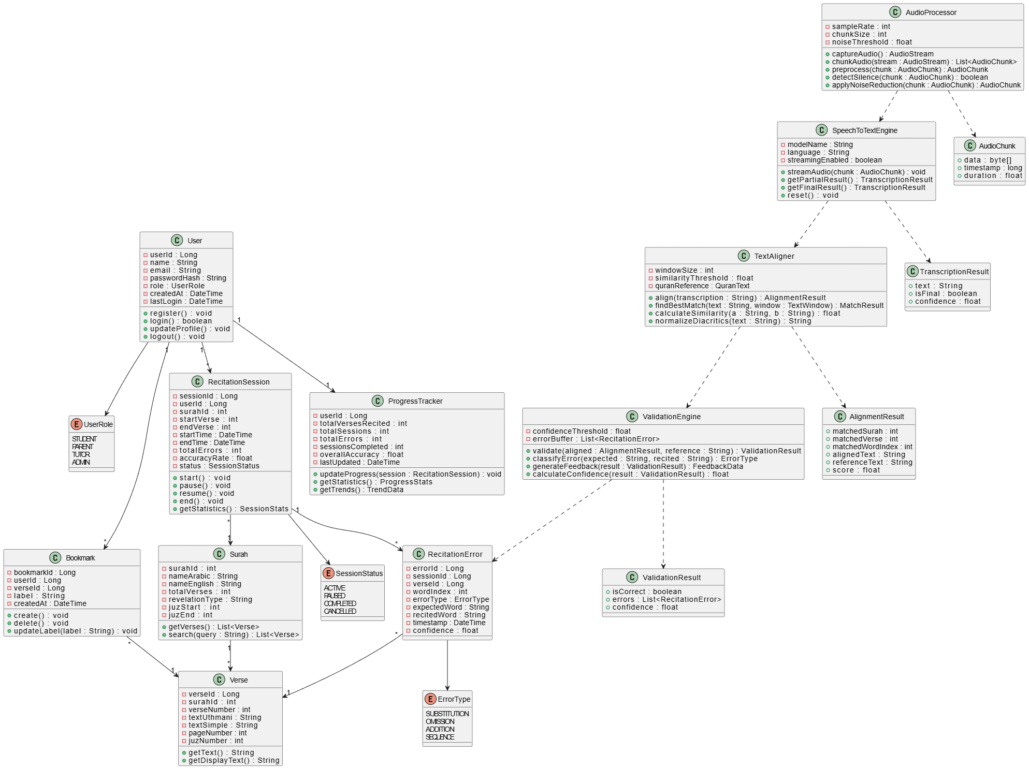
5.5.3 Sequence Diagram
The Sequence Diagram shall illustrate the end-to-end flow of a live recitation session involving the following lifelines: User, MobileApp (UI), AudioProcessor, SpeechToTextEngine, TextAligner, ValidationEngine, and Database.
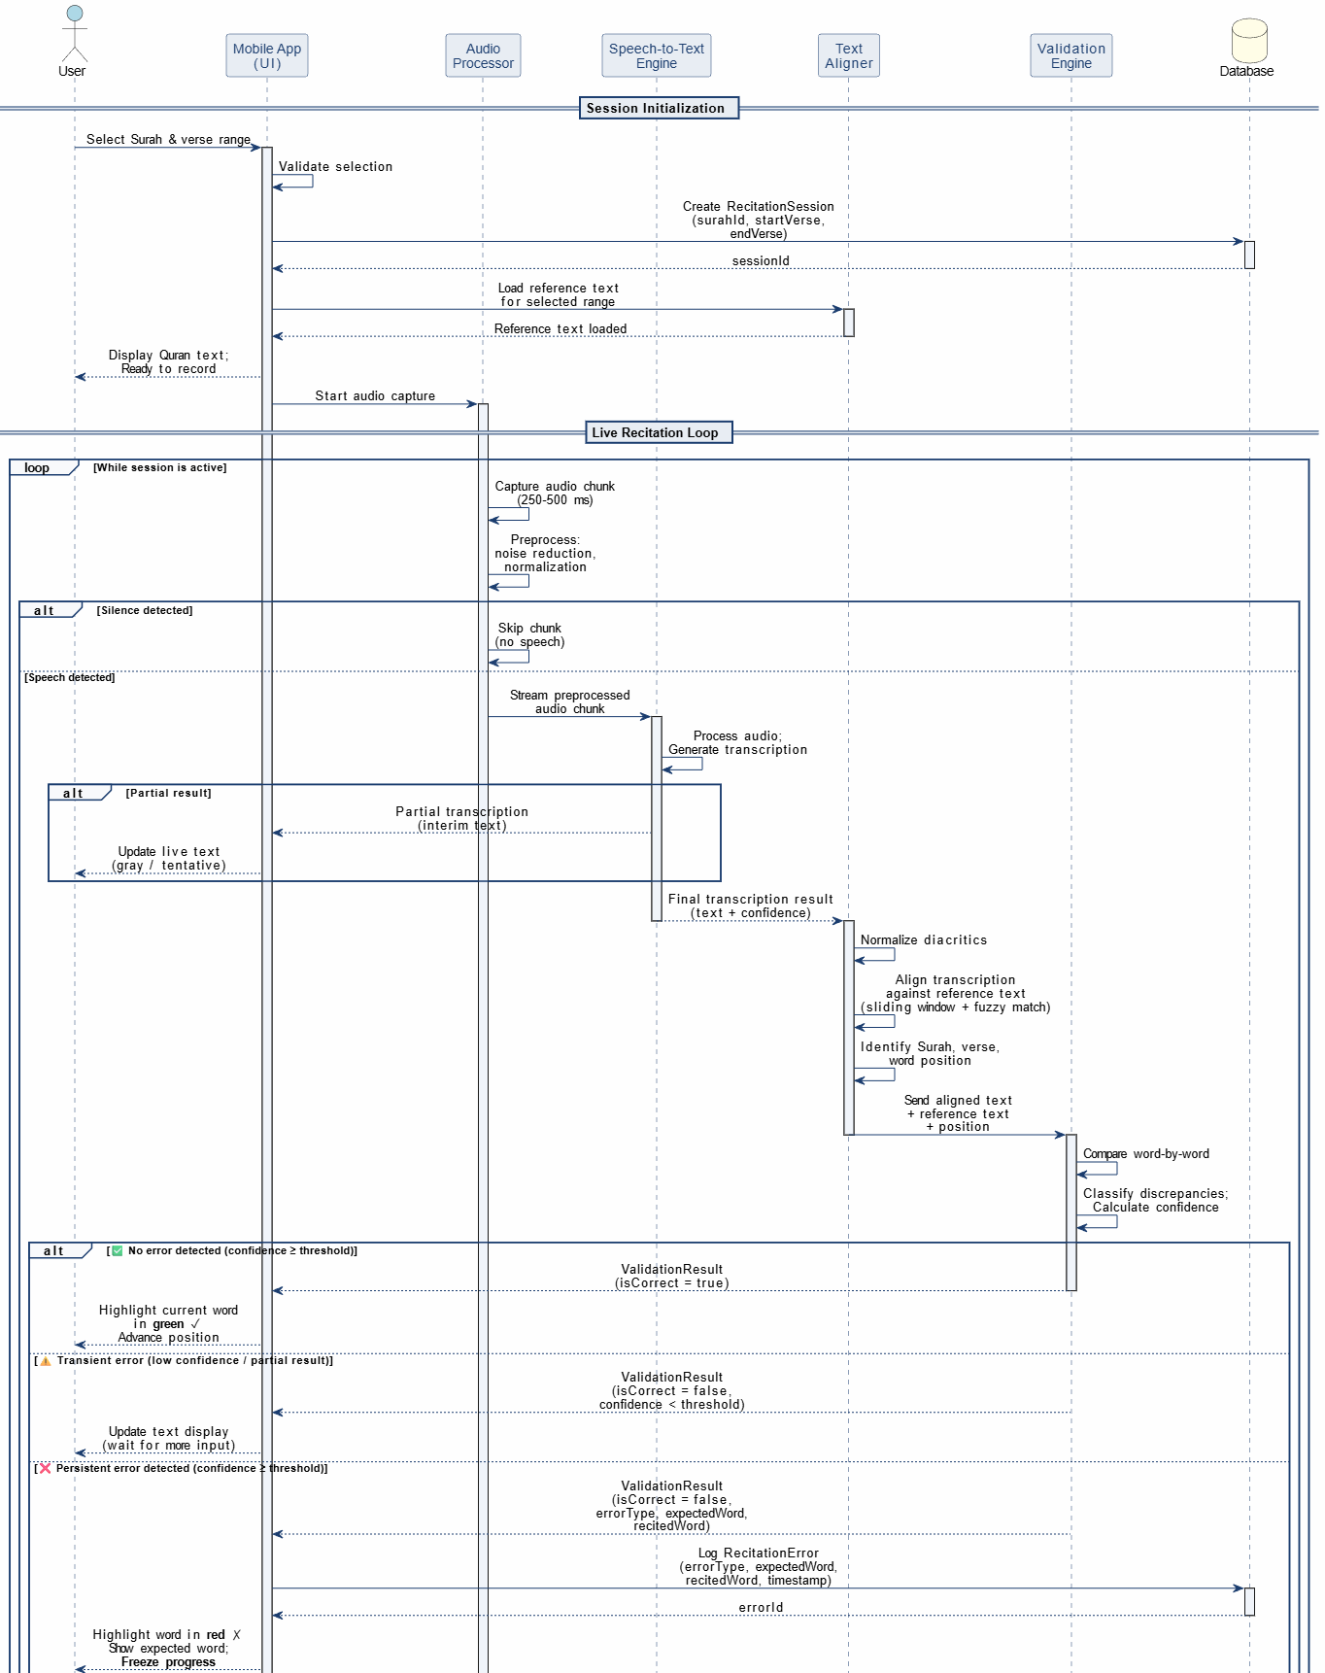
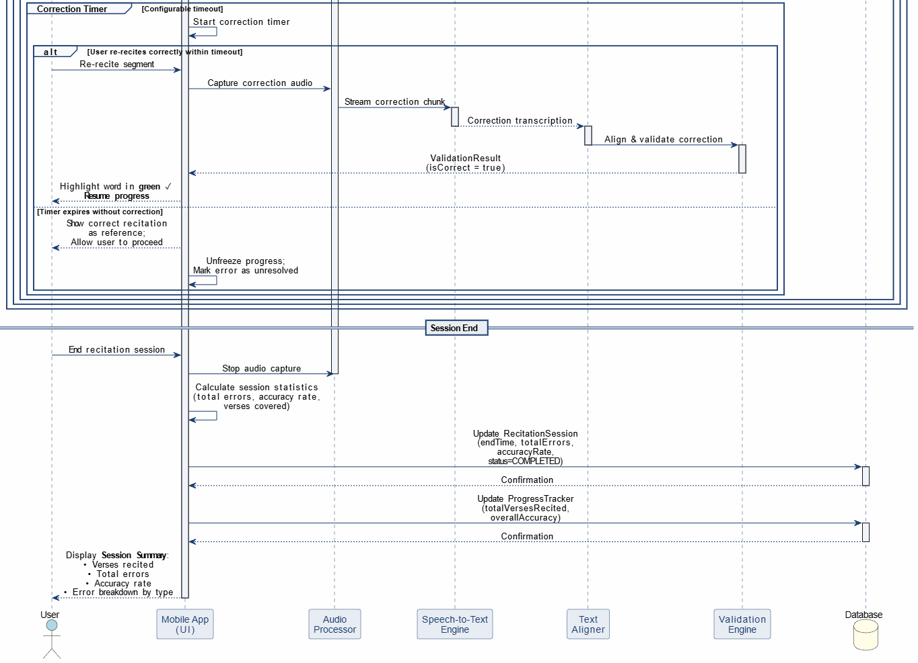

5.5.4 Entity-Relationship Diagram (ERD)
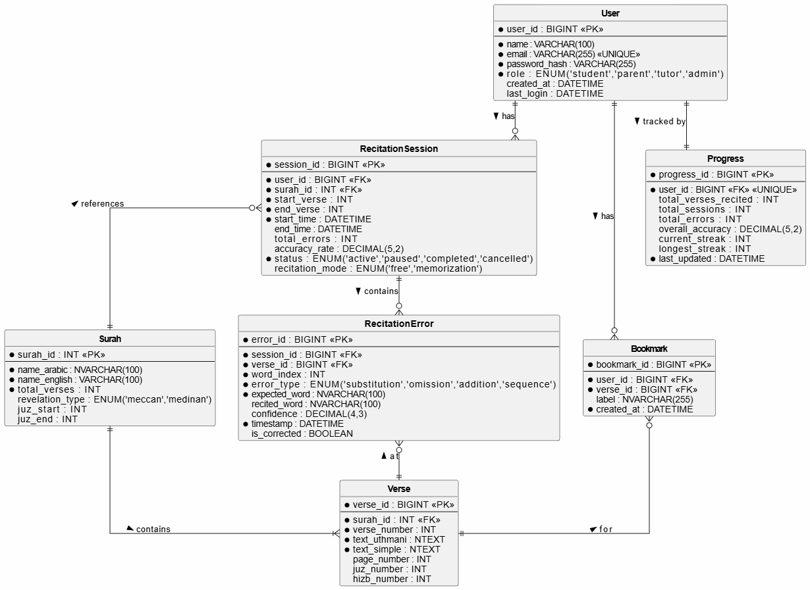
5.6 AI Components
The artificial intelligence subsystem of Qurany constitutes the core differentiating capability of the application. It encompasses three tightly integrated modules that operate in concert to deliver real-time recitation evaluation.
5.6.1 Streaming Speech-to-Text (STT) Module
Purpose:
To convert the user's live audio recitation into text in real time with minimal latency.
Expected Feature List:
- Support for continuous (streaming) audio input rather than batch-only processing.
- High accuracy for Modern Standard Arabic and Classical (Quranic) Arabic phonetics.
- Recognition of Tajweed-influenced pronunciation patterns (e.g., Idgham, Ikhfa, Madd).
- Low-latency partial result generation to enable real-time feedback.
- Robustness to ambient noise, varying microphone qualities, and diverse speaker accents.
Feature Selection Process:
- Baseline Evaluation: Establish performance benchmarks using pre-trained Arabic STT models (e.g., OpenAI Whisper, Google Cloud Speech-to-Text) on a Quranic Arabic test set.
- Feature Gap Analysis: Identify specific weaknesses (e.g., poor handling of elongated vowels, inability to distinguish between similar-sounding letters such as ض and ظ).
- Feature Prioritization: Rank features by impact on transcription accuracy using metrics such as Word Error Rate (WER) and Character Error Rate (CER).
- Iterative Enhancement: Incrementally add domain-specific features (e.g., Quranic language model, Tajweed-aware acoustic model) and measure improvement.
Training Process:
- Pre-trained Model Selection: Begin with a robust, pre-trained Arabic speech recognition model as the foundation (e.g., Whisper large-v3 or a comparable open-source model).
- Domain-Specific Fine-Tuning: Fine-tune the selected model on a curated dataset of Quranic recitations, exposing the model to the unique phonetic characteristics, prosodic patterns, and vocabulary of the Quran.
- Data Augmentation: Apply augmentation techniques including speed perturbation, noise injection, and room impulse response simulation to improve robustness.
- Evaluation and Iteration: Evaluate the fine-tuned model on a held-out test set of diverse reciters (varying in age, gender, accent, and proficiency level) and iterate on the training configuration.
Dataset Requirements:
- Primary Source — Quranic Universal Library: A comprehensive corpus of Quranic recitations by multiple renowned reciters, providing diverse recitation styles and accurate transcription labels.
- Supplementary Sources: Recordings from Quran memorization centers, publicly available recitation datasets, and community-contributed recitations (with consent and quality verification).
- Dataset Composition: A minimum of 500 hours of labeled Quranic audio, covering all 114 Surahs, with representation from at least 20 distinct reciters.
- Annotation Standards: Each audio segment must be annotated with the corresponding Quranic text in Uthmani script, verse boundaries, and Surah/verse identifiers.
5.6.2 Text Alignment Module
Purpose:
To map the incrementally transcribed text to the exact position within the canonical Quranic text, enabling the system to determine which verse and word the user is currently reciting.
Technical Approach:
- Sequence Matching Algorithms: Employ algorithms such as the Smith-Waterman algorithm or dynamic time warping adapted for text to find optimal local alignment.
- Fuzzy Matching: Incorporate fuzzy string matching (e.g., Levenshtein distance, Jaro-Winkler similarity) to handle minor transcription inaccuracies.
- Contextual Windowing: Maintain a sliding window over the Quranic text based on the expected recitation position, reducing search space and improving speed.
- Diacritical Normalization: Normalize diacritical marks (Tashkeel) in both the transcription and reference text to ensure consistent comparison.
5.6.3 Live Validation Engine
Purpose:
To compare the aligned transcription against the reference Quranic text on a word-by-word basis and generate real-time error annotations.
Validation Logic:
- Exact Match: The recited word matches the expected word exactly (after normalization) — marked as correct.
- Substitution Error: The recited word differs from the expected word — flagged with the expected word displayed.
- Omission Error: The user skips one or more words — detected by a gap in the alignment.
- Addition Error: The user inserts words not present in the reference text — detected by extraneous tokens.
- Sequence Error: The user recites correct words in the wrong order — detected by alignment discontinuities.
Each validation decision is accompanied by a confidence score. Low-confidence decisions (e.g., when the STT output is ambiguous) are handled conservatively, with the system waiting for additional audio input before flagging an error.

6. Work Plan
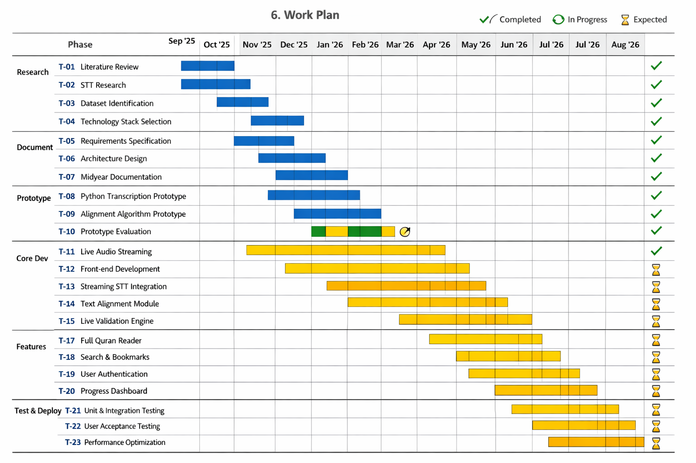

7. References
[1] Tarteel AI. (2024). Tarteel — AI-Powered Quran Companion. Available at: https://www.tarteel.ai/
[2] OpenAI. (2023). Whisper: Robust Speech Recognition via Large-Scale Weak Supervision. arXiv:2212.04356.
[3] Quran.com. (2024). Quranic Universal Library — Open-Source Quran Data. Available at: https://quran.com/

