**To Do: Eco-Friendly Fleet Management**

**Create EC2 Instances and Load Balancer:**

Launch EC2 instances using a predefined AMI.

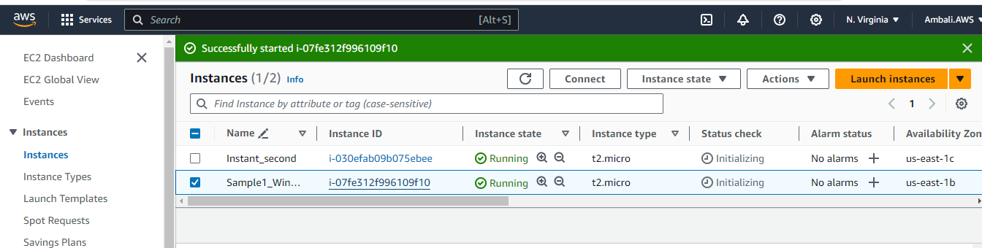

Create an Elastic Load Balancer (ELB) to distribute traffic.

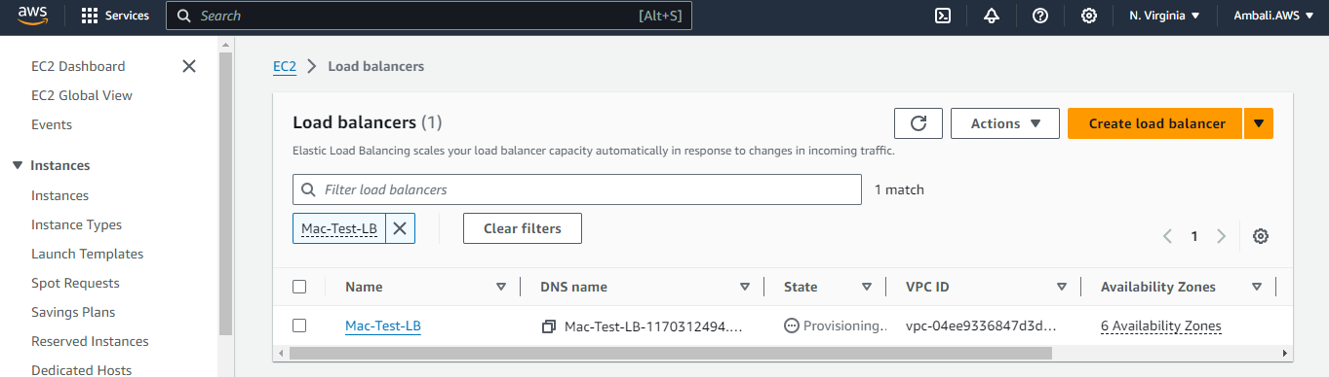

* Create an Auto Scaling Group for the EC2 instances.
* Configure scaling policies to add or remove instances based on CPU utilization.

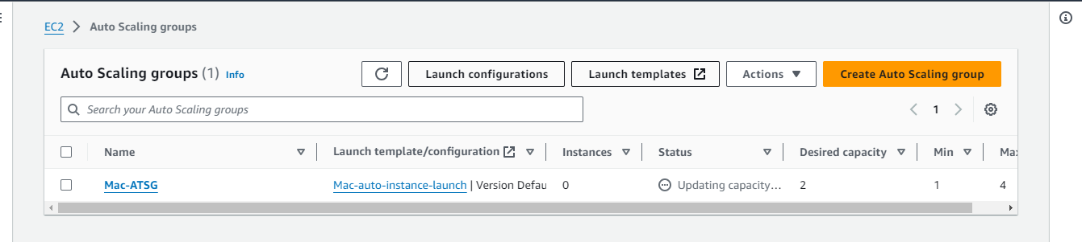

Implement scaling policies that consider cost optimization.