User account creation

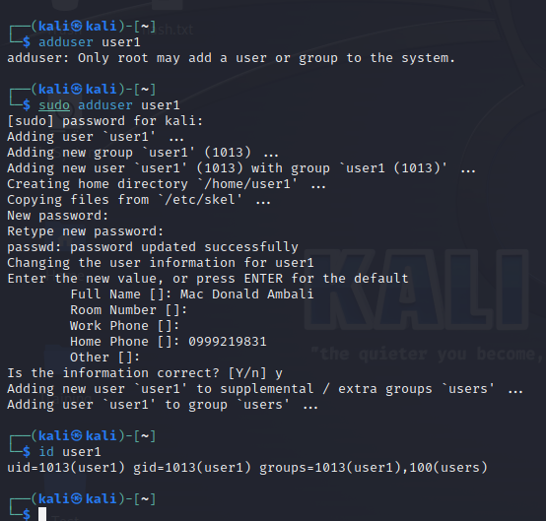

User Password Reset to strong one

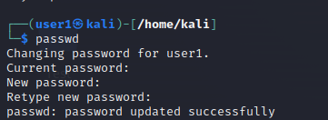

Restricting Owner of the parent folder to RW access

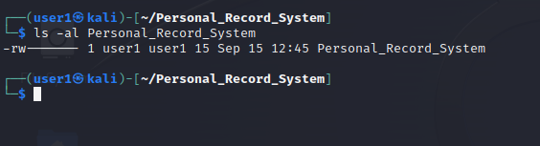

Folder Archiving using Tar

