**Project Report**

**Course No:** ME 366

**Course Title :** Electro-Mechanical System Design and Practice

**Group No :** C-27

**Project Title:** Arduino Based Indoor Seedling Growing Chamber.

**Date of Submission** : 30-07-2021

**Submitted By:**

* Al-Kabir Hossain (Student ID : 1610161)
* Alif Jawad ( Student ID :1710156 )
* Yamin Mansur (Student ID: 1710176)
* Hriti Saha (Student ID : 1710177 )

**Department of Mechanical Engineering**

**Bangladesh University of Engineering and Technology**

**Abstract :**

The project is based on **“HYDROPONICS”** technology which is ​termed as the future of agriculture.It is aprocess of hydroculture which involves growing plants without soil,by using ​mineral nutrient solution.​It is a systematic  way to skip the soil,  sub  in a different material to support the roots ​of the plant and grow crops  directly  in nutrient- rich water.​ It will allow growers to produce food anywhere  in the world,  at any time  ofthe year, ​and to net higher yields with fewer resources​ .In a densely populated country like Bangladesh, it is important to grow crops in a limited ​land area and this technology ensures farming without the necessity of land area, enables ​us to grow plant even inside our room.​

**Acknowledgement :**

Working on this project was a great source of immense knowledge for us. We would like to express our sincere gratitude to our Supervisor Abdul Aziz Shuvo for his guidance and valuable support throughout the course of this project work .We would also like to thank our friend Hasibul Karim who helped us with animation.We acknowledge with a great sense of gratitude, the encouragement and inspiration received from our faculty members .We would like to thank our parents and friends who helped us a lot finalizing the project within a limited time frame.

**Table of contents :**

Abstract ……………………………………………………………….. 2

Acknowledgement………………………………………………………..2

1. Introduction ………………………………………………………….. .. 4

2. Background …………………………………………………………….. 4

3. Literature and Review…………………………………………………….5

4. Design and Methodology ………………………………………………...5

5. Components……………………………………………………………….11

6. Calculation…………………………………………………………………14

7. SWOT Analysis……………………………………………………………15

8. Conclusion………………………………………………………………….16

9. Reflection on Learning……………………………………………………..16

10. Future Work………………………………………………………………..17

11. References………………………………………………………………….17

1. **Introduction :**

This seemingly subtle shift in how we make food skipping the soil, that is is actually revolutionary it allows growers to produce food anywhere in the world, at any time of the year, and to net higher yields with fewer resources. Growing seasons and regions are in major flux right now as temperatures change and growing conditions change along with them. Even in “normal” conditions, there are plenty of places where the ground just isn’t conducive for farming (like deserts, concrete jungles. Plants grown in well-managed systems are living the good life. Since roots are bathed in all the nutrients they need, plants spend more time growing upward and less time and energy growing extensive root systems to search for food. Growth rates vary based on the type of system and quality of care, but hydro plants can mature up to 25 percent more quickly than the same plants grown in soil, with increased crop yield, to boot. This developed system actually use less water than traditional soil-based systems. This is because closed systems aren’t subject to the same rates of evaporation. Plus, the water used in this system can be filtered, re-populated with nutrients, and fed back to plants again so that water is constantly being recycled instead of wasted.

1. **Background :**

Hydroponic systems have existed for centuries, providing an alternative agricultural method to soil-based growing for large crop yields. Recently, hydroponic systems have attracted increased attention from the home grower market, as they provide a way to grow plants easily indoors, thereby allowing individuals living in urban environments to grow their own fresh produce. Our system would prove highly attractive to this emerging consumer market, as we plan to construct a fully automated, inexpensive, and compact hydroponic system. Using simple construction methods and easily available components, we will create a streamlined hydroponic system that will remove the hassle of manual hydroponic systems that require frequent adjustments.

The main objective of our design is to create a fully-automated, counter-top, hydroponic herb garden. A successful product would provide consumers with the ability to grow herbs in urban living environments easily and cost-effectively.

Plant care is a routine and important activity to keep plants healthy and well groomed. Plant care includes many aspects i.e. watering, rejuvenation, fertilizer, and others. So many types of plants with different forms of treatment are different and all treatments are usually done manually. Although the types of plants are very diverse, water remains the main source of life for all plants to help the photosynthesis process, especially in plants Hydroponics that lives rely on nutrients from the water. Automatic watering system for plant hydroponics and The temperature around the plants will be detected by sensors (LM - 35). hydroponic flow system starts from the detection of a moisture sensor and a temperature sensor. The sensor detection results will be connected with a Relay connected to the microcontroller port. We also use the LCD screen to display the moisture and temperature reading at any time of the process.

1. **Literature Review :**

In some literature, Hydroponics is one of the best alternatives for plants on narrow land. There have been several papers published in several journals in hydroponics systems in recent years; they suggest how hydroponic plant systems work. To supply hydroponic plant nutrients is very appropriate if done by using microprocessors for nutrient control [2]. According to Kumar and Cho, that waste nutrients from hydroponics plants can be reused [3]. In terms of processor-based hydroponic growth spaces, it is more easily controlled via a virtual instrument system using Lab VIEW [4]. Another paper is the development of an automatic microcontroller system for Deep Water Culture (DWC), this paper provides a basic idea of hydroponic water culture. This paper also discusses the methodology used to measure pH values of the sensors and also maintains water levels in hydroponic reservoirs [5]. Other studies are related to the hydroponic nutrient solution control system and factor analysis that influences it. This paper also addresses the difficulties of control that occurred during automation [6]. The other work related to this project is work with control and monitoring of plants in real time has been performance by Dan Wang, Jinling Zhao, Linsheng Huang, Deheng Xu in 2015 [7]. This research focuses on monitoring the data of aquaponic plants which will be sent to smartphones trough the internet of things. The next related is works about automatic addition of nutrients have been made by Rajeev Lochan Mishra and Preet Jain in 2015 [8] which uses electrodes as a benchmark of the amount of nutrients, then if the nutrients under the pump conditions will turn on to add the nutrient. Related works about aotomatic plant watering has been perfomance by Devika et al [9], and the watering object using a plant grown on soil where the humidity sensor will detect the soil moisture level, if the soil is not moist / dry then the system will automatically do the watering.

1. **Design and methodology:**

**4.1: Working Procedure:**

In our project, the system works in mainly three major steps. We are focused to control two properties: temperature and moisture content, suitable for the growth of a plant inside our model. Steps for doing this are as follows:

**4.1.1: Moisture Control-**

For the production of adequate food, plants must be supplied enough water. From moisture content of the soil, we can predict if there is sufficient water inside the chamber. To do this, we have introduced two YL-69 SOIL HYGROMETER HUMIDITY AND SOIL MOISTURE SENSOR.

**Sensor working criteria-**

This sensor basically has an inherent hygrometer. Hygrometer works on the principle called evaporative cooling. When water evaporates from a hot surface, it becomes cool as water molecules take heat energy (equal to its latent heat of vaporization) from the surface. That’s why, wet bulb always shows lower temperature than dry bulb.

Evaporation of water is inversely proportional to the humidity in atmosphere. In dry atmosphere, evaporation will be high causing higher decrease in wet bulb and vice-versa. At 100% humid condition, dry and wet bulb would show same temperature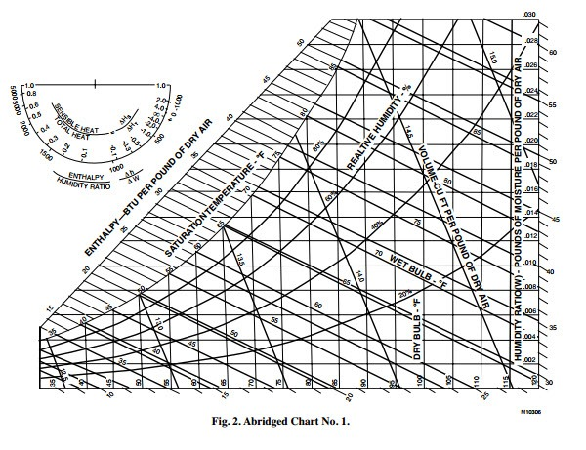.

From the deviation of temperature in dry and wet bulb using psychometry and relative humidity, it is possible to calculate the moisture percentage in the soil at a particular time.

**Controlling moisture content-**

When the moisture percentage is below a certain threshold, a motor is set to start pumping water inside the chamber. As soon as it reaches the allowable limit, the pump stops automatically.

To control overflow of water, pump works for 3 seconds and then rests for 1 second. To ensure this, we used relay in the circuit.

**4.1.2: Temperature control-**

A moderate temperature should be ensured within the chamber for calculated growth of the plants. So, there must be two controlling phenomenon( heating in case of low temperature inside the chamber and cooling in case of higher temperature). To measure temperature, we have introduced LM-35 temperature sensor.

**Sensor working criteria-**

LM35 is a temperature sensor that outputs an analog signal which is proportional to the instantaneous temperature. The output voltage can easily be interpreted to obtain a temperature reading in Celsius.

In order to understand the working principle of LM35 temperature sensor we have to understand the linear scale factor. In the features of LM35 it is given to be **+10 milli volt per degree centigrade**. It means that with increase in output of 10 mills volt by the sensor Vout pin the temperature value increases by one. For example, if the sensor is outputting 100 mills volt at Vout pin the temperature in centigrade will be 10-degree centigrade.

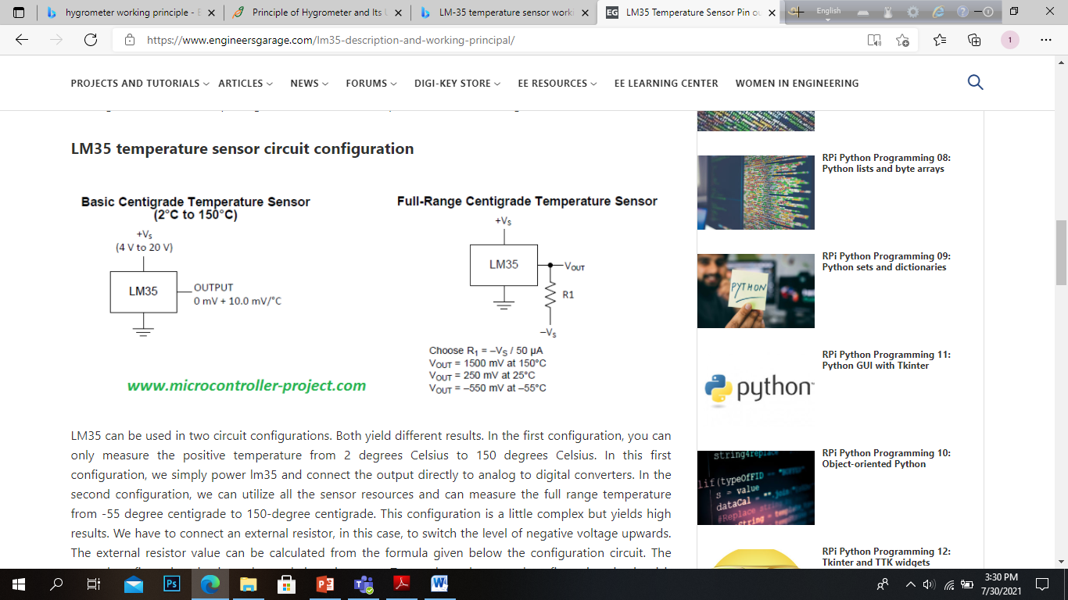 

(b)

(a)

**Figure**: Two different circuit configuration for LM-35 sensor. **(a)**Basic Centigrade Temperature sensor , **(b)** Full-Range Centigrade Temperature Sensor

LM35 can be used in two circuit configurations. In the first configuration, you can only measure the positive temperature from 2 degrees Celsius to 150 degrees Celsius.In this first configuration, we simply power LM-35 and connect the output directly to analog to digital converters. In the second configuration, we can utilize all the sensor resources and can measure the full range temperature from -55 degree centigrade to 150-degree centigrade. This configuration is a little complex but yields high results. We have to connect an external resistor, in this case, to switch the level of negative voltage upwards.

As in our case, we are not allowing negative temperature inside the chamber, so the first circuit configuration is used here.

**Controlling temperature-**

1. **In case of lower temperature:**

When temperature is below a certain threshold value, a heating fan is used to raise the temperature. In front of the fan, a bulb is placed. At lower temperature reading, the bulb is turned on. The hot air produced due to the heat produced from the bulb is sucked inside the chamber using the fan. The fan acts as an ID(induced draft) fan that inhales air and through forced convection process, the soil bed slowly gains heat.

1. **In case of higher temperature:**

When temperature exceeds a minimum value, a cooling fan is set to start. As the temperature inside the chamber is higher than the outside temperature, induced air form the environment would cool down the temperature of inside air through slowly attaining thermal equilibrium.

Additional control mechanism is also set to increase or decrease the speed of heating or cooling fan so that the chamber can attain desired temperature within short span of time when necessary.

**4.2: Mechanical Design:**

(b)

(a)

**Figure:** Mechanical design. **(a)** Isometric View, **(b)** Front View

The whole setup can be divided into 4 major parts-

1. **The measuring devices**-

Two sensors are used to measure temperature and moisture content: (1) LM-35 temperature sensor,(2) YL-69 SOIL HYGROMETER HUMIDITY AND SOIL MOISTURE SENSOR.

(b) **The control devices-**

Two fans and a pump are used to control properties inside the chamber. Fans are mounted on the two sides of chamber wall and a motor pumps water from the water tank.

(c)**The control unit**-

The control unit is mounted on top of the chamber. It consists of Arduino UNO, capacitors, resistors, relay and other circuit components. The total mechanism is controlled from here. Arduino code is installed into the Arduino UNO beforehand.

**(d)Working chamber**-

Working chamber is mainly the part where seedlings would grow. It hosts the soil bed and the plants. Moisture sensors are inserted into the soil bed. In the lower part, a water tank is placed with which the chamber is connected through a piping network. This water tank holds water to be supplied in case of low moisture content.

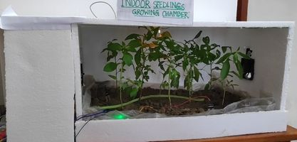

Figure: Actual image of our handmade project

**4.3: Circuit Diagram:**

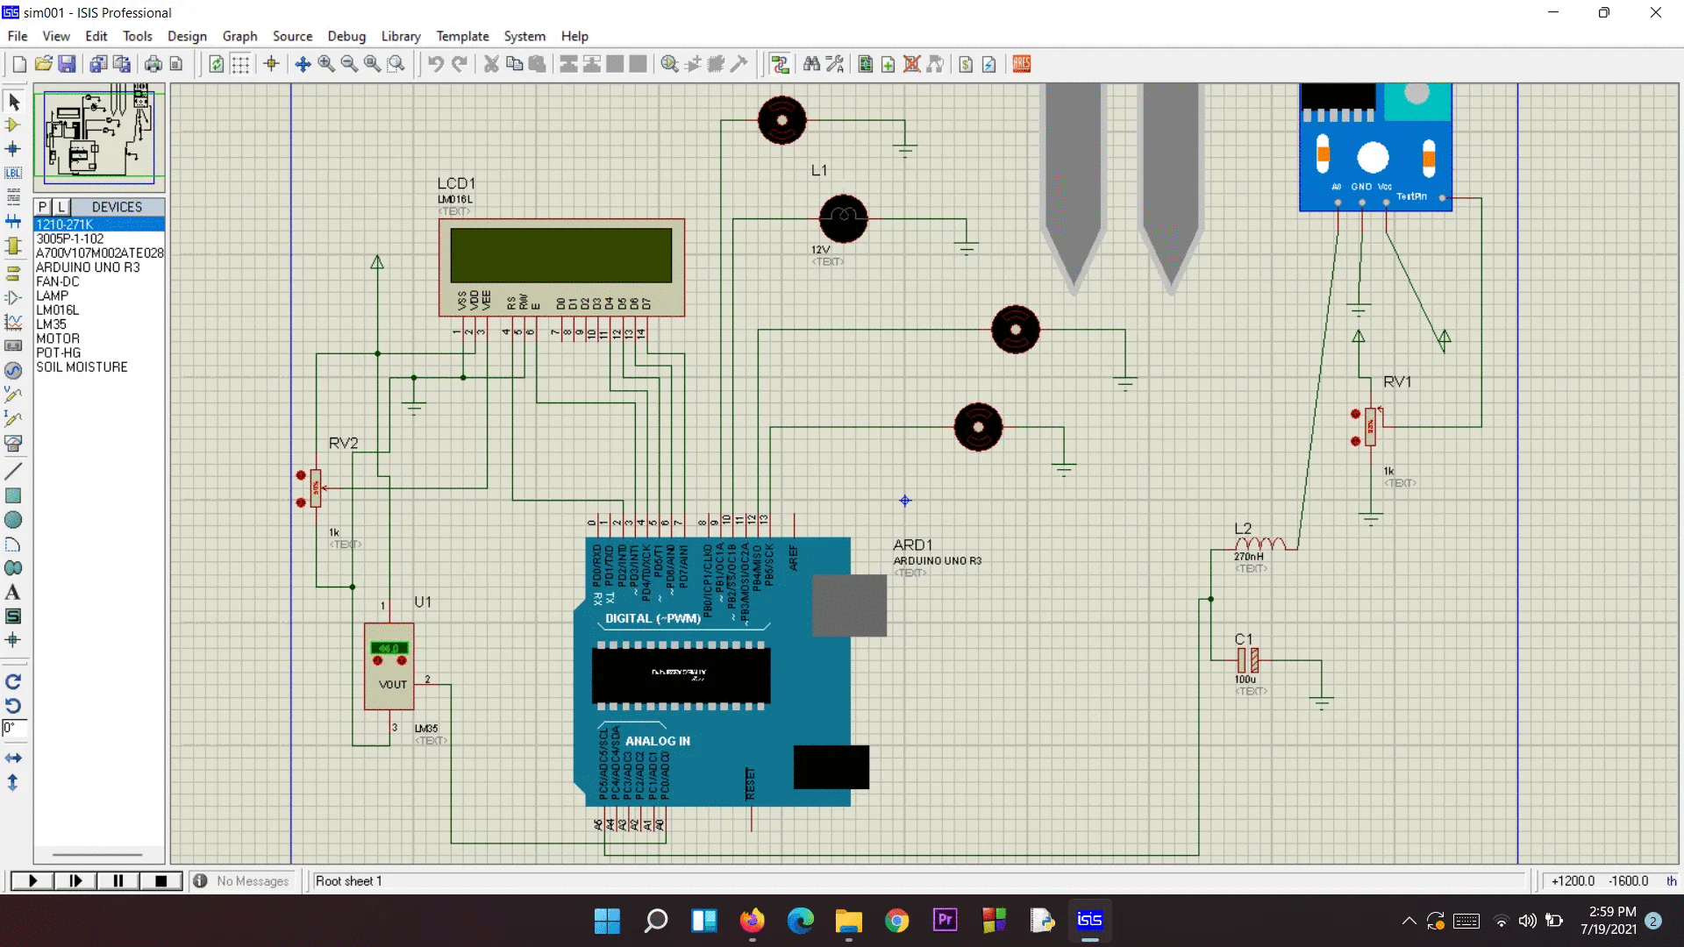

(d)

(h)

(g)

(f)

(e)

(c)

(b)

(a)

**Figure**: Circuit diagram (Proteus Design)

Here,

a = 16 X 2 LCD display

b= Arduino UNO board

c=LM-35 temperature sensor

d= Hygrometer soil moisture sensor

e= Water Pump

f= Heating bulb

g=Cooling fan

h= heating fan

5. **Components:**

5.1: **ARDUINO UNO:**

Arduino is an open-source electronics platform based on easy-to-use hardware and software. It is a single board microcontroller unit which contain the ATmega328 chip. In our project, the ports of the Arduino board are used as connecting wires to different electrical components. We also used it to power up our LCD and sensor. Most importantly, the Arduino is the brain of the whole process. It implements the necessary command and process the data to give out meaningful result.

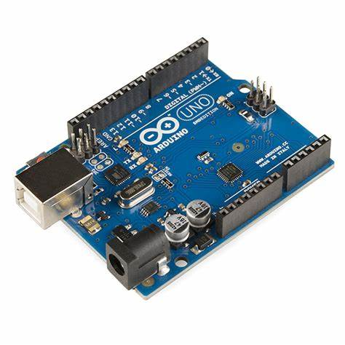

**Figure:** Arduino UNO board

5.2: **LCD Display:**

LCD display is primarily used a user interface, where it prompts the user to input the value of different features. In our case,it displays the temperature and the moisture content. In this project, we are using a 16x2 LCD display.

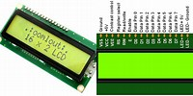

5.3: **LM-35 Temperature Sensor:**

The advantage of LM-35 is it does not require any external calibration. The coating also protects it from self-heating. In our project, the input voltage of the sensor was 5V or 5000 mV and the linear scale factor was 10 mV/˚C. Pin 1 must be connected to input voltage and pin 3 should be connected to analog to digital converter.

**Steps to calculate temperature using LM35 temperature sensor:**

* Build circuit.
* Power LM35 vcc to +5-20 volts and gnd to ground.
* Connect Vout to analog to digital converter input.
* Sample the ADC reading, vout output voltage.
* Convert the voltage to temperature.

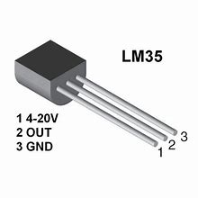

5.4: YL-69 SOIL HYGROMETER HUMIDITY AND SOIL MOISTURE SENSOR:

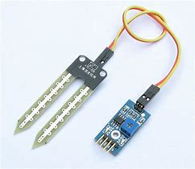

**Figure**: Soil Moisture Sensor

The soil moisture sensor or the hygrometer is usually used to detect the humidity of the soil. So, it is perfect to build an automatic watering system or to monitor the soil moisture of your plants.

The sensor is set up by two pieces: the electronic board (at the right), and the probe with two pads, that detects the water content (at the left).

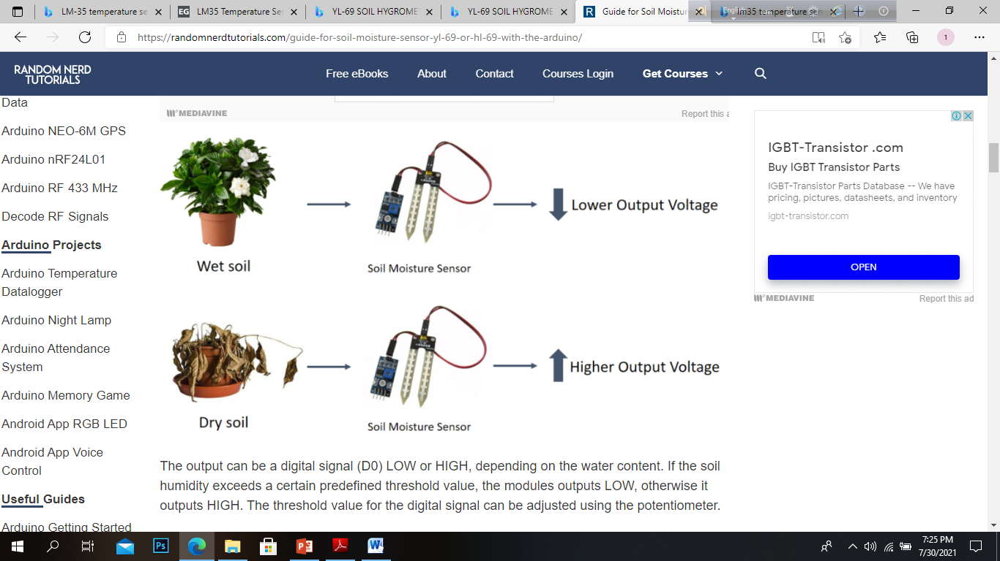

6. **Calculation:**

* **Temperature calculation:​**

LM-35 temperature sensor gives output as voltage and the output voltage is linearly comparative with Celsius temperature. The linear scale factor of our sensor was 10mV/˚C i.e. it shows 10 mv deflection for every degree centigrade temperature change. As in our case, the input voltage was 5 V or 5000 mV, calculation of temperature for the arduino reading would be as follows:

​For arduino reading upto 1024 , we have voltage readings upto      5000mV​

For, arduino value as X, we have voltage reading                                (5000/1024)*X mV​

​Now, to convert voltage reading to temperature, TEMPERATURE= (VOLTAGE READING/10)⁰C​

* ​**Moisture reading: ​**

Moisture reading is taken as percentage. We have used 2 moisture sensors are and an average of the two readings is taken as arduino ​reading. Average value would ensure the uniformity of moisture reading over the whole soil bed.  ​

​For arduino reading upto 1024 , we have moisture percentage as      100%​

For, arduino value as X, we have moisture content reading                 (100/1024)*X%

**7.SWOT analysis:**

**8.Conclusion:**

One of the major issues in our present world is for agriculture supply to cope up with the rapidly increasing population. Since the amount of cultivable lands are also decreasing, we need to look for alternatives where we can grow more in less space with all the adequate supplies.

In our project, we have developed such a system where we can cultivate plants inside homes and in multilayers without constant supervision and reliance on the weather. In our system , there are mainly two parts- the plants growing chamber and the control chamber. In the control chamber, we have an arduino UNO board to control and an LED screen to monitor the conditions of the environment. This system can be altered for a specific plant in one time for the best results, since different plants require different amounts of water and temperature for the best growth. With the proper materials to develop chambers and knowledge of plants, we believe this system can help us reduce all the problems that our agriculture faces today.

**9.Reflection on Learning:**

This has been a really challenging project for us since we come from different districts and we were not familiar with the work. Regardless, we learnt how to work with Arduino in both software and hardware and tried our level-best to give our project a reality.

For this project to run, we have learnt how to use Arduino and Proteus. Since we are from different places, we divided our work to increase productivity. We believe this knowledge of Arduino and running simulations in proteus will help us technically and practically in our future academic and professional life. But since we have only learnt about the very basics, we will try to improve our learning and understanding, so we can truly bring a change.

**10.Future Work:**

In our project, we had some major shortcomings from the very beginning. We had limitations as to what materials we can use, where we can assemble everything and how to make it with minimal cost. Moreover, there were not easy facilities of soldering or frame making to give our project strength. These are some of the places where improvements can be made.

In our project, we didn’t use light or nutrition sensor as it is not available commonly online. As a result, this portion of our project needs to be handled manually still, but with the availability of these 2 sensors, we believe we can develop a greater project at a lower cost than the current marketplace.

In the future, we want to connect the controls with our mo bile devices so we can control and monitor from a distance without constant presence.

**11.References:**

[1] Wang D, Zhao J, Huang L and Xu D 2015 Design of A Smart Monitoring and Control System for Aquaponics Proc. of the 5 th Int. Conf. on Information Engineering for Mechanics and Materials (ICIMM 2015)

[2] Velazquez L A, Hernandez M A, Leon M, Dominguez R B and Gutierrez J M 2013 First Advances on the Development of a Hydroponic System for Cherry Tomato Culture Proc. of IEEE 10th Int. Conf. on Elect. Eng. Comp. Sc. and Automatic Control (CCE).

[3] Kumar RR and Cho JY 2014 Reuse of Hydroponic Waste Solution Environ Sci Pollut Res Int [http://link.springer.com/article/10.1007/s11356-01430243](https://l.facebook.com/l.php?u=http%3A%2F%2Flink.springer.com%2Farticle%2F10.1007%2Fs11356-01430243%3Ffbclid%3DIwAR0TUMK8SZiBRz525sDJ7hz-kdmiPDaGDqEb2RUw-IbJWp8Ucc065IrEmZs&h=AT3Xs8U6PNxsRt8oks7KpvjNLMhq0EMHLi5PhXwVZRmdb8lkgiD9gDeO8uR1cl1at_XwiJlugET4t3pUm-_Sb5RwEfZO3BqCcKaGL2SOYqPXSEieJgj25Pby7ECrmXy97fwieA).

[4] Asumadu J A, Smith B, Dogan N S, Loretan P A and Aglan H 1996 Microprocessor-Based Instrument for Hydroponic Growth Chambers Used in Ecological Life Support Systems Instrumentation and Measurement Technology IEEE Instrumentation and Measurement Technology Conf. 1

[5] Saaid M F, Yahya N A M, Noor M Z H and Ali M S A M 2013 A Development of an Automatic Microcontroller System for Deep Water Culture (DWC) IEEE 9th Int. Colloquium on Signal Processing and its Applications.

[6] Chenzhong Y, Yinchun H and Weihong Z 2004 Research of Hydroponics Nutrient Solution Control Technology Proc. 5’ World Congress on Intelligent Control and Automation 1.

[7] Shafahi M and Woolston D 2014 Aquaponics: A Sustainable Food Production System Proc. of the ASME 2014 International Mechanical Engineering Congress and Exposition.

[8] Mishra R L and Jain P 2015 Design and Implementation of Automatic Hydroponics System Using ARM Processor Int. J. of Advanced Research in Electrical, Electronics and Instrumentation Engineering 4.

[9] Devika S V, Khamuruddeen S, Khamurunnisa S, Thota J and Shaik K 2014 Arduino Based Automatic Plant Watering System Int. J. of Advanced Research in Comp. Sc. and Software Engineering 4

[10] https://www.pharmaguideline.com/2013/09/principle-of-hygrometer-and-its-use-in-manufacturing.html

[11] https://www.engineersgarage.com/lm35-description-and-working-principal/

[12] https://www.howstuffworks.com/