**Name: Yamin Li**

**netID: ylf245**

**Project A: Simple Solar System**

1. User’s Guide

This project built a simple solar system, which consists of

the sun, eight planets with the moon orbiting the earth and rings of Saturn.

This system is very easy to interact with. User can press “F1” to show the users’ instruction of this system. Users can press Space key to run or stop the motion of system, use “Q” to accelerate or “S” to slow down the system. Press “I” to zoom in which enables users to see more details about Earth with moon or rings of Saturn, “O” to zoom out so that users can look at the solar system in the God’s view. Also, users can adjust the view by pressing “Up” key (view up) or “Down” key (view down). Also, users can use mouse to drag the system anywhere they want it to be. With mouse click, and “D” key, users can see more information of each planet. Besides, in the webpage, we have buttons to control the speed of the planets.

1. Results

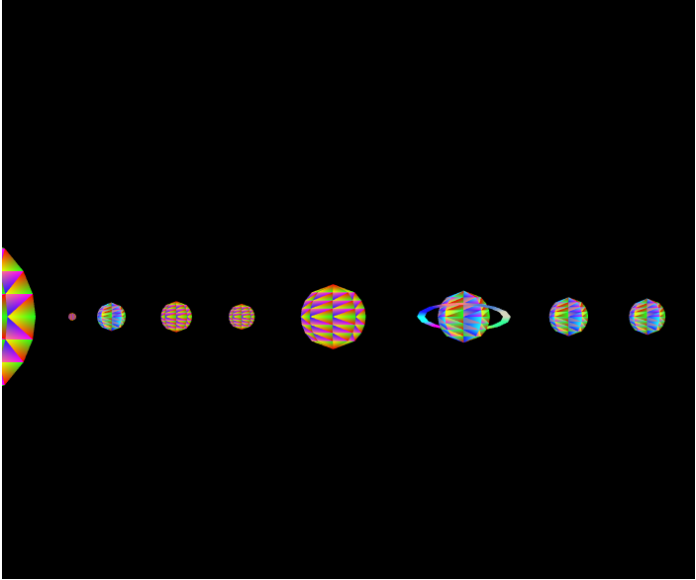

Figure 1. Overview of the system

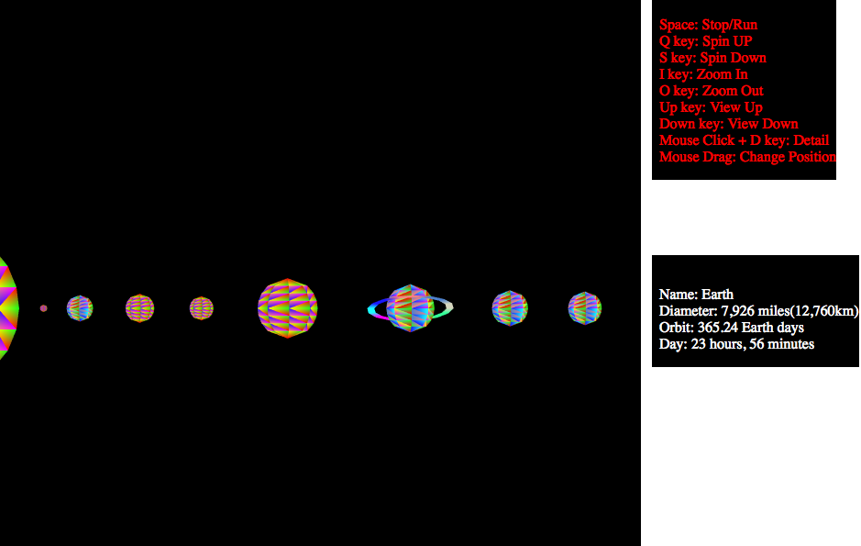

Figure 2. Mouse click to see detail of any planet

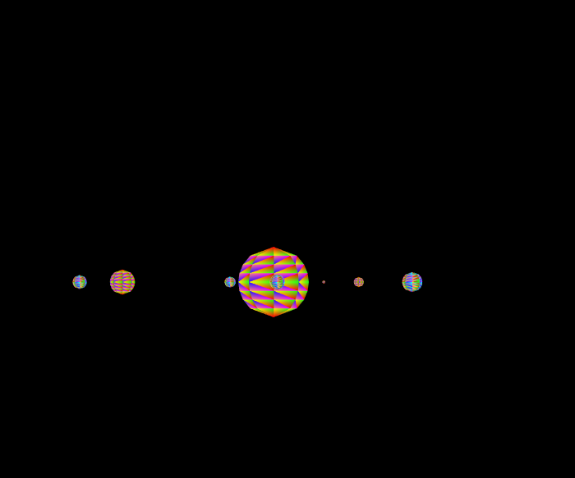

Figure 3. Mouse drag the system to different position

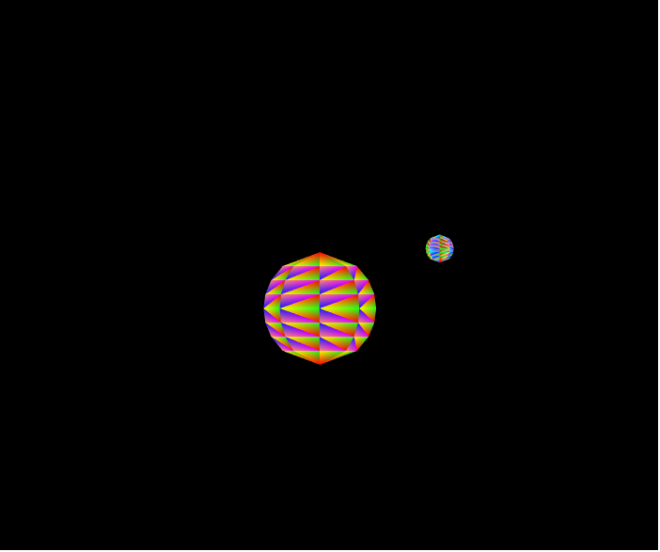 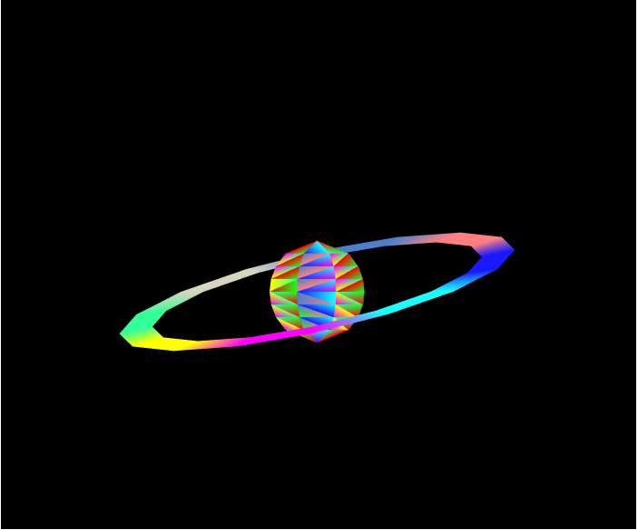

1. Earth with moon (b) rings of Saturn

Figure 4. Zoom in(“I”) to see more detail

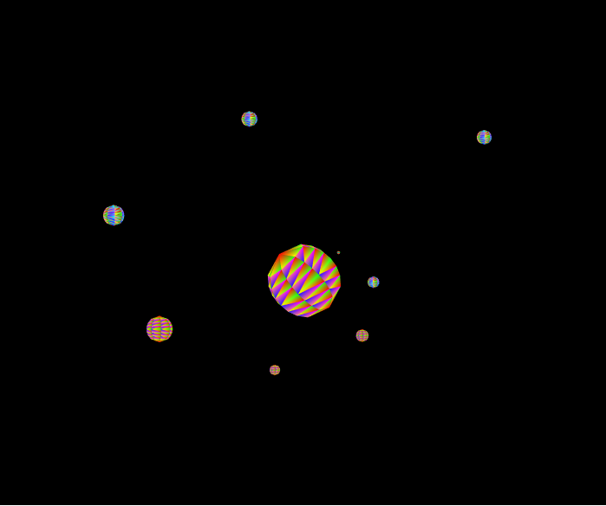

Figure 5. Different Camera view angle (Up or Down key) (a)

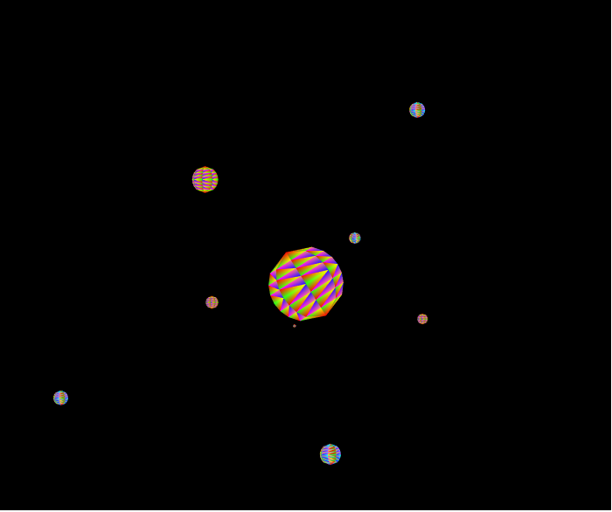

Figure 6. Different Camera view angle (Up or Down key) (b)