**Name: Yamin Li**

**netID: ylf245**

**Project B**

1. User’s Guide

This project built a simple system to perform the effect of the diffuse shading over 3D self designed objects, also it shows how to control the view angle or position of the looking camera from two different scenes (perspective view and orthographic view).

This system is very easy to interact with. User can press “F1” to show the users’ instruction of this system. Users can press Up/Down/Right/Left keys to move the camera position up/down/right/left. This is similar to users walking in the scene. Users can press W/A/S/D to look up/left/down/right from a specific position. In the webpage, users can use the “Spin>>” / “Spin<<” / “

Run/Stop” to accelerate or slow down or stop objects rotating.

1. Results

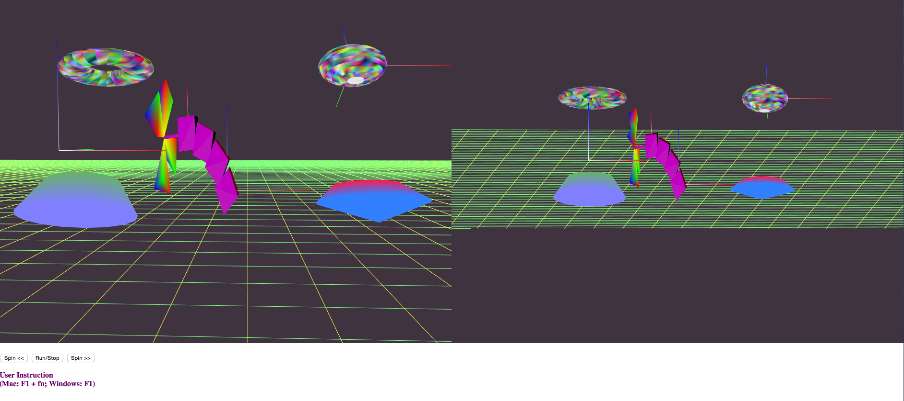

Figure 1. Overview of the system

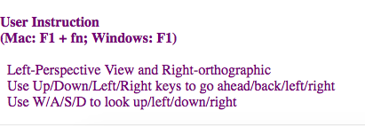

Figure 2. User Instruction

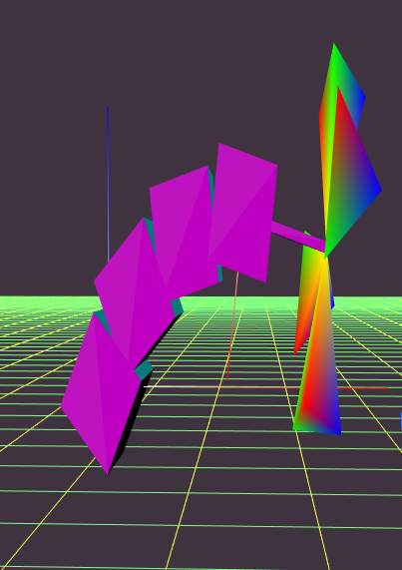 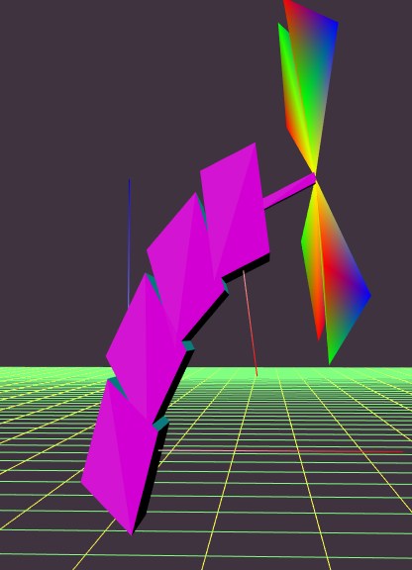 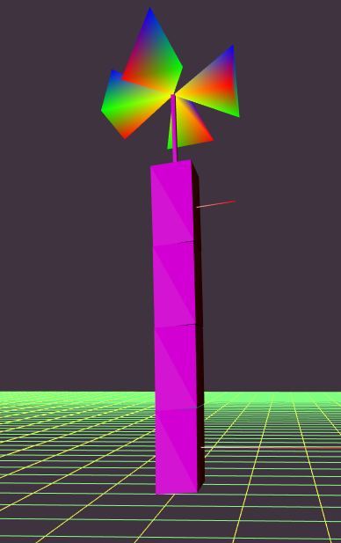 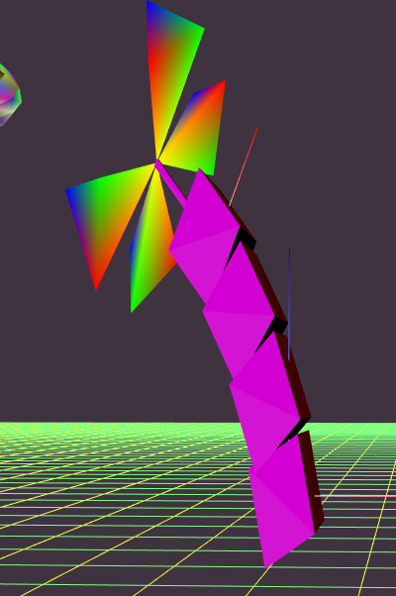 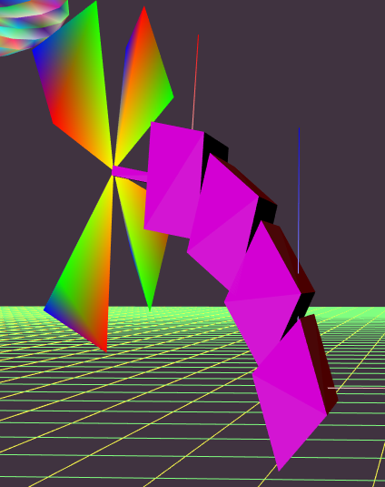

Figure 3. Animated, Adjustable 3-Jointed, 4-Segment Shape

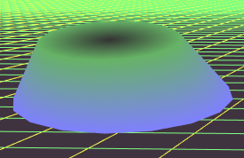 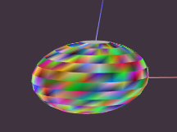

1. Cylinder (b) Sphere

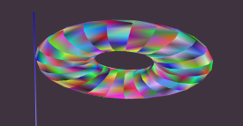 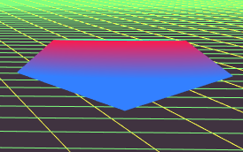

1. Torus (b) Diamond

Figure 4. 4 Additional Multi-color 3D Shapes placed on ground plane

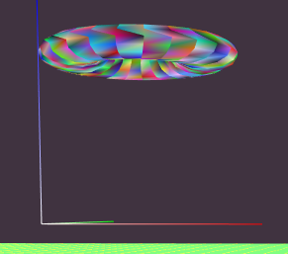 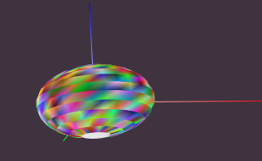 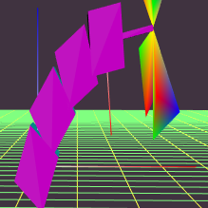

1. one set fixed (b) two with joint objects

Figure 5. Draw 3D Axes

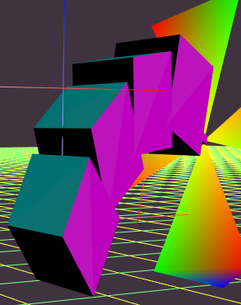 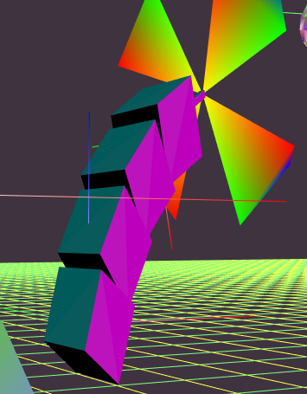 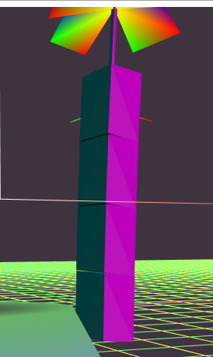

1. (2) (3)

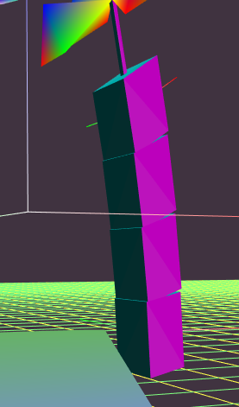 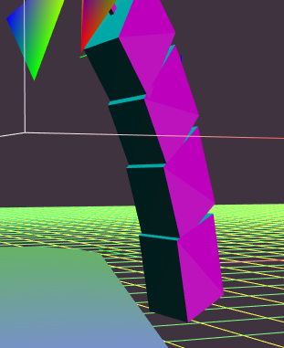 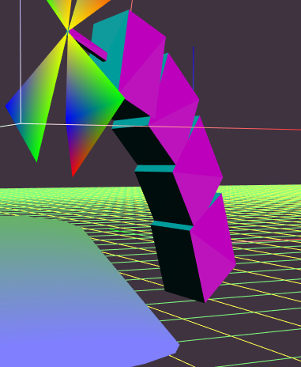

(4) (5) (6)

Figure 6. Simple Diffuse Overhead Shading

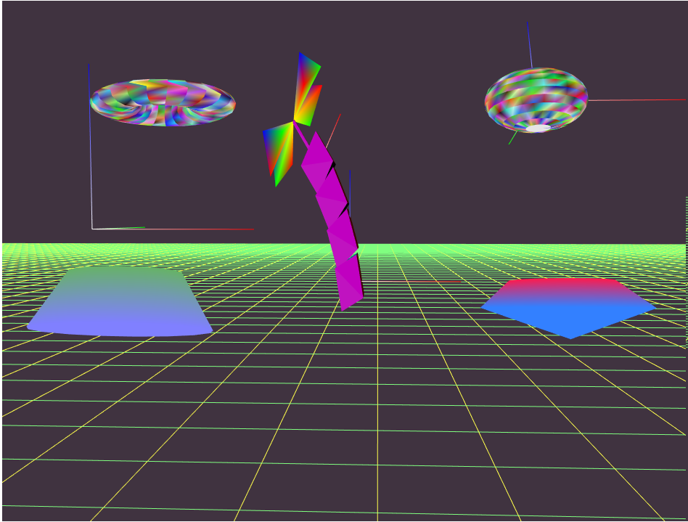 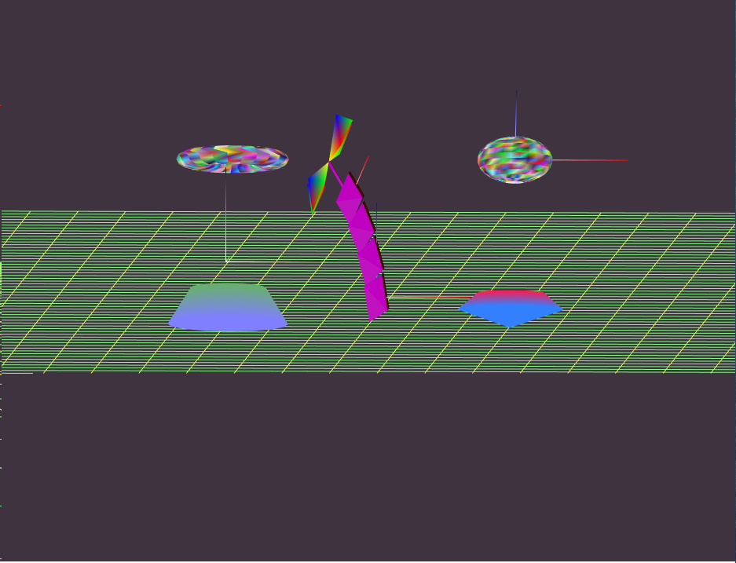

1. Perspective camera (b) Orthographic camera

Figure 7. 2 Side-by-Side Viewports

(perspective and orthographic camera)

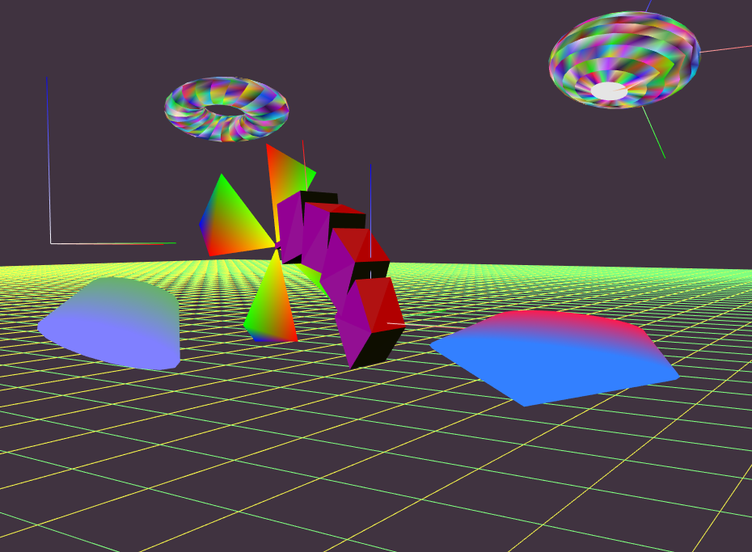 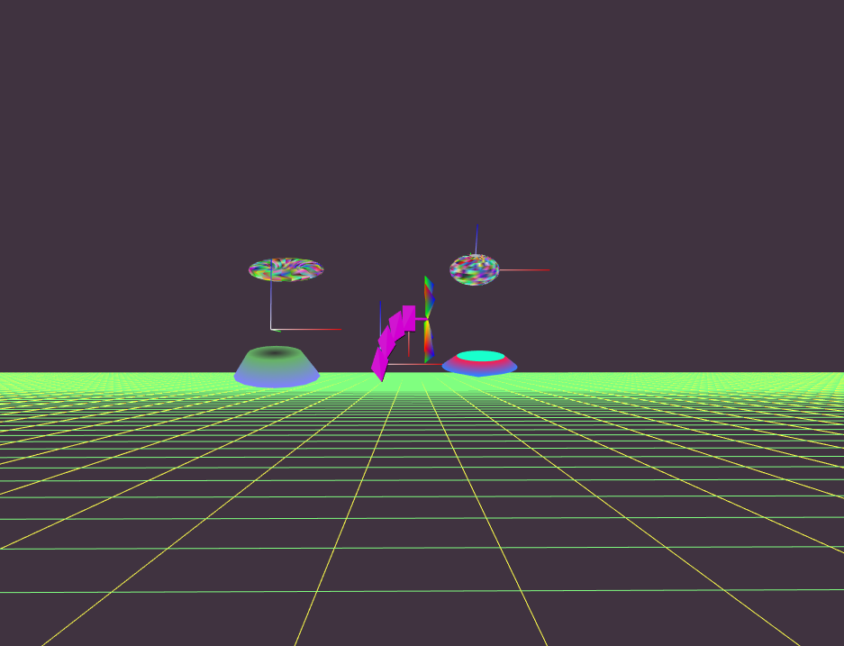 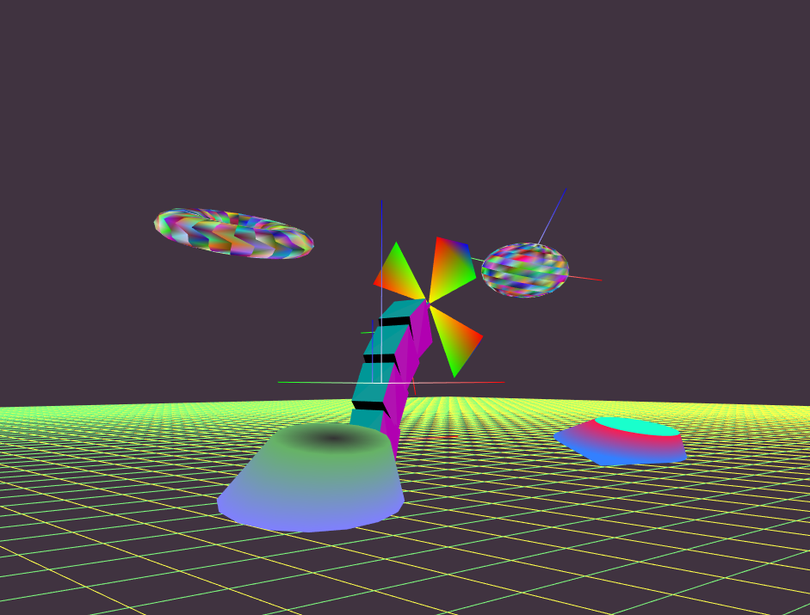

(a) From right&Down (b) From away (c) From Left&Up

Figure 8. Smoothly adjustable 3D View Control