**Name: Yamin Li**

**netID: ylf245**

**Project C**

1. User’s Guide

This project built a simple system to perform the different effect of Gouraud shading and Phong shading for Phong Lighting and Blinn-Phong Lighting over three 3D self designed objects with different-looking material for each, also it shows how to control the view angle or position of the looking camera (5DOF Camera Control) in a perspective view on the scene which fills the entire browser window of any shape. In the system, we place two kinds of light. One light source is attached to the camera, and the other one’s location can be adjustable by the user, also user can set up the ambient, diffuse, specular value of the light.

This system is very easy to interact with. User can press “F1” to show the users’ instruction of this system. Users can press Up/Down/Right/Left keys to move the camera position up/down/right/left. This is similar to users walking in the scene. Users can press W/A/S/D to look up/left/down/right from a specific position. Press I/O/Space to accelerate or slow down or stop objects rotating; N to switch on/off the headlight; M to switch on/off the world light, and use the right Control Panel to adjust the world light Position/Amibient/Diffuse/Specular; P to switch between Blinn-Phong lighting and Phong Light; G to swtich between Phong shading and Gouraud shading;

T to do simple texture maps.

1. Results

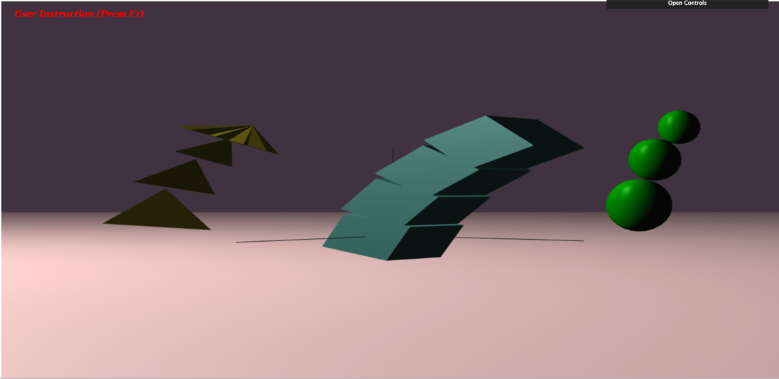

Figure 1. Overview of the system

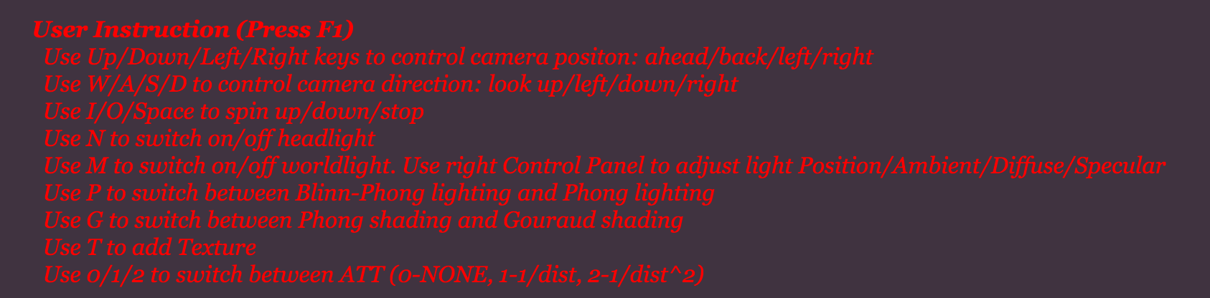

Figure 2. User Instruction

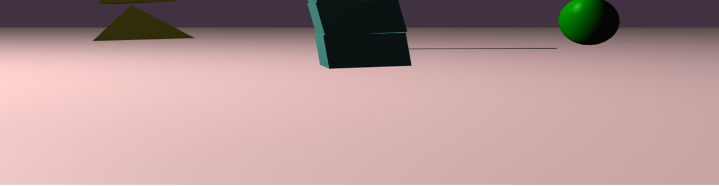

Figure 3. Ground-Plane Surface

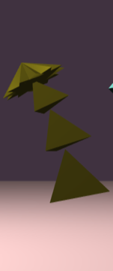 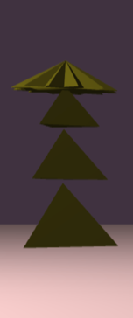 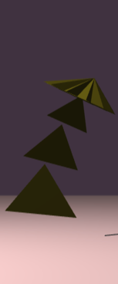 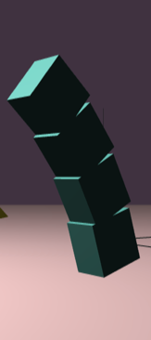 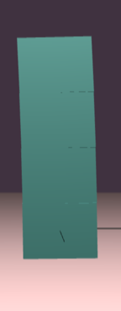 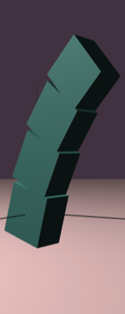 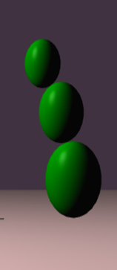 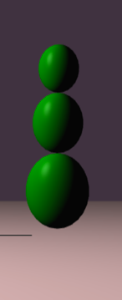 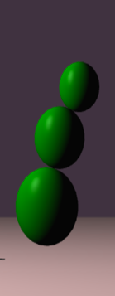

Figure 3. 3 Jointed, Continually Flexing Shapes (with Different-looking material)

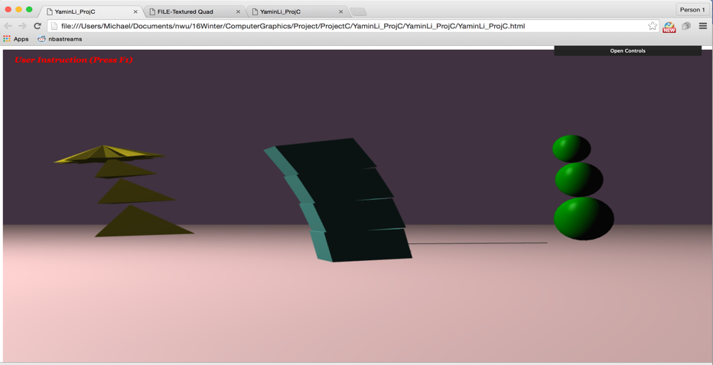

Figure 4. Single-Viewport Display

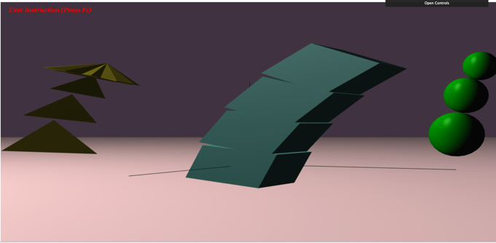 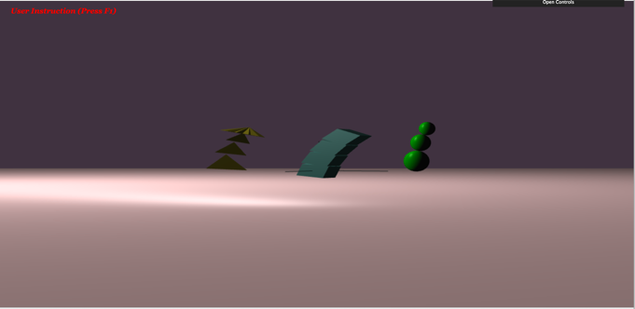

(a)Move Forward (b)Move Back

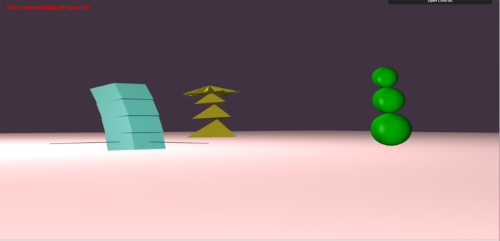 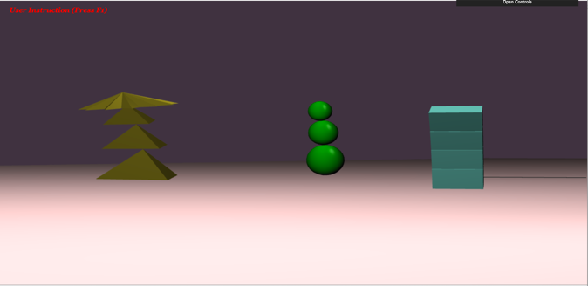

(c)Move Right and Pan Left (d)Move Left and Pan Right

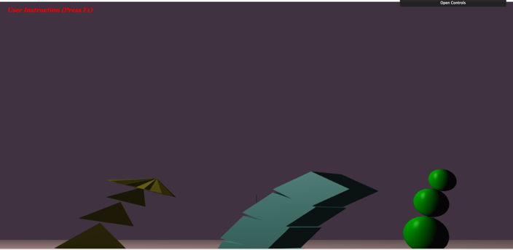 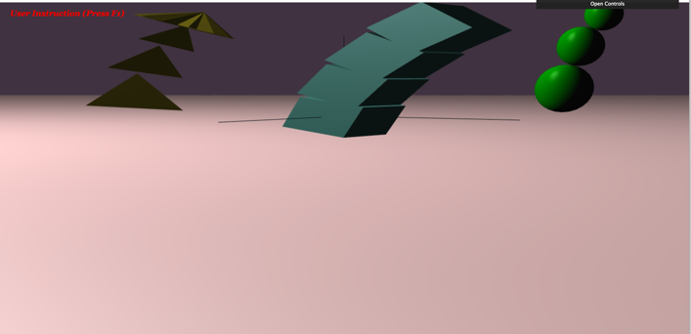

(e)Tilt Up (f)Tilt Down

Figure 5. 5-DOF Camera Control

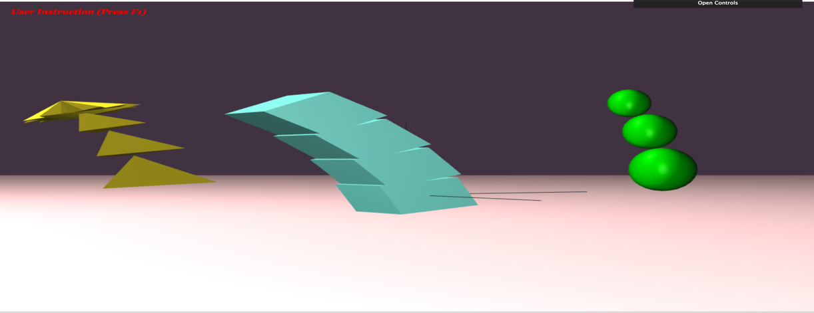

Figure 6. Switch on the Head Light

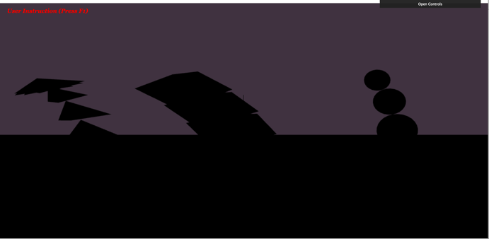 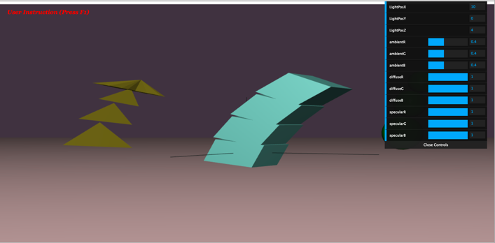

(a)Switch off (b)Change Position

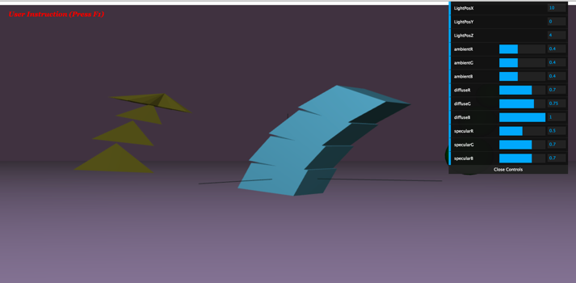 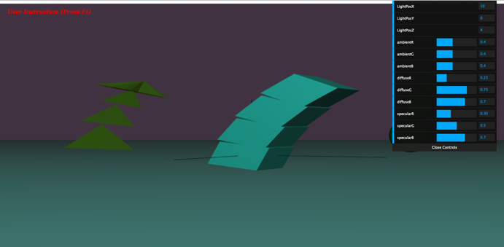

(c)Different Ambient/Diffuse/Specular light amounts

Figure 7. World Light Control

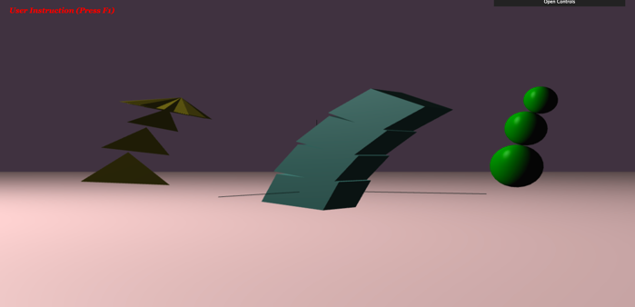 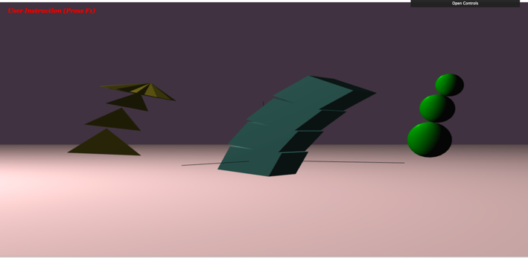

(a)Blinn-Phong lighting and Phong shading (b) Phong lighting and Phong shading

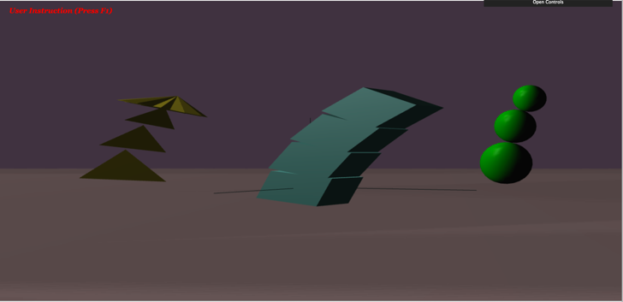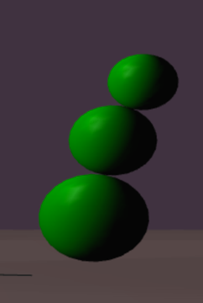

(c)Blinn-Phong lighting and Gouraud shaing

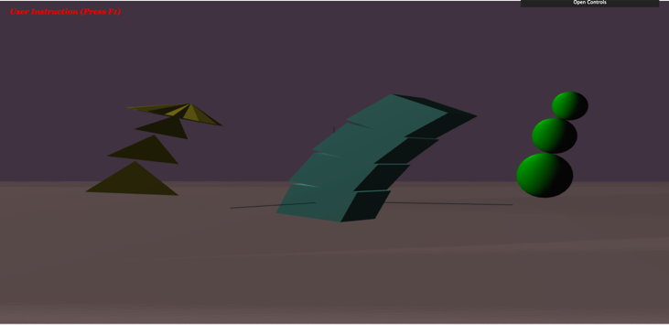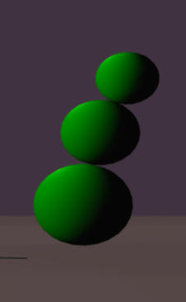

(d)Phong lighting and Gouraud shaing

Figure 7. Four lighting/shading methods

Extra Credit:

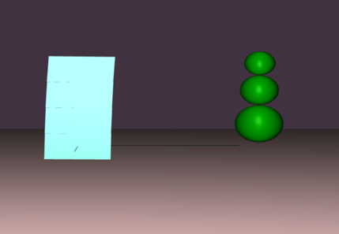 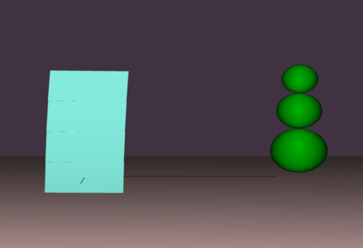 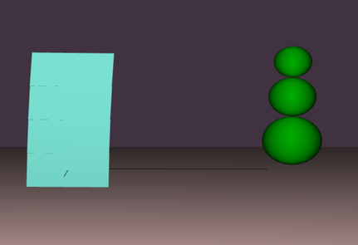

(a)None (b)1/dist (c)1/dist^2

Figure 8. 3 user-selected distance dependencies

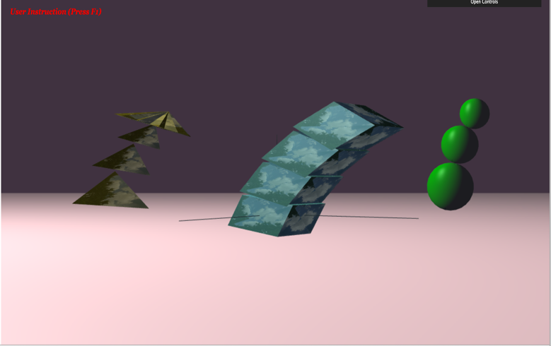 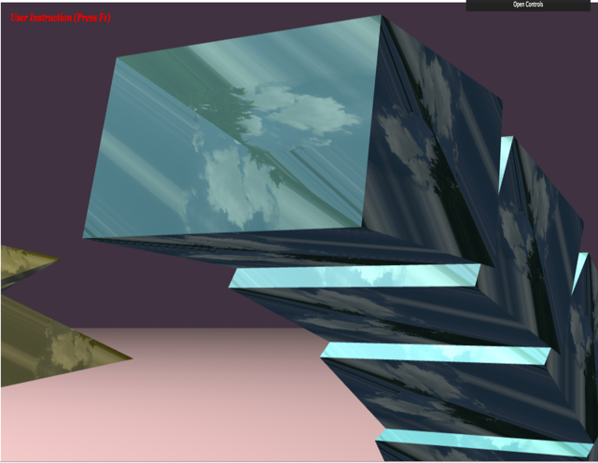

Figure 9. Simple Texture Maps Figure 10. Advanced Texture Maps(Mirror)