Educational organization using service now

Team Id:NM2025TMID14035

Team size:5

Team leader:Yamini v

Team member:Vinodhini S

Team mem ber:Janani M

Team member:Sangeetha M

Team member:Santhiya S

Problem Statement:

Our educational organization struggles with slow, manual processes for handling student and staff requests, and we need ServiceNow to streamline and automate these services.

Objective:

Our educational organization aims to enhance operational efficiency and improve the student experience by leveraging ServiceNow to streamline workflows, automate support services, and centralize communication.

Skills:

streamline administrative processes and enhance student support services.

Task 1:Creating a Update set

# Activity : Creating Update set

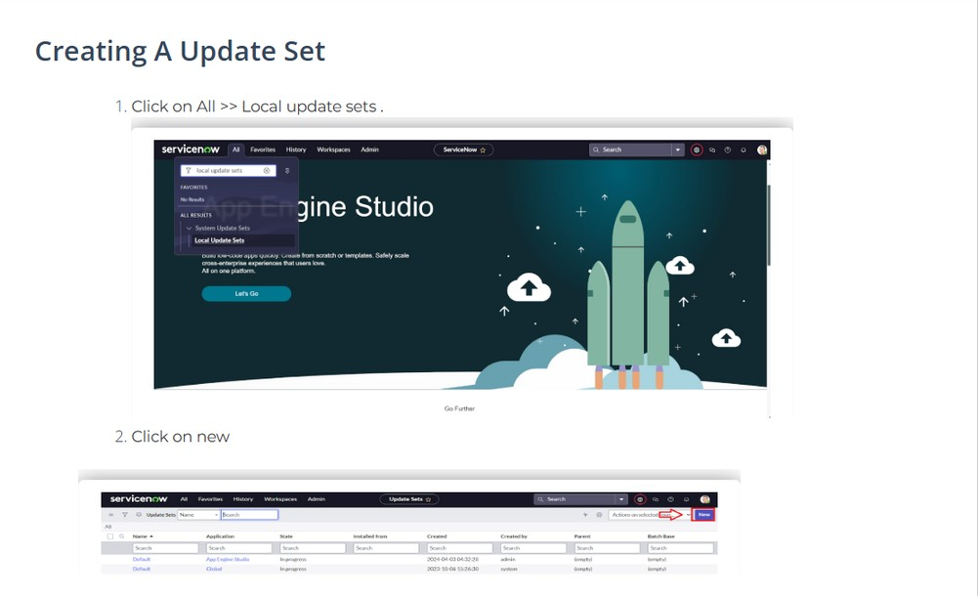

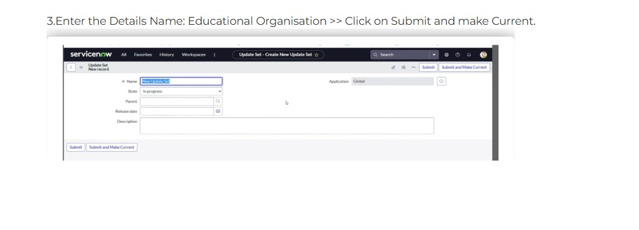

Task 2: Creating a Table

Activity 1: Creating Salesforce table

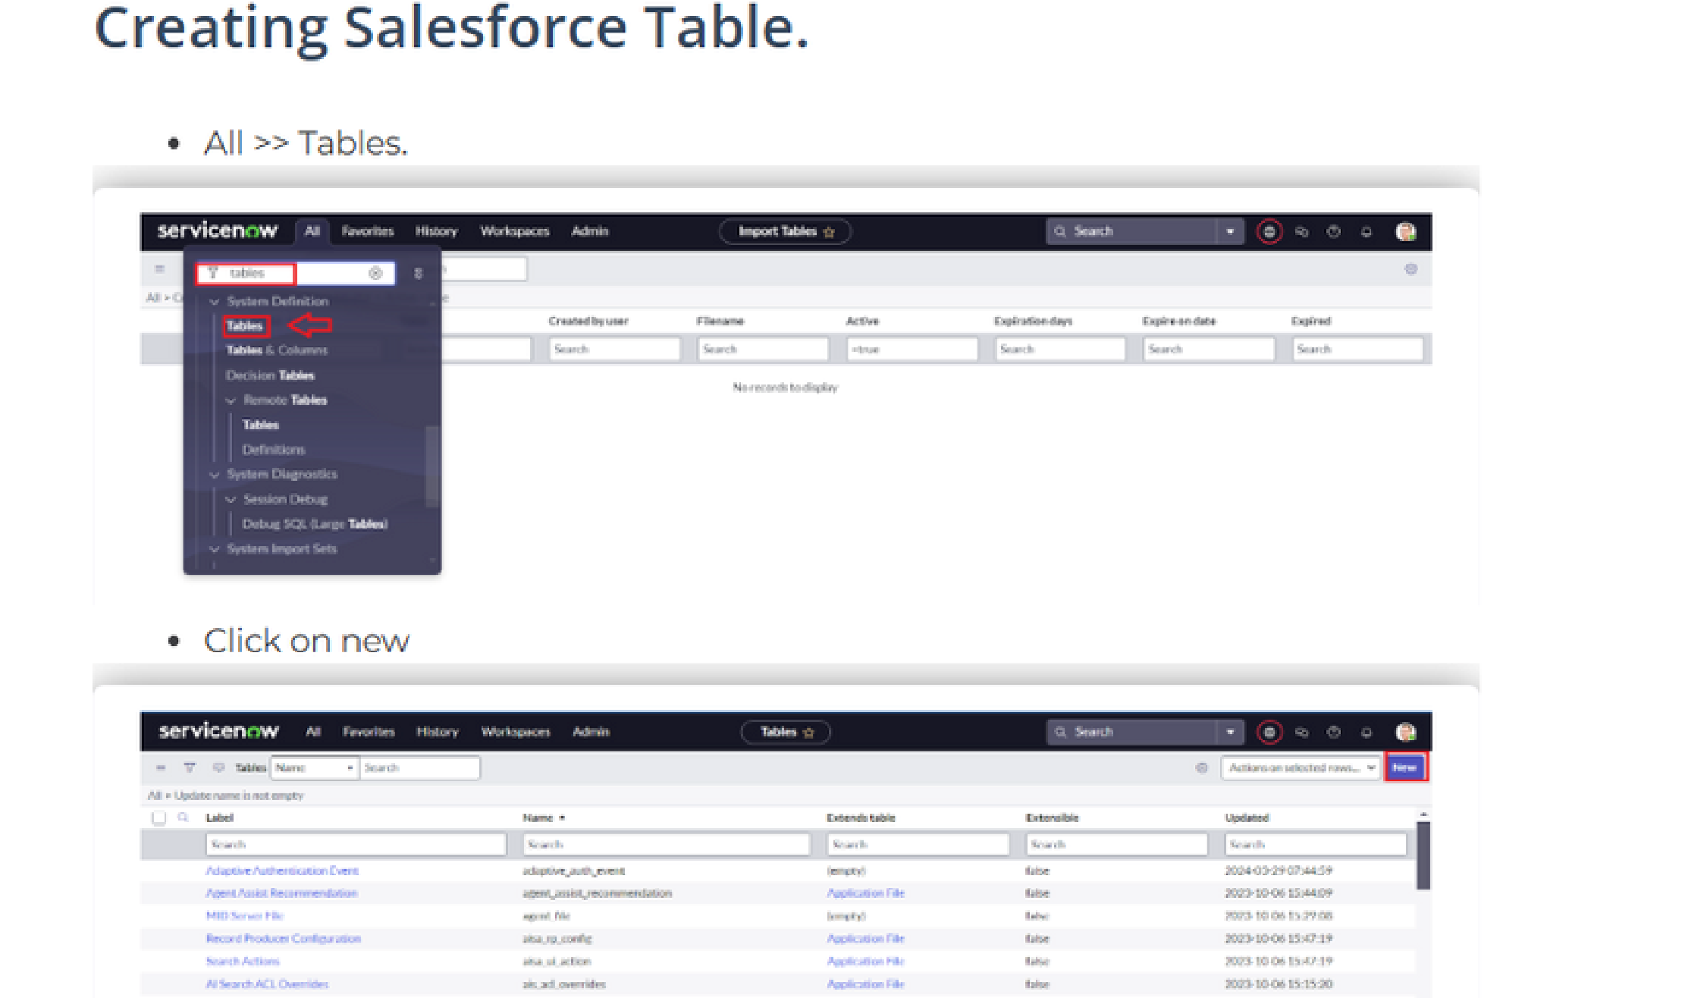

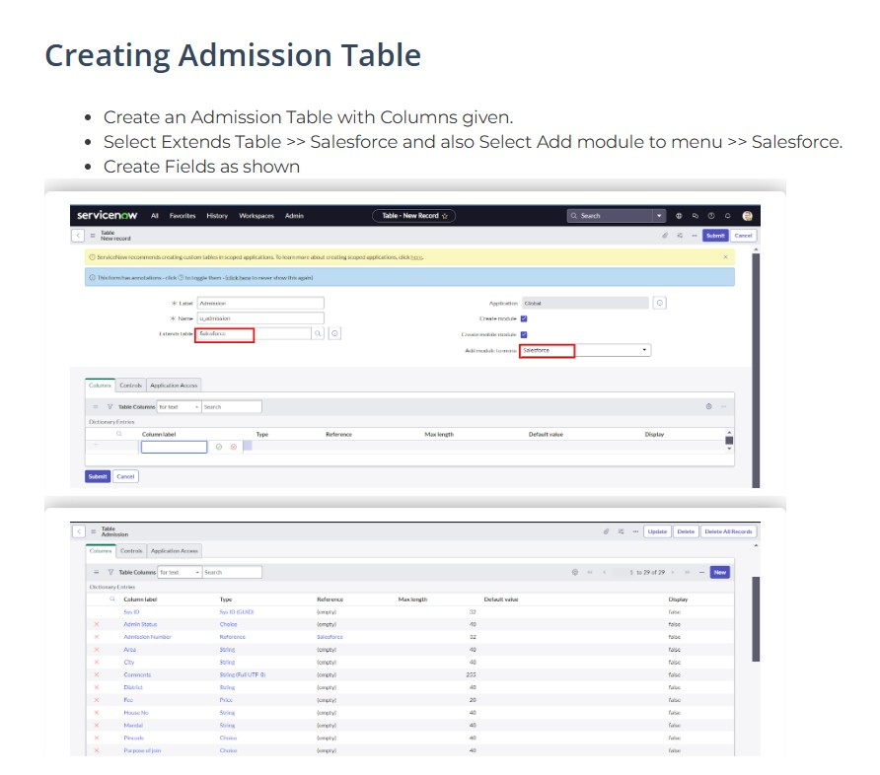

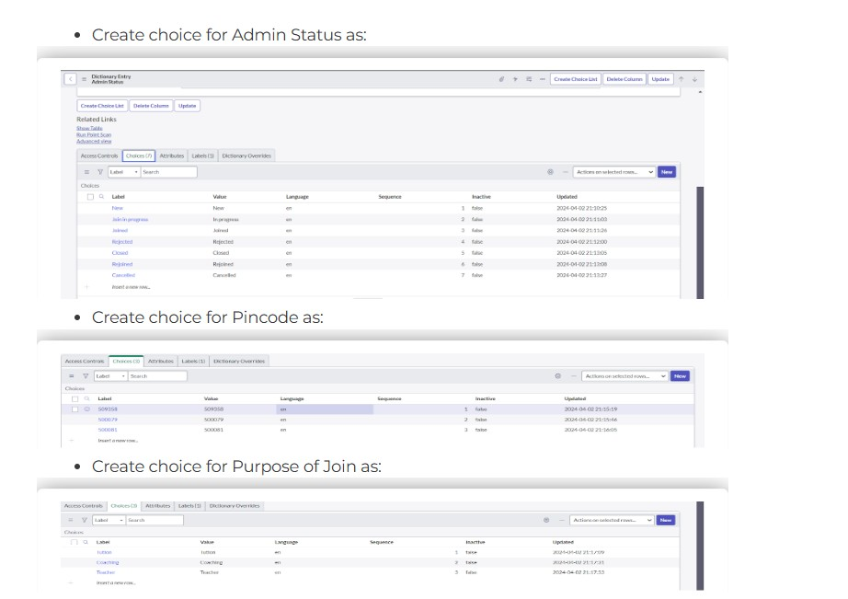

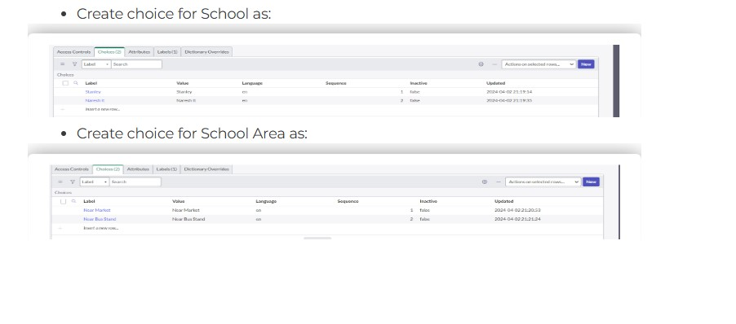

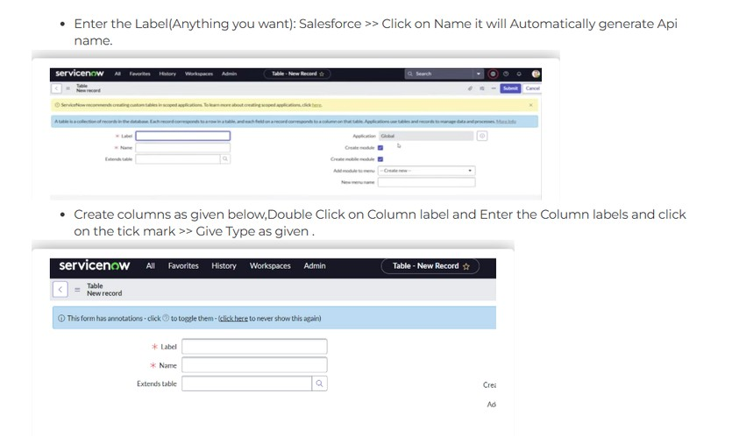

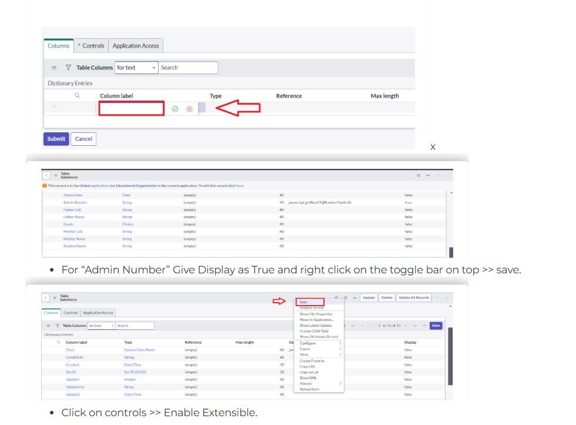

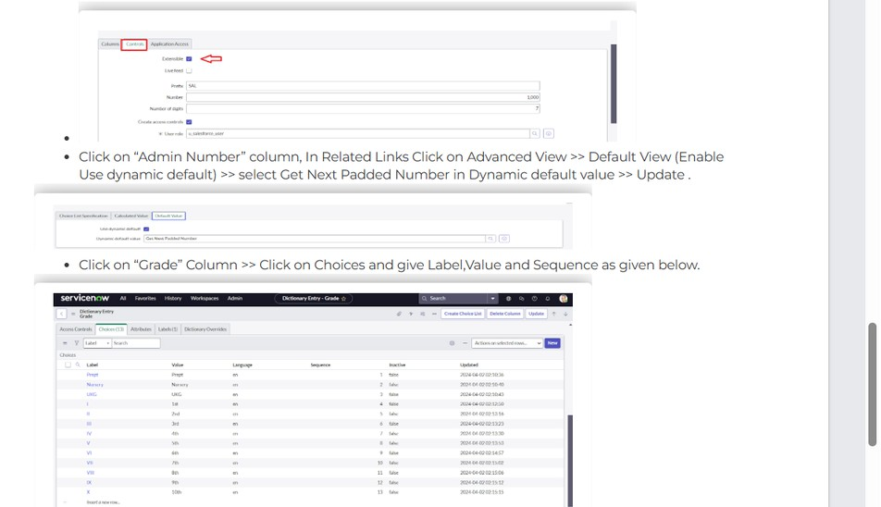

# Activity 2: Creating Admission Table

## Activity 3: Creating Student progress Table

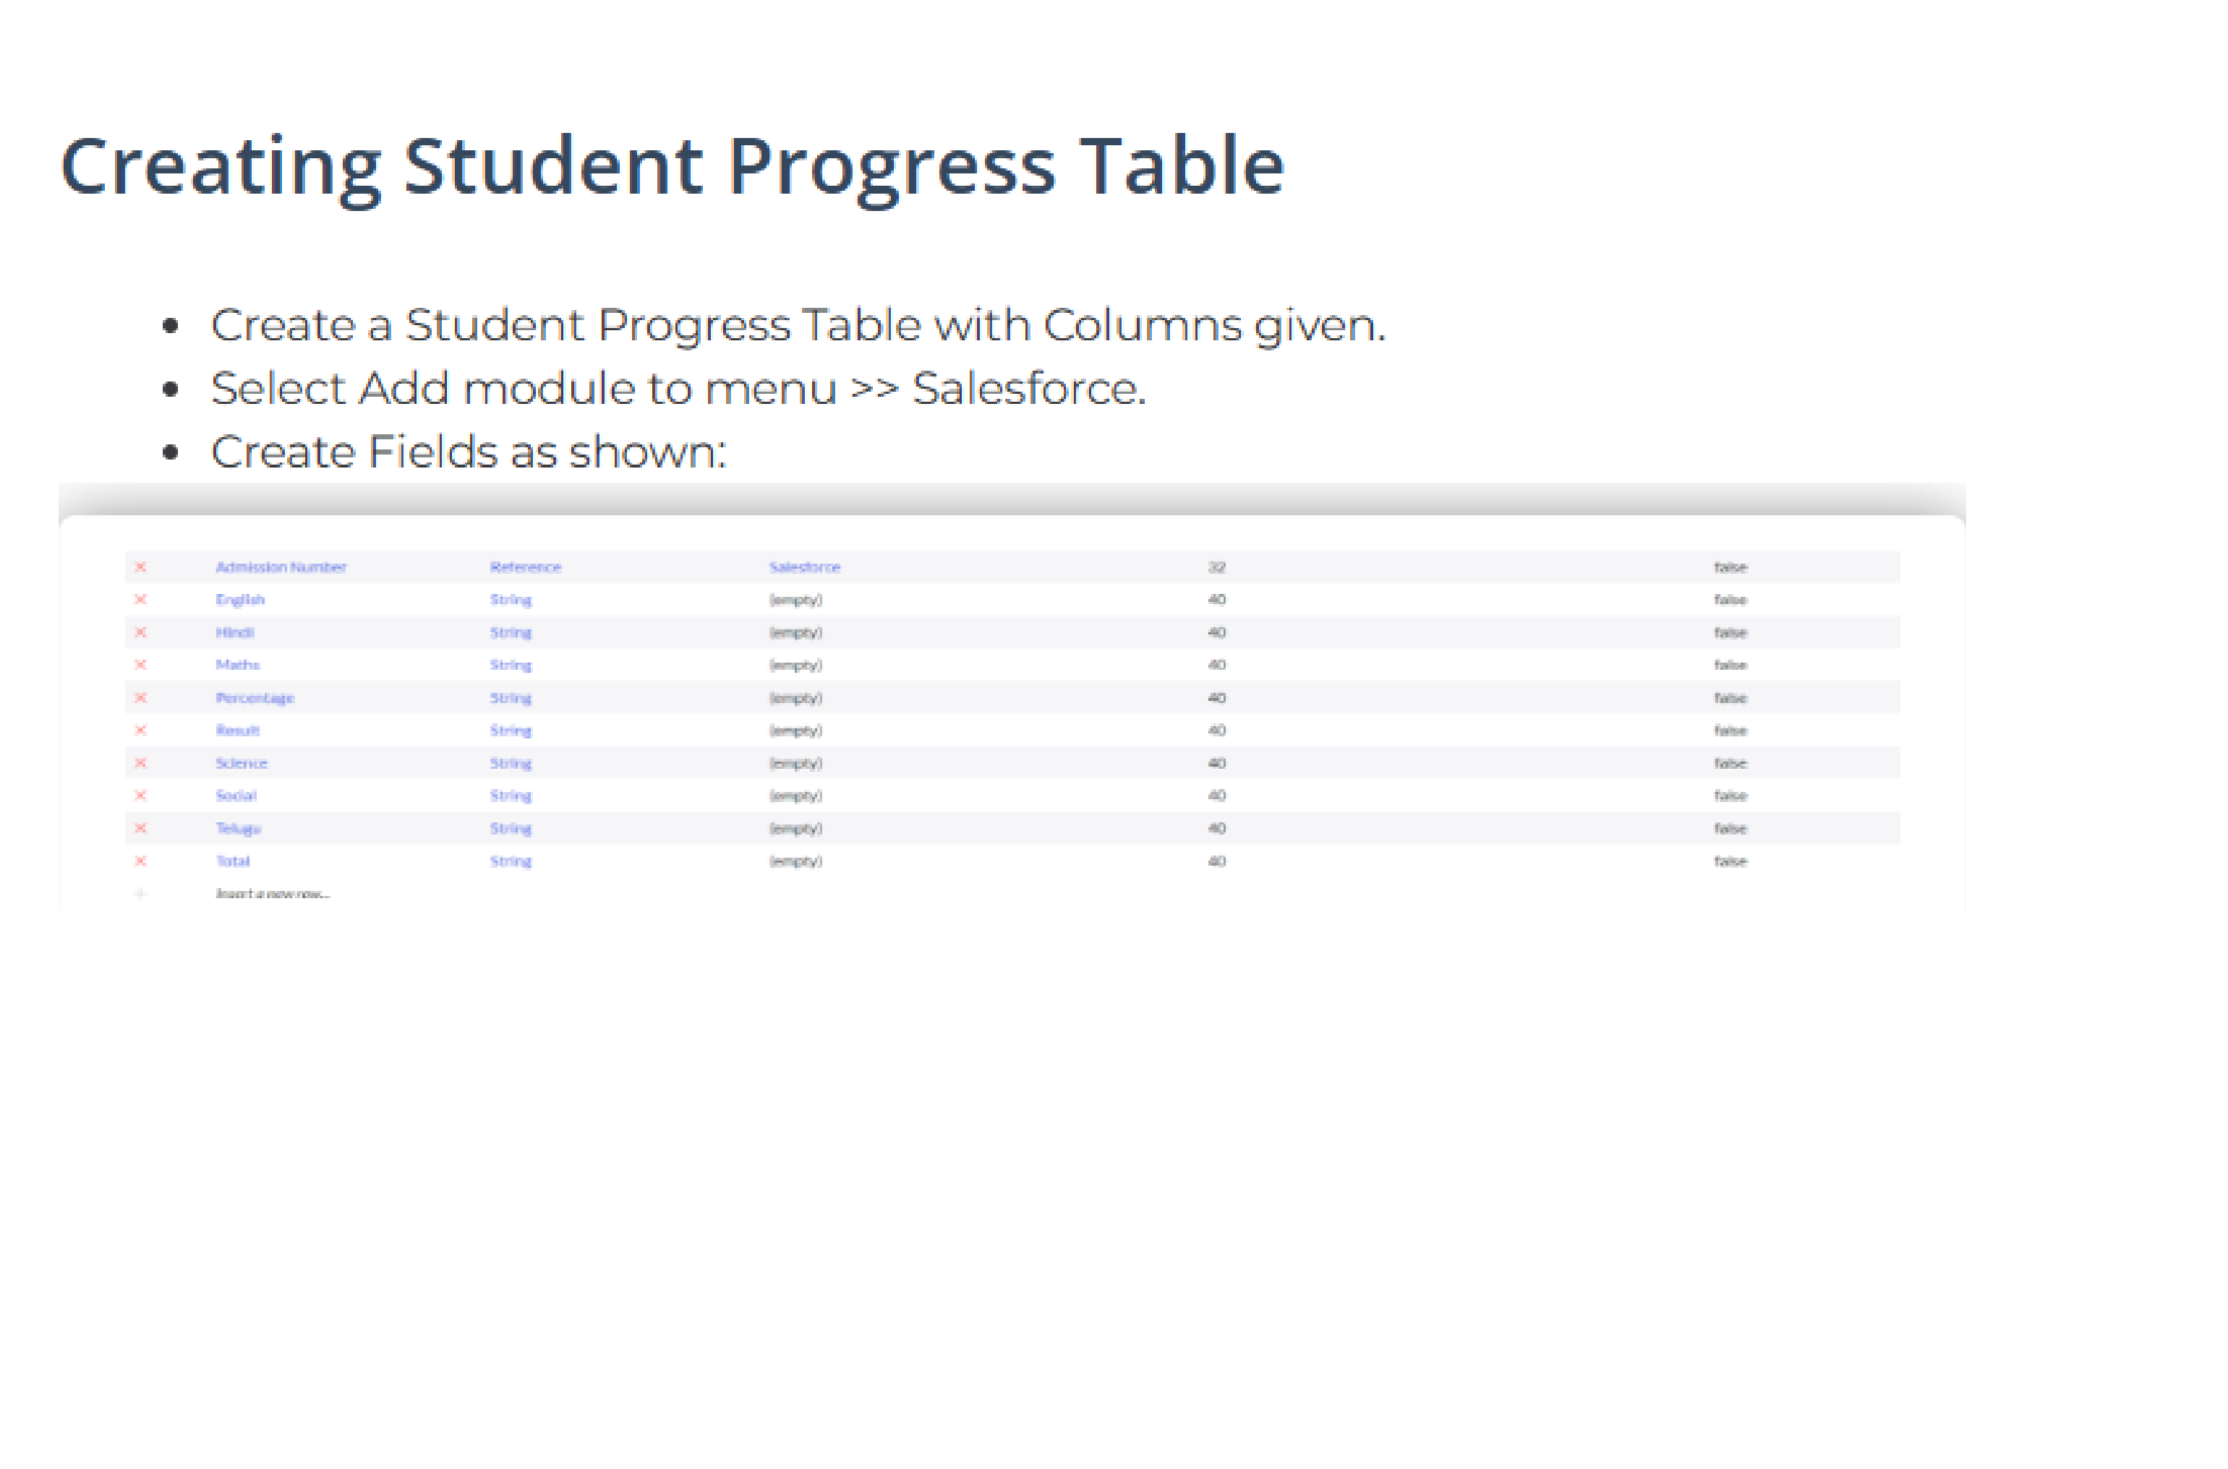

Task :Form Layout

Activity 1: Configuration Table Form for student progress table

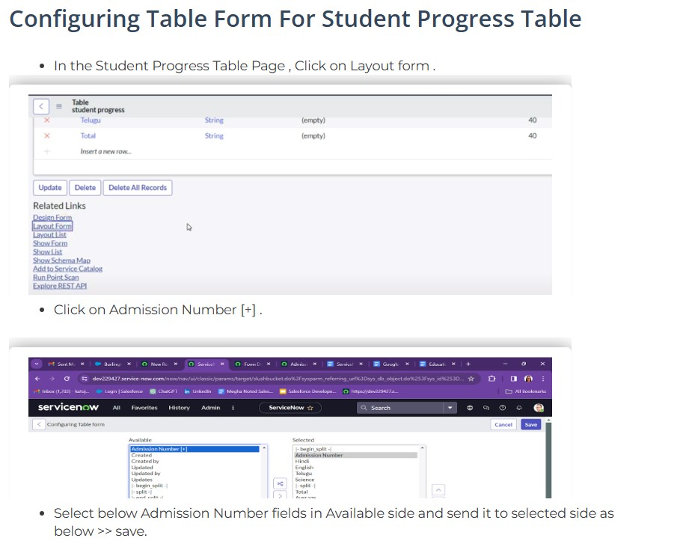

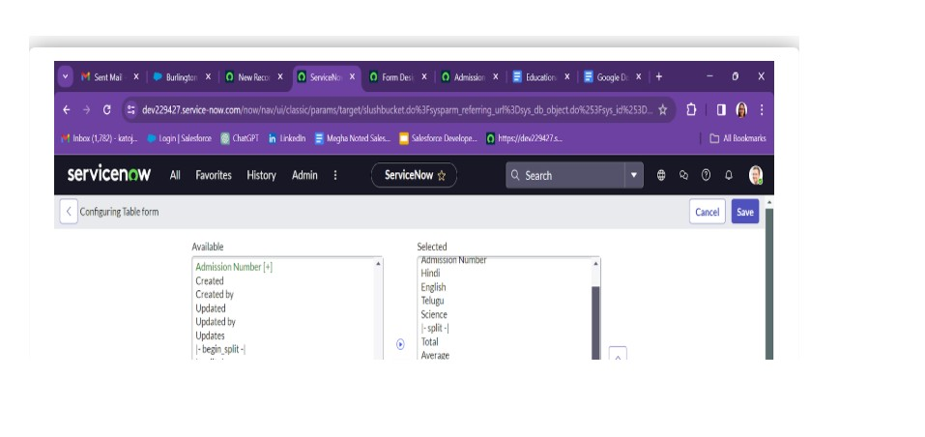

Task 4: Form Design

## Activity 1: Creating Design for salesforce table

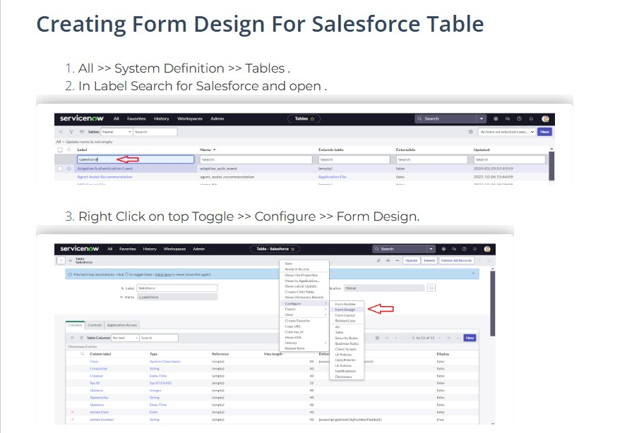

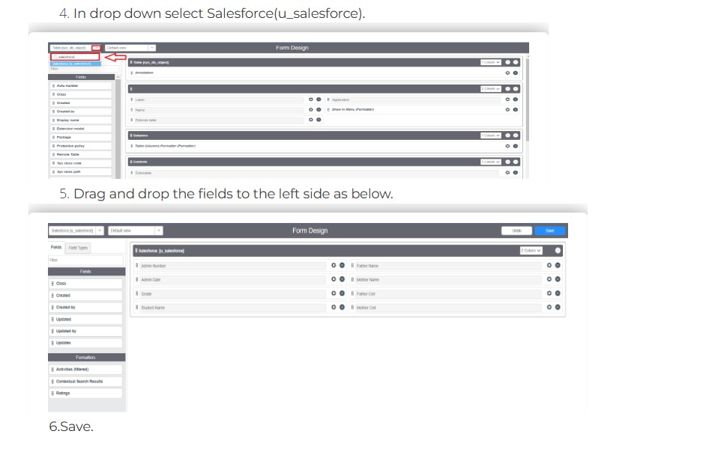

## Activity 2: Creating form for Admission table

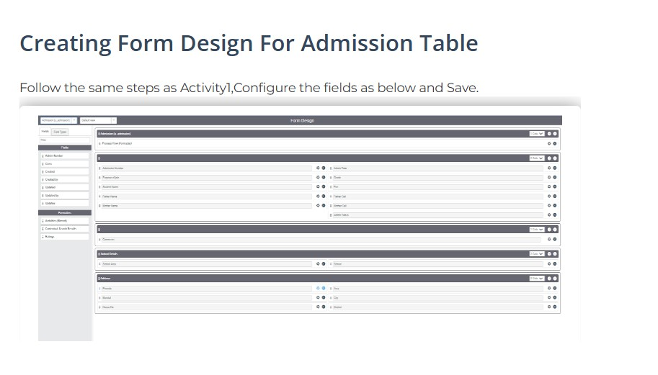

## Activity 3: Creating Design for student progress table

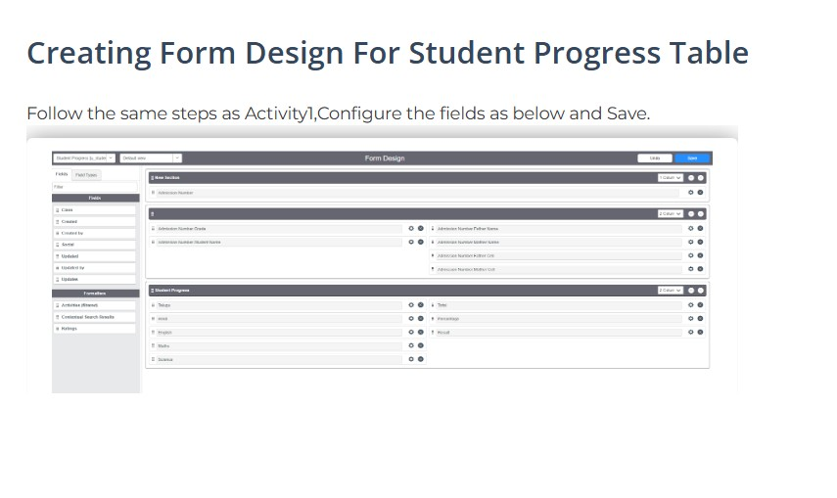

## Task 5: Number Maintainance

Activity 1: Creating number maintanance for admin number

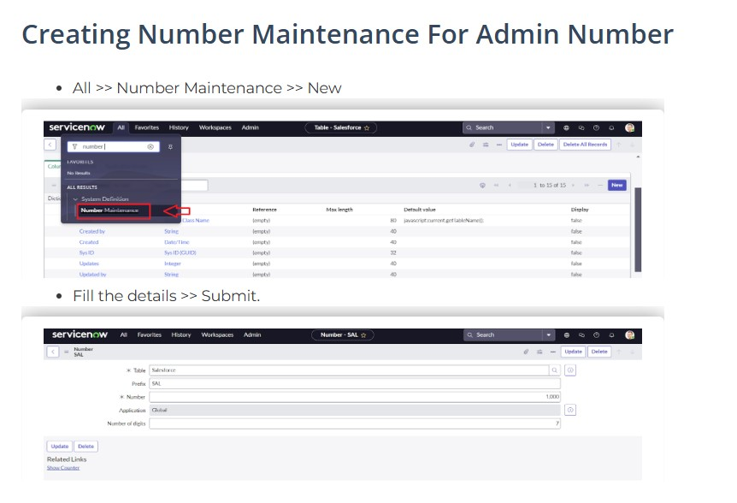

## Task 6: Process flow

Activity 1: Creating process flow for Admission table

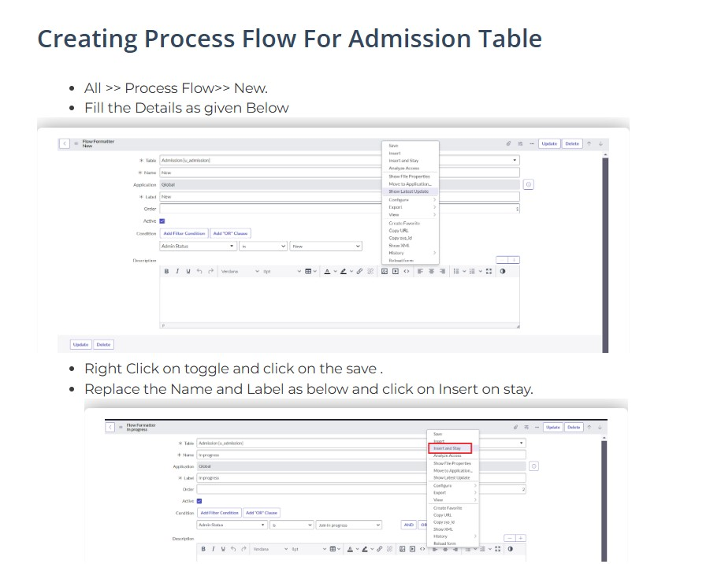

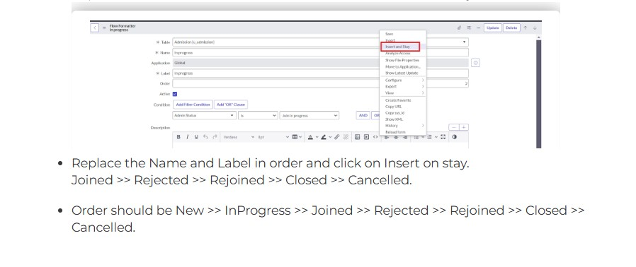

## Task 7: Client Script

### Activity 1: Creating “Auto populate: client script for admission table

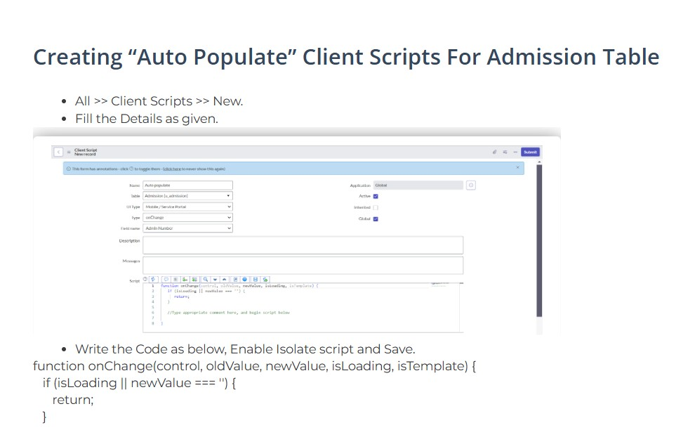

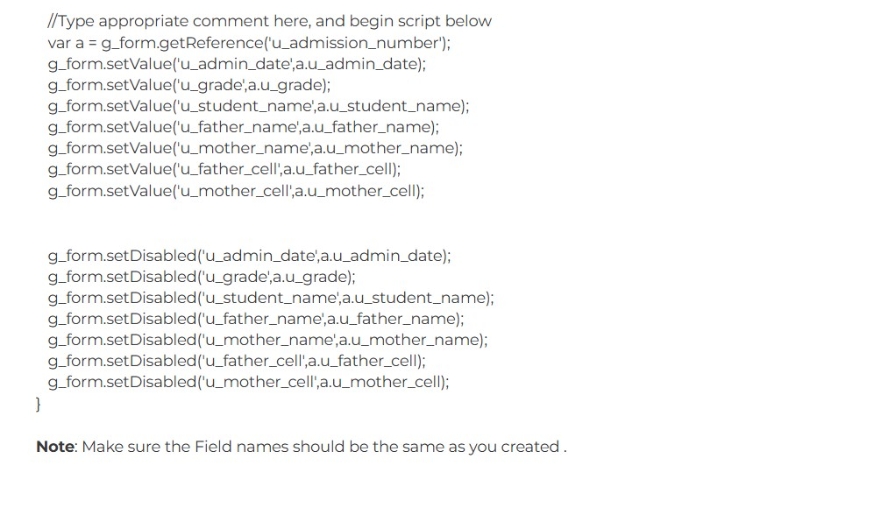

Activity 2: Creating “ Pincode update “ client script for admission table

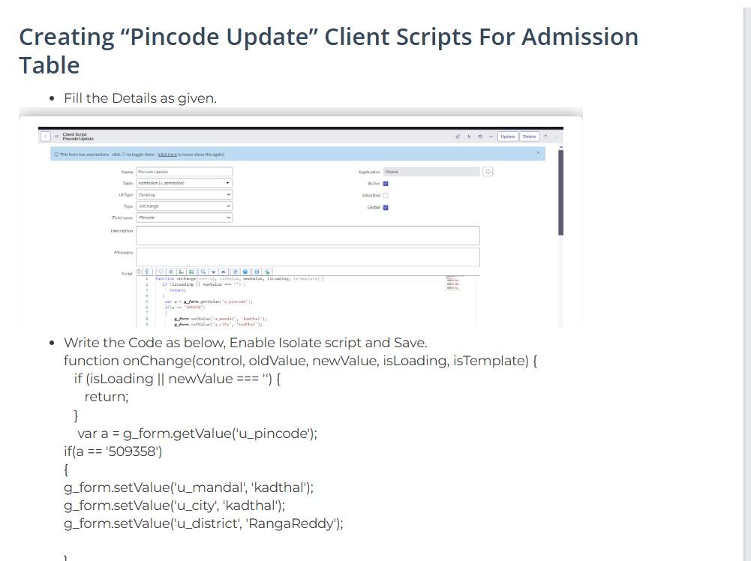

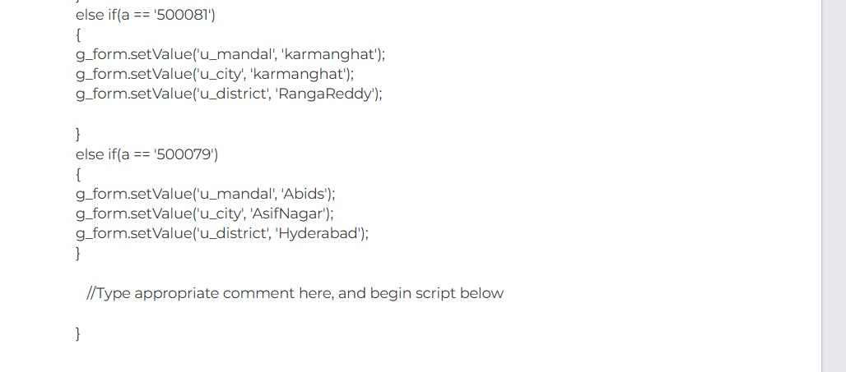

### Activity 3: Creating “ Disable Fields” client Scripts for progress table

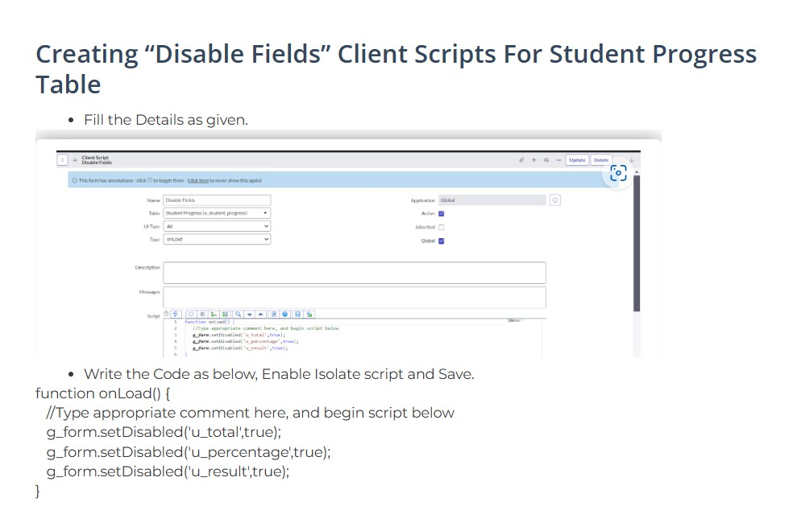

### Activity 4: creating “Total Update “ client scripts for student progress table

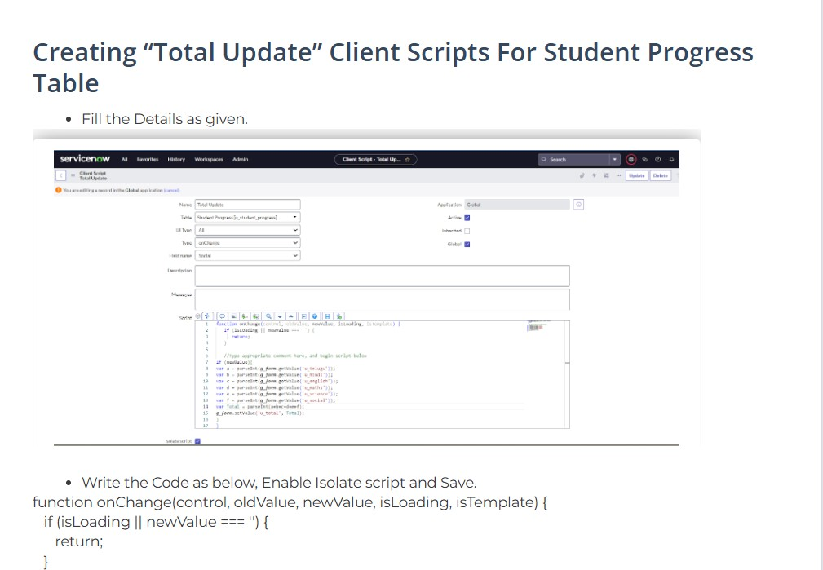

### Activity 5: creating “ Result “ client script for student progress table

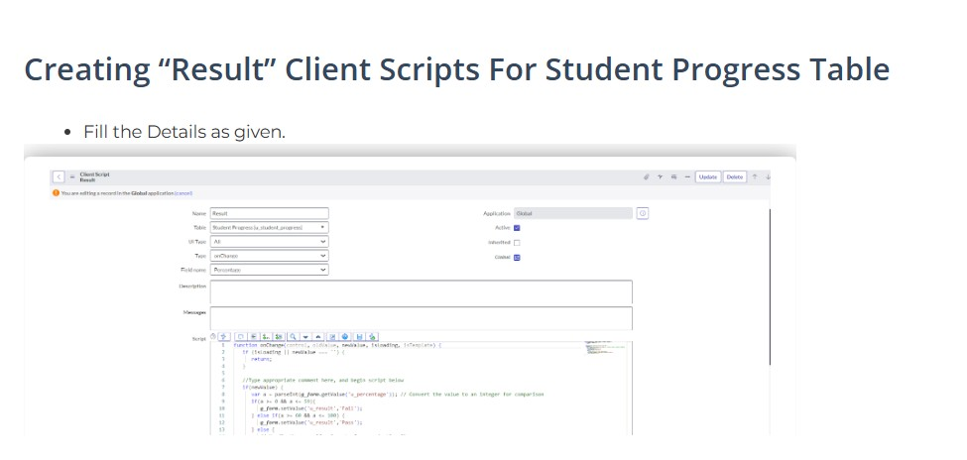

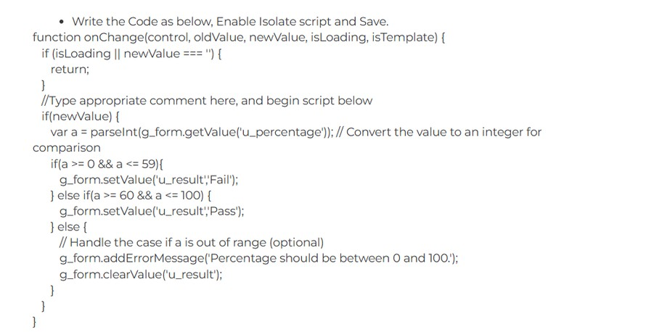

### Activity 6: creating “Percentage” client scripts for student progress table

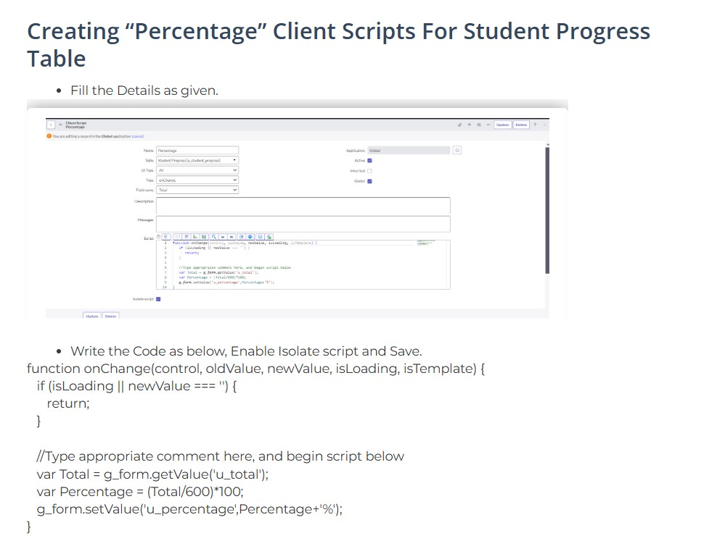

conclusion:

By implementing ServiceNow, educational organizations can streamline operations, enhance service delivery, and create a more efficient and connected campus experience for students, faculty, and staff.