**Data:**

This dataset contains information of users in a social network. This social network has several business clients which can post ads on it. One of the clients has a car company which has just launched a luxury SUV for a ridiculous price. Build a Bernoulli Naïve Bayes model using this dataset and classify which of the users of the social network are going to purchase this luxury SUV. 1 implies that there was a purchase and 0 implies there wasn’t a purchase.

**Data Dictionary:**

|  |  |  |  |
| --- | --- | --- | --- |
| **Name of Feature** | **Description** | **Type** | **Relevance** |
| User ID | User Id of a client | Quantity, Ratio | Irrelevant |
| Gender | Gender of a client | Quality, Nominal | Relevant |
| Age | Age of a client | Quality, Ratio | Relevant |
| Estimated Salary | Estimated Salary of a client | Quantity, Ratio | Relevant |
| Purchased | It shows that client purchase SVU or not. Purchased(1) and not purchased(0) | Quality, Binary | Relevant |

**Histogram of all variables:** 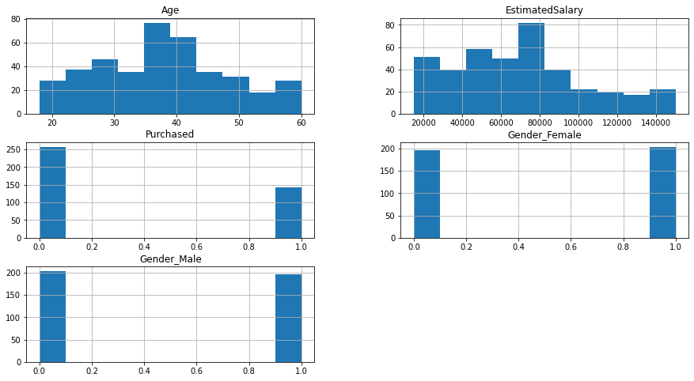

**Confusion Matrix:**

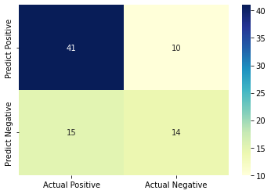

**Model Prediction:**

* 1 means purchase, and 0 means not purchase. Predictions are showing that more people are not interested in purchasing.
* As the accuracy is around 70%, maybe purchase will happen. As I had less data, and the price is ridiculous, it mostly depends on the mind-set of the people.