**Data**

The data is a mixture of both categorical and numerical data. It consists the number of customers who churn. Derive insights and get possible information on factors that may affect the churn decision.

|  |
| --- |
| **Data Dictionary** |

|  |  |  |  |
| --- | --- | --- | --- |
| **Name of Feature** | **Description** | **Type** | **Relevance** |
| Customer ID | Unique ID | Quantity, Nominal | Irrelevant |
| Count | No of Customers with a single ID | Quantity, Nominal | Relevant |
| Quarter | Which quarter the customer took account | Quality, Nominal | Relevant |
| Referred a Friend | Friends referred by customer | Quality, Nominal | Relevant |
| Number of Referrals | Number of referrals customer reffered. | Quantity, count | Relevant |
| Tenure in Months | Number of months the customer has stayed with the company | Quantity, count | Relevant |
| Offer | Which offer customer took | Quality, Nominal | Relevant |
| Phone Service | Whether the customer has a phone service or not (Yes, No) | Quality, Nominal | Relevant |
| Avg Monthly Long Distance Charges | Charges for long distance services in monthly average | Quantity, Interval | Relevant |
| Multiple Lines | Whether the customer has multiple lines or not (Yes, No, No phone service) | Quality, Nominal | Relevant |
| Internet Service | Internet service is taken or not | Quality, Nominal | Relevant |
| Internet Type | Customer’s internet service provider (DSL, Fiber optic, No) | Quality, Nominal | Relevant |
| Avg Monthly GB Download | How much data customer download in monthly average in GB | Quantity, Interval | Relevant |
| Online Security | Whether the customer has online security or not (Yes, No, No internet service) | Quality, Nominal | Relevant |
| Online Backup | Online back up is there or not | Quality, Nominal | Relevant |
| Device Protection Plan | Device protection plan is taken or not | Quality, Nominal | Relevant |
| Premium Tech Support | Premium Tech Support  is taken or not | Quality, Nominal | Relevant |
| Streaming TV | Streaming TV  is taken or not | Quality, Nominal | Relevant |
| Streaming Movies | Streaming Movies  is taken or not | Quality, Nominal | Relevant |
| Streaming Music | Streaming Music  is taken or not | Quality, Nominal | Relevant |
| Unlimited Data | Unlimited Data  is taken or not | Quality, Nominal | Relevant |
| Contract | What is a contract of customer | Quality, Nominal | Relevant |
| Paperless Billing | Paperless Billing  is taken or not | Quality, Nominal | Relevant |
| Payment Method | What is payment method of customer | Quality, Nominal | Relevant |
| Monthly Charge | Monthly charges of customer | Quantity, Interval | Relevant |
| Total Charges | Total charges of customer upto now. | Quantity, Ratio | Relevant |
| Total Refunds | Total Refunds  of customer upto now. | Quantity, Ratio | Relevant |
| Total Extra Data Charges | Total Extra Data Charges  of customer upto now. | Quantity, Ratio | Relevant |
| Total Long Distance Charges | Total Long Distance Charges  of customer upto now. | Quantity, Ratio | Relevant |
| Total Revenue | (Total charges+Total Long Distance charges) – Total Refunds | Quantity, Ratio | Relevant |

**Elbow Curve:**

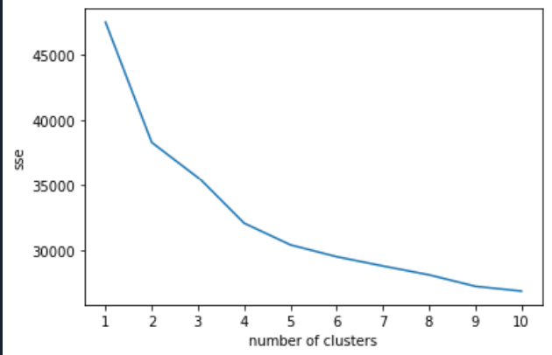

**Dendrogram:**

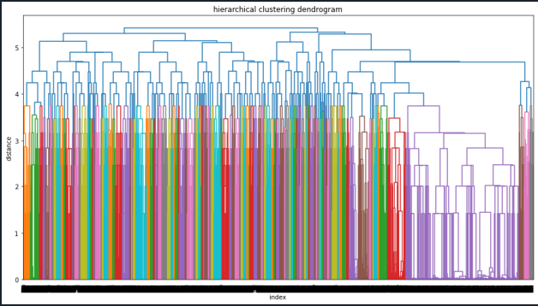

**Clusters:**

