**Data**

The data is a mixture of both categorical and numerical data. It consists the number of customers who churn (customers who left). Derive insights and get possible information on factors that may affect the churn decision. (We have to find what decisions made customers left)

|  |
| --- |
| **Data Dictionary** |

|  |  |  |  |
| --- | --- | --- | --- |
| **Name of Feature** | **Description** | **Type** | **Relevance** |
| Customer ID | Unique ID | Quantity, Nominal | Irrelevant |
| Count | No of Customers with a single ID | Quantity, Nominal | Relevant |
| Quarter | Which quarter the customer took account | Quality, Nominal | Relevant |
| Referred a Friend | Friends referred by customer | Quality, Nominal | Relevant |
| Number of Referrals | Number of referrals customer reffered. | Quantity, count | Relevant |
| Tenure in Months | Number of months the customer has stayed with the company | Quantity, count | Relevant |
| Offer | Which offer customer took | Quality, Nominal | Relevant |
| Phone Service | Whether the customer has a phone service or not (Yes, No) | Quality, Nominal | Relevant |
| Avg Monthly Long Distance Charges | Charges for long distance services in monthly average | Quantity, Interval | Relevant |
| Multiple Lines | Whether the customer has multiple lines or not (Yes, No, No phone service) | Quality, Nominal | Relevant |
| Internet Service | Internet service is taken or not | Quality, Nominal | Relevant |
| Internet Type | Customer’s internet service provider (DSL, Fiber optic, No) | Quality, Nominal | Relevant |
| Avg Monthly GB Download | How much data customer download in monthly average in GB | Quantity, Interval | Relevant |
| Online Security | Whether the customer has online security or not (Yes, No, No internet service) | Quality, Nominal | Relevant |
| Online Backup | Online back up is there or not | Quality, Nominal | Relevant |
| Device Protection Plan | Device protection plan is taken or not | Quality, Nominal | Relevant |
| Premium Tech Support | Premium Tech Support  is taken or not | Quality, Nominal | Relevant |
| Streaming TV | Streaming TV  is taken or not | Quality, Nominal | Relevant |
| Streaming Movies | Streaming Movies  is taken or not | Quality, Nominal | Relevant |
| Streaming Music | Streaming Music  is taken or not | Quality, Nominal | Relevant |
| Unlimited Data | Unlimited Data  is taken or not | Quality, Nominal | Relevant |
| Contract | What is a contract of customer | Quality, Nominal | Relevant |
| Paperless Billing | Paperless Billing  is taken or not | Quality, Nominal | Relevant |
| Payment Method | What is payment method of customer | Quality, Nominal | Relevant |
| Monthly Charge | Monthly charges of customer | Quantity, Interval | Relevant |
| Total Charges | Total charges of customer upto now. | Quantity, Ratio | Relevant |
| Total Refunds | Total Refunds  of customer upto now. | Quantity, Ratio | Relevant |
| Total Extra Data Charges | Total Extra Data Charges  of customer upto now. | Quantity, Ratio | Relevant |
| Total Long Distance Charges | Total Long Distance Charges  of customer upto now. | Quantity, Ratio | Relevant |
| Total Revenue | (Total charges+Total Long Distance charges) – Total Refunds | Quantity, Ratio | Relevant |

**Elbow Curve:**

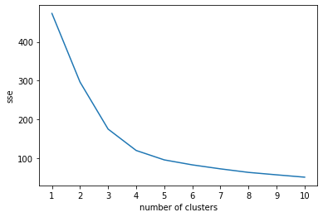

**Dendrogram:**

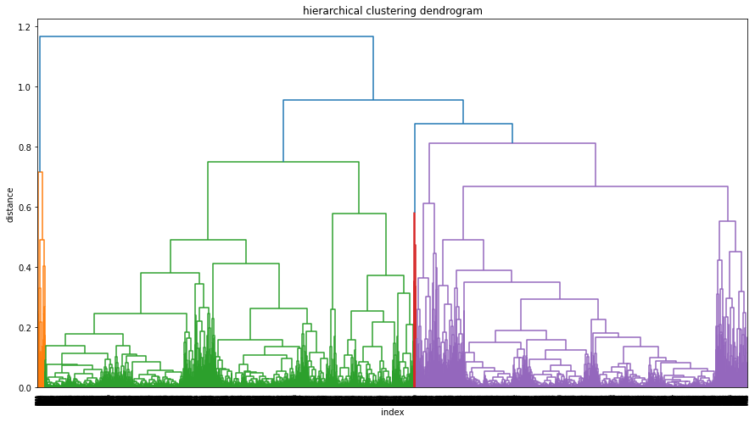

**Clusters:**



**Analysis on Data:**

* Cluster 0 and 2 customers stayed for long period and used more services and their total revenue is also high.
* Cluster 1 and 3 customers stayed for short period and used less services and their total revenue is also less.
* Maybe service costs are high, so that people having less revenue cannot able to offer and quitting soon. So if service costs become less then, people may stay for long period.