**Data**

The Entertainment Company, which is a startup online movie watching platform, wants to improvise its collection of movies and showcase those that are highly rated, and recommend those movies to its customer by their movie watching footprints. For this the company has collected its data and shared it with you to provide some analytical insights and also to come up with a Recommendation Algorithm so that it can automate its process for effective recommendations based on Users Interest and behavior patterns.

Remember the ratings are between -9 to +9.

|  |
| --- |
| **Data Dictionary** |

|  |  |  |  |
| --- | --- | --- | --- |
| **Name of Feature** | **Description** | **Type** | **Relevance** |
| Id | Unique ID | Quantity, Normal | Relevant |
| Titles | Movie titles | Quality, Nominal | Relevant |
| Category | Category of movies | Qualityy, Nominal | Relevant |
| Reviews | Ratings of movies | Quality, Nominal | Relevant |

**Boxplot for reviews:**

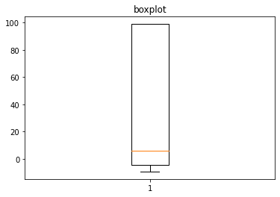

**Scatter plot for reviews and category:**

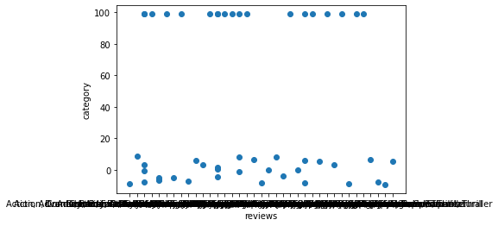

**Histogram for reviews:**

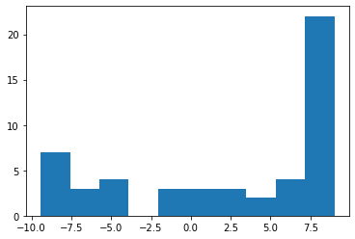

**Scatter plot for reviews and category:**

