**FINAL PROJECT**

**APPLICATION ENGINEERING DEVELOPMENT**

**Project Title : iCare – Smart healthcare Platform**

**Submitted by : Yamini Sehrawat**

**Course : INFO 5100**

**Professor : Dr. Kal Bugrara**

**Head TA : Spandan Brahmbhatt**

**Submitted on : 12/10/2015**

**Problem Statement**

1. Medical resources are most important element of the heathy society. It is immensely important to efficiently utilize these medical resources. If we have the way to monitor patient’s vital stats 24X7 then we can also proactively inform them when to visit their doctor. This helps in saving doctors and hospitals critical time which can used for emergencies.
2. Medication Reviews: Information about medication safety is of major concern. Patients are taking medicines without complete information about the risks involved. If we have the mechanism where drug response from the patients is directly fed to pharmaceuticals companies and their primary doctors, there response time in improving the drug is increased by many folds. This feedback loop will be helpful for Health Official Authority (FDA) to monitor drugs present in the market.
3. Maintaining centralized medical history for every patient is another challenge for health care industry. If this problem is solved then doctors can view this record save time in collecting medical history. This will also come handy during medical emergency for the patient.

**SCOPE OF PROJECT**

The application covers wide range of scenarios and work for different types of enterprises in a network, such as Pharmaceutical companies, Hospitals, Pharmacies and specifically the patients.

The application implements IOT feature to smartly track patient’s vital stats and health conditions to save time and cost effectively.

The application also shows the interaction of different entities with each other, so distinct yet able to interact under the same platform. The interaction of pharmaceutical company with patient, with hospitals, with pharmacies etc.

These entities not only interact under a single network but also interact within different networks making the application available over a national level, so that most extreme tasks can be accomplished on the click of a button.

**Ways Application coping with the above issues**

1. The application is based on sensors which are used to track vital signs for enrolled patients and proactively provide medical services. The system smartly tracks the patient’s health and indicate them when to visit doctors in case of any health concern. This will enable the patients to discuss their health issues with their doctors on time.

**Assumption**: Every individual in a community is enrolled in the healthcare services and regularly track their vital stats and health conditions, and act actively to inform their doctors about the health conditions based on the result of vital stats.

1. The application provides a provision to maintain a centralized patient medical record. A hospital can create a record of the patient if the patient is visiting hospital for the first time and then a universal record of the patient would be created and every time a patient visits the same hospital or some other hospital, the hospital can take out patient information and then can add the medical information of the patient which he/she would be treated for. This way the hospital can see the entire patient record and the diseases the patient has been treated for in their or in some other hospital. Even in the times of emergency the doctor will have patient record to take into account the problems before attempting any procedure on patient.

**Assumption**: The assumption we have to make in this case is that the patient uses a global Id and the data for every patient is saved at a centralized place from where the healthcare provider can access each and every information about the patient.

1. Application include the functionality where the patient has the capability to send the drug feedback to the pharmaceutical companies. Here, Doctors can also send the feedback of the drugs taken from the patients to the pharma companies. The feedback from the patient or doctor will also be reflected in the FDA panel and in case the pharmaceutical company does not take any action the FDA can forcefully call back the product from the market.
2. The application provide the information about the approval and disapproval of the drug directly to the pharmacy companies.

**Assumption**: FDA is checking each and every drug that has been produced by the pharma companies anywhere around the globe and should be allowed to approve or disapprove it.

**Object Model**

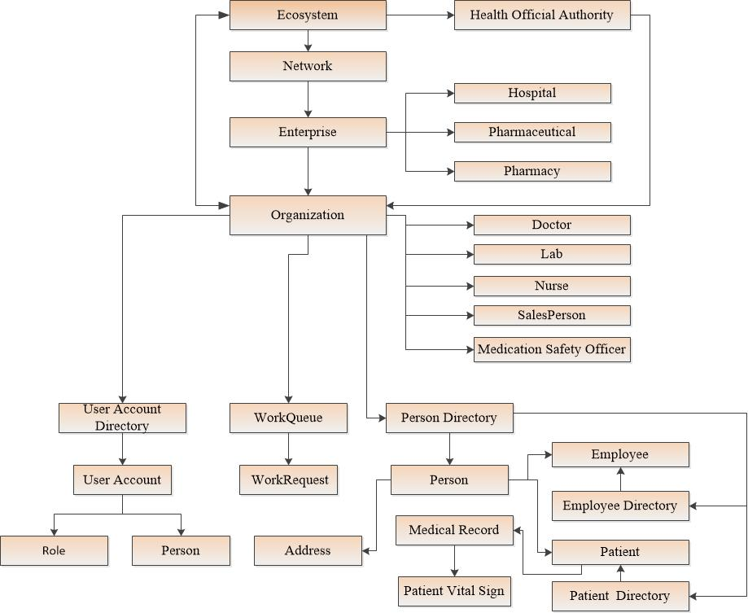

**Ecosystem** – The ecosystem is considered as the top level in the entire system. It includes multiple networks.

**Network** – The network here means the scope of the project, what all areas the project cover, the project can be made on a global level, national level or intercity level using this network.

This network consist of enterprises.

**Enterprise**: - A network can have multiple enterprises and these enterprises represent the companies or the organization which will use the application to interact with each other on a regional, national or global level.

This model represent three types of enterprises:

1. Pharmaceutical companies,
2. Pharmacies,
3. Hospitals.

Each and every enterprise in the system has a different role to play.

**Organization**: - Enterprises consist of different organization, these organization represents the entities which are present in the enterprises.

These organization represent different types of departments in the enterprise:

In Hospital Enterprise, there are following organizations:

1. Doctor Organization,
2. Lab Organization
3. Nurse Organization

In Pharmaceutical Enterprise, there is Medicine Safety officer,

In Pharmacy Enterprise, there is Sales Manager.

**User Account** – It describes the user login provided to every member of the enterprise in the ecosystem.

**Patient**: - This is the most important component of the organization on which the entire enterprise depends, it is the patient for whom the entire ecosystem revolves and make communication.

**Work Request**: This is the way of communication for all the enterprises with each other. With the help of this work request they can share information.

**Medical History:** It represents the medical checkup done for every patient by the hospitals. Every person who is enrolled in healthcare services or visited the hospital in terms of any problems with his health is a patient. The medical record will add up to form a medical history for the patient which is very necessary to keep the patient health in terms of any discomfort as with the help of these record a doctor can address the patient and proceed with further treatment.