**Absences:**

1. **Absences By Total Count:**

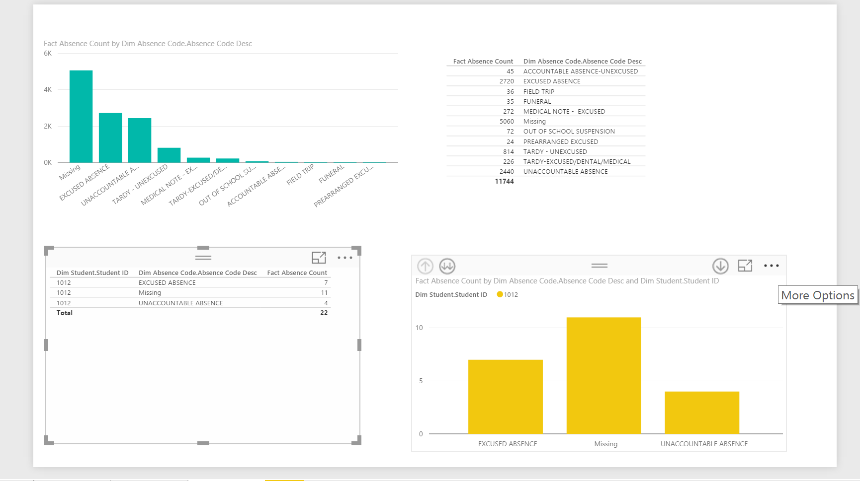

1. **Absences by Particular date:**

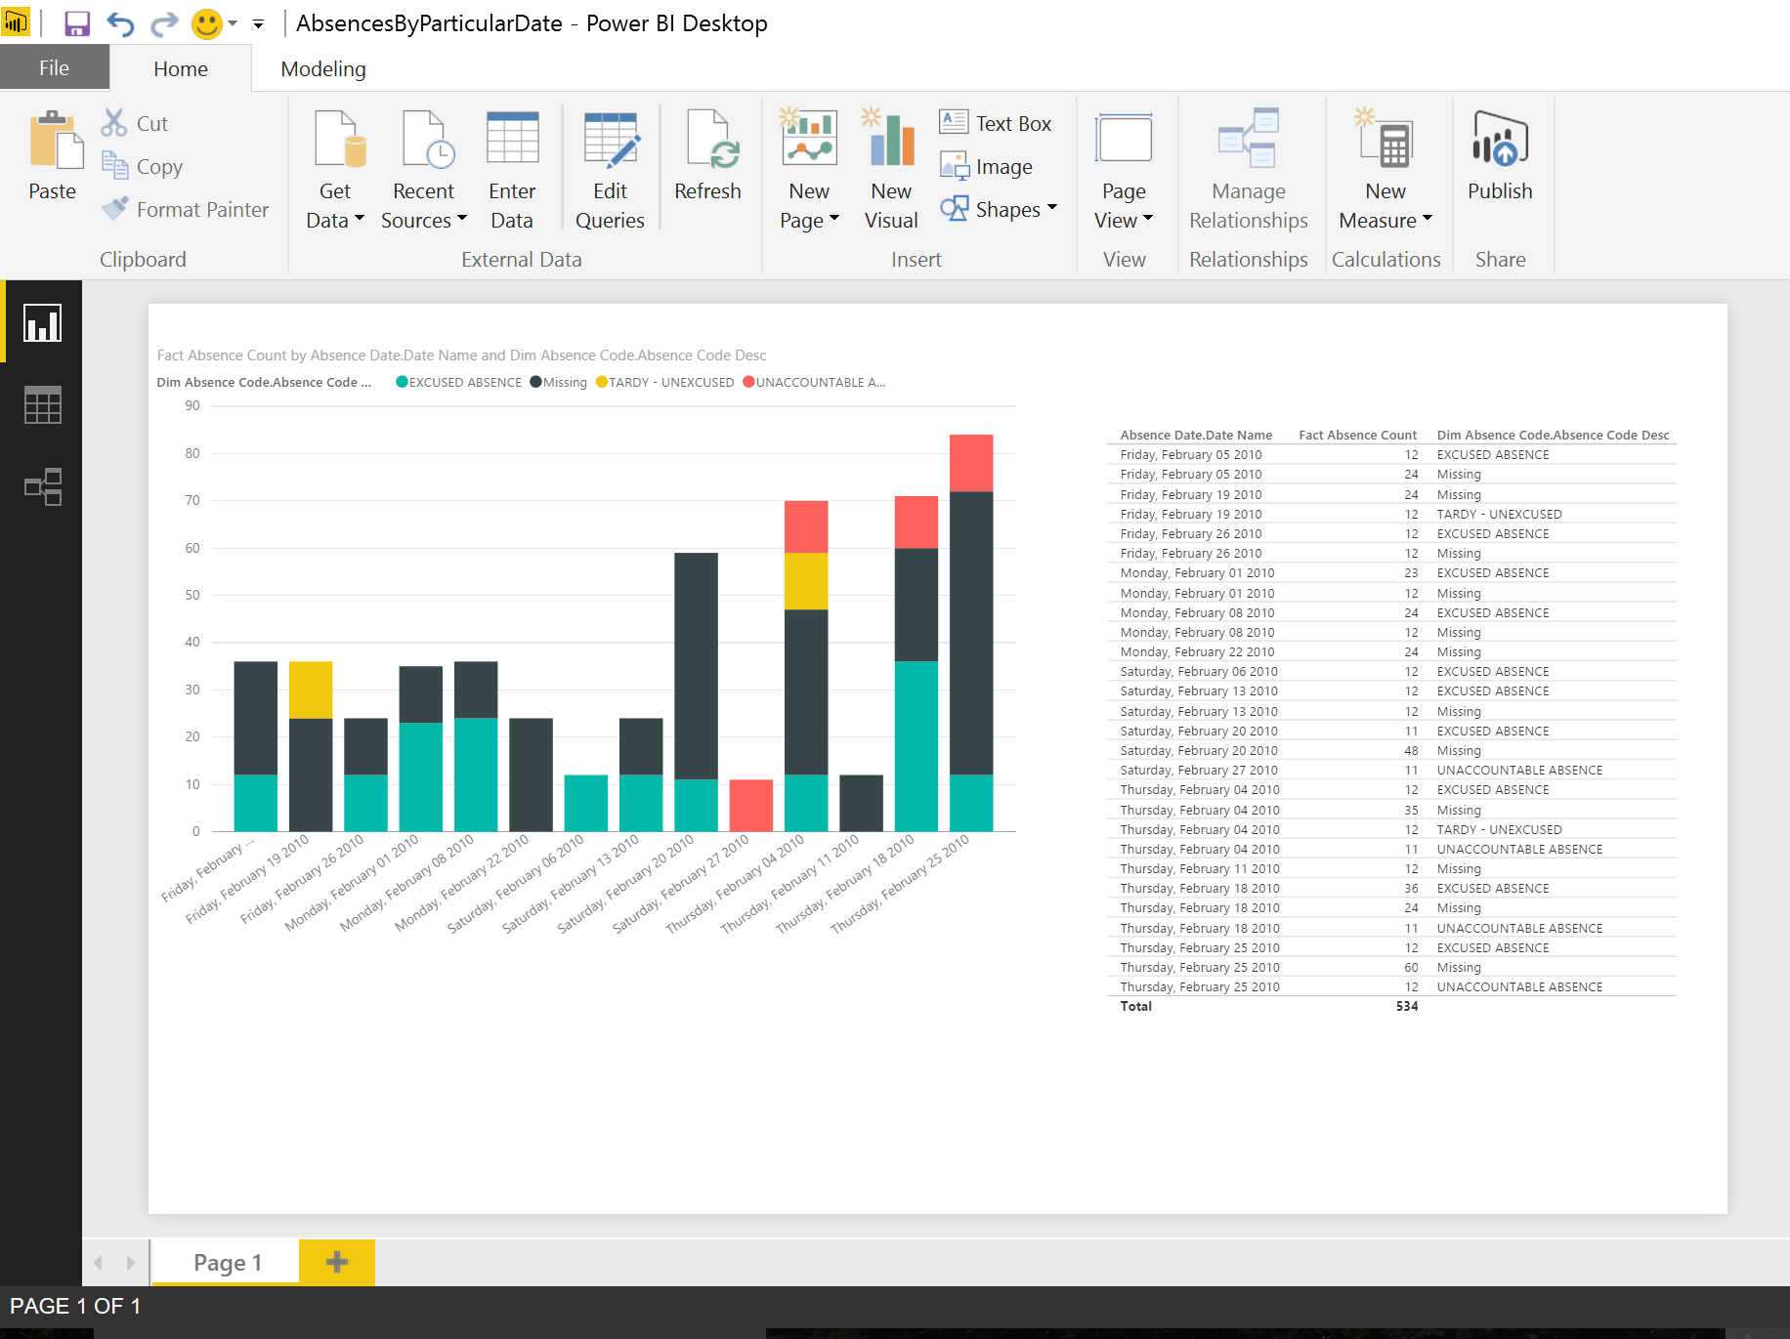

1. **Absences By Facility:**

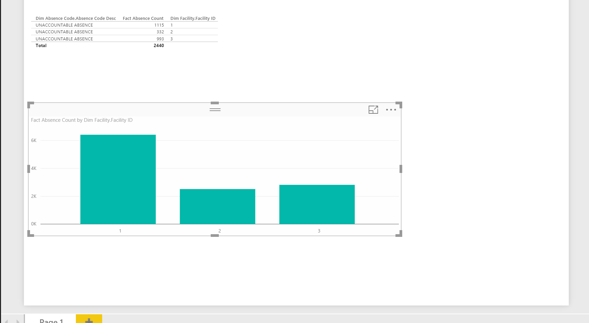

**Discipline Behavior:**

1. **Discipline behavior Overall count and discipline actions and events on a particular date:**

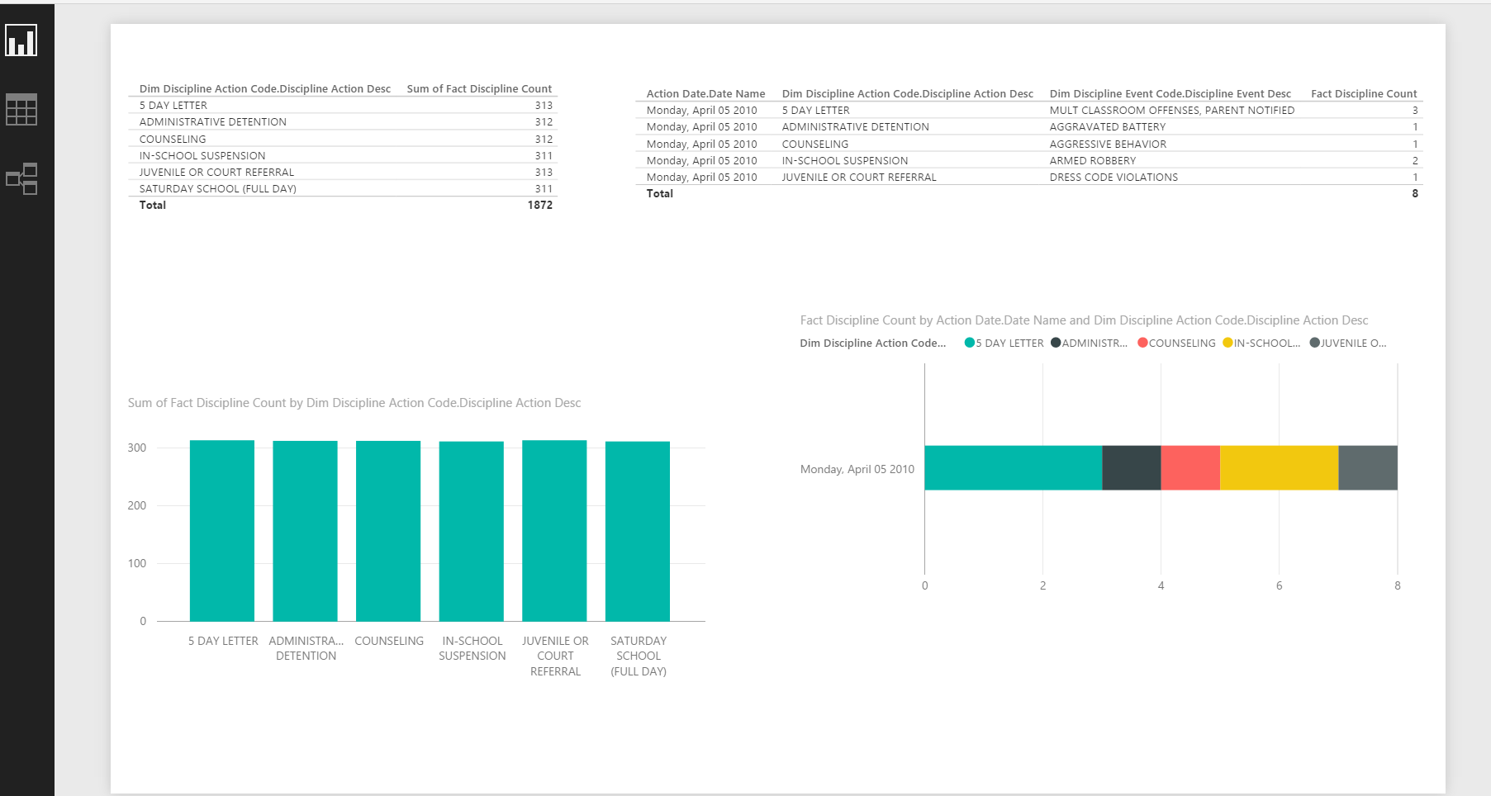

1. **Discipline By Action and month:**

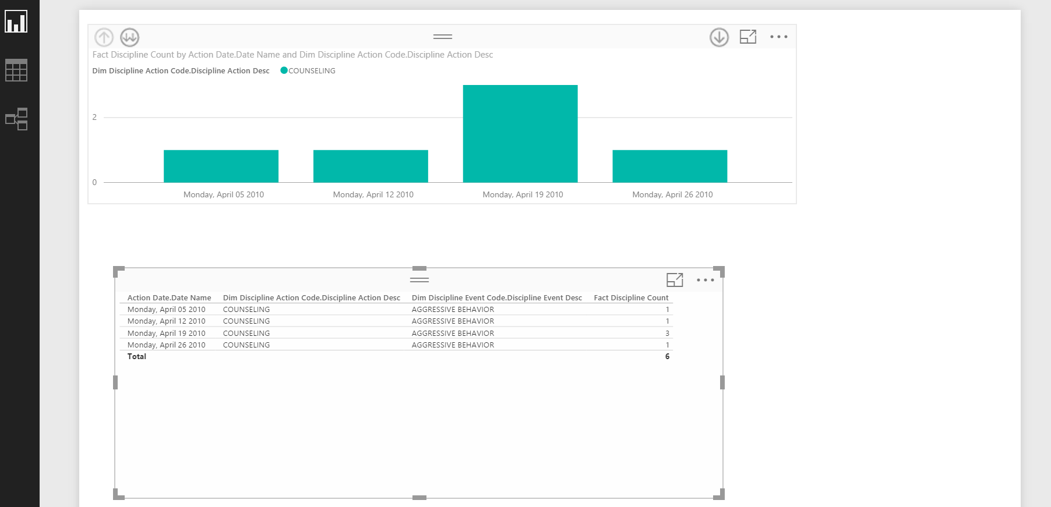

**Action and Events:**

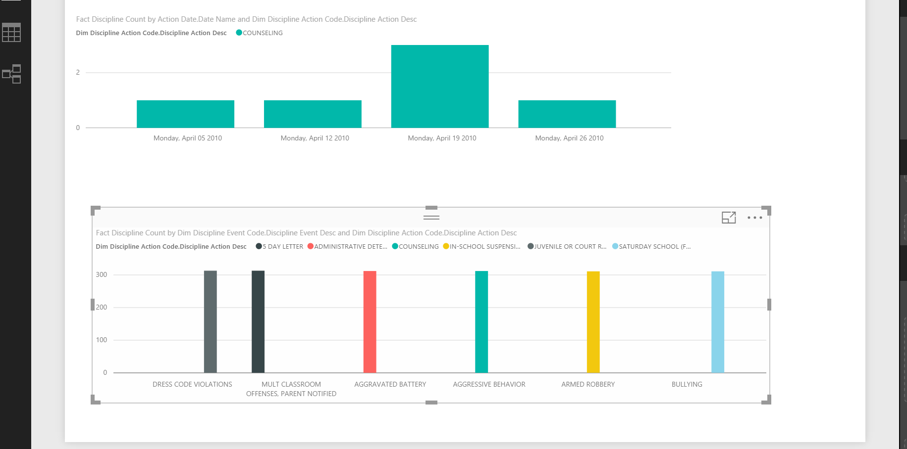

**Academic behavior:**

1. **By Students and Performance Level:**

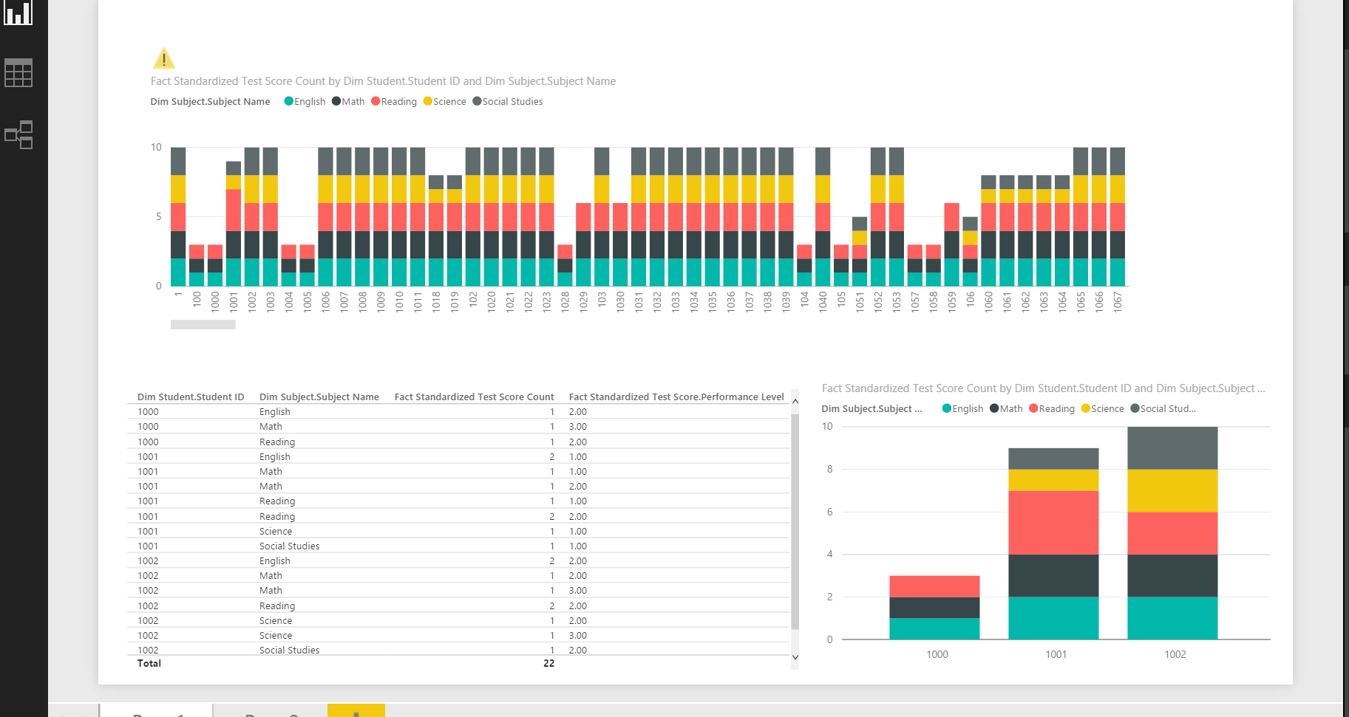

1. **Times tested:**

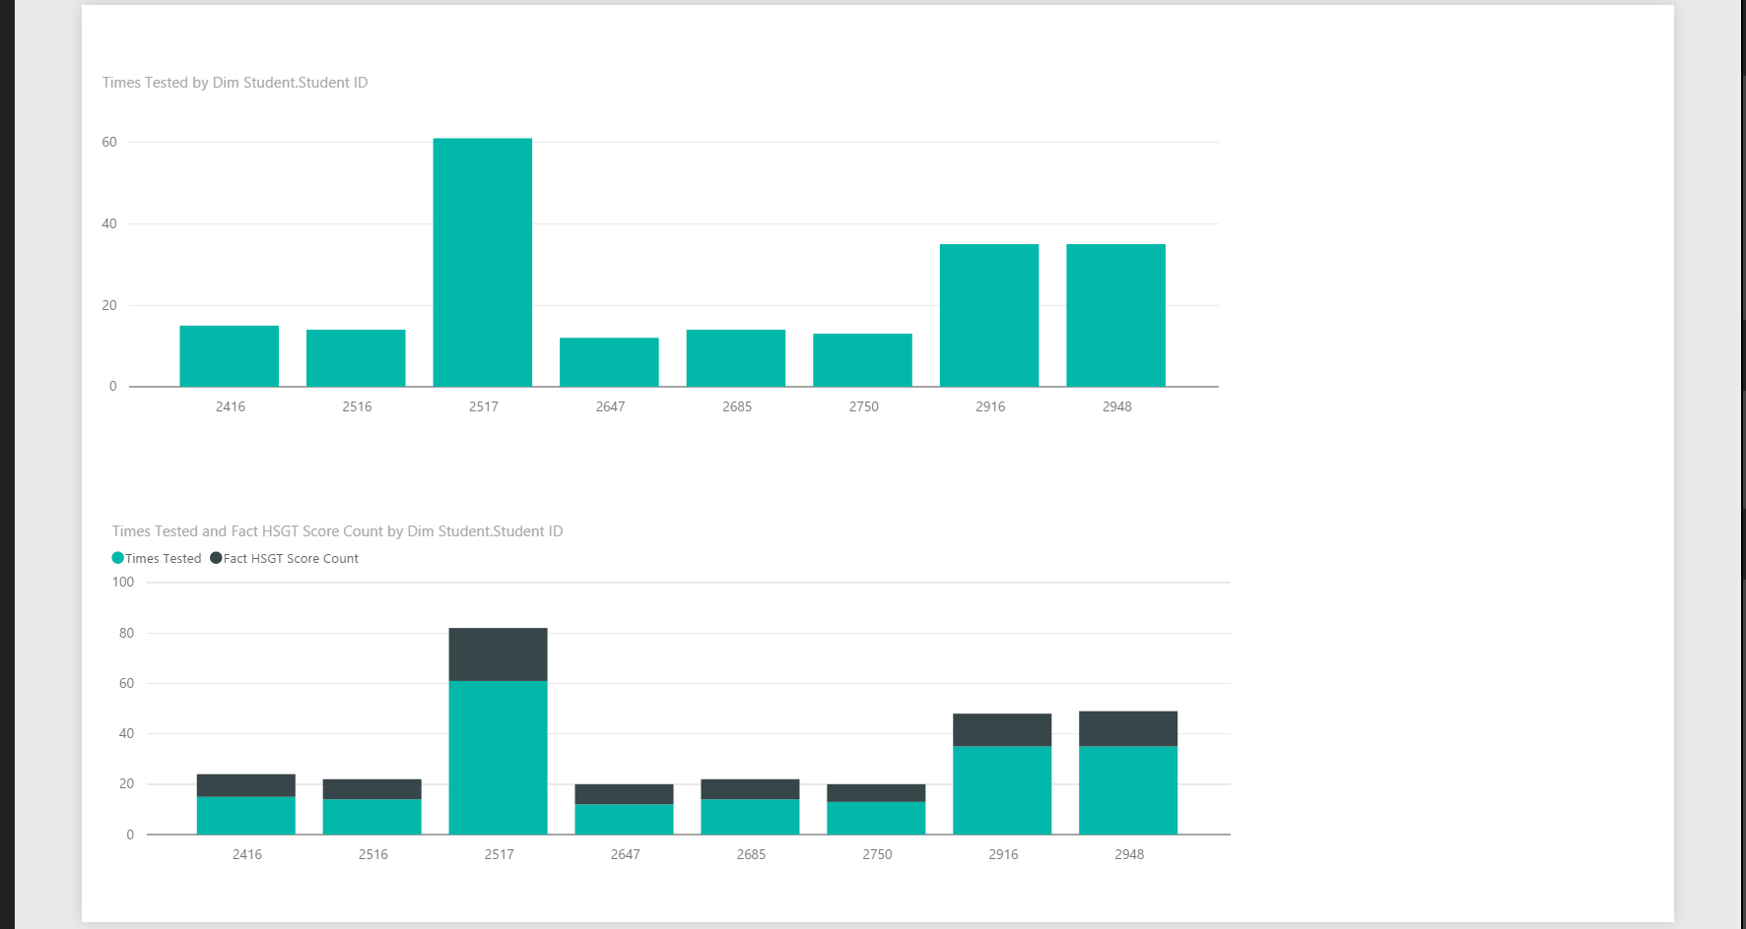

**Special Programs: overall count and enrollments**

