**FINAL PROJECT**

**WEB DESIGN AND USER EXPERIENCE**

**Project Title : Public Library**

**Submitted by : Yamini Sehrawat**

**Course : INFO 6150**

**Professor : Yusuf Ozbek**

**Submitted on : 12/18/2015**

**PROJECT DESCRIPTION**

The project shows the web layout used for the most common **Public Libraries** websites. It also extends public library websites design by incorporating latest technologies as taught in web design course work. This includes **Responsive Web Design**. The web page design auto fits the screen size user selects. This gives the control in the hand of the user and increases the time user can spend on the website. There is also an **Auto suggest feature**. This feature is very useful for the user to help them find the stuff they are looking for in the webpage.

**Technology Used:**

1. **HTML**
2. **CSS**
3. **JavaScript**
4. **JQuery**
5. **Bootstrap**
6. **Ajax**

**This is the home page of the application.**

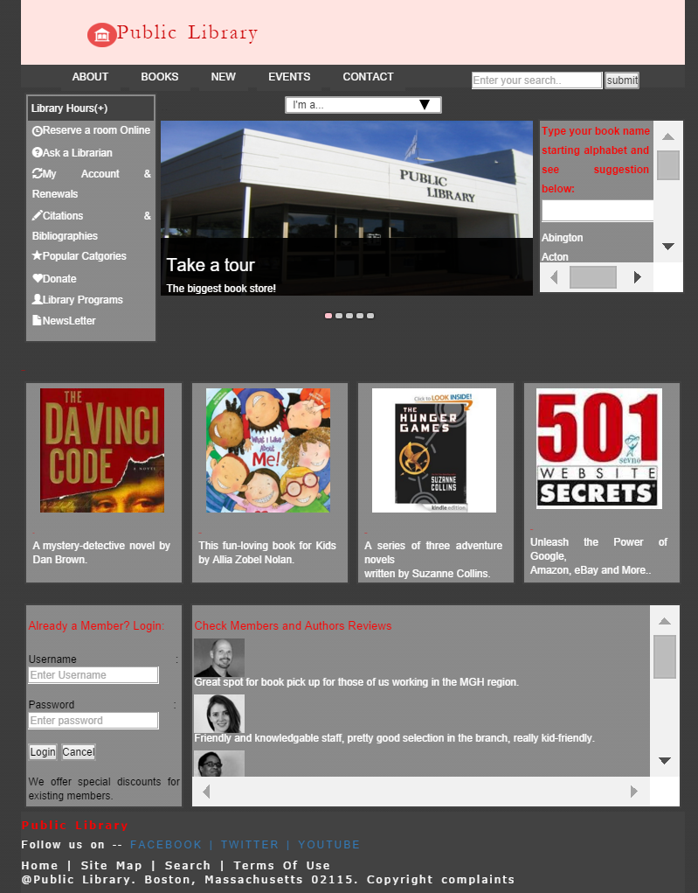

The user can login here. If the login is successful, an alert is thrown to confirm successful login otherwise

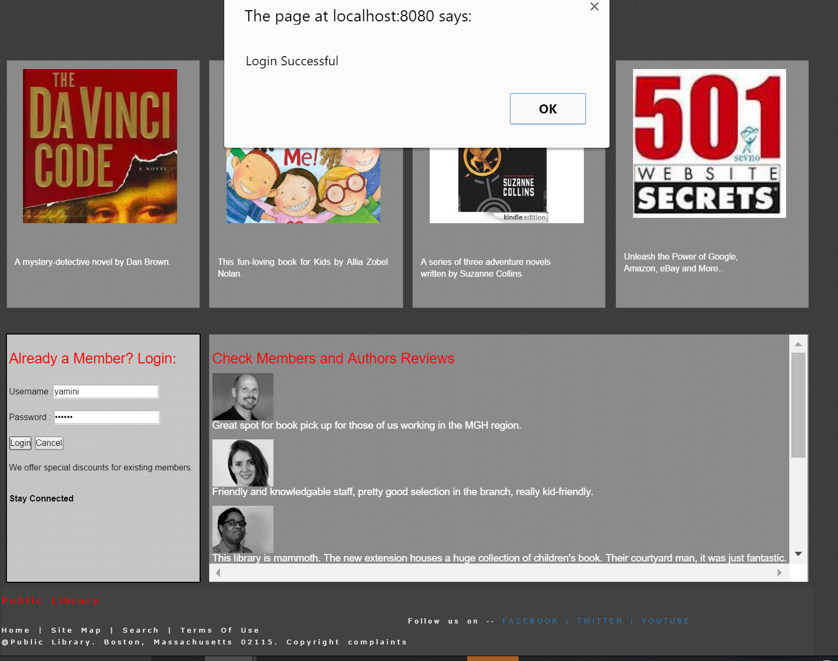

When username/password is wrong, Alert will show error as in the below screenshot.

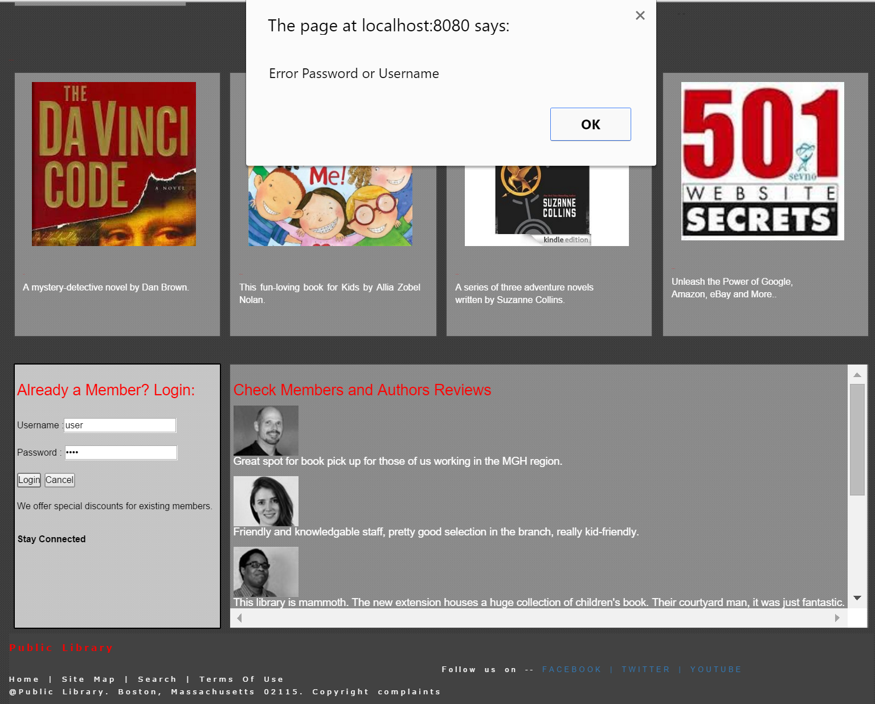

This is the page where users can send their feedback and contact the library facility. It has validation for the email check.



This is the page where users can send their feedback and contact the library facility. It has validation for the email check.

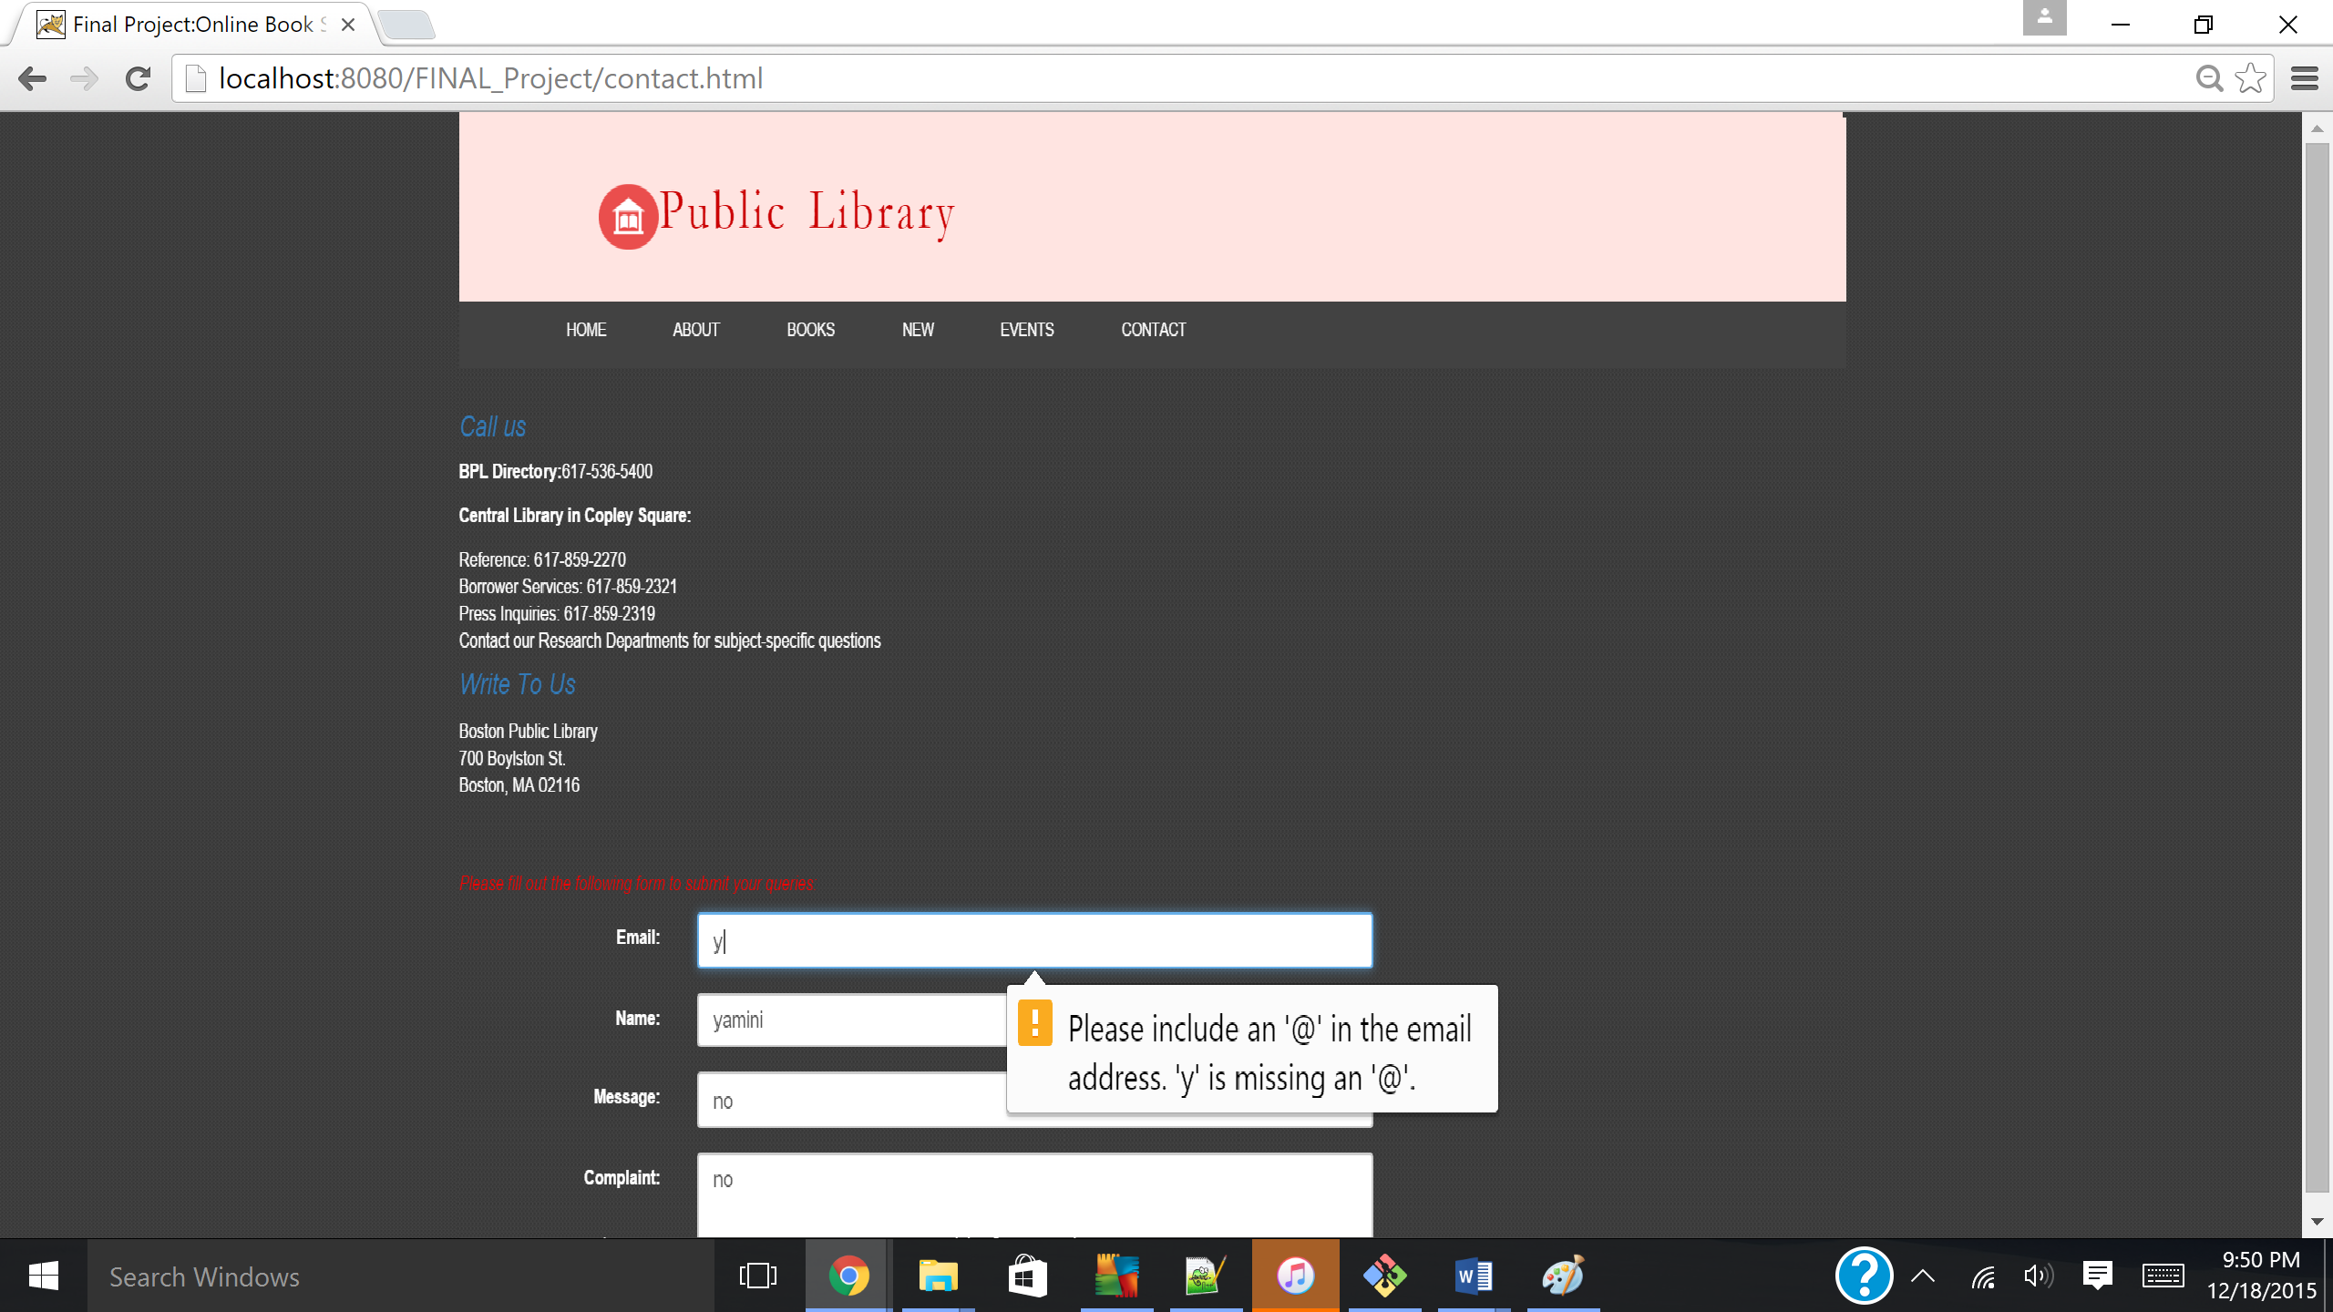

Popup message.

This page shows navigation for side menu bar from the home page.

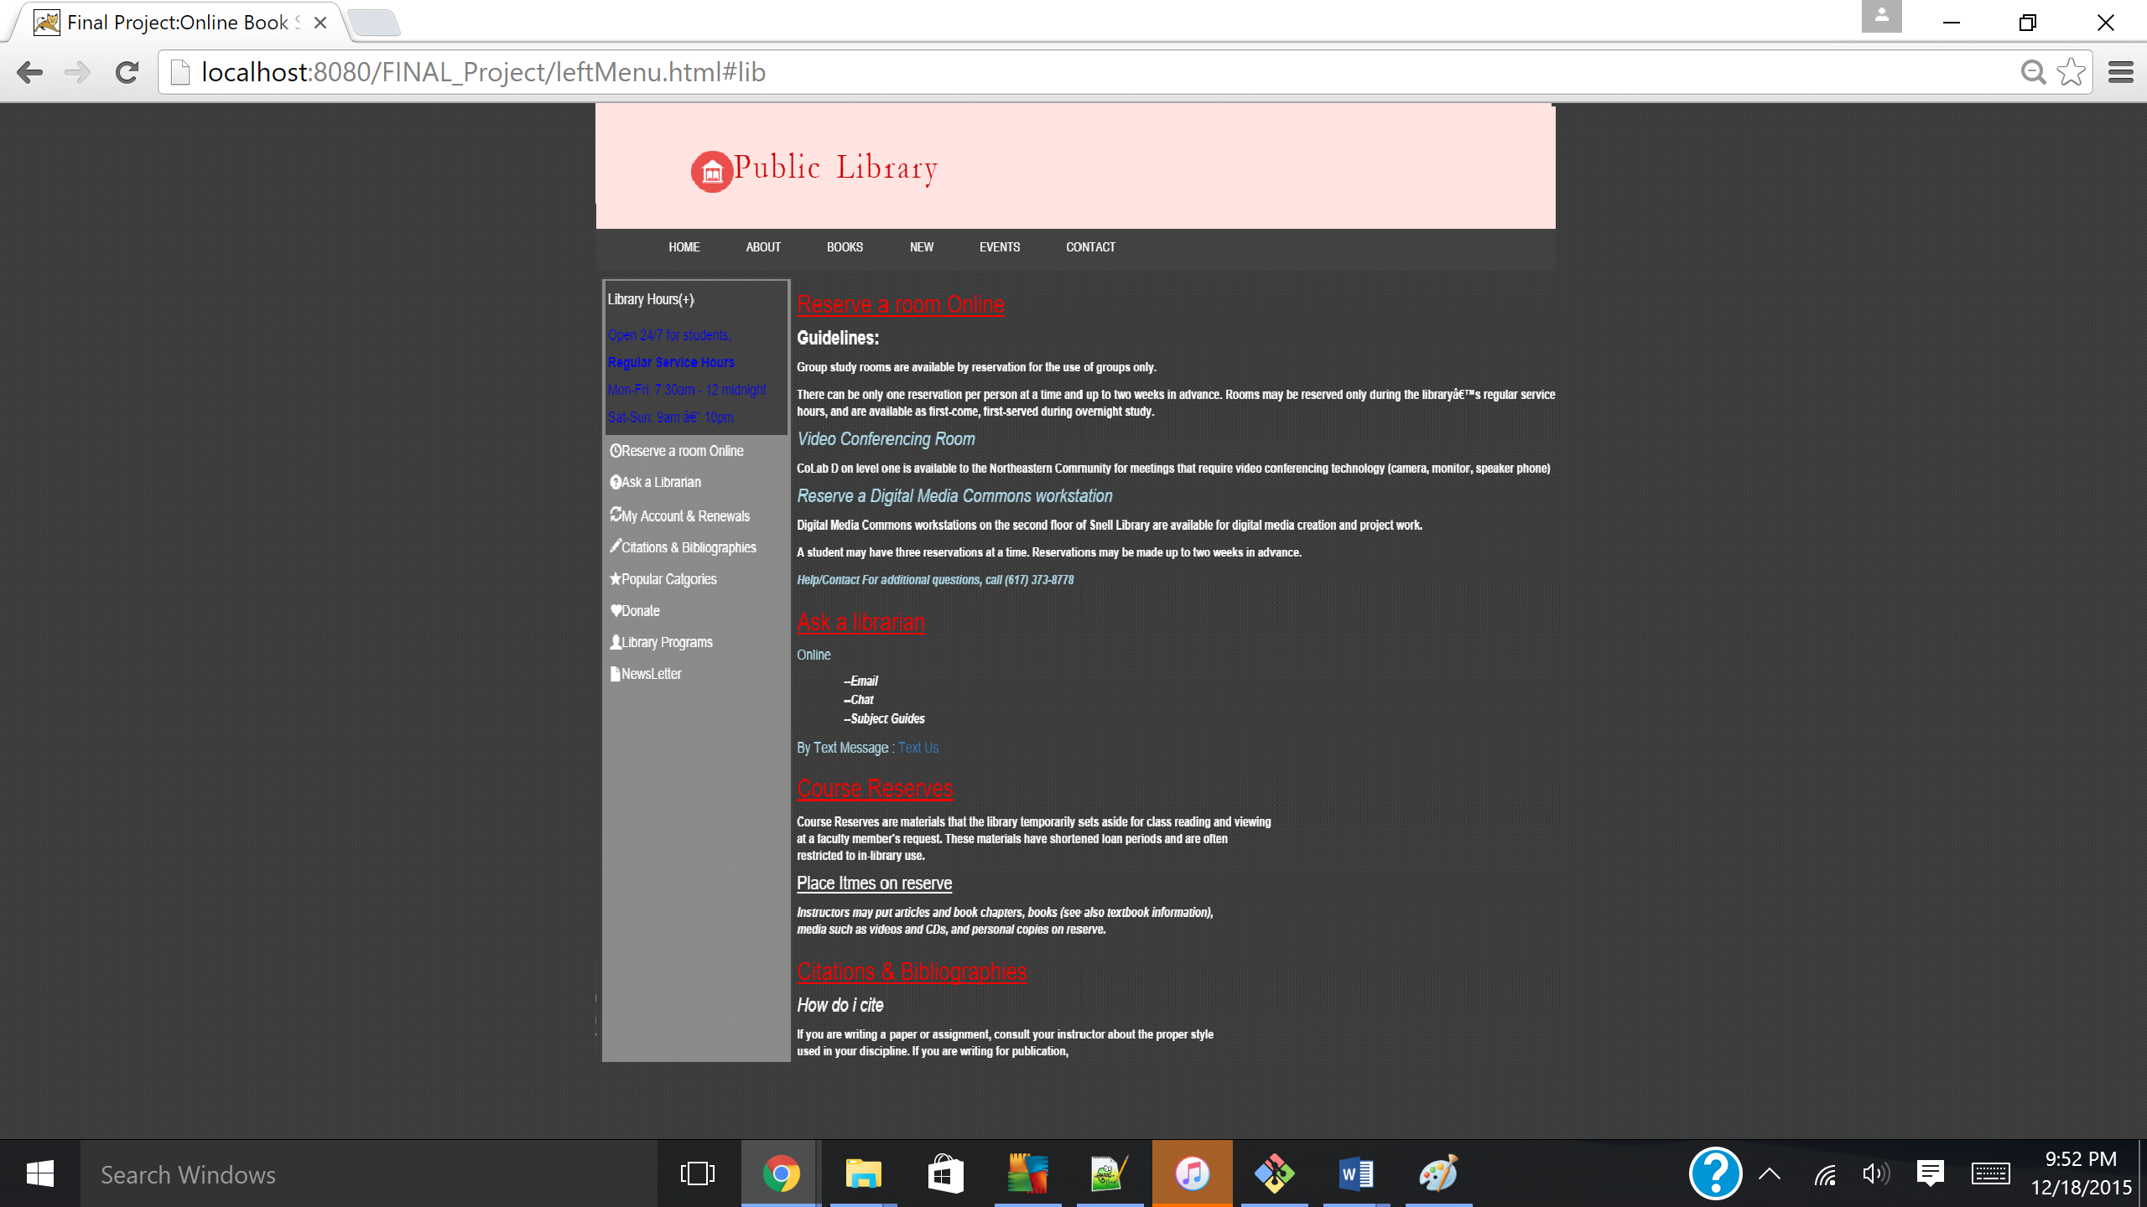

**Source Code Files:**

1. **Project.html (Main file)**

**<!DOCTYPE html>**

**<html>**

**<head>**

**<title>Final Project:Online Book Store</title>**

**<link rel="stylesheet" type="text/css" href="projectStyle.css">**

**<link rel="stylesheet" type="text/css" href="queries.css">**

**<meta name="viewpoint" content="width=device-width,initial-scale=1">**

**<!-- Latest compiled and minified CSS -->**

**<link rel="stylesheet" href="http://maxcdn.bootstrapcdn.com/bootstrap/3.3.5/css/bootstrap.min.css">**

**<!-- jQuery library -->**

**<script src="https://ajax.googleapis.com/ajax/libs/jquery/1.11.3/jquery.min.js"></script>**

**<!-- Latest compiled JavaScript -->**

**<script src="http://maxcdn.bootstrapcdn.com/bootstrap/3.3.5/js/bootstrap.min.js"></script>**

**<script>**

**$(document).ready(function(){**

**$("#flip").click(function(){**

**$("#panel").slideToggle("slow");**

**});**

**$('input[type="text"]').focus(function() {**

**$(this).addClass("focus");**

**});**

**$('input[type="text"]').blur(function() {**

**$(this).removeClass("focus");**

**});**

**});**

**</script>**

**<script type="text/javascript">**

**var dimages=new Array();**

**var numImages=5;**

**for (i=0; i<numImages; i++)**

**{**

**dimages[i]=new Image();**

**dimages[i].src="image"+(i+1)+".png";**

**}**

**var curImage=-1;**

**function swapPicture()**

**{**

**if (document.images)**

**{**

**var nextImage=curImage+1;**

**if (nextImage>=numImages)**

**nextImage=0;**

**if (dimages[nextImage] && dimages[nextImage].complete)**

**{**

**var target=0;**

**if (document.images.img)**

**target=document.images.img;**

**if (document.all && document.getElementById("img"))**

**target=document.getElementById("img");**

**if (target)**

**{**

**target.src=dimages[nextImage].src;**

**curImage=nextImage;**

**}**

**setTimeout("swapPicture()", 2000);**

**}**

**else**

**{**

**setTimeout("swapPicture()", 200);**

**}**

**}**

**}**

**setTimeout("swapPicture()", 2000);**

**function ajaxFunction(bookName)**

**{**

**//1. Create XmlHttpRequest Object**

**//This could be written into an external .js file that could be used within other pages as well.**

**var xmlHttp;**

**try // Firefox, Opera 8.0+, Safari**

**{**

**xmlHttp=new XMLHttpRequest();**

**}**

**catch (e)**

**{**

**try // Internet Explorer**

**{**

**xmlHttp=new ActiveXObject("Msxml2.XMLHTTP");**

**}**

**catch (e)**

**{**

**try**

**{**

**xmlHttp=new ActiveXObject("Microsoft.XMLHTTP");**

**}**

**catch (e)**

**{**

**alert("Your browser does not support AJAX!");**

**return false;**

**}**

**}**

**}**

**//2. Call the server-side script**

**//bookName is the function parameter passed when the JS function is called**

**xmlHttp.open("GET", "books.jsp?q=" + bookName, true); //q is the name of the parameter to be used in JSP**

**xmlHttp.send(); //leave blank, or pass null. Not used with GET requests**

**//3. Check the server-data is ready**

**xmlHttp.onreadystatechange=function()**

**{**

**if(xmlHttp.readyState==4)**

**{**

**//4. Manipulate the DOM**

**var bookDiv = document.getElementById("bookDiv");**

**var serverData = xmlHttp.responseText;**

**bookDiv.innerHTML = serverData;**

**}**

**}**

**}**

**</script>**

**</head>**

**<body>**

**<div class="container">**

**<div class="header">**

**<div class="header1">**

**<h1><img src="Images/headImage.png" alt="headingImage" width="50px" height="40px"/>Public Library</h1>**

**</div>**

**</div>**

**<div class="navigation">**

**<ul class="dropdown">**

**<li id="menu-list"> <a href=""><span><img src="Images/menu.png" alt="menu icon" width="20px" /></span></li>**

**</ul>**

**<ul class="menu">**

**<li class="link-list-item"> <a href="topNavigation1.html">ABOUT </a></li>**

**<li class="link-list-item"> <a href="topNavigation2.html">BOOKS</a></li>**

**<li class="link-list-item"> <a href="imageNavigation.html">NEW </a></li>**

**<li class="link-list-item"> <a href="topNavigation3.HTML">EVENTS</a></li>**

**<li class="link-list-item"> <a href="contact.html">CONTACT</a></li>**

**<li class="link-list-item-right" id="searchText"><input type="text" name="search" placeholder="Enter your search..">**

**<input type="submit" value="submit" id="linkBtn"/></li>**

**<li class="link-list-item-right">**

**<select id="sel1" maxlength="10">**

**<option data-hidden="true">I'm a...</option>**

**<option>Graduate Student</option>**

**<option>Undergraduate Student</option>**

**<option>Faculty And Staff</option>**

**<option>Parent/Family Member</option>**

**<option>Alumnus/a </option>**

**<option>arlotte</option>**

**<option> Charlotte student</option>**

**<option>Retiree</option>**

**</select>**

**</li>**

**</ul>**

**</div>**

**<!-- leftBody starts -->**

**<div class="leftBody1">**

**<div id="flip">Library Hours(+)</div>**

**<div id="panel">Open 24/7 for students,<br />**

**<strong> Regular Service Hours</strong><br/>**

**Mon-Fri: 7:30am - 12 midnight<br/>**

**Sat-Sun: 9am – 10pm<br/></div>**

**<ul class="left-menu">**

**<li class="left-menu-list"><a href="leftMenu.html#reserve"><span class="glyphicon glyphicon-time"></span>Reserve a room Online</a></li>**

**<li class="left-menu-list"><a href="leftMenu.html#lib"><span class="glyphicon glyphicon-question-sign"></span>Ask a Librarian</a></li>**

**<li class="left-menu-list"><a href="http://myneu.neu.edu/cp/home/displaylogin"><span class="glyphicon glyphicon-refresh"></span>My Account & Renewals</a></li>**

**<li class="left-menu-list"><a href="leftMenu.html#cite"><span class="glyphicon glyphicon-pencil"></span>Citations & Bibliographies</a></li>**

**<li class="left-menu-list"><a href="leftMenu.html"><span class="glyphicon glyphicon-star"></span>Popular Catgories</a></li>**

**<li class="left-menu-list"><a href="contact.html"><span class="glyphicon glyphicon-heart"></span>Donate</a></li>**

**<li class="left-menu-list"><a href="topNavigation3.HTML"><span class="glyphicon glyphicon-user"></span>Library Programs</a></li>**

**<li class="left-menu-list"><a href="topNavigation1.html"><span class="glyphicon glyphicon-file"></span>NewsLetter</a></li>**

**</ul>**

**</div><!--leftBody div ends here-->**

**<!--rightBody1 starts-->**

**<div class="slider">**

**<input type="radio" id="control1" name="controls" checked="checked" class="radioP"/>**

**<label for="control1"></label>**

**<input type="radio" id="control2" name="controls"/>**

**<label for="control2"></label>**

**<input type="radio" id="control3" name="controls"/>**

**<label for="control3"></label>**

**<input type="radio" id="control4" name="controls"/>**

**<label for="control4"></label>**

**<input type="radio" id="control5" name="controls"/>**

**<label for="control5"></label>**

**<div class="sliderinner">**

**<ul>**

**<li>**

**<img src="Images/lib1.jpg" width="700px" height="306px"/>**

**<div class="desc">**

**<div class="desc-text">**

**<h2>Take a tour</h2>**

**<p>The biggest book store!</p>**

**</div>**

**</div>**

**</li>**

**<li>**

**<img src="Images/image-slider-2.jpg" />**

**<div class="desc">**

**<div class="desc-text">**

**<h2>Digital Library</h2>**

**<p>A special library with focused collection of digital objects. </p>**

**</div>**

**</div>**

**</li>**

**<li>**

**<img src="Images/lib2.jpg" width="700px" height="306px" />**

**<div class="desc">**

**<div class="desc-text">**

**<h2>Research and specialized services</h2>**

**<p>Research Services include vast non-circulating collections and professional staff.</p>**

**</div>**

**</div>**

**</li>**

**<li>**

**<img src="Images/image-slider-4.jpg" />**

**<div class="desc">**

**<div class="desc-text">**

**<h2>Updated Catalog</h2>**

**<p>Use the online catalog to find books, videos, cds, etc. that you can check out and take home.</p>**

**</div>**

**</div>**

**</li>**

**<li>**

**<img src="Images/image-slider-5.jpg" />**

**<div class="desc">**

**<div class="desc-text">**

**<h2>Discounts</h2>**

**<p>Special discounts on selected items for students.</p>**

**</div>**

**</div>**

**</li>**

**</ul>**

**</div>**

**</div><!--slider--><!-- rightBody1 ends -->**

**<!-- rightBody3 starts -->**

**<div class="rightBody3">**

**<form>**

**<p style="color:red;"><Strong>Type your book name starting alphabet and see suggestion below:</strong> <br/><input type="text" onKeyUp="ajaxFunction(this.value)"/>**

**<div id="bookDiv"></div>**

**</form>**

**</div>**

**<!-- rightBody3 ends -->**

**<div class="separation">**

**<h3>..</h3>**

**</div>**

**<div class="content">**

**<h3 style="color:red;"> Popular books</h3>**

**<div class="insidecontent">**

**<div class="section section-l section-m section-s">**

**<div class="image"><a href="imageNavigation.html#imageCard1"><img src="Images/card1.jpeg"></a></div>**

**<div class="text">**

**<h3><a href="#">Novel</a></h3>**

**<span>**

**A mystery-detective novel by Dan Brown.**

**</span>**

**</div>**

**</div>**

**<div class="section section-l section-m section-s">**

**<div class="image"><a href="imageNavigation.html#imageCard2"><img src="Images/card2.jpg" width="330px" height="245px"></a></div>**

**<div class="text">**

**<h3><a href="#">Kids Books</a></h3>**

**<span>**

**This fun-loving book for Kids by Allia Zobel Nolan.**

**</span>**

**</div>**

**</div>**

**<div class="section section-l section-m section-s">**

**<div class="image"><a href="imageNavigation.html#imageCard3"><img src="Images/card3.jpg"></a></div>**

**<div class="text">**

**<h3><a href="#">Adventure</a></h3>**

**<span>**

**A series of three adventure novels<br/>**

**written by Suzanne Collins.**

**</span>**

**</div>**

**</div>**

**<div class="section section-l section-m section-s" id="global-section">**

**<div class="image"><a href="imageNavigation.html#imageCard4"><img src="Images/card4.jpeg"></a></div>**

**<div class="text">**

**<h3><a href="#">Challenge</a></h3>**

**<span>**

**Unleash the Power of Google,<br/>**

**Amazon, eBay and More..**

**</span>**

**</div>**

**</div>**

**</div>**

**</div>**

**<div class="leftBody3">**

**<h1 style="text-align:left;color:red;font-size:20px;">**

**Already a Member? Login:**

**</h1><br/>**

**<form name="login">**

**Username :<input type="text" name="userid" placeholder="Enter Username"/><br/><br/>**

**Password : <input type="password" name="pswrd" placeholder="Enter password"/><br/><br/>**

**<input type="button" onclick="check(this.form)" value="Login"/>**

**<input type="reset" value="Cancel"/>**

**</form>**

**<br/>**

**<p> We offer special discounts for existing members.</p><br/>**

**<p><strong> Stay Connected</strong></p>**

**</div>**

**<div class="rightBody4">**

**<h3 style="text-align:left;color:red;font-size:20px;"> Check Members and Authors Reviews</h3>**

**<img src="Images/e4.jpg" class="imageScroll"alt="e4"/><p class="textScroll">Great spot for book pick up for those of us working in the MGH region.</p>**

**<img src="Images/e5.jpg" class="imageScroll" alt="e5"/><p class="textScroll">Friendly and knowledgable staff, pretty good selection in the branch, really kid-friendly.</p>**

**<img src="Images/e6.jpg" class="imageScroll" alt="e6"/><p class="textScroll">This library is mammoth. The new extension houses a huge collection of children's book. Their courtyard man, it was just fantastic. It definitely makes you feel like you are in New England for sure. </p>**

**<img src="Images/e4.jpg" class="imageScroll" alt="e4"/><p class="textScroll">Grand and beautiful library castle vibe. The courtyard is a must, a little gem that many Bostonians themselves haven't seen. </p>**

**<p>The popular study room with the green desk lamps is always packed. There are plenty other rooms to study or do homework, just go look for them.**

**Take your time and the explore. It's like a library, art museum, castle combo! Don't worry about getting lost. Rooms are labeled from the outside and**

**directories on every flow</p>**

**<p>The Boston Athenaeum is a must see for locals and visitors alike. It is a really interesting place to check out that is a little off the beaten path.**

**It is only about a block away from the state house almost right on the freedom trail so it is an easy attraction to add to your list! There are only a few**

**rooms open to non-members so it is not a hugely time consuming item to add to your list. It is a beautiful place to visit and tons of history. </p>**

**</div>**

**<div class="footer">**

**<div class="insidefooter">**

**<div class="foot" id="name"><a href="">Public Library</a></div>**

**<span> Follow us on -- <a href="">FACEBOOK | TWITTER | YOUTUBE</a></span>**

**<div class="foot" id="sm"><span><a href=""> Home | Site Map | Search | Terms Of Use<br />**

**@Public Library. Boston, Massachusetts 02115. Copyright complaints</div></span>**

**<div>**

**</div>**

**</div>**

**<script type="text/javascript">**

**function check(form)/*function to check userid & password*/**

**{**

**/*the following code checkes whether the entered userid and password are matching*/**

**if((form.userid.value == "yamini" && form.pswrd.value == "yamini")||(form.userid.value == "user" && form.pswrd.value == "pass"))**

**{**

**window.open('Project.html')/*opens the target page while Id & password matches*/**

**alert("Login Successful")/*displays error message*/**

**window.document.getElementById("#header").innerHtml = "WelCome Yamini, Graduate STudent!";**

**}**

**else**

**{**

**alert("Error Password or Username")/*displays error message*/**

**}**

**}**

**</script>**

**</body>**

**</html>**

1. **topNavigation1.html**

**<!DOCTYPE html>**

**<html>**

**<head>**

**<title>Final Project:Public Library</title>**

**<link rel="stylesheet" type="text/css" href="projectStyle.css">**

**<link rel="stylesheet" type="text/css" href="queries.css">**

**<meta name="viewpoint" content="width=device-width,initial-scale=1">**

**<!-- Latest compiled and minified CSS -->**

**<link rel="stylesheet" href="http://maxcdn.bootstrapcdn.com/bootstrap/3.3.5/css/bootstrap.min.css">**

**<!-- jQuery library -->**

**<script src="https://ajax.googleapis.com/ajax/libs/jquery/1.11.3/jquery.min.js"></script>**

**<!-- Latest compiled JavaScript -->**

**<script src="http://maxcdn.bootstrapcdn.com/bootstrap/3.3.5/js/bootstrap.min.js"></script>**

**<script>**

**$(document).ready(function(){**

**$("#flip").click(function(){**

**$("#panel").slideToggle("slow");**

**});**

**});**

**</script>**

**</head>**

**<body>**

**<div class="container">**

**<div class="header">**

**<div class="header1">**

**<h1><img src="Images/headImage.png" alt="headingImage" width="50px" height="40px"/>Public Library</h1>**

**</div>**

**</div>**

**<div class="navigation">**

**<ul class="dropdown">**

**<li id="menu-list"> <a href=""><span><img src="images/menu.png" alt="menu icon" width="20px" /></span></li>**

**</ul>**

**<ul class="menu">**

**<li class="link-list-item"> <a href="Project.html">HOME </a></li>**

**<li class="link-list-item"> <a href="topNavigation1.html">ABOUT </a></li>**

**<li class="link-list-item"> <a href="topNavigation2.html">BOOKS</a></li>**

**<li class="link-list-item"> <a href="imageNavigation.html">NEW </a></li>**

**<li class="link-list-item"> <a href="topNavigation3.HTML">EVENTS</a></li>**

**<li class="link-list-item"> <a href="contact.html">CONTACT </a></li>**

**</ul>**

**</div>**

**<div class="mainContent">**

**<h3><ins>General Information</ins></h3>**

**<p> The Faneuil Branch of the Public Library is a remarkable and well-loved building and institution. Opened in 1932,**

**the 7,600 square foot branch is a well preserved example of a well- constructed Art Deco building, with intact details inside and out.</p>**

**<p> The stone building is a solid anchor located at the geographical and cultural heart of the community..<p>**

**<p> There can be only one reservation per person at a time and up to two weeks in advance.**

**Rooms may be reserved only during the library’s regular service hours, and are available as first-come, first-served during overnight study.<p>**

**<h4 style="color:Lightblue;font-style:italic;">Board Of Trustees</h4>**

**<h5 style="color:ping;font-style:italic;">Chairman of the Board : Mr. Robert E. Gallery</h5>**

**<h5 style="color:pink;font-style:italic;">Vice Chairman of the Board : Ms. Evelyn Arana-Ortiz</h5>**

**<h5 style="color:pink;font-style:italic;"> Board Members </h5>**

**<ul class="board">**

**<li> Ms. Zamawa Arenas</li>**

**<li> Ms. Cheryl Cronin</li>**

**<li> Ms. Laura DeBonis</li>**

**<li> Ms. Carol Fulp</li>**

**<li> Mr. John T. Hailer</li>**

**<li> Mr. Paul A. La Camera</li>**

**<li> Mr. Byron Rushing</li>**

**</ul>**

**</div>**

**<div class="footer">**

**<div class="insidefooter">**

**<div class="foot" id="name"><a href="">Public Library</a></div>**

**<span> Follow us on -- <a href="">FACEBOOK | TWITTER | YOUTUBE</a></span>**

**<div class="foot" id="sm"><span><a href="">Home | Site Map | Search | Terms Of Use<br />**

**@Public Library. Boston, Massachusetts 02115. Copyright complaints</div></span>**

**<div>**

**</div>**

**</div>**

**</body>**

**</html>**

1. **topNavigation2.html**

**<!DOCTYPE html>**

**<html>**

**<head>**

**<title>Final Project:Online Book Store</title>**

**<link rel="stylesheet" type="text/css" href="projectStyle.css">**

**<link rel="stylesheet" type="text/css" href="queries.css">**

**<meta name="viewpoint" content="width=device-width,initial-scale=1">**

**<!-- Latest compiled and minified CSS -->**

**<link rel="stylesheet" href="http://maxcdn.bootstrapcdn.com/bootstrap/3.3.5/css/bootstrap.min.css">**

**<!-- jQuery library -->**

**<script src="https://ajax.googleapis.com/ajax/libs/jquery/1.11.3/jquery.min.js"></script>**

**<!-- Latest compiled JavaScript -->**

**<script src="http://maxcdn.bootstrapcdn.com/bootstrap/3.3.5/js/bootstrap.min.js"></script>**

**</head>**

**<body>**

**<div class="container">**

**<div class="header">**

**<div class="header1">**

**<h1><img src="Images/headImage.png" alt="headingImage" width="50px" height="40px"/>Public Library</h1>**

**</div>**

**</div>**

**<div class="navigation">**

**<ul class="dropdown">**

**<li id="menu-list"> <a href=""><span><img src="images/menu.png" alt="menu icon" width="20px" /></span></li>**

**</ul>**

**<ul class="menu">**

**<li class="link-list-item"> <a href="Project.html">HOME </a></li>**

**<li class="link-list-item"> <a href="topNavigation1.html">ABOUT </a></li>**

**<li class="link-list-item"> <a href="topNavigation2.html">BOOKS</a></li>**

**<li class="link-list-item"> <a href="imageNavigation.html">NEW </a></li>**

**<li class="link-list-item"> <a href="topNavigation3.HTML">EVENTS</a></li>**

**<li class="link-list-item"> <a href="contact.html">CONTACT </a></li>**

**</ul>**

**</div>**

**<div class="mainContent">**

**<p>Use the <a href="">Online catalog</a> to find books, videos, cds, etc. that you can check out and take home. </p>**

**<p>You can also find BPL research materials (acquired by the library after 1974) for in-building us</p>**

**<p> Public Library now offers streaming movies, television episodes, music, and audio books. Popular titles are always available <br/>**

**so you can borrow what you like, when you like and enjoy them on your computer, Android device, or iOS device.</p>**

**<h4><strong>Online Collection:<strong></h4>**

**<p>Many of our collections can be accessed online. Manuscripts, ebooks, photos and other images, videos, sound archives, and more are available for viewing,**

**listening, and downloading.A few online collections require your Boston Public Library card number and PIN, but most do not. </p>**

**<button type="button" onclick="loadDoc()" style="background-color:red;">Get my Popular Book collection</button>**

**<br><br>**

**<table id="demo"></table>**

**</div>**

**<script>**

**function loadDoc() {**

**var xhttp = new XMLHttpRequest();**

**xhttp.onreadystatechange = function() {**

**if (xhttp.readyState == 4 && xhttp.status == 200) {**

**myFunction(xhttp);**

**}**

**};**

**xhttp.open("GET", "books.xml", true);**

**xhttp.send();**

**}**

**function myFunction(xml) {**

**var i;**

**var xmlDoc = xml.responseXML;**

**var table="<tr><th>Author</th><th>Title</th></tr>";**

**var x = xmlDoc.getElementsByTagName("CD");**

**for (i = 0; i <x.length; i++) {**

**table += "<tr><td>" +**

**x[i].getElementsByTagName("AUTHOR")[0].childNodes[0].nodeValue +**

**"</td><td>" +**

**x[i].getElementsByTagName("TITLE")[0].childNodes[0].nodeValue +**

**"</td></tr>";**

**}**

**document.getElementById("demo").innerHTML = table;**

**}**

**</script>**

**<div class="footer">**

**<div class="insidefooter">**

**<div class="foot" id="name"><a href="">Public Library</a></div>**

**<span> Follow us on -- <a href="">FACEBOOK | TWITTER | YOUTUBE</a></span>**

**<div class="foot" id="sm"><span><a href=""> Home | Site Map | Search | Terms Of Use<br />**

**@Public Library. Boston, Massachusetts 02115. Copyright complaints</div></span>**

**<div>**

**</div>**

**</div>**

**</body>**

**</html>**

1. **topNavigation3.html**

**<!DOCTYPE html>**

**<html>**

**<head>**

**<title>Final Project:Online Book Store</title>**

**<link rel="stylesheet" type="text/css" href="projectStyle.css">**

**<link rel="stylesheet" type="text/css" href="queries.css">**

**<meta name="viewpoint" content="width=device-width,initial-scale=1">**

**<!-- Latest compiled and minified CSS -->**

**<link rel="stylesheet" href="http://maxcdn.bootstrapcdn.com/bootstrap/3.3.5/css/bootstrap.min.css">**

**<!-- jQuery library -->**

**<script src="https://ajax.googleapis.com/ajax/libs/jquery/1.11.3/jquery.min.js"></script>**

**<!-- Latest compiled JavaScript -->**

**<script src="http://maxcdn.bootstrapcdn.com/bootstrap/3.3.5/js/bootstrap.min.js"></script>**

**</head>**

**<body>**

**<div class="container">**

**<div class="header">**

**<div class="header1">**

**<h1><img src="Images/headImage.png" alt="headingImage" width="50px" height="40px"/>Public Library</h1>**

**</div>**

**</div>**

**<div class="navigation">**

**<ul class="dropdown">**

**<li id="menu-list"> <a href=""><span><img src="images/menu.png" alt="menu icon" width="20px" /></span></li>**

**</ul>**

**<ul class="menu">**

**<li class="link-list-item"> <a href="Project.html">HOME </a></li>**

**<li class="link-list-item"> <a href="topNavigation1.html">ABOUT </a></li>**

**<li class="link-list-item"> <a href="topNavigation2.html">BOOKS</a></li>**

**<li class="link-list-item"> <a href="imageNavigation.html">NEW </a></li>**

**<li class="link-list-item"> <a href="topNavigation3.HTML">AUTHOR</a></li>**

**<li class="link-list-item"> <a href="contact.html">CONTACT </a></li>**

**</ul>**

**</div>**

**<div class="mainContent">**

**<h4 style="font-color:red;font-style:italic;"><strong><a href="">Upcoming Popular Program and Events:</a><strong></h4>**

**<p>The Public Library hosts thousands of programs and dozens of exhibitions each year. Find out more about these events, which are free to all<p><br/>**

**<h5 style="font-color:red;font-style:italic;"><a href=""> Author talk Shows</a></h5>**

**<p>Visiting authors run the gamut of first-time writers to best-selling novelists with a string of books under their belts.<p><br/>**

**<h5 style="font-color:red;font-style:italic;"><a href=""> Computer Classes</a></h5>**

**<p> The library offers a wide range of free computer and technology training workshops ranging from computer basics to eBooks to social media.<p><br/>**

**<h5 style="font-color:red;font-style:italic;"><a href=""> Concert in the CourtYard</a></h5>**

**<p>Enjoy free, lunchtime concert series throughout the summer.</p>**

**<h5 style="font-color:red;font-style:italic;"> <a href="">Local and Family History Series</a> </h5>**

**<p>The library hosts a variety of rotating exhibitions and displays at the Central Library and throughout the branch system.<p><br/>**

**<h5 style="font-color:red;font-style:italic;"><a href="">Exhibitions</a></h5>**

**<p>A series of guest lecturers at the Central Library teach you more about the rich history of Greater Boston and how to learn more about your roots.</p><br/>**

**<h5 style="font-color:red;font-style:italic;"><a href="">Proposals </a></h5>**

**<p>If you'd like to perform or propose another program at the Boston Public Library, please read through our programming needs and guidelines.</p><br/>**

**<h5 style="font-color:red;font-style:italic;"><a href="">Programs in the Community</a></h5>**

**<p>Our programs extend beyond the library's walls and into the Boston community. Learn about our partnerships with other organizations and find out where you might**

**find us in your neighborhood.</p><br/>**

**</div>**

**<div class="footer">**

**<div class="insidefooter">**

**<div class="foot" id="name"><a href="">Public Library</a></div>**

**<span> Follow us on -- <a href="">FACEBOOK | TWITTER | YOUTUBE</a></span>**

**<div class="foot" id="sm"><span><a href=""> Home | Site Map | Search | Terms Of Use<br />**

**@Public Library. Boston, Massachusetts 02115. Copyright complaints</div></span>**

**<div>**

**</div>**

**</div>**

**</body>**

**</html>**

1. **imageNavigation.html**

**<!DOCTYPE html>**

**<html>**

**<head>**

**<title>Final Project:Online Book Store</title>**

**<link rel="stylesheet" type="text/css" href="projectStyle.css">**

**<link rel="stylesheet" type="text/css" href="queries.css">**

**<meta name="viewpoint" content="width=device-width,initial-scale=1">**

**<!-- Latest compiled and minified CSS -->**

**<link rel="stylesheet" href="http://maxcdn.bootstrapcdn.com/bootstrap/3.3.5/css/bootstrap.min.css">**

**<!-- jQuery library -->**

**<script src="https://ajax.googleapis.com/ajax/libs/jquery/1.11.3/jquery.min.js"></script>**

**<!-- Latest compiled JavaScript -->**

**<script src="http://maxcdn.bootstrapcdn.com/bootstrap/3.3.5/js/bootstrap.min.js"></script>**

**<script>**

**$(document).ready(function(){**

**$('[data-toggle="popover"]').popover();**

**});**

**</script>**

**</head>**

**<body>**

**<div class="container">**

**<div class="header">**

**<div class="header1">**

**<h1><img src="Images/headImage.png" alt="headingImage" width="50px" height="40px"/>Public Library</h1>**

**</div>**

**</div>**

**<div class="navigation">**

**<ul class="dropdown">**

**<li id="menu-list"> <a href=""><span><img src="Images/menu.png" alt="menu icon" width="20px" /></span></li>**

**</ul>**

**<ul class="menu">**

**<li class="link-list-item"> <a href="Project.html">HOME </a></li>**

**<li class="link-list-item"> <a href="topNavigation1.html">ABOUT </a></li>**

**<li class="link-list-item"> <a href="topNavigation2.html">BOOKS</a></li>**

**<li class="link-list-item"> <a href="topNavigation2.html">NEW </a></li>**

**<li class="link-list-item"> <a href="topNavigation3.HTML">EVENTS</a></li>**

**<li class="link-list-item"> <a href="contact.html">CONTACT</a></li>**

**</ul>**

**</div>**

**<div class="mainContent">**

**<h3 id="imageCard1" style="color:red;font-style:italic;"><ins>The Da Vinci Code</ins></h3>**

**<p> A murder in Paris' Louvre Museum and cryptic clues in some of Leonardo da Vinci's most famous paintings lead to the discovery of a religious mystery.**

**For 2,000 years a secret society closely guards information that -- should it come to light -- could rock the very foundations of Christianity.</p>**

**<p>The Da Vinci Code is a 2003 mystery-detective novel by <strong>Dan Brown.</strong></p>**

**<strong>Publisher:</strong>Doubleday (US) Transworld & Bantam Books (UK)<br/>**

**<strong>Publication date:</strong>April 2003<br/><br/>**

**<h3 id="imageCard2" style="color:red;font-style:italic;"><ins>What I Like about Me</ins></h3>**

**<p> This book is about children with different qualities that they love about themselves. They embrace these qualities no matter how different they are from**

**other children.The content of this book focuses on embracing your unique qualities</p>**

**<strong> Author: </strong>Allia Zobel Nolan, Miki Sakamoto<br/>**

**<strong>Publication date:</strong> August 30, 2005<br/><br/>**

**<h3 id="imageCard3" style="color:red;font-style:italic;"><ins>The Hunger Games</ins></h3>**

**<p> The Hunger Games is a series of three adventure novels written by the American author Suzanne Collins. The series is set in The Hunger Games universe,**

**and follows young characters Katniss Everdeen and Peeta Mellark</p>**

**<strong>Publisher : </strong> Scholastic Corporation<br/>**

**<strong>Publication date:</strong> August 30, 2005<br/>**

**<h3 id="imageCard4" style="color:red;font-style:italic;"><ins>501 WebSite Secrets</ins></h3>**

**<p> Shows Internet users how to get the most out of Internet searches, portals, and commerce sites.Reveals the secrets behind directory sites, indexing,**

**and search result rankings</p>**

**<strong>Author : </strong> Michael Miller <br/>**

**<strong>Publication date:</strong> February 2004<br/><br/>**

**</div>**

**<p style="color:red;font-style:italic;font-size:20px">**

**<a href="#" data-toggle="popover" title="Read Books" data-content="Visit Library to excess full catalog!">Explore More books....</a>**

**</p>**

**<br/>**

**<div class="footer">**

**<div class="insidefooter">**

**<div class="foot" id="name"><a href="">Public Library</a></div>**

**<span> Follow us on -- <a href="">FACEBOOK | TWITTER | YOUTUBE</a></span>**

**<div class="foot" id="sm"><span><a href="">Home | Site Map | Search | Terms Of Use<br />**

**@Public Library. Boston, Massachusetts 02115. Copyright complaints</div></span>**

**<div>**

**</div>**

**</div>**

**</body>**

**</html>**

1. **leftMenu.html**

**<!DOCTYPE html>**

**<html>**

**<head>**

**<title>Final Project:Online Book Store</title>**

**<link rel="stylesheet" type="text/css" href="projectStyle.css">**

**<link rel="stylesheet" type="text/css" href="queries.css">**

**<meta name="viewpoint" content="width=device-width,initial-scale=1">**

**<!-- Latest compiled and minified CSS -->**

**<link rel="stylesheet" href="http://maxcdn.bootstrapcdn.com/bootstrap/3.3.5/css/bootstrap.min.css">**

**<!-- jQuery library -->**

**<script src="https://ajax.googleapis.com/ajax/libs/jquery/1.11.3/jquery.min.js"></script>**

**<!-- Latest compiled JavaScript -->**

**<script src="http://maxcdn.bootstrapcdn.com/bootstrap/3.3.5/js/bootstrap.min.js"></script>**

**<script>**

**$(document).ready(function(){**

**$("#flip").click(function(){**

**$("#panel").slideToggle("slow");**

**});**

**});**

**</script>**

**</head>**

**<body>**

**<div class="container">**

**<div class="header">**

**<div class="header1">**

**<h1><img src="Images/headImage.png" alt="headingImage" width="50px" height="40px"/>Public Library</h1>**

**</div>**

**</div>**

**<div class="navigation">**

**<ul class="dropdown">**

**<li id="menu-list"> <a href=""><span><img src="images/menu.png" alt="menu icon" width="20px" /></span></li>**

**</ul>**

**<ul class="menu">**

**<li class="link-list-item"> <a href="Project.html">HOME </a></li>**

**<li class="link-list-item"> <a href="topNavigation1.html">ABOUT </a></li>**

**<li class="link-list-item"> <a href="topNavigation2.html">BOOKS</a></li>**

**<li class="link-list-item"> <a href="imageNavigation.html">NEW </a></li>**

**<li class="link-list-item"> <a href="topNavigation3.HTML">EVENTS</a></li>**

**<li class="link-list-item"> <a href="contact.html">CONTACT </a></li>**

**</ul>**

**</div>**

**<div class="leftMenuBody1">**

**<div id="flip">Library Hours(+)</div>**

**<div id="panel">Open 24/7 for students,<br />**

**<strong> Regular Service Hours</strong><br/>**

**Mon-Fri: 7:30am - 12 midnight<br/>**

**Sat-Sun: 9am – 10pm<br/></div>**

**<ul class="left-menu">**

**<li class="left-menu-list"><a href="#" id="reserve"><span class="glyphicon glyphicon-time"></span>Reserve a room Online</a></li>**

**<li class="left-menu-list"><a href="#" id="lib"><span class="glyphicon glyphicon-question-sign"></span>Ask a Librarian</a></li>**

**<li class="left-menu-list"><a href="#"><span class="glyphicon glyphicon-refresh"></span>My Account & Renewals</a></li>**

**<li class="left-menu-list"><a href="#" id="cite"><span class="glyphicon glyphicon-pencil"></span>Citations & Bibliographies</a></li>**

**<li class="left-menu-list"><a href="#"><span class="glyphicon glyphicon-star"></span>Popular Catgories</a></li>**

**<li class="left-menu-list"><a href="#"><span class="glyphicon glyphicon-heart"></span>Donate</a></li>**

**<li class="left-menu-list"><a href="#"><span class="glyphicon glyphicon-user"></span>Library Programs</a></li>**

**<li class="left-menu-list"><a href="#"><span class="glyphicon glyphicon-file"></span>NewsLetter</a></li>**

**</ul>**

**</div><!--leftBody div ends here-->**

**<!--rightBody1 starts-->**

**<div class="linkMenuRightBody">**

**<h3><ins>Reserve a room Online</ins></h3>**

**<h4><strong>Guidelines:<strong></h4>**

**<p> Group study rooms are available by reservation for the use of groups only.<p>**

**<p> There can be only one reservation per person at a time and up to two weeks in advance.**

**Rooms may be reserved only during the library’s regular service hours, and are available as first-come, first-served during overnight study.<p>**

**<h4 style="color:Lightblue;font-style:italic;">Video Conferencing Room</h4>**

**<p>CoLab D on level one is available to the Northeastern Community for meetings that require video conferencing technology (camera, monitor, speaker phone)<p>**

**<h4 style="color:Lightblue;font-style:italic;">Reserve a Digital Media Commons workstation </h4>**

**<p>Digital Media Commons workstations on the second floor of Snell Library are available for digital media creation and project work.</p>**

**<p> A student may have three reservations at a time. Reservations may be made up to two weeks in advance.</p>**

**<p style="color:Lightblue;font-style:italic;">Help/Contact**

**For additional questions, call <strong> (617) 373-8778 <strong></p>**

**</div>**

**<div class="linkMenuRightBody">**

**<h3><ins>Ask a librarian</ins></h3>**

**<h5 style="color:LightBlue;">Online</h5>**

**<ul class="rightMenu">**

**<li class="right-menu-list"><a href="Email.html">--Email</a></li>**

**<li class="right-menu-list"><a href="Email.html">--Chat</a></li>**

**<li class="right-menu-list"><a href="Email.html">--Subject Guides</a></li>**

**</ul>**

**<h5 style="color:LightBlue;">By Text Message : <a href="#">Text Us</a></h5>**

**<div class="linkMenuRightBody">**

**<h3><ins>Course Reserves</ins></h3>**

**<p>Course Reserves are materials that the library temporarily sets aside for class reading and viewing <br/>**

**at a faculty member's request. These materials have shortened loan periods and are often<br/> restricted to in-library use.</p>**

**<h4><ins>Place Itmes on reserve</ins></h4>**

**<p style="font-style:italic;">Instructors may put articles and book chapters, books (see also textbook information),<br/> media such as videos and CDs, and personal**

**copies on reserve.</p>**

**</div>**

**<div class="linkMenuRightBody">**

**<h3><ins>Citations & Bibliographies</ins></h3>**

**<h4 style="font-style:italic;">How do i cite</h4>**

**<p>If you are writing a paper or assignment, consult your instructor about the proper style <br/>used in your discipline. If you are writing for publication,<br/>**

**check the author guidelines on a publisher's web page for the required style.</p>**

**<h4 style="font-style:italic;">Is there a Software to help manage my citations?</h4>**

**<p>Yes! Both <a href="#">EndNote</a> and <a href="#">RefWorks</a> are licensed for use by current NU faculty, staff, and students.</p>**

**</div>**

**<div class="footer">**

**<div class="insidefooter">**

**<div class="foot" id="name"><a href="">Northeastern University</a></div>**

**<span> Follow us on -- <a href="">FACEBOOK | TWITTER | YOUTUBE</a></span>**

**<div class="foot" id="sm"><span><a href="">NEU Home | Site Map | Search | Terms Of Use<br />**

**@NortheasternUniversity. Boston, Massachusetts 02115. Copyright complaints</div></span>**

**<div>**

**</div>**

**</div>**

**</body>**

**</html>**

1. **contact.html**

**<!DOCTYPE html>**

**<html>**

**<head>**

**<title>Final Project:Online Book Store</title>**

**<link rel="stylesheet" type="text/css" href="projectStyle.css">**

**<link rel="stylesheet" type="text/css" href="queries.css">**

**<meta name="viewpoint" content="width=device-width,initial-scale=1">**

**<!-- Latest compiled and minified CSS -->**

**<link rel="stylesheet" href="http://maxcdn.bootstrapcdn.com/bootstrap/3.3.5/css/bootstrap.min.css">**

**<!-- jQuery library -->**

**<script src="https://ajax.googleapis.com/ajax/libs/jquery/1.11.3/jquery.min.js"></script>**

**<!-- Latest compiled JavaScript -->**

**<script src="http://maxcdn.bootstrapcdn.com/bootstrap/3.3.5/js/bootstrap.min.js"></script>**

**<script src="http://jqueryvalidation.org/files/dist/jquery.validate.min.js"></script>**

**<script src="http://jqueryvalidation.org/files/dist/additional-methods.min.js"></script>**

**</head>**

**<body>**

**<div class="container">**

**<div class="header">**

**<div class="header1">**

**<h1><img src="Images/headImage.png" alt="headingImage" width="50px" height="40px"/>Public Library</h1>**

**</div>**

**</div>**

**<div class="navigation">**

**<ul class="dropdown">**

**<li id="menu-list"> <a href=""><span><img src="Images/menu.png" alt="menu icon" width="20px" /></span></li>**

**</ul>**

**<ul class="menu">**

**<li class="link-list-item"> <a href="Project.html">HOME </a></li>**

**<li class="link-list-item"> <a href="topNavigation1.html">ABOUT </a></li>**

**<li class="link-list-item"> <a href="topNavigation2.html">BOOKS</a></li>**

**<li class="link-list-item"> <a href="topNavigation2.html">NEW </a></li>**

**<li class="link-list-item"> <a href="imageNavigation.html">EVENTS</a></li>**

**<li class="link-list-item"> <a href="contact.html">CONTACT </a></li>**

**</ul>**

**</div>**

**<div class="mainContent">**

**<br/>**

**<h4 style="font-style:italic; color:red;"><a href="#">Call us</a></h4>**

**<p><strong>BPL Directory:</strong>617-536-5400</p>**

**<p><strong>Central Library in Copley Square:</strong></p>**

**<p> Reference: 617-859-2270<br/>**

**Borrower Services: 617-859-2321<br/>**

**Press Inquiries: 617-859-2319<br/>**

**Contact our Research Departments for subject-specific questions </p>**

**<h4 style="font-style:italic;color:red;"><a href="#">Write To Us</a></h4>**

**<p>Boston Public Library<br/>**

**700 Boylston St.<br/>**

**Boston, MA 02116</p><br/></br>**

**<p style="font-style:italic;color:red;"> Please fill out the following form to submit your queries:</p>**

**<form class="form-horizontal" role="form" id="myForm" onSubmit="return validateForm();">**

**<div class="form-group">**

**<label class="control-label col-sm-2" for="email" style="color:white;">Email:</label>**

**<div class="col-sm-6">**

**<input type="email" class="form-control" name="email" placeholder="Enter email">**

**</div>**

**</div>**

**<div class="form-group">**

**<label class="control-label col-sm-2" for="name" style="color:white;">Name:</label>**

**<div class="col-sm-6">**

**<input type="text" class="form-control" name="name" placeholder="Enter Full Name">**

**</div>**

**</div>**

**<div class="form-group">**

**<label class="control-label col-sm-2" for="msg" style="color:white;">Message:</label>**

**<div class="col-sm-6">**

**<input type="text" class="form-control" id="msg" placeholder="Enter your message">**

**</div>**

**</div>**

**<div class="form-group">**

**<label class="control-label col-sm-2" for="com" style="color:white;">Complaint:</label>**

**<div class="col-sm-6">**

**<textarea class="form-control" rows="5" id="comment"></textarea>**

**</div>**

**</div>**

**<div class="form-group">**

**<div class="col-sm-offset-2 col-sm-6">**

**<div class="checkbox">**

**<label style="color:white;"><input type="checkbox"> Remember me</label>**

**</div>**

**</div>**

**</div>**

**<div class="form-group">**

**<div class="col-sm-offset-2 col-sm-8">**

**<button type="submit" class="btn btn-default">Submit</button>**

**</div>**

**</div>**

**</form>**

**</div>**

**<div class="footer">**

**<div class="insidefooter">**

**<div class="foot" id="name"><a href="">Public Library</a></div>**

**<span> Follow us on -- <a href="">FACEBOOK | TWITTER | YOUTUBE</a></span>**

**<div class="foot" id="sm"><span><a href="">Home | Site Map | Search | Terms Of Use<br />**

**@Public Library.Boston, Massachusetts 02115. Copyright complaints</div></span>**

**<div>**

**</div>**

**</div>**

**</body>**

**</html>**

1. **projectStyle.css**

**\* {**

**padding: 0px;**

**margin: 0px;**

**}**

**body {**

**margin: 0 auto;**

**font-family: "Helvetica Neue",Helvetica,Arial,sans-serif;**

**font-size: 10px;**

**line-height: 1.42857143;**

**color: #333;**

**background-image: url('Images/body-bg.png');**

**width: 100%;**

**height: auto;**

**}**

**.container {**

**width: 100%;**

**height: auto;**

**}**

**.header {**

**width: 100%;**

**height: 10%;**

**background-color: MistyRose;**

**margin:0;**

**}**

**.header1 {**

**width: 80%;**

**padding: 2% 0;**

**margin: 0 auto;**

**}**

**.header h1 {**

**height: 100%;**

**width: 100%;**

**padding: auto 2%;**

**color: #cb0103;**

**font-size: 36px;**

**font-family: "Didot", "Didot LT STD", "Hoefler Text", Garamond, "Times New Roman", serif;**

**word-spacing: 5px;**

**letter-spacing: 3px;**

**}**

**.navigation{**

**width: 100%;**

**height: 40px;**

**background-color: #424242;**

**}**

**.navigation ul {**

**width: 90%;**

**margin: 0 auto;**

**}**

**.dropdown {**

**display: none;**

**}**

**.link-list-item {**

**width: auto;**

**margin-left: 1%;**

**padding: 1% 2%;**

**font-size:11px;**

**display: inline-block;**

**color: white;**

**background-color: #424242;**

**}**

**.link-list-item:hover {**

**width: auto;**

**margin-left: 1%;**

**padding: 1% 2%;**

**font-size:11px;**

**display: inline-block;**

**color: white;**

**background-color: black;**

**-moz-box-shadow: 0 0 .1px #ccc;**

**-webkit-box-shadow: 0 0 .1px #ccc;**

**box-shadow: 0 0 .1px #ccc;**

**}**

**.link-list-item a{**

**text-decoration: none;**

**color: white;**

**}**

**.link-list-item-right{**

**float: right;**

**text-decoration:none;**

**list-style-type:none;**

**text-align:right;**

**width: auto;**

**margin-left: 1%;**

**padding: 1% 2%;**

**}**

**.leftBody1{**

**float: left;**

**width: 20%;**

**height: auto;**

**margin: 0.5%;**

**padding: 0.3%;**

**background-color: rgba(255,255,255,.4);**

**border: 1px solid #424242;**

**line-height:1.98em;**

**border-radius: 2px;**

**color: white;**

**text-align: justify;**

**}**

**.focus {**

**border: 2px solid #AA88FF;**

**background-color: #FFEEAA;**

**}**

**#searchText{**

**margin-top:0;**

**}**

**#panel, #flip {**

**padding: 2px;**

**text-align: left ;**

**background-color: #424242;**

**border: solid 1px #424242;**

**}**

**#panel {**

**padding: 2px;**

**display: none;**

**color: blue;**

**}**

**.left-menu-list{**

**list-style-type:none;**

**width: auto;**

**margin-left: 1%;**

**padding: 1% 2%;**

**color:white;**

**}**

**.left-menu-list a{**

**text-decoration:none;**

**color:white;**

**}**

**.slider {**

**float:left;**

**height: 300px;**

**min-width: 260px;**

**max-width: 640px;**

**margin: auto;**

**margin-top: 2px;**

**position: relative;**

**}**

**.sliderinner {**

**width: 100%;**

**height: 100%;**

**overflow: hidden;**

**position: relative;**

**}**

**.sliderinner>ul {**

**list-style: none;**

**height: 100%;**

**width: 500%;**

**overflow: hidden;**

**position: relative;**

**left: 0px;**

**-webkit-transition: left .8s cubic-bezier(0.77, 0, 0.175, 1);**

**-moz-transition: left .8s cubic-bezier(0.77, 0, 0.175, 1);**

**-o-transition: left .8s cubic-bezier(0.77, 0, 0.175, 1);**

**transition: left .8s cubic-bezier(0.77, 0, 0.175, 1);**

**}**

**.sliderinner>ul>li {**

**width: 20%;**

**height: 320px;**

**float: left;**

**position: relative;**

**}**

**.sliderinner>ul>li>img {**

**margin: auto;**

**height: 100%;**

**}**

**.slider input[type=radio] {**

**position: absolute;**

**left: 50%;**

**bottom: 5px;**

**visibility: hidden;**

**}**

**.slider label {**

**position: absolute;**

**left: 50%;**

**bottom: -45px;**

**width: 12px;**

**height: 10px;**

**background-color:#ccc;**

**-webkit-border-radius: 50%;**

**-moz-border-radius: 50%;**

**border-radius: 50%;**

**cursor: pointer;**

**-webkit-box-shadow: 0px 0px 3px rgba(0,0,0,.8);**

**-moz-box-shadow: 0px 0px 3px rgba(0,0,0,.8);**

**box-shadow: 0px 0px 3px rgba(0,0,0,.8);**

**-webkit-transition: background-color .2s;**

**-moz-transition: background-color .2s;**

**-o-transition: background-color .2s;**

**transition: background-color .1s;**

**}**

**.slider input[type=radio]#control1:checked~label[for=control1] { background-color: pink; }**

**.slider input[type=radio]#control2:checked~label[for=control2] { background-color: pink; }**

**.slider input[type=radio]#control3:checked~label[for=control3] { background-color: pink; }**

**.slider input[type=radio]#control4:checked~label[for=control4] { background-color: pink; }**

**.slider input[type=radio]#control5:checked~label[for=control5] { background-color: pink; }**

**.slider label[for=control1] { margin-left: -36px }**

**.slider label[for=control2] { margin-left: -18px }**

**.slider label[for=control4] { margin-left: 18px }**

**.slider label[for=control5] { margin-left: 36px }**

**.slider input[type=radio]#control1:checked~.sliderinner>ul { left: 0 }**

**.slider input[type=radio]#control2:checked~.sliderinner>ul { left: -100% }**

**.slider input[type=radio]#control3:checked~.sliderinner>ul { left: -200% }**

**.slider input[type=radio]#control4:checked~.sliderinner>ul { left: -300% }**

**.slider input[type=radio]#control5:checked~.sliderinner>ul { left: -400% }**

**.desc {**

**position: absolute;**

**bottom: 0;**

**left: 0;**

**width: 100%;**

**font-family:"Helvetica Neue",Helvetica,Arial,sans-serif;**

**z-index: 1000;**

**}**

**.desc-text {**

**background-color: rgba(0,0,0,.9);**

**padding:10px;**

**top: 0;**

**z-index: 4;**

**-webkit-transition: opacity .2s;**

**-moz-transition: opacity .2s;**

**-o-transition: opacity .2s;**

**transition: opacity .2s;**

**color: #fff;**

**color: #fff;**

**}**

**.rightBody3{**

**float: right;**

**width: 22.1%;**

**height: 300px;**

**margin-left:0px;**

**padding: 0.3%;**

**background-color: rgba(255,255,255,.4);**

**border: 1px solid #424242;**

**line-height:1.98em;**

**border-radius: 2px;**

**color: white;**

**text-align: justify;**

**overflow:scroll;**

**}**

**.separation{**

**display:block;**

**margin-top:10px;**

**border-bottom:1px solid #black;**

**}**

**.content {**

**width: 100%;**

**height: auto;**

**float: left;**

**margin: 2% 0;**

**}**

**.content h3{**

**color:white;**

**font-style:italic;**

**font-size:1px;**

**}**

**.insidecontent {**

**width: 100%;**

**margin: 0 auto;**

**}**

**.section h3{**

**color:red;**

**}**

**.section a{color:red;}**

**.section {**

**float: left;**

**width: 24%;**

**height: 350px;**

**margin: 0.5%;**

**padding: 0.3%;**

**background-color: rgba(255,255,255,.4);**

**border: 1px solid #424242;**

**border-radius: 3px;**

**color: white;**

**text-align: justify;**

**font-size:12px;**

**}**

**.section:hover {**

**float: left;**

**width: 24%;**

**height: 350px;**

**margin: 0.5%;**

**padding: 0.3%;**

**background-color: rgba(255,255,255,.7);**

**border: 1px solid black;**

**color: black;**

**border-radius: 3px;**

**text-align: justify;**

**}**

**.image {**

**text-align:center;**

**width: 93%;**

**height: auto;**

**margin: 2%;**

**padding: 1%;**

**border-radius: 3px;**

**}**

**.image img{**

**text-align:center;**

**width: 90%;**

**height: auto;**

**}**

**.text {**

**float: left;**

**width: 93%;**

**height: auto;**

**margin: 2%;**

**padding: 1%;**

**}**

**table,th,td {**

**border : 1px solid black;**

**border-collapse: collapse;**

**}**

**th,td {**

**padding: 5px;**

**}**

**.leftMenuBody1{**

**float: left;**

**width: 20%;**

**height: 850px;**

**margin: 0.5%;**

**padding: 0.3%;**

**background-color: rgba(255,255,255,.4);**

**border: 1px solid #424242;**

**line-height:1.98em;**

**border-radius: 2px;**

**color: white;**

**text-align: justify;**

**}**

**.linkMenuRightBody{**

**display:inline;**

**width:auto;**

**text-align:justify;**

**font-size: 12px;**

**font-style:normal;**

**color:white;**

**}**

**.linkMenuRightBody h3{color:red;}**

**.right-menu-list {**

**list-style-type:none;**

**width: auto;**

**margin-left: 1%;**

**color:white;**

**line-height:1.5em;**

**font-style:italic;**

**}**

**.right-menu-list a{**

**width: auto;**

**margin-left: 3%;**

**padding: 1% 2%;**

**color:white;**

**}**

**.footer{**

**width: 100%;**

**height: 5%;**

**background-color: #424242;**

**float: left;**

**word-spacing: 4px;**

**letter-spacing: 3px;**

**font-size:10px;**

**}**

**.insidefooter {**

**width: 100%;**

**margin: 0 auto;**

**}**

**.insidefooter span{**

**color:white;**

**}**

**.foot {**

**width: auto;**

**padding: 1% 0%;**

**color: white;**

**background-color: #424242;**

**}**

**#name a{**

**color:red;**

**font-size:12px;**

**font-weight:bold;**

**}**

**.foot a{**

**text-decoration: none;**

**color: white;**

**font-family: Verdana, Geneva, sans-serif;**

**}**

**#cr {**

**float: right;**

**}**

**#sm {**

**float: left;**

**}**

**.mainContent{**

**color:white;**

**text-align:justify;**

**font-size:12px;**

**}**

**.board{**

**text-align:justify;**

**}**

**.leftBody3{**

**float: left;**

**width: 24%;**

**height: 350px;**

**margin: 0.5%;**

**padding: 0.3%;**

**background-color: rgba(255,255,255,.4);**

**border: 1px solid #424242;**

**border-radius: 3px;**

**color: black;**

**text-align: justify;**

**font-size:12px;**

**}**

**.leftBody3:hover {**

**float: left;**

**width: 24%;**

**height: 350px;**

**margin: 0.5%;**

**padding: 0.3%;**

**background-color: rgba(255,255,255,.7);**

**border: 1px solid black;**

**color: black;**

**border-radius: 3px;**

**text-align: justify;**

**}**

**.rightBody4{**

**float:left;**

**width:74%;**

**height:350px;**

**overflow:scroll;**

**margin: 0.5%;**

**padding: 0.3%;**

**background-color: rgba(255,255,255,.4);**

**border: 1px solid #424242;**

**border-radius: 3px;**

**color: white;**

**}**

**.rightBody4.imageScroll{**

**margin-left:0;**

**text-align:left;**

**float:left;**

**width:20%;**

**height:auto;**

**margin: 2%;**

**padding: 1%;**

**border-radius: 3px;**

**}**

1. **queries.css ( For page responsiveness)**

**@media screen and (min-width:992px) and (max-width: 1360px) {**

**.link-list-item {**

**width: auto;**

**margin-left: .5%;**

**padding: .5% .5%;**

**display: inline-block;**

**color: white;**

**background-color: #424242;**

**}**

**.link-list-item:hover {**

**width: auto;**

**margin-left: .5%;**

**padding: .5% .5%;**

**display: inline-block;**

**color: white;**

**background-color: black;**

**-moz-box-shadow: 0 0 .1px #ccc;**

**-webkit-box-shadow: 0 0 .1px #ccc;**

**box-shadow: 0 0 .1px #ccc;**

**}**

**.leftBody1{**

**float: left;**

**width: 20%;**

**height: auto;**

**margin: 0.5%;**

**padding: 0.3%;**

**background-color: rgba(255,255,255,.4);**

**border: 1px solid #424242;**

**line-height:1.98em;**

**border-radius: 2px;**

**color: white;**

**text-align: justify;**

**}**

**.left-menu-list{**

**list-style-type:none;**

**width: auto;**

**margin-left: 1%;**

**padding: 1% 2%;**

**color:white;**

**}**

**.left-menu-list a{**

**text-decoration:none;**

**color:white;**

**}**

**}**

**@media screen and (min-width:768px) and (max-width: 992px) {**

**.dropdown {**

**display: block;**

**margin-left: .5%;**

**padding: .5% .5%;**

**}**

**.menu {**

**display: none;**

**}**

**.leftBody1{**

**display:block;**

**width: 100%;**

**height: auto;**

**margin-left: .5%;**

**padding: .5% .5%;**

**background-color: rgba(255,255,255,.4);**

**border: 1px solid #424242;**

**line-height:1.98em;**

**border-radius: 2px;**

**color: white;**

**text-align: justify;**

**}**

**.left-menu-list{**

**list-style-type:none;**

**display:block;**

**width: 100%;**

**height:auto;**

**margin-left: .5%;**

**padding: .5% .5%;**

**}**

**.left-menu-list a{**

**text-decoration:none;**

**width: 100%;**

**height: auto;**

**color:white;**

**}**

**.section {**

**float: left;**

**width: 46%;**

**height: 400px;**

**margin: 1%;**

**padding: 0.5%;**

**background-color: rgba(255,255,255,.4);**

**border: 1px solid #424242;**

**border-radius: 3px;**

**color: white;**

**text-align: justify;**

**}**

**.section:hover {**

**float: left;**

**width: 46%;**

**height: 400px;**

**margin: 1%;**

**padding: 0.5%;**

**background-color: rgba(255,255,255,.7);**

**border: 1px solid black;**

**color: black;**

**border-radius: 3px;**

**text-align: justify;**

**}**

**.rightBody3{**

**display:none;**

**}**

**.separation{**

**display:none;**

**}**

**.leftMenuBody1{**

**display:none;**

**}**

**.rightBody4{**

**display:none;**

**}**

**.leftBody3{**

**float: left;**

**width: 46%;**

**height: 350px;**

**margin: 1%;**

**padding: 0.5%;**

**background-color: rgba(255,255,255,.7);**

**border: 1px solid black;**

**color: black;**

**border-radius: 3px;**

**text-align: justify;**

**}**

**}**

**@media screen and (max-width: 768px) {**

**.dropdown {**

**display: block;**

**margin-left: .5%;**

**padding: .5% .5%;**

**}**

**.menu {**

**display: none;**

**}**

**.leftBody1{**

**display:none;**

**}**

**.section {**

**float: left;**

**width: 94%;**

**height: 520px;**

**margin: 2%;**

**padding: 1%;**

**background-color: rgba(255,255,255,.4);**

**border: 1px solid #424242;**

**border-radius: 3px;**

**color: white;**

**text-align: justify;**

**}**

**.section:hover {**

**float: left;**

**width: 94%;**

**height: 520px;**

**margin: 2%;**

**padding: 1%;**

**background-color: rgba(255,255,255,.7);**

**border: 1px solid black;**

**color: black;**

**border-radius: 3px;**

**text-align: justify;**

**}**

**.section:active {**

**float: left;**

**width: 94%;**

**height: 520px;**

**margin: 2%;**

**padding: 1%;**

**background-color: rgba(255,255,255,.7);**

**border: 1px solid black;**

**color: black;**

**border-radius: 3px;**

**text-align: justify;**

**}**

**.rightBody3{**

**display:none;**

**}**

**.separation{**

**display:none;**

**}**

**.image {**

**text-align:center;**

**width: 80%;**

**height: auto;**

**margin: 2%;**

**padding: 1%;**

**border-radius: 1px;**

**}**

**.image img{**

**text-align:center;**

**width: 80%;**

**height: auto;**

**}**

**.text {**

**float: left;**

**width: 80%;**

**height: auto;**

**margin: 2%;**

**padding: 1%;**

**}**

**.slider {**

**display:none;**

**}**

**.foot, #sm, #cr {**

**width: 100%;**

**float: left;**

**}**

**.separation{**

**display:none;**

**}**

**.leftMenuBody1{**

**display:none;**

**}**

**.rightBody4{**

**display:none;**

**}**

**.leftBody3{**

**float: left;**

**width: 94%;**

**height: 350px;**

**margin: 1%;**

**padding: 0.5%;**

**background-color: rgba(255,255,255,.7);**

**border: 1px solid black;**

**color: black;**

**border-radius: 3px;**

**text-align: justify;**

**}**

**}**

1. **books.jsp**

**<%**

**String [] books = new String[351];**

**books[0] = "Abandoned";**

**books[1] = "Abandoned On The Trail";**

**books[2] = "Abdallah The Adite";**

**books[3] = "Abductors";**

**books[4] = "Abemartin";**

**books[5] = "Aberdeen";**

**books[6] = "Amesbury";**

**books[7] = "Amherst";**

**books[8] = "Andover";**

**books[9] = "Aquinnah";**

**books[10] = "Arlington";**

**books[11] = "Ashburnham";**

**books[12] = "Ashby";**

**books[13] = "Ashfield";**

**books[14] = "Ashland";**

**books[15] = "Athol";**

**books[16] = "Attleboro";**

**books[17] = "Auburn";**

**books[18] = "Avon";**

**books[19] = "Ayer";**

**books[20] = "Babbitt";**

**books[21] = "Baby Charlie";**

**books[22] = "Baby Mary";**

**books[23] = "Bedford";**

**books[24] = "Belchertown";**

**books[25] = "Bellingham";**

**books[26] = "Belmont";**

**books[27] = "Berkley";**

**books[28] = "Berlin";**

**books[29] = "Bernardston";**

**books[30] = "Beverly";**

**books[31] = "Billerica";**

**books[32] = "Blackstone";**

**books[33] = "Blandford";**

**books[34] = "Bolton";**

**books[35] = "Boston";**

**books[36] = "Bourne";**

**books[37] = "Boxborough";**

**books[38] = "Boxford";**

**books[39] = "Boylston";**

**books[40] = "Braintree";**

**books[41] = "Brewster";**

**books[42] = "Bridgewater";**

**books[43] = "Brimfield";**

**books[44] = "Brockton";**

**books[45] = "Brookfield";**

**books[46] = "Brookline";**

**books[47] = "Buckland";**

**books[48] = "Burlington";**

**books[49] = "Cambridge";**

**books[50] = "Canton";**

**books[51] = "Carlisle";**

**books[52] = "Carver";**

**books[53] = "Charlemont";**

**books[54] = "Charlton";**

**books[55] = "Chatham";**

**books[56] = "Chelmsford";**

**books[57] = "Chelsea";**

**books[58] = "Cheshire";**

**books[59] = "Chester";**

**books[60] = "Chesterfield";**

**books[61] = "Chicopee";**

**books[62] = "Chilmark";**

**books[63] = "Clarksburg";**

**books[64] = "Clinton";**

**books[65] = "Cohasset";**

**books[66] = "Colrain";**

**books[67] = "Concord";**

**books[68] = "Conway";**

**books[69] = "Cummington";**

**books[70] = "Dalton";**

**books[71] = "Danvers";**

**books[72] = "Dartmouth";**

**books[73] = "Dedham";**

**books[74] = "Deerfield";**

**books[75] = "Dennis";**

**books[76] = "Dighton";**

**books[77] = "Douglas";**

**books[78] = "Dover";**

**books[79] = "Dracut";**

**books[80] = "Dudley";**

**books[81] = "Dunstable";**

**books[82] = "Duxbury";**

**books[83] = "East Bridgewater";**

**books[84] = "East Brookfield";**

**books[85] = "East Longmeadow";**

**books[86] = "Eastham";**

**books[87] = "Easthampton";**

**books[88] = "Easton";**

**books[89] = "Edgartown";**

**books[90] = "Egremont";**

**books[91] = "Erving";**

**books[92] = "Essex";**

**books[93] = "Everett";**

**books[94] = "Fairhaven";**

**books[95] = "Fall River";**

**books[96] = "Falmouth";**

**books[97] = "Fitchburg";**

**books[98] = "Florida";**

**books[99] = "Foxborough";**

**books[100] = "Framingham";**

**books[101] = "Franklin";**

**books[102] = "Freetown";**

**books[103] = "Gardner";**

**books[104] = "Georgetown";**

**books[105] = "Gill";**

**books[106] = "Gloucester";**

**books[107] = "Goshen";**

**books[108] = "Gosnold";**

**books[109] = "Grafton";**

**books[110] = "Granby";**

**books[111] = "Granville";**

**books[112] = "Great Barrington";**

**books[113] = "Greenfield";**

**books[114] = "Groton";**

**books[115] = "Groveland";**

**books[116] = "Hadley";**

**books[117] = "Halifax";**

**books[118] = "Hamilton";**

**books[119] = "Hampden";**

**books[120] = "Hancock";**

**books[121] = "Hanover";**

**books[122] = "Hanson";**

**books[123] = "Hardwick";**

**books[124] = "Harvard";**

**books[125] = "Harwich";**

**books[126] = "Hatfield";**

**books[127] = "Haverhill";**

**books[128] = "Hawley";**

**books[129] = "Heath";**

**books[130] = "Hingham";**

**books[131] = "Hinsdale";**

**books[132] = "Holbrook";**

**books[133] = "Holden";**

**books[134] = "Holland";**

**books[135] = "Holliston";**

**books[136] = "Holyoke";**

**books[137] = "Hopedale";**

**books[138] = "Hopkinton";**

**books[139] = "Hubbardston";**

**books[140] = "Hudson";**

**books[141] = "Hull";**

**books[142] = "Huntington";**

**books[143] = "Ipswich";**

**books[144] = "Kingston";**

**books[145] = "Lakeville";**

**books[146] = "Lancaster";**

**books[147] = "Lanesborough";**

**books[148] = "Lawrence";**

**books[149] = "Lee";**

**books[150] = "Leicester";**

**books[151] = "Lenox";**

**books[152] = "Leominster";**

**books[153] = "Leverett";**

**books[154] = "Lexington";**

**books[155] = "Leyden";**

**books[156] = "Lincoln";**

**books[157] = "Littleton";**

**books[158] = "Longmeadow";**

**books[159] = "Lowell";**

**books[160] = "Ludlow";**

**books[161] = "Lunenburg";**

**books[162] = "Lynn";**

**books[163] = "Lynnfield";**

**books[164] = "Malden";**

**books[165] = "Manchester-by-the-Sea";**

**books[166] = "Mansfield";**

**books[167] = "Marblehead";**

**books[168] = "Marion";**

**books[169] = "Marlborough";**

**books[170] = "Marshfield";**

**books[171] = "Mashpee";**

**books[172] = "Mattapoisett";**

**books[173] = "Maynard";**

**books[174] = "Medfield";**

**books[175] = "Medford";**

**books[176] = "Medway";**

**books[177] = "Melrose";**

**books[178] = "Mendon";**

**books[179] = "Merrimac";**

**books[180] = "Methuen";**

**books[181] = "Middleborough";**

**books[182] = "Middlefield";**

**books[183] = "Middleton";**

**books[184] = "Milford";**

**books[185] = "Millburysa";**

**books[186] = "Millis";**

**books[187] = "Millville";**

**books[188] = "Miltonis";**

**books[189] = "Monroey";**

**books[190] = "Monson";**

**books[191] = "Montague";**

**books[192] = "Montereydd";**

**books[193] = "Montgomerys";**

**books[194] = "Mount Washington Boy";**

**books[195] = "Nahantii";**

**books[196] = "Nantucketjj";**

**books[197] = "Natick stories";**

**books[198] = "Needham stories";**

**books[199] = "New Ashford";**

**books[200] = "New Bedford stories ";**

**books[201] = "New Braintree stories ";**

**books[202] = "New Marlborough stories ";**

**books[203] = "New Salem";**

**books[204] = "Newbury stories ";**

**books[205] = "Newburyport";**

**books[206] = "Newton stories ";**

**books[207] = "Norfolk";**

**books[208] = "North Adams stories ";**

**books[209] = "North Andover";**

**books[210] = "North Attleborough";**

**books[211] = "North Brookfield";**

**books[212] = "North Reading";**

**books[213] = "Northampton";**

**books[214] = "Northborough";**

**books[215] = "Northbridge";**

**books[216] = "Northfield";**

**books[217] = "Norton stories ";**

**books[218] = "Norwell";**

**books[219] = "Norwood";**

**books[220] = "Oak Bluffs";**

**books[221] = "Oakham";**

**books[222] = "Orange";**

**books[223] = "Orleans";**

**books[224] = "Otis";**

**books[225] = "Oxford";**

**books[226] = "Palmer";**

**books[227] = "Paxton";**

**books[228] = "Peabody";**

**books[229] = "Pelham";**

**books[230] = "Pembroke";**

**books[231] = "Pepperell";**

**books[232] = "Peru";**

**books[233] = "Petersham";**

**books[234] = "Phillipston";**

**books[235] = "Pittsfield";**

**books[236] = "Plainfield";**

**books[237] = "Plainville";**

**books[238] = "Plymouth";**

**books[239] = "Plympton";**

**books[240] = "Princeton";**

**books[241] = "Provincetown";**

**books[242] = "Quincy";**

**books[243] = "Randolph";**

**books[244] = "Raynham";**

**books[245] = "Reading";**

**books[246] = "Rehoboth";**

**books[247] = "Revere";**

**books[248] = "Richmond";**

**books[249] = "Rochester";**

**books[250] = "Rockland";**

**books[251] = "Rockport";**

**books[252] = "Rowe";**

**books[253] = "Rowley";**

**books[254] = "Royalston";**

**books[255] = "Russell";**

**books[256] = "Rutland";**

**books[257] = "Salem";**

**books[258] = "Salisbury";**

**books[259] = "Sandisfield";**

**books[260] = "Sandwich";**

**books[261] = "Saugus";**

**books[262] = "Savoy";**

**books[263] = "Scituate";**

**books[264] = "Seekonk";**

**books[265] = "Sharon";**

**books[266] = "Sheffield";**

**books[267] = "Shelburne";**

**books[268] = "Sherborn";**

**books[269] = "Shirley";**

**books[270] = "Shrewsbury";**

**books[271] = "Shutesbury";**

**books[272] = "Somerset";**

**books[273] = "Somerville";**

**books[274] = "South Hadley";**

**books[275] = "Southampton";**

**books[276] = "Southborough";**

**books[277] = "Southbridge";**

**books[278] = "Southwick";**

**books[279] = "Spencer";**

**books[280] = "Springfield";**

**books[281] = "Sterling";**

**books[282] = "Stockbridge";**

**books[283] = "Stoneham";**

**books[284] = "Stoughton";**

**books[285] = "Stow";**

**books[286] = "Sturbridge";**

**books[287] = "Sudbury";**

**books[288] = "Sunderland";**

**books[289] = "Sutton";**

**books[290] = "Swampscott";**

**books[291] = "Swansea";**

**books[292] = "Taunton";**

**books[293] = "Templeton";**

**books[294] = "Tewksbury";**

**books[295] = "Tisbury";**

**books[296] = "Tolland";**

**books[297] = "Topsfield";**

**books[298] = "Townsend";**

**books[299] = "Truro";**

**books[300] = "Tyngsborough";**

**books[301] = "Tyringham";**

**books[302] = "Upton";**

**books[303] = "Uxbridge";**

**books[304] = "Wakefield";**

**books[305] = "Wales";**

**books[306] = "Walpole";**

**books[307] = "Waltham";**

**books[308] = "Ware";**

**books[309] = "Wareham";**

**books[310] = "Warren";**

**books[311] = "Warwick";**

**books[312] = "Washington";**

**books[313] = "Watertown";**

**books[314] = "Wayland";**

**books[315] = "Webster";**

**books[316] = "Wellesley";**

**books[317] = "Wellfleet";**

**books[318] = "Wendell";**

**books[319] = "Wenham";**

**books[320] = "West Boylston";**

**books[321] = "West Bridgewater";**

**books[322] = "West Brookfield";**

**books[323] = "West Newbury";**

**books[324] = "West Springfield";**

**books[325] = "West Stockbridge";**

**books[326] = "West Tisbury";**

**books[327] = "Westborough";**

**books[328] = "Westfield";**

**books[329] = "Westford";**

**books[330] = "Westhampton";**

**books[331] = "Westminster";**

**books[332] = "Weston";**

**books[333] = "Westport";**

**books[334] = "Westwood";**

**books[335] = "Weymouth";**

**books[336] = "Whately";**

**books[337] = "Whitman";**

**books[338] = "Wilbraham";**

**books[339] = "Williamsburg";**

**books[340] = "Williamstown";**

**books[341] = "Wilmington";**

**books[342] = "Winchendon";**

**books[343] = "Winchester";**

**books[344] = "Windsor stories ";**

**books[345] = "Winthrop stories ";**

**books[346] = "Woburn stories ";**

**books[347] = "Worcester stories ";**

**books[348] = "Worthington stories ";**

**books[349] = "Wrentham";**

**books[350] = "Yarmouth";**

**//read user input**

**String book = request.getParameter("q"); //q is the name of the parameter from AJAX call**

**//I am using UL/LI to return the data to xmlHttp object. Could be anything.**

**String result = "<UL>";**

**for (String currentbook : books) //new for loop**

**{**

**if (currentbook.contains(book))**

**{**

**result += "<LI>" + currentbook + "</LI>";**

**}**

**}**

**result += "</UL>";**

**out.println(result); //send this to xmlHttp object**

**%>**

1. **books.xml (for populating table)**

**<CATALOG>**

**<CD>**

**<TITLE>Empire Burlesque</TITLE>**

**<AUTHOR>Bob Dylan</AUTHOR>**

**<COUNTRY>USA</COUNTRY>**

**<COMPANY>Columbia</COMPANY>**

**<PRICE>10.90</PRICE>**

**<YEAR>1985</YEAR>**

**</CD>**

**<CD>**

**<TITLE>Hide your heart</TITLE>**

**<AUTHOR>Bonnie Tyler</AUTHOR>**

**<COUNTRY>UK</COUNTRY>**

**<COMPANY>CBS Records</COMPANY>**

**<PRICE>9.90</PRICE>**

**<YEAR>1988</YEAR>**

**</CD>**

**<CD>**

**<TITLE>Greatest Hits</TITLE>**

**<AUTHOR>Dolly Parton</AUTHOR>**

**<COUNTRY>USA</COUNTRY>**

**<COMPANY>RCA</COMPANY>**

**<PRICE>9.90</PRICE>**

**<YEAR>1982</YEAR>**

**</CD>**

**<CD>**

**<TITLE>Still got the blues</TITLE>**

**<AUTHOR>Gary Moore</AUTHOR>**

**<COUNTRY>UK</COUNTRY>**

**<COMPANY>Virgin records</COMPANY>**

**<PRICE>10.20</PRICE>**

**<YEAR>1990</YEAR>**

**</CD>**

**<CD>**

**<TITLE>Eros</TITLE>**

**<AUTHOR>Eros Ramazzotti</AUTHOR>**

**<COUNTRY>EU</COUNTRY>**

**<COMPANY>BMG</COMPANY>**

**<PRICE>9.90</PRICE>**

**<YEAR>1997</YEAR>**

**</CD>**

**<CD>**

**<TITLE>One night only</TITLE>**

**<AUTHOR>Bee Gees</AUTHOR>**

**<COUNTRY>UK</COUNTRY>**

**<COMPANY>Polydor</COMPANY>**

**<PRICE>10.90</PRICE>**

**<YEAR>1998</YEAR>**

**</CD>**

**<CD>**

**<TITLE>Sylvias Mother</TITLE>**

**<AUTHOR>Dr.Hook</AUTHOR>**

**<COUNTRY>UK</COUNTRY>**

**<COMPANY>CBS</COMPANY>**

**<PRICE>8.10</PRICE>**

**<YEAR>1973</YEAR>**

**</CD>**

**<CD>**

**<TITLE>Maggie May</TITLE>**

**<AUTHOR>Rod Stewart</AUTHOR>**

**<COUNTRY>UK</COUNTRY>**

**<COMPANY>Pickwick</COMPANY>**

**<PRICE>8.50</PRICE>**

**<YEAR>1990</YEAR>**

**</CD>**

**<CD>**

**<TITLE>Romanza</TITLE>**

**<AUTHOR>Andrea Bocelli</AUTHOR>**

**<COUNTRY>EU</COUNTRY>**

**<COMPANY>Polydor</COMPANY>**

**<PRICE>10.80</PRICE>**

**<YEAR>1996</YEAR>**

**</CD>**

**<CD>**

**<TITLE>When a man loves a woman</TITLE>**

**<AUTHOR>Percy Sledge</AUTHOR>**

**<COUNTRY>USA</COUNTRY>**

**<COMPANY>Atlantic</COMPANY>**

**<PRICE>8.70</PRICE>**

**<YEAR>1987</YEAR>**

**</CD>**

**<CD>**

**<TITLE>Black angel</TITLE>**

**<AUTHOR>Savage Rose</AUTHOR>**

**<COUNTRY>EU</COUNTRY>**

**<COMPANY>Mega</COMPANY>**

**<PRICE>10.90</PRICE>**

**<YEAR>1995</YEAR>**

**</CD>**

**<CD>**

**<TITLE>1999 Grammy Nominees</TITLE>**

**<AUTHOR>Many</AUTHOR>**

**<COUNTRY>USA</COUNTRY>**

**<COMPANY>Grammy</COMPANY>**

**<PRICE>10.20</PRICE>**

**<YEAR>1999</YEAR>**

**</CD>**

**<CD>**

**<TITLE>For the good times</TITLE>**

**<AUTHOR>Kenny Rogers</AUTHOR>**

**<COUNTRY>UK</COUNTRY>**

**<COMPANY>Mucik Master</COMPANY>**

**<PRICE>8.70</PRICE>**

**<YEAR>1995</YEAR>**

**</CD>**

**<CD>**

**<TITLE>Big Willie style</TITLE>**

**<AUTHOR>Will Smith</AUTHOR>**

**<COUNTRY>USA</COUNTRY>**

**<COMPANY>Columbia</COMPANY>**

**<PRICE>9.90</PRICE>**

**<YEAR>1997</YEAR>**

**</CD>**

**<CD>**

**<TITLE>Tupelo Honey</TITLE>**

**<AUTHOR>Van Morrison</AUTHOR>**

**<COUNTRY>UK</COUNTRY>**

**<COMPANY>Polydor</COMPANY>**

**<PRICE>8.20</PRICE>**

**<YEAR>1971</YEAR>**

**</CD>**

**<CD>**

**<TITLE>Soulsville</TITLE>**

**<AUTHOR>Jorn Hoel</AUTHOR>**

**<COUNTRY>Norway</COUNTRY>**

**<COMPANY>WEA</COMPANY>**

**<PRICE>7.90</PRICE>**

**<YEAR>1996</YEAR>**

**</CD>**

**<CD>**

**<TITLE>The very best of</TITLE>**

**<AUTHOR>Cat Stevens</AUTHOR>**

**<COUNTRY>UK</COUNTRY>**

**<COMPANY>Island</COMPANY>**

**<PRICE>8.90</PRICE>**

**<YEAR>1990</YEAR>**

**</CD>**

**<CD>**

**<TITLE>Stop</TITLE>**

**<AUTHOR>Sam Brown</AUTHOR>**

**<COUNTRY>UK</COUNTRY>**

**<COMPANY>A and M</COMPANY>**

**<PRICE>8.90</PRICE>**

**<YEAR>1988</YEAR>**

**</CD>**

**<CD>**

**<TITLE>Bridge of Spies</TITLE>**

**<AUTHOR>T'Pau</AUTHOR>**

**<COUNTRY>UK</COUNTRY>**

**<COMPANY>Siren</COMPANY>**

**<PRICE>7.90</PRICE>**

**<YEAR>1987</YEAR>**

**</CD>**

**<CD>**

**<TITLE>Private Dancer</TITLE>**

**<AUTHOR>Tina Turner</AUTHOR>**

**<COUNTRY>UK</COUNTRY>**

**<COMPANY>Capitol</COMPANY>**

**<PRICE>8.90</PRICE>**

**<YEAR>1983</YEAR>**

**</CD>**

**<CD>**

**<TITLE>Midt om natten</TITLE>**

**<AUTHOR>Kim Larsen</AUTHOR>**

**<COUNTRY>EU</COUNTRY>**

**<COMPANY>Medley</COMPANY>**

**<PRICE>7.80</PRICE>**

**<YEAR>1983</YEAR>**

**</CD>**

**<CD>**

**<TITLE>Pavarotti Gala Concert</TITLE>**

**<AUTHOR>Luciano Pavarotti</AUTHOR>**

**<COUNTRY>UK</COUNTRY>**

**<COMPANY>DECCA</COMPANY>**

**<PRICE>9.90</PRICE>**

**<YEAR>1991</YEAR>**

**</CD>**

**<CD>**

**<TITLE>The dock of the bay</TITLE>**

**<AUTHOR>Otis Redding</AUTHOR>**

**<COUNTRY>USA</COUNTRY>**

**<COMPANY>Atlantic</COMPANY>**

**<PRICE>7.90</PRICE>**

**<YEAR>1987</YEAR>**

**</CD>**

**<CD>**

**<TITLE>Picture book</TITLE>**

**<AUTHOR>Simply Red</AUTHOR>**

**<COUNTRY>EU</COUNTRY>**

**<COMPANY>Elektra</COMPANY>**

**<PRICE>7.20</PRICE>**

**<YEAR>1985</YEAR>**

**</CD>**

**<CD>**

**<TITLE>Red</TITLE>**

**<AUTHOR>The Communards</AUTHOR>**

**<COUNTRY>UK</COUNTRY>**

**<COMPANY>London</COMPANY>**

**<PRICE>7.80</PRICE>**

**<YEAR>1987</YEAR>**

**</CD>**

**<CD>**

**<TITLE>Unchain my heart</TITLE>**

**<AUTHOR>Joe Cocker</AUTHOR>**

**<COUNTRY>USA</COUNTRY>**

**<COMPANY>EMI</COMPANY>**

**<PRICE>8.20</PRICE>**

**<YEAR>1987</YEAR>**

**</CD>**

**</CATALOG>**

**THANK**

**YOU**