Git Assignment 2:
- Make a new branch:
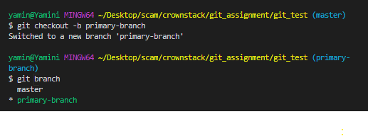
By the command checkout –b option means new branch (named primary-branch) is created and skip to the newly made branch.
- Push the branch to GitHub:
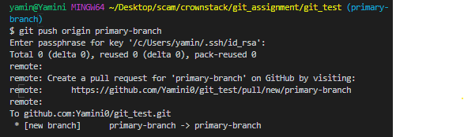
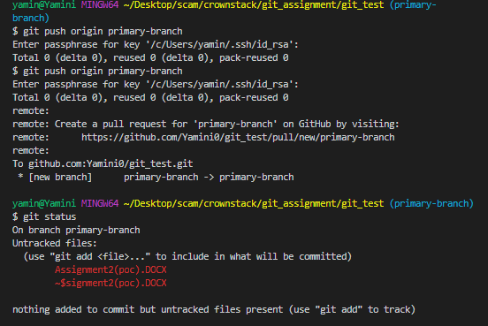
In the above image we see we have copied all the content of master branch o the primary-branch.

- Make a new file and made a commit to the primary-branch.
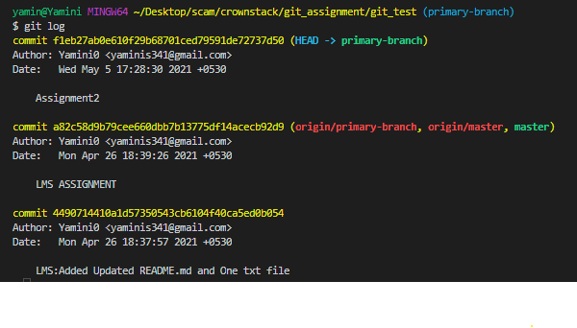
- Make a push to primary-branch.
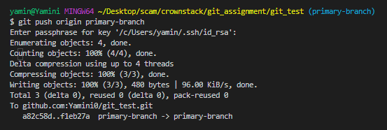

- Merge the primary-branch to master branch:

