Git-assignment 2:
- Make a new branch:
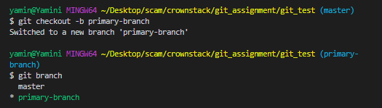
- push the newly made branch
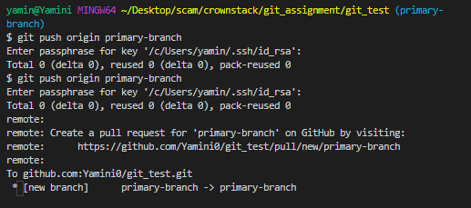
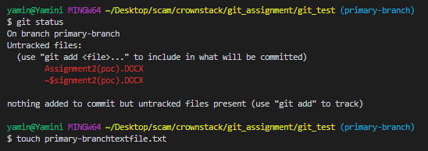

- Add the untracked files and commit them to primary-branch
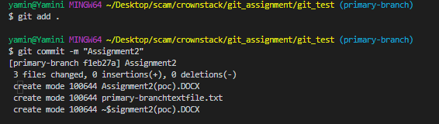

- See the branches
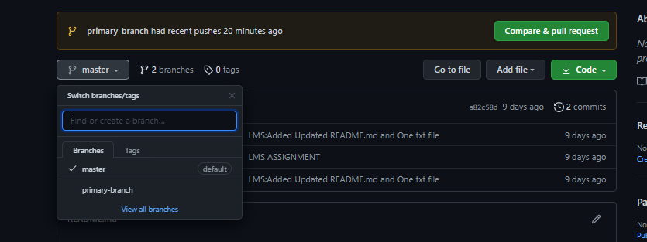
Commit on primary branch
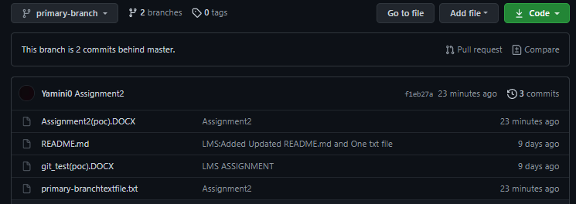
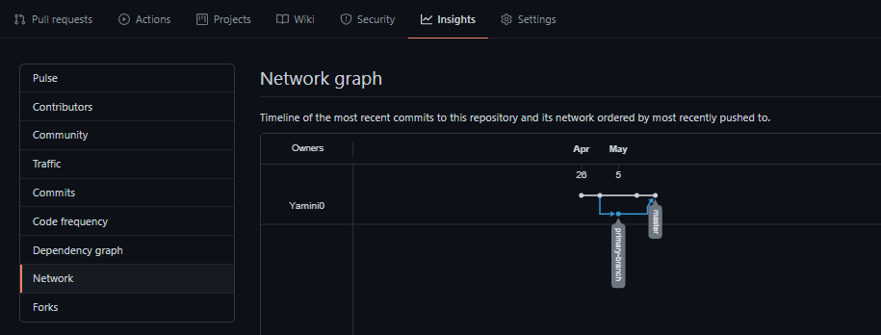
Hence we can see the graph insight of the branches.

