Git-Assignment 1:
- Make account on “https://github.com” and add a new repository named “git_test”.
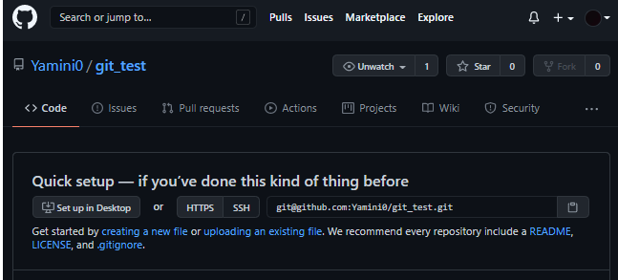
- Install git bash.
- Check the version of Git: “git --version”
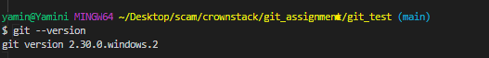
- Connect the remote repository (made on github) to the local repository.
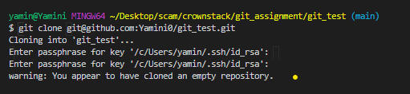
You have successfully cloned the local repository to remote repository.
- Git remote: to establish the connection local and remote repository.
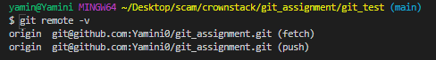
This will display the URL of the repository you created in GitHub, which is the remote for your local copy.
- Command : touch README.md : Make a new file named “README.md”
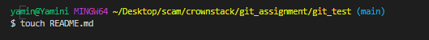
- Check the status : git status

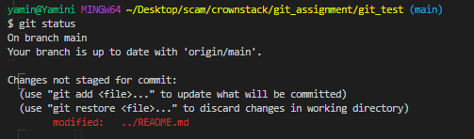
Its red means the file README.md is in unstaging area.
- Git add command : git add [filename] : will add the given file to tracked file.
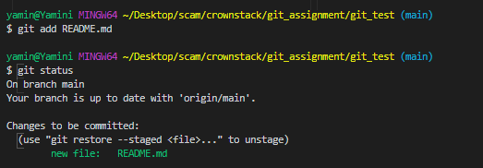
Now its green means the file README.md is in staged area of the git.
- Git commit: git commit –m “a message” will commit you file
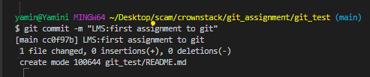
- View log: git log
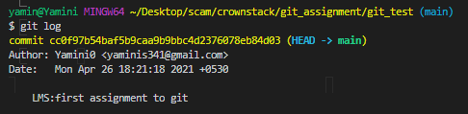

Lets try adding new file then understand the concept of git more clearly.
- Make a new dummy .txt file. And check the status.
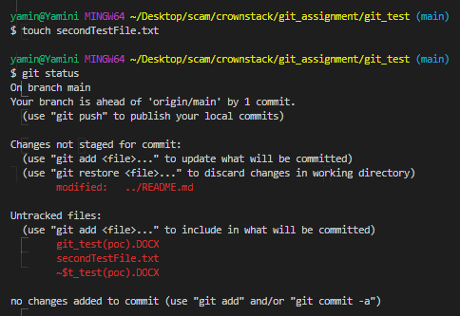
This shows you have done 1 commit and the newly made file is named as untracked file means it is in unstaging area.
- Try to make some changes in README.md and sees the changes.
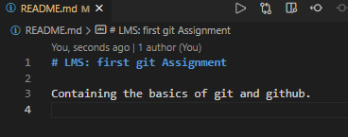
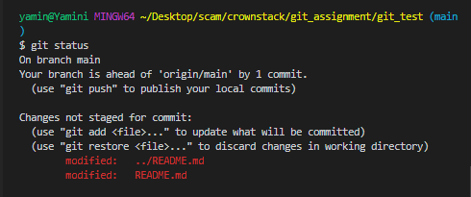
We have commit the file named README.md and make some changes in that it will again come to unstaged area of the git meaning we have to again commit it so it can be reflected.
- Just try to add only README.md the check the status again.
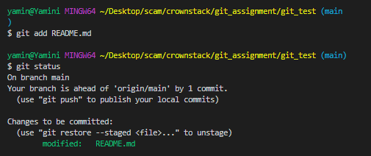
Its again green .

- To add all the files : git add .
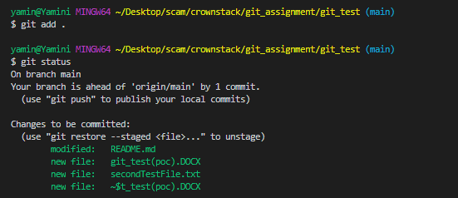

Finally make a commit command
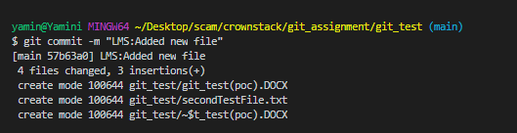

Now to push the files to GitHub.
