**ETHICS IN DATA SECURITY**

Yamini Praveena Tella, Professor: Dr. Elliot Sloane

Department of Computer Science, Villanova University, Villanova PA

**INTRODUCTION:**

With the advancement of technology, life is getting simpler and easier in all aspects. In today’s world automatic systems are preferred over manual system. With the rapid increase in the number of users of internet over the past decade has made internet a part and parcel of life. But this rapid growth of internet made personal data or information less secure. Now-a-days we are seeing several cases where private and secure information is hacked from social networking sites, emails and even private telephonic conversations.

In the project, I worked to show how ethics are maintained to resolve a common ethical issue which is “Inappropriate sharing of information”. Information/ Data play a major role in everyone’s life. If your private data went into wrong hands you can guess the consequences of it. Most of the organizations hold employees or users private data. Here private data includes user credit card information, SSN, Mobile numbers, Address and many. If this data is accessed by unauthorized persons who have negative intentions, there will be a great loss to the individual they violate the privacy of the individuals and intrude their personal space.

To protect the data I have developed a web application in which data is password and pin protected. I have also designed the application in such a way that user can share the information to the other persons by providing a pin to them and he can change the pin whenever he wanted. He can also prioritize the information and set the visibility levels to different persons. For example, in my web application there are two roles admin and doctor. The information that is shared with doctor is different from the information that is shared with admin. I have created views to each field so that user can set the options to make which part of data to be visible and which part of data should be hidden. The detailed concept of this is explained in below pages.

To implement this system I have considered a scenario of hospital. Many hospitals also hold patients private data. In my application user can only provide access of his personal data to admin and doctors with the help of a pin.

**MODULES IN THE APPLICATION:**

There are 3 modules in this web application:

1. Patient module
2. Doctor Module
3. Admin module

**HARDWARE AND SOFTWARE REQUIREMENTS:**

**Software Requirement:**

* Application Server : Tomcat 5.0
* Back End : MySQL
* Front End : JAVAEE
* Web Technologies : SERVELTS, JSP,JAVA SCRIPT,HTML

**Hardware Requirement**

* Processor : Pentium-III Processor or above
* RAM Memory : 128 MB or above
* Hard Disk : 20 GB or above

**PROJECT IMPLEMENTATION METHODOLOGY**

I have used MVC architecture to implement my application. Here MVC means:

M – Model

V- View

C- Controller

* Model (DAO) consists of application data and business rules.
* Controller (Servlet) mediates input, converting it into commands for the model or view.
* A view (JSP) can be any output representation of data, such as an html or jsp page.

**Advantage of using MVC:**

* Code is separated into 3 categories. This separation allows flexibility because the view doesn’t care about the underlying model, supporting multiple file formats easier.
* Enhancements in views and other support of technologies for building the view can be implemented easily.
* Guy who is working on view does not need to know about the underlying Model code base and its architecture, vice-versa for the model.
* It can re-usable and independently tested.

I have used Eclipse IDE to write my Java code. Following is my design pattern:

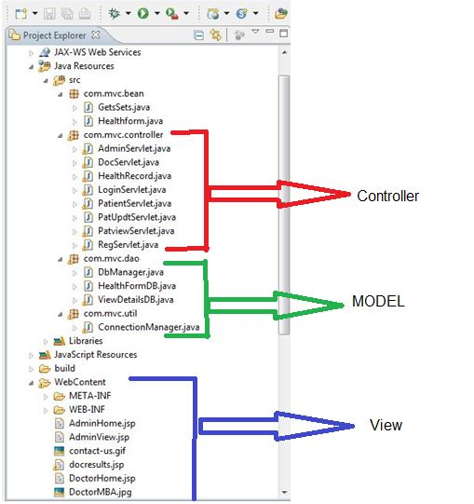

**Flow of my Project:**

I have created 3 roles in my project:

1. Patient
2. Doctor
3. Admin

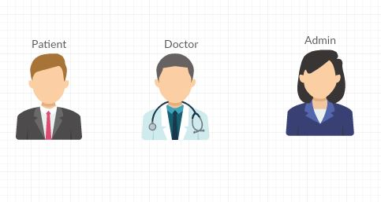

1. **START Page:**

When I execute my application the start page of my application is as shown below:

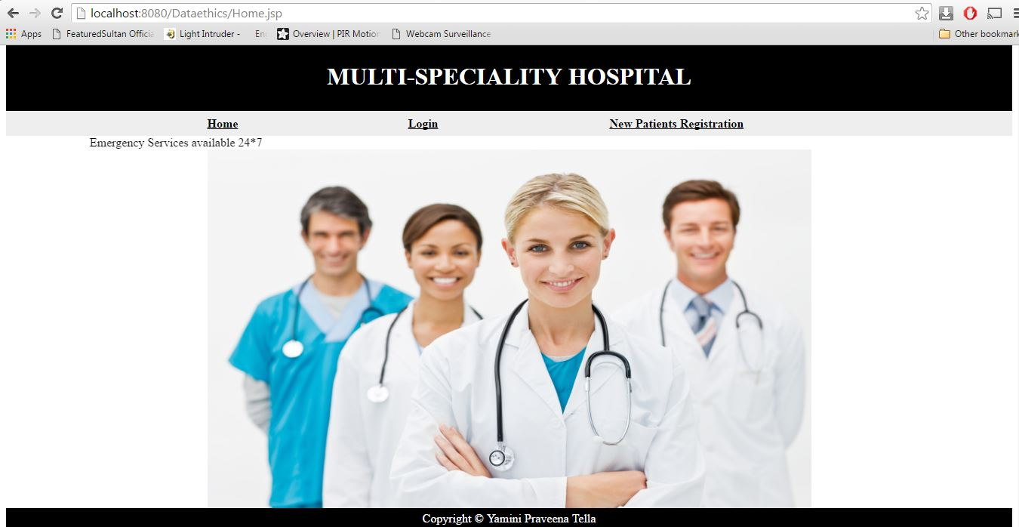

I have provided 3 menus in this page.

* Home page
* Login page and
* New patient registration page.

If already existing patients, they can directly login to the page by clicking on the login menu else they need to register first and create their own username and password to login to the application.

1. **New Patient Registration:**

By clicking on the new patient registration tab the following page appears:

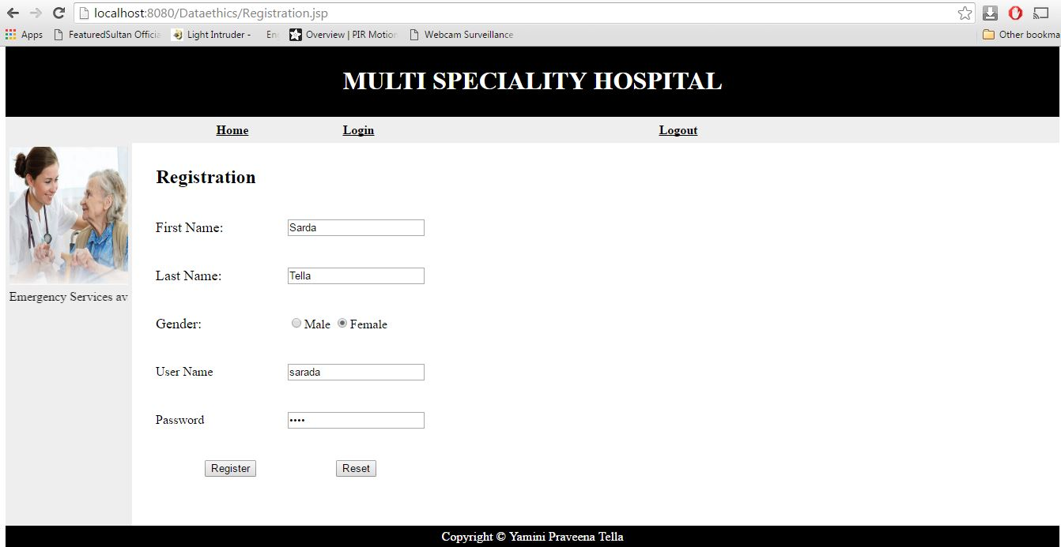

I have provided the user to create his/her own username and password to login to the system and save his personal data. Without his login credentials no-one can access the data.

After clicking on the “Register” button the following page appears saying he is successfully registered into the system.

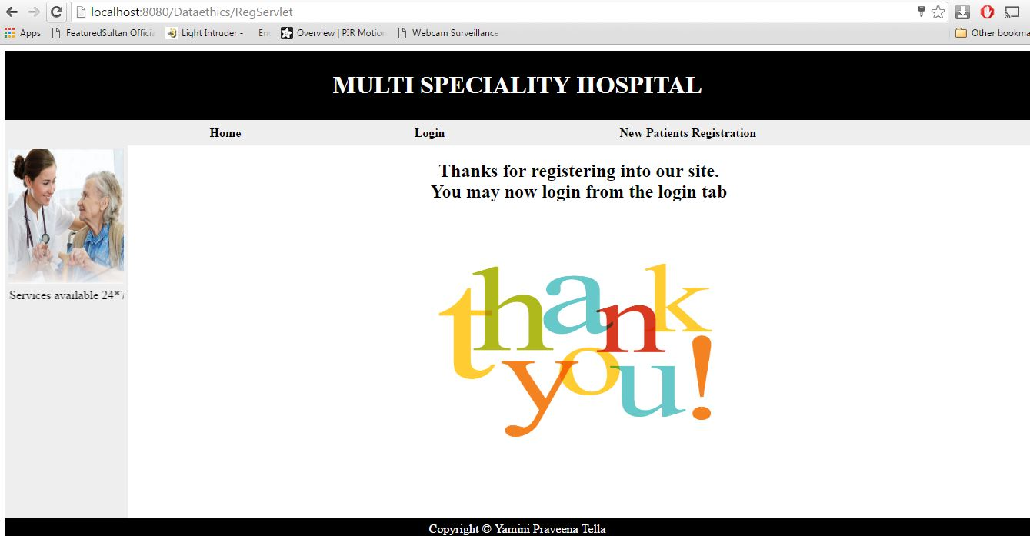

The patient can now login to the application with the set username and password in Login page.

1. **Login Page:**

By clicking on the Login tab, the page appears as shown below and if you give the wrong credentials i.e. if you give wrong username and password then you will not be able to login to the system. It will display a error message called “Incorrect username/password! Please try again!”.

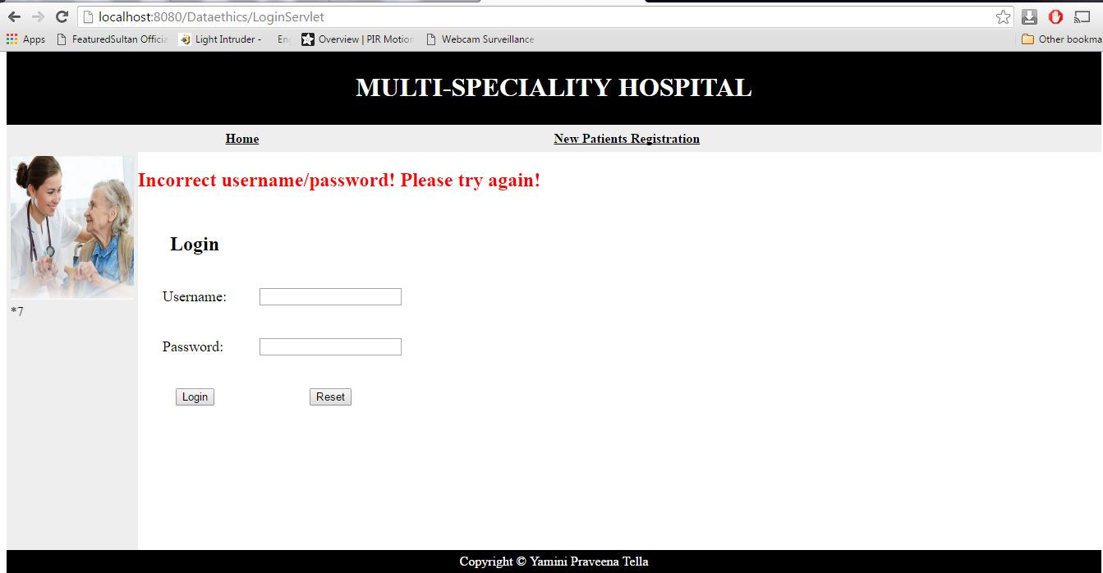

If you give the correct username and password, you will be able to login to the application. And you can see your home page, i.e., Patient Home page as shown below:

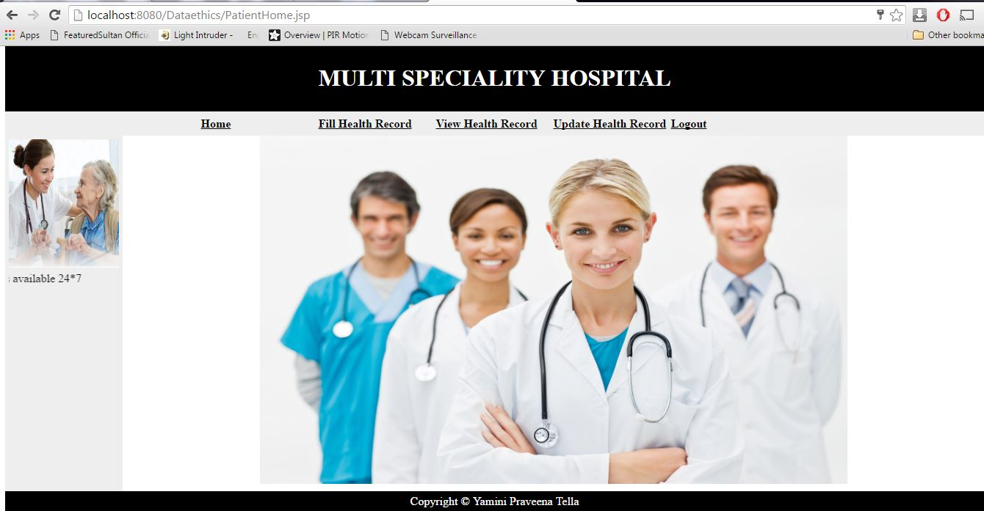

1. **Patient Home Page:**

In the patient home page, we have the following modules:

1. Fill Health record
2. View Health Record
3. Update Health Record
4. Logout
   1. **Fill Health Record:**

The patient after logged successfully into the system he can now fill the health record. When filling the health record he can provide the visibility options i.e. which fields to be shared and which fields to be hidden.

When we click on the tab it is as shown below:

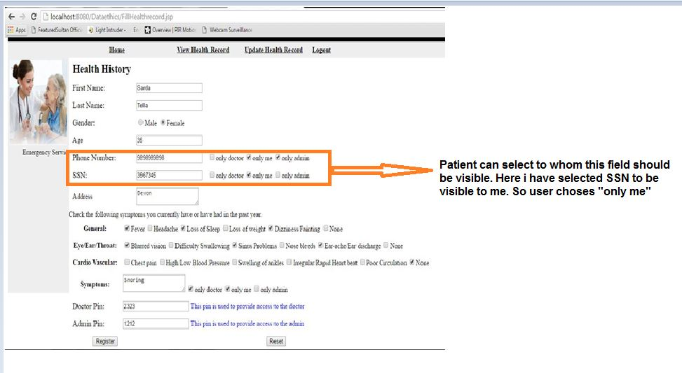

We can observe in the above record I have provided three options for the user to select to whom the fields to be available:

C:\Users\Personal\Desktop\Ehealth-Final\opt.JPG

He can click on the above 3 options to whom the field should be visible. Like this the user can prioritize data and make his private information like SSN to be hidden by clicking “only me” option. So to the fields when “only me” is selected it will not be available to anyone and no one can access this data. Like this I am following ethics to resolve an issue called “***Inappropriate sharing of information***”.

The patient can also set a pin to the doctor and admin to provide access to them to view his/her record. It is as shown below:

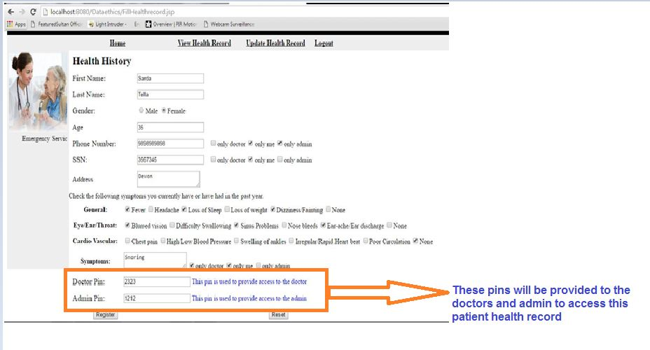

Only with this pin doctor/admin can view the records. Without this pin no one can view or get access to the health record. I have created two separate pins to doctor and admin.After filling the record the patient should click on register button to save the record.

**4.2. View Health Record:**

The patient after filling the health record can view it anytime by clicking on View Health Record menu. It is as shown below:

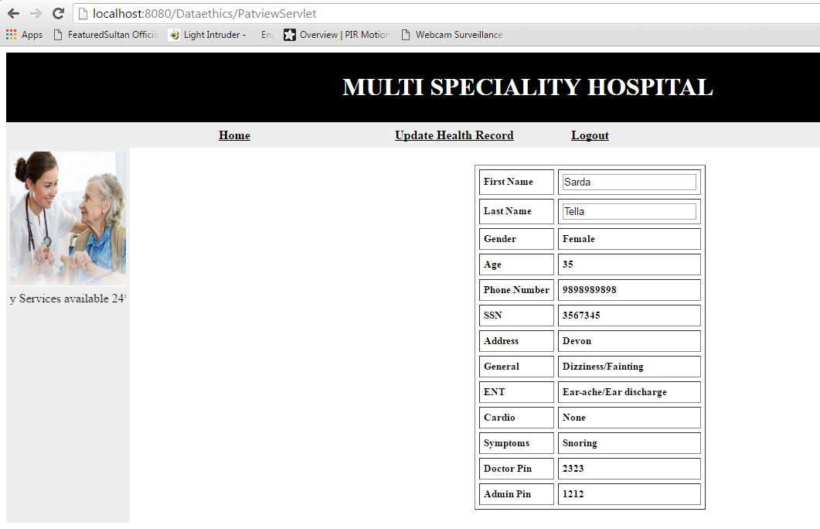

While providing access to the doctor/admin, the patient should provide his/her First Name, Last Name and pin generated while filling the health record. Only with these details the doctor/admin will be allowed to view the health record.

1. **Doctor Module:**

In the doctor module, I have created a login for doctor and his own home page to access the patient records. In the login page when the doctor enter his correct login credentials he will be redirected to “Doctor Home page” which as shown below:

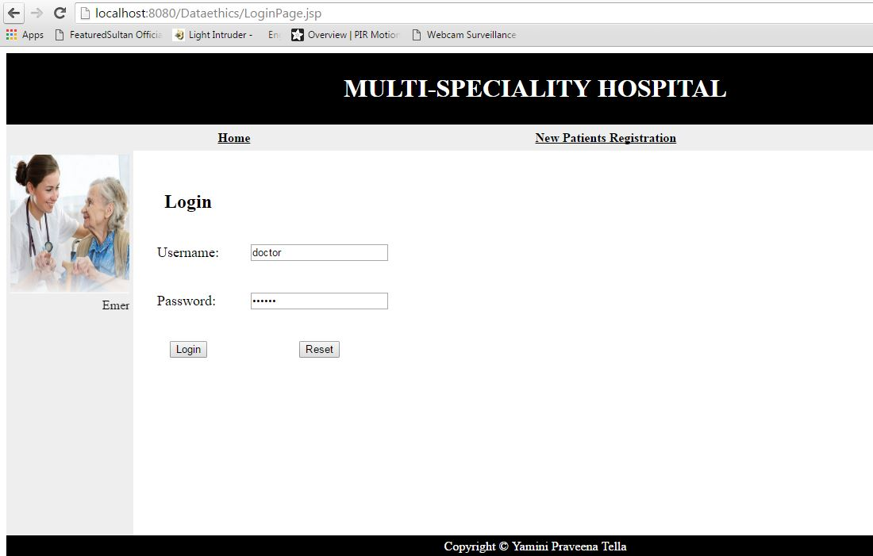

Doctor Home Page:

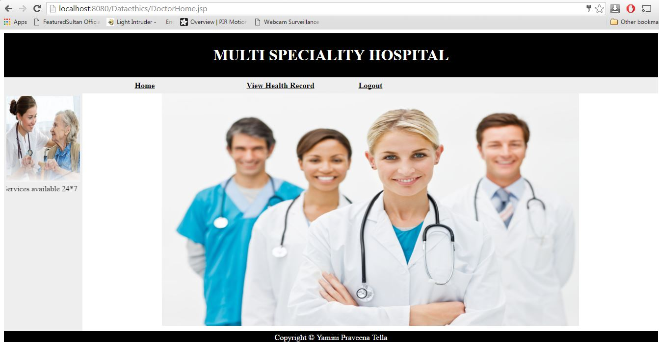

In this module, I have created two menus:

* View Health Record
* Logout

**5.1. View Patient Health Record:**

When the doctor clicks on this menu following page will get open:

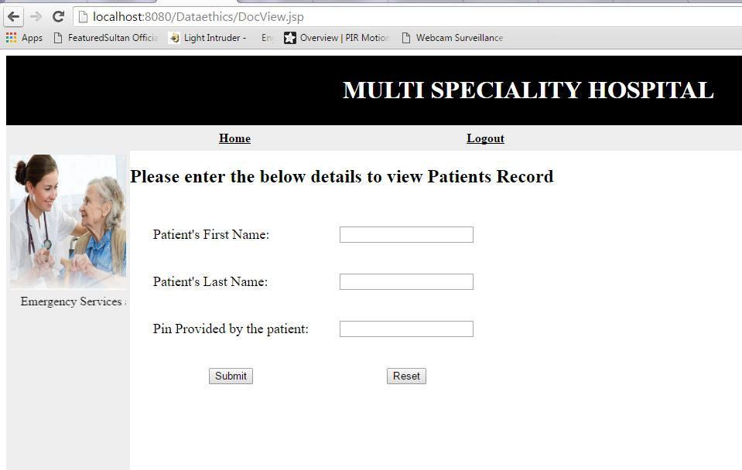

The doctor should enter the Patients First name, Last name and Pin provided by the patient. If any one of these fields is incorrect the doctor will not be able to access the records. Also there may be several persons with same name and also different patients may create same pin unknowingly. In order to make sure for the doctor that he is opening the correct patient record which he is going to review, I have provided three fields for the doctor to open the record. ***Every life counts so we should follow ethics*** by providing pins like this to retrieve the records.

If the doctor provides the wrong credentials, an error message will be shown on the screen to the doctor:

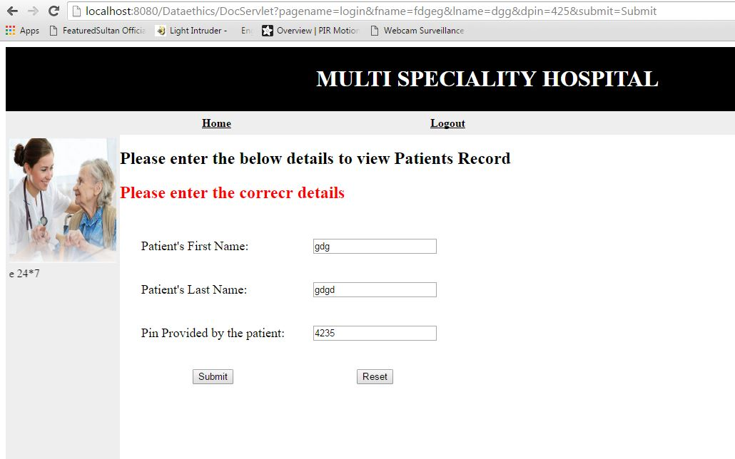

After providing the correct credentials he will be able to view the patients health record as shown below:

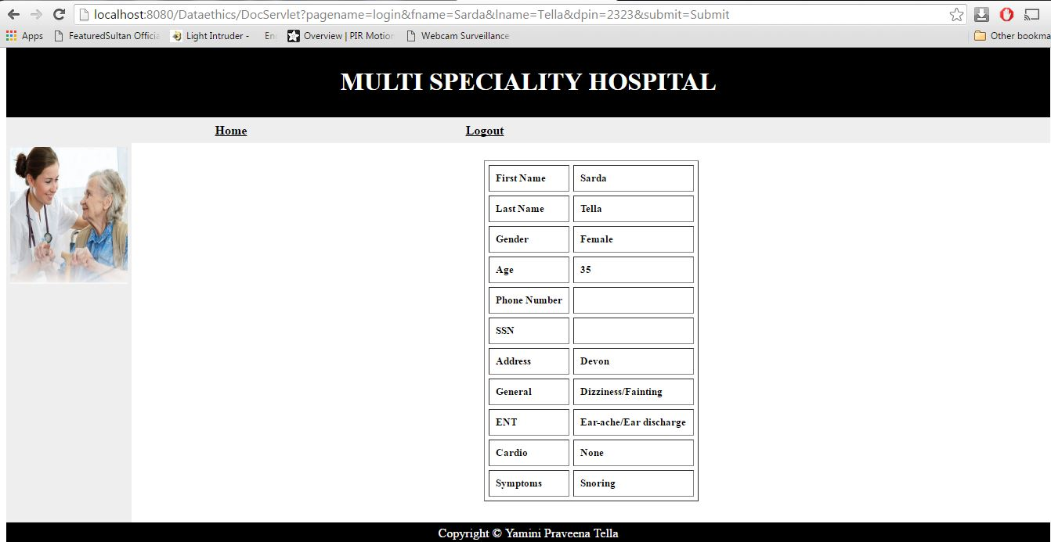

As you can see in the record the Phone number and SSN fields are empty. Because the patient while filling the record he didn’t choose the option “Only doctor”. So they are not available to the doctor. Also doctor requires only health related data. Like this following the ethics the patient can set his options which data to be available to the doctor.

After viewing the record the doctor can click on Logout to logout from the system.

1. **Admin Module:**

In the doctor module, I have created a login for the admin and his own home page to access the patient records. In the login page when the admin enter his correct login credentials he will be redirected to “Admin Home page” which as shown below:

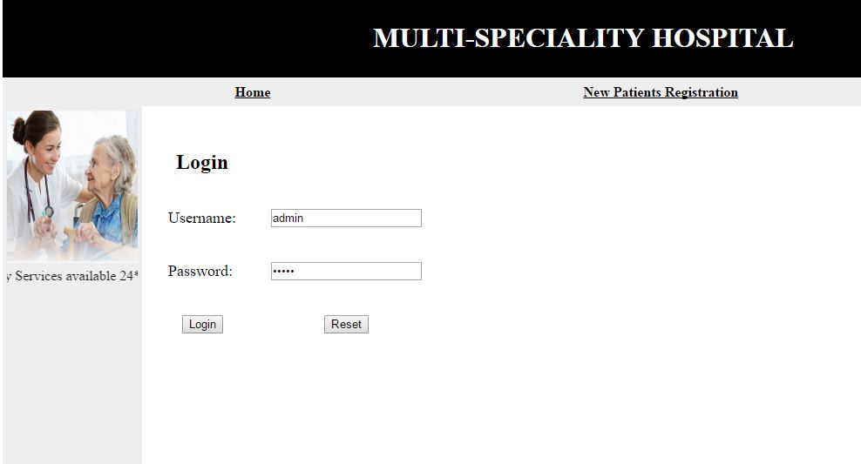

Admin Home Page:

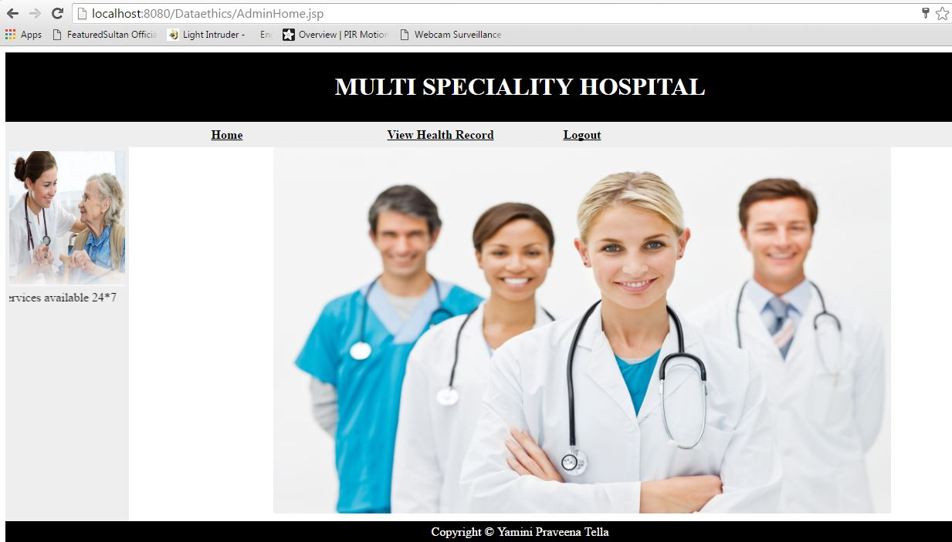

In this module, I have created two menus:

* View Admin Health Record
* Logout

**6.1. View Patient Health Record:**

When the admin clicks on this menu following page will get open:

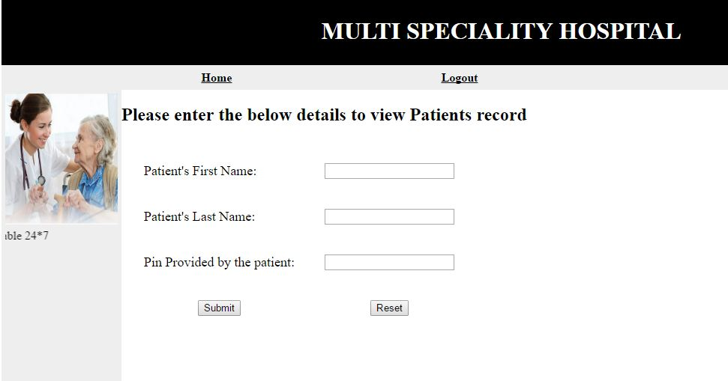

The admin should enter the Patients First name, Last name and Pin provided by the patient. If any one of these fields is incorrect the admin will not be able to access the records. Also there may be several persons with same name and also different patients may create same pin unknowingly. In order to make sure for the admin that he is opening the correct patient record which he is going to review for billing or any other contact information, I have provided three fields for the admin to open the record.

If the admin provides the wrong credentials, an error message will be shown on the screen to the admin:

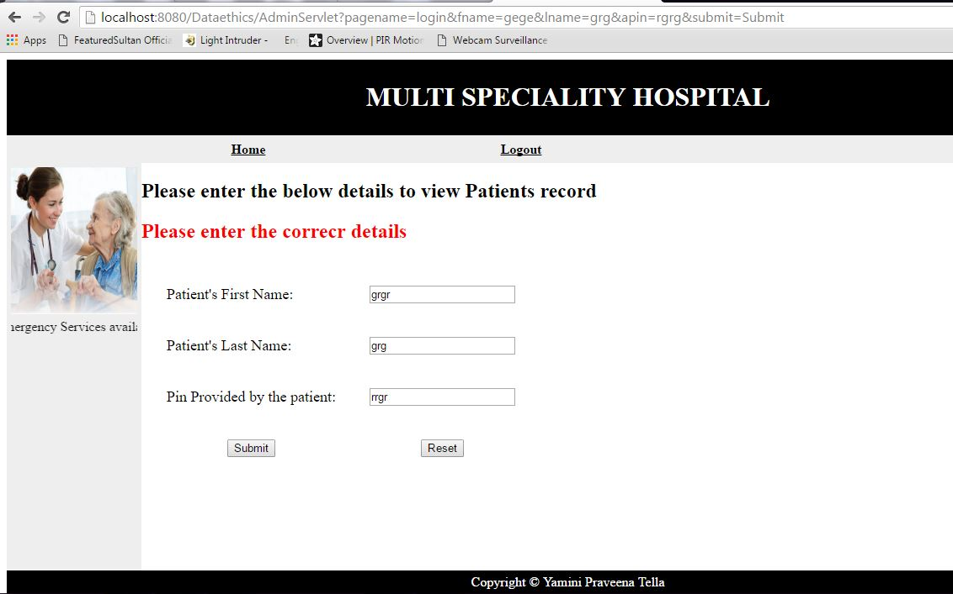

After providing the correct credentials he will be able to view the patient’s health record as shown below:

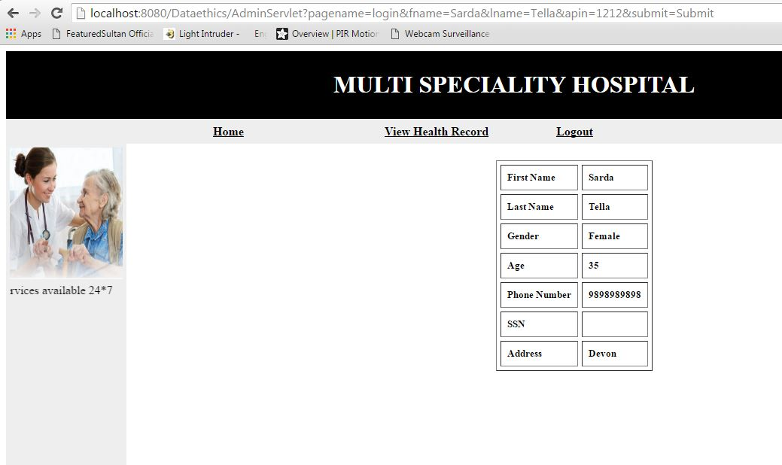

As you can see only few fields are displayed on the screen. As the patient set the visibility for the admin as only Name, gender, age and contact details. After viewing the record he can logout from the application by clicking on Logout menu.

1. **Update Health Record for Patient:**

When the pin is shared with doctor/admin after their job is done, the patient should be able to change the pins to protect his personal information. The patient should login to the application and click on Update health record. In the Update Health record, I have made those two pins as editable. With the help of this the user can change the pin in order to abide with the rules. It is as shown below:

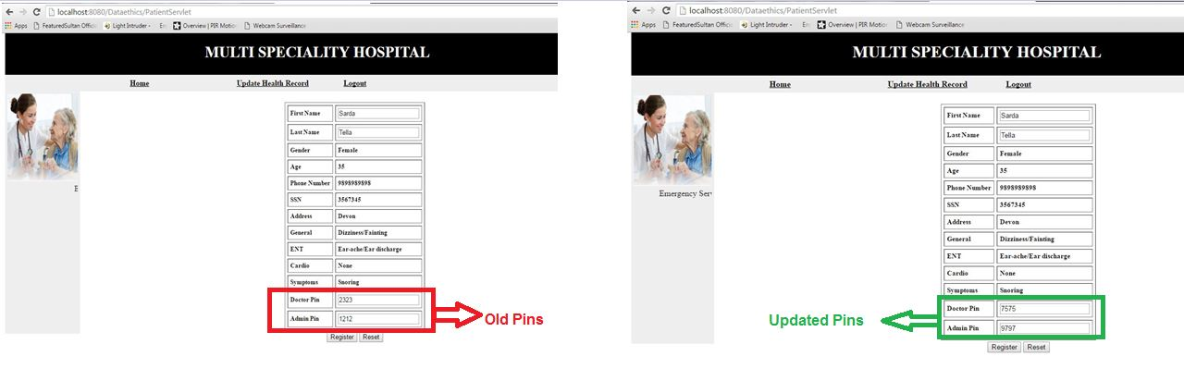

When the doctor tries to login to the application with the old pins, the application will not allow doctor to view it and throws an error message Invalid details as shown below:

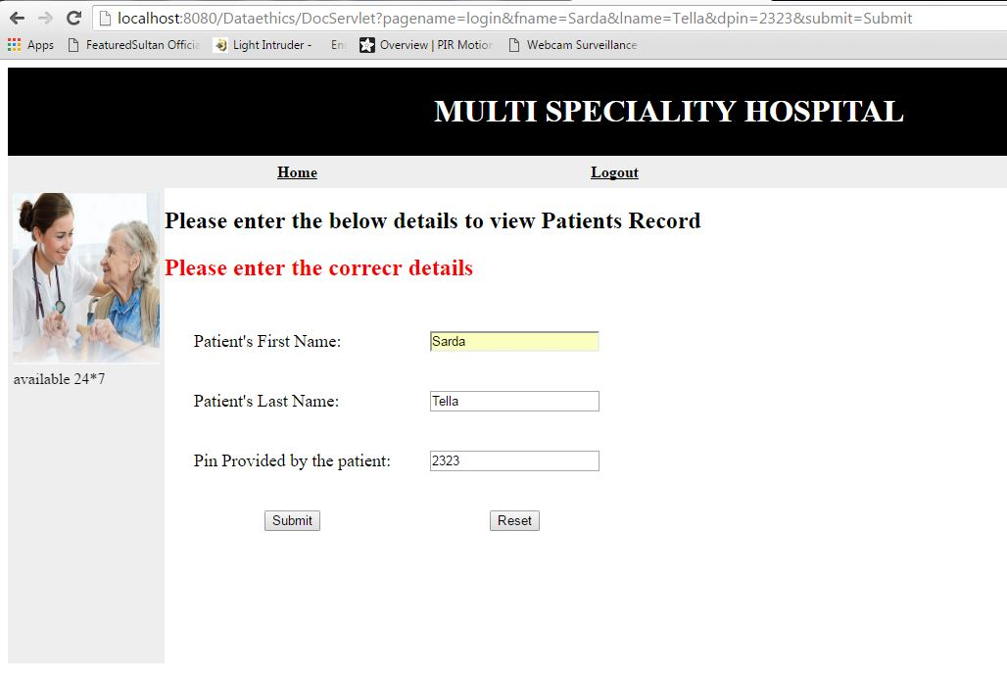

In case if patient provides new updated pin to the doctor, if the doctor enters the new pin then the doctor can view the record of patient as shown below:

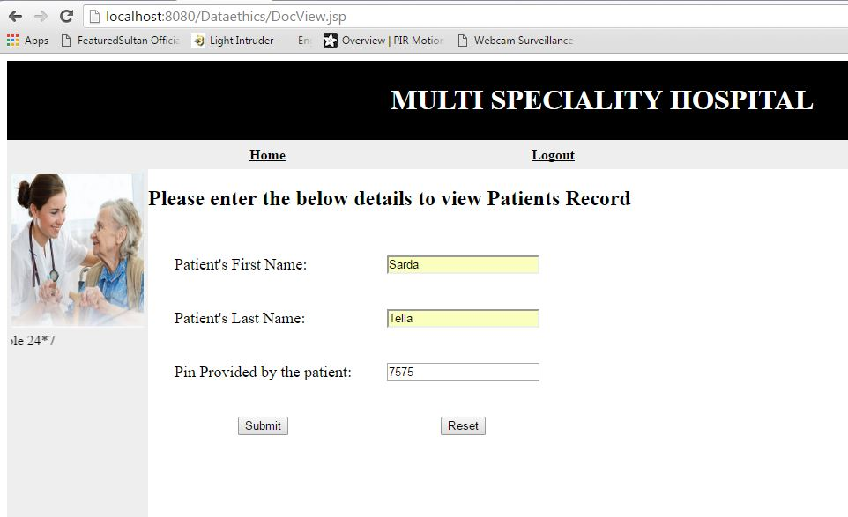

When he clicks on submit with the updated pin he can access the record as shown below:

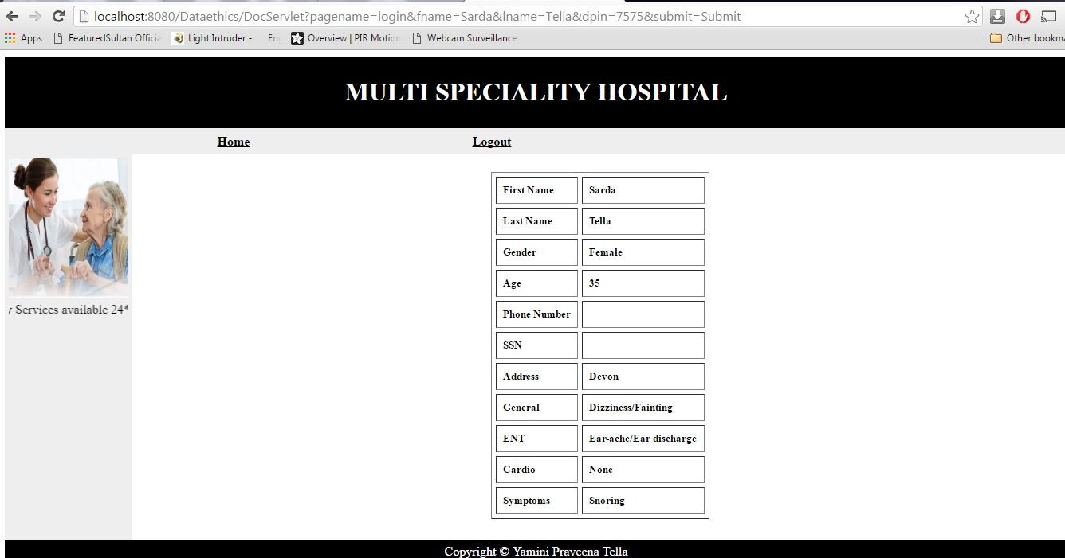

The same case with admin as well. The application will not allow admin to view the records with old pins and throws an error message if he try to access with the old pin as shown below:

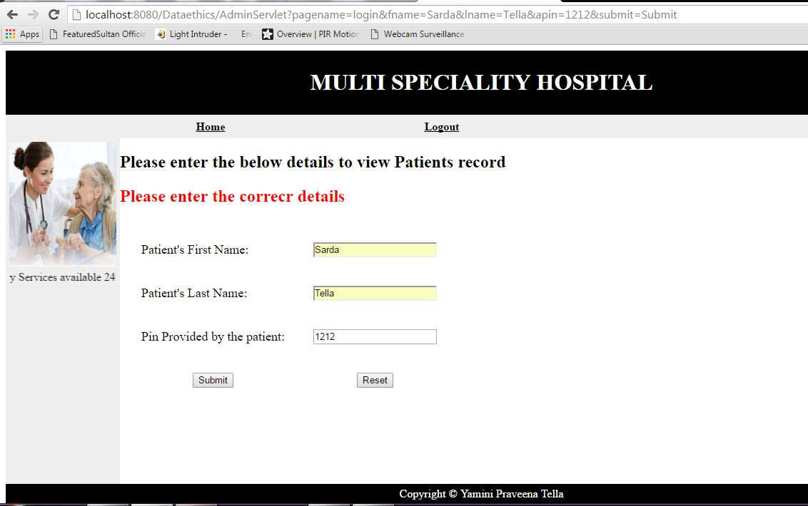

If he gives the updated pin then he can view the record as shown below:

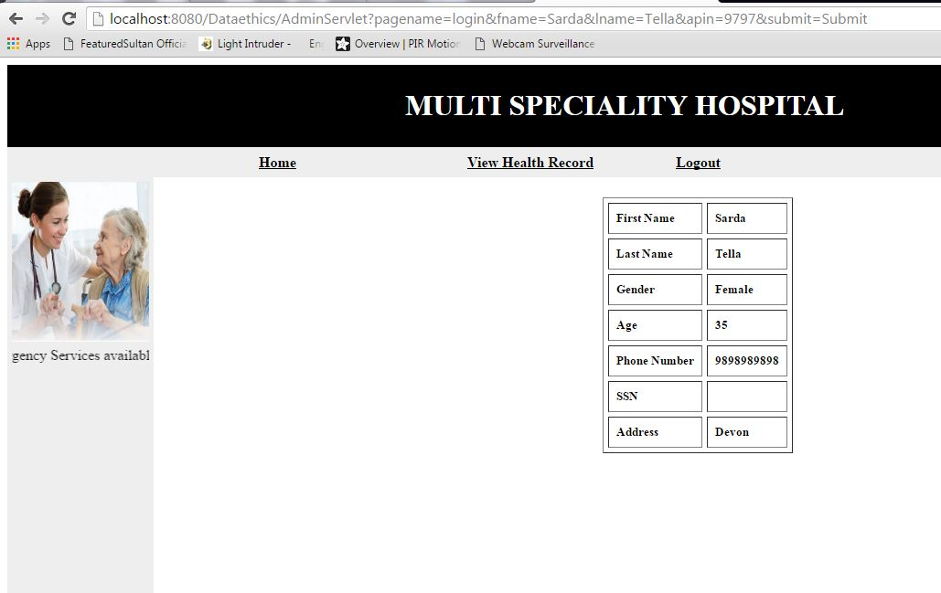

1. **Logout Module:**

The patient, doctor and admin after performing all their actions, they can logout from the application with the help of logout module. When they click on logout module it will redirect to the Home page as shown below:



**Future Scope:**

1. In the future we can add an automatic SMS or Email alerts to the patient which contains the information of the doctor who has opened his record.
2. We can also generate an automatic pin after the doctor/admin closed the record and send this pin to the patient in an email or to the mobile. This will be helpful in scenarios like if the patient is busy and unable to change the pin. At any point later he can set his desired pin.

**Conclusion:**

With the help of this application, user has control over his personal data. He can give access to people of his choice and can revoke the access by changing the password anytime he wants. Also this application has a special feature called “Session Timeout”. If the user stays inactive for more than some time period, say 15minutes the application will automatically logged out and the user have to re-login in to the application. This will be helpful in scenarios like if doctor/patient /admin forget to logout from the application. Thus following this kind of ethics resolve the issue “Inappropriate sharing of information” and also the user’s personal data can be protected without reaching the wrong hands.