**LABVIEW**

**LabVIEW Installation Steps:**

**Step:1** Open the link [https://www.ni.com/en/support/downloads/software-products/download.labview.html#559079](https://cognine1-my.sharepoint.com/personal/yamini_pothana_cognine_com/Documents/Yamini%20Pothana/Learnings/LabView/LabVIEW.docx) to download LabVIEW from official website.   
  
**Step:2** Sign up for NI and then login to download.

**Step:3** Choose the below options to download the community version of LabVIEW 2025 Q1 and then click on download.

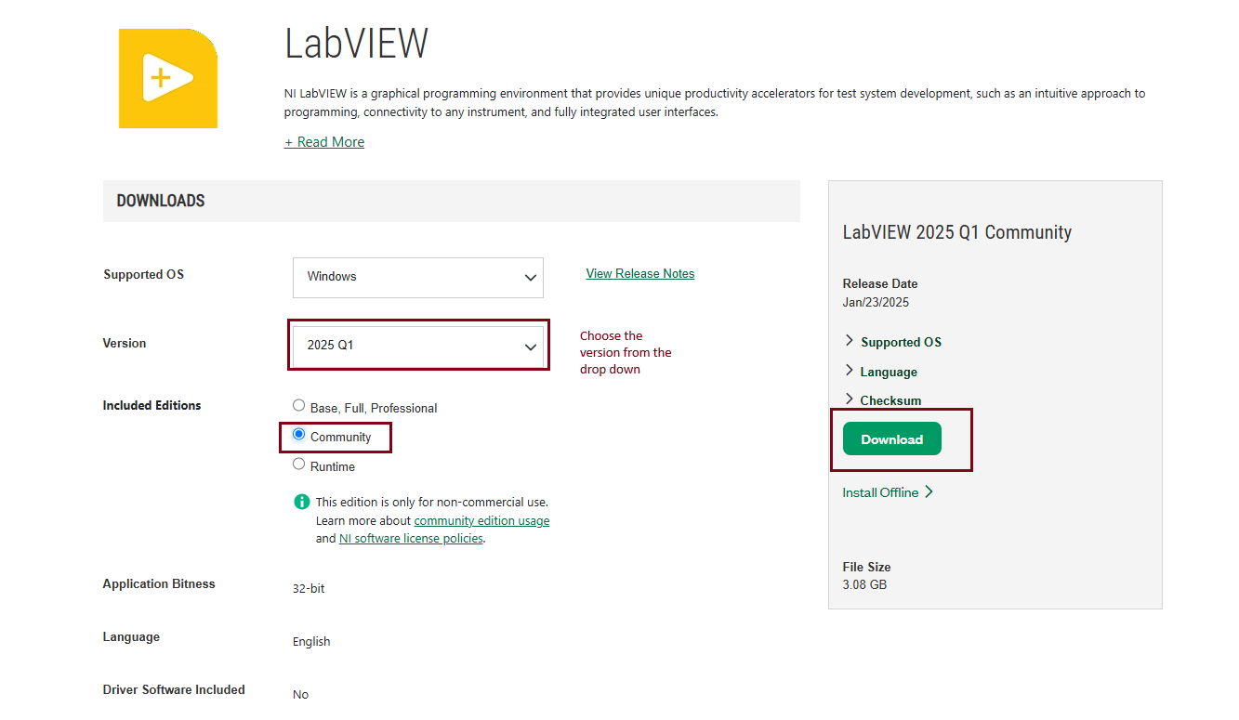

**Step:4** A Disc image file is downloaded in your downloads andon double click on the file, it will redirect to the **.exe folder** which includes multiple other files as well.

**Step:5** click on **install.exe** which further install the LabVIEW Application**.  
Step6:** VI package manager is installed automatically and choose **3D Express** or any software and install it.

LabVIEW installation is completed and ready for development:

**Overview:**

* LabVIEW, i.e., Laboratory Virtual Instrument Engineering Workbench.
* It is known as a graphical programming environment that is widely used in research labs, industries, and academics.
* The tool is utilized by using a programming language named “G” (Graphical programming language).
* programs are created using pictorial forms which in turn are called “Block Diagrams”.

**Palettes:** There are three palettes in LabVIEW:

* **Controls Palette**: Available only on the Front panel, it consists of various controls and indicators required by the user while building the front panel.
* In simple, Controls palette is the User Interface where the user can visualize all the metrics.

* + - **Function Palette**: Available only on the Block Diagram, it is used to build flow. Different function palettes include Numeric, Array, Time and Dialog, and Waveform.
    - In simple Function palette is the block diagram on which all the programming and functionality is created using the various functions.
    - There are many functions in function palette which are categorized as programming, measurement I/O, Mathematics, Signal processing, Data connectivity etc.

* 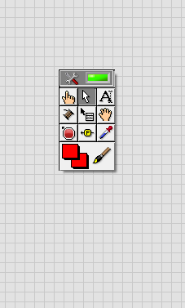**Tool Palette:**

Using the Tool Palette, users can create, modify, and debug Virtual Instruments. The tool palette is available on both the front panel and the Block Diagram. Different tools available are:

* **Operating tool button**: For text selection or for changing the values of controls.
* **Positioning Tool**: For resizing, selecting, and positioning.
* **Labelling Tool**: For free labels and editing text.
* **Object shortcut Menu Tool**: For opening the shortcut menu of an object.

Shortcut for Tools palette : **Shift + right click**

Some of the window’s shortcuts frequently used in LabVIEW are:

* **Cntrl + B = Deletes all broken wires in VI**
* **Cntrl +. = Stop the running VI**
* **Cntrl + E = Toggle between front and block diagram**
* **Cntrl + T = Both panels in once screen**

**The below are some important functions used:**

**1. Formula Node:**

In LabVIEW, a Formula Node is a special type of node that allows you to perform mathematical operations and data manipulation using a text-based formula language. It's a powerful tool for performing complex calculations, data transformations, and conditional logic.

Here are some key features and benefits of Formula Nodes:

**How it works:**

You create a Formula Node on the Block Diagram by right-clicking and selecting **"Structures" > "Formula Node".**

Inside the Formula Node, you enter a formula using a syntax similar to mathematical notation.

The formula can reference inputs, constants, and other nodes on the Block Diagram.

The Formula Node evaluates the formula and returns the result as an output.

**Formula Language:**

The Formula Node language is similar to mathematical notation, with some LabVIEW-specific extensions. You can use various operators, functions, and syntax elements to perform calculations and data manipulation. Some examples:

**Arithmetic operators:** +, -, *, /, ^, etc.

**Comparison operators**: ==,=, >, <, >= , <=

**Logical operators:** AND, OR, NOT

**Functions**: SIN, COS, TAN, EXP, LOG, etc.

**Conditional statements:** IF, ELSE, CASE

**Benefits:**

**Easy to use:** Formula Nodes provide a simple, intuitive way to perform complex calculations and data manipulation.

**Flexible:** You can use a wide range of mathematical functions and operators to create custom formulas.

**Efficient:** Formula Nodes can be more efficient than using multiple nodes and wires to perform the same calculation.

**Reusability**: You can reuse Formula Nodes in different parts of your program or even in other LabVIEW projects.

**Common use cases:**

**Data transformation**: Use Formula Nodes to perform data conversions, scaling, or normalization.

**Conditional logic:** Implement conditional statements, such as IF-THEN-ELSE or CASE statements, to control program flow.

**Mathematical calculations:** Perform complex mathematical operations, such as trigonometry, exponential functions, or statistical analysis.

**Signal processing:** Use Formula Nodes to implement signal processing algorithms, such as filtering or convolution.

**Layout:**

**Tab Control:**

They are just like the web pages in a web site.

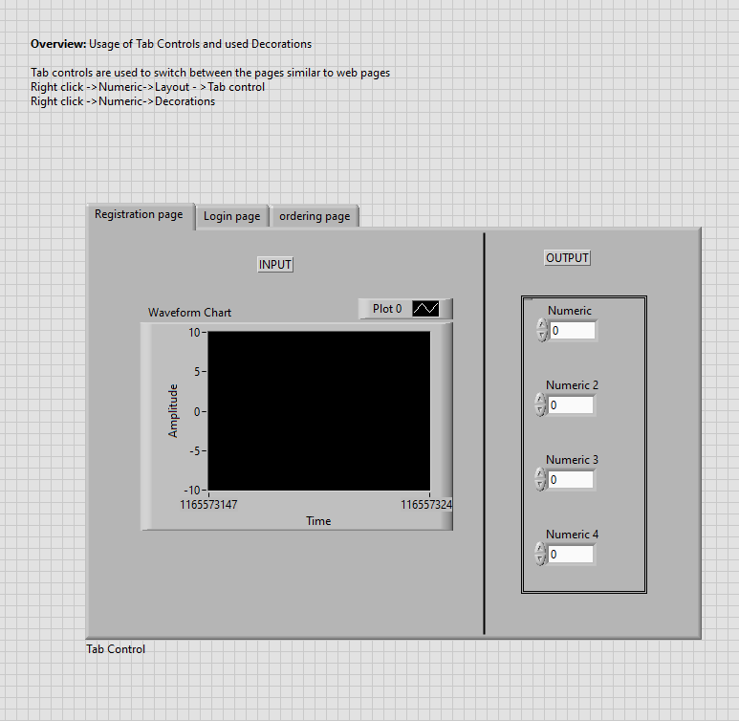

Controls Palette:

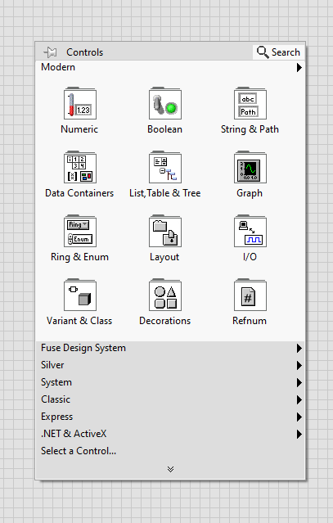

Numeric **Controls**:

**Boolean Controls:**

**String Controls:**

**Array:**

**List, Table & Tree:**

**Ring & Enum:**

**Input/Output:**

**Decorations:**

**Function Palette:**

**Timing functions:**

This document covered the entire installation process of LabVIEW and basic introduction along with the overview of the LabVIEW which includes front panel, block diagram and tools palette.

*******************************