**WEB TECHNOLOGIES**

**TEAM-1**

**TASK-2**

**Integrate Bootstrap 5 in Task 1 (with 5 different controls form Bootstrap)**

We will integrate Bootstrap 5, a popular CSS framework, to enhance the styling and functionality of our web page. Bootstrap offers a variety of components and utilities that make it easy to create responsive and visually appealing designs. We will use different Bootstrap controls to demonstrate its capabilities and improve the user experience of our page.

Here is how our Home Page looks:

This is a basic HTML file that includes Bootstrap 5 to style the navigation bar and content section. The navigation bar is responsive and includes links to different tutorial pages. The content section provides information about programming languages, including their characteristics and popular examples. Overall, the file demonstrates the use of Bootstrap for styling and layout purposes in a web page.

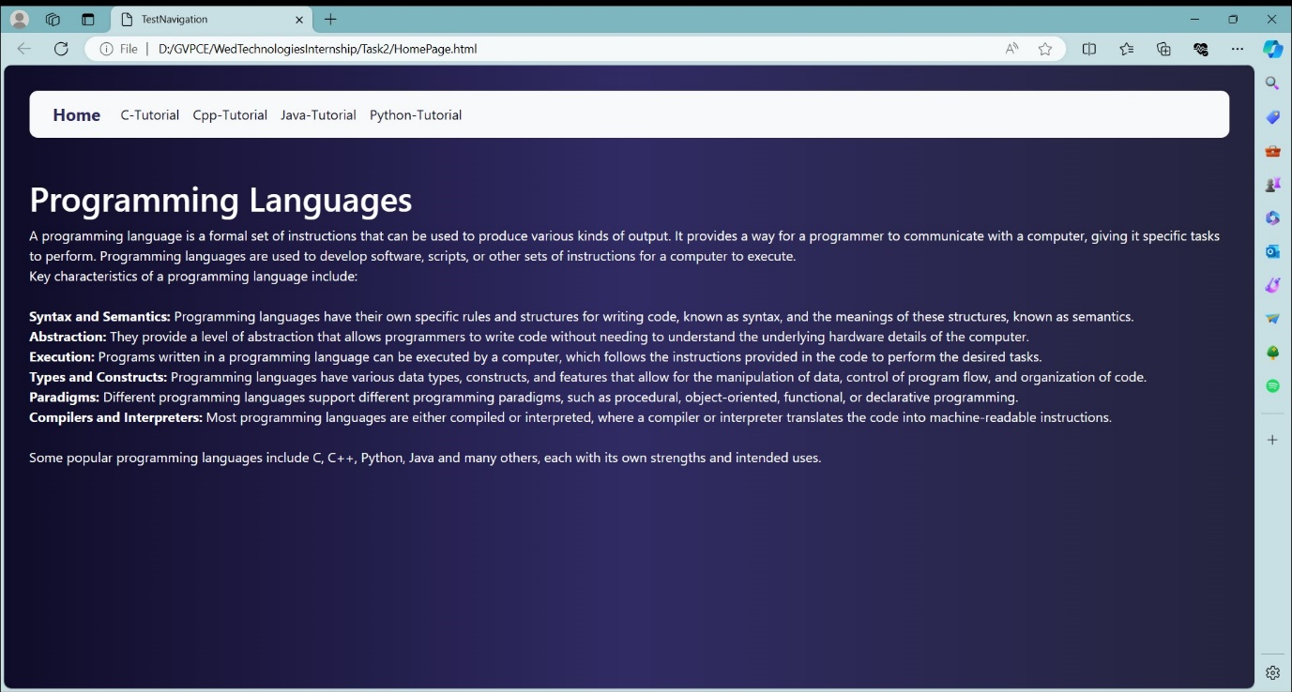

This is the code for the above Home Page.

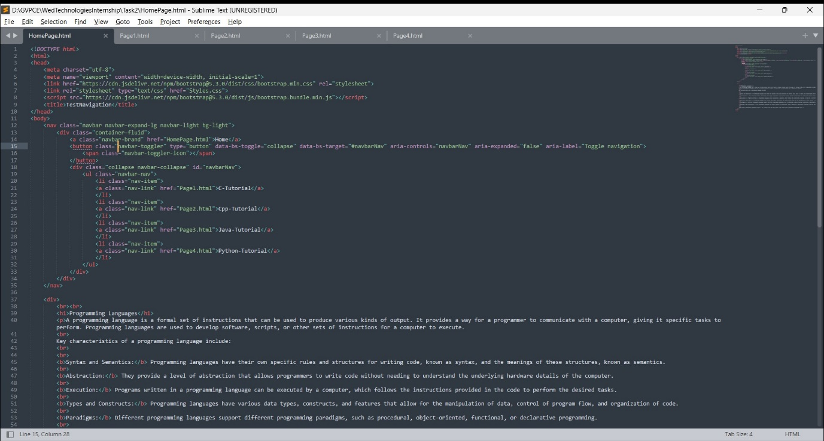

This homepage code is an HTML file that uses Bootstrap 5 for styling and includes a navigation bar (**navbar**) and a content section (**div.container**).

**<!DOCTYPE html>**: This declaration specifies that the document is an HTML5 document.

1. **<html lang="en">**: The opening tag for the HTML document. The **lang="en"** attribute specifies that the document is in English.
2. **<head>**: The head section of the document, which contains meta information about the document, such as character encoding and viewport settings.
   * **<meta charset="UTF-8">**: Specifies the character encoding for the document as UTF-8, which supports a wide range of characters.
   * **<meta name="viewport" content="width=device-width, initial-scale=1.0">**: Configures the viewport to ensure that the page is responsive and scales correctly on different devices.
   * **<link href="https://cdn.jsdelivr.net/npm/bootstrap@5.3.0/dist/css/bootstrap.min.css" rel="stylesheet">**: Links to the Bootstrap CSS file hosted on a CDN (Content Delivery Network), which is used for styling the page.
   * **<link rel="stylesheet" type="text/css" href="Styles.css">**: Links to an external CSS file (**Styles.css**) for additional custom styling.
3. **<script src="https://cdn.jsdelivr.net/npm/bootstrap@5.3.0/dist/js/bootstrap.bundle.min.js"></script>**: Includes the Bootstrap JavaScript file, which is necessary for some Bootstrap components to function properly (such as the navbar toggler).
4. **<title>TestNavigation</title>**: Sets the title of the document, which appears in the browser tab.
5. **<body>**: The body section of the document, which contains the visible content of the page.
   * **<nav class="navbar navbar-expand-lg navbar-light bg-light">**: Defines a navigation bar with Bootstrap classes for styling. The **navbar-expand-lg** class makes the navbar expand to full width on large screens (**lg** breakpoint). The **navbar-light** class sets a light color scheme for the navbar, and the **bg-light** class sets a light background color.
     + Inside the navbar:
       - **<div class="container-fluid">**: Wraps the contents of the navbar in a container for better alignment and responsiveness.
       - **<a class="navbar-brand" href="HomePage.html">Home</a>**: Defines a link to the homepage (**HomePage.html**) with the text "Home" as the brand of the navbar.
       - **<button class="navbar-toggler" type="button" data-bs-toggle="collapse" data-bs-target="#navbarNav" aria-controls="navbarNav" aria-expanded="false" aria-label="Toggle navigation">**: Creates a button for toggling the navbar on smaller screens.
       - **<div class="collapse navbar-collapse" id="navbarNav">**: Defines the collapsible content of the navbar, which is shown or hidden based on the navbar toggler button's state.
         * **<ul class="navbar-nav">**: Defines an unordered list for the navbar items.

Inside the list:

**<li class="nav-item">**: Defines a list item for a navbar item.

**<a class="nav-link" href="Page1.html">C-Tutorial</a>**: Defines a link to a tutorial page (**Page1.html**) with the text "C-Tutorial" as the navbar item.

* + **<div class="container">**: Defines a container for the main content of the page, which helps with layout and responsiveness.
    - Inside the container:
      * **<h1>Programming Languages</h1>**: Displays a heading for the content section.
      * **<p>**: Starts a paragraph for the content.
        + The paragraph contains information about programming languages, including their characteristics and usage.

This homepage code sets up a basic structure for a webpage using Bootstrap 5, with a navigation bar for easy navigation and a content section to display information.

Top of Form

In the same way, all other pages were also written with similar structure and content but with different titles, links, and content specific to each tutorial. Let's break down the structure of the other pages:

1. **Cpp-Tutorial (Page2.html)**:
   * The navigation bar contains a link to the C++ tutorial page (**Page2.html**).
   * The content section provides information about C++ programming, including its history, features, and syntax.
   * It also covers data types in C++.
2. **Java-Tutorial (Page3.html)**:
   * The navigation bar contains a link to the Java tutorial page (**Page3.html**).
   * The content section provides information about Java programming, including its history, features, and syntax.
   * It also covers data types in Java.
3. **Python-Tutorial (Page4.html)**:
   * The navigation bar contains a link to the Python tutorial page (**Page4.html**).
   * The content section provides information about Python programming, including its history, features, and syntax.
   * It also covers data types in Python.

Each page follows the same overall structure with Bootstrap for styling, a navigation bar for easy navigation between tutorial pages, and a content section providing information about the respective programming language.

This is the Styles.css Page. Where all the styles are added to the web pages in common.

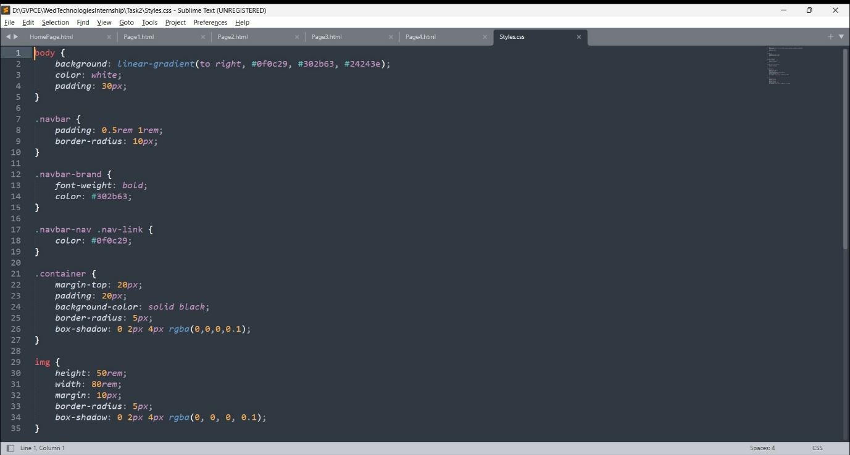

Let’s look in the C-Tutorial Page looks:

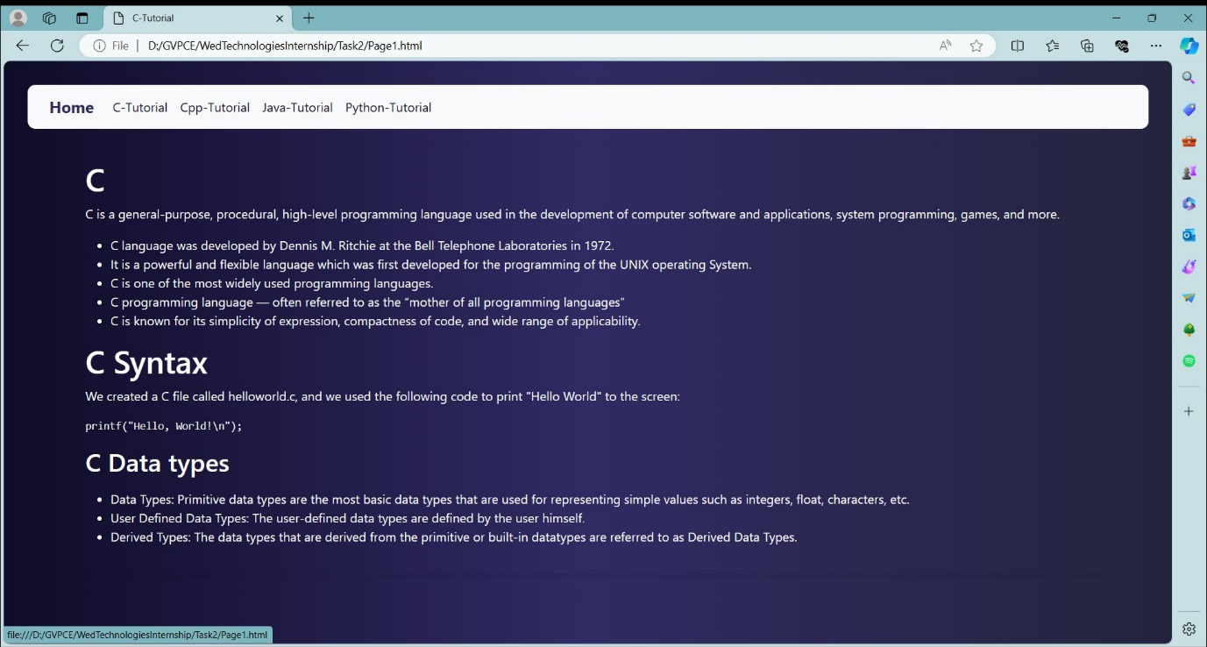

This HTML file is a tutorial page focused on the C programming language. It includes Bootstrap 5 for styling and a navigation bar to navigate between different tutorial pages. The content provides an introduction to C, including its history, features, and syntax. It also covers data types in C.

This file is connected to the previous one through the navigation bar, which allows users to switch between different tutorial pages, such as C, C++, Java, and Python. Each tutorial page provides specific information about the respective programming language.

In this way we can navigate through different Pages like CPP-Tutorial, Java-Tutorial and Python Tutorial. We have used a common external CSS to make our work simpler. Here are the remaining web pages where we can navigate between each other.

This is the C++ Tutorial Page:

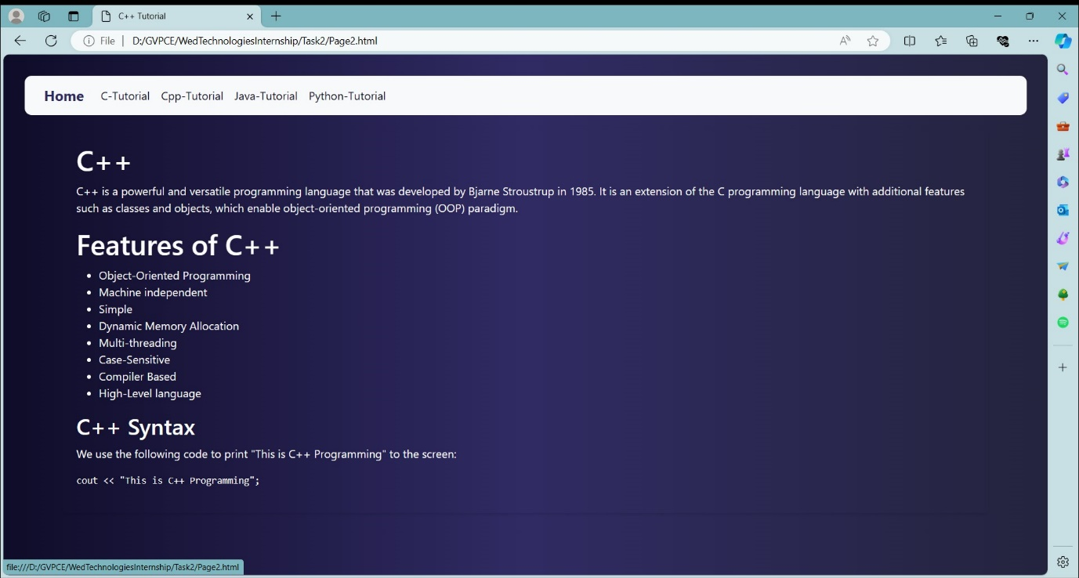

This is the Python Tutorial Page:

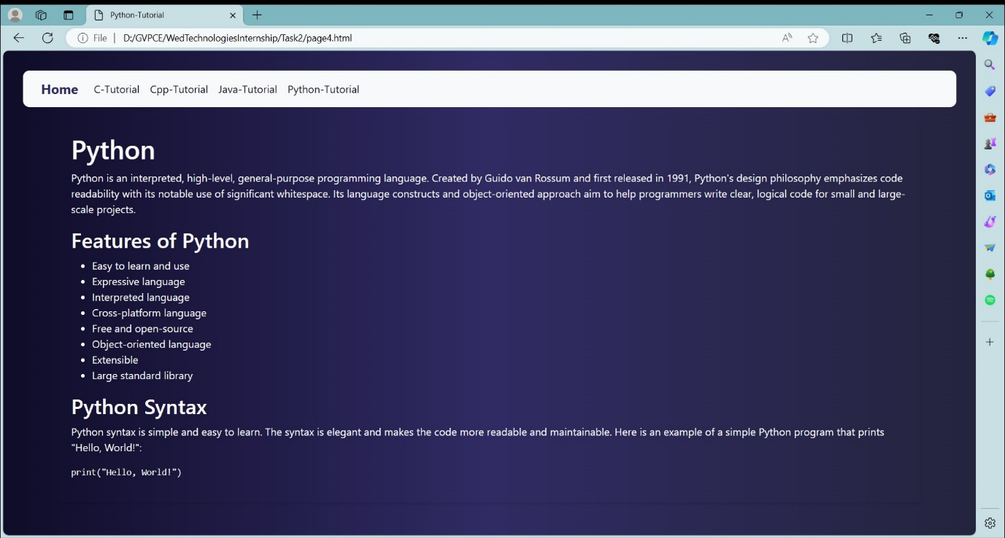

This is the Java Tutorial Page:

