Posting Graphics

- Login to the GPJ Annotator by entering your ID and password and click “Go!”
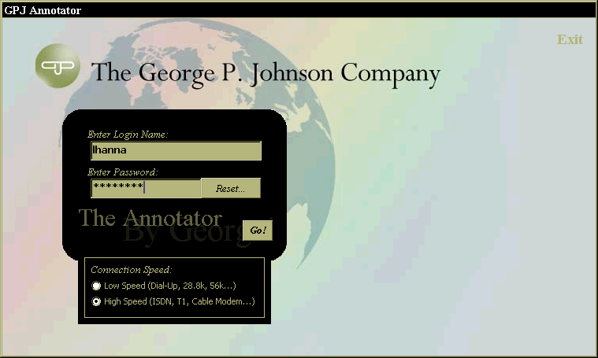
- Enter the Graphic Importer module of the Annotator application by clicking the “Graphic Importer” option.


- To add a new file into the Graphic Delivery Tool click on the “Add a Graphic…” tab and select the appropriate client drive in the “Look In:” list box.
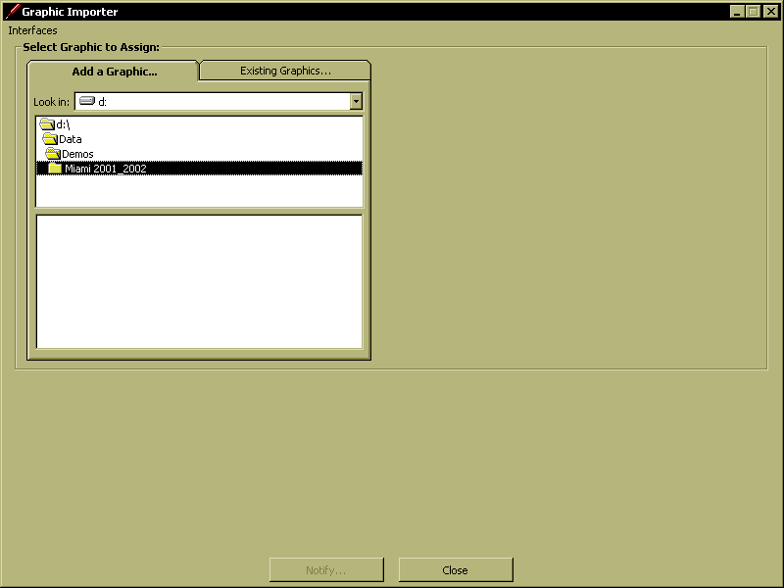

NOTE: The following instructions are for adding files one at a time. The Graphic Importer also allows you to add files in multiple batches. The differences are described beginning in section 15.

- Navigate to the folder in which the file is stored and select the file to be imported.
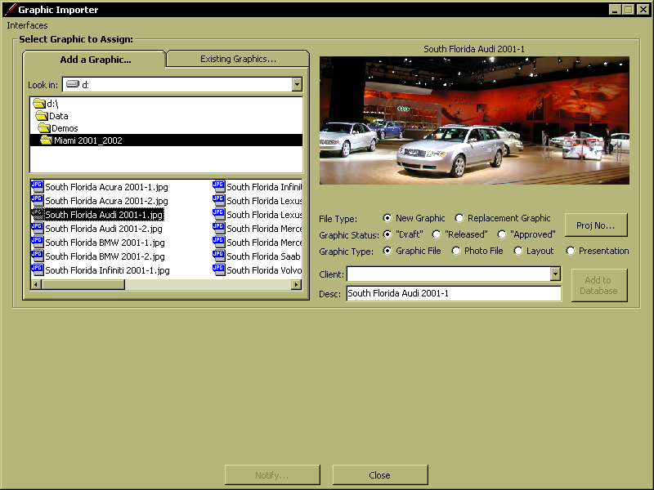

A small image of the selected file will display on the right had side. The path and description (title) of the file will automatically populate for you.
- If you know the project (or job) number click the “Proj No…” button.
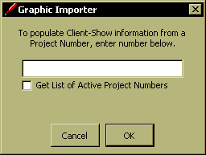

At this point there are two options for entering the Project Number. If you are confident you know the number, type it in the textbox provided, and click “OK” and the associated Client will automatically be selected in the “Client:” listbox.

If you wish, you can check the “Get List of Active Project Numbers” option and the textbox will become a drop-down list containing all the current active project numbers in JD Edwards. NOTE: If this option is checked, future selections of the “Proj No…” button will force the Active Project Numbers list to populate, which may take a little longer. De-selecting the checkbox, will return the textbox option.
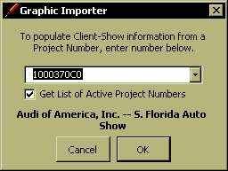
Upon selection of a Project Number from the provided list, a prompt will inform you of the associated Client and Show. If this is correct, click “OK” and the associated Client will automatically be selected in the “Client:” listbox.
- Set File Type, Graphic Status & Graphic Type:
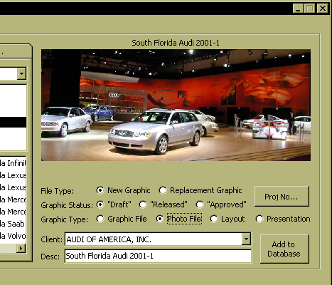
Select whether the file is a “New” or “Replacement” file. “New” means that this file has not yet been imported into the tool. “Replacement” means that this file is replacing a file that has already been imported – it most likely is a different version of a file.
- If you selected “New”, set the “Graphic Status:” option.
- “Draft” status means that the file posted has not been reviewed and approved by the Team. Draft files are only available for internal GPJ viewing.
- “Released” status means that the file has been approved for Client, or non-GPJ, viewing, but has not yet been approved for production.
- “Approved” status means that the file has been approved for production by the Team and will be available for viewing by all Annotator users.

- Set the “Graphic Type:” option.
- A “Graphic File” is an image file without any layout information, or the titleblock associated with a layout file.
- A “Photo File” a digital photo. These may be onsite photos taken at a show, or photos of individual displays.
- A “Layout” file is a graphic file containing layout information. Traditionally, these contain a titleblock.
- A “Presentation”-type file may be a computer rendering, or a proposal.

- Confirm the client name, and the description of the file. The description should follow the GPJ standard file naming convention. If everything appears to be OK, click the “Add to Database” button.
- After selecting “Add to Database”, a prompt (in red) will alert you that the file was added to the database.
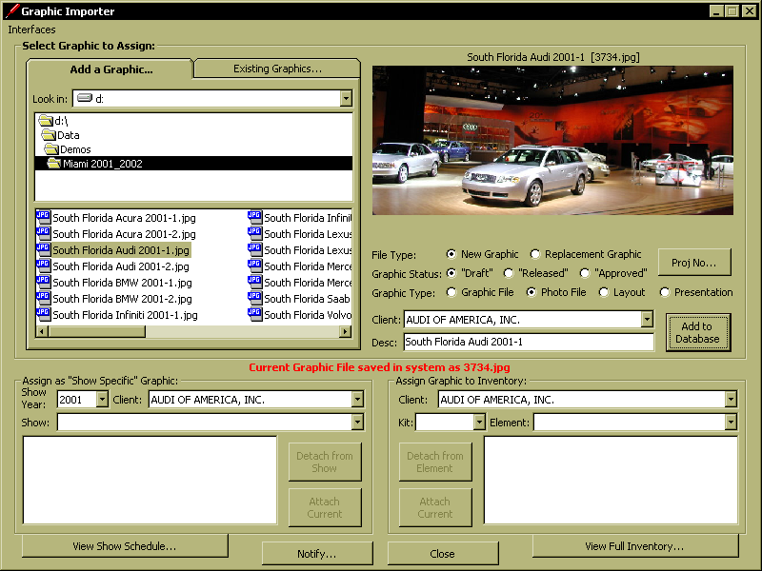

NOTE: After the first database add of a Graphic Importer session, the interface will change to display the Graphic Assignment options. This is where you can attach a graphic file to either a Show, or an Element in a Client’s Inventory.

- If you selected “Replacement”, the “Existing Graphics…” tab will come into focus and you will need to select the file to be replaced. Pick the client name from within the “Client:” list box.
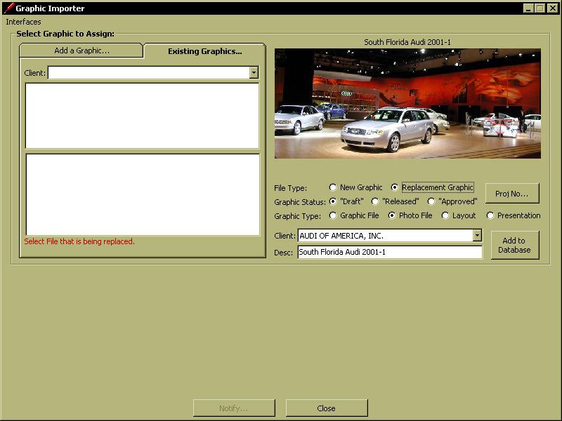

- The list of files available for that client will display. Drill down until you find the file to replace. Select the name of the file to be replaced and click the “Update Database” button on the right hand side.

NOTE: Be aware that if the graphic file you are replacing was a different “Graphic Type” than the new file, the “Graphic Type” option will change to the formers type. This is also true for the Client. Be certain to review the input prior to clicking “Update Database”.
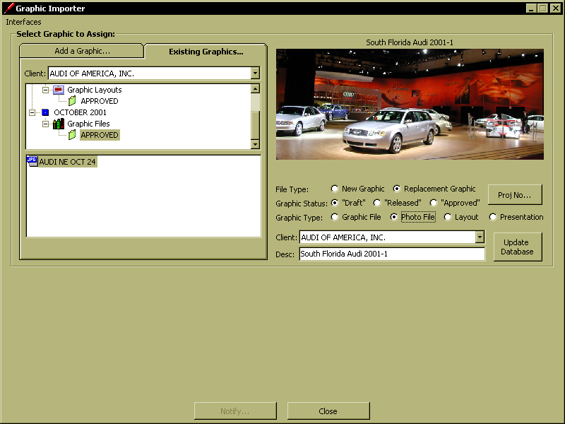
- After selecting “Update Database”, the interface will notify you of the update as shown in section 10, above.

- To confirm that the file has been added or replaced in the database click on the “Database Graphic” tab. Select the client name from the “Client:” list box and navigate to the current month/year. You should see the file name appear in the list.

- Importing Graphic Files in Multi-Batches. The process to post graphic files in multi-batches is nearly identical to the procedure described above with a few important qualifications.

From the “Add a Graphic…” tab, locate your folder containing the files you wish to import. Using Windows-standard selection options, highlight all the files you wish to import. Note that only the last one selected will appear in the viewer.

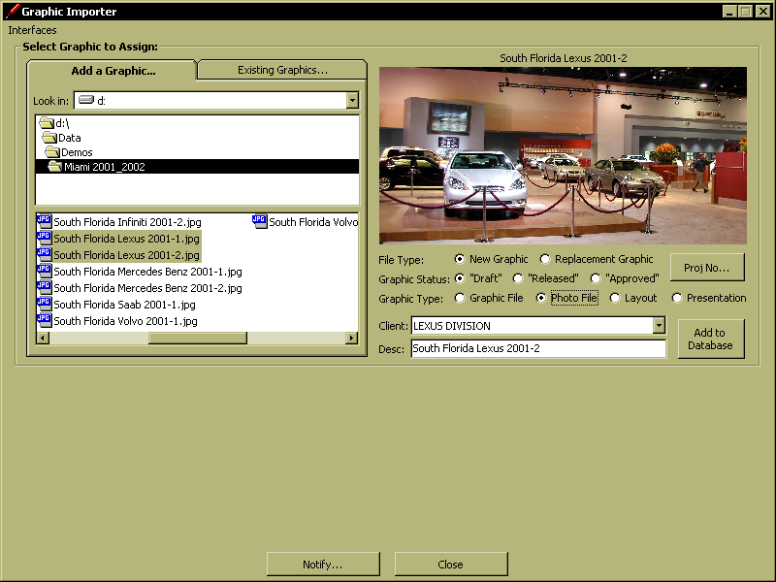

- Set the “Graphic Status:” and the “Graphic Type:” options, noting that all the imported files must be consistent in Status and Type.

- Set the “Client:” either by selecting from the drop-down list, or by entering the Project Number from the “Proj No…” provided menu. Remember, all the highlighted files will be associated to this one selected Client.

- When using the multiple entry option, the “Desc:” value will be dictated by each of the individual file’s names. If you change the “Desc:” textbox, only the first file will be affected. In this situation, it is important to incorporate the GPJ standard file naming convention.

- Select “Add to Database” to import all the select files.
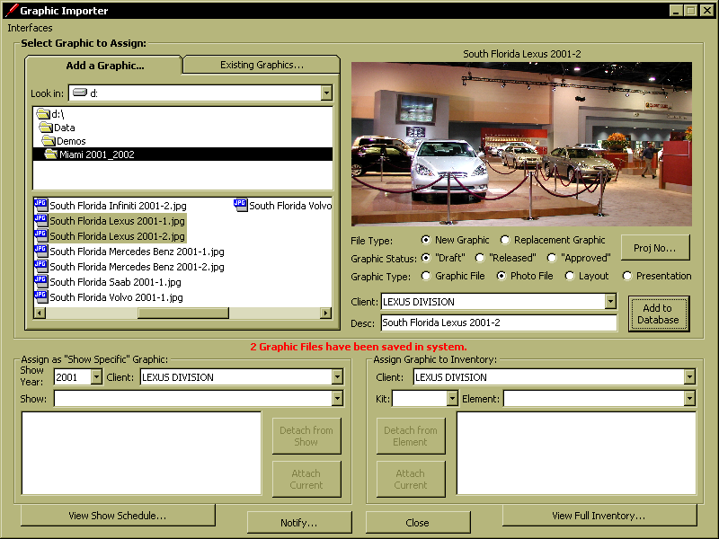
A prompt in red will alert you as to how many files were added to the database. To confirm the add, you can access the “Existing Graphics…” tab, and path to the correct folder to verify they were added.

Notification of Posted Files

- Once a Graphic File has been added to the Client’s database of Graphics, a notification of its availability must be made before it will be viewable in the GPJ Annotator. As shown along the bottom of the menu in the previous screen shot, the “Notify…” button becomes enabled once a file has been posted. Selecting “Notify…” brings up the following menu.
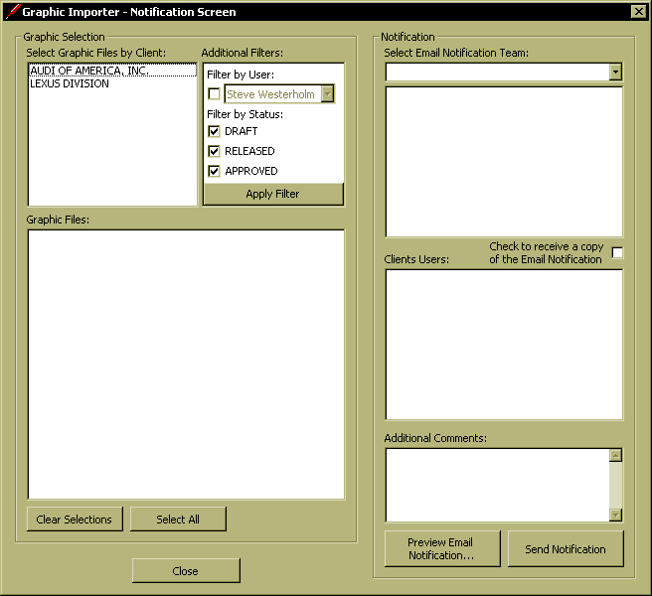

This interface will display all the posted graphic files that are waiting for notification, not just the files posted by you.

NOTE: If you go to exit the Graphics Importer, and have posted Graphics to the Annotator, without sending out a notification, you will receive the following prompt reminding you of the existence of non-notified files.
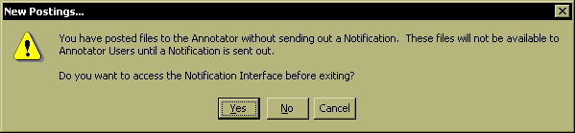

“Yes” takes you to the interface, “No” allows you to exit, but you, and other posters, will be reminded during future sessions until a notification is sent out. Also, remember the files will not be available for viewing until the notification occurs.

- From the “Select Graphic Files by Client:”, choose the graphic Client whose files you will be notifying. Once chosen, a list of all their non-notified files will populate in the “Graphic Files:” listbox, based on the current additional filters.
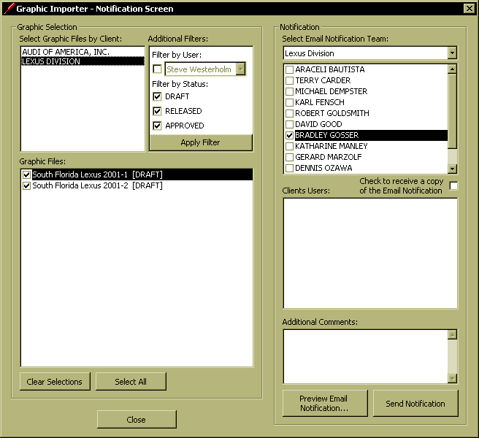

- In order to easily group notification files use the “Additional Filters:” options. By checking the “Filter by User:” option, you can select your, or another users, name to filter the graphics list to only include files posted by you. Further filters include an option to “Filter by Status:”. These filters provide the ability to select only Draft, Released or Approved files, or any combination of the three. Ultimately, the “Graphics List:” files can be individually checked, or unchecked.

- In order to complete the posting process, it is necessary to have had a Client Email Notification Team setup in the Annotator. If no Team has been setup, the “Notification” section of the interface will be disabled. In this situation, contact the A/E and have them arrange to have a Team created. It is a simple process to setup the Team, but it should be initiated by the A/E.

- If an Email Notification Team has been set in the Annotator, the Team associated with your “Client:” selection will populate in the “Notification” section. The Team members setup as Graphics Mandatory Recipients (those who will automatically receive notifications of all newly posted Graphics, Comments and Annotations) will be pre-selected, or checked. These Team members cannot be un-selected.

- If any “Client Users” (non-GPJ personnel) have been setup with Annotator access for the selected “Client:”, this users will display in the “Client Users:” listbox. If checked, these Client Users will be alerted of “Released” and “Approved” graphics only. A ”Draft” graphic is intended for internal viewing only. Even if a Client User is setup as a Graphics Mandatory Recipient for an Email Notification Team, they will not be notified of “Draft” postings.

- “Additional Comments:” can be added in the provided textbox. Any comments entered here will be included in the automated email to all those checked in either the “Email Notification Team” listbox, or the “Client Users” listbox.

- To verify the contents of the outgoing email as correct, click on the “Preview Email Notification…” button, to review the outgoing message. Also, if you are not a member of the Email Notification Team, you may check the option to send yourself a copy of the notification for your records.
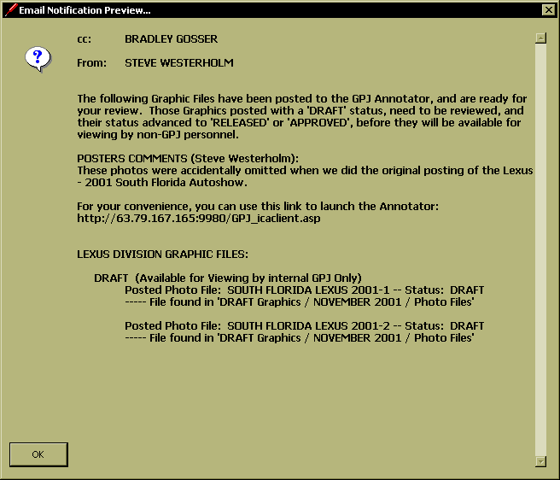

- The screen below shows a sample email notification.
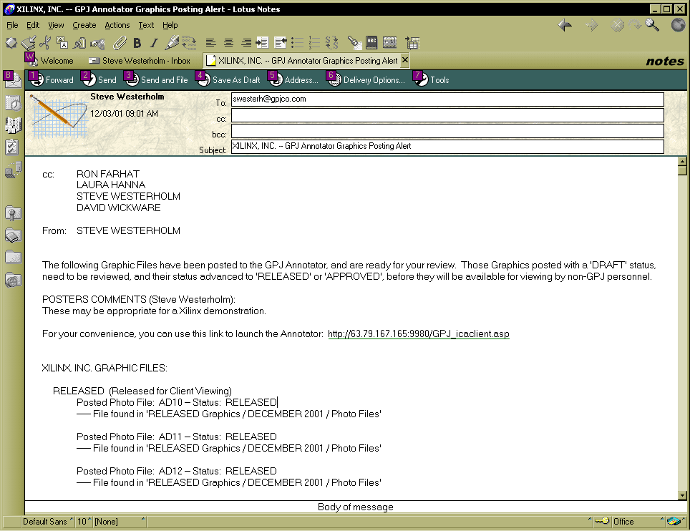

Editing Existing Graphic Files

- After opening a file from the “Existing Graphics…” tab, there is a variety of edit options available when you select the “Options…” button.
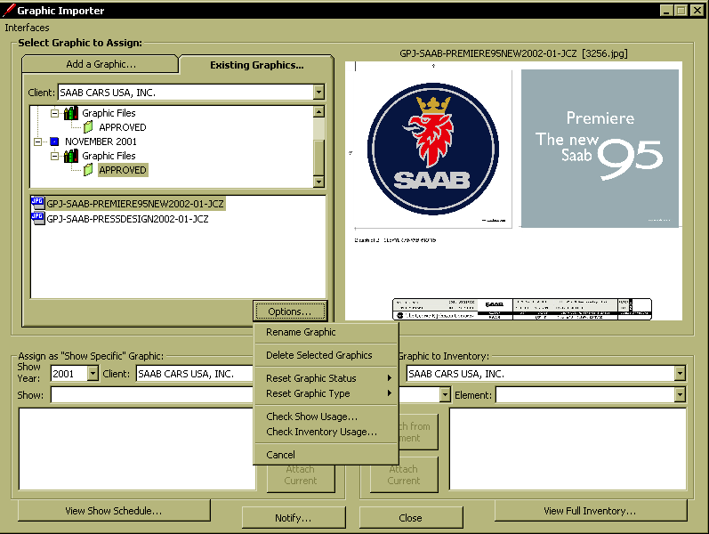

- “Rename Graphic” is a single-selection only option; it will only allow you to edit the name of the current file. Once selected, the file name becomes editable, and upon completion (hitting the <enter> key) the revised name is saved to the database.

- “Delete Selected Graphics” supports multi-select. All files highlighted will be either deleted or de-activated upon selection.

- If a file is attached to any Shows where the Show open date is before ‘today’, the file will be de-activated. To be de-activated means it is no longer available to attach to a Show or to an Element in a Client’s Inventory, but the file will continue to be viewable when accessed from either the “Active Show Graphics…” tab or the “Show Season…” tab in the Annotator. If this de-activated file was attached to any future Shows, it will be detached.
- If the file has not been attached to any Shows, which opened prior to ‘today’, then the file is truly deleted, and detached from all Shows and Elements in the Inventory.

NOTE: “Delete Selected Graphics” works differently than “Canceling” Graphics in the Annotator. The Graphic Importer is intended to be more of a “housekeeping” tool, and as such, there is no automated email alert to the Team of a file delete. If a file is “Canceled” in the Annotator, it requires a notification prior to the delete becoming permanent.

- “Reset Graphic Status” supports multi-select. On the flyout menu you will find the two status changes available. If one is selected, the status level of all the highlighted files will be edited, but keep in mind that the files will not be available to view at the new status until a notification has been sent out. These modified files will now be in the “Notify…” interface.
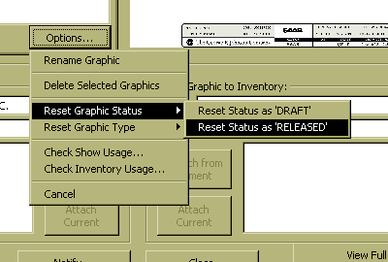

- “Reset Graphic Type” supports multi-select. On the flyout menu you will find the three type changes available. If one is selected, the Graphic Type of all the highlighted files will be edited.
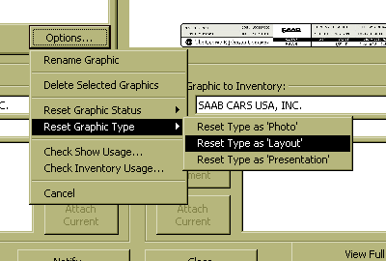

- “Check Show Usage” and “Check Inventory Usage” provides you with quick views of all the selected files assignments.

