GPJ Annotator Installation Instructions
NOTE: Please close all current Applications before beginning install.

Installation of the Annotator is an easy three-step process. Installation should take no more than 5-10 minutes, and in most cases will not require you to reboot your computer. All required files are available to you on the network.
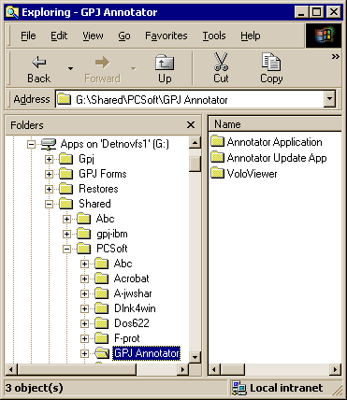
To begin, launch Windows Explorer and path to “G:\Shared\PCSoft\GPJ Annotator”, as shown on the screen at right.

STEP 1: Install VoloViewer
- Open the VoloViewer folder and double-click on “VoloVEc.exe”
- Once “VoloVEc.exe” has been double-clicked, allow the VoloViewer to initiate its installation. This may take a few moments. Be patient, you will prompted eventually.
- Once install commences, accept all the default values as shown below.
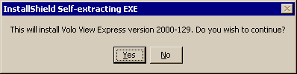

YES
Be Patient… This is just getting the install ready.

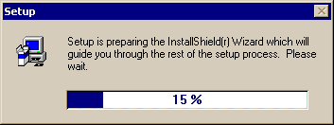

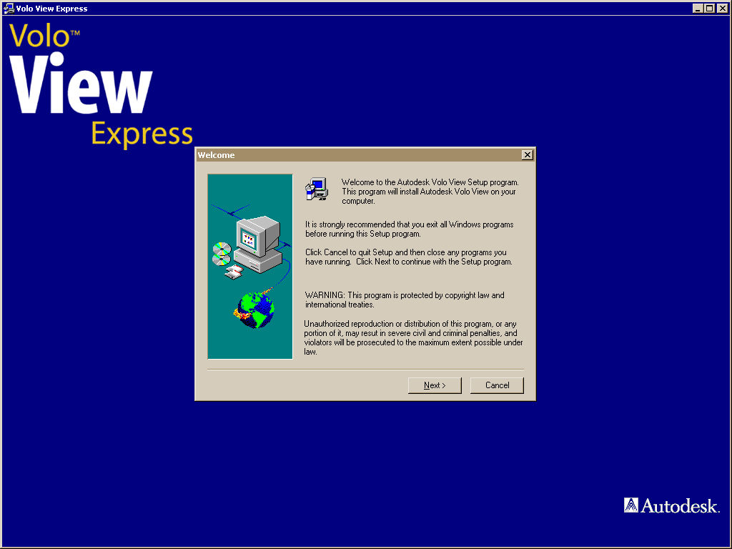

Now you’re into it… Keep hitting “Next” to accept defaults.

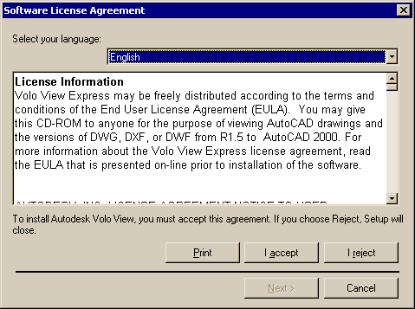
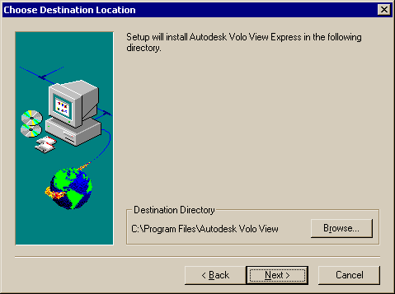
Accept
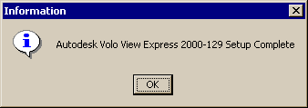
This path is used by the Annotator Update installed in Step 3. Do not change, hit “Next”.
This will show when you are done!

STEP 2: Install Annotator
- Back in Windows Explorer, enter the “Annotator Application” folder and double-click on the “Setup.exe” file to launch the setup. NOTE: Some computers are setup to not show known file extensions, so you may see two files named “Setup”. One is the “EXE” file and the other is an “LST” file. You can easily tell the difference by right-clicking on the file and selecting “Properties”. On the General Tab you will see the files full name.
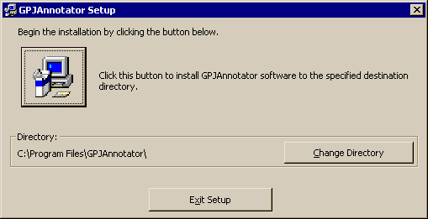
- NOTE: Sometimes, at this point, you will be prompted of an out-of-date file that requires you to reboot before proceeding. I’m sorry, but you will need to reboot, and once again path to “Annotator Application” and double-click the “Setup.exe”.
- Once again, accept all the defaults offered during the installation, by selecting “CONTINUE” or “OK” as you are prompted.
Click Here
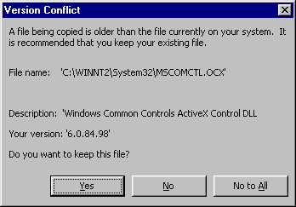
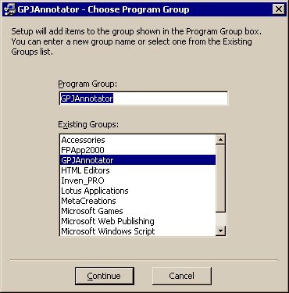
- If any “Version Conflict” message boxes, like the one at left, pops up during install, select “YES” (the default) so the install keeps your existing file. NOTE: The File Name may vary.
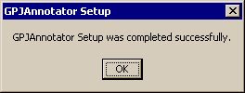
YES

STEP 3: Install Annotator Update App
The “Annotator Update App” is used to update the Annotator whenever the Application has been changed and a new “EXE” is available. When you launch the Annotator, the startup screen prompts you if you are running on the most current version. If not, you will be prompted to run “Annotator Update”, as well as how. So, it is important to install it.
- Back in Windows Explorer, enter the “Annotator Update App” folder. and double-click on the “Setup.exe” file to launch the setup.
- 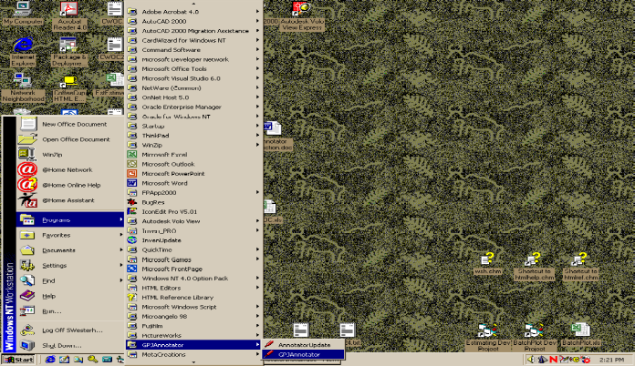Once again, accept all the defaults offered during the installation, by selecting “CONTINUE” or “OK” as you are prompted. Install will be very similar to the Annotator Install above.
- This App is very small, and will install quickly.

If you want easier access to the Annotator: From the “Start\Programs” menu, right-click on ”GPJ Annotator” (shown at right), hold down, drag & drop onto your desktop. Accept “Create Shortcut Here” to create a launch-able Icon.

