Q1: Wap to demonstrate ternery operator. Define a variable marks ask its value from user and using ternery operator check if marks>40 store “Pass” in result variable else store “Fail”

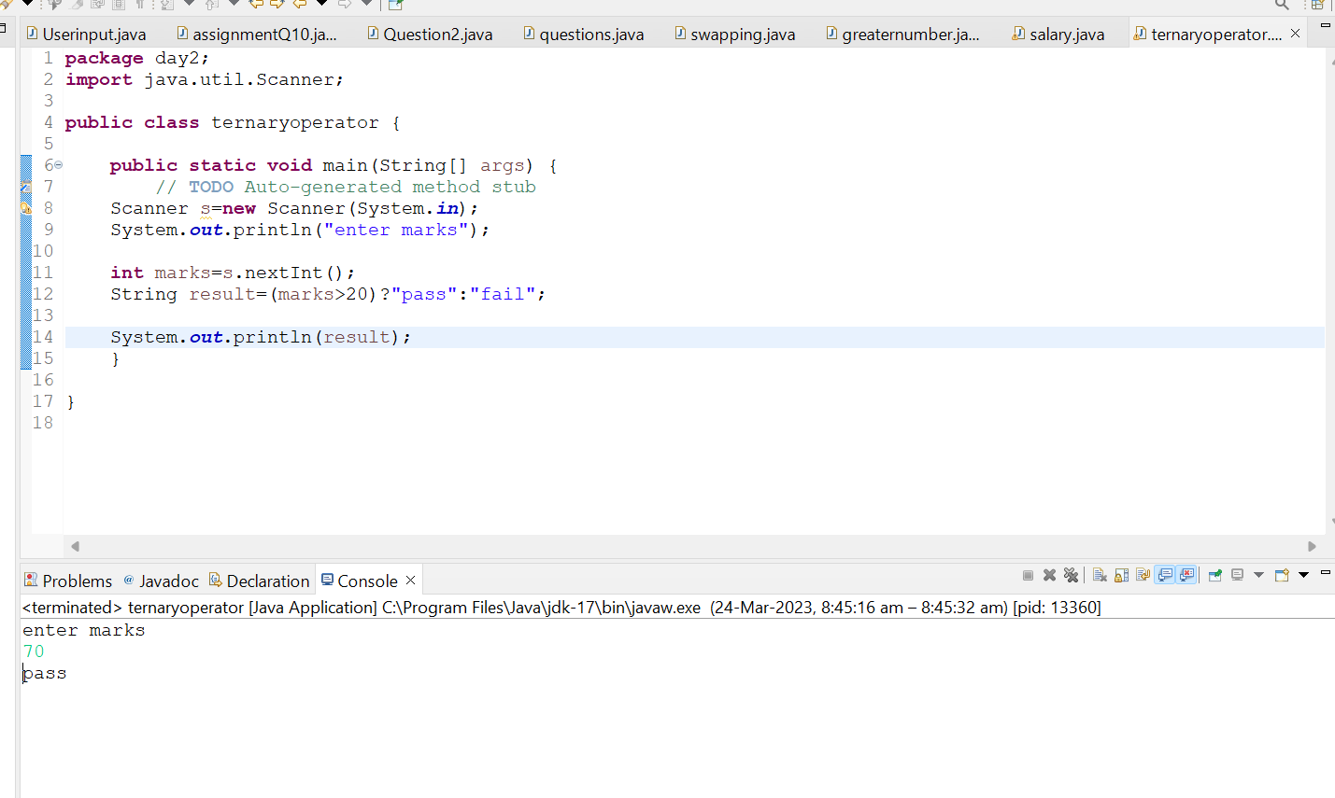

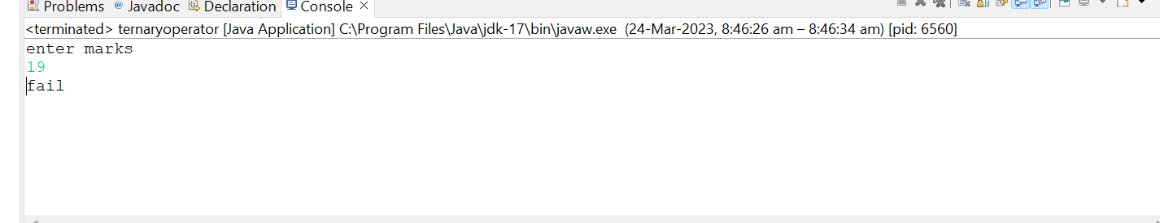

Q 2. Using ternary check if number entered by user is positive or negative. In case number is positive store “Positive number” else store negative number to Result variable

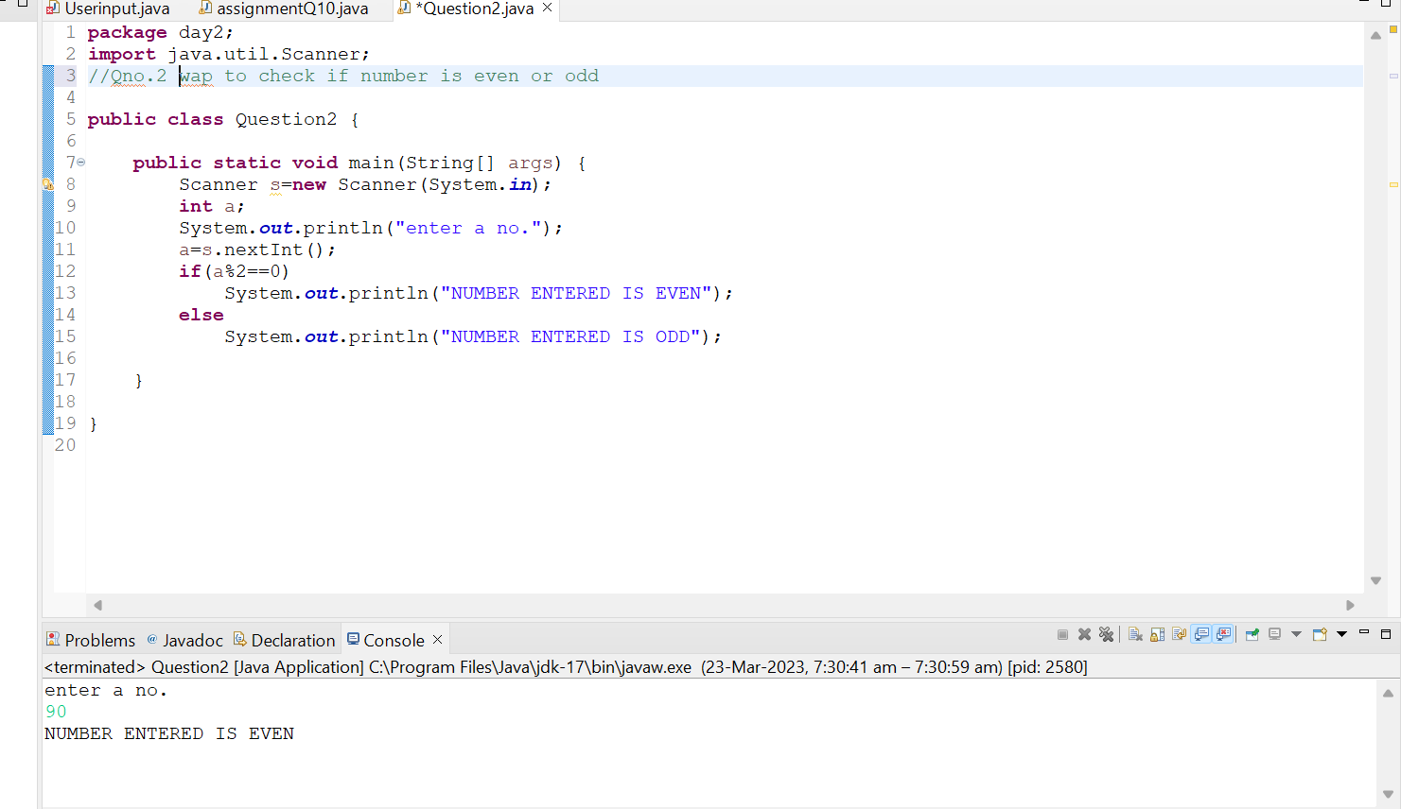

Q 3:Wap to ask name, age and salary of an employee and print on console.

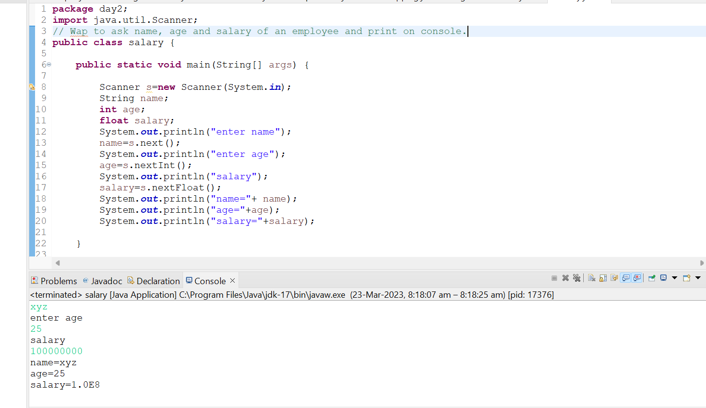

Q4: wap that ask two numbers from user and print greater number among two

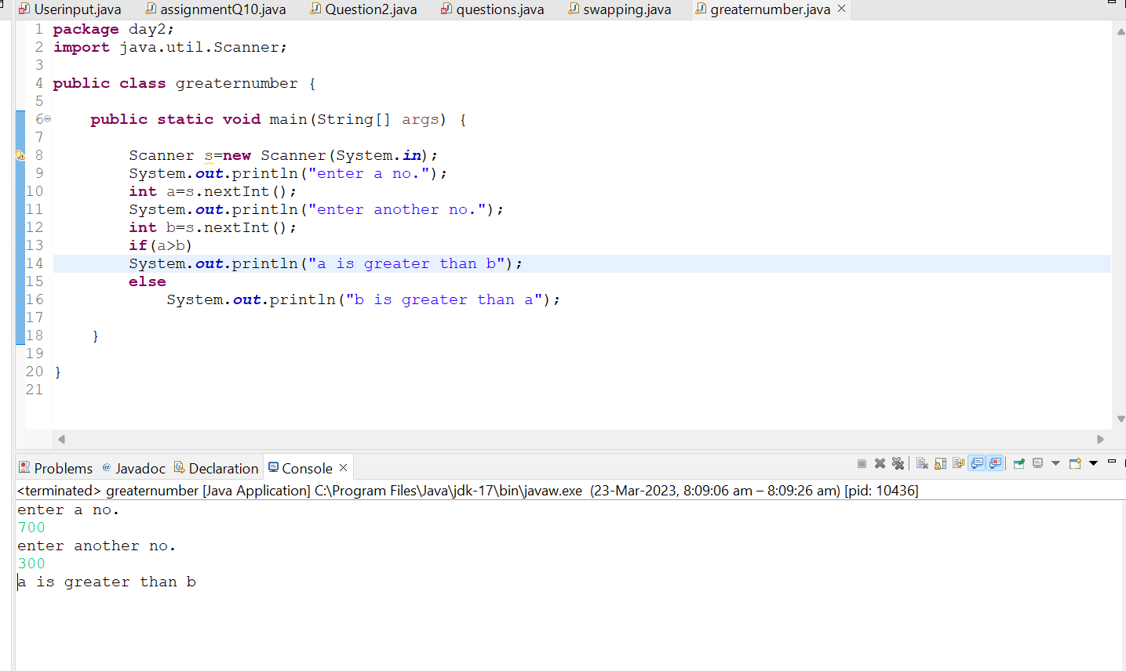

Q 5: wap to ask product name and price of product from user and calculate discount i.e

if price> 2000 then discount is 10 percent of price else discount is 7% of price

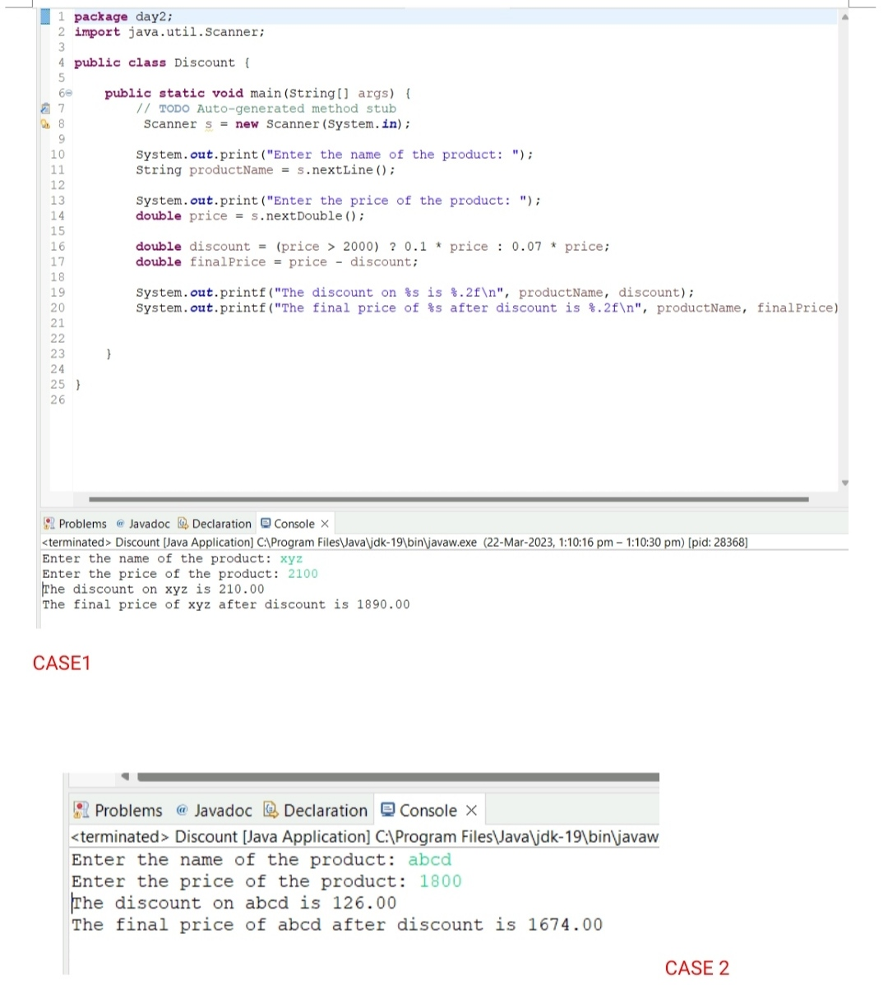

Q6: Wap to swap two numbers

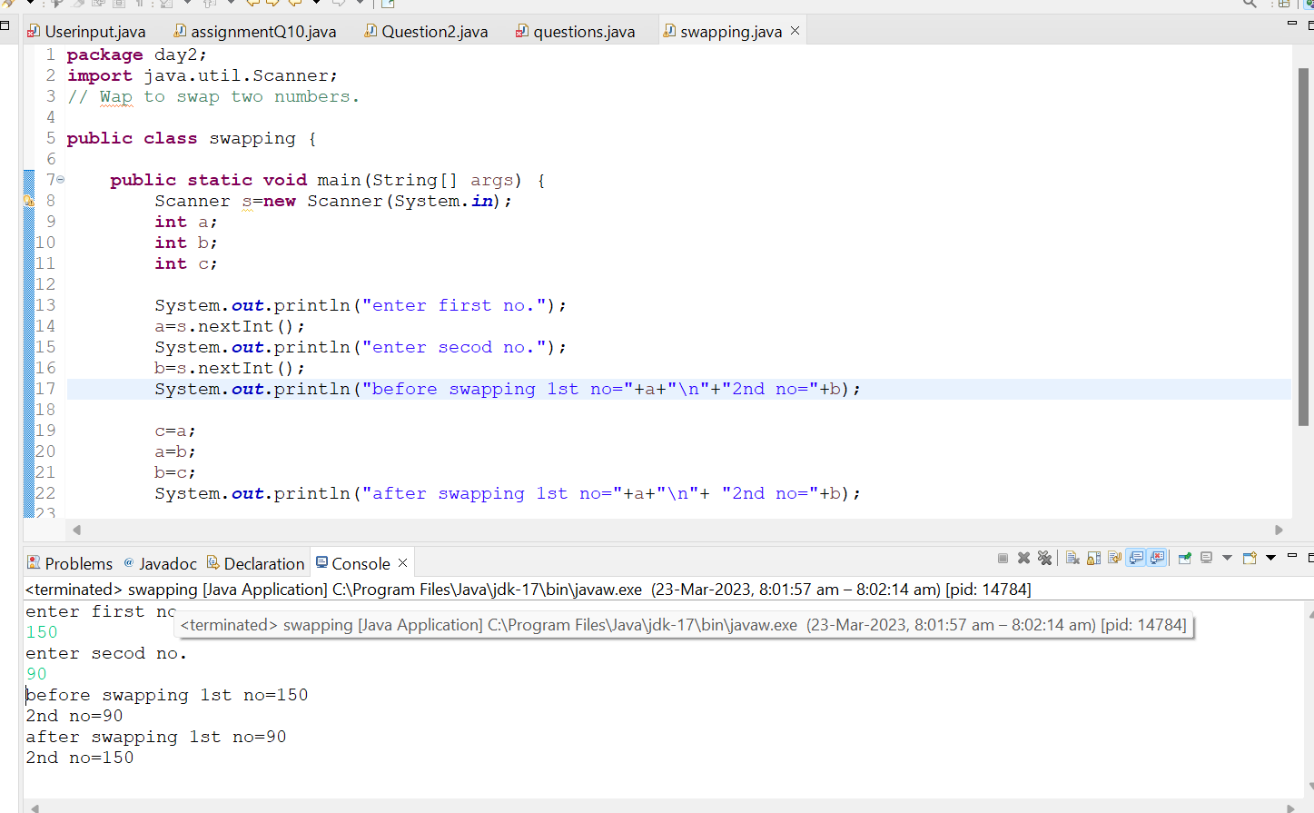

Q 7: How to swap two numbers without using a third variable?

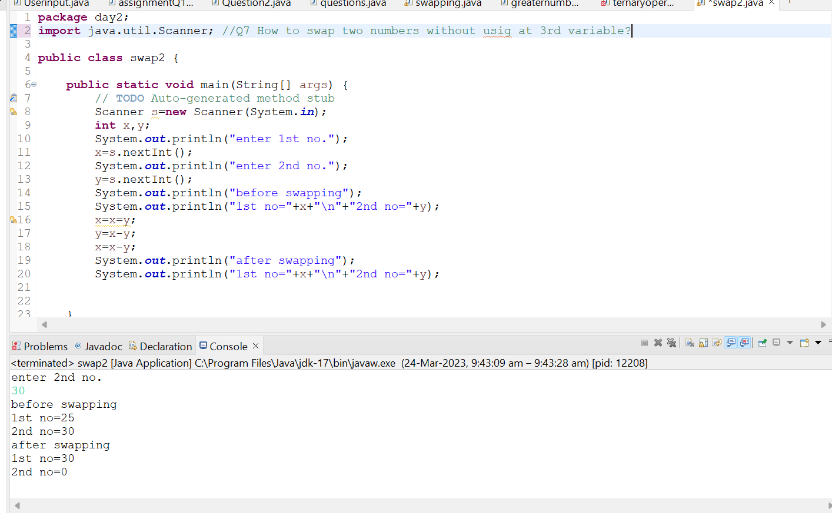

Q 8: Wap to swap two numbers using a third variable

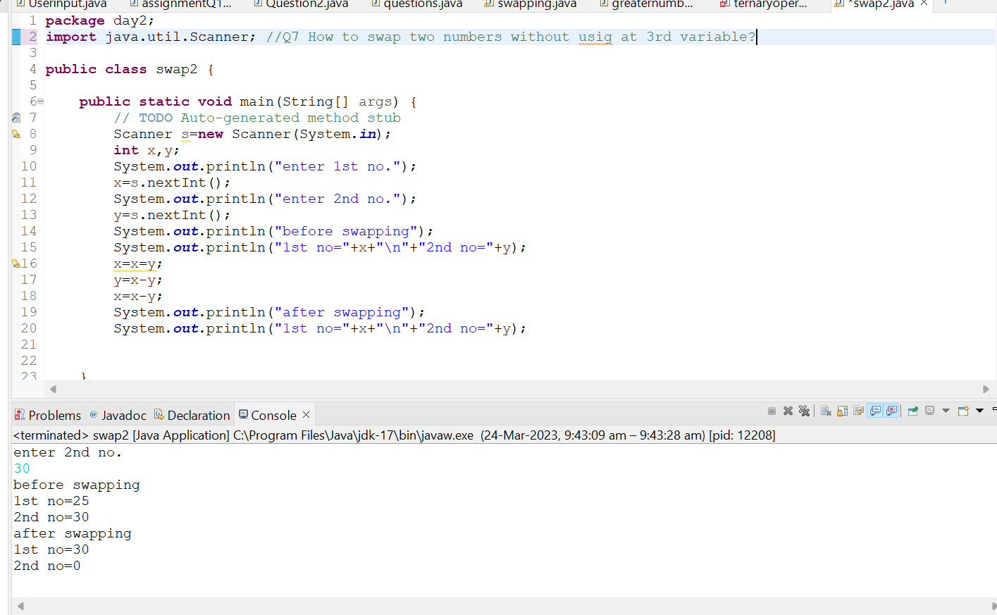

Q10: Wap to check greater number among three numbers.

