**Assignment ASDM**

**1. Commercial Pharmaceutical Application**

**1.1 Components**

**1.1.a** Story**>**1. PRESCRIPTION MANAGEMENT SYSTEM

2. PHARMACY INVENTORY

3. DRUG DATABASE

4. AUTHENTIC PATIENT PRESCRIPTION

**1.1.b** Task**>**1. PRESCRIPTION ANALYSIS

**1.1.c** Bug**>**1. SOME MEDICINES NOT AVAILABLE

**1.1.d SPRINT 1**

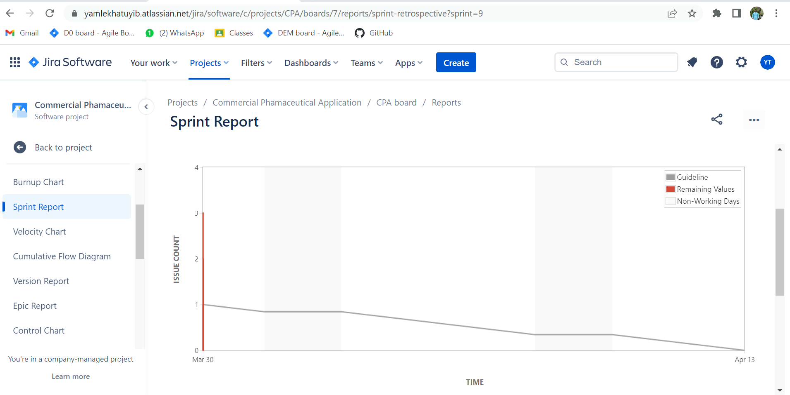

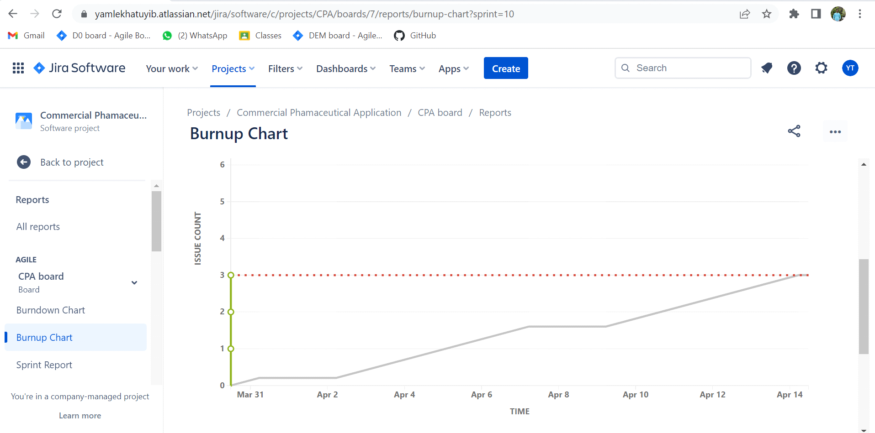

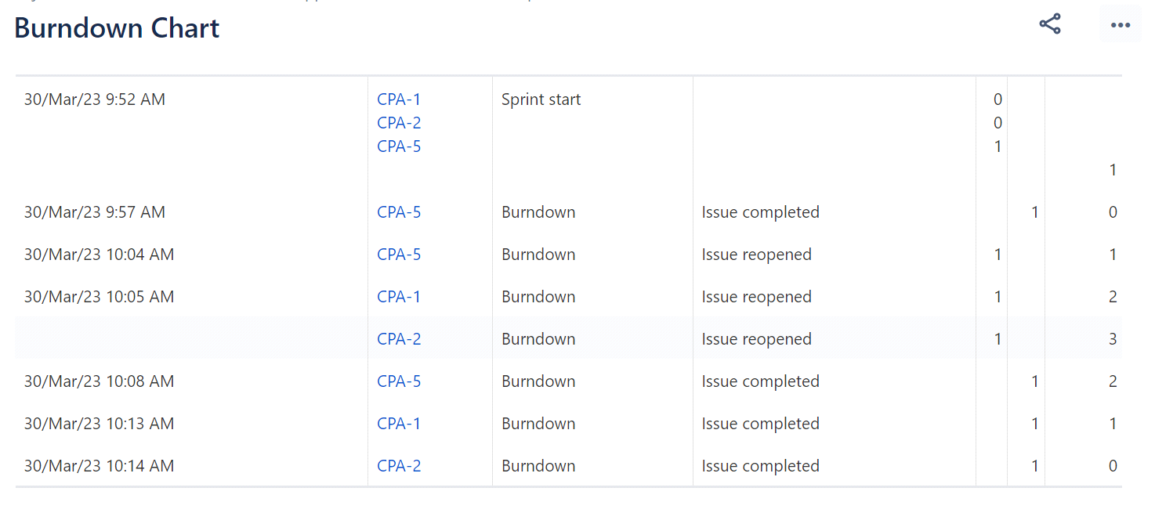

**1.1.e SPRINT 2**

