# Laptop Name:

Laptops under 50000: Best picks for you | - Times of India (August ...

# Link:

https://timesofindia.indiatimes.com/most-searched-products/electronics/laptops/laptops-under-rs-50000-top-choices-for-your-personal-business-needs/articleshow/86672348.cms

# Image:



# Laptop Name:

Best Laptops Under Rs 50000 in India With Price, Features ...

# Link:

https://www.gadgets360.com/laptops/laptops-under-50000

# Image:



# Laptop Name:

10 Best Laptops Under 50000 in India 2023

# Link:

https://www.outlookindia.com/whats-hot/best-laptops-under-50000-in-india-news-267743

# Image:

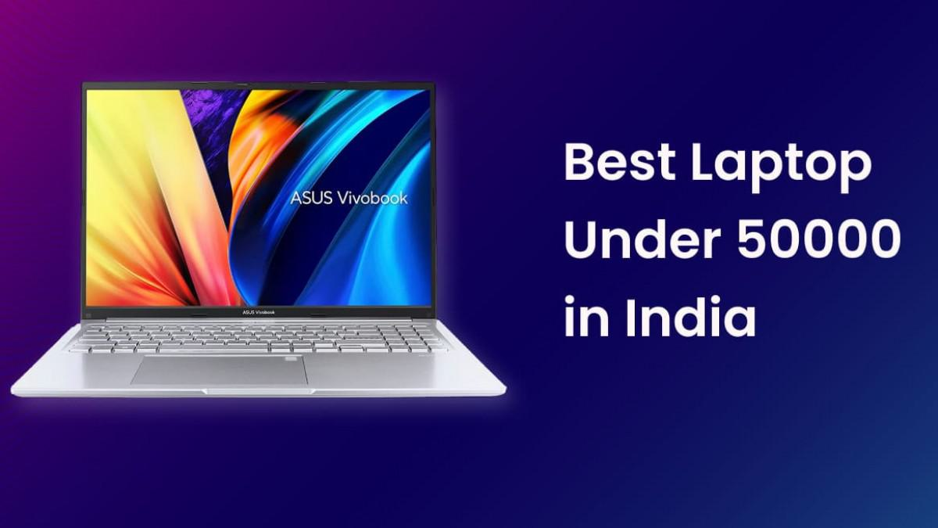

# Laptop Name:

Best Laptops Under Rs 50000 Online at India's Best Online ...

# Link:

https://www.flipkart.com/q/best-laptops-under-rs-50000

# Image:



# Laptop Name:

Best Laptops Under Rs. 50,000 in India (9th September 2023 ...

# Link:

https://www.91mobiles.com/top-10-laptops-below-50000-in-india

# Image:



# Laptop Name:

10 Best Laptops Under 50000 in India (September 2023) - Ultimate ...

# Link:

https://www.newindianexpress.com/expressdeals/laptops/best-laptops-under-50000-in-india/549.html

# Image:

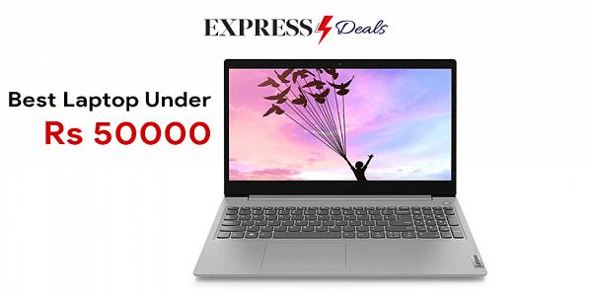

# Laptop Name:

What's the best laptop right now in India in under 50k and 60k ...

# Link:

https://www.reddit.com/r/india/comments/y4frqo/whats_the_best_laptop_right_now_in_india_in_under/

# Laptop Name:

Best Laptop Under 50000 In India - The Hindu

# Link:

https://www.thehindu.com/brandhub/best-laptops-under-50000-in-india/article66200169.ece

# Image:



# Laptop Name:

Best Laptop under 50,000 in India - Price & Specs (September 2023 ...

# Link:

https://www.digit.in/top-products/best-laptops-under-50000-3611.html

# Image:



# Laptop Name:

Best Business Laptops Under 50000 In India

# Link:

https://english.jagran.com/top-deals/electronics/laptop/best-business-laptops-under-50000-in-india-10083694

# Image:

