**CSC3002F Assignment 1 Report 1**

**Names:**

**Sibusiso Mayalo (MYLSIB001)**

**Luvo Ntshewula (NTSLUV003)**

**Yamkela Venfolo (VNFYAM001)**

**Functionality overview**

Our chart app runs on a protocol of a client-server based architecture. Which requires our clients to connect to a server in order to exchange data between them using a TCP socket. In our chart application we have taken into consideration of issues like bandwidth – which is an issue and is relatively expensive when acquiring a data. Security –the massages between clients are private, when a client sends a message it’s only the destination client that can view the message. Reusability – the client once sign up to the application does no lose their login details so that they can reuse them when they login again.

This chart application functionalities and features. Includes 1-to-1 private chart with an online client, broadcast messages to all online clients, an image message to online client, broadcast image to all online clients, 1-to-1 private audio message and Broadcast Audio message.

**Features**

**1-to-1 private chart with online client**

The clients are able to send private text messages to each other. When the source client chooses the option of sending a text message to another client, the source client is given a list of online clients which it can choose from to send a text message. The text message that is sent to the client will not be seen by any other client on the server.

**Broadcast message to online client.**

The client is able to send a text message to all online clients on the server. When the source client choose the option of sending text to all online client which is option 3. The message sent by the source client will be forwarded to all the online clients in the server.

**Image message to online client**

The client is able to send the image to one of the online clients. The source client specify the path of the image. If it is in the CSC3002F_Assignment1 folder then the source client must just specify its name. There is a consent which is when the source client sends an image the server notify the destination client that the specified source client sends an image. The server only sends the image if the response from the destination client is “Yes”. If the response of the destination client is “No”. Then the server deletes the image so that it does not infringe the source client privacy.

**Image Broadcast to all online clients**

The source client can be able to broadcast the image. Were it is possible for very client online at that time to view the image. It is the same as sending the image to 1 client. Were the client has to specify the path of the image. If it’s in the CSC3002F_Assignment1 then the client just specify the name of the image. Also there is a consent were the server notify all the online clients about the image sent. So the destination client receive the image only if the response is “Yes”. If the response is no then it doesn’t receive the image.

**1-to-1 private Audio Message**

Clients are able to send each other audio messages privately. When the client chooses the option of sending an audio. The source client receives a list of online clients that it can choose from to send the audio. The audio can only be played by the destination client of the server not any other client on the server.

**Screen shorts:**

**text messages**:

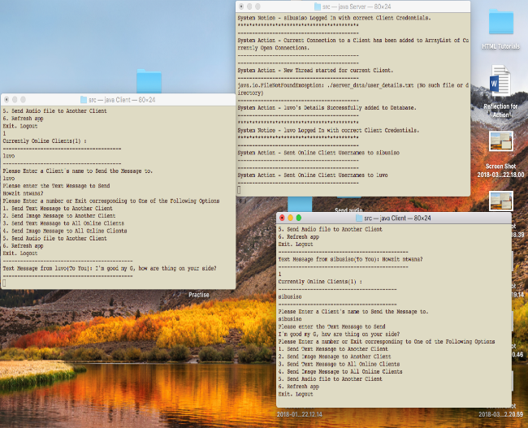 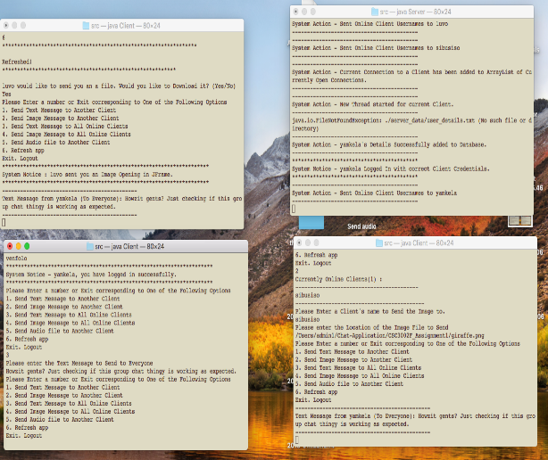 *FIGURE 1.1: 1-to-1 message between Luvo and sibusiso FIGURE 1.2: TEXT MESSAGE from yamkela TO ALL CLIENTS*

**iMAGE mESSAGES:**

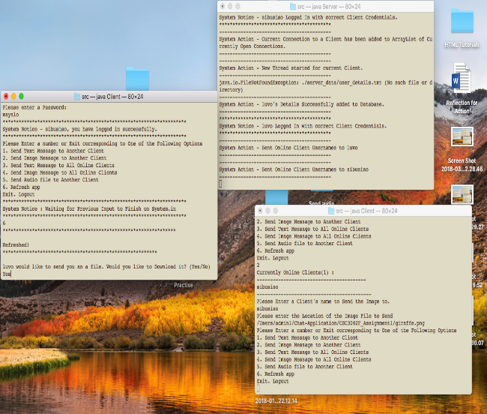 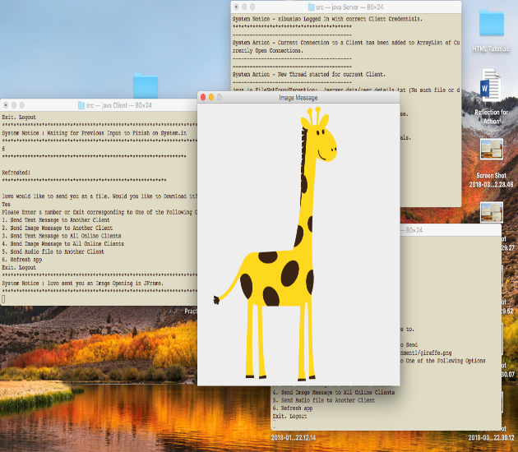*FIGURE1.3 IMAGE MESSAGE from Luvo to sibusiso*

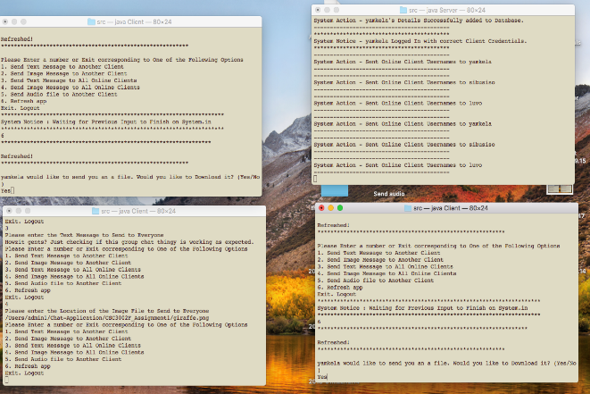 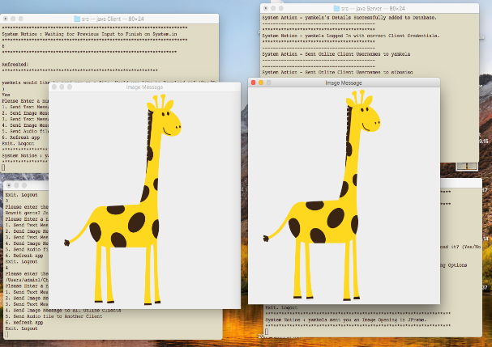 *fIGURE 1.4: iMAGE MESSAGE from Yamkela TO ALL INLINE CLIENTS*

**aUDIO mESSAGE:**

**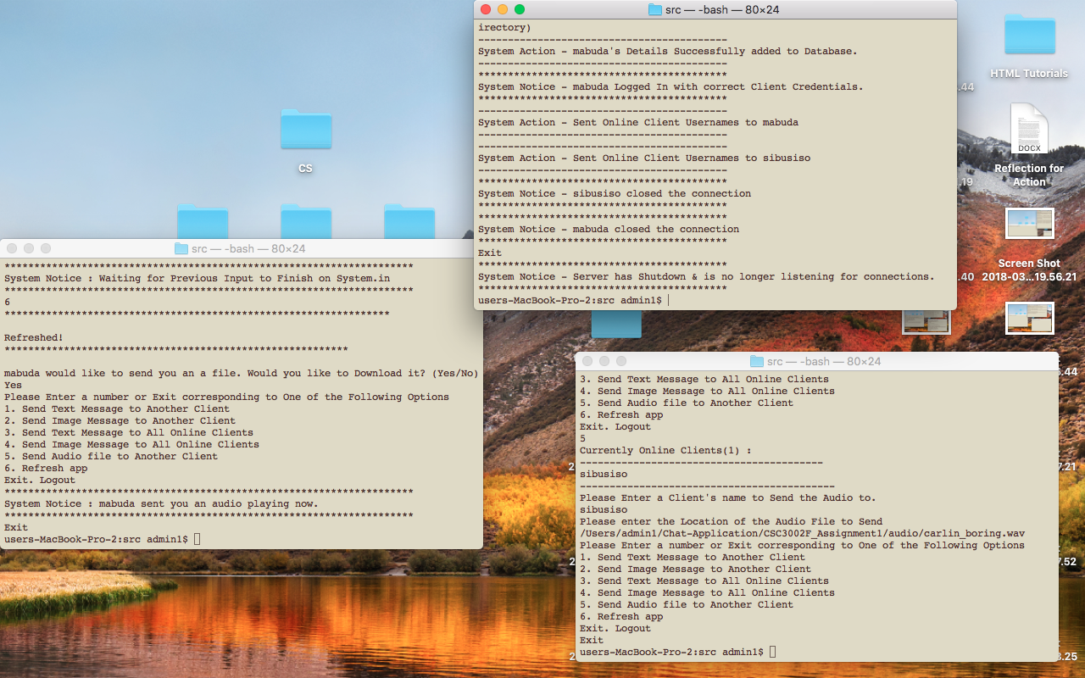***fIGURE1.6: aUDIO MESSAGE TO AN ONLINE CLIENT*

**Server shutting down:**

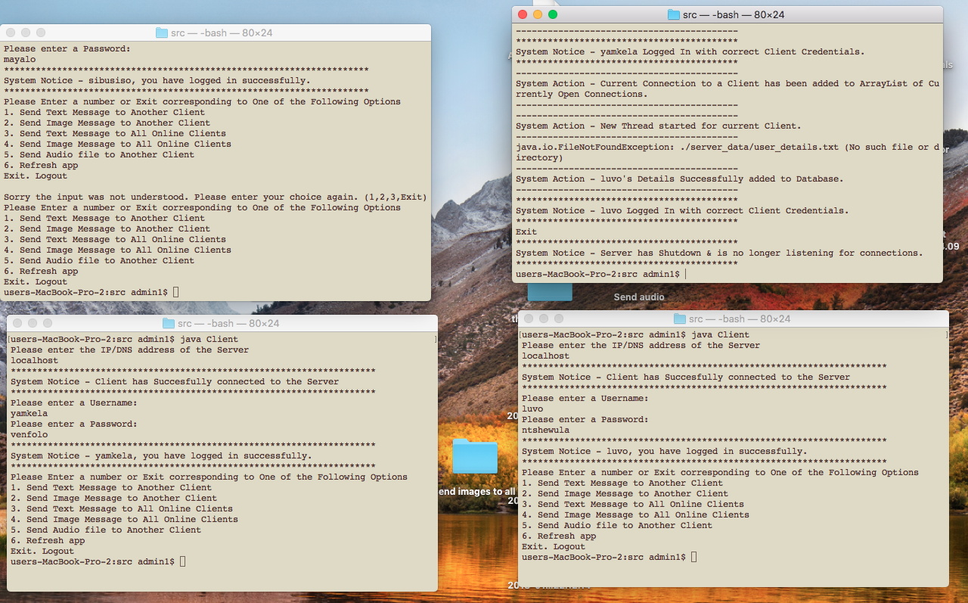

*Figure 1.7: showing the server shutting down.*